USER GUIDE

ALTIOSTAR HR SOFTWARE

2014

# CORE MODULES

# DEFINE MASTER DATA

## **Role**

* *Go to Setup >> Role*
* *Click on the Add button.*
* *To Add >> Fill in the Role name and description*
* *Assign the necessary permissions and save the details.*
* *The roles will be visible in the grid.*
* *To Edit >> select a particular role, make the necessary changes and click on Save.*
* *To activate >> Check the Is Active check box. Select a particular role from the grid and click on the ‘Activate’ check box. The role will be activated.*
* *To Deactivate >> Select a particular role from the grid and uncheck the checkbox. The role will be de activated.*

## **Designations**

* *Go to Setup>>Designation.*

*// Snapshot*

* *Click on Add button.*
* *Enter the designation name, and select a role and save the details. The designations will be visible in the grid.*
* *The role selection is to map the designation to a particular Role.*
* *Based on the mapping above, the UI will vary for an employee, a team manager, a consultant and HR*

*//Snapshot*

* *To edit, select a particular designation, make the necessary changes and save the details.*
* *To activate, check the check box. Select a particular designation from the status column and click on the Activate checkbox. The designation will be activated.*
* *To Deactivate, Select a particular designation from the grid and uncheck the check box. The designation will be deactivated.*

## **Relation**

* *Go to Setup>> Relation.*

*// Snapshot*

* *To Add, Fill in the relation and click on Save.*
* *The relation will be visible in the grid.*

*//Snapshot*

* *To edit, select a particular relation, make the necessary changes and save the details.*
* *To activate, check the check box. Select a particular designation from the status column and click on the ‘Activate’ checkbox. The designation will be activated.*
* *To Deactivate, Select a particular designation from the grid and uncheck the check box. The designation will be deactivated.*

## **Country**

* *Go to Setup>> Country*
* *Click on the add button.*
* *Fill in the country code and country name*
* *Click on save button*
* *To edit, select an entry from grid and click on edit button*
* *Make the necessary changes and click on the save button*
* *To activate, Select the entry from the grid and check the checkbox in the status column. The entry will be activated.*
* *To deactivate, select the entry from the grid and uncheck the checkbox in the status column .The entry will be deactivated*

## **Location**

* *Go to Setup>>Locations*
* *Click on add button.*
* *Enter the location name and map the location to a country and click on save.*
* *To edit, select an entry from grid and click on edit button*
* *Make the necessary changes and click on the save button*
* *To activate, Select the entry from the grid and check the checkbox in the status column. The entry will be activated.*
* *To deactivate, select the entry from the grid and uncheck the checkbox in the status column .The entry will be deactivated*

## **Consultant**

* *Go to Setup>>Consultant*
* *Click on add button.*
* *Select the designation as consultant*
* *Fill in the consultant name, contact person, telephone number; email id, address and click on save.*
* *To edit, select an entry from grid and click on edit button*
* *Make the necessary changes and click on the save button*
* *To activate, Select the entry from the grid and check the checkbox in the status column. The entry will be activated.*
* *To deactivate, select the entry from the grid and uncheck the checkbox in the status column .The entry will be deactivated*
* *To create users >> select a consultant from the grid and click on the ‘Create User’ button*

*Give a username and password and click on save.*

*The consultant will now be able to login with the created username and password.*

* *To reset password>> select a consultant from the grid and click on ‘Reset Password’ button*

*The old password will be reset. The default reset password is 123456789*

## **Marital Status**

* *Go to Setup>>Marital Status*
* *Click on add button.*
* *Fill in the marital status and click on save.*
* *To edit, select an entry from grid and click on edit button*
* *Make the necessary changes and click on the save button*
* *To activate, Select the entry from the grid and check the checkbox in the status column. The entry will be activated.*
* *To deactivate, select the entry from the grid and uncheck the checkbox in the status column .The entry will be deactivated*

## **Team**

* *Go to Setup>>Team*
* *Click on add button.*
* *Enter a Team name and select the team manager from the manager drop down.*

*The manager drop down will load all employees in the organization. The user can pick the team manager here.*

* *To edit, select an entry from grid and click on edit button*
* *Make the necessary changes and click on the save button*
* *To activate, Select the entry from the grid and check the checkbox in the status column. The entry will be activated.*
* *To deactivate, select the entry from the grid and uncheck the checkbox in the status column .The entry will be deactivated*

## **Setting configuration**

* *Go to Setup>>Setting Configuration.*
* *Only 3 parameters can be modified here.*
* *They are Leave Count, Annual Conveyance Allowance and Medical Reimbursement*

*As per the Altiostar process, the following values are fixed.*

*Leave count = 30 (30 annual leaves per year)*

*Annual conveyance allowance = Rs. 9600*

*Medical reimbursement (Rs. 15000)*

* *To modify any of the above, click on a particular cell in the value column. Enter the number and press enter key.*
* *A message ‘Setting configuration updated successfully ‘will be shown*

## **Holiday**

* *Go to Setup>>Holiday*
* *Click on Add button.*
* *Select the country.*
* *Enter the holiday name, select a date and fill in the description and click on save*
* *To edit, select an entry from grid and click on edit button*
* *Make the necessary changes and click on the save button*
* *To activate, Select the entry from the grid and check the checkbox in the status column. The entry will be activated.*
* *To deactivate, select the entry from the grid and uncheck the checkbox in the status column .The entry will be deactivated.*

# Employee

## **View Employee**

* *Login to the application.*
* *Go to employee>>View Employee.*
* *Select View Employee*.

## Add an Employee

* *To add an employee, click on Add button.*
* *There are 6 following tabs available to the employee to fill in.*
* *Employee personal details, Occupational Details, Education Details, Carrier Summary, Altiostar CTC and Document upload.*
* *Fill in all the details in the employee personal details page and click on save button.*
* *Click on Occupational details tab, the page opens.*
* *Select the joining date using date picker.*
* *Select the Country, location, designation and Team name using drop down.*
* *On selecting the Team Name the Manager Name is displayed automatically.*
* *Fill in the other details and click on save button.*
* *Click on Education Details tab to add the education details of the employee. The page opens.*
* *Click on Add button. Fill in all the details and click on save button.*
* *To edit the details, select the entry from the grid and click on Edit Button.*
* *Make the necessary changes and click on save button.*
* *To delete the details, select the entry from the grid and click on Delete button.*
* *Click On Carrier Summary tab. The page opens.*
* *Click on Add button. The pop up opens.*
* *If the employee is fresher, select the fresher radio button.*
* *On selecting fresher, all the fields get disabled. Click on save button.*
* *If the employee is experienced, select the Experienced radio button.*
* *Fill in all the details and click on save button.*
* *To edit the details, select the entry from the grid and click on Edit Button.*
* *Make the necessary changes and click on save button.*
* *To delete the details, select the entry from the grid and click on Delete button.*
* *Click on Altiostar CTC tab. The page opens.*
* *Enter the CTC (Yearly), all other fields are filled automatically.*
* *Click on save button.*
* *Click on Document Upload tab.*
* *To upload the document, click on “Please select a document to upload”.*
* *The pop up opens. Enter the document title and browse the file.*
* *Click on save button.*
* *To view the document, select the entry from the grid and click on View Document.*
* *To delete the document, select the document from the grid and click on Delete option.*
* *On clicking Back tab the user is navigated to View employee page.*

## View/Modify the Employee details

* *To view the employee details, select the employee from the grid.*
* *Click on View button.*
* *The employee details are displayed.*
* *To modify make a necessary changes and click on save button.*

## Delete

* *Select an entry from the grid and click on Delete button.*
* *A confirmation message is provided. Click on OK button*.

Create users

* *Select an employee from the grid and click on Create users.*
* *Enter the login name and password.*
* *Click on save button.*

## Leave Modify

* *Select an employee whose leave has to modify. The leave request page opens.*
* *Select the entry from the grid and click on Modify button.*
* *The leave details are displayed. Click on Reset date selection.*
* *Click and drag the mouse on the calendar to modify the From and To date.*
* *On doing this From date, To date and days count will be shown automatically on the left hand side.*
* *Click on Submit button.*
* *To approve, select the entry from the grid and click on Approve button.*
* *To reject, select the entry from the grid and click on Reject button.*

## Upload Employee data

* *To upload employee details, click on Upload Employee Data.*
* *A pop up opens. Brows the file of a proper format (.xsls only) which includes all the mandatory details of the employee page.*
* *Click on save button.*

## Refresh

* *To refresh the page, click on Refresh button.*

## Employee Filter

* *Enter search criteria in any one of the field or all the fields and click on Search option.*
* *Based on the search option, the records will be displayed in the grid*
* *On clicking Reset button, the page is refreshed and all the employee details are displayed in the grid.*

## Employee Self information

* *Go to employee>>View*
* *Click on Employee self information*
* *There are 6 following tabs available to the employee.*
* *Employee personal details, Occupational Details, Education Details, Carrier Summary, Altiostar CTC and Document upload.*
* *The user will not have the privilege to change any of the following details>> Employee personal details, Occupational Details, Education Details, Carrier Summary, Altiostar CTC.*
* *The user can upload, view and delete the document.*

## **Reports**

### Team wise Employee Report

* *Go to Reports>>Employee*
* *Click on Team wise Employee Report.*
* *Select the Team Name from the drop down and click on Generate.*
* *The Report gets generated.*
* *To export the report to Word or PDF or to the Excel, click on Export option.*

### Exit Employee Report

* *Go to Reports>>Employee*
* *Click on Exit Employee Report.*
* *Click on Generate button. The Report gets generated.*
* *To export the report to Word or PDF or to the Excel, click on Export option.*

### Employee Joining Date Report

* *Go to Reports>>Employee*
* *Click on Employee joining Date Report.*
* *Select the From date and To date using date picker.*
* *Click on Generate button. The Report gets generated.*
* *To export the report to Word or PDF or to the Excel, click on Export option.*

### Employee Type Report

* *Go to Reports>>Employee*
* *Click on Employee Type Report.*
* *Select the Employee Type from the drop down and click on Generate.*
* *The Report gets generated.*
* *To export the report to Word or PDF or to the Excel, click on Export option.*

### All Employee Details

* *Go to Reports>>Employee*
* *Click on All Employee Report.*
* *Click on Generate button. The Report gets generated.*
* *To export the report to Word or PDF or to the Excel, click on Export option.*

### Employee Details

* *Go to Reports>>Employee*
* *Click on Employee Details.*
* *Enter Employee Code and click on Generate button.*
* *The Report gets generated.*
* *To export the report to Word or PDF or to the Excel, click on Export option.*

# LEAVE MODULE

## **View Leave Balance**

* *Login to the application.*
* *Go to Employee >> Leave.*
* *Click on Employee Leave Request.*
* *Your leave balance is now visible.*
* *The page displays Total leaves, used leaves and Balance leaves.*

## **Leave Request**

* *Login to the application.*
* *Go to Employee >> Leave*
* *Click on Employee Leave Request.*
* *Click on the Leave Request tab.*
* *Click on Add button. The pop up opens.*

***Note:*** *You cannot make a leave request on a weekend (Saturday & Sunday) and on a holiday*

* *Select the leave type*
* *Click and drag the mouse on the days you wish to request leave*
* *On doing this, the From date, To date and days count will be shown automatically on the left and side.*
* *Type in the reason and click on the Submit button.*
* *To modify the Leave request, select the entry from the grid and click on ‘Modify’.*
* *Make the necessary changes and click on save.*
* *To delete the Leave request, select the entry from the grid and click on Delete.*
* *A confirmation message is displayed. Click on Ok button.*
* *On clicking Expand option of each Request, Employee comment and manager comment will be shown.*

## **Checking Leave Status**

* *Login to the application.*
* *Go to Employee >> Leave*
* *Click on Employee Leave Request.*
* *Click on the Leave Request tab.*
* *The status of the leave will be visible in the last column.*

## **To approve/ reject a Leave request**

* *Login to the application as a Manager.*
* *Go to Employee >> Leave*
* *Click on Leave Approval.*
* *Select a request from the grid and click on Approve/Reject.*
* *To Approve a leave request >> Select a request from the grid and click on Approve button.*

*Enter the comments and click on save.*

* *To Reject a leave request >> Select a request from the grid and click on Reject button.*

*Enter the comments and click on save.*

* *The status of the leave will be visible in the last column.*
* *On clicking Expand option of each Request, Employee comment and manager comment will be shown.*

# Attendance

## **Employee Attendance**

* *Login to the application.*
* *Go to Attendance>>Employee Attendance.*
* *Choose the year and month from the drop down.*
* *Click on Upload file.*
* *Browse the file and click on save button.*
* *Click on View monthly attendance.*
* *Employee Attendance details are displayed in the grid.*

# Appraisal

## **Appraisal Intimation**

* *Go to Employee>> Appraisal.*
* *Click on Appraisal Intimation. The page opens*
* *Click on Goal Intimation to intimate the Goal.*
* *A pop up opens, select the intimation date using Date picker.*
* *Browse and upload the Form, click on save button.*
* *On clicking Cancel button the action is discarded.*
* *To update the intimation, select the row and click on Update Intimation.*
* *On updating, click on save button to save the changes.*
* *To delete the intimation, select the row and click on Delete button.*
* *To view the form, select the row and click on View Form.*
* *To intimate the Appraisal, select a row whose goal is already submitted and then click on Appraisal Intimation.*

## **Conduct Appraisal**

* *Select Intimation year from the combo box.*
* *The Team name & respective Team members with Goal and Grade status is displayed in the grid.*
* *To download the form, click on Download Form.*
* *To upload the goal for a team member, select the team member and click on Upload goal.*
* *A pop opens, browse the form and click on save button.*
* *After Goal submission, select the row and click on Notify Goal to notify goal submission.*
* *To edit the uploaded goal, select the row and click on Edit Goal option.*
* *To delete the goal, Select the row and click on Delete.*
* *To upload the grade for a team member, select the team member and click on Upload grade.*
* *A pop opens, browse the form and click on save button.*
* *After Grade submission, select the row and click on Notify Grade to notify grade submission.*
* *To edit the uploaded grade, select the row and click on Edit Grade option.*
* *To delete the grade, Select the row and click on Delete.*
* *To view the uploaded form, select the row and click on View Form.*

## **View Grade/Goal**

* *Select Intimation year from the combo box.*
* *Click on Expand option provided for each team to view the status of all the team members belonging to respective team.*
* *Select the team member and click on View button to view the Grade/Goal submitted.*
* *Team Name, Goal Submitted and Grade submitted are displayed in different colors.*

## **View Appraisal**

* *Select Intimation year from the Combo box.*
* *Select the team member and Click on view button to view the uploaded form.*
* *To promote the employee, select the team member and click on Promote Employee.*
* *The pop up opens displaying the employee name and current designation.*
* *Select the promoted designation from the combo box.*
* *Click on Promote button.*
* *On clicking Cancel button the action is discarded.*
* *To Hike the salary of the employee, select the team member and click on Salary Hike.*
* *The pop up opens displaying the employee name and current Salary.*
* *Enter the salary after hike in the text field. The Hike percentage is displayed automatically.*
* *Click on Hike option.*

## **Reports**

### Promotion Report

* *Select the Team Name from the combo box.*
* *Select From date and To date using date picker.*
* *Click on Generate option to generate the report.*
* *On clicking Export option the reports generated can be exported to Excel, Word and PDF.*

### Salary Hike Report

* *Select the Team Name from the combo box.*
* *Select From date and To date using date picker.*
* *Click on Generate option to generate the report.*
* *On clicking Export option the reports generated can be exported to Excel, Word and PDF.*

# Exit Management

* *Login to the application as HR.*
* *Go to Employee >> View.*
* *Click on View Employee.*
* *Select an Employee to be exited and click on View.*
* *Click on Occupational details tab and fills the Exit date and Type of Exit.*
* *One day prior to the exit date, the employee whose exit date is filled in will receive a notification asking him/her to fill the Clearance form.*

## **Upload Clearance form**

* *Login to the application as an Employee.*
* *Go to the Employee >> Exit management.*
* *Click on Upload Clearance form.*
* *Select an employee and Click on Upload Clearance form button.*
* *Browse the file and click on save button.*
* *To view the uploaded Clearance form, Select an employee and Click on ‘View’ button.*

## **Exit Management**

* *Login to the application as HR manager.*
* *Go to Employee >> Exit management.*
* *Click on Exit management.*
* *To view the Clearance form, Select an Employee from the grid and click on ‘View’ button.*
* *To Issue Relieving Letter, Select an Employee from the grid and click on Issues Relieving Letter.*
* *The HTML editor opens, Make the necessary changes in the Relieving letter and Click on save changes.*
* *To Issue Experience Letter, Select an Employee and click on Issues Experience Letter.*
* *The HTML Editor opens, Make the necessary changes in the Experience letter and Click on Save changes.*
* *On clicking Send Email, the Email is sent to the Employee.*
* *To take the Print of Relieving Letter and Experience letter, Click on Print Letter.*

## **Exit management reports**

### Exit Employee by Resignation Report

* *Go to Reports >> Exit management.*
* *Click on Exit Employee by Resignation Report.*
* *Select From date and To date using date picker.*
* *Click on Generate button. The report gets generated.*
* *To export the Report to PDF, Word or to Excel click on Export option.*

### Exit Employee by Termination Report:

* *Go to reports >> Exit management.*
* *Click on Exit Employee by Termination Report.*
* *Select From date and To date using date picker.*
* *Click on ‘Generate’ button. The report gets generated.*
* *To export the Report to PDF, Word or to Excel click on Export option.*

### Exit Employee by Team report

* *Go to reports >> Exit management.*
* *Click on Exit Employee by Team Report.*
* *Select From date and To date using date picker.*
* *Click on Generate button. The report gets generated.*
* *To export the Report to PDF, Word or to Excel click on export option.*

# Inventory Module

## **Asset Category**

* *Go to Inventory and click on Asset Category*
* *Click on the Add button*
* *Fill in the asset category name , description and click on Save*
* *To modify an asset category, select the entry from the grid, make the necessary changes and click on the save button.*
* *To deactivate >>Select an entry and click on edit. Uncheck the check box and click on save*
* *To activate >> Select an entry and click on edit. Check the check box and click on save.*

## **Asset Sub Category**

* *Go to Inventory and click on Asset Sub Category*
* *Click on the Add button*
* *Fill in the asset Subcategory name , description and click on Save*
* *To modify an asset subcategory, select the entry from the grid, make the necessary changes and click on the save button.*
* *To deactivate >>Select an entry and click on edit. Uncheck the check box and click on save*
* *To activate >> Select an entry and click on edit. Check the check box and click on save.*

## **Manufacturer**

* *Go to Inventory and click on Manufacturer*
* *Click on the Add button*
* *Fill in the manufacturer name, description and click on Save*
* *To modify an asset sub category, select the entry from the grid, make the necessary changes and click on the save button.*
* *To deactivate >>Select an entry and click on edit. Uncheck the check box and click on save*
* *To activate >> Select an entry and click on edit. Check the check box and click on save.*

## **Manage Assets**

* *Login as admin*
* *Go to Inventory>>Manage Assets*
* *Add an asset >> the asset number will be generated automatically.*
* *Enter the asset name; select the asset category, sub category, manufacturer, manufacturing date, warranty date.*
* *Enter the asset cost and vendor details. Click on save button.*
* *To modify, select an asset and click on the edit button. Make the necessary changes and click on the save button*
* *To delete, select an entry from the grid and click on the delete button*
* *To refresh the page click on the refresh button*

## **Assign Assets**

*This feature allows the admin or any concerned person to assign assets to a user or a team and track them till returning*

* *Click on the add button*
* *Select the option User or Team*
* *On selecting user, the employee list will be available and a user needs to be picked from the list.*
* *On selecting Team, a list of teams will be displayed and a team needs to be selected post which the team manger name will be displayed*
* *Select the asset name and all the asset details will be filled in automatically*
* *Select the date issued and mention the reason for issuing the asset to a user or a team*
* *Click. Thus the asset has been assigned successfully*

***Note:*** *An asset that is assigned to a user or a team or outside the company cannot be selected here*

## **Returning an asset**

* *Select the asset to be returned from the grid and click on view*
* *Check the is returned check box*
* *Select the returning date, mention the comments.*
* *Enter the location of the asset (where the asset has been restored. Example: Placed on the rack) and click on save.*
* *On returning the asset, the entry is cleared from the grid and it is available to be issued to others*

## **Outgoing Devices**

*This feature tracks the devices that moving out of the company for various reasons such as demo, servicing etc*

* *Go to Inventory and click on Outgoing Devices*
* *Click on the add button*
* *Mention the reason for a device to go outside the company*
* *Select the asset from the list, the details will be filled in automatically*
* *Select the outgoing date and then click on the Save button*

***Note:*** *An asset that is assigned to a user or a team or outside the company cannot be selected here*

## Returning an outgoing device

* *Select the asset to be returned from the grid and click on view*
* *Select the returning date and click on the save button*

*On returning the asset, the entry is cleared from the grid and it is available to be issued to others*

### Asset assigned to a Team

* *Go to Reports >> Inventory*
* *Click on Asset assigned to a Team*
* *Select a team from the drop down and click on generate button*
* *To export the Report to PDF, Word or to Excel click on Export option.*

### Asset assigned to a User

* *Go to Reports >> Inventory*
* *Click on Asset assigned to a User*
* *Select an employee from the drop down and click on generate button*
* *To export the Report to PDF, Word or to Excel click on Export option.*

### Outgoing devices report

* *Go to Reports >> Inventory*
* *Click on Outgoing devices report*
* *Pick a From date and To date and click on the generate button*
* *To export the Report to PDF, Word or to Excel click on Export option.*

### Assets by Category

* *Go to Reports >> Inventory*
* *Click on Assets by Category*
* *Select an asset category from the grid and click on the generate button*
* *To export the Report to PDF, Word or to Excel click on Export option.*

### Assets by Sub Category

* *Go to Reports >> Inventory*
* *Click on Assets by Subcategory*
* *Select an asset subcategory from the grid and click on the generate button*
* *To export the Report to PDF, Word or to Excel click on Export option.*

### Total Asset List

* *Go to Reports >> Inventory*
* *Click on Total Asset List*
* *Click on the generate button. The report gets generated.*
* *To export the Report to PDF, Word or to Excel click on Export option.*

# RECRUITMENT MANAGEMENT

## Define Recruitment Master

### Candidate Competency

* Login as HR.
* Go to Recruitment>> candidate competency.

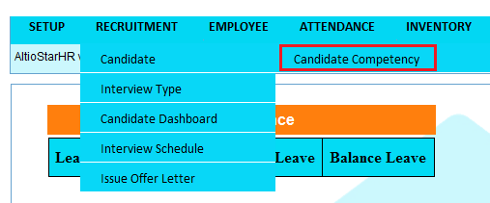

* Candidate Competency page will be displayed.

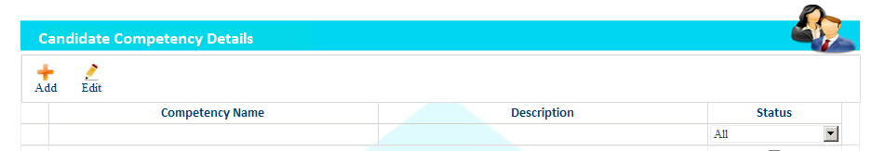

* Click on Add.
* Enter competency name and description and click on save button.

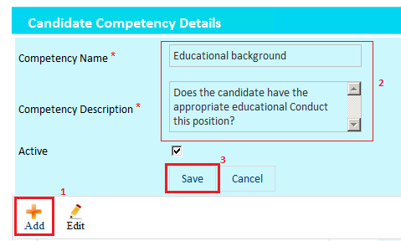

* Competency added successfully.

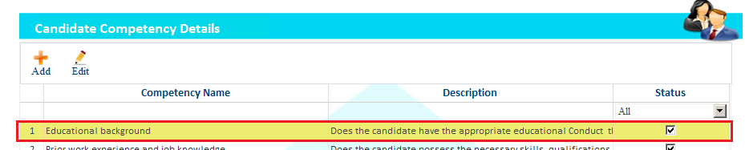

* To Edit, Select competency from grid and click on Edit button. Make necessary changes and click on save button.
* To Deactivate, uncheck the check box, warning message will be displayed.
* Click on ok button.
* Competency deactivated successfully.

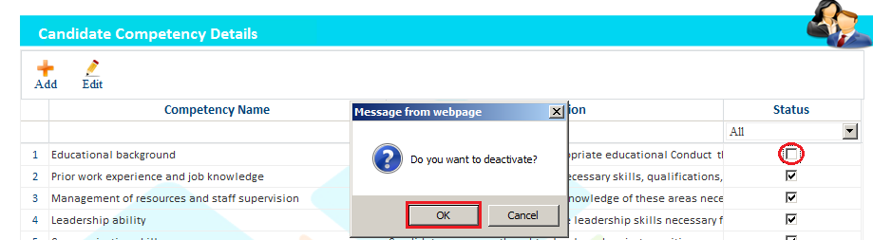

* To view Deactivated entry, select Inactive option from status combo box, on doing this deactivated entry will appears.

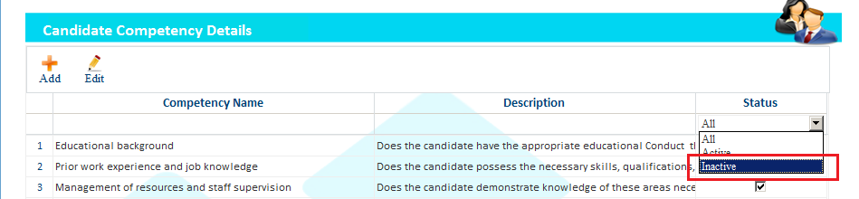

### **Interview Type**

* Login as HR.
* Go to Recruitment and select Interview Type.

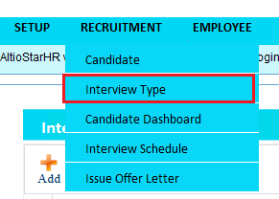

* Interview Types Detail page will be displayed.

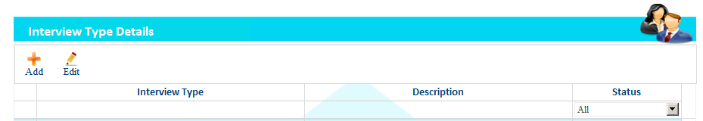

* Click on Add.
* Enter Interview Type and description and click on save button.

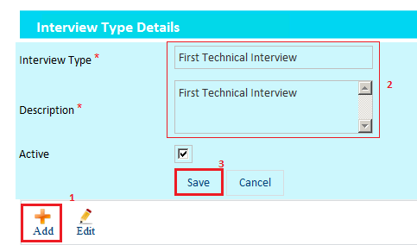

* Interview Type added successfully.

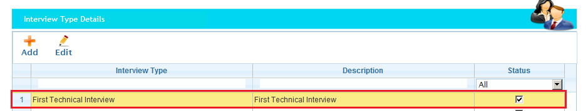

* To Edit, Select interview type from grid and click on Edit button. Make necessary changes and click on save button.
* To Deactivated, uncheck the check box, warning message will be displayed.
* Click on ok button.
* Interview type deactivated successfully.

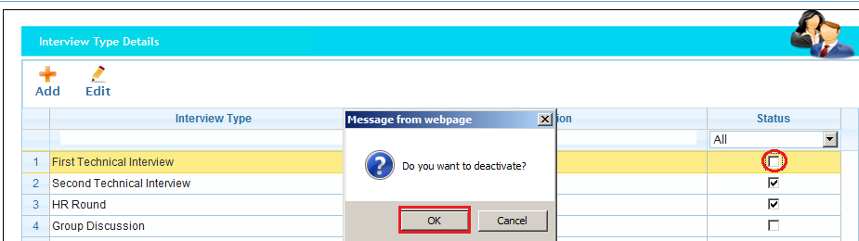

* To view Deactivated entry, select Inactive option from status combo box, on doing this deactivated entry will appears.

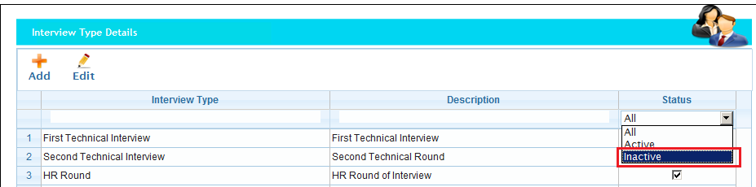

## **Recruitment: Consultant**

### **Candidate Dashboard**

* Login as Consultant.
* Go to Recruitment and select Candidate Dashboard.

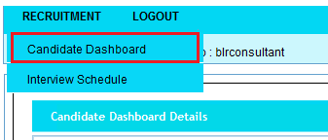

* Candidate dashboard details page will be displayed.

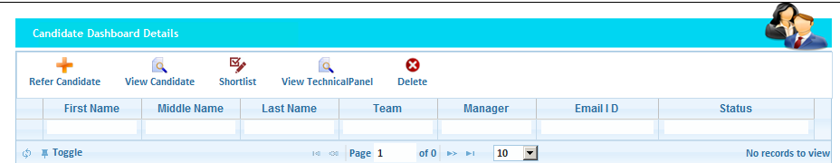

* Click on Refer Candidate icon.

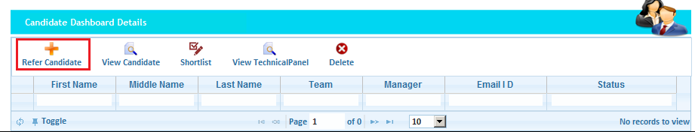

* First specify Team manager and candidate type as a fresher’s or experienced.

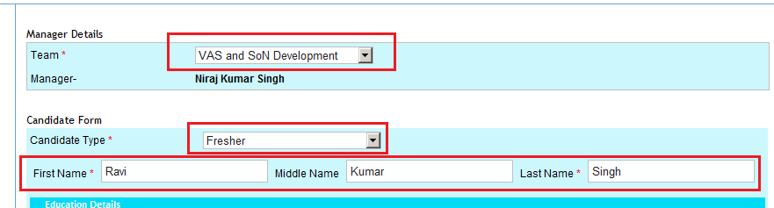

* Add education details of the candidate.

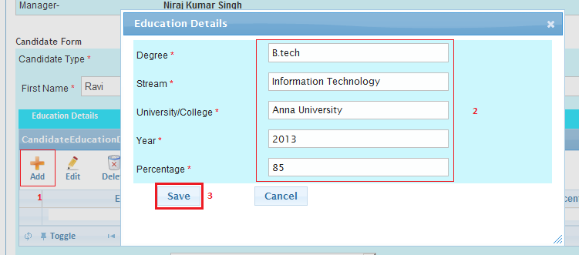

* Enter all the details and upload resume.
* Click on Save.

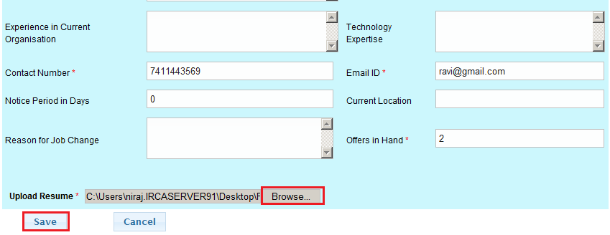

* Candidate added successfully.

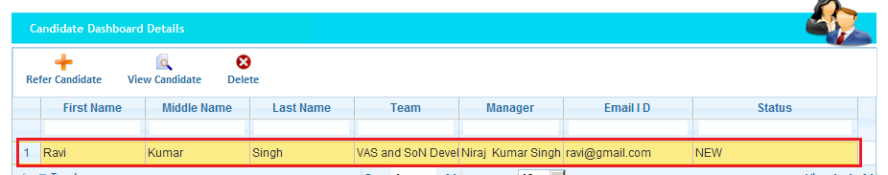

* Notification goes to HR and Team manger

### **Shortlist/Approved by Team Manager**

* Login as Team Manager.
* Go to Recruitment and select Candidate Dashboard.

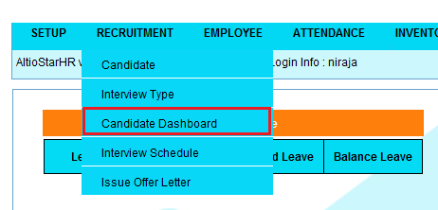

* Added candidate will be displayed in the list.
* Select the candidate and click on view candidate.
* Download the resume and view. If resume is applicable for particular requirement then select the candidate and click on shortlist.

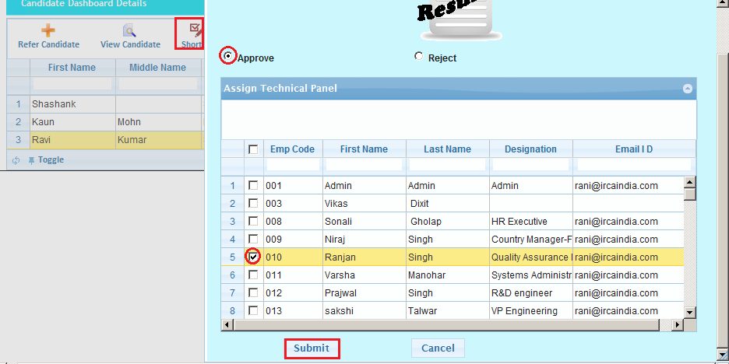

* Select Approved radio button and select the technical panel and then click on submit.
* Candidate approved successfully by manage.
* Status will be displayed as a Manager approved.

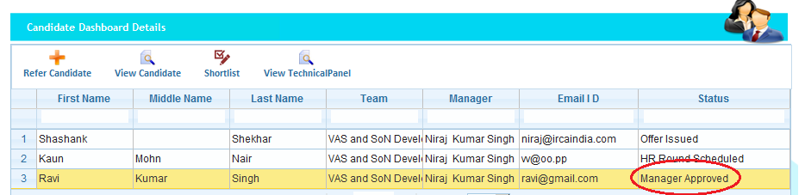

* Notification goes to HR, consultant and technical panel.

### **Rejected by Team manager.**

* Login as Team Manager.
* Go to Recruitment and select Candidate Dashboard.



* Added candidate will be displayed in the list.
* Select the candidate and click on view candidate.
* Download the resume and view. If resume is not applicable for particular requirement then select the candidate and click on shortlist.
* Select reject radio button and enter remarks and click on submit.

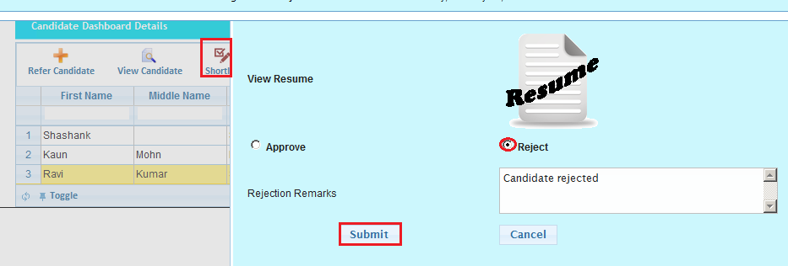

* Candidate rejected successfully.
* Notification goes to consultant and HR.

### **Schedule interview (First Round) by technical panel**

* Login as Technical panel.
* Go to Recruitment and select Interview Schedule.

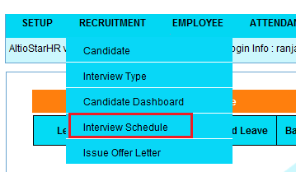

* Candidate will be listed in Interview scheduled details Grid.

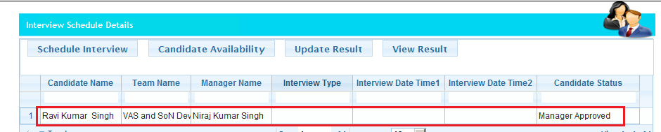

* Select the candidate and click on Schedule interview.
* Specify Interview type, two prefer date and time and click on Save.

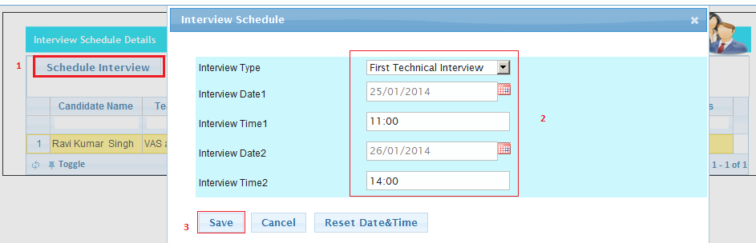

* Interview schedule successfully.

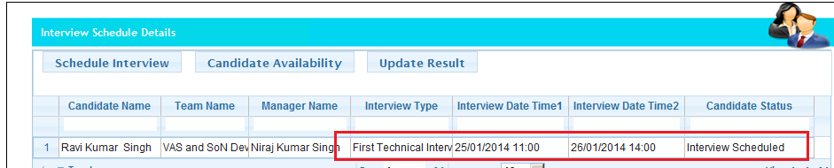

* Notification goes to Consultant, Manager and HR.

### **Check Availability by Consultant**

* Login as Consultant.
* Go to Recruitment and select Interview Schedule.



* Candidate will be listed in Interview scheduled details Grid.

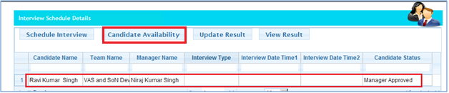

* Select the candidate and click on candidate availability.
* Select check box “Is candidate Available” and click on save.

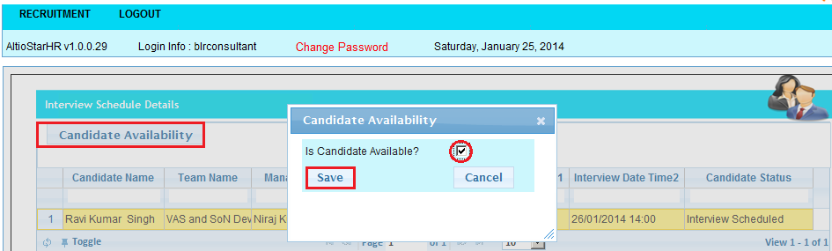

* Candidate status will be changed successfully.

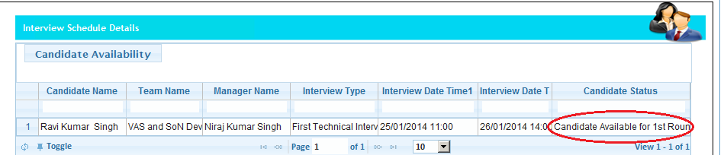

* Notification goes to Technical panel, manager and HR.

### **Candidate result updated by Technical panel.**

* Login as Technical panel.
* Go to Recruitment and select Interview Schedule.



* Candidate will be listed in Interview scheduled details Grid.



* Select the candidate and click on Update result.

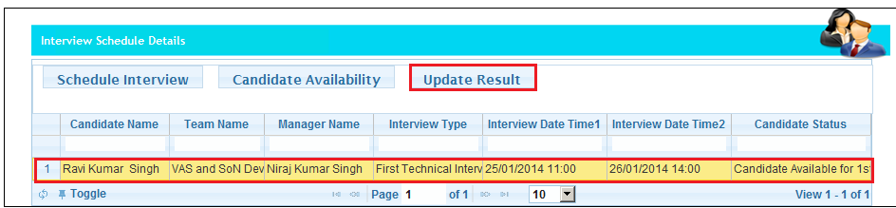

* Candidate evolution page will be displayed.

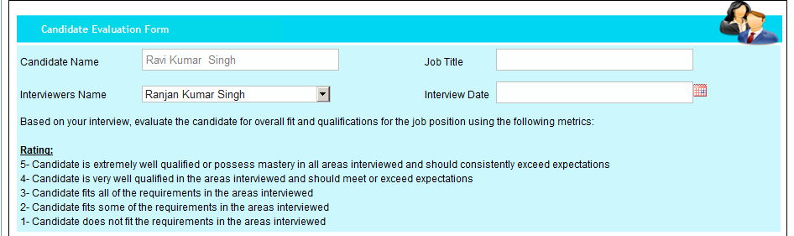

* Enter the job title of the candidate and specify the interview date.
* Select the competency rating and write the “Strengths, Weaknesses and Other Considerations”.
* Select Hire radio button and click on save.

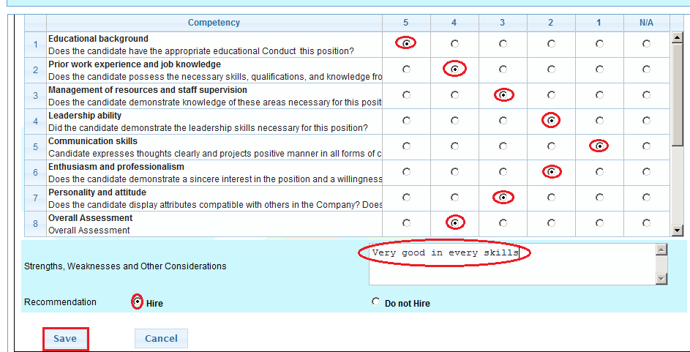

* First round clear successfully by candidate.

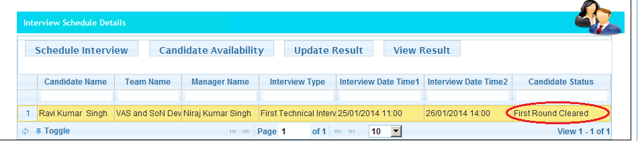

* Notification goes to Hr, Team manger and consultant.

### **Assign Technical panel for Second round**

* Login as Team Manager.
* Go to Recruitment and select Candidate Dashboard.



* Added candidate will be displayed in the list.
* Select the candidate and click on shortlist.
* Already assigned technical panel will be displayed.

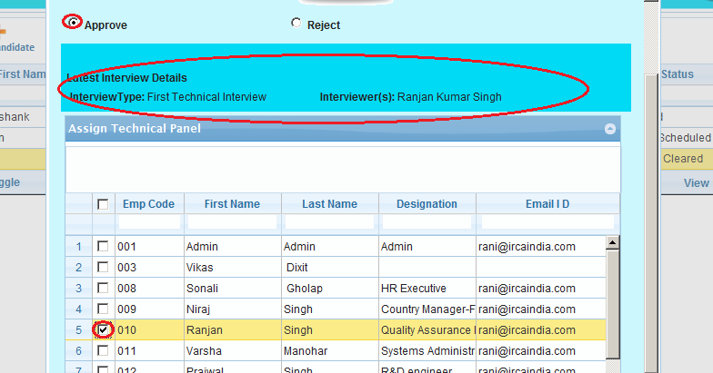

* Select Approved radio button and select the technical panel and then click on submit.
* Candidate approved successfully by manage.
* Status will be displayed as a Manager approved 2nd round.

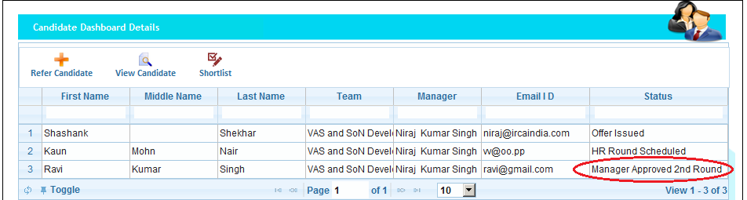

* Notification goes to HR, consultant and technical panel.

### **Schedule interview (Second Round) by technical panel**

* Login as Technical panel.
* Go to Recruitment and select Interview Schedule.



* Candidate will be listed in Interview scheduled details Grid.



* Select the candidate and click on Schedule interview.
* Specify Interview type, two prefer date and time and click on Save.



* Interview schedule successfully for second round.



* Notification goes to Consultant, Manager and HR.

### **Check Availability by Consultant**

* Login as Consultant.
* Go to Recruitment and select Interview Schedule.



* Candidate will be listed in Interview scheduled details Grid.



* Select the candidate and click on candidate availability.
* Select check box “Is candidate Available” and click on save.



* Candidate status will be changed successfully.



* Notification goes to Technical panel, manager and HR.

### Candidate result updated by Technical panel.

* Login as Technical panel.
* Go to Recruitment and select Interview Schedule.



* Candidate will be listed in Interview scheduled details Grid.



* Select the candidate and click on Update result.



* Candidate evolution page will be displayed.



* Enter the job title of the candidate and specify the interview date.
* Select the competency rating and write the “Strengths, Weaknesses and Other Considerations”.
* Select Hire radio button and click on save.



* Second round clear successfully by candidate.



* Notification goes to Hr, Team manger and consultant.

### Schedule interview (HR Round) by HR manager

* Login as Technical panel.
* Go to Recruitment and select Interview Schedule.



* Candidate will be listed in Interview scheduled details Grid.



* Select the candidate and click on Schedule interview.
* Specify Interview type, two prefer date and time and click on Save.



* Interview schedule successfully for HR round.



* Notification goes to Consultant and Team Manager

### Check Availability by Consultant

* Login as HR manager.
* Go to Recruitment and select Interview Schedule.



* Candidate will be listed in Interview scheduled details Grid.



* Select the candidate and click on candidate availability.
* Select check box “Is candidate Available” and click on save.



* Candidate status will be changed successfully.



* Notification goes to HR manager and Team manager.

### Candidate result updated by HR manger.

* Login as Technical panel.
* Go to Recruitment and select Interview Schedule.



* Candidate will be listed in Interview scheduled details Grid.



* Select the candidate and click on Update result.



* Candidate evolution page will be displayed.



* Enter the job title of the candidate and specify the interview date.
* Select the competency rating and write the “Strengths, Weaknesses and Other Considerations”.
* Select Hire radio button and click on save.



* HR round clear successfully by candidate.



* Notification goes to Team manger and consultant.

### Issue offer letter

#### Fix salary

* Login as HR Manager.
* Go to Recruitment and select Issue Offer Letter.

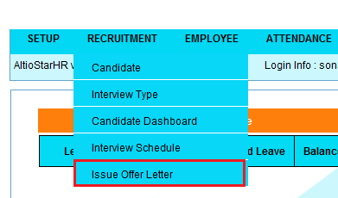

* Issue offer letter page will be displayed.

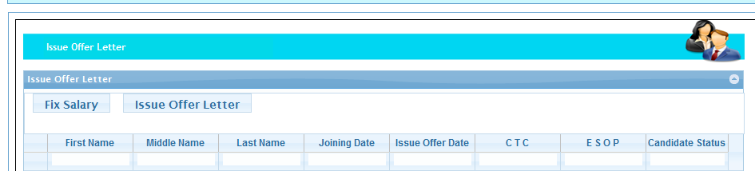

* Select the candidate and click on Fix Salary.

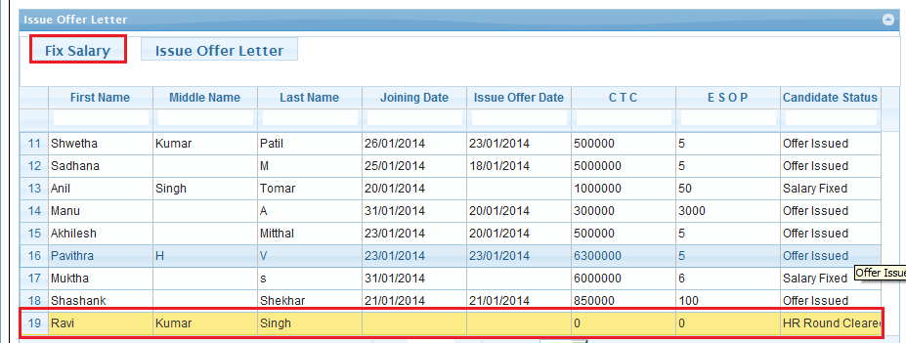

* Fix salary page will be displayed.
* Select the joining date and enter the Yearly CTC.
* All calculation made automatically.
* Click on save button.

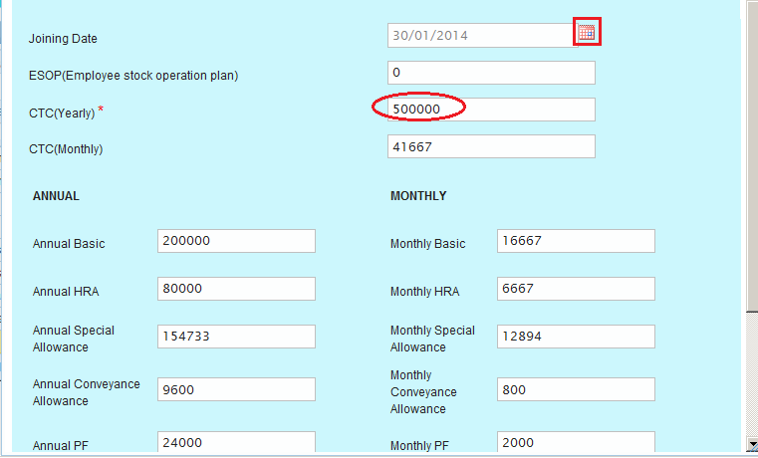

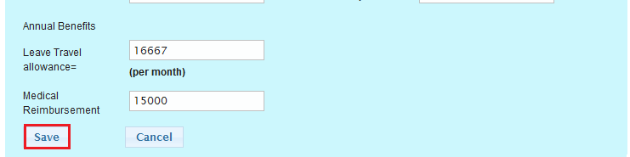

* Salary fixed successfully.
* Status will be changed to Salary fixed.

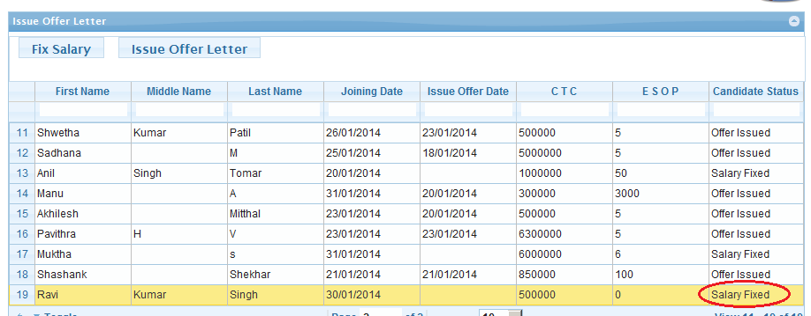

#### Issue offer letter

* Login as HR Manager.
* Go to Recruitment and select Issue Offer Letter.



* Issue offer letter page will be displayed.



* Select the candidate and click on Issue offer letter.

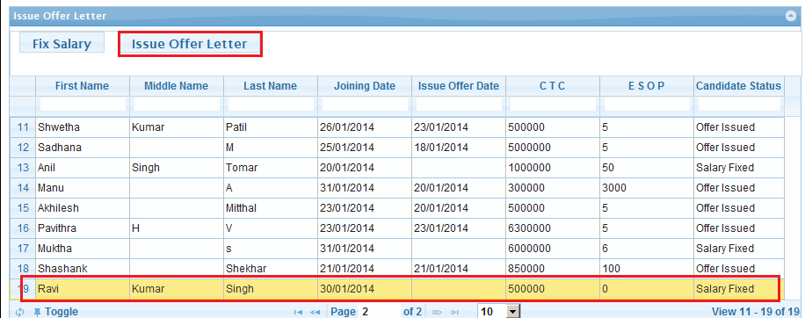

* Offer letter HTML editor page will be displayed.
* If need then we can edit anything.
* Offer letter contains salary breakups and all things.
* Click on save button.

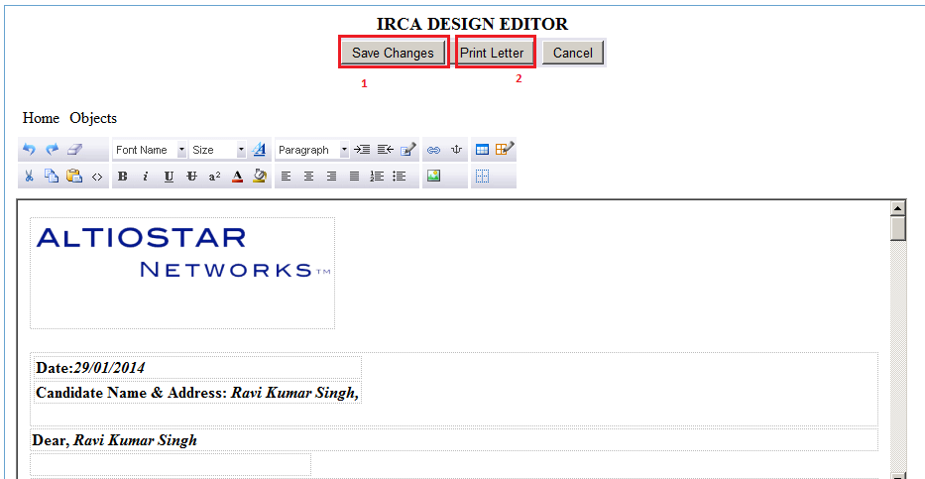

* Click on print letter
* Printable page will be displayed.
* Click on print.

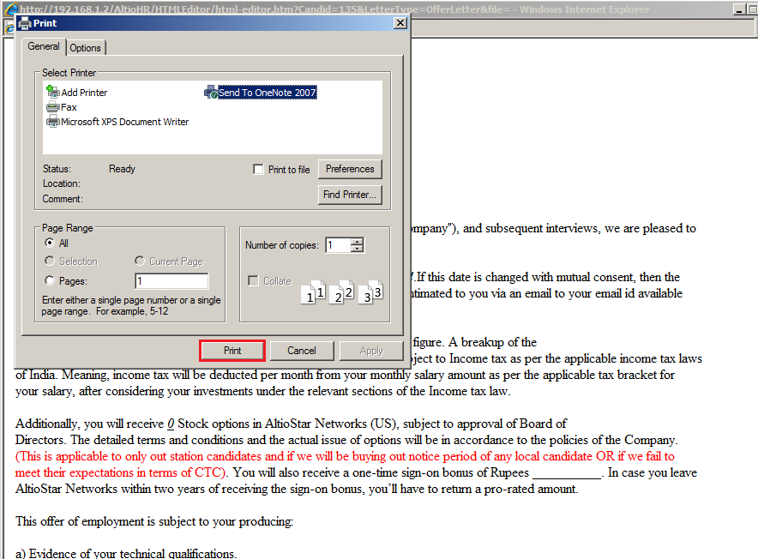

* Offer letter printed successfully.
* Reminder email to be sent to HR 3 prior to joining date.

## Recruitment: Employee Referral

### Candidate Dashboard

* Login as Employee.
* Go to Recruitment and select Candidate Dashboard.



* Candidate dashboard details page will be displayed.



* Click on Refer Candidate icon.



* First specify Team manager and candidate type as a fresher’s or experienced.



* Add education details of the candidate.



* Enter all the details and upload resume.
* Click on Save.



* Candidate added successfully.



* Notification goes to HR and Team manger.

### Shortlist/Approved by Team Manager

* Login as Team Manager.
* Go to Recruitment and select Candidate Dashboard.



* Added candidate will be displayed in the list.
* Select the candidate and click on view candidate.
* Download the resume and view. If resume is applicable for particular requirement then select the candidate and click on shortlist.



* Select Approved radio button and select the technical panel and then click on submit.
* Candidate approved successfully by manage.
* Status will be displayed as a Manager approved.



* Notification goes to HR, Employee and Technical panel.

### Rejected by Team manager

* Login as Team Manager.
* Go to Recruitment and select Candidate Dashboard.



* Added candidate will be displayed in the list.
* Select the candidate and click on view candidate.
* Download the resume and view. If resume is not applicable for particular requirement then select the candidate and click on shortlist.
* Select reject radio button and enter remarks and click on submit.



* Candidate rejected successfully.
* Notification goes to Employee and HR.

### Schedule interview (First Round) by technical panel

* Login as Technical panel.
* Go to Recruitment and select Interview Schedule.



* Candidate will be listed in Interview scheduled details Grid.



* Select the candidate and click on Schedule interview.
* Specify Interview type, two prefer date and time and click on Save.



* Interview schedule successfully.



* Notification goes to Employee, Manager and HR.

### Check Availability by Employee

* Login as Employee.
* Go to Recruitment and select Interview Schedule.



* Candidate will be listed in Interview scheduled details Grid.



* Select the candidate and click on candidate availability.
* Select check box “Is candidate Available” and click on save.



* Candidate status will be changed successfully.



* Notification goes to Technical panel, manager and HR.

### Candidate result updated by Technical panel.

* Login as Technical panel.
* Go to Recruitment and select Interview Schedule.



* Candidate will be listed in Interview scheduled details Grid.



* Select the candidate and click on Update result.



* Candidate evolution page will be displayed.



* Enter the job title of the candidate and specify the interview date.
* Select the competency rating and write the “Strengths, Weaknesses and Other Considerations”.
* Select Hire radio button and click on save.



* First round clear successfully by candidate.



* Notification goes to Hr, Team manger and Employee.

### Assign Technical panel for Second round

* Login as Team Manager.
* Go to Recruitment and select Candidate Dashboard.



* Added candidate will be displayed in the list.
* Select the candidate and click on shortlist.
* Already assigned technical panel will be displayed.



* Select Approved radio button and select the technical panel and then click on submit.
* Candidate approved successfully by manage.
* Status will be displayed as a Manager approved 2nd round.



* Notification goes to HR, Employee and technical panel.

### Schedule interview (Second Round) by technical panel

* Login as Technical panel.
* Go to Recruitment and select Interview Schedule.



* Candidate will be listed in Interview scheduled details Grid.



* Select the candidate and click on Schedule interview.
* Specify Interview type, two prefer date and time and click on Save.



* Interview schedule successfully for second round.



* Notification goes to Employee, Manager and HR.

### Check Availability by Employee

* Login as Employee.
* Go to Recruitment and select Interview Schedule.



* Candidate will be listed in Interview scheduled details Grid.



* Select the candidate and click on candidate availability.
* Select check box “Is candidate Available” and click on save.



* Candidate status will be changed successfully.



* Notification goes to Technical panel, manager and HR.

### Candidate result updated by Technical panel.

* Login as Technical panel.
* Go to Recruitment and select Interview Schedule.



* Candidate will be listed in Interview scheduled details Grid.



* Select the candidate and click on Update result.



* Candidate evolution page will be displayed.



* Enter the job title of the candidate and specify the interview date.
* Select the competency rating and write the “Strengths, Weaknesses and Other Considerations”.
* Select Hire radio button and click on save.



* Second round clear successfully by candidate.



* Notification goes to Hr, Team manger and Employee.

### Schedule interview (HR Round) by HR manager

* Login as Technical panel.
* Go to Recruitment and select Interview Schedule.



* Candidate will be listed in Interview scheduled details Grid.



* Select the candidate and click on Schedule interview.
* Specify Interview type, two prefer date and time and click on Save.



* Interview schedule successfully for HR round.



* Notification goes to Employee and Team Manager

### Check Availability by Employee

* Login as HR manager.
* Go to Recruitment and select Interview Schedule.



* Candidate will be listed in Interview scheduled details Grid.



* Select the candidate and click on candidate availability.
* Select check box “Is candidate Available” and click on save.



* Candidate status will be changed successfully.



* Notification goes to HR manager and Team manager.

### Candidate result updated by HR manger.

* Login as Technical panel.
* Go to Recruitment and select Interview Schedule.



* Candidate will be listed in Interview scheduled details Grid.



* Select the candidate and click on Update result.



* Candidate evolution page will be displayed.



* Enter the job title of the candidate and specify the interview date.
* Select the competency rating and write the “Strengths, Weaknesses and Other Considerations”.
* Select Hire radio button and click on save.



* HR round clear successfully by candidate.



* Notification goes to Team manger and Employee.

### Issue offer letter

#### Fix salary

* Login as HR Manager.
* Go to Recruitment and select Issue Offer Letter.



* Issue offer letter page will be displayed.



* Select the candidate and click on Fix Salary.



* Fix salary page will be displayed.
* Select the joining date and enter the Yearly CTC.
* All calculation made automatically.
* Click on save button.





* Salary fixed successfully.
* Status will be changed to Salary fixed.



#### Issue offer letter

* Login as HR Manager.
* Go to Recruitment and select Issue Offer Letter.



* Issue offer letter page will be displayed.



* Select the candidate and click on Issue offer letter.



* Offer letter HTML editor page will be displayed.
* If need then we can edit anything.
* Offer letter contains salary breakups and all things.
* Click on save button.



* Click on print letter
* Printable page will be displayed.
* Click on print.



* Offer letter printed successfully.
* Reminder email to be sent to HR 3 prior to joining date.

## Recruitment: Others (HR Referral)

### Candidate Dashboard

* Login as HR.
* Go to Recruitment and select Candidate Dashboard.



* Candidate dashboard details page will be displayed.



* Click on Refer Candidate icon.



* First specify Team manager and candidate type as a fresher’s or experienced.



* Add education details of the candidate.



* Enter all the details and upload resume.
* Click on Save.



* Candidate added successfully.



* Notification goes to Team manger.

### Shortlist/Approved by Team Manager

* Login as Team Manager.
* Go to Recruitment and select Candidate Dashboard.



* Added candidate will be displayed in the list.
* Select the candidate and click on view candidate.
* Download the resume and view. If resume is applicable for particular requirement then select the candidate and click on shortlist.



* Select Approved radio button and select the technical panel and then click on submit.
* Candidate approved successfully by manage.
* Status will be displayed as a Manager approved.



* Notification goes to HR and technical panel.

### Rejected by Team manager

* Login as Team Manager.
* Go to Recruitment and select Candidate Dashboard.



* Added candidate will be displayed in the list.
* Select the candidate and click on view candidate.
* Download the resume and view. If resume is not applicable for particular requirement then select the candidate and click on shortlist.
* Select reject radio button and enter remarks and click on submit.



* Candidate rejected successfully.
* Notification goes to HR.

### Schedule interview (First Round) by technical panel

* Login as Technical panel.
* Go to Recruitment and select Interview Schedule.



* Candidate will be listed in Interview scheduled details Grid.



* Select the candidate and click on Schedule interview.
* Specify Interview type, two prefer date and time and click on Save.



* Interview schedule successfully.



* Notification goes to HR and Manager .

### Check Availability by HR

* Login as Employee.
* Go to Recruitment and select Interview Schedule.



* Candidate will be listed in Interview scheduled details Grid.



* Select the candidate and click on candidate availability.
* Select check box “Is candidate Available” and click on save.



* Candidate status will be changed successfully.



* Notification goes to Technical panel and Team manager.

### Candidate result updated by Technical panel.

* Login as Technical panel.
* Go to Recruitment and select Interview Schedule.



* Candidate will be listed in Interview scheduled details Grid.



* Select the candidate and click on Update result.



* Candidate evolution page will be displayed.



* Enter the job title of the candidate and specify the interview date.
* Select the competency rating and write the “Strengths, Weaknesses and Other Considerations”.
* Select Hire radio button and click on save.



* First round clear successfully by candidate.



* Notification goes to Hr, Team manger and Employee.

### Assign Technical panel for Second round

* Login as Team Manager.
* Go to Recruitment and select Candidate Dashboard.



* Added candidate will be displayed in the list.
* Select the candidate and click on shortlist.
* Already assigned technical panel will be displayed.



* Select Approved radio button and select the technical panel and then click on submit.
* Candidate approved successfully by manage.
* Status will be displayed as a Manager approved 2nd round.



* Notification goes to HR, Employee and technical panel.

### Schedule interview (Second Round) by technical panel

* Login as Technical panel.
* Go to Recruitment and select Interview Schedule.



* Candidate will be listed in Interview scheduled details Grid.



* Select the candidate and click on Schedule interview.
* Specify Interview type, two prefer date and time and click on Save.



* Interview schedule successfully for second round.



* Notification goes to HR and Manager.

### Check Availability by HR

* Login as HR.
* Go to Recruitment and select Interview Schedule.



* Candidate will be listed in Interview scheduled details Grid.



* Select the candidate and click on candidate availability.
* Select check box “Is candidate Available” and click on save.



* Candidate status will be changed successfully.



* Notification goes to Technical panel, manager .

### Candidate result updated by Technical panel.

* Login as Technical panel.
* Go to Recruitment and select Interview Schedule.



* Candidate will be listed in Interview scheduled details Grid.



* Select the candidate and click on Update result.



* Candidate evolution page will be displayed.



* Enter the job title of the candidate and specify the interview date.
* Select the competency rating and write the “Strengths, Weaknesses and Other Considerations”.
* Select Hire radio button and click on save.



* Second round clear successfully by candidate.



* Notification goes to Team manger and HR.

### Schedule interview (HR Round) by HR manager

* Login as HR.
* Go to Recruitment and select Interview Schedule.



* Candidate will be listed in Interview scheduled details Grid.



* Select the candidate and click on Schedule interview.
* Specify Interview type, two prefer date and time and click on Save.



* Interview schedule successfully for HR round.



* Notification goes to Team Manager

### Check Availability by HR

* Login as HR manager.
* Go to Recruitment and select Interview Schedule.



* Candidate will be listed in Interview scheduled details Grid.



* Select the candidate and click on candidate availability.
* Select check box “Is candidate Available” and click on save.



* Candidate status will be changed successfully.



* Notification goes to Team manager.

### Candidate result updated by HR manger.

* Login as Technical panel.
* Go to Recruitment and select Interview Schedule.



* Candidate will be listed in Interview scheduled details Grid.



* Select the candidate and click on Update result.



* Candidate evolution page will be displayed.



* Enter the job title of the candidate and specify the interview date.
* Select the competency rating and write the “Strengths, Weaknesses and Other Considerations”.
* Select Hire radio button and click on save.



* HR round clear successfully by candidate.



* Notification goes to Team manger.

### Issue offer letter

#### Fix salary

* Login as HR Manager.
* Go to Recruitment and select Issue Offer Letter.



* Issue offer letter page will be displayed.



* Select the candidate and click on Fix Salary.



* Fix salary page will be displayed.
* Select the joining date and enter the Yearly CTC.
* All calculation made automatically.
* Click on save button.





* Salary fixed successfully.
* Status will be changed to Salary fixed.



#### Issue offer letter

* Login as HR Manager.
* Go to Recruitment and select Issue Offer Letter.



* Issue offer letter page will be displayed.



* Select the candidate and click on Issue offer letter.



* Offer letter HTML editor page will be displayed.
* If need then we can edit anything.
* Offer letter contains salary breakups and all things.
* Click on save button.



* Click on print letter
* Printable page will be displayed.
* Click on print.



* Offer letter printed successfully.
* Reminder email to be sent to HR 3 days prior to joining date.