1.Spring data jpa handson

HANDS ON-1
1. The project was created successfully
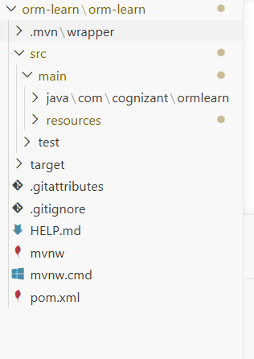
2. Database configuration.
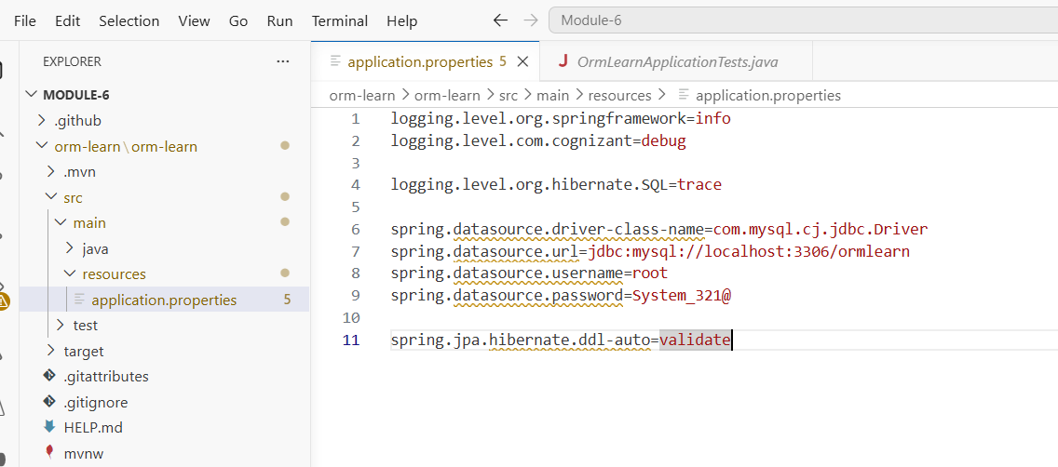
3.Database containing data
MySQL SELECT * FROM country
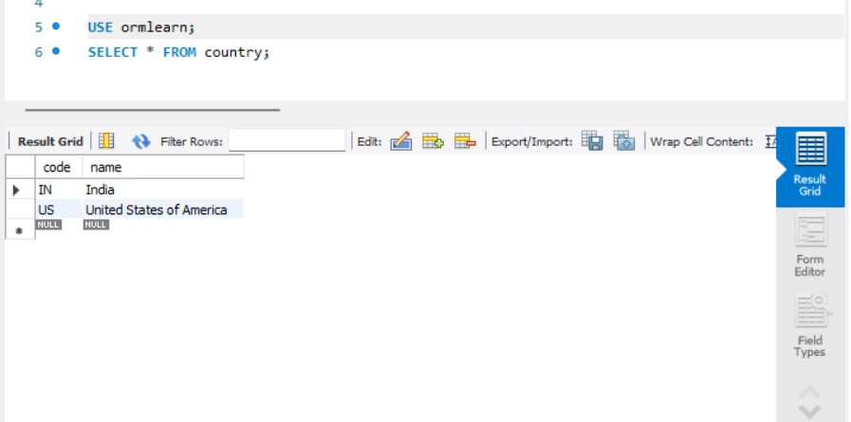
4. JPA mapping.
Country.java
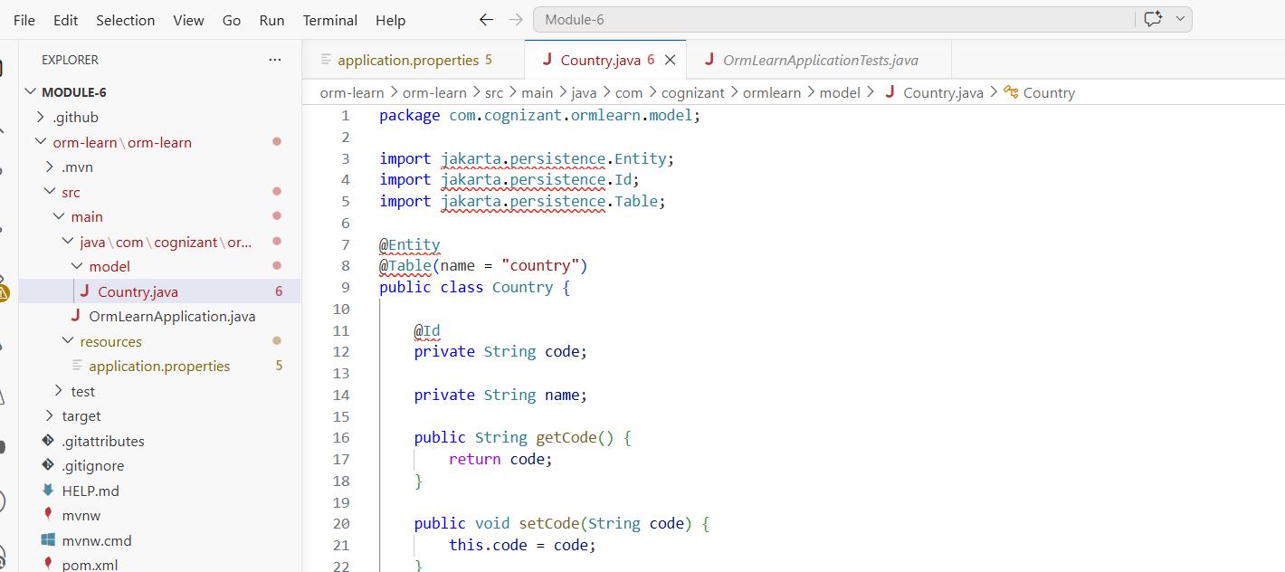
5. CountryRepository.java
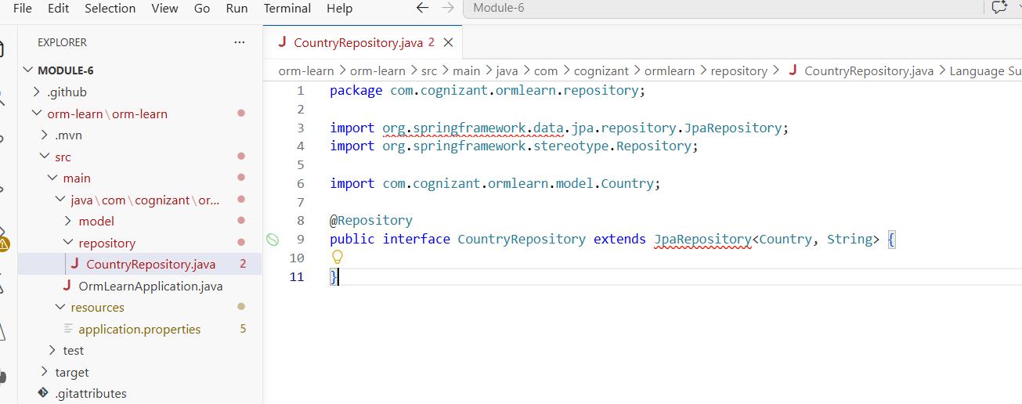
6. CountryService.java
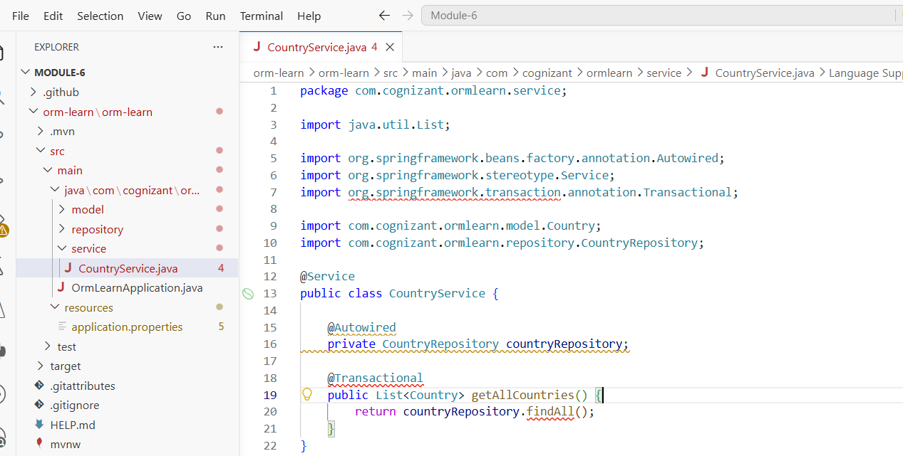

7. OrmLearnApplication.java
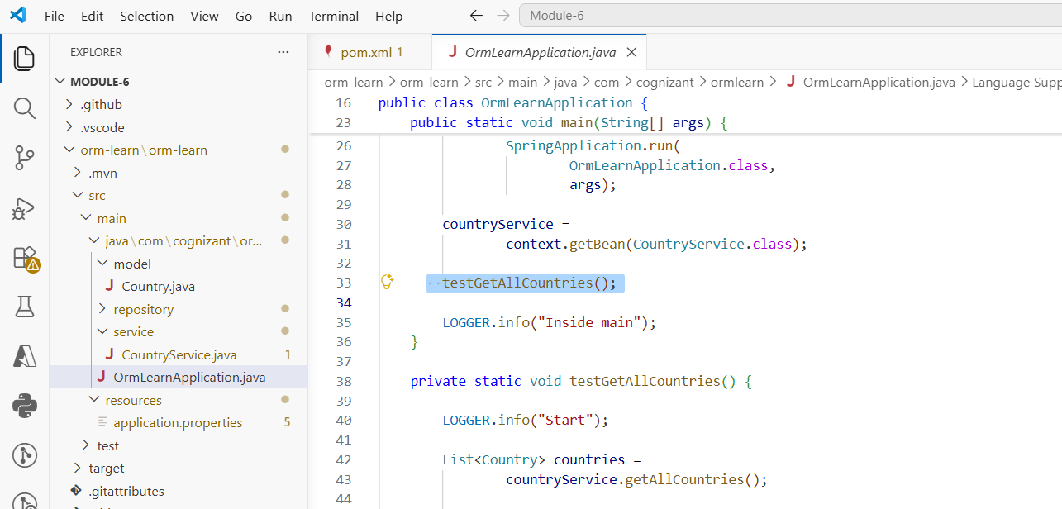
8.BUILD SUCCESS output
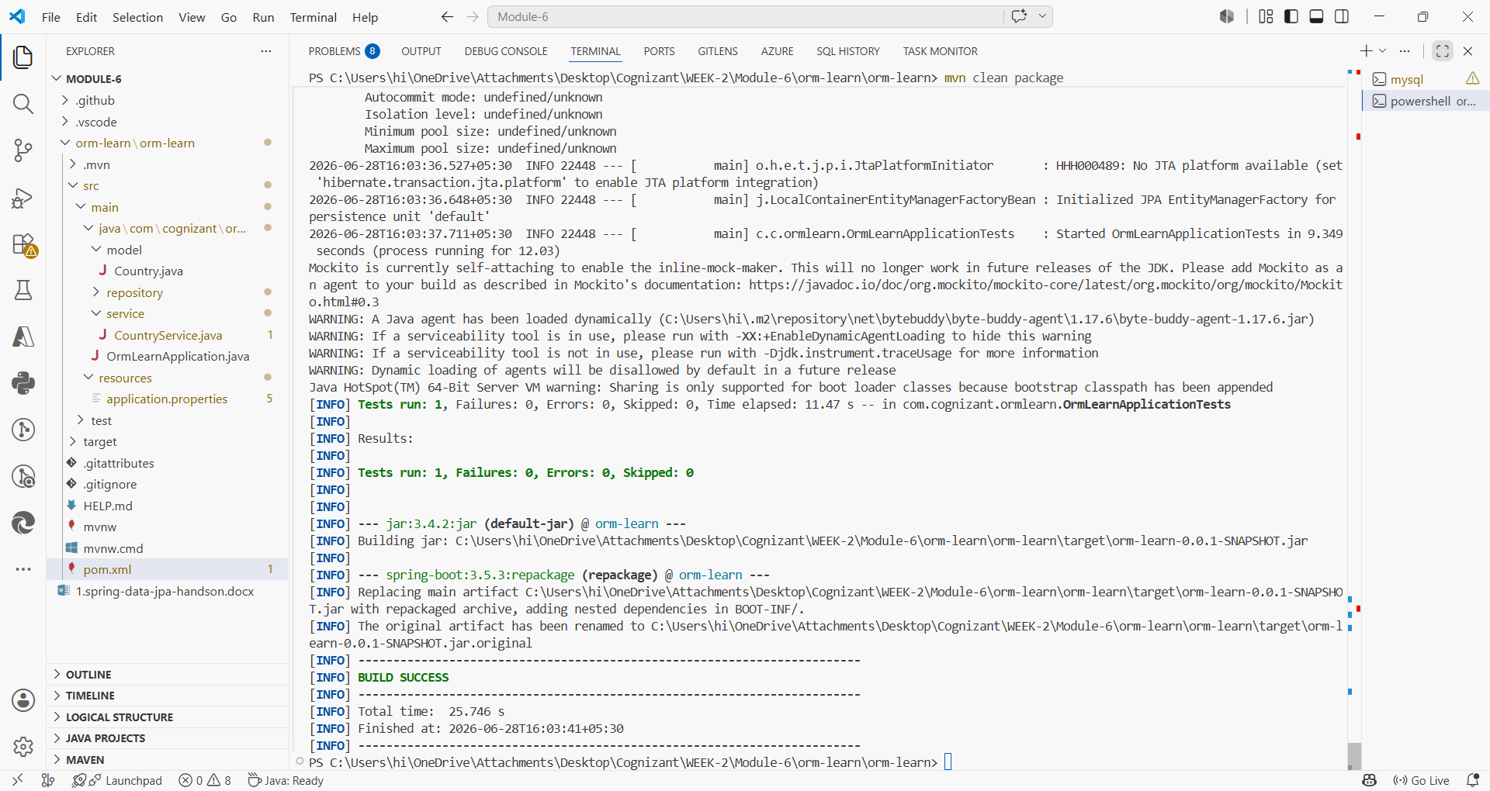
9. Final console output showing countries
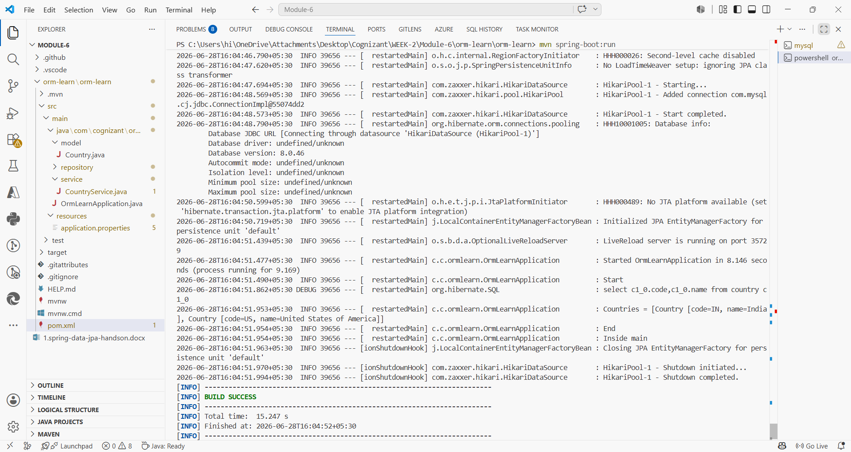
HANDS ON -4
GOAL: To understand the difference between- JPA, Hibernate, Spring Data JPA.
JPA (Java Persistence API)
- JPA is a specification.
- It tells developers:
- How entities should work
- How persistence should work
- How ORM should work
- But JPA itself cannot connect to the database.
- Example:
@Entity
@Table
@Id
Hibernate
- Hibernate is an implementation of JPA.
- Hibernate actually performs:
- Insert
- Update
- Delete
- Select
- Example:
Session session = factory.openSession();
Transaction tx = session.beginTransaction();
session.save(employee);
tx.commit();
- In simple words to say lots of code is required.
Spring Data JPA
- Spring Data JPA sits on top of Hibernate.
- It removes boilerplate code.
- Instead of:
Session session = factory.openSession();
Transaction tx = session.beginTransaction();
session.save(employee);
tx.commit();
session.close();

- You simply write:
employeeRepository.save(employee);

- Spring automatically handles:
- Transactions
- Sessions
- Repository implementation

