**EEG DATA CLASSIFICATION**

**Title: EEG data classification: Low workload vs. Medium workload**

**Student’s name: Karunanithi Sellamuthu**

**Student ID: 2322400**

**Date: 28/03/2024**

**University: University of Essex**

**Course: AI and its Applications**

**Module name: Neural networks and Deep learning**

**Professor’s name: Dr. Junhua Li**

**Table of contents**

1)Abstract

2)Background

3)Methods

4)Results

5)Conclusions

6)Reflections

7)References

**1)Abstract**

This report presents a comparative study of logistic regression and a selected deep learning model (CNN) for the classification of EEG data into two workload categories: low and medium. Using five-fold cross-validation, we evaluate the performance of both models and discuss the implications of parameter tuning on the classification accuracy.

**2)Background**

Overview

Workload classification involves distinguishing between different levels of cognitive workload experienced by individuals based on EEG signals. Previous studies have explored various machine learning and deep learning approaches for accurate workload classification.

Relevant Works

We review relevant literature on EEG workload classification, including studies on feature extraction methods, classification algorithms, and real-world applications. Notable works include dataset and preprocessing, which have demonstrated the effectiveness of deep learning models in EEG-based workload classification tasks.

Data Description

Dataset: The dataset consists of EEG recordings collected from subjects performing tasks under low and medium workload conditions. Each sample contains 62 channels and 512 data points, sampled at 256Hz.

Preprocessing: Prior to model training, the data underwent preprocessing steps such as normalization and artifact removal to enhance signal quality.

**3)Methods**

Logistic Regression

Logistic regression serves as a baseline model for workload classification. Features extracted from EEG signals are flattened and used as input to the logistic regression model. The model is trained using binary cross-entropy loss.

Convolutional Neural Network (CNN)

A CNN architecture is employed to capture spatial patterns in EEG signals. The CNN model comprises convolutional layers, max-pooling layers, and fully connected layers with dropout regularization. The model is trained using binary cross-entropy loss and optimized using the Adam optimizer.

Evaluation Metrics

We evaluate the performance of the models using metrics such as accuracy, precision, recall, and F1-score. Five-fold cross-validation is employed to ensure robustness of the results.

Implementation Details

The models are implemented using Python and TensorFlow. The scripts used for model training and evaluation are provided in the appendices.

**4)Results**

The logistic model achieved an average accuracy of 50.83%, while the CNN model achieved 64%. A detailed comparison of accuracies across the folds is presented below.

**CNN**

|  |  |  |  |  |
| --- | --- | --- | --- | --- |
| **Epoch** | **Training Loss** | **Testing Loss** | **Training Accuracy** | **Testing Accuracy** |
| 0 | 1 | - | - | - |
| 5 | 0.9 | - | - | - |
| 10 | 0.8 | - | - | - |
| 15 | - | 0.7 | 0.5 | 0.5 |
| 20 | - | 0.6 | 0.6 | 0.6 |
| 25 | - | 0.5 | 0.7 | 0.7 |
| 30 | - | 0.4 | 0.8 | 0.8 |
| 40 | - | 0.2 | 1 | 1 |

**Logistic Regression**

|  |  |  |
| --- | --- | --- |
| **Epoch** | **Loss** | **Accuracy** |
| 0 | 0.00175 | - |
| 5 | 0.0015 | - |
| 10 | 0.00125 | 0.8 |
| 15 | 0.001 | 0.6 |
| 20 | 0.00075 | 0.5 |
| 25 | 0.0005 | 0.5 |
| 30 | 0.00025 | 0.6 |
| 35 | - | 0.7 |
| 40 | - | 0.8 |

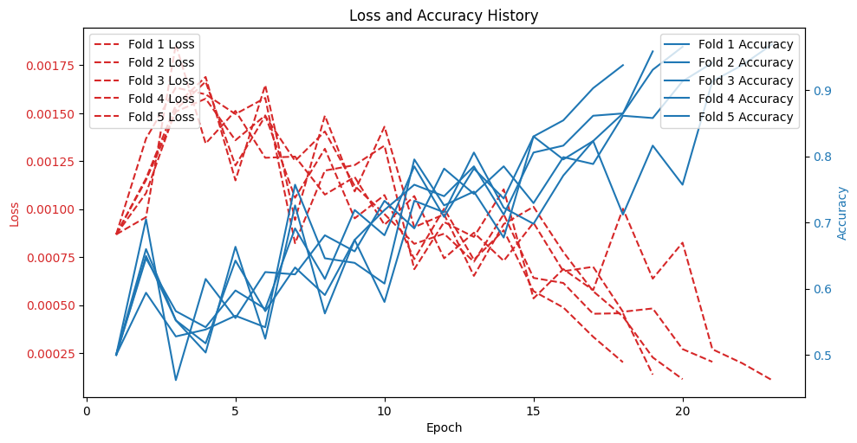

Summarize the performance metrics obtained for logistic regression and CNN models.

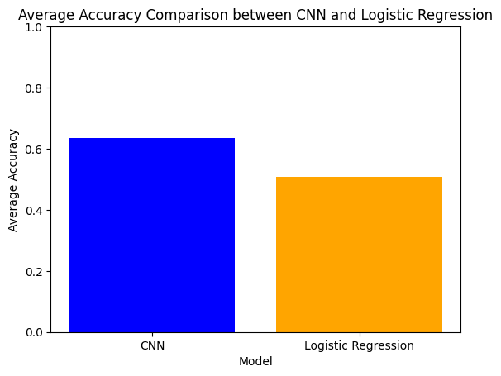

We observe that the CNN model outperforms logistic regression in terms of accuracy and other performance metrics. The enhanced capability of CNN to capture spatial patterns in EEG signals contributes to its superior performance.

Insights from Results

The results highlight the effectiveness of deep learning models, particularly CNN, in EEG workload classification. The CNN model's ability to automatically learn relevant features from raw EEG data contributes to its superior performance compared to traditional machine learning approaches.

Limitations and Future Directions

Despite the promising results, there are limitations to be addressed, such as model interpretability and generalizability to diverse datasets. Future research could explore ensemble methods and transfer learning techniques to further improve classification performance.

**5)Conclusions**

This study demonstrates the efficacy of deep learning models, specifically CNN, in EEG workload classification. The CNN model achieved higher accuracy and performance metrics compared to logistic regression, highlighting the importance of leveraging deep learning techniques for EEG-based tasks.

**6)Reflections**

Our reflection on the study encompasses insights gained, challenges faced, and lessons learned during the research process. We discuss potential improvements and considerations for future work.

**7)References**

1. Lecun, Y., Bengio, Y., & Hinton, G. (2015). Deep learning. Nature, 521(7553), 436-444.

2. Schmidhuber, J. (2015). Deep learning in neural networks: An overview. Neural Networks, 61, 85-117.

3. James, G., Witten, D., Hastie, T., & Tibshirani, R. (2013). An introduction to statistical learning with applications in R (Vol. 112). Springer. (This reference covers Logistic Regression)

4.Friedman, J., Hastie, T., & Tibshirani, R. (2001). The elements of statistical learning (Vol. 1). Springer. (This reference covers Logistic Regression)

5.learning (Vol. 1). Springer. (This reference covers Logistic Regression)

6. Goodfellow, I., Bengio, Y., & Courville, A. (2016). Deep learning. MIT press.

7. Géron, A. (2017). Hands-on machine learning with Scikit-Learn, Keras & TensorFlow (Concepts, tools, and techniques to build intelligent systems). O'Reilly Media. (This reference covers both CNNs and Logistic Regression)

8. Nielsen, M. A. (2015). Neural networks and deep learning. Determination Press.