Software Requirements Specification
for
Full-Stack IoT Predictive Maintenance System
using ML, DL, DNN and QML

Prepared by:
Arundathi B
1RUB25CSE0002
SOCSE, RV University

CONTENTS
Section | Title | Page
I | Introduction | 2
II | Overall Description | 3
III | External Interface Requirements | 5
IV | System Features | 6
V | Non-functional Requirements | 7
VI | Other Requirements | 8
Appendix A | Glossary | 8
Appendix B | Analysis Models | 8

I. INTRODUCTION
A. Purpose and Scope of SRS
The purpose of this Software Requirements Specification (SRS) is to define the functional and non-functional requirements for the IoT Predictive Maintenance System. This system predicts whether a turbofan jet engine will fail within the next 30 operating cycles, based on real-time sensor readings collected during flight operations.
The system uses the NASA C-MAPSS dataset, which contains sensor readings from 709 engines across four operating subsets. It applies a full machine learning pipeline including classical ML models (Random Forest, XGBoost, SVM), deep learning models (1D-CNN, BiLSTM), a DNN architecture (CNN-LSTM with Attention), and Quantum ML models (QNN and QLSTM) implemented using pure PyTorch variational quantum circuits.
The SRS document describes the system structure, data pipeline, model pipeline, web-based full-stack interface, deployment strategy using Docker and Kubernetes, and MLOps components including MLflow, DVC, and GitHub Actions. It serves as a reference for developers, testers, and academic reviewers.
B. Document Conventions
This document follows standard IEEE SRS conventions. Bold text is used for key terms and section titles. Bullet points present lists of requirements. All requirement statements are written in clear, unambiguous language. The following abbreviations are used consistently:
Abbreviation | Full Form
SRS | Software Requirements Specification
ML | Machine Learning
DL | Deep Learning
DNN | Deep Neural Network
QML | Quantum Machine Learning
VQC | Variational Quantum Circuit
API | Application Programming Interface
RUL | Remaining Useful Life
DVC | Data Version Control
CI/CD | Continuous Integration / Continuous Deployment
C. Intended Audience and Reading Suggestions
This SRS is intended for the following readers:
- Developers: to understand system architecture, model pipeline, and implementation requirements.
- Testers: to design test cases and verify that all requirements are met.
- Project guide or professor: to evaluate the academic and technical scope of the system.
- Evaluators: to assess the use of ML, DL, DNN, and QML in a real-world IoT use case.
Readers are recommended to begin with Section I (Introduction) and Section II (Overall Description), then proceed to the sections most relevant to their role.
D. Product Scope
The IoT Predictive Maintenance System is a web-based full-stack application designed to predict engine failure risk in turbofan jet engines. The system processes 14 sensor readings per engine cycle, applies a 30-cycle sliding window, and outputs a binary classification: HEALTHY (no failure expected within 30 cycles) or FAILURE IMMINENT (failure expected within 30 cycles).
The system is trained on the NASA C-MAPSS dataset and demonstrates two scenarios: Single Engine mode (FD001 subset, single operating condition) and Multi Engine mode (all four subsets combined, multiple operating conditions). Eighteen trained models are served through a FastAPI backend and displayed through an HTML/JS dashboard. The system is containerised using Docker and orchestrated with Kubernetes.
E. References
- IEEE Computer Society. IEEE Recommended Practice for Software Requirements Specifications (IEEE Std 830-1998). IEEE, 1998.
- Saxena, A. et al. Damage Propagation Modeling for Aircraft Engine Run-to-Failure Simulation. NASA Technical Report, 2008.
- PyTorch Documentation. https://pytorch.org/docs
- MLflow Documentation. https://mlflow.org/docs
- FastAPI Documentation. https://fastapi.tiangolo.com
- DVC Documentation. https://dvc.org/doc
- Kubernetes Documentation. https://kubernetes.io/docs
II. OVERALL DESCRIPTION
A. Product Perspective
The IoT Predictive Maintenance System is a standalone full-stack application. It integrates five major components: a data preprocessing pipeline, a model training pipeline, a FastAPI REST backend, a web-based frontend dashboard, and a DevOps pipeline. The system does not depend on any external IoT streaming infrastructure and operates on pre-processed NASA C-MAPSS data files. It can be extended in the future to support real-time sensor streaming via MQTT or Kafka.
The system is designed for academic demonstration and research purposes. It proves that quantum-inspired ML approaches can be applied effectively to time-series sensor data in a full-stack deployment context.
B. Product Functions
The major functions of the system are:
- Data Preprocessing: Load NASA C-MAPSS sensor data, drop seven low-variance sensors, apply piecewise RUL labelling with a cap of 125 cycles, assign binary class label (failure if RUL is 30 or fewer cycles), apply 30-cycle sliding window sequences, and normalise using MinMaxScaler.
- Model Training: Train nine model types (RF, XGB, SVM, DNN, CNN1D, BiLSTM, CNN-LSTM-Attention, QNN, QLSTM) on two dataset variants (FD001 only and all four subsets combined), producing 18 trained model files.
- Experiment Tracking: Log all hyperparameters, per-epoch training and validation loss and accuracy, final test accuracy, F1 score, precision, recall, AUC-ROC, and confusion matrix plots to MLflow for all 18 models.
- Prediction API: Serve all 18 trained models through a FastAPI backend. Accept engine sensor windows as input and return binary predictions with confidence scores.
- Ensemble Prediction: Run all nine models simultaneously on a given engine window and combine results by majority vote.
- Dashboard: Display all model results, allow engine selection, model selection, live prediction, and ensemble prediction through a tabbed web interface with light and dark theme support.
C. User Classes and Characteristics
- Professor or Academic Reviewer: Views the dashboard to assess model performance, compares ML/DL/DNN/QML results, and evaluates the full-stack deployment. No technical interaction with the codebase required.
- Developer: Runs the training script, starts the backend and frontend, and manages Docker and Kubernetes deployment. Requires Python and command-line knowledge.
- System Administrator: Manages Kubernetes cluster, DVC remote storage, and GitHub Actions pipeline. Requires DevOps knowledge.
D. Operating Environment
Component | Specification
Training OS | Ubuntu 22.04 (RunPod cloud GPU pod)
Training GPU | CUDA 12.4 compatible GPU (e.g. RTX 3090 / A100)
Demo OS | Windows 10/11 or macOS or Linux
Python Version | Python 3.11
PyTorch Version | 2.4.1 with CUDA 12.4
Backend Framework | FastAPI 0.111 + Uvicorn 0.30
Frontend | HTML5, CSS3, Vanilla JavaScript, Nginx
Containerisation | Docker Desktop (Windows/macOS/Linux)
Orchestration | Kubernetes (Docker Desktop built-in)
Browser | Google Chrome, Firefox, or Edge (modern versions)
MLflow | Version 2.13.0, local file-based backend
E. Design and Implementation Constraints
- The QML models are implemented using pure PyTorch variational quantum circuits without PennyLane, due to known version conflicts between PennyLane and autoray on CUDA environments.
- Quantum simulation runs on CPU. PyTorch GPU acceleration is used for all classical DL and DNN models.
- Model files range from 3 KB (QNN) to 80 MB (RF COMBINED). Git repository excludes model and data files. DVC is used for model versioning.
- The SVM model is subsampled to a maximum of 30,000 training samples due to kernel computation cost.
- Kubernetes is deployed using Docker Desktop's built-in Kubernetes cluster, not a cloud provider.
F. User Documentation
- README_FINAL.md: Complete step-by-step guide to run the project on Windows including backend, frontend, and MLflow commands.
- API documentation: Available at http://localhost:8000/docs (FastAPI Swagger UI) when backend is running.
G. Assumptions and Dependencies
- The NASA C-MAPSS dataset files (train_FD001.txt through train_FD004.txt, test files, and RUL files) must be present in the data/ folder.
- Trained model files must be present in the models/ folder before running the backend.
- Python 3.11 with required packages (fastapi, uvicorn, torch, scikit-learn, xgboost, mlflow, joblib) must be installed.
- Docker Desktop with Kubernetes enabled is required for container deployment.
III. EXTERNAL INTERFACE REQUIREMENTS
A. User Interfaces
The system provides a professional web dashboard accessible at http://localhost:3000. The dashboard contains eight navigation tabs:
- Overview: Summary statistics for all 18 models, paradigm comparison, and accuracy bar chart.
- Single Engine: Select an engine from the FD001 dataset and run any of the nine models (ML, DL, DNN, QML) to get a prediction.
- Multi Engine: Same interface using COMBINED dataset models.
- Ensemble: Select an engine and run all nine models simultaneously with voting result.
- All Results: Filterable table of all 18 model results with accuracy, F1, precision, recall, and AUC.
- Models and CM: Model cards showing accuracy bars and training metrics.
- Quantum: Explanation of the VQC architecture and QNN/QLSTM results.
- About: Project architecture, tech stack, and MLOps pipeline description.
The dashboard supports light and dark theme toggle. It works offline (with synthetic samples) when the backend is not running and shows live predictions when the backend is active.
B. Hardware Interfaces
- Input: Keyboard and mouse for browser interaction.
- Display: Standard monitor (minimum 1280 x 720 resolution recommended).
- Processing: Standard CPU for demo. GPU used only during model training on RunPod.
- Storage: Minimum 2 GB free space for model files and dataset.
- Network: Local loopback (localhost) only. No internet required for demo.
C. Software Interfaces
- FastAPI REST API: Backend exposes endpoints at port 8000. GET /results returns training metrics. POST /predict accepts engine window and model name. POST /ensemble/{tag} runs all nine models.
- MLflow Tracking: File-based MLflow backend at ./mlflow_runs. Access via http://localhost:5000.
- Nginx: Serves the frontend index.html on port 80 inside Docker container (mapped to port 3000 on host).
- Kubernetes: Backend deployed as ClusterIP service. Frontend deployed as NodePort service on port 30080.
D. Communications Interfaces
- HTTP protocol over localhost for browser-to-backend communication.
- REST API with JSON request and response format.
- CORS (Cross-Origin Resource Sharing) is enabled on the FastAPI backend to allow browser requests from the frontend origin.
IV. SYSTEM FEATURES
A. System Feature 1: Engine Failure Prediction
Description and Priority: This is the primary feature of the system. The user selects an engine from the dataset and a model type. The system retrieves the last 30 cycles of sensor readings for that engine, preprocesses the data, runs inference using the selected trained model, and returns a binary prediction with a confidence score. Priority: High.
Stimulus/Response Sequence:
- User selects an engine from the engine list in the dashboard.
- User selects a model type from the dropdown.
- User clicks Run Prediction.
- The frontend sends a POST request to /predict with the engine window and model name.
- The backend loads the model file, preprocesses the input, runs inference, and returns the prediction label and confidence.
- The dashboard displays HEALTHY with a green indicator or FAILURE IMMINENT with a red indicator and a failure probability bar.
Functional Requirements:
- REQ-1: The system shall accept a 30-timestep window of 14 sensor features as input.
- REQ-2: The system shall load the correct model file based on model name and dataset tag.
- REQ-3: The system shall return a binary prediction (0 = HEALTHY, 1 = FAILURE IMMINENT) and a failure probability score.
- REQ-4: The system shall return inference time in milliseconds.
- REQ-5: The system shall cache loaded models in memory to avoid repeated disk reads.
B. System Feature 2: Ensemble Prediction
Description and Priority: All nine models run simultaneously on one engine window and combine their predictions by majority vote. Priority: High.
Functional Requirements:
- REQ-6: The system shall run all nine models (RF, XGB, SVM, DNN, CNN1D, BiLSTM, CNNLSTMAttn, QNN, QLSTM) in sequence for a given engine window.
- REQ-7: The system shall aggregate votes and return the ensemble label, confidence, individual model predictions, and vote counts.
- REQ-8: The dashboard shall display each model's individual vote with its confidence score.
C. System Feature 3: MLflow Experiment Tracking
Description and Priority: All training runs are tracked in MLflow with full metrics and artifacts. Priority: Medium.
Functional Requirements:
- REQ-9: The system shall log hyperparameters for every model run.
- REQ-10: The system shall log per-epoch training loss, validation loss, training accuracy, and validation accuracy.
- REQ-11: The system shall log final test accuracy, F1 score, precision, recall, and AUC-ROC.
- REQ-12: The system shall save confusion matrix plots and training curve plots as MLflow artifacts.
- REQ-13: MLflow tracking data shall be portable and viewable on a different machine by copying the mlflow_runs folder.
V. OTHER NON-FUNCTIONAL REQUIREMENTS
A. Performance Requirements
- The backend shall return a prediction response within 2 seconds for ML models and within 5 seconds for QML models on standard laptop CPU.
- The ensemble endpoint shall complete all nine model inferences and return results within 30 seconds.
- The MLflow dashboard shall load experiment results within 3 seconds on localhost.
B. Safety Requirements
- The system shall handle missing model files gracefully and return an HTTP 404 error with a clear message.
- The system shall validate input window shape before running inference and return HTTP 422 if the shape is incorrect.
- No user health data or personal information is collected or stored by this system.
C. Security Requirements
- The system is deployed on localhost only and is not exposed to the internet.
- No authentication is required for the demonstration environment.
- Kubernetes network policies isolate backend and frontend containers within the cluster.
D. Software Quality Attributes
- Reliability: All 18 model files are saved and versioned using DVC. The skip-if-exists logic in the training script prevents retraining.
- Maintainability: All hyperparameters are defined in a single CFG dictionary in train.py. Models, data, and plots are stored in separate directories.
- Scalability: Kubernetes deployments support horizontal scaling. The backend can be scaled to multiple replicas by changing the replica count in the deployment YAML.
- Usability: The dashboard works without any installation on the client side. The light/dark theme toggle improves readability.
- Portability: Docker images allow the application to run on any operating system with Docker Desktop installed.
E. Business Rules
- The system uses the Single Engine label for FD001 models and Multi Engine label for COMBINED models on the dashboard. The internal dataset names (FD001, COMBINED) are not shown to the end user.
- The binary failure threshold is set at 30 cycles of RUL. This is the standard literature threshold for C-MAPSS binary classification.
- QML models are included for innovation and comparison purposes. The primary accuracy models are BiLSTM and CNN-LSTM-Attention.
VI. OTHER REQUIREMENTS
- The models/ directory must contain all 18 trained model files before running the backend. These files are tracked using DVC and can be restored using the dvc pull command.
- The data/ directory must contain all 12 NASA C-MAPSS text files (train, test, and RUL files for FD001 through FD004).
- GitHub Actions pipeline requires a public or private GitHub repository with secrets configured for any DVC remote storage.
APPENDIX A: GLOSSARY
Term | Definition
RUL | Remaining Useful Life — the number of operating cycles remaining before engine failure.
C-MAPSS | Commercial Modular Aero-Propulsion System Simulation — NASA dataset for engine degradation.
VQC | Variational Quantum Circuit — a parameterised quantum circuit used as a trainable layer in QML models.
Sliding Window | A 30-cycle rolling sequence of sensor readings used as input to DL and QML models.
Binary Classification | The output task of the system: predicting 0 (HEALTHY) or 1 (FAILURE IMMINENT).
Focal Loss | A modified binary cross-entropy loss function that down-weights easy examples and focuses on hard examples. Used for DL models to handle class imbalance.
PCA | Principal Component Analysis — used to compress 14 sensor features to 8 components for QML input.
DVC | Data Version Control — tool for versioning large model and dataset files outside of Git.
MLflow | Open-source platform for tracking machine learning experiments, metrics, and model artifacts.
Kubernetes | Container orchestration system for deploying, scaling, and managing containerised applications.
APPENDIX B: ANALYSIS MODELS
B-A. Data Flow Diagram (DFD)
The data flow in the system follows this sequence: NASA C-MAPSS raw text files are loaded and parsed into a Pandas DataFrame. Seven low-variance sensors are removed. RUL labels are computed using a piecewise linear function capped at 125 cycles. Binary labels are assigned based on the 30-cycle failure threshold. The data is split by engine unit IDs into training, validation, and test sets. MinMaxScaler is fitted on the training set and applied to all sets. Sliding windows of 30 timesteps are created for DL and QML models. Flat feature vectors with rolling statistics are created for ML models. PCA to 8 components is applied for QML input. Processed data is passed to model training functions. Trained models are saved as .pt or .pkl files. Inference-time requests from the FastAPI backend follow the same preprocessing path using the saved scaler.
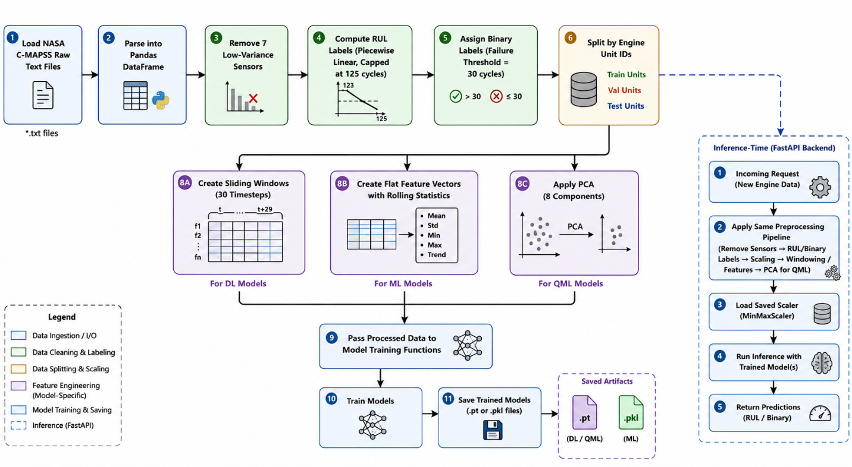
Figure 1. Data flow diagram
B-B. UML Use Case Diagram
The system has two primary actors: the User (professor or demo viewer) and the Developer.
User use cases: View Overview Dashboard, Select Engine, Select Model, Run Single Prediction, View Prediction Result, Run Ensemble Prediction, View Ensemble Vote Results, Filter Results Table, Toggle Light/Dark Theme, View Quantum Tab, View About Tab.
Developer use cases: Train All Models, View MLflow Tracking, Manage DVC Model Versions, Deploy with Docker Compose, Deploy with Kubernetes, Push to GitHub (triggers CI/CD), Run PyUnit Tests, Run Pylint.
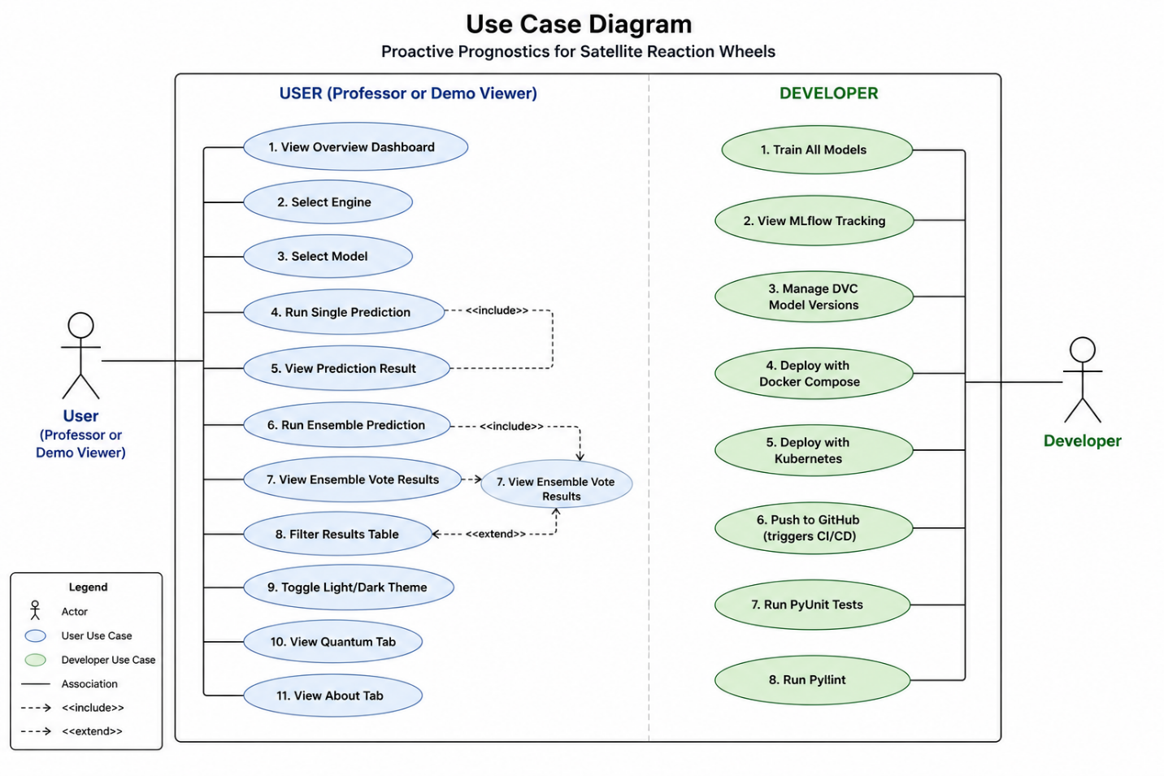
Figure 2. Use Case Diagram
B-C. Entity Relationship (ER) Diagram
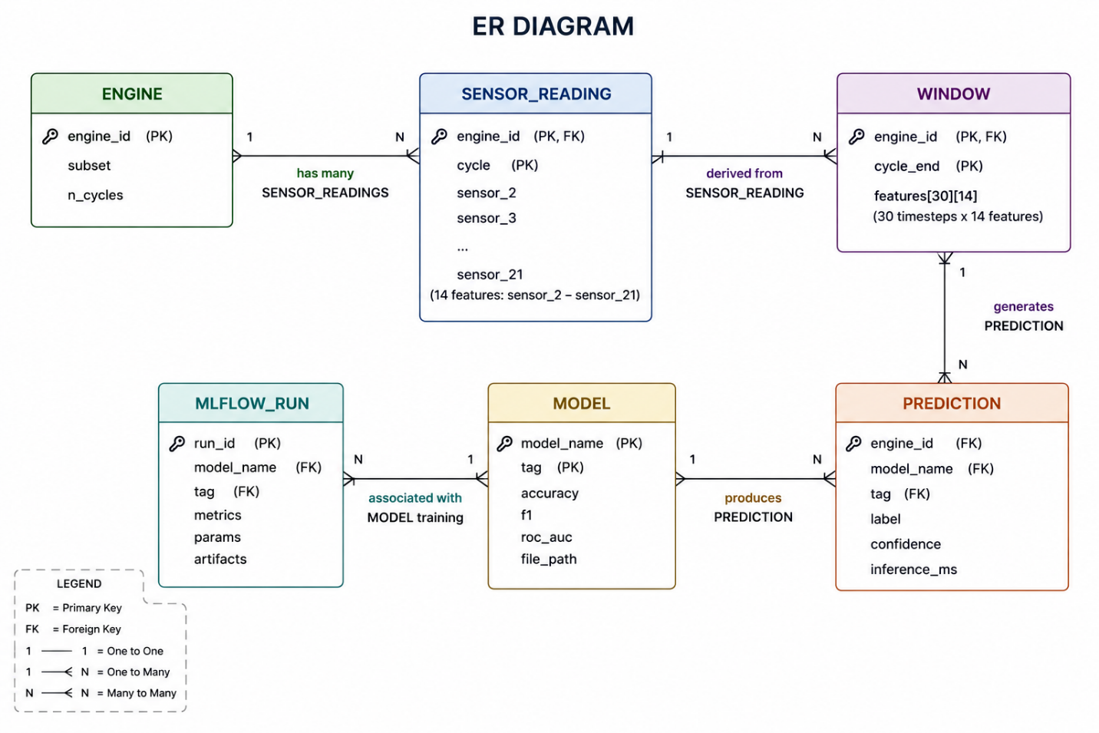
The primary entities and their relationships in the system are as follows:
Entity | Attributes | Relationship
ENGINE | engine_id, subset, n_cycles | Has many SENSOR_READINGS
SENSOR_READING | engine_id, cycle, sensor_2 to sensor_21 (14 features) | Belongs to ENGINE
WINDOW | engine_id, cycle_end, features[30][14] | Derived from SENSOR_READING
PREDICTION | engine_id, model_name, tag, label, confidence, inference_ms | Generated from WINDOW using MODEL
MODEL | model_name, tag, accuracy, f1, roc_auc, file_path | Produces PREDICTION
MLFLOW_RUN | run_id, model_name, tag, metrics, params, artifacts | Associated with MODEL training

