23/9/26
GENETIC ALGORITHM FOR OPTIMISATION PROBLEMS
import random
items = [(10, 5), (40, 4), (30, 6), (50, 3), (35, 2)]
capacity = 10
population_size = 8
generations = 10
def fitness(gene):
total_value, total_weight = 0, 0
for bit, (value, weight) in zip(gene, items):
if bit == 1:
total_value += value
total_weight += weight
return total_value if total_weight <= capacity else 0
def random_gene():
return [random.randint(0,1) for _ in items]
def crossover(parent1, parent2):
point = random.randint(1, len(items)-1)
return parent1[:point] + parent2[point:]
def mutate(gene):
i = random.randint(0, len(gene)-1)
gene[i] = 1 - gene[i]
return gene
population = [random_gene() for _ in range(population_size)]
for gen in range(generations):
population = sorted(population, key=fitness, reverse=True)
best = population[0]
print(f"Gen {gen+1}: Best gene {best}, Value = {fitness(best)}")
new_pop = [best[:]]
while len(new_pop) < population_size:
p1, p2 = random.sample(population[:4], 2) # select parents
child = crossover(p1, p2)
if random.random() < 0.3: # mutation chance
child = mutate(child)
new_pop.append(child)
population = new_pop
print("\nOptimal Solution Found:")
print("Gene:", best)
print("Value:", fitness(best))

OUTPUT:
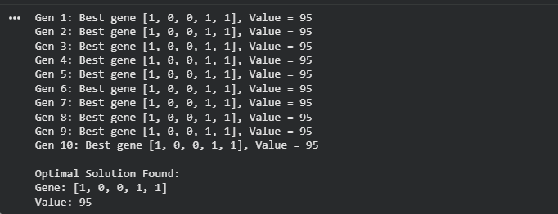

30/09/2026
PARTICLE SWARM OPTIMISATION
import random, math
cities = [(0,0), (2,3), (5,2), (6,6), (8,3)]
def dist(a, b):
return math.sqrt((a[0]-b[0])**2 + (a[1]-b[1])**2)
def route_length(route):
return sum(dist(cities[route[i]], cities[route[(i+1)%len(route)]]) for i in range(len(route)))
num_particles = 6
iterations = 10
particles = [random.sample(range(len(cities)), len(cities)) for _ in range(num_particles)]
pbest = particles[:]
pbest_val = [route_length(p) for p in particles]
gbest = pbest[pbest_val.index(min(pbest_val))]
gbest_val = min(pbest_val)
for t in range(iterations):
for i in range(num_particles):
a, b = random.sample(range(len(cities)), 2)
particles[i][a], particles[i][b] = particles[i][b], particles[i][a]
val = route_length(particles[i])
if val < pbest_val[i]:
pbest[i], pbest_val[i] = particles[i][:], val
best_val = min(pbest_val)
if best_val < gbest_val:
gbest_val = best_val
gbest = pbest[pbest_val.index(best_val)]
print(f"Iter {t+1}: Best route length = {gbest_val:.2f}")
print("\nOptimal Route Found:")
print("Route:", gbest)
print("Distance:", gbest_val)

OUTPUT:
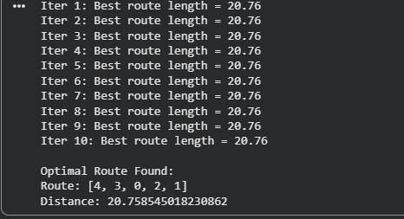

OPTIMISATION VIA GENE EXPRESSION
import random
def objective_function(x):
return x**2 + 4*x + 4

POPULATION_SIZE = 10
MUTATION_RATE = 0.1
CROSSOVER_RATE = 0.8
GENERATIONS = 25

population = [random.uniform(-10, 10) for _ in range(POPULATION_SIZE)]
for generation in range(GENERATIONS):

best_x = min(population, key=objective_function)
best_value = objective_function(best_x)

if generation % 5 == 0:
print("Generation:", generation)
print("Best x:", round(best_x, 4))
print("Best fitness value:", round(best_value, 4))
print("------------------------")

new_population = []

while len(new_population) < POPULATION_SIZE:
parent1 = min(random.sample(population, 2),
key=objective_function)

parent2 = min(random.sample(population, 2),
key=objective_function)

if random.random() < CROSSOVER_RATE:
child = (parent1 + parent2) / 2
else:
child = parent1

# Mutation
if random.random() < MUTATION_RATE:
child += random.uniform(-1, 1)

new_population.append(child)

# Replace population
population = new_population

best_x = min(population, key=objective_function)
best_value = objective_function(best_x)

print("\n========== FINAL RESULT ==========")
print("Best solution (x) =", round(best_x, 4))
print("Minimum value f(x) =", round(best_value, 4))
print("==================================")

OUTPUT:


