Personalized Affective Feedback to Address Students’ Frustration in ITS

In this paper author is describing concept to detect frustration in students and this frustration detection technique is using by many Intelligent Tutoring System with the help of Learning Models. Prior frustration detection can allow institution to help students overcoming from frustration, this frustration can develop in students due to lack of concentration, confusion and getting bored during classes.

In this paper by detecting frustration we can send motivational messages to praise student which can help him in fighting frustration, to achieve this we present a strategy to respond to students’ frustration by offering motivational messages that address different causes of frustration. Based on attribution theory, these messages are created to praise the student’s effort, attribute the results to the identified cause, show sympathy for failure or obtain feedback from the students.

All existing techniques were able to detect frustration but they don’t propose any concept of motivating frustrated student to overcome from this problem, but in propose system not only we are detecting frustration we are able to find cause or problem of frustration and offer him with motivational and sympathy messages to fight frustration.

To build this system we are using theory-driven approach based machine learning model and previous students LOGS DATA, using this log data and machine learning we will build a learning model and then whenever we issue new student data then this application apply new student data on that learning model to predict best matching result, this result will contains information about students whether he is suffering with any frustration or performing well, if suffering from frustration then what its root cause. All this information we can get from learning model result.

To implement learning model we are using PYTHON machine learning Algorithms and we are using past student log data.

Dataset Information

To implement above technique we are using ‘Mindspark’ previous students data, this data contains students’ performance average values collected from various tests like confusion, concentration, bored and frustration. Below I am showing few records from 50000 students dataset and this dataset name is ‘affect_estimates.csv’ which is available inside dataset folder.

Dataset values

**id, student, observed_confused, observed_concentrating, observed_bored, observed_frustrated, affect, to**

0, 72720, 0.17183861, 0.428695172, 0.393139273, 0.164317191, 0, 1

1, 72720, 0.132175878, 0.65661031, 0.184330121, 0.128531024, 1, 1

2, 72720, 0.079290338, 0.770555317, 0.131177962, 0.08729333, 1, 1

3, 72720, 0.05293958, 0.836300731, 0.118124247, 0.035456825, 1, 2

In above dataset all bold names are the dataset column names and below are the average values. In above columns ‘affect, to’ show important values of dataset such as whether student is frustrated or not, if frustrated then what its cause. In dataset we have given values from 0 to 5 and below are the description of those values

NUL = 0

ENG = 1

BOR = 2

MULT = 3

FRU = 4

CON = 5

If NUL means student performing well and in dataset we give value as 0, ENG means student is having engaging concentration problem, BOR means getting bored, MULT means student is suffering from multiple problems such as lack of concentration and confusion etc, FRU means frustration and CON means confused. In dataset we cannot used normal names as learning models work only on integer values not on names, so we assign unique values to each problem. In dataset if we get values as 0,1 then ‘affect is’ 0 which means performing ok and ‘to’ is 1 which means having engage concentration problem.

If we get result as 0, 0 then ‘affect’ 0 means performing well and ‘to’ 0 means has no problem.

If we get result as 1, 1 then ‘affect’ 1 means having concentration problem and ‘to’ 1 means is effecting student state.

Similarly algorithm will evaluate all states and give us the result. To get result just we need to enter student current average values.

Screen shots

To run this project install python and setup DJANGO webserver and then deploy code on DJANGO and run from web browser to get below home page screen

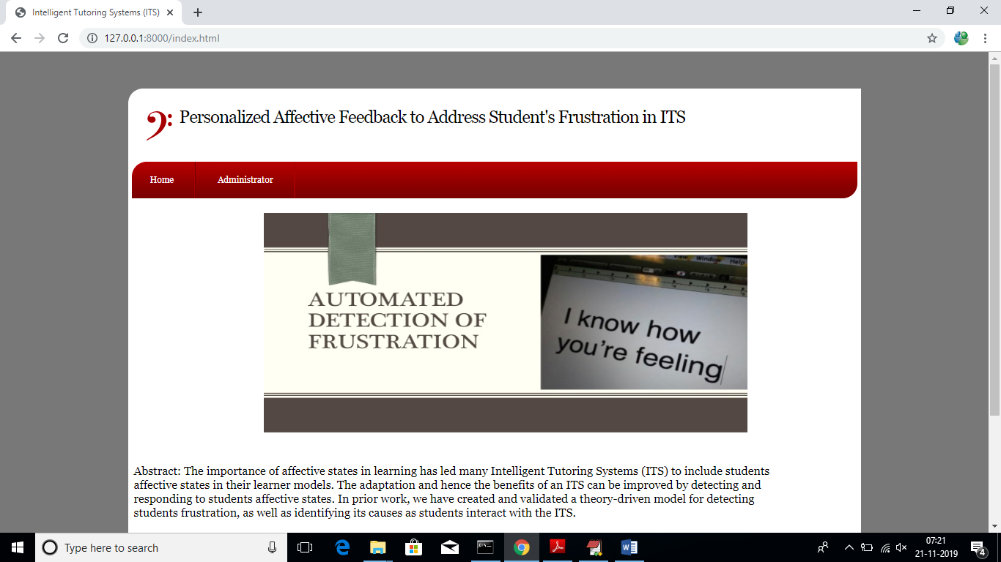

This application mainly used by ITS Administrators, so I have only one user as ‘Admin’. Now click on ‘Administrator’ link to get below login screen

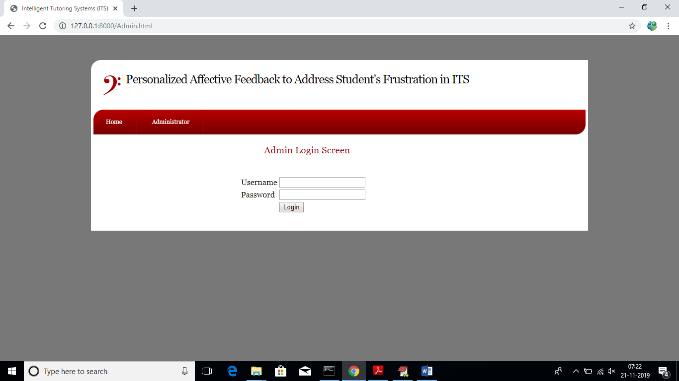

In above screen enter username and password as ‘admin’ to login to application

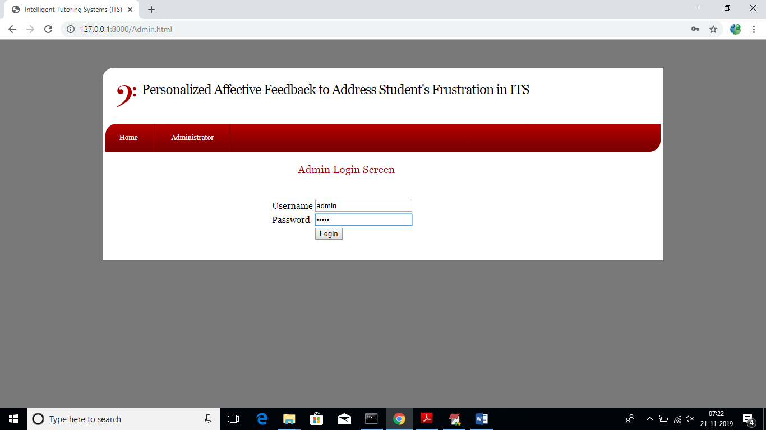

After login will get below screen

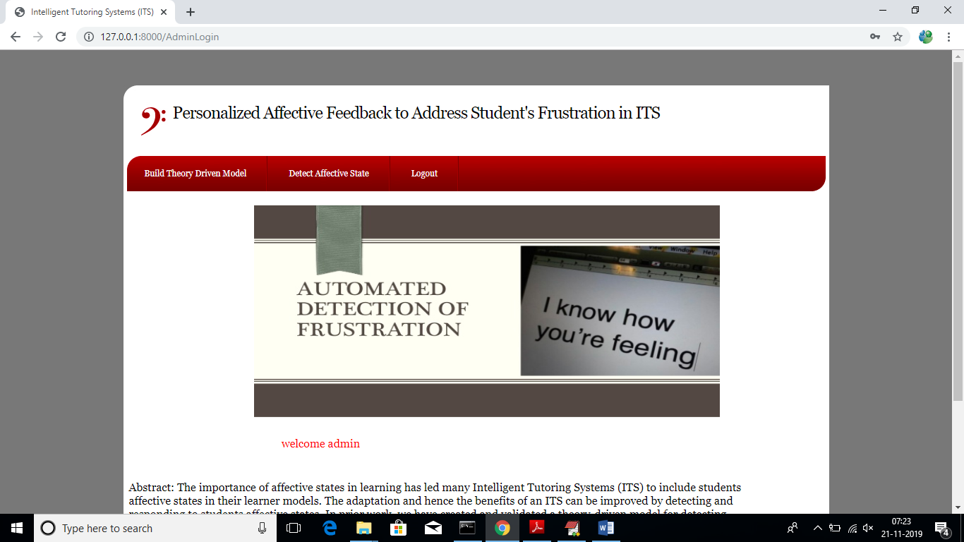

Now first admin need to build learning model using ‘theory-driven approach’, so click on ‘Build Theory Driven Model’ link to build model from the dataset

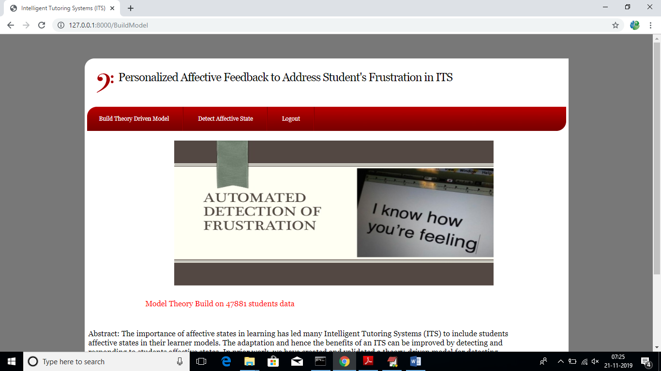

In above screen we can see in red lines that application build learning model using 47881 number of students data. We need to build model only one time, once after building model we can predict student frustration just by entering values. Now click on ‘Detect Affective State’ link to get below screen

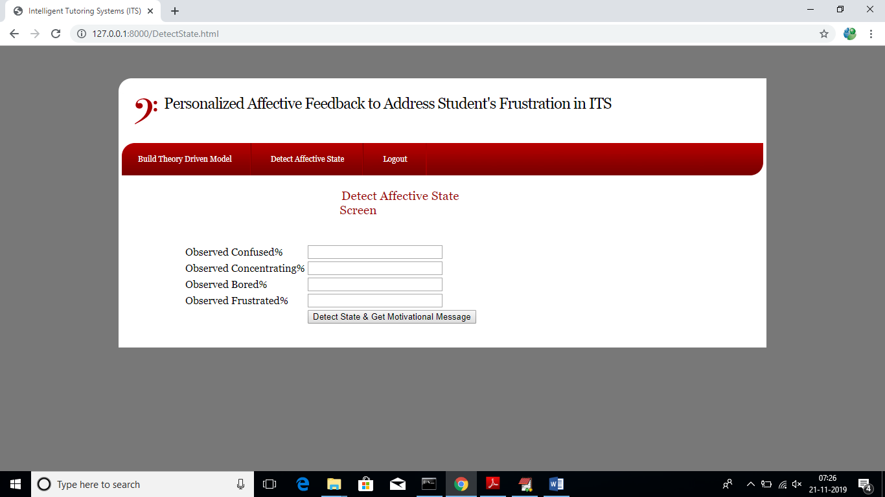

In above screen we need to enter current student performance values to detect his frustration problem.

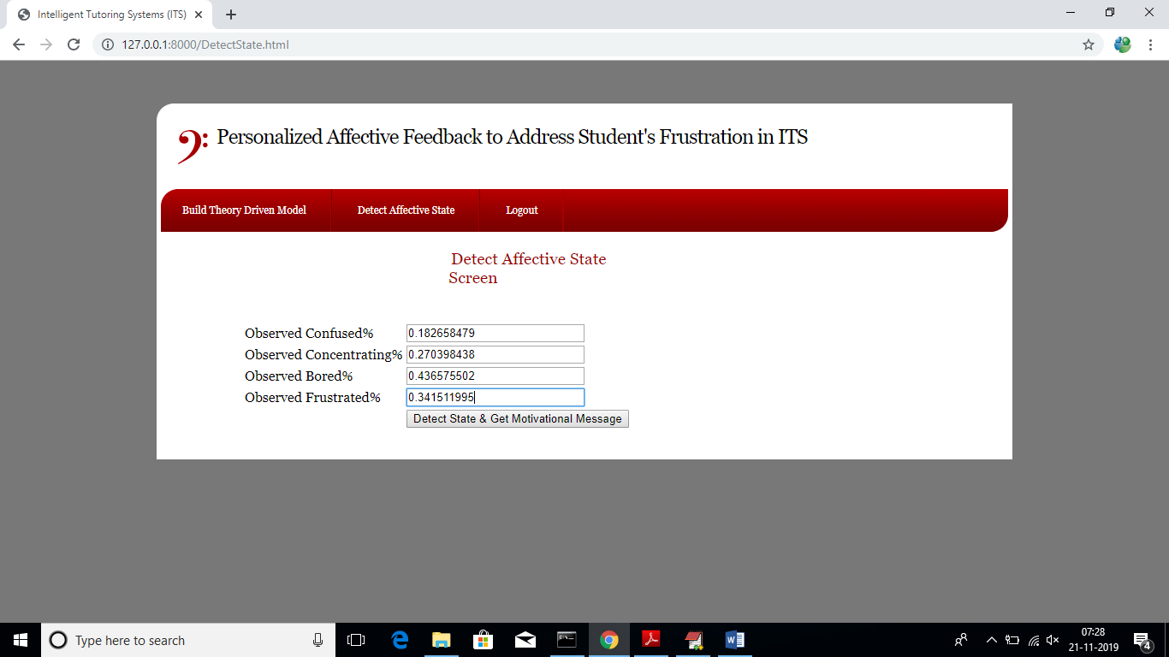

In above screen I entered some values and now click on button to get result. For above value we got below result

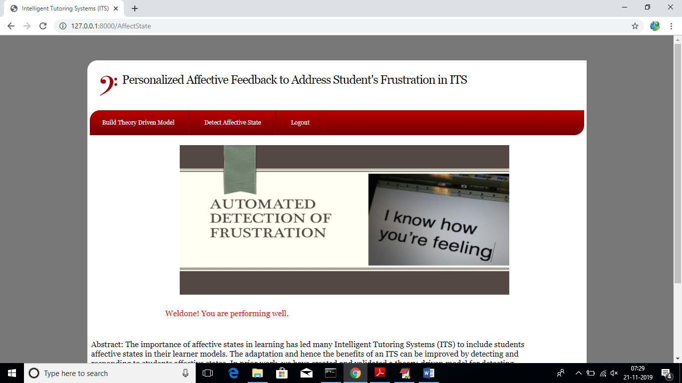

In above screen we got result as ‘Student performing well’, now we will test with some other values

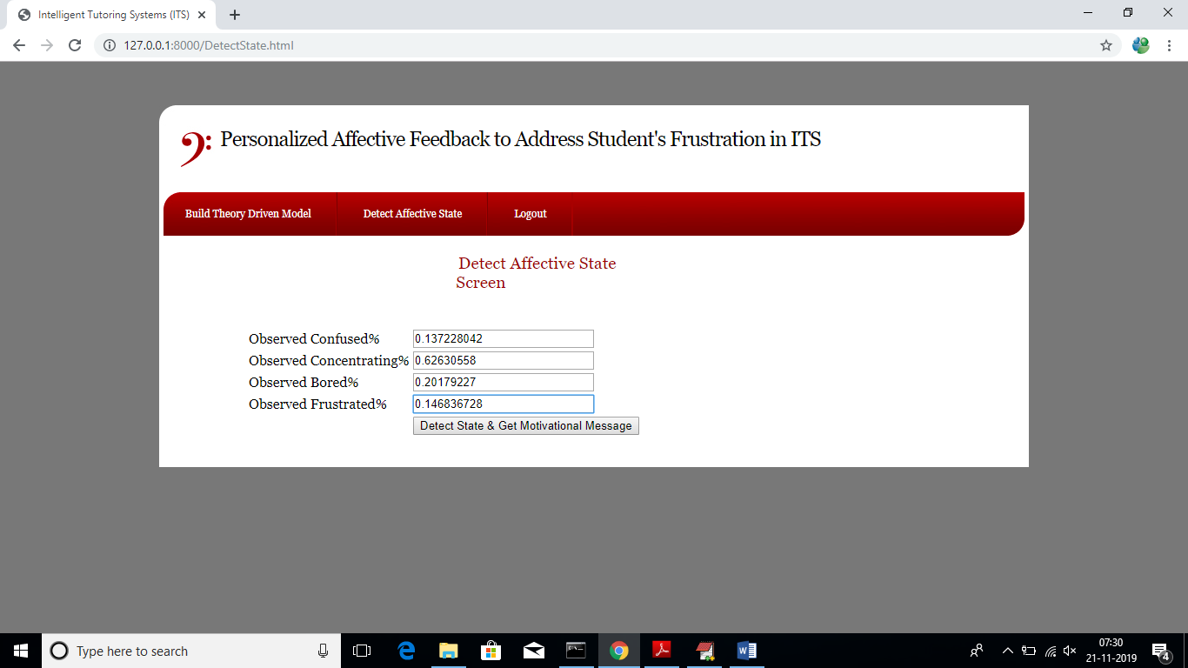

For above screen values we got below result

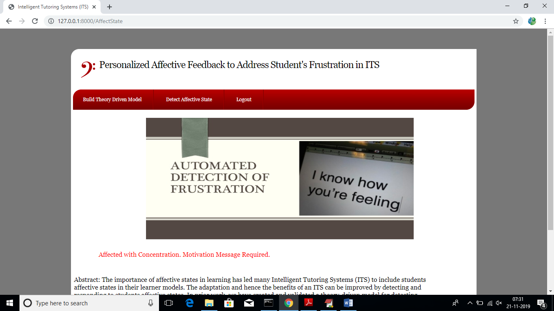

In above screen we can see student is frustrated and the root cause is lack of concentration and it will tell admin to send motivation messages. Similarly u can test with any values and if u confuse then u can use below values to detect various frustration causes

0.182658479, 0.270398438, 0.436575502, 0.341511995 (performing well)

0.137228042, 0.62630558, 0.20179227, 0.146836728 (concentration)

0.189066738, 0.141477004, 0.679874718, 0.221267894 (bored)

0.61980617, 0.303662777, 0.100092664, 0.159191519 (confuse)

0.348913103, 0.205860093, 0.36019364, 0.326235294 (frustration)