Docker

Command to pull the postgress docker from Docker hub:docker run postgress:9.6 [if unable to find postgress:9.6 image It will automatically start download from Docker hub]

­­__­­

**Docker Basic commands:**

docker pull <image> [image to pull from docker hub]

docker run <image> [run the image if not exist pull from docker]

docker start<container id>

docker stop <container id>

docker ps [Provides list of running containers]

docker ps -a [provides history of containers]

docker run redis:4.0 [it start downloads the redis 4.0 version image from docker hub if redis 4.0 not installed on machie previously]

docker images [provides list of docker images]

container is a running environmet for image

Note:

1.conflicst when same port on host machine

2.No conflict occur when same port on container

Port Binding :

docker run -p6000:6379 redis

docker run -p6000:6379 -d redis [running redis image on detached mode]

Containers logs:

docker logs <container id> or docker logs <container name> [provides the logs]

docker run -d -p6001:6379 --name redis-older redis:4.0 [running the redis 4.0 version image with custome name]

docker exec -it <containerid> /bin/bash [is used to open teminal for container to check configurations like env variables etc…]

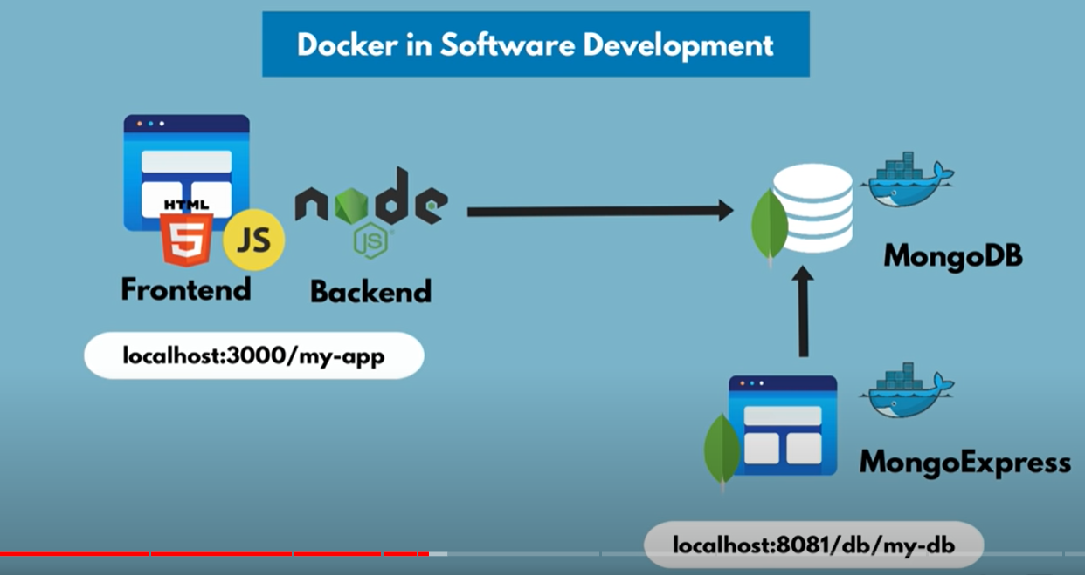

docker network ls [provides list of network]

docker network create mongo-network [creates a new network with name mongo-network ]

docker run -p 27017:27017 -d -e MONGO_INITDB_ROOT_USERNAME=admin -e MONGO_INITDB_ROOT_PASSWORD=password --name mongodb -–net mongo-network mongo

docker run -d -p 8081:8081 -e ME_CONFIG_MONGODB_ADMINUSERNAME=admin -e ME_CONFIG_MONGODB_ADMINPASSWORD=password -e ME_CONFIG_MONGODB_SERVER=mongodb --net mongo-network --name mongo-express mongo-express

docker run -d \

-p 8081:8081 \

-e ME_CONFIG_MONGODB_ADMINUSERNAME = admin \

-e ME_CONFIG_MONGODB_ADMINPASSWORD = password \

-e ME_CONFIG_MONGODB_SERVER = mongodb \

--net mongo-network \

--name mongo-express \

mongo-express

docker compose [YAML]:

docker-compose -f docker-compose.yaml up

docker-compose -f docker-compose.yaml down

**Docker File:**

Docker file is a blue print for creating images.