1. OS image - Raspbian
   1. <https://www.raspberrypi.org/downloads/>

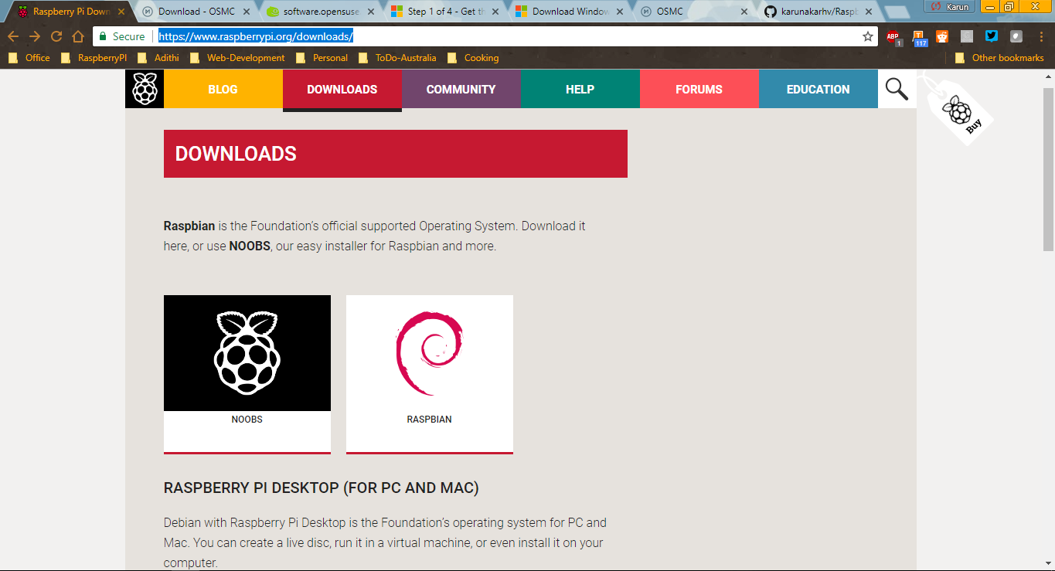

* 1. Since file size was huge around 1.6 GB, preferred to download via Torrent.

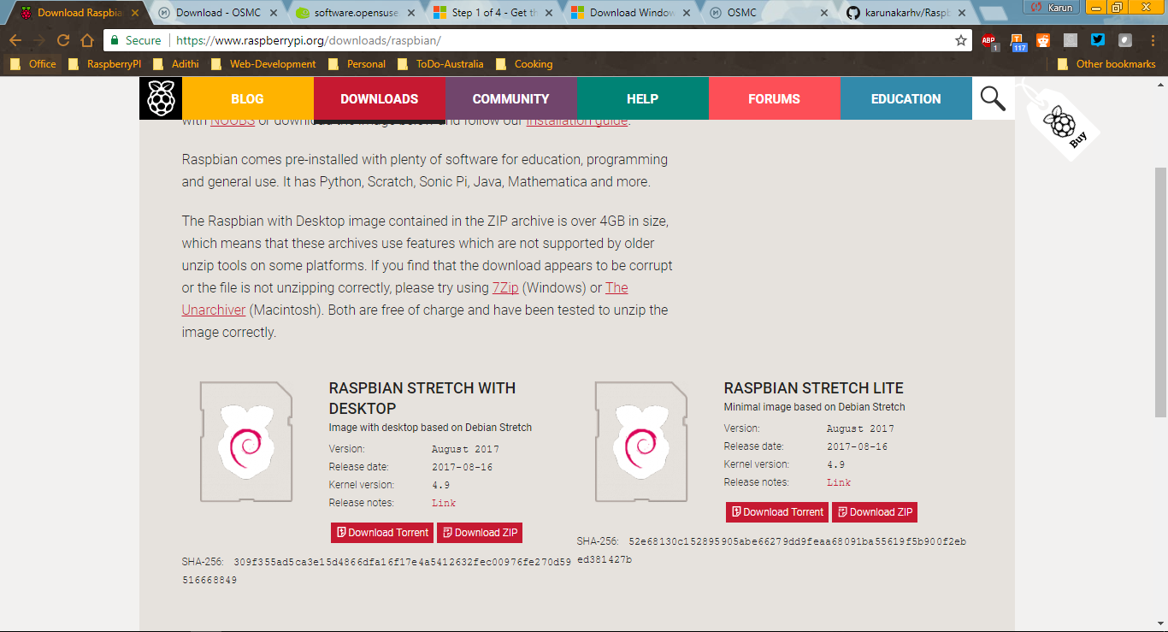

1. **SDFormatter** 
   1. <https://www.sdcard.org/downloads/formatter_4/eula_windows/index.html>

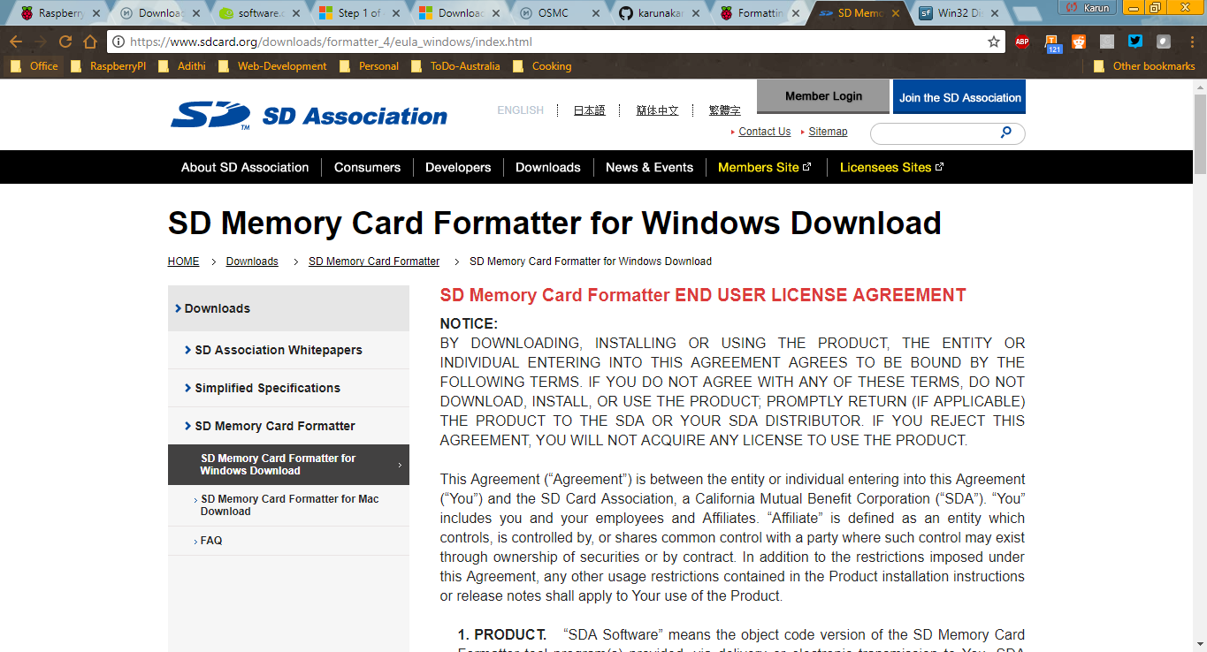

* 1. Help Manual - <https://www.raspberrypi.org/documentation/installation/sdxc_formatting.md>

1. **Win32 Disk Imager Tool**
   1. Website - <https://sourceforge.net/projects/win32diskimager/>

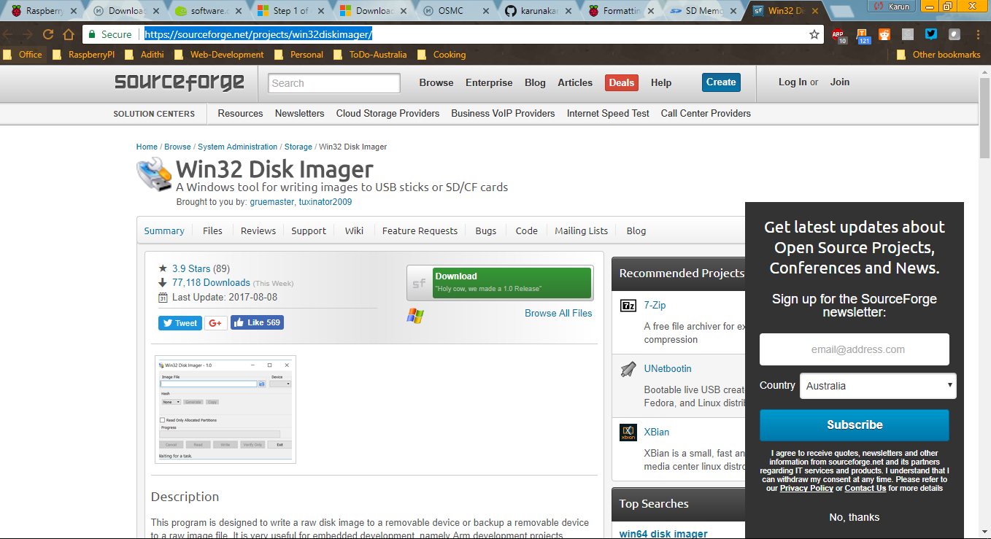

1. **Putty – Remote Connection**
   1. URL - <http://www.putty.org/>

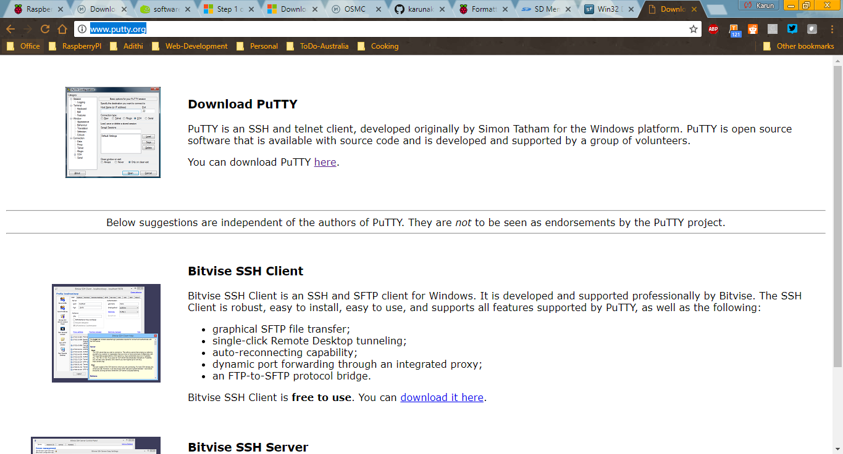

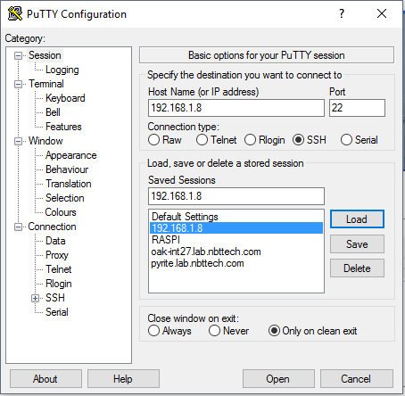

Username - pi

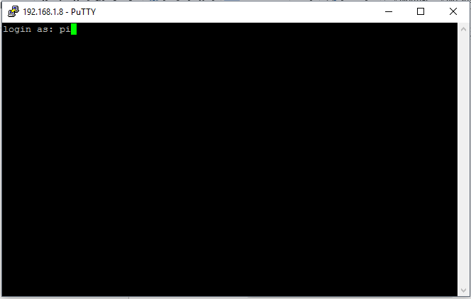

Password - raspberry

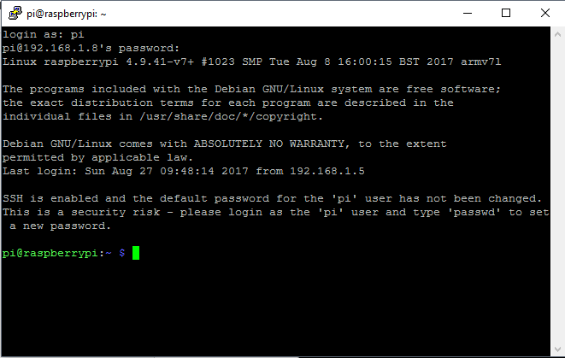

1. **Advanced IP Scanner**
   1. <https://www.advanced-ip-scanner.com/>

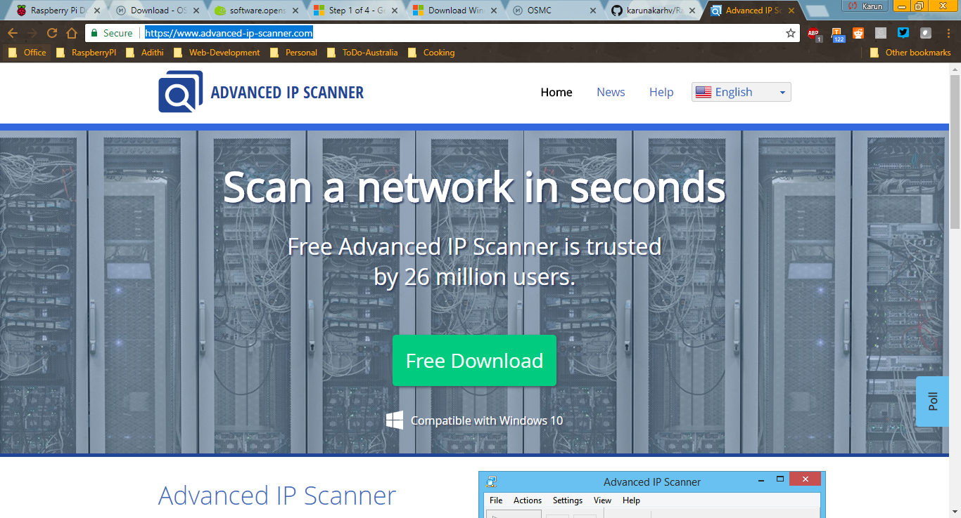

Advanced IP Scan

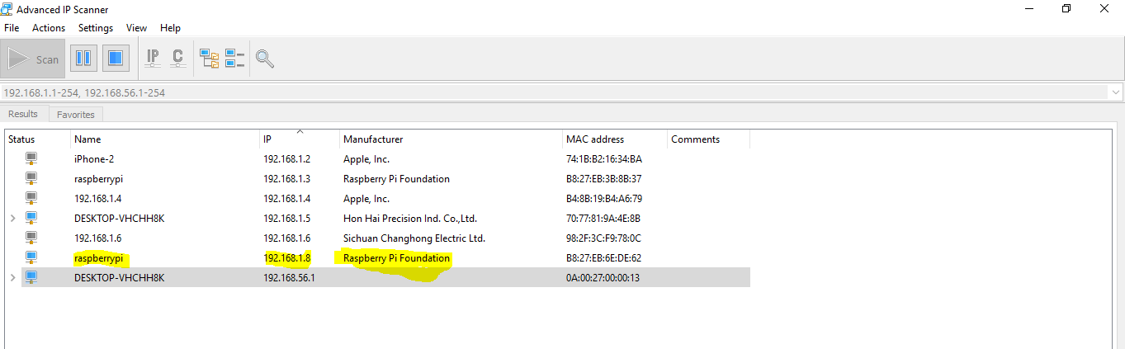

VNC Viewer

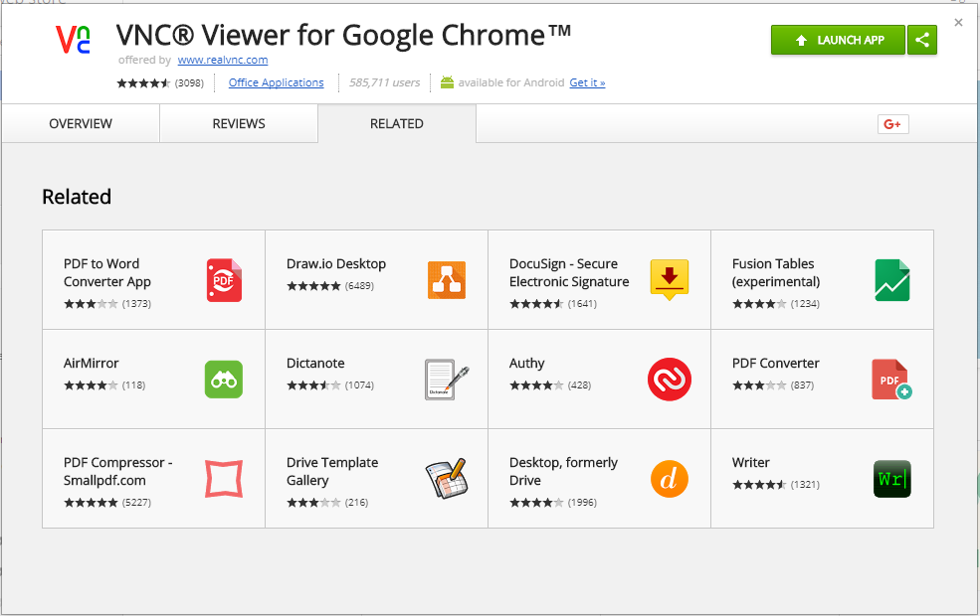

VNC Viewer Connection Screen

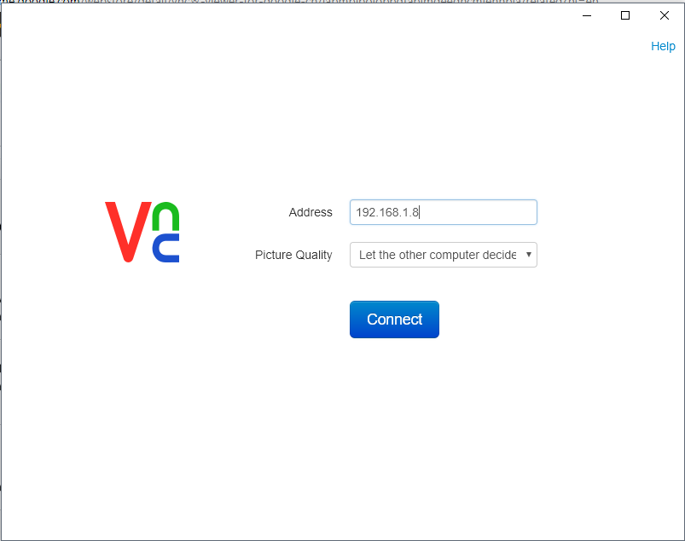

Connected Screen – Desktop

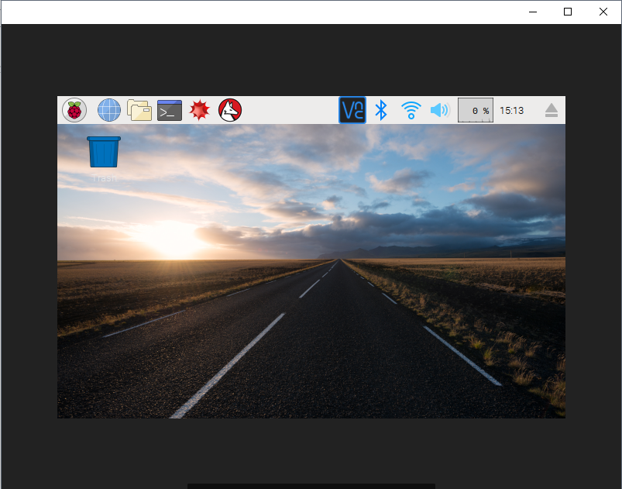

Rasbian Desktop

