**Test-Results**

|  |  |
| --- | --- |
| **Steps** | **Actual Result** |
| 1. Navigate to https://www.unibet.com.au/racing | Racing Page is loaded successfully. |
| 2. Click on the last event in the Next To Go that has the “F” icon | Event Page is loaded successfully. |
| 3. Click on Lowest Fixed Price | Lowest Fixed Price event is loaded successfully. |
| 4. Verify the following is populated to the bet slip.   1. Event Name 2. Event type icon 3. Price 4. Runner sequence 5. Runner name 6. Market. Ex. Fixed (Win) | Following information is populated successfully.  Event Name R9 BELMONT PARK USA  Event Type Thoroughbred  Runner Sequence 10  Runner Name Brazillionaire  Price 2.50  Market Fixed (Win) |

**Results Screenshot:**

**Racing Page:**

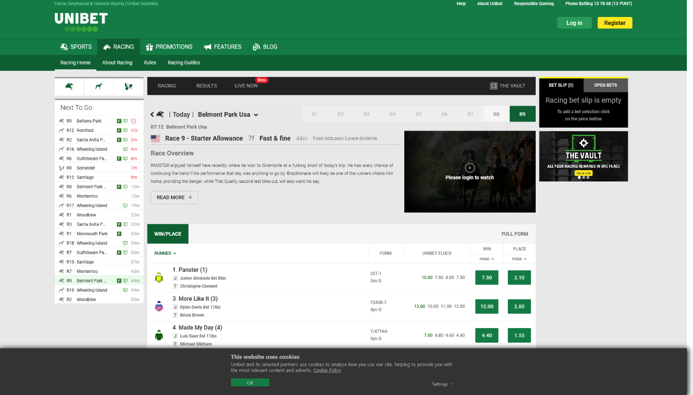

**Bet Slip Page:**

