This is edited from Desktop Version of the Blog Post in Narsampet…!

This is an another line of Document where the actual line was written from Labotop…  
By Karunakar

Added Image from labtop dude…!

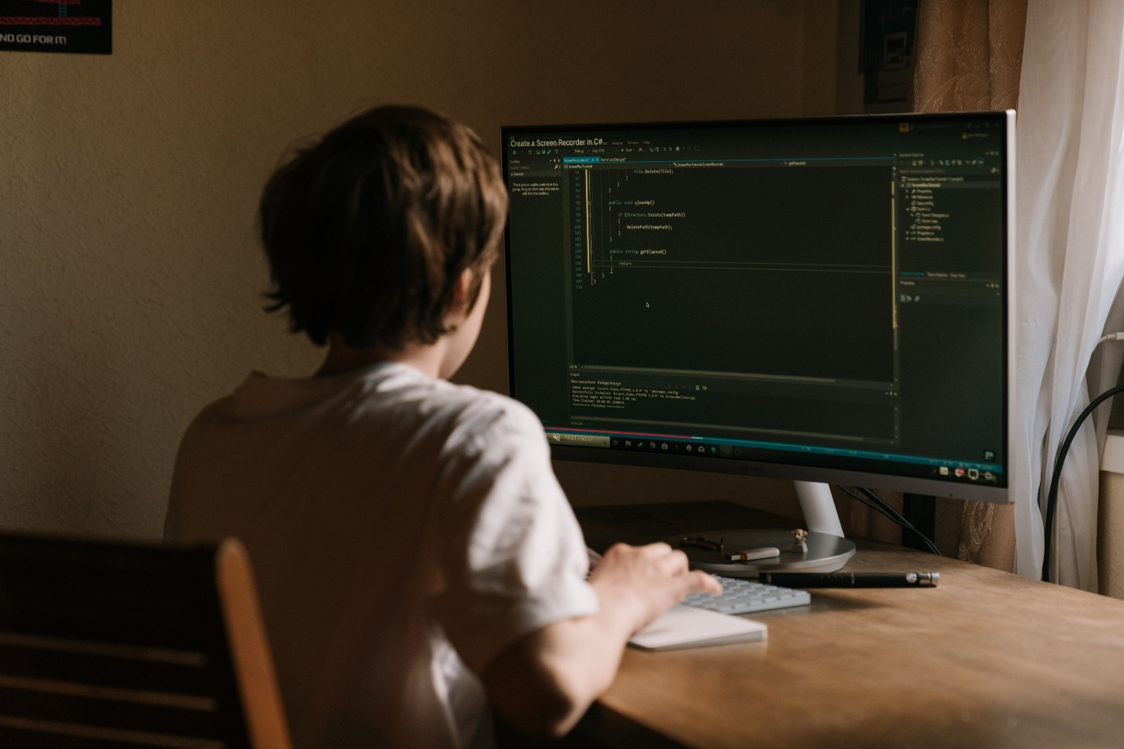

The above image has been added in laptop using the image from the local computer…!