

**SYSC 5709S**

**COURSE PROJECT- THEATRE RESERVATION SYSTEM**

**DEVELOPER GUIDE**

**THEATRE RESERVATION**

Theatre reservation system allows booking of movies to the customers ahead of time by just login into their profiles. Prior to the online booking system, customers were standing in long queues to confirm their booking for the movies. This waste hours of the precious time of the customers and makes it very monotonous and time-consuming work. This Theater Reservation System gives efficiency by reducing the scope of time-consuming tasks performed by standing in long queues. Also, the theatre staff don’t need to manage the manual booking system. Moreover, this system provides a way to handle the larger growing of customer data and provides a solution to the growing human error while booking tickets by staff. This system uses the real time data analytics to handle the growing data of the users and managing their profiles and updating the database for shows and show timings.

**USERS-** In Theatre Reservation System, there are two types of users. Admin and multiple customers who can access the functionalities by login into their accounts.

* **ADMIN-** Admin has privileges to add the movies, edit movie formats, check the booked tickets, manage timings of show, change price of movie, check revenue of data.
* **USER-** A new user have to register to use the booking system. A user can view and update his/her profile. A user can see the movie list, check the show timings for a movie, check the seat availability, book the ticket, add credit to his profile.

**FLOW CHART OF THE SYSTEM**

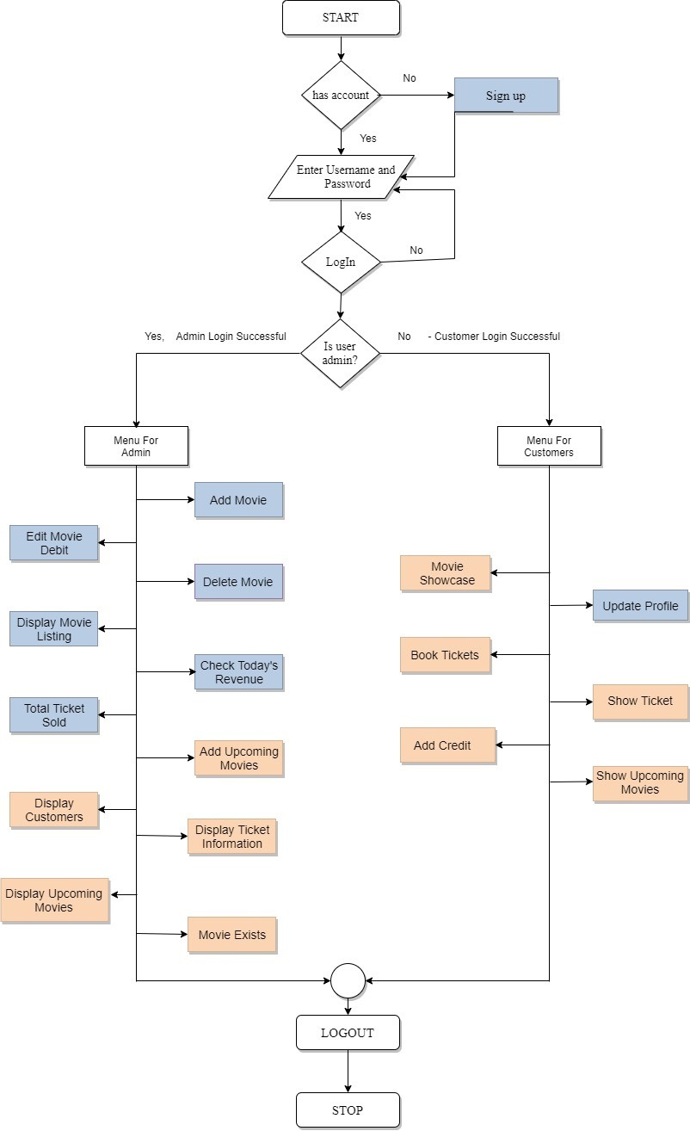

LEGENDS- RELEASE 1 RELEASE 2

**ORGANIZATION OF FILES AND FOLDERS**

1. **bin:** Bin folder contains the binary files which are actual executable files of Booking system.

This folder contains the following files:

* theatre_reservation_system.exe
* Test.exe

1. **include:** This holds the declaration and definitions of files which can be shared with other files. Theatre Reservation System contains following header files:

* upcomming.h
* setup.h
* movie.h
* login.h
* customer.h
* admin.h

1. **lib:** This is an inbuilt function and contains the following files:

* libmysql.dll

1. **doc:** The documents of Theatre Reservation System are in this folder

* user_manual.docx
* developer_guide.docx
* **HTML**
* **LATEX**

1. **database:** To create, insert and update the data into the database, several queries are required. This SQL folder contains the script of SQL queries which helps to manage the whole system.

* theatre_reservation_system.sql

1. **external_files:** This folder contains the files that are required to execute the SQL queries

**(C:\cygwin64\user\include)**

* mysql.h
* mysql_time.h
* mysql_com.h
* my_list.h
* my_alloc.h
* mysql_version.h
* typelib

1. **obj:**  This folder holds the files that contains the object code of the project. Following are the object files of the theatre reservation system:

* testobj/Test.o
* upcomming.o
* movie.o
* main.o
* login.o
* customer.o
* admin.o

1. **src:**  Source file contains the whole code of the project. Theatre Reservation System has the following .c files:

* upcomming.c
* movie.c
* main.c
* login.c
* customer.c
* admin.c

1. **test:**  Following file contains the test input.

* Test.c
* testresults.txt

**GITHIB LINK:**

<https://github.com/karunarora/Group_B_theatreReservationSystem>