

**Advance topics in software engineering**

**Theatre Reservation system: User guide**

**SUBMITTED TO: SUBMITTED BY:**

**Dr. Cristina Ruiz Martin Karun Arora - 101131647**

**Jasvir Grewal - 101121160**

**Harashdeep Kaur Minhas - 101125628**

**Paramveer Singh- 101130864**

**Installing Cygwin, GCC**

**Windows – Installation**

1) Goto **http://www.cygwin.com/.**

2) Here search for "Installing Cygwin" and select the correct version (32 bit or 64 bit) for your PC.

3) Download the chosen file.

4)

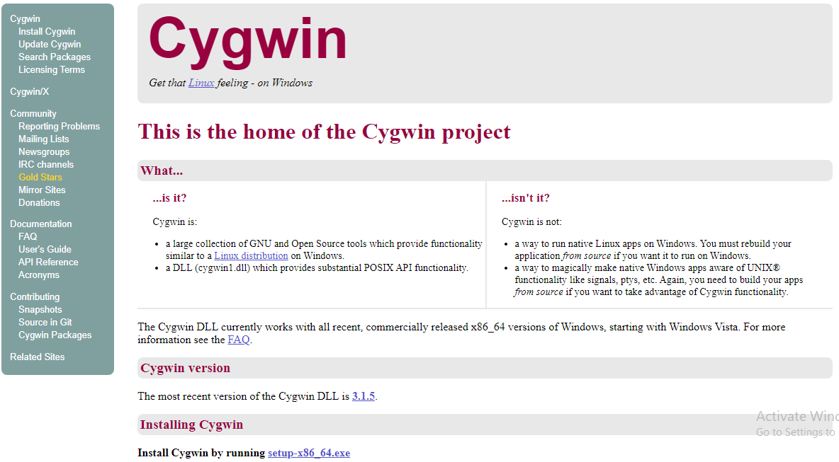

Fig 1: Cygwin page.

5) Open the setup-x86_64.exe (64-bit) or setup-x86.exe (32-bit). Then click Next.

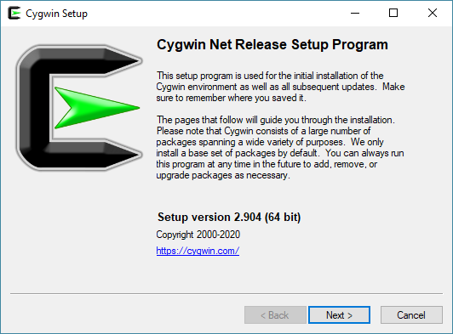

Fig 2: Cygwin Setup Program.

6) Select root directory and users. Then click next.

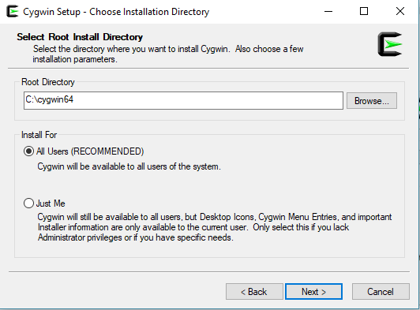

Fig 3: Choose Installation.

7) Select path to directory.

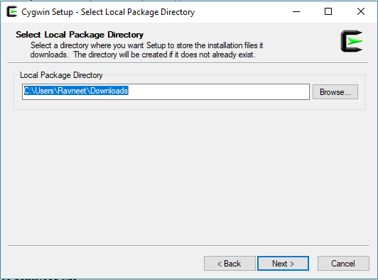

Fig 4: Installation path.

8) Select “Use System Proxy Setting” and then click Next.

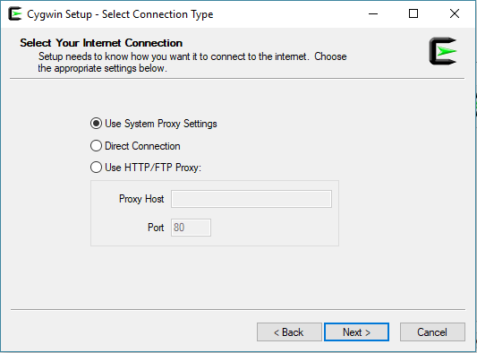

Fig 5: Select connection type.

9) Select download site.

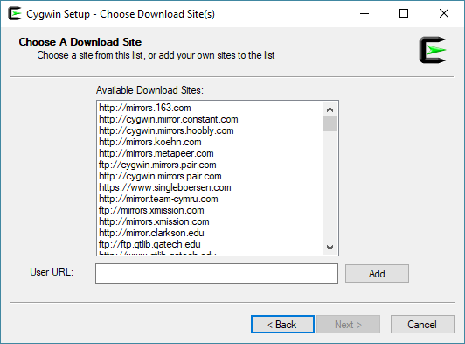

Fig 6: Choose download site.

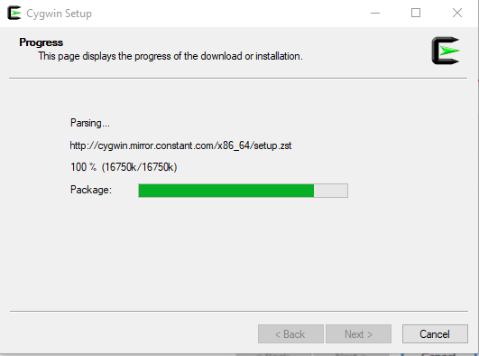10) Now, the installation process will start.

Fig 7: Downloading.

11) Now when we click on “All”, we can see the list of existing packages. Click Next.

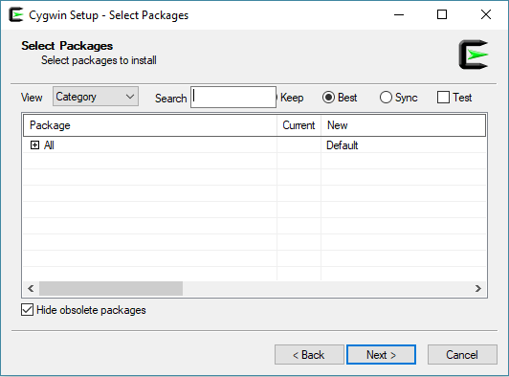It is going to install the default tools and libraries.

Fig 8: Select packages.

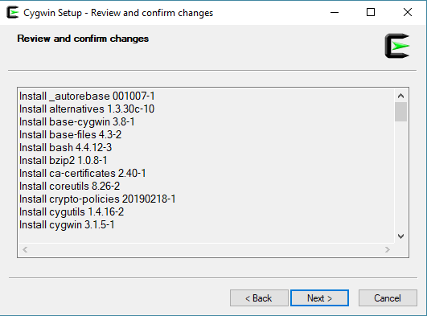12) This window will appear. Click on Next.

Fig 9: Review and confirm.

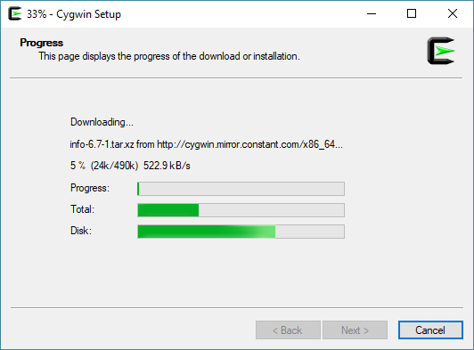13) The progress window will appear as shown below.

Fig 10: Setup progress.

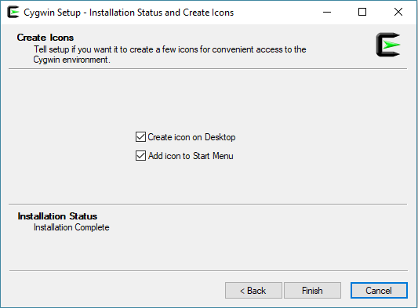14) When installation finishes, select “Create icon on Desktop” and/or “Add icon to Start Menu”. Then click Finish.

Fig 11 Setup Finish.

15) When installation finishes, open the cygwin64 folder, following content can be seen.

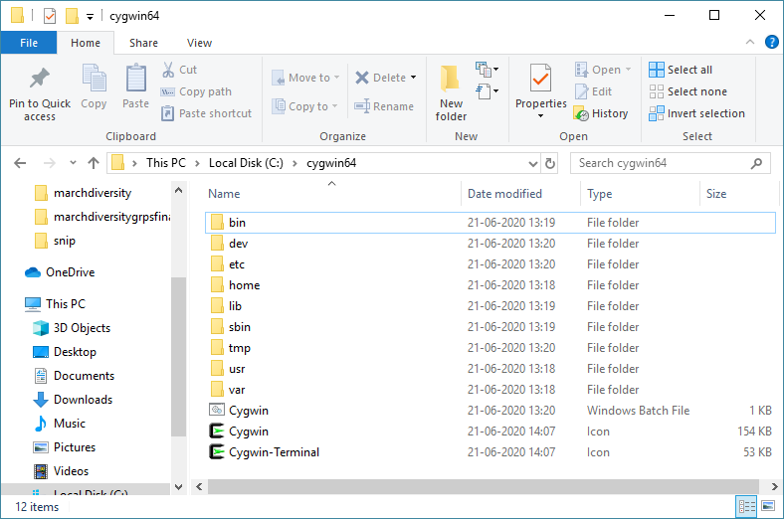

Fig 12: C:\cygwin64

16) Open the windows Command Prompt by typing “cmd” in Windows search. Then type cd c:\cygwin64

For the 64-bit installation, type: Setup-x86_64.exe -q -P chere -P wget -P gcc-g++ -P make -P diffutils -P libmpfr-devel -P libgmp- devel -P libmpc-devel

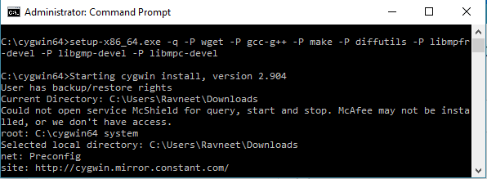It is going to install all the required libraries and the latest version of gcc/g++ compiler.

Fig 13: Command prompt.

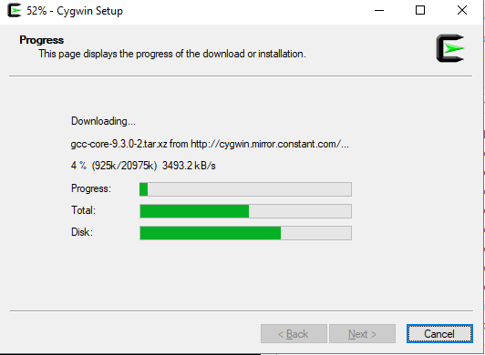17) Now a progress window will appear which will show the required packages are downloaded and installed.

Fig 14: Setup

When the installation process is done, the window gets closed.

18) Right click on the Cygwin icon on desktop, and select “Run as administrator”.

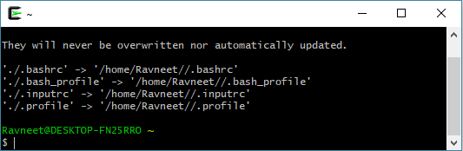

19) Type the following command on the terminal and press “Enter”:

wget rawgit.com/transcode-open/apt-cyg/master/apt-cyg

20) Type the given command and press “Enter” install apt-cyg /bin

"apt-cyg" is a command in Cygwin like the "sudo apt-get" command in Linux. It is used to install packages, update them, list them, etc.

**Installing MySQL**

1) **Go to** <https://dev.mysql.com/downloads/installer/>, select the operating system.

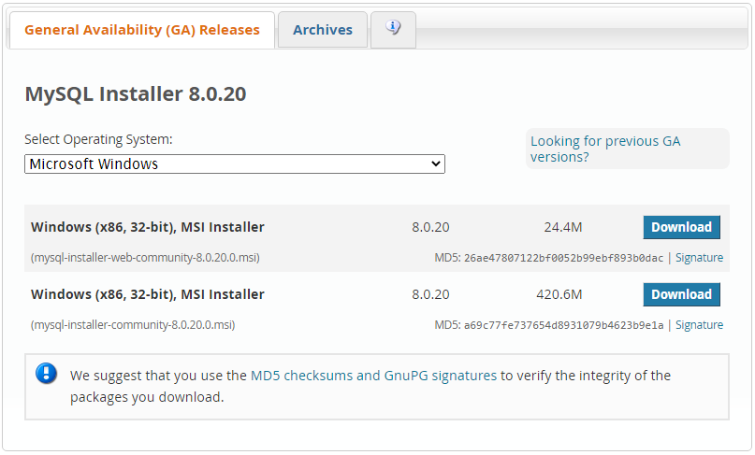

2) Select the installer and click on download.

3) You can choose the option to download without login.

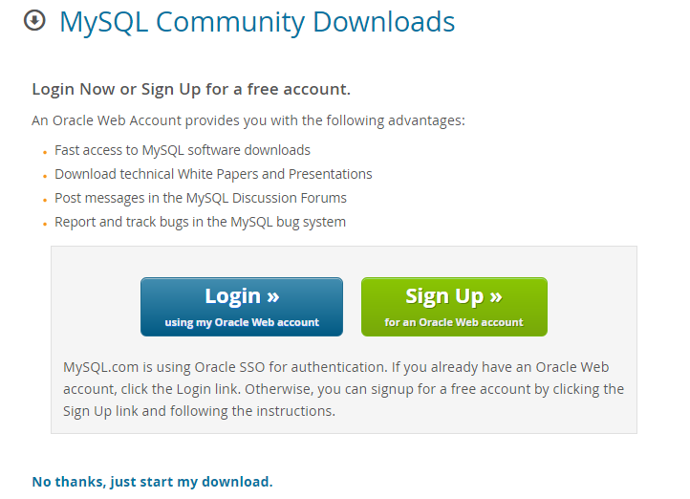

4) when download gets complete double click on the downloaded file, then downloading will start.

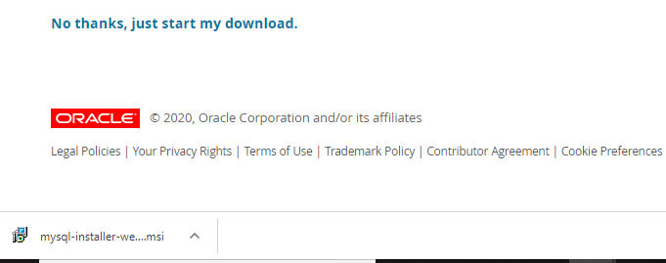

5) Now, choose the **setup type**. Click on option **Full**and then click on **Next.**

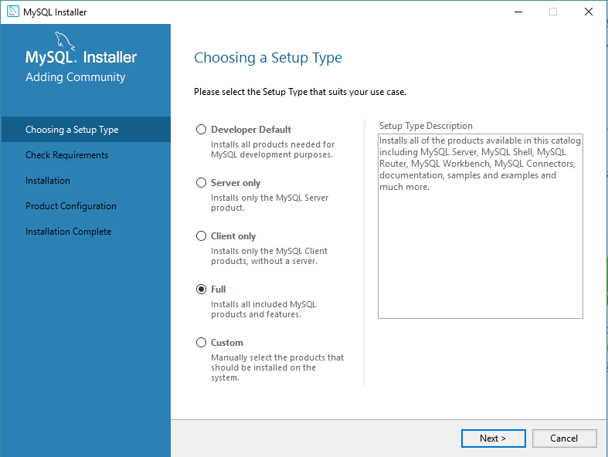

6) Now click on **Next**, some products may fail to install. You can skip them or resolve them. I will skip by clicking on **Next.**

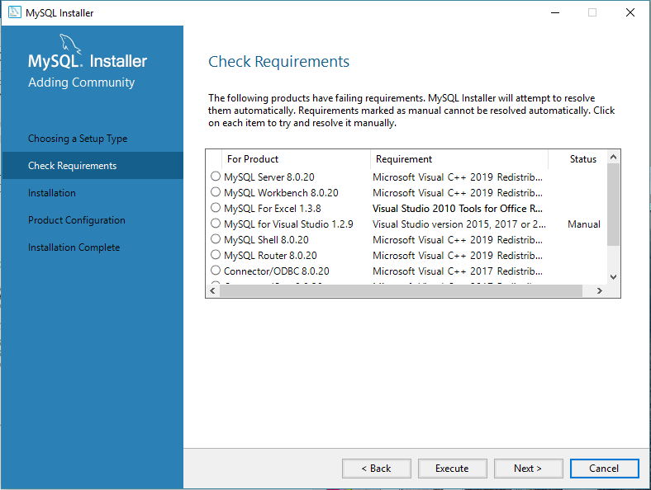

 7) Now, a dialog box will appear asking for confirmation of the products which are not getting installed. Just click on **Yes.**

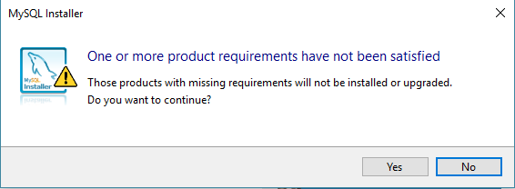

8) After you click on Execute, the products start getting installed.

Now, when the installation gets completed, click on **Next.**

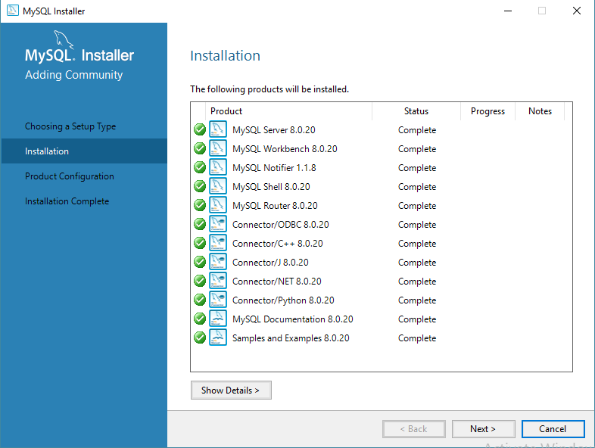

9) You will see product configuration window, just click on next.

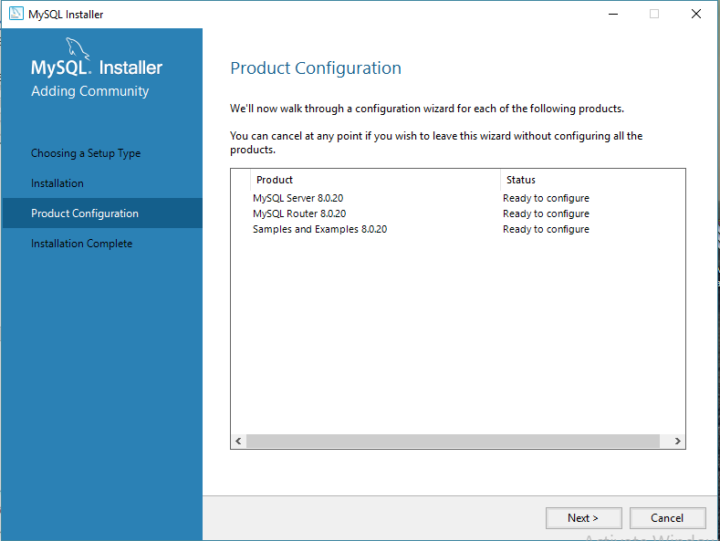

10) Now select Standalone MySQL Server and then click on **Next.**

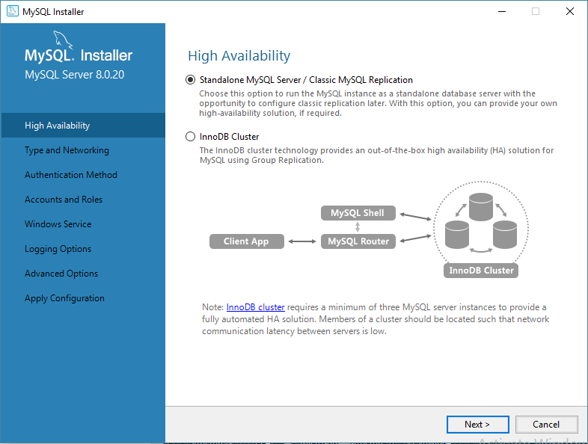

11) After you click on Next, give the**server configuration**. Here Port number is 3306 and then click on **Next.**

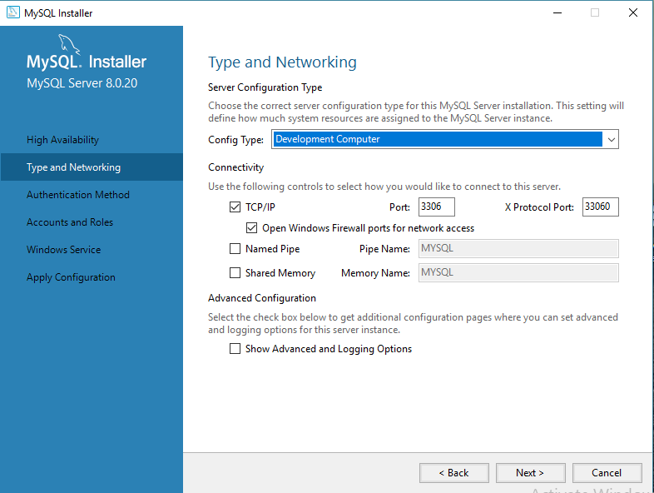

12) Now choose encryption option as authentication method

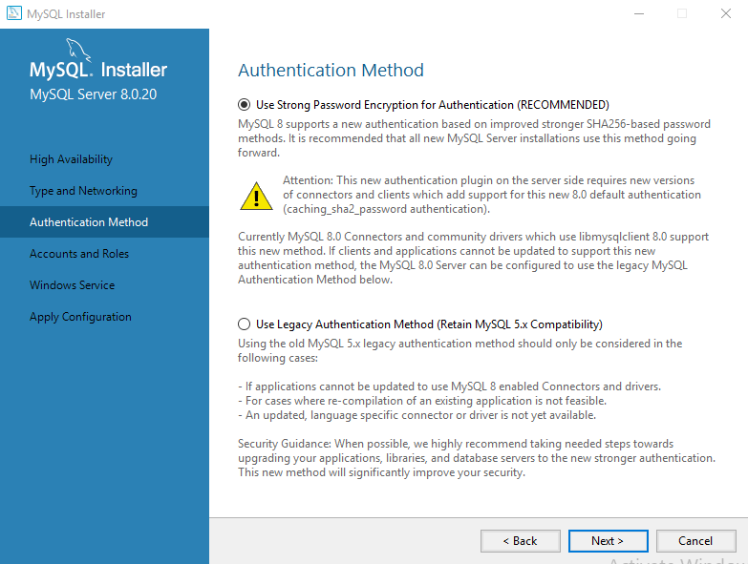

13) Choose password as ‘1234’.

14) Check the start server option and click next.

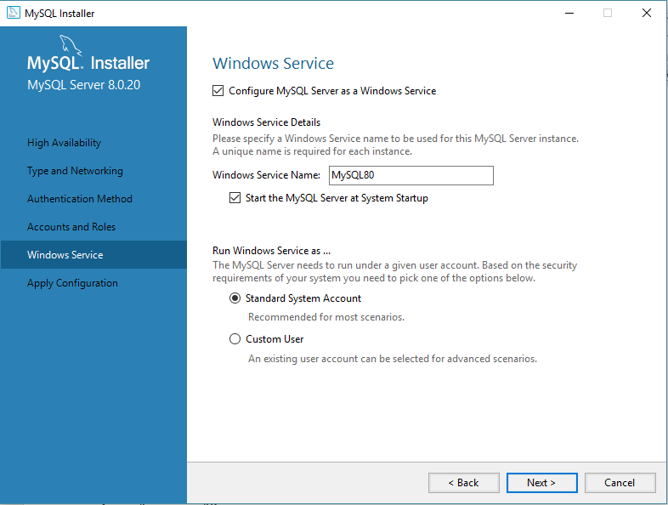

15)Now, a list of the configurations will appear which will be applied. So, if you agree click on **Execute.** Then click on **Finish**.

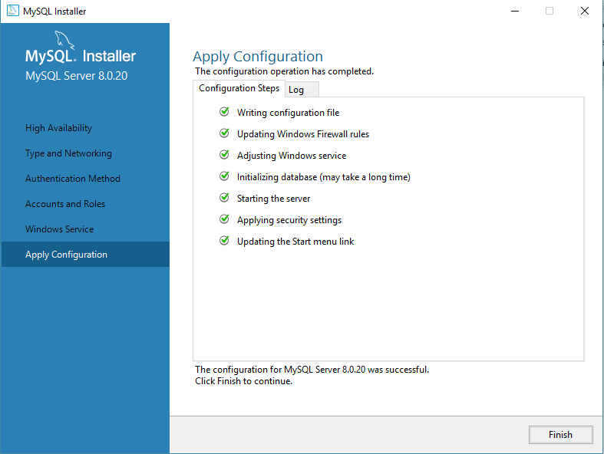

16) In the next window, you can choose router configuration. Then click on **Next** and then on **Finish.**

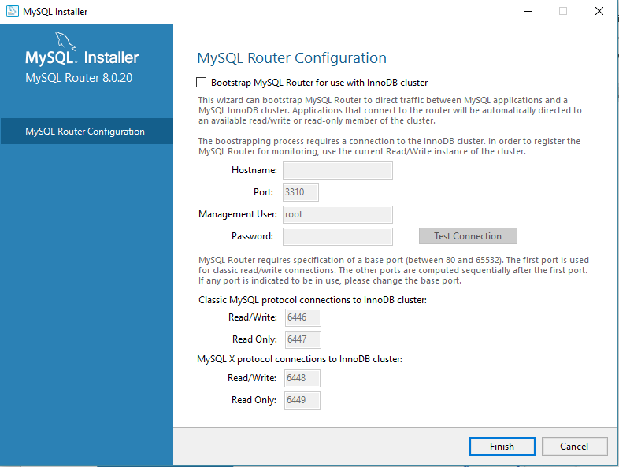

17) Once you click on **Finish**, you will see the following window **’Connect to server’**. Here give the root password (1234).

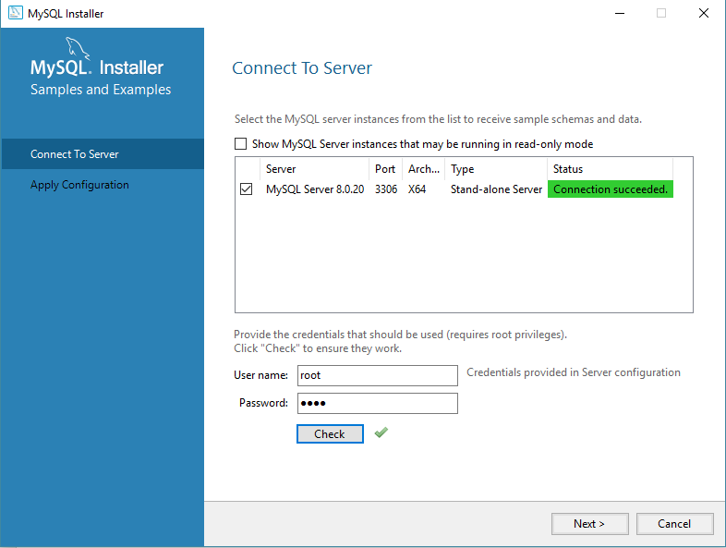

18) After you click on **Next**, select the configurations applied and click on **Execute.** After the configurations get applied, you will see the following screen. Click on **Finish**.

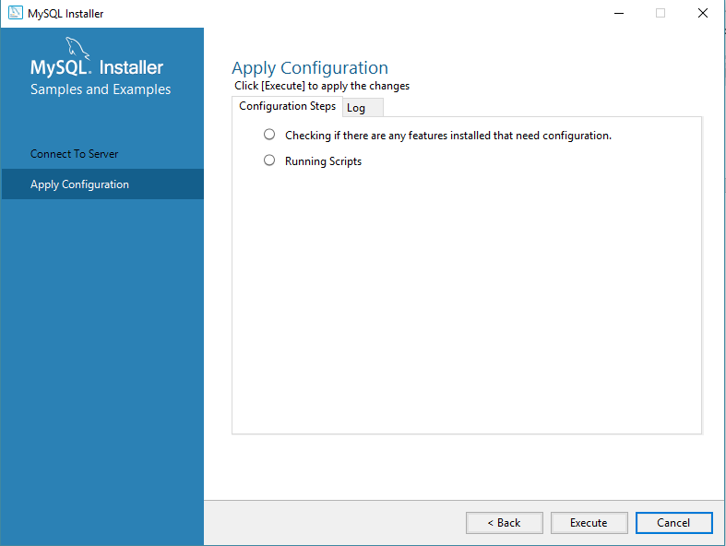

19) To check if MySQL is installed, open the MySQL Shell and give the root password.

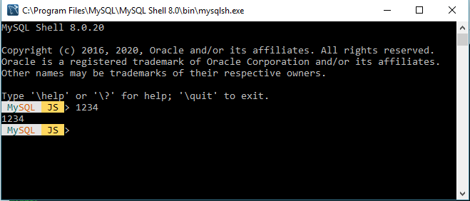

20) Now start and launch “MySQL workbench”, click on “MySQL connections” and enter the password.

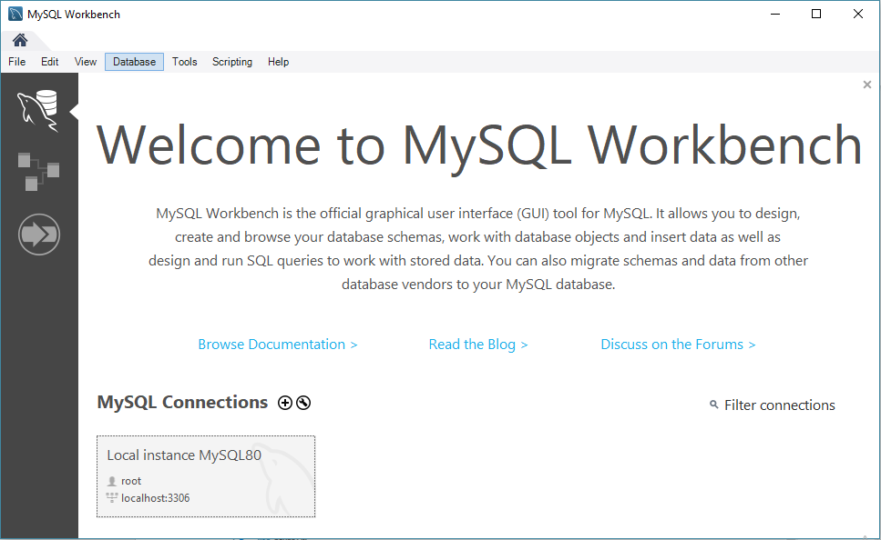

21) Now, open the script “theatre_reservation_system ”, which is present under database folder of project. and run this script.

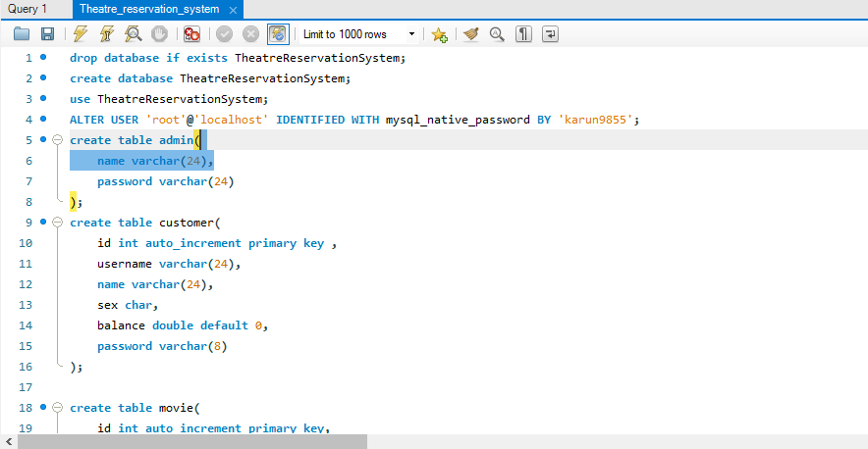

**Downloading theatreReservationSystem**

1) Install Git bash (or any other software to clone the project).

2) Create a new folder for the project. Right Click inside the folder and open a git bash here. Right Click +” Git Bash here”.

3) Type the following command in the git terminal:

Git clone [https://github.com/karunarora/Group_B_theatreReservationSystem](https://github.com/karunarora/Group_B_theatreReservationSystem/tree/development)

4) Go to C:\Program Files\MySQL\MySQL Server 8.0\lib , Copy “libmysql.dll” file and replace this file.

In folder ...\ Group_B_theatreReservationSystem-development\bin, .. \ Group_B_theatreReservationSystem-development\lib, ..\ Group_B_theatreReservationSystem-development\src and ..\ Group_B_theatreReservationSystem-development\test

**Running theatre_reservation_system:**

1) Compiling the project.

a) Open the downloaded folder, open ..\ theatre_reservation_system.

b) Copy path.

c) Open Cygwin64 Terminal, type cd (path) and enter.

d) Type “make” and enter.



Fig1: Copy make file folder path.

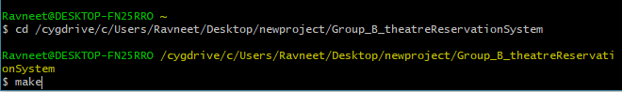

Fig2: Type make and enter.

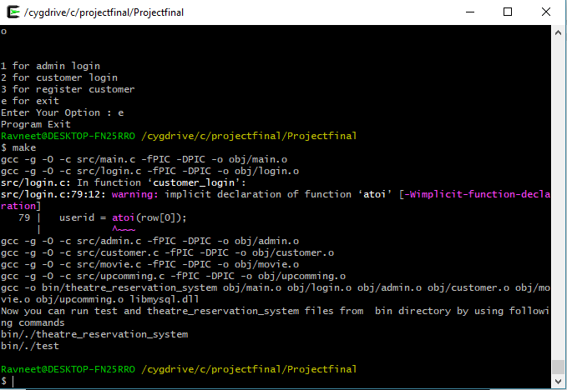

Fig3: Creation of object file

If you type bin/./test, you will see test case result in file testresult in folder ..\ theatre_reservation_system \test

2) After you type bin/./theatre_reservation_system ,You will see Login screen.

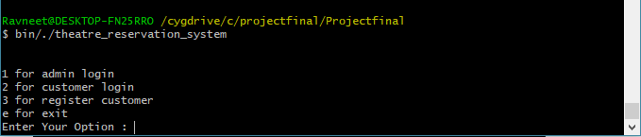

1. If user login as “Admin”, following options will appear.

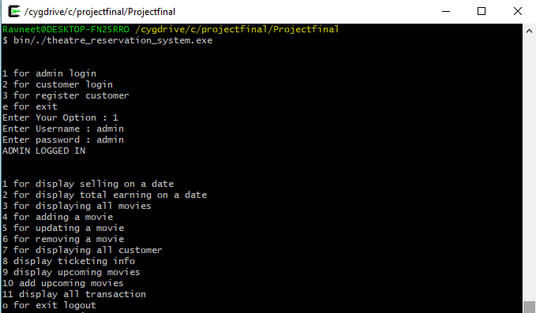

Fig 4: Admin login

b) If user login as “Customer” the following option will appear.

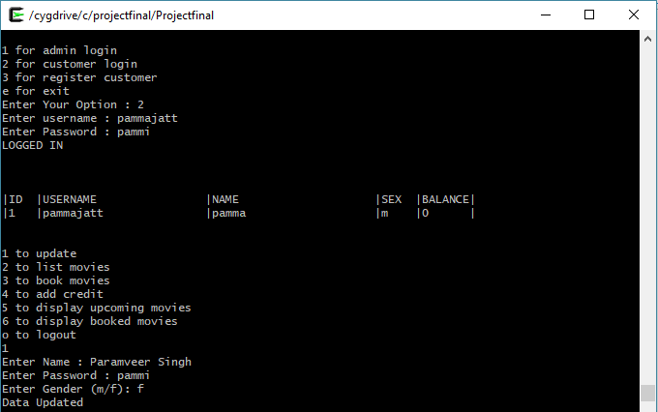

Fig 5: Customer login

c) If user logins as “register customer” the following option will appear

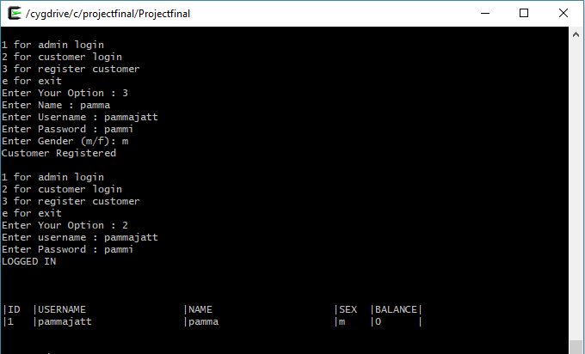

Fig 6: Customer can register using register customer