📚 BookStore
A Full-Stack MERN Online Bookstore Application
Project Documentation
Team member: Musala KarunaTeja
MongoDB · Express.js · React.js · Node.js

Index
1. Introduction 3
2. Objectives 3
3. Technologies Used 3
4. System Architecture 3
5. Key Features 4
6. Database Design 4
7. API Documentation 5
8. Installation & Setup 5
9. Future Enhancements 5
10. Conclusion 6

1. Introduction
BookStore is a full-stack web application built using the MERN stack (MongoDB, Express.js, React.js, and Node.js). It provides a complete online bookstore experience where users can browse an extensive catalog of books, read and write reviews, add books to a cart, place orders, and track order status. Administrators are provided a dedicated dashboard to manage inventory and fulfil customer orders.
The application is designed to be responsive, ensuring a smooth experience across desktops, tablets, and smartphones.

2. Objectives
- Provide an intuitive platform for browsing and purchasing books.
- Allow users to search, filter, and sort books by genre, price, and rating.
- Enable authenticated users to write and read reviews.
- Implement a shopping cart and checkout workflow.
- Give administrators tools to manage books and orders.
- Ensure the platform works seamlessly across all device sizes.

3. Technologies Used

3.1 Frontend
- React.js (Javascript Library) — component-based UI
- React Router — client-side routing
- Axios — HTTP client for API communication
- HTML5 & CSS3 — structure and styling
- Vite — build tool and development server

3.2 Backend
- Node.js (Javascript Runtime)
- Express.js (Web Framework)
- MongoDB with Mongoose (Database & ODM)
- JSON Web Tokens (JWT) — authentication
- bcrypt.js — password hashing

4. System Architecture
The application follows a client-server architecture. The React frontend communicates with the Express backend through a RESTful API. The backend handles business logic, authentication, and interacts with MongoDB for persistent data storage.

4.1 Folder Structure
book-store/
├── backend/
│ ├── config/ (database connection)
│ ├── controllers/ (business logic)
│ ├── middleware/ (auth & error handling)
│ ├── models/ (User, Book, Order schemas)
│ ├── routes/ (API route definitions)
│ ├── seed.js
│ └── server.js
└── frontend/
└── src/
├── api/ (Axios instance)
├── context/ (Auth & Cart context)
├── components/ (Navbar, Footer, BookCard...)
├── pages/ (Home, Books, Cart, Admin...)
├── App.jsx
└── main.jsx

5. Key Features

5.1 User Features
- Browse and search the full book catalog
- Filter books by genre and sort by price or rating
- View detailed book information and customer reviews
- Register, log in, and manage a personal account
- Add books to a shopping cart and check out
- Place orders and track their status
- Write and submit book reviews with ratings

5.2 Admin Features
- Add, view, and delete books from the catalog
- View all customer orders
- Update order status (pending, confirmed, shipped, delivered, cancelled)

6. Database Design

6.1 User Model
- name, email, password (hashed), role (user/admin)

6.2 Book Model
- title, author, description, genre, language, price, stock, coverImage, rating, reviews

6.3 Order Model
- user, items (book, quantity, price), totalAmount, shippingAddress, status, paymentMethod

7. API Documentation
The table below summarizes the primary REST API endpoints exposed by the backend.
Method | Endpoint | Description | Access
POST | /api/auth/register | Register a new user | Public
POST | /api/auth/login | Login and receive a token | Public
GET | /api/auth/me | Get current user profile | Private
GET | /api/books | List, search, filter books | Public
GET | /api/books/:id | Get a single book | Public
POST | /api/books | Create a new book | Admin
PUT | /api/books/:id | Update a book | Admin
DELETE | /api/books/:id | Delete a book | Admin
POST | /api/books/:id/reviews | Add a review to a book | Private
POST | /api/orders | Place a new order | Private
GET | /api/orders/my | Get logged-in user's orders | Private
GET | /api/orders/:id | Get a single order | Private
GET | /api/orders | Get all orders | Admin
PUT | /api/orders/:id/status | Update order status | Admin

8. Installation & Setup

8.1 Backend Setup
cd backend
npm install
cp .env.example .env
npm run dev

8.2 Frontend Setup
cd frontend
npm install
npm run dev

9. Future Enhancements
- Integrate online payment gateways (Razorpay/Stripe)
- Add wishlist functionality
- Implement personalized book recommendations
- Add email notifications for order updates
- Support multiple languages and currencies
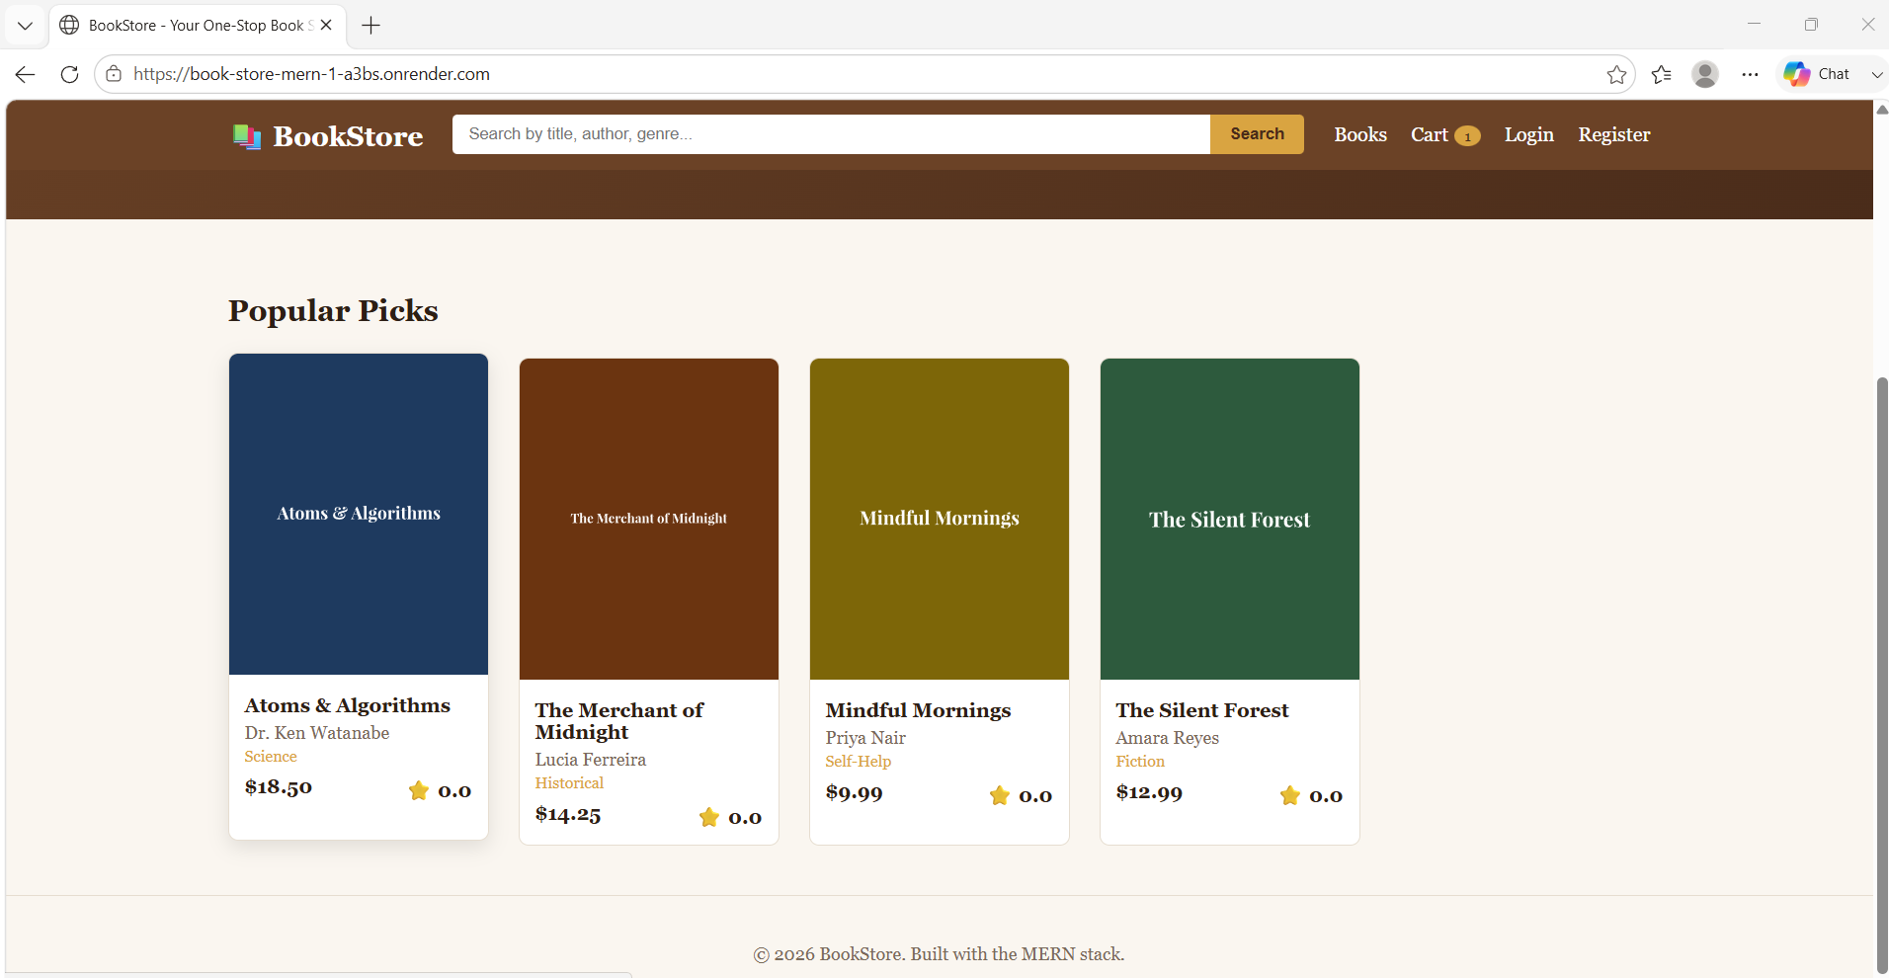
Login page
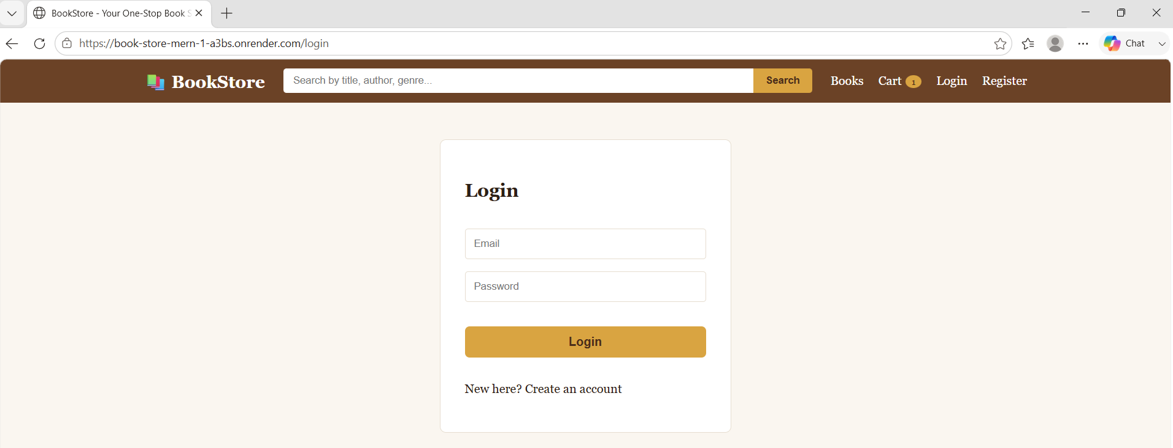
Registration Page
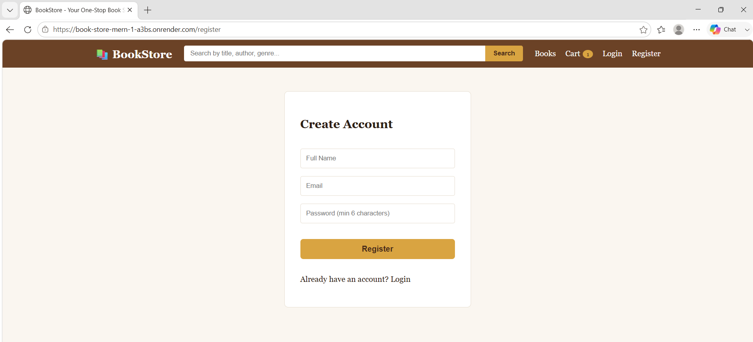
Find a Book
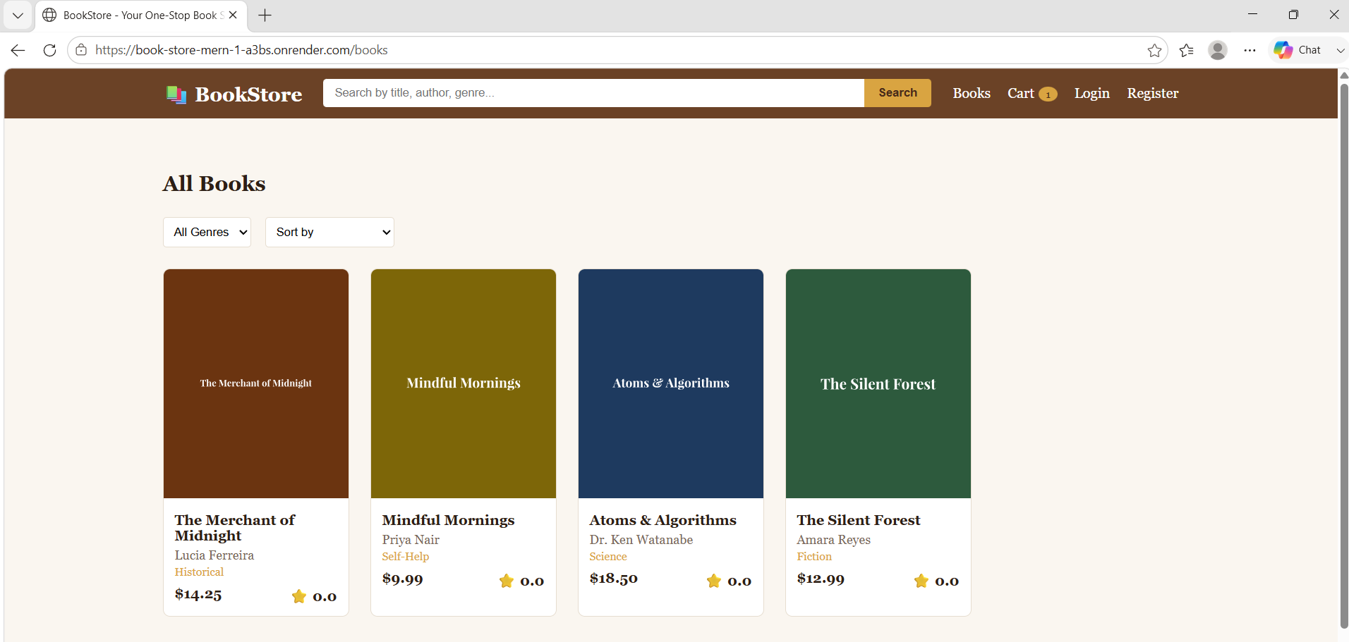
Cart
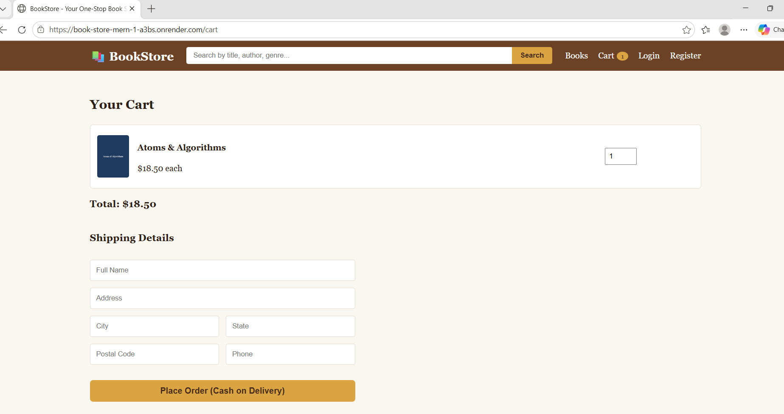

10. Conclusion
BookStore demonstrates a complete implementation of a modern e-commerce platform using the MERN stack. It covers essential real-world concepts such as authentication, role-based access control, RESTful API design, state management, and responsive UI development, making it a strong foundation for further enhancement and production deployment.

