IshwarI Pet Technology

OFFER FOR PET BLOWER

DOC# QTN/07/09/2018-03


IPT 1L/6C PET BLOWER 6500-6600 BPH FOR WATER

BUDGETORY PROPOSAL/QUOTATION

 |  | Quote | QTN/07/09/18-03
IshwarI Pet |  | Number
 |  | Date
Technology
 |  | Validity | 30 Days
Title | PET Stretch Blow Molding Machine .
Kind Attn. - | MR.SANKET
Our Address: |  | Customer Address:
Ishwari PET Technology,
Near Mercedez Benz Plant, |  | M/S Shiv Shakti Beverages
MIDC Chakan,
Vill:Mahalunge,
PUNE - 410501.
Contact Person: |  | Customer Contact Person:
Name | Yogesh Todkar | Name | Mr. Sanket
Cell | +91 9890731823 | Cell | 9726402220
Skype | - | Skype
E-mail | ishwaripet2014@gmail.com | E-mail
Website |  | Website

Dear sir,

Thank you for approaching us for your requirement of PET Blower. We are more than pleased to offer you our best solution to meet your needs. Request to go thru’ the following details to understand our offered product and its features.

Product Details

M/c Model : IPT 1L/6C

Automatic PET blowing station with Auto preform loading and Bottle Ejection system.
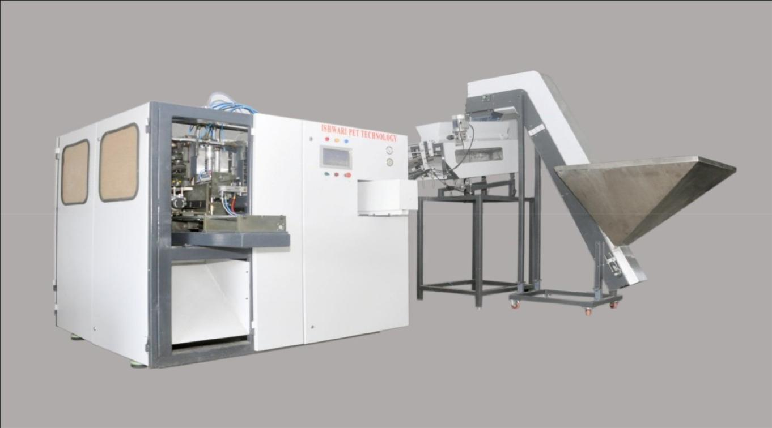

The above Machine is designed to blow PET containers up to 1 Ltr capacity with output rate of 6500-6600 Bottles per hour.

Salient Features:

- Preform Auto Loading unit with In-feed assembly and SS Hopper.

- Pneumatic preform Stretching unit.
- Pneumatic Mould Clamping system.
- No preform-No Blow logic for Compressed air conservation.
- Air RECOVERY system to reduce LP air consumption.
- Compact Foot-print with In-built Electrical Control Panel.
- Simple Mechanical construction with Electro-Pneumatic controls for easy maintenance.
- Trouble-free operation with autonomous maintenance. Built with Industry standard components and parts.

- Touchscreen HMI from BnR.

- Automation Control PLC and I/O by BnR.austria
- Low Pressure Pneumatic System Actuators and valves by FESTO.
- High Pressure Blowing valves by NORGREN.
Technical Specifications

TYPE | PARTICULAR | AUTO-1L/6C
 | Number of cavity | 6 cavities
 | Theoretical output | 6500-6600 Bottles/hr (1L – 21g )
BOTTLE | Max. Bottle volume | 1 liter
 | Max. neck diameter | 25-30 mm
 | Max. Bottel diameter | 90 mm
 | Max. Bottle height | 300 mm
 | Number of IR lamps | 14 No’s
ELECTRICAL
ELECTRICAL | Max. heating power | 42 kw
SYSTEM
SYSTEM | Installation power for blow | 50 kw
 | molding | 50 kw
 | Operating pressure | 8 kg / CM²
AIR SYSTEM | Low pressure Compressor | 170 CFM
AIR SYSTEM | Blowing pressure | 35-40 kg/ CM²
 | High pressure Compressor | 270 CFM
 | Operating pressure | 4 kg / CM²
CHILLER WATER
CHILLER WATER | Temperature | 6 TO 8 ^{O}C
 | Capacity | 8TR

Scope of Supply

S. No | Scope of supply | Quantity | Price INR
1 |  | 1
1 | IPT 1L/6C Auto PET Blowing Machine with
 | ➔ Auto Preform loder and Hopper(SS) |  | 69,00,000/-
 | ➔ Auto Bottle Ejection and Transfer unit. |  | 69,00,000/-
 | ➔ PNUMATIC Stretch Blow unit
 | ➔ Air Recovery Unit
 | ➔ Air Receiver/Tank made of SS.
2 | OIL FREE COMPRESSOR PACKAGE
 | INCLUSIVE | 1 SET | 37,91,800/-
 | 100HP @270 CFM @40kg | 1 SET | 37,91,800/-
 | OIL FREE COMPRESOR
 | 40HP @170CFM@10KG SCREW COMPRESOR
 | HP&LP DRYEERS WITH FILTERS
 | HP&LP RESERVOIR TANKS
 | Cooling tower 50 TR
3 | Chiller 8 tan | 1 | 3,35,000/-
4 | MOULD 1000ML,500ML,250ML | 3 SET | 12,50,000/-
4 | Installation and Commissioning |  | Excluded
 | Travel Tickets, Accommodation and local living
 | expenses to be borne by customer.
 | Grand Total ( INR ) |  | 1,22,76,800/-

General TERMS & CONDITIONS

Prices | Prices quoted in Indian Rupee, Net, excluding GST Tax 18% .
Delivery terms | Ex-Works Pune.
Delivery time | 10 weeks after receipt of advance along with valid Purchase order.The
 | delivery time is subject to confirmation on order placement and any other
 | mutually agreed pre-approvals.
Warranty | 12 months from the date of installation or 15 months from the date of
 | delivery, whichever is earlier and against Product defect/workmanship only.
 | Excludes Electrical/Pneumatic components and would be replaced on
 | chargeable basis.
Freight and forwarding | Extra at actuals
Transit Insurance | Extra at actuals / arranged by buyer.
Validity | This quotation is valid for 30 days.
Payment Scheme | 60% Advance against confirm purchase order, 30% before dispatch of
 | material at site, 10% after installation.100% advance for all Engineering
 | Change Note (ECN).
Limitation of Liability | To the fullest extent permitted by law and notwithstanding any provision to
 | the contrary, Ishwari PET shall in no event be liable for any special, indirect,
 | consequential, or incidental damage or lost profits, lost opportunities, lost
 | revenues, business interruption, obligations to compensate a third party or
 | other similar indirect damage arising under or in connection with the parties’
 | cooperation.

