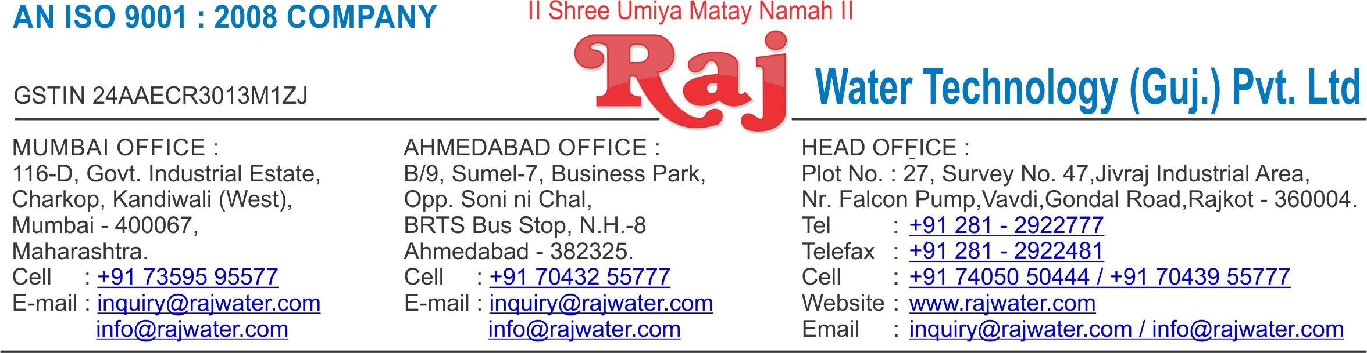

Date :- 17th December 2018

Quotation No | :- RW/2018-19/Q_9699/R_2
Concern Person | :- | Mr. Abdul Rasik
Concern Number | :- 7902858321
Email Id | :- | rasbee@gmail.com
Company Name | :-
Address | :-


Quotation For Packaged Drinking Water Project

Dear Sir ,

We are pleased to enclose our detailed Techno-Commercial offer, based on your requirement.

Contents of the Quotation

Commercial Proposal
Terms & Condition
Technical Specification for each product

Machinery Offer

Packaged Drinking Water Project

We hope the same is in line with your requirement. We shall gladly assist you in case you need any further clarification or information.

With warm Regards,

For , Raj Water Technology (Guj.) Pvt. Ltd.

DESHANI KHUSHBU

Designation : Marketing Asst. Manager

Mobile : 7405050444
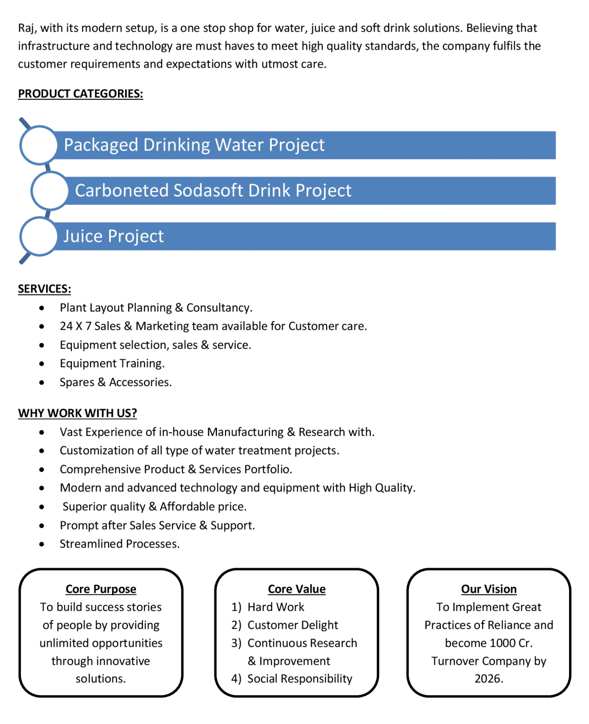
Price – Mineral Water Project –ISI

System | Sr No | Equipment Name | 2000 LPH
Water Purification system

Sys-1 | 1.1  1.2  1.3  1.4 | Mineral Water Plant SS 304 2000 Lph With UV System  Storage Tank -2000 liter SS 304  Ozone System  Fully Automatic Glass Filling Machine(Premium) Capacity 1500 Glass/hr(filling up to 650ml) conveyor + in built batch coding S Piping (Plant To Filling Machine) |  | 550000  70000  35000  885000
With CIF charges Port BJL-Banjul

Total Price For Entire Water Treatment system (Sys 1 ) 1540000

Terms & Condition

- Price

The Quoted Prices Are CIF Banjul Port

- TAX

GST 18% Extra Applicable. (For India)

- Payment

50% Advance Along With The Purchase Order, 30% After Inspection, & 20% Before Material Dispatch.

In Case Of Cancellation Of Confirmed Order Due To Any Reason, As A Part Of Penalty 25% Amount Of The Order Value Shall Have To Pay By You To Raj Water.

- Packing, Freight & Transit Insurance, & Unloading

Packing Charge Will Be Extra (Depend On Packing Material)

Transport To Be Arranged By The Customer OR If Arranged By Raj Water: Extra At Actual Plus GST.

Transportation Insurance In The Scope Of Buyer.

Unloading In The Scope Of Buyer. Buyer Has To Ready Forklift Or Crane And Unskilled Labor.

- Delivery

Schedule For Dispatch Will Be Notified.

Delivery Dates Are Approximate Only, And Assume Timely Receipt Of All Information, Test Materials & Payment.

- Warranty

We Shall Provide 1 Year Warranty For The Following:

Manufacturing Defects, Raw Water Pump, High Pressure Pump, Treated Water Transfer Pump.

Due To Fluctuation In Power Supply, Attempted Repaired By Person Other Than Our Technical Representative, Improper Handling Or Negligence By End Users, Poor Maintenance, Improper Use Of Equipment, That All Type Of Damage Not Covered In Warranty Create Area.

During The Warranty Period, We Shall Provide Supervisory Services Of Our Technical Representative As And When Required.

- Accommodation

Technician Charge Will Be Extra 1000/- Rs. Per Day.

Travelling, Lodging And Boarding, Local Conveyance And Any Other Miscellaneous Expense Of Our Technical Representative Will Have To Be Borne By Client.

- Validity

Our Offer Is Valid For Your Acceptance For A Period Of 6 Months From The Date; Thereafter It Will Be Subject To Confirmation By Us.

- Image

Images Are For Representation Purpose Only.

- Jurisdiction

All Terms Subject To Rajkot, Gujarat Jurisdiction.

