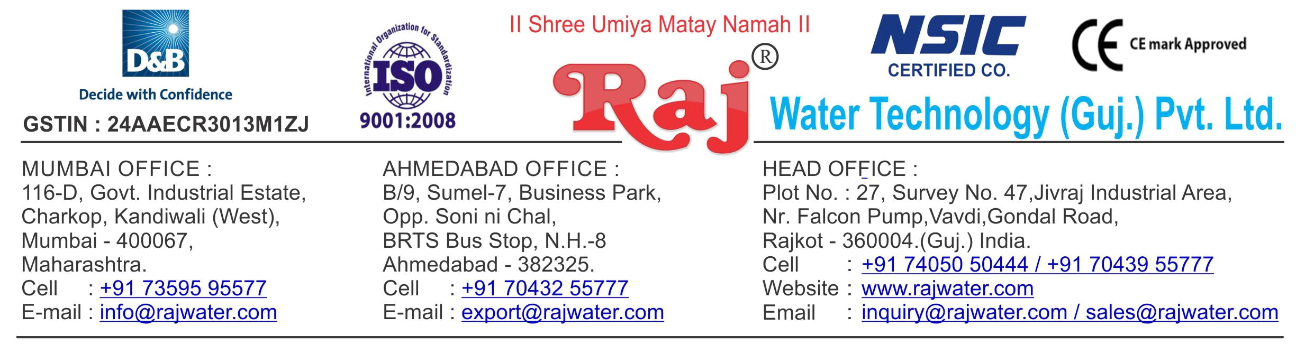

 |  | Date :- 29th December 2018
 |  | Saturday
Quotation No | :- RW/2018-19/Q_10779/R_3
Concern Person | :- Mr. Ketanbhai Kantilal Kachhadiya
Concern Number | :- | 9925303909
Email Id | :- | rkkachhadiya3@gmail.com
Company Name | :- Patel Food & Beverages
Address | :- 319, Shubham Industrial Estate Makna , Kamrej,Surat-394325 Gujarat


Quotation For Packaged Drinking Water Project

Dear Sir ,

We are pleased to enclose our detailed Techno-Commercial offer, based on your requirement.

Contents of the Quotation

Commercial Proposal
Terms & Condition
Technical Specification for each product

Machinery Offer

Packaged Drinking Water Project

We hope the same is in line with your requirement. We shall gladly assist you in case you need any further clarification or information.

With warm Regards,

For , Raj Water Technology (Guj.) Pvt. Ltd.

DESHANI KHUSHBU

Designation : Marketing Asst. Manager

Mobile : 7405050222
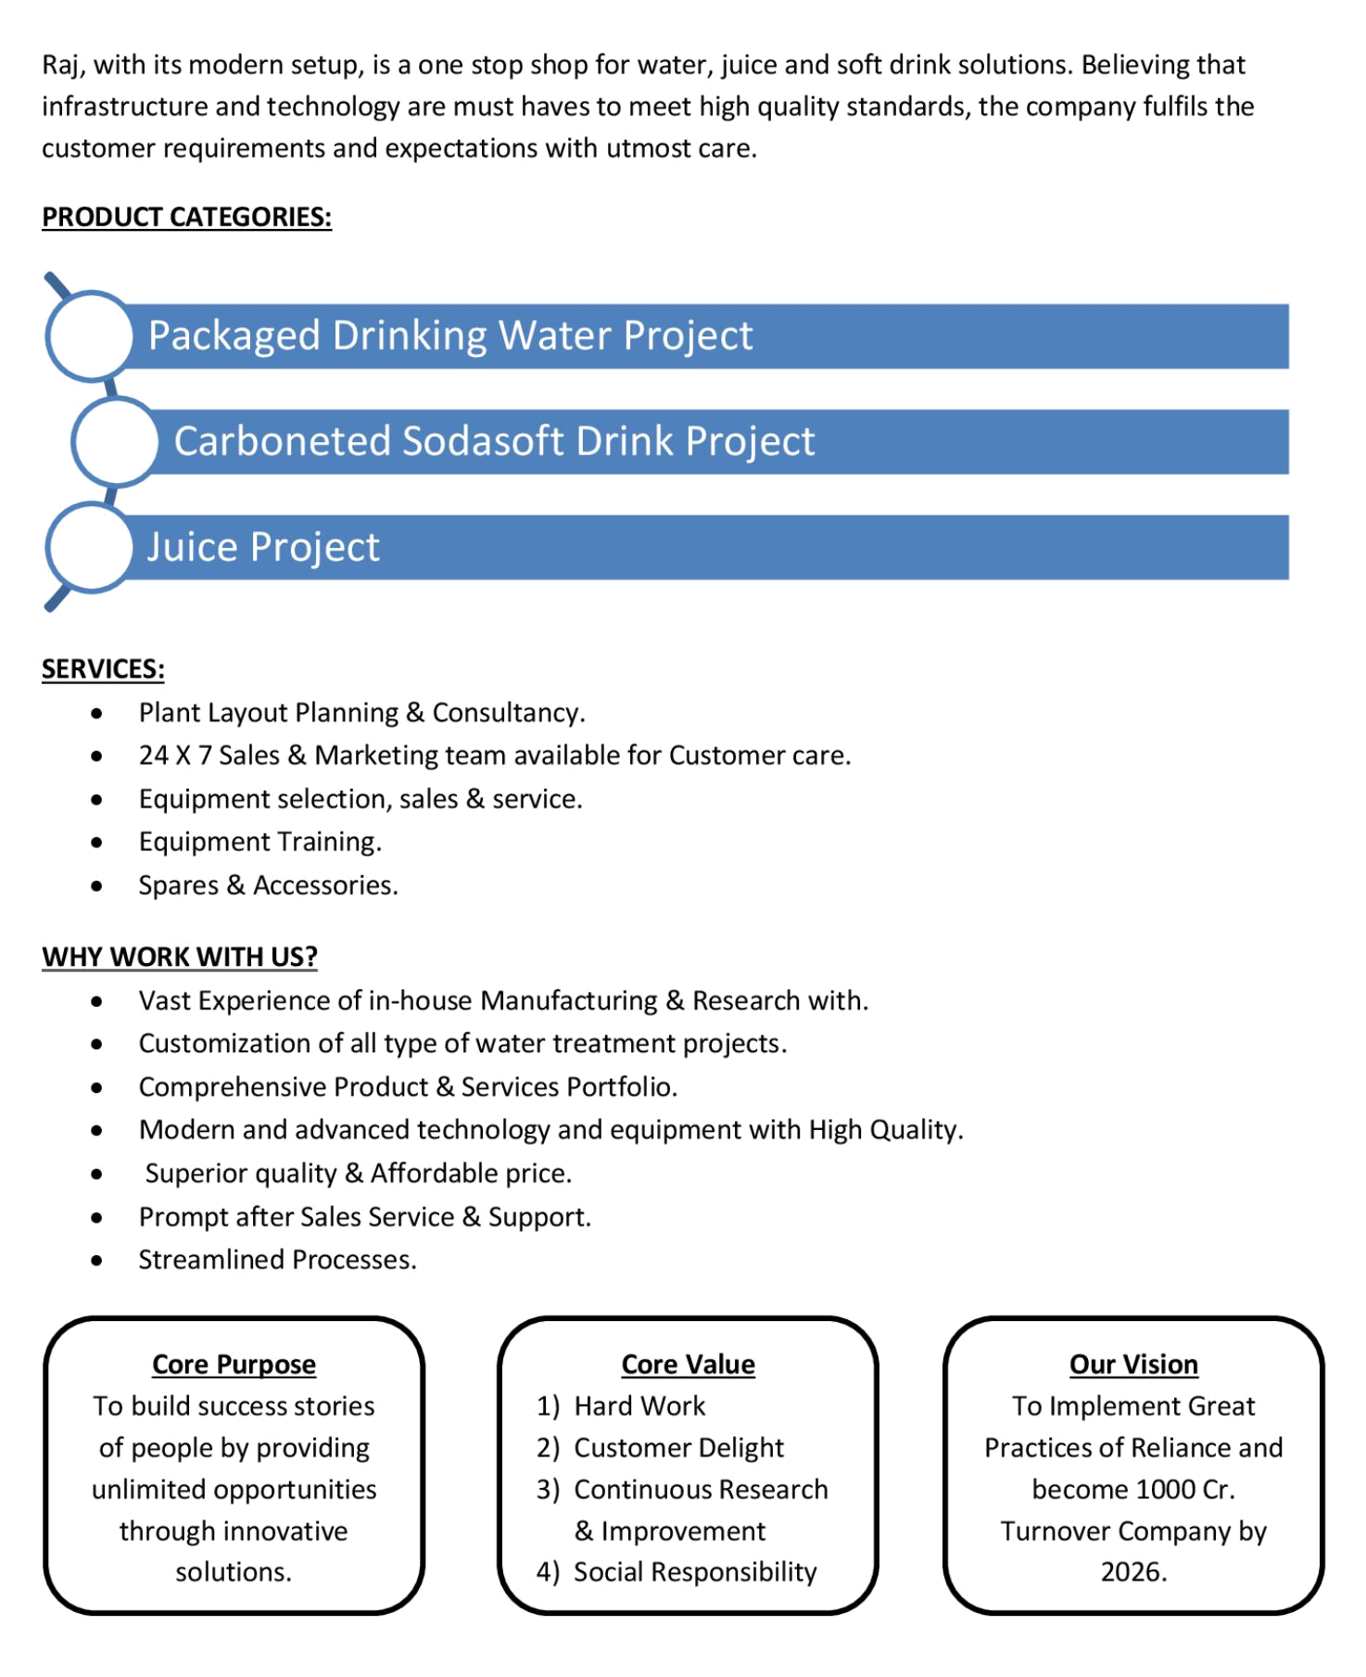
Commercial Proposal

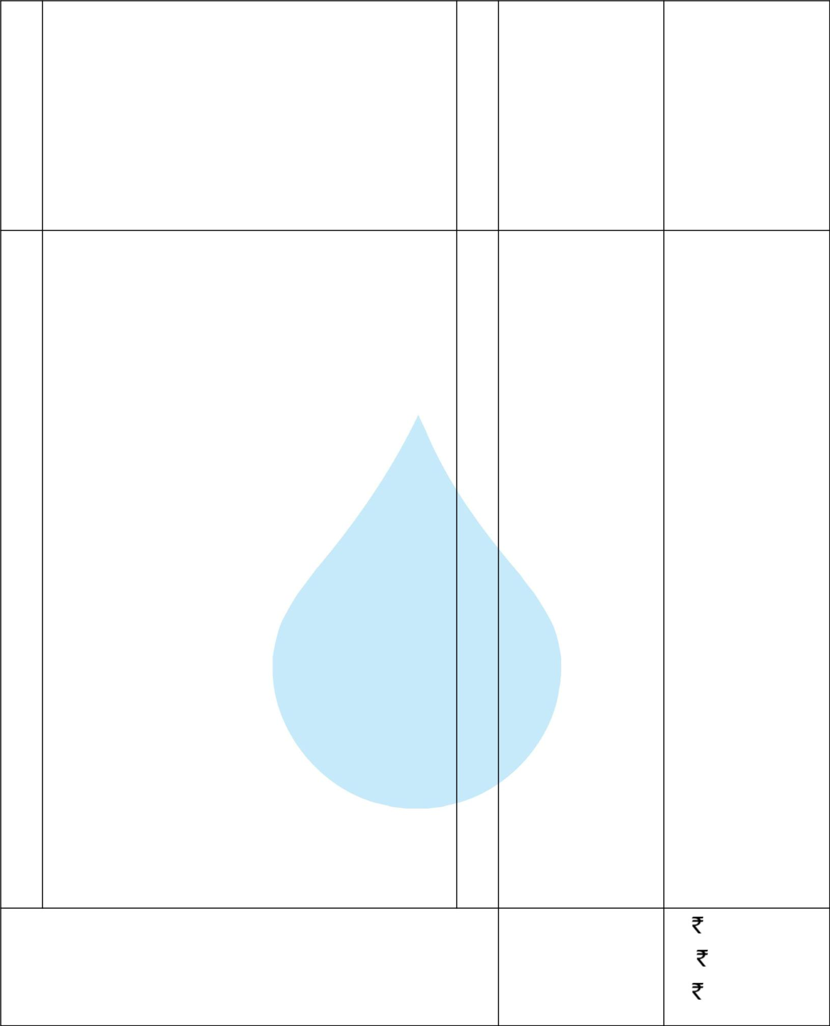
Sr | Equipment Name | Qty | Basic Rate | Amount
No.
1 Automatic RO Plant SS 316 10000 Liter Per Hours With |  | 1 | 1495000.00 | 1495000.00
 | SS 316 5000 Liter Storage Tank 2 Nos,With U.V
 | System
 | Ozonation Circulation System 25 GM ,Oxygenation
 | System,Added Mineral System
 | Piping RO to filling Machine 3 Feet

 | Sub Total | 14,95,000.00
 | GST @ 18% | 2,69,100.00
 | P &F | 35,282.00
 | Total Amount | 17,99,382.00

Terms & Condition

- Price

The Quoted Prices Are Ex-factory. (For India)

The Quoted Prices Are FOB. (For Export)

- TAX

GST 18% Extra Applicable. (For India)

- Payment

50% Advance Along With The Purchase Order, 30% After Inspection, & 20% Before Material Dispatch.

In Case Of Cancellation Of Confirmed Order Due To Any Reason, As A Part Of Penalty 25% Amount Of The Order Value Shall Have To Pay By You To Raj Water.

- Packing, Freight & Transit Insurance, & Unloading

Packing Charge Will Be Extra (Depend On Packing Material)

Transport To Be Arranged By The Customer OR If Arranged By Raj Water: Extra At Actual Plus GST.

Transportation Insurance In The Scope Of Buyer.

Unloading In The Scope Of Buyer. Buyer Has To Ready Forklift Or Crane And Unskilled Labor.

- Delivery

Schedule For Dispatch Will Be Notified.

Delivery Dates Are Approximate Only, And Assume Timely Receipt Of All Information, Test Materials & Payment.

- Warranty

We Shall Provide 1 Year Warranty For The Following:

Manufacturing Defects, Raw Water Pump, High Pressure Pump, Treated Water Transfer Pump.

Due To Fluctuation In Power Supply, Attempted Repaired By Person Other Than Our Technical Representative, Improper Handling Or Negligence By End Users, Poor Maintenance, Improper Use Of Equipment, That All Type Of Damage Not Covered In Warranty Create Area.

During The Warranty Period, We Shall Provide Supervisory Services Of Our Technical Representative As And When Required.

- Accommodation

Technician Charge Will Be Extra 1000/- Rs. Per Day.

Travelling, Lodging And Boarding, Local Conveyance And Any Other Miscellaneous Expense Of Our Technical Representative Will Have To Be Borne By Client.

- Validity

Our Offer Is Valid For Your Acceptance For A Period Of 6 Months From The Date; Thereafter It Will Be Subject To Confirmation By Us.

- Image

Images Are For Representation Purpose Only.

- Jurisdiction

All Terms Subject To Rajkot, Gujarat Jurisdiction.
Technical Specification

1. Raw Water Feeding Pump
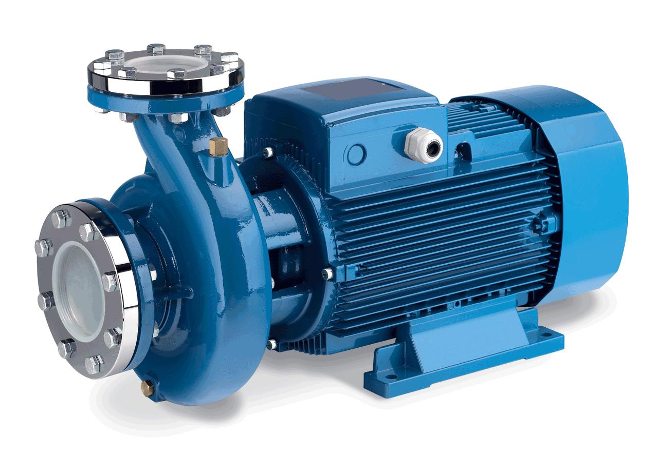

Type :

Centrifugal

Max. Flow :

22.00 m3/HR

Working Flow :

20.00 m3/HR

Working Pressure :

2 Kg. / Cm 2

M.O.C. :

C.I.

Power :

5.0 HP

Manufacturer :

Kirloskar / EQI

Nos. Offered :

1 Nos.
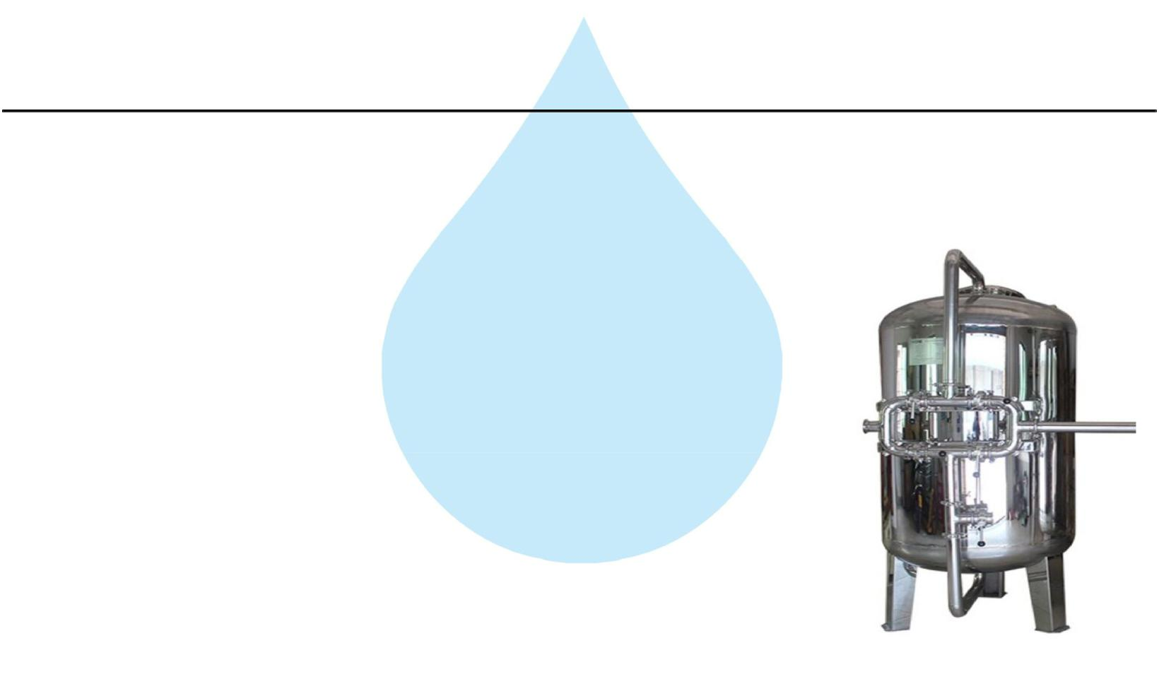

Application :-

To Pump Raw Water at Required Pressure so as to enable Transfer Through The RO Pre-Treatment Stage.

2. Pressure Sand Filter (SS)

Type :

Down Flow Graded Sand Type

Model :

4872/RW/MFG

M.O.C. :

SS 316

Size Dia X Height :

1200 mm Dia X 1800 mm

Pipe Line Size :

40 mm.

Valves :

Automatic Valve

Max. Flow :

22.00m3/HR

Working Flow :

20.00 m3/HR

Application :-

By means of Multi size Graded sand filled in the Vessel of stainless steel material, which is natural process of filtration adopted by the nature Raw Water is first filtered by filtration unit in series prior feeding RO Plant. Pressure Sand Filter Unit is provided for removal of suspended matters & turbidity from raw water. PSF Unit is a SS vertical Pressure Vessel. Internally, it is fitted with bottom collecting system. Uniform grades silica quartz sand is charged on the supporting media of pebbles and gravels.

3. Activated Carbon Filter (SS)
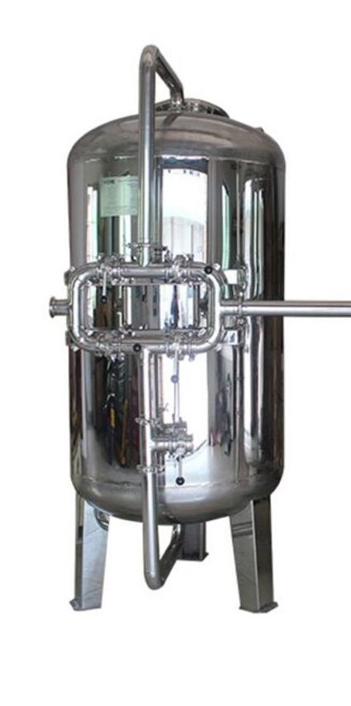

Type :

Down Flow Graded Sand Type

Model :

4872/RW/MFG

M.O.C. :

SS 316

Size Dia X Height :

1200 mm X 1800 mm

Pipe Line Size :

40 mm

Carbon Qty. :

750Kgs.

Valves :

Automatic Valve

Max. Flow :

22.00 m3/HR

Working Flow :

20.00 m3/HR

Application :-

To Remove taste, odour, chlorine, colour and. It can absorb contaminated particles of Oil & Grease from the raw water. It will control the BOD & COD in the raw water. Activated Carbon can remove Chlorine, Odour, & Colour other organic material from feed water prior to reverse osmosis. This Carbon granules having larger surface area and specific property to absorb organics.
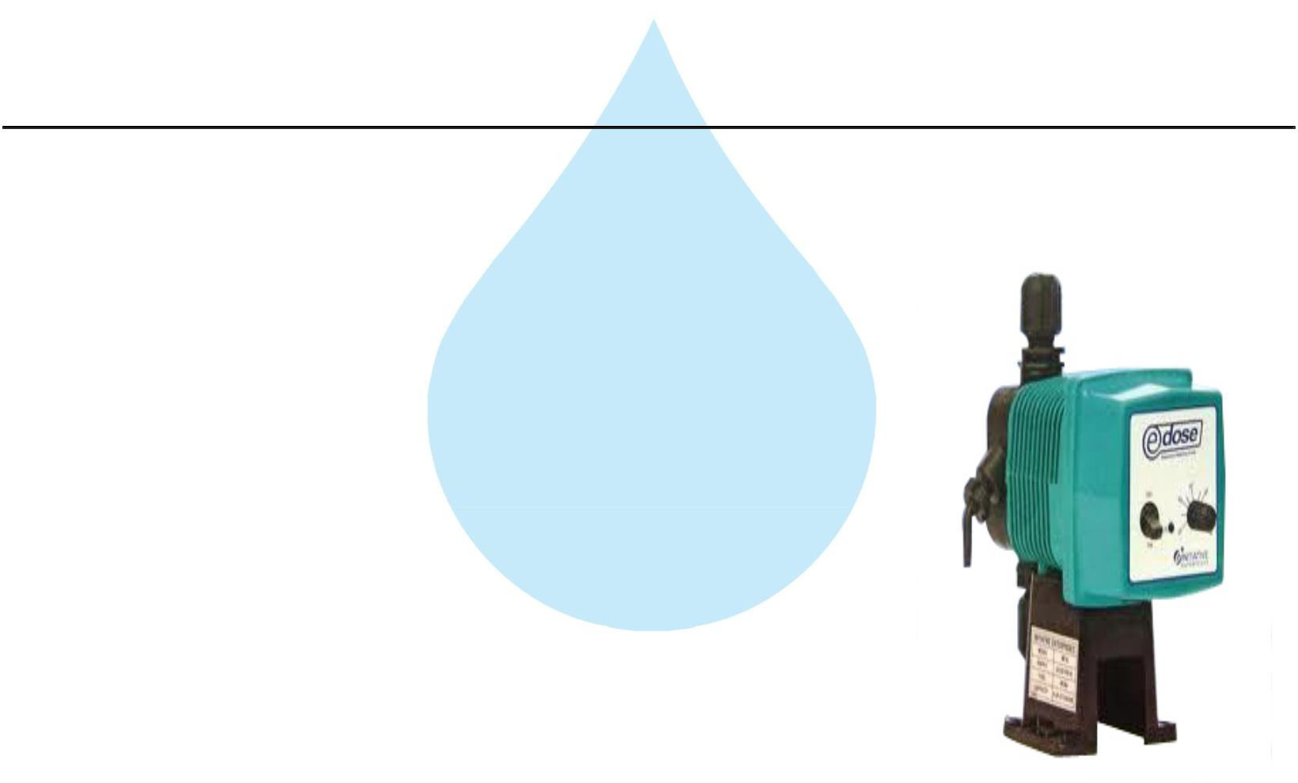

4. Antiscalant Dosing Pump

Type :

Ele. Diaphragm Type

Capacity :

0 to 6 LPH

M.O.C. :

PP

Dosing Chemical :

Antiscalent

Dosing Rate :

3 to 4 LPH

Make :

E Dose/ I Dose

Nos :

1 Nos

Application :-

The hardness salts of calcium & magnesium are likely to be precipitated if concentration exceeds its solubility limit

- it may faults the membranes resulting into scaling which ultimately leads to poor treated water quality from R.O.System.

5. Antiscaling Dosing Tank
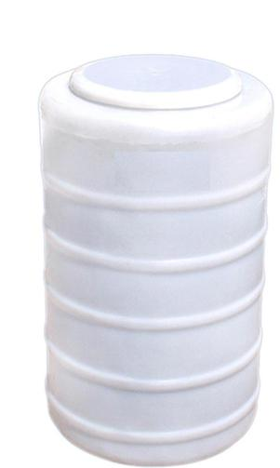

Type :

Conical Bottom

Capacity :

100 Ltr.

M.O.C. :

HDPE

Manufacturer :

Reputed

Nos :

1 Nos

6. Micron Cartridge Filter
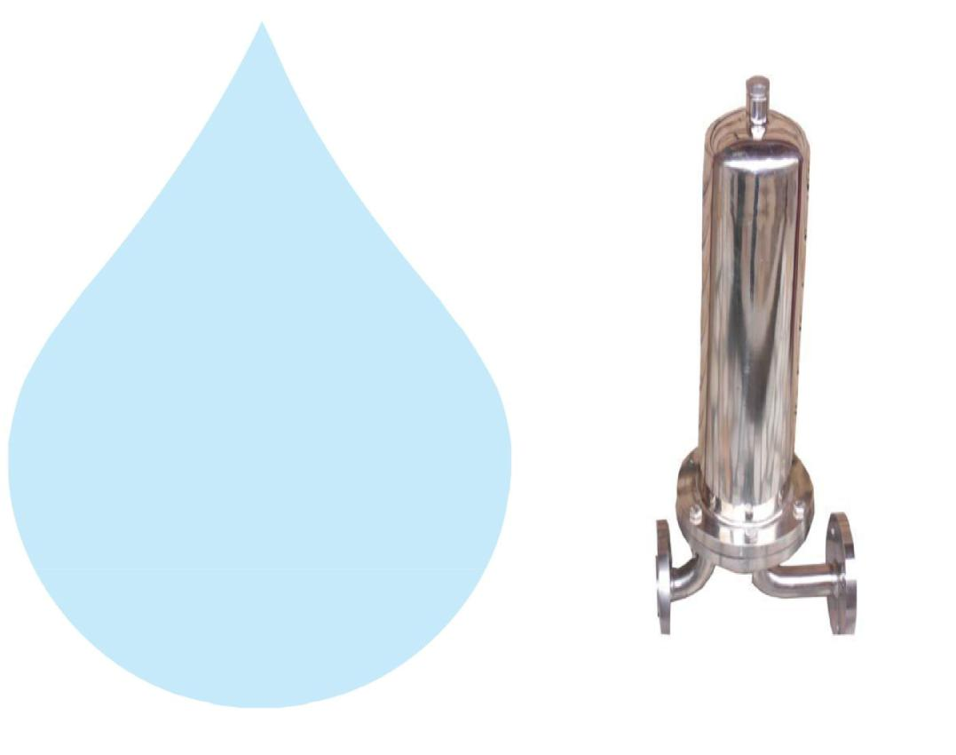

Model :

Size :

Micron Rating :

Type of Candle :

Material of Housing :

Nos. of Candles :

Max. Flow :

Working Flow :

MCF 30/RW/SS

30" Long

5 Micron

P. P. Spun / Wound

SS 316

6 Nos. (Jumbo)

22.00m3/HR

20.00 m3/HR

Application :-

To protect the membrane and the high pressure pump from suspended particles by removing them up to 5 Micron.

7. High Pressure Pump
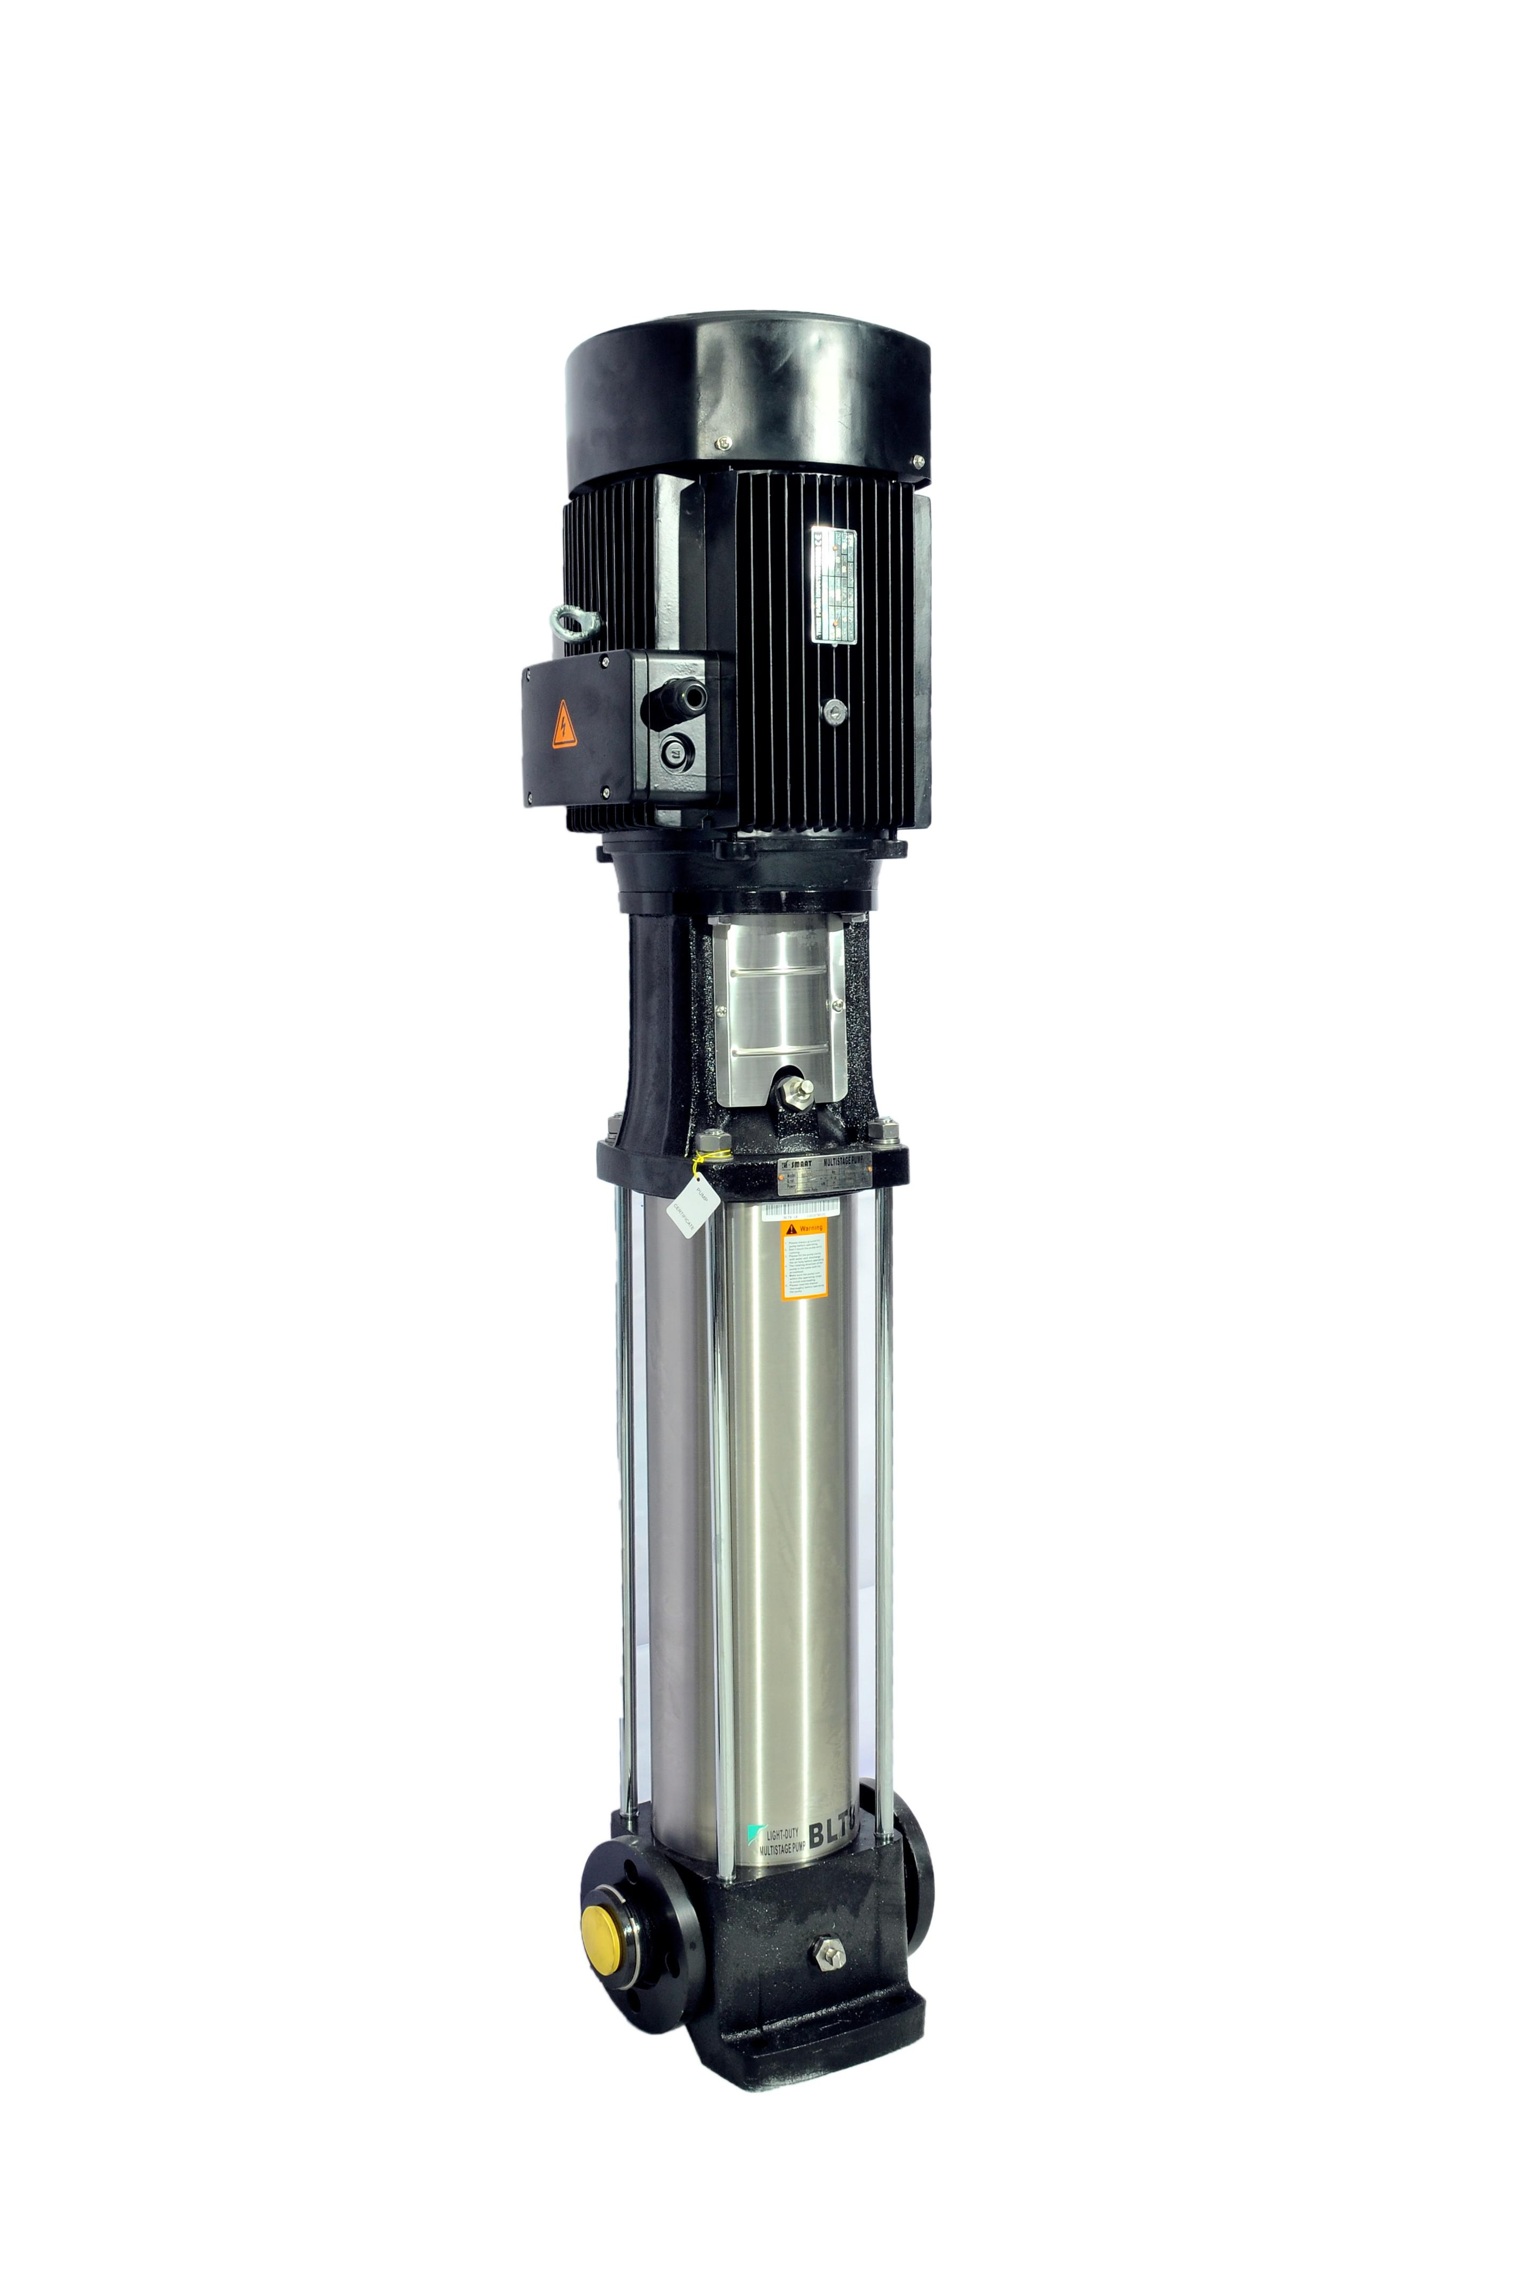

Type : | Vertical Centrifugal Pump
M.O.C. : | SS
Max. Pressure : | 13 | Kgs. / Cm 2.
Working Pressure : | 10 | Kgs. / Cm 2.
Max. Flow : | 22.00 m3/HR
Working Flow : | 20.00 m3/HR
Motor : | 15 | HP
Manufacturer : | 2900 RPM
Nos. Offered : | 3 Phase
Make of Pump : | Grundfoss

Application :-

For Reverse Osmosis Process to take place feed pressure of water need to be raised. For this purpose a Vertical Multistage Centrifugal High Pressure Pump in S.S construction is provided R.O. System requires operating pressure of about 14-16 kg/cm^2 . High-pressure pump is fitted with S.S. discharge pipe work with necessary control valves. Necessary instruments like a High Pressure Switch, Pressure Gauge and recirculation valves are provided for safer operation of system
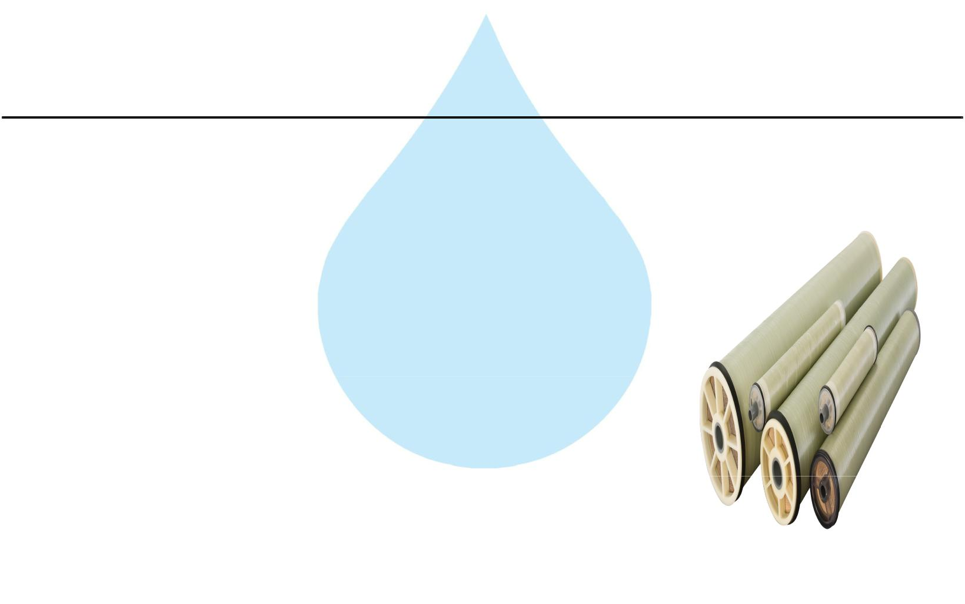

8. RO Membrane

Model :

8040 Element

Type :

TFC Spiral Wound

Material :

Polymide

Size :

8" Dia X 40" Long

Manufacturer :

Toray / Hydranautics / Dow / EQI

Nos. Offered :

12 Nos.

Application :-

To reduce Raw Water T.D.S. through the concept of Reverse Osmosis where R.O. Modules processes Raw Water and produces Purified Water having the Salt Rejection of Raw Water in the range of 90 – 95%. By using Semi permeable Membrane filter elements, where ion filtration process is carried out by applying pressure in the water. So finally we will get Low salt water with low total dissolve solids and High purity. Here will have to drain the water at one side to Wash the Membrane filter elements continuously because of filtration process there is nothing to be polluted in the system.
9. SS Pressure Vessels
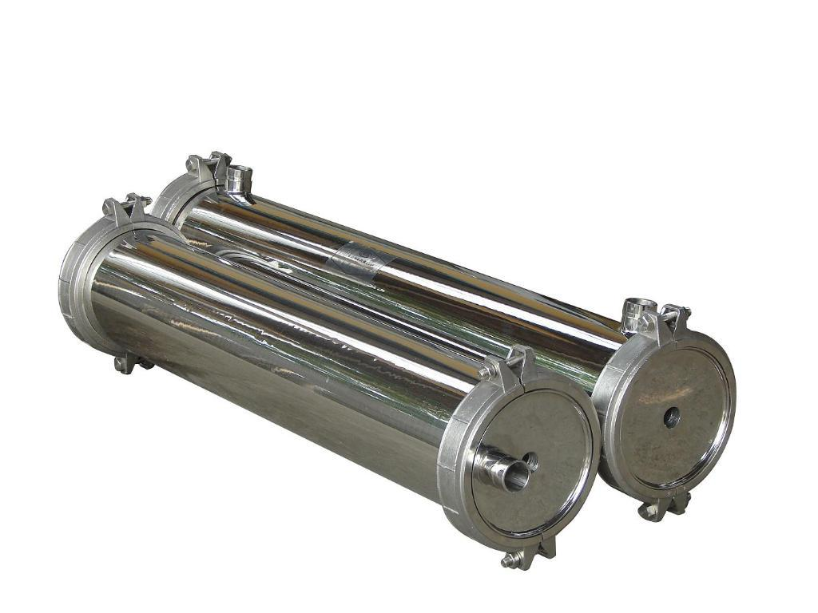

M.O.C. : | SS 316
Type : | Code/ SIDE/4
Size : | 8" X 160"
Max. Pressure : | 400 PSI
Working Pressure : | 150 PSI
Nos. Offered : | 3 Nos.

10. Mineral Dosing Pump
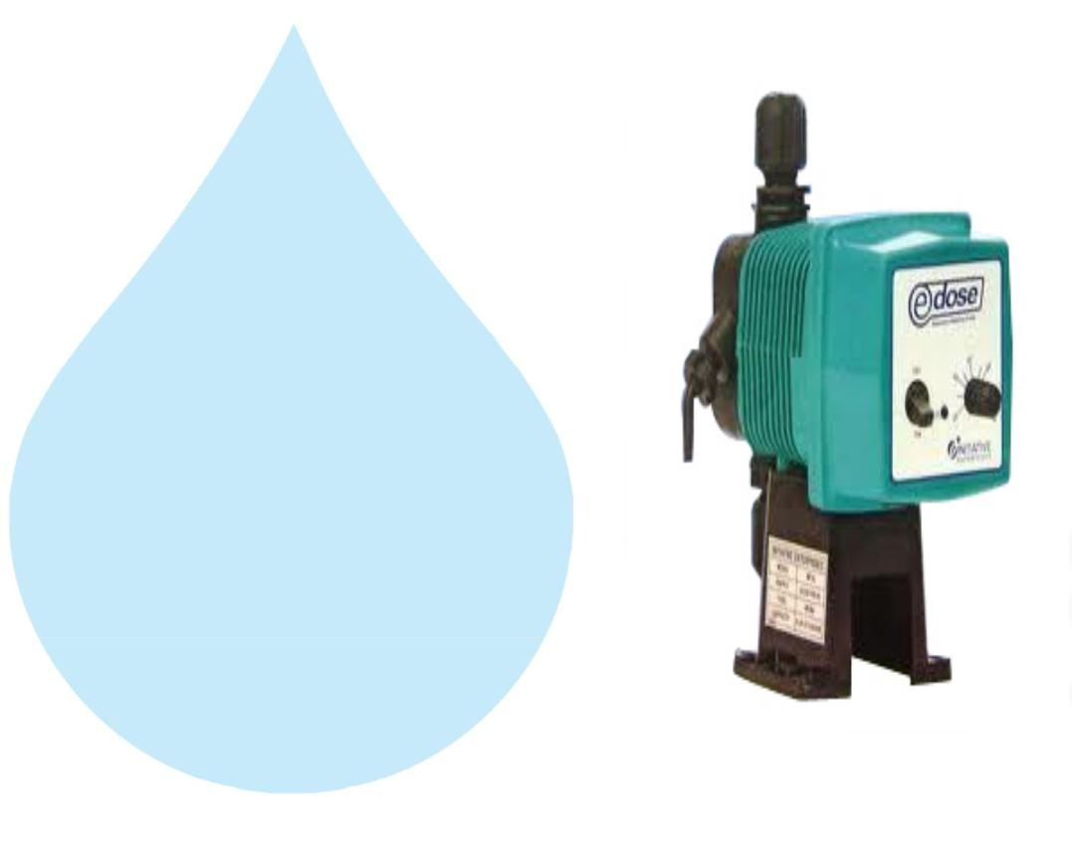

Type :

M.O.C. of Dosing

pump :

Electronic Diaphragm type

PP

Capacity : :

Make :

0 to 6 lph

E Dose / I Dose

11. Mineral Dosing Tank
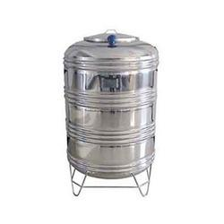

Type : | Conical bottom
Capacity : : | 100 ltr
M.O.C. : | SS 304

12. Pressure Gauges
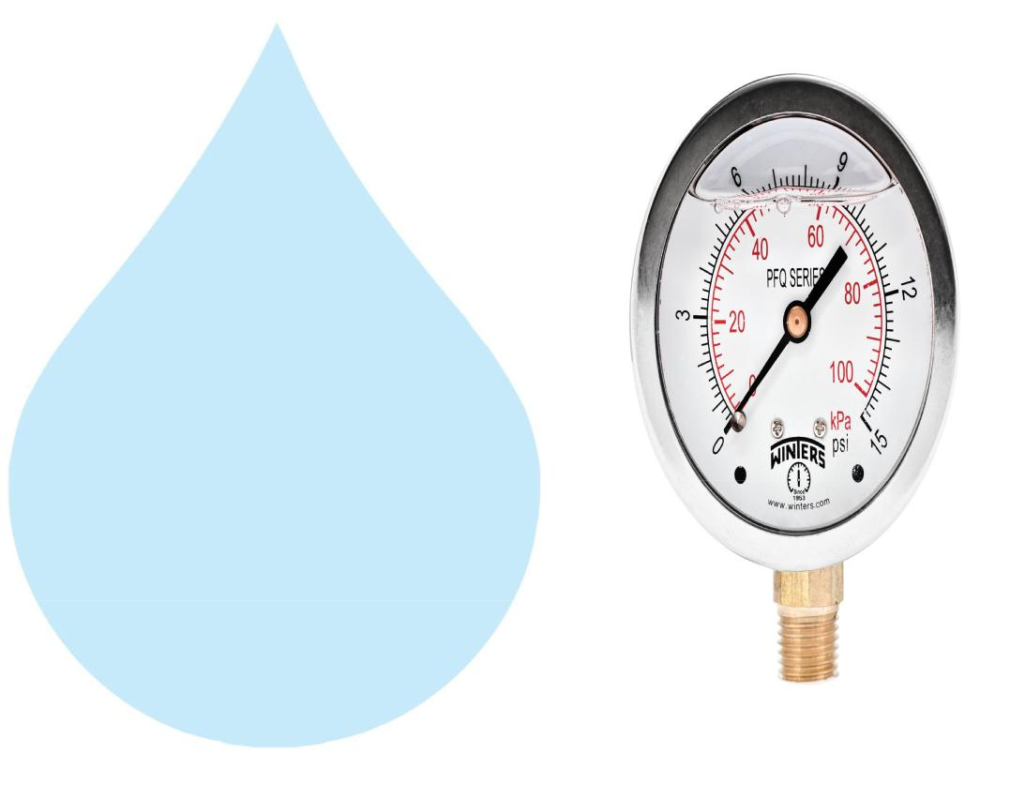

Pressure Gauges : | 9 | Nos.
Type : | Burdone Tube Type
Make : | Raj
Range : | 0 | - 28 , 0 - 7 Kg/cm2

13. Rota Meters
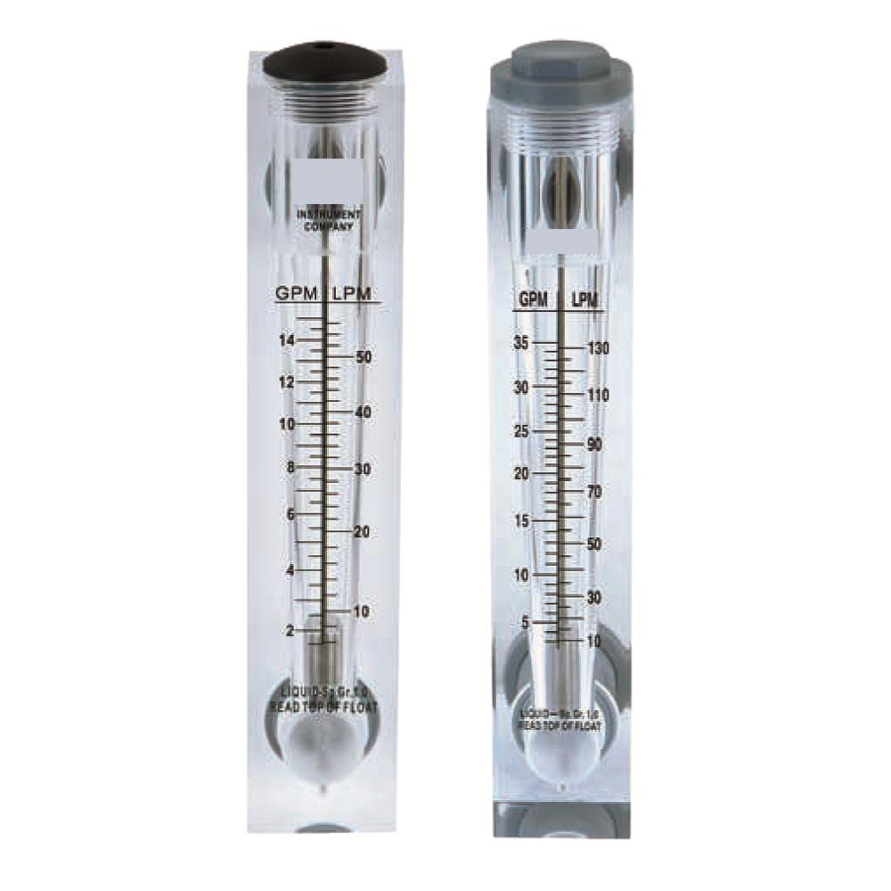

Rota Meters :

Type :

M.O.C. :

Reject Water Range :

Treated Water Range

:

2 Nos.

Float

Acrylic Body

SS Float (0 - 20000 Lph.)

SS Floar (0 - 12000 Lph.)

14. Control Panel - PLC Base
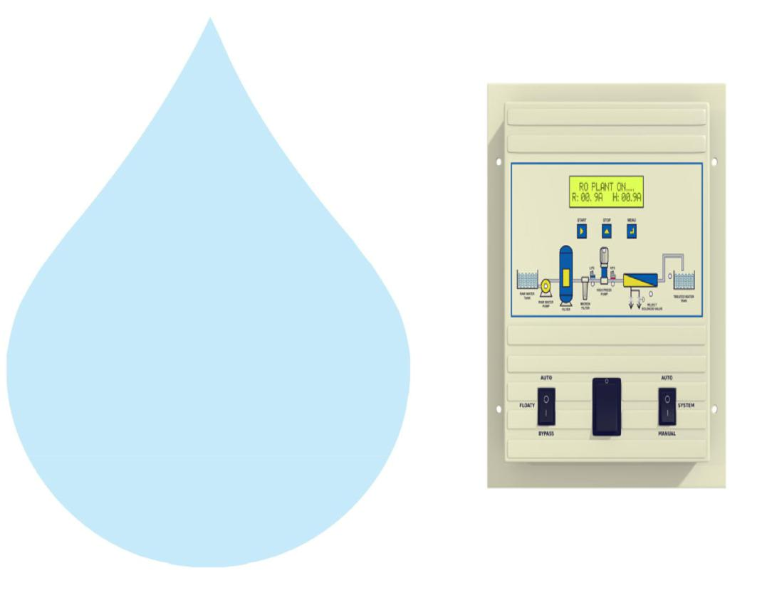

Make : Astral

15. Pressure Switch
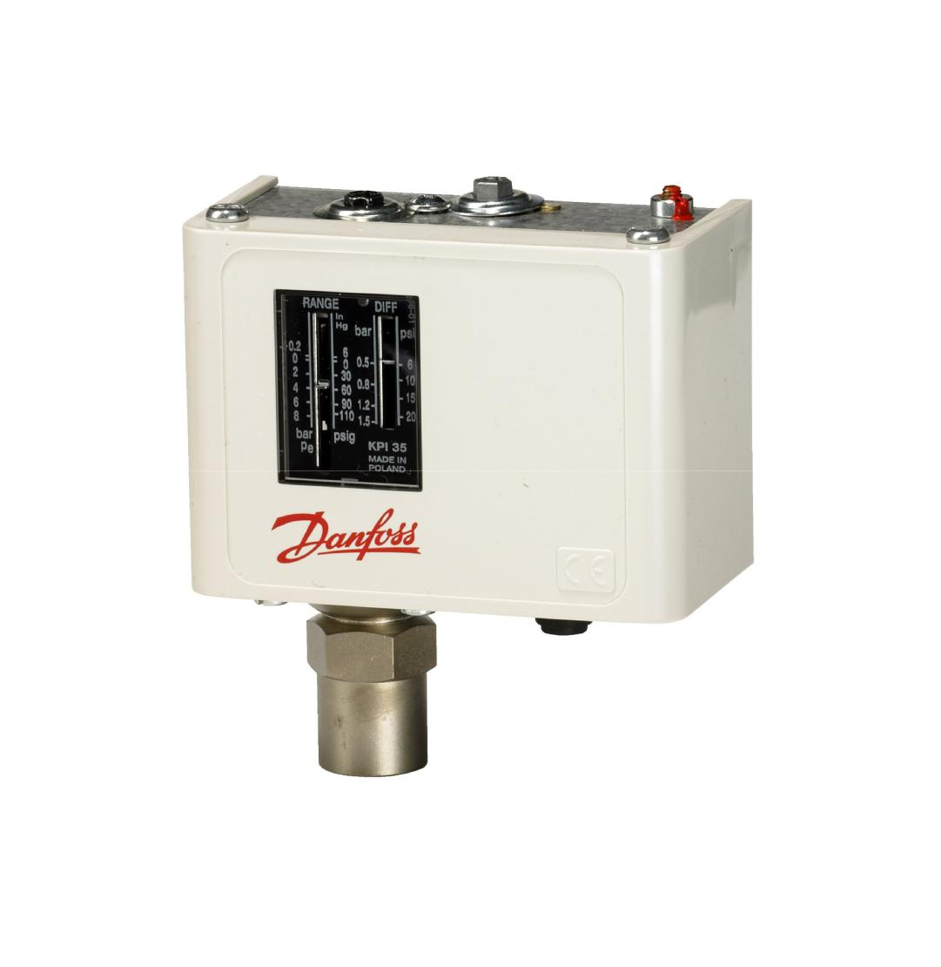

Pressure Switch :

2 Nos.

Type :

Low / High Pr.

Make :

Denfoss

Model :

IPS 70 / 400

16. Treated Water Storage Tank
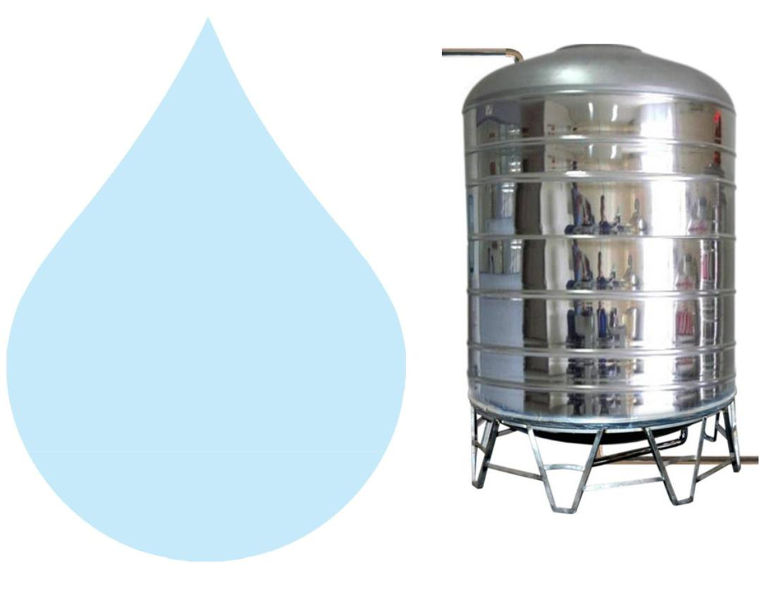

Nos. Offered :

1 Nos.

Type :

Vertical Cylindrical Type

M.O.C. :

SS 316

Capacity :

5000 Ltr.

Application :-

To store Reverse Osmosis permeate (product) water. It can remove back pressure in R.O. Membrane elements. It is only storage of the treated Water.

17. Treated Water Transfer Pump
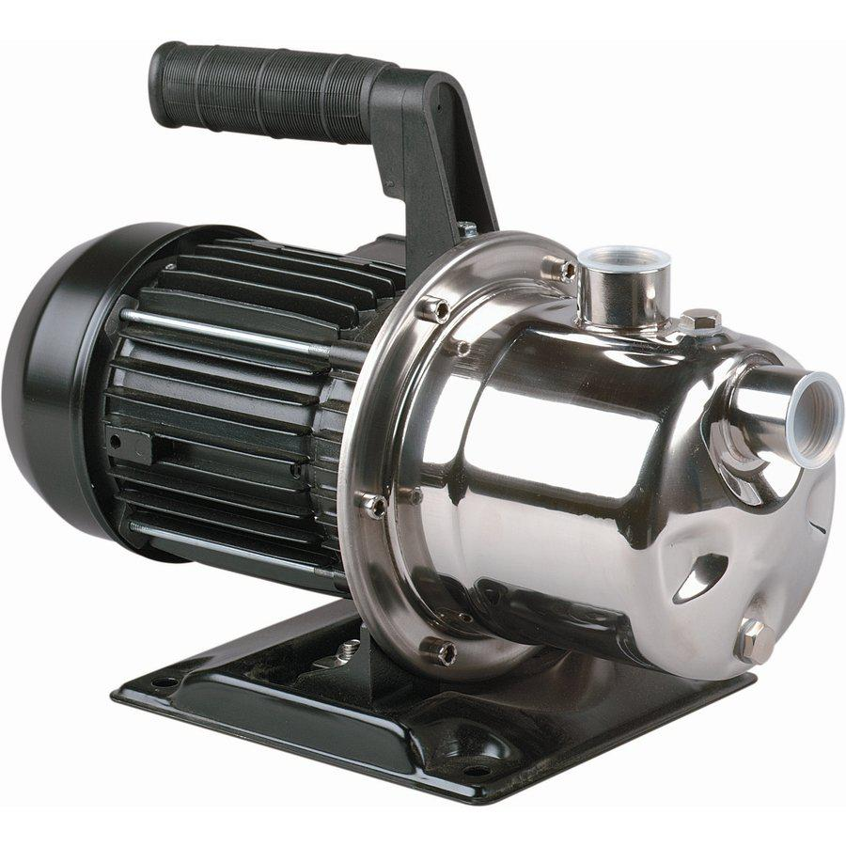

Type :

Monoblock

Make :

PNC/Eqi

M.O.C. :

SS

Capacity :

2.0 HP

Working Flow :

10 M3/ HR

Application :-

To feed water to downstream to micron filters and UV system and filling line
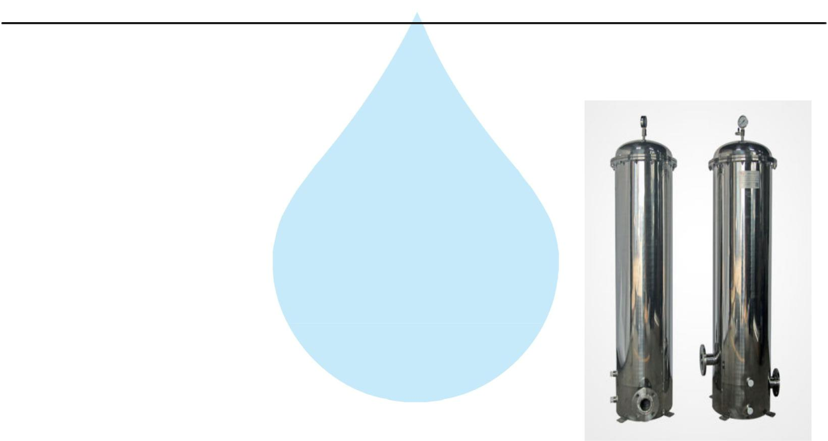

18. Post Micron Cartridge Filter-1

Model :

MCF 30/RW/SS

Size :

30" Long

Micron Rating :

2.0 Micron

Type of Candle :

P. P Spun

Material of Housing :

SS 316

Nos. of Candles :

2 Nos

Working Flow :

10.00 m3/HR

Application :-

During storage, atmospheric or any other contamination may take place in treated water. Hence, after passing water from R.O. System, water is once again passed through a micron cartridge filter. To remove micron particles up to 2.0 Micron sizes.

19. Post Micron Cartridge Filter-2
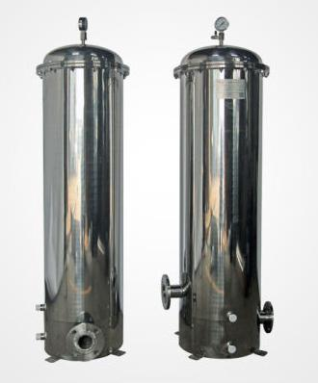

Model :

MCF 30/RW/SS

Size :

30" Long

Micron Rating :

1.0 Micron

Type of Candle :

P. P. Spun

Material of Housing :

SS 316

Nos. of Candles :

2 Nos

Working Flow :

10.00 m3/HR

Application :-

This Vessel fitted internally with P.P spun micron cartridge elements having absolute ratings of 1.0 micron & 0.2 microns which removes all bacterial impurities present in the water and make the water free of particulates.
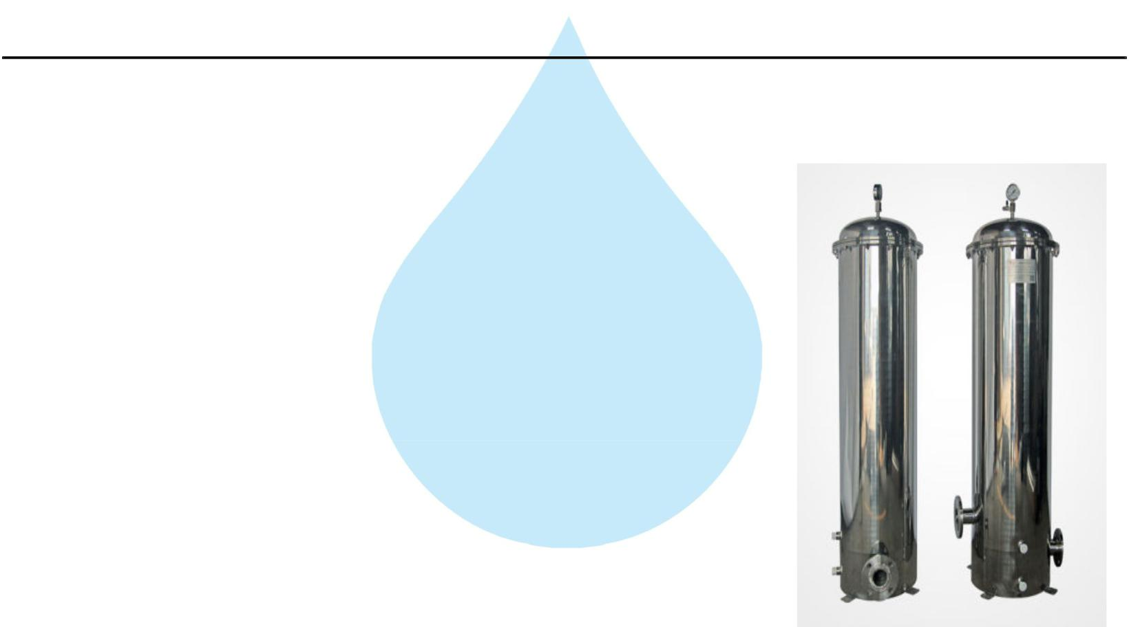

20. Post Micron Cartridge Filter-3

Model :

MCF 30/RW/SS

Size :

30" Long

Micron Rating :

0.5 Micron

Type of Candle :

P. P Spun

Material of Housing :

SS 316

Nos. of Candles :

2 Nos

Working Flow :

10.00 m3/HR

Application :-

During storage, atmospheric or any other contamination may take place in treated water. Hence, after passing water from R.O. System, water is once again passed through a micron cartridge filter. To remove micron particles up to 2.0 Micron sizes.

21. U. V. Disinfection System
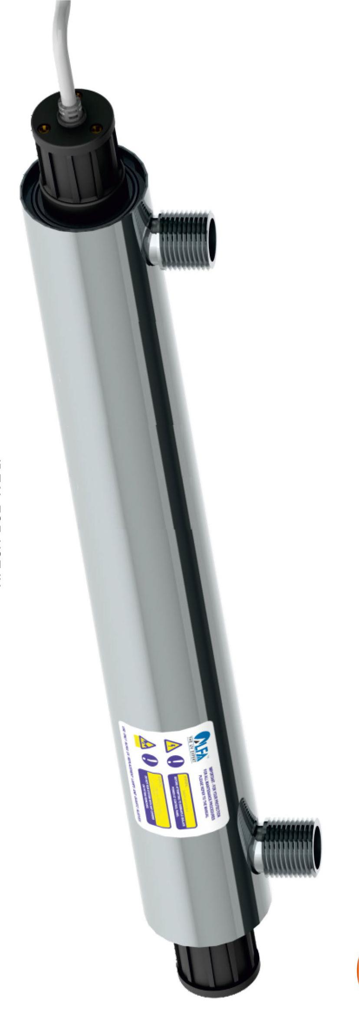

Type :

Fluorescent Tube

Working Flow :

10000 Lph

Working Pressure :

1 Kg. / Cm 2

Material :

SS 316

Make :

Raj

Nos. Offered :

1 Nos.

Application :-

For removal of micro biological organisms up to 99.9%.
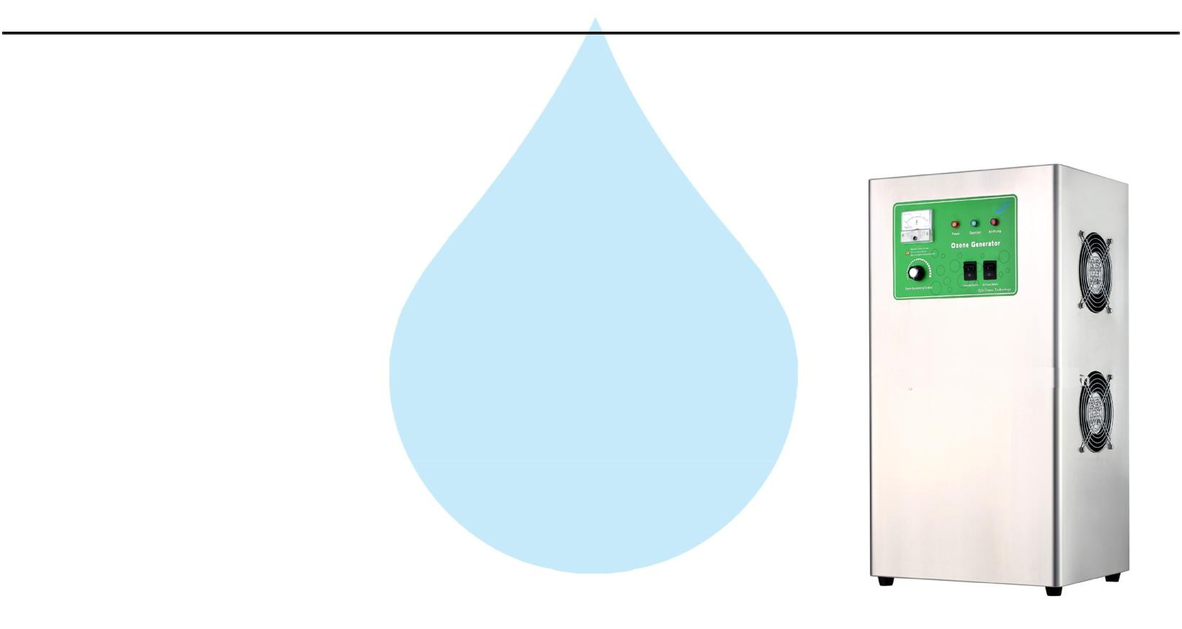

22. Ozone Generator

Nos. Offered :

1 Nos.

Type :

Natural Air Type 25 Gm

Flow Rate :

10000 Lph.

Ozone Dosing :

1 PPM

Casing :

SS

Make :

Aqua Zone or Equi

Application :-

Though R.O. System rejects all the micro – organisms like bacterial & virus and even after passing through U.V. System it may redevelop in packed bottles over a period of time. Hence, it is necessary to disinfect RO water prior to bottling filling. So that by using ozone gas generator we are producing ozone gas i.e. O3, & is passed through the water, as ozone is having capacity to kill the bacteria as well as to control the further growth In the stored & packed water. Also it is increasing the level of oxygen in the water, where water Becoming very healthy.

23. Oxygen Generator
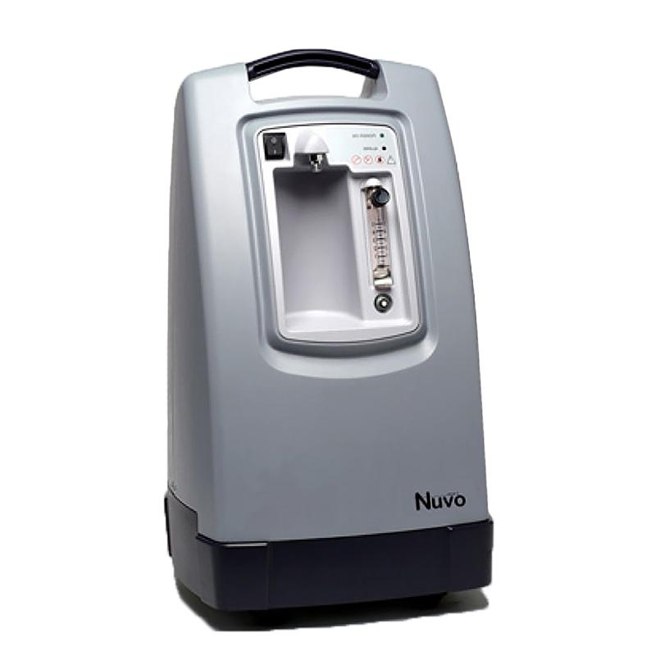

Nos. Offered :

1 Nos.

Type :

Natural Air Type

Flow Rate :

10000 Lph

Make :

NUVO

Application :-

Though R.O. System rejects all the micro – organisms like bacterial & virus and even after passing through U.V. System it may redevelop in packed bottles over a period of time. Hence, it is necessary to disinfect RO water prior to bottling filling. So that by using ozone gas generator we are producing ozone gas i.e. O3, & is passed through the water, as ozone is having capacity to kill the bacteria as well as to control the further growth In the stored & packed water. Also it is increasing the level of oxygen in the water, where water Becoming very healthy.
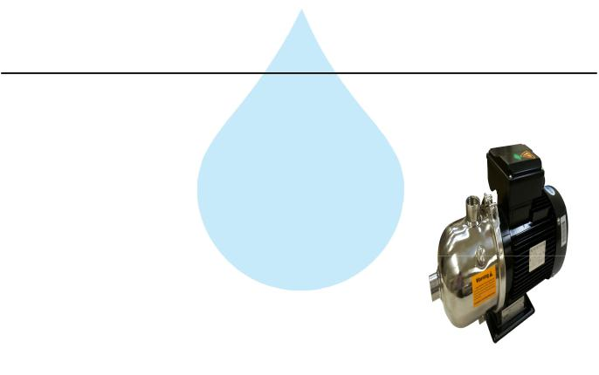

24. Ozone Circulation Pump

Type :

Monoblock

Make :

PNC/Eqi

M.O.C. :

SS

Capacity :

1.0 HP

Working Flow :

10.00 m3/HR

25. Ozone Circulation Tank
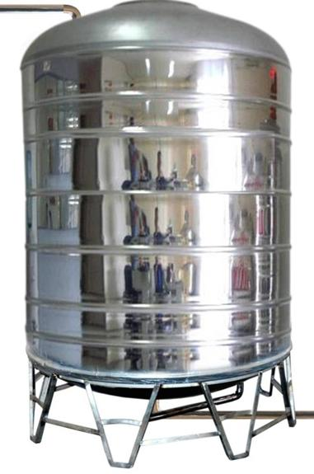

Nos. Offered :

1 Nos.

Type :

Vertical Cylindrical Type

M.O.C. :

SS 316

Capacity :

5000 Ltr.

Application :-

For required ppm Ozone gas mix up in finish product water. In ozone re-circulating tank water re-circulating by required flow rate pump . Ventury of ozone install out let of Pump it suction ozone and mix-up help with static mixer. This tank is provided with one no. of re-circulating pump and one no. of product water transfer pump to the filling section.
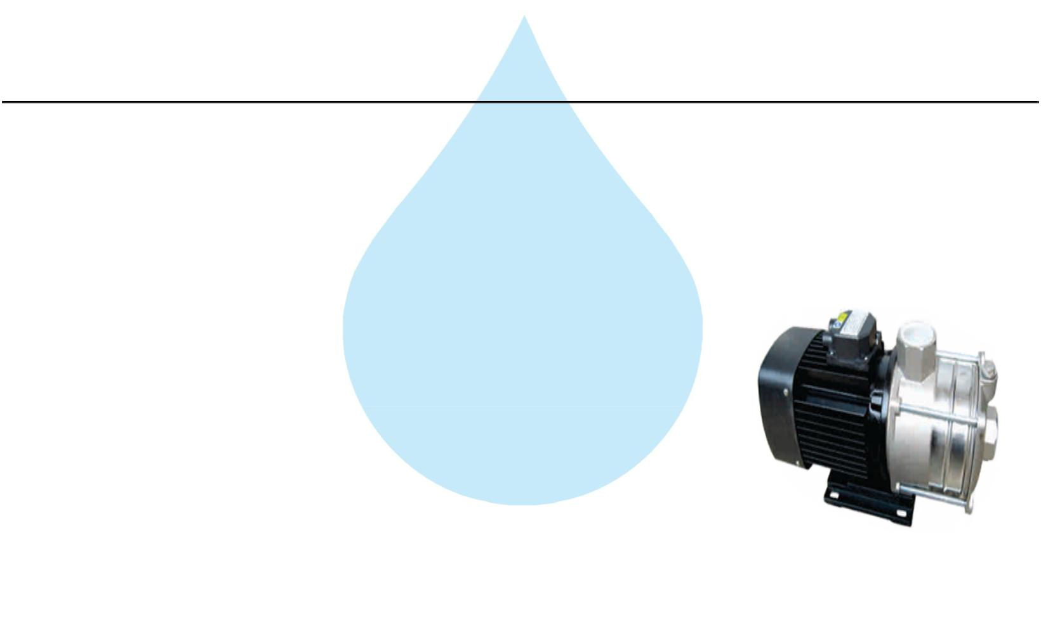

26. Final Water Transfer Pump

Type :

Monoblock

Make :

PNC/Eqi

M.O.C. :

SS

Capacity :

2.0 HP

Working Flow :

10M3/ HR

Application :-

To feed water to downstream to micron filters and UV system and filling line

27. Stand For Unit
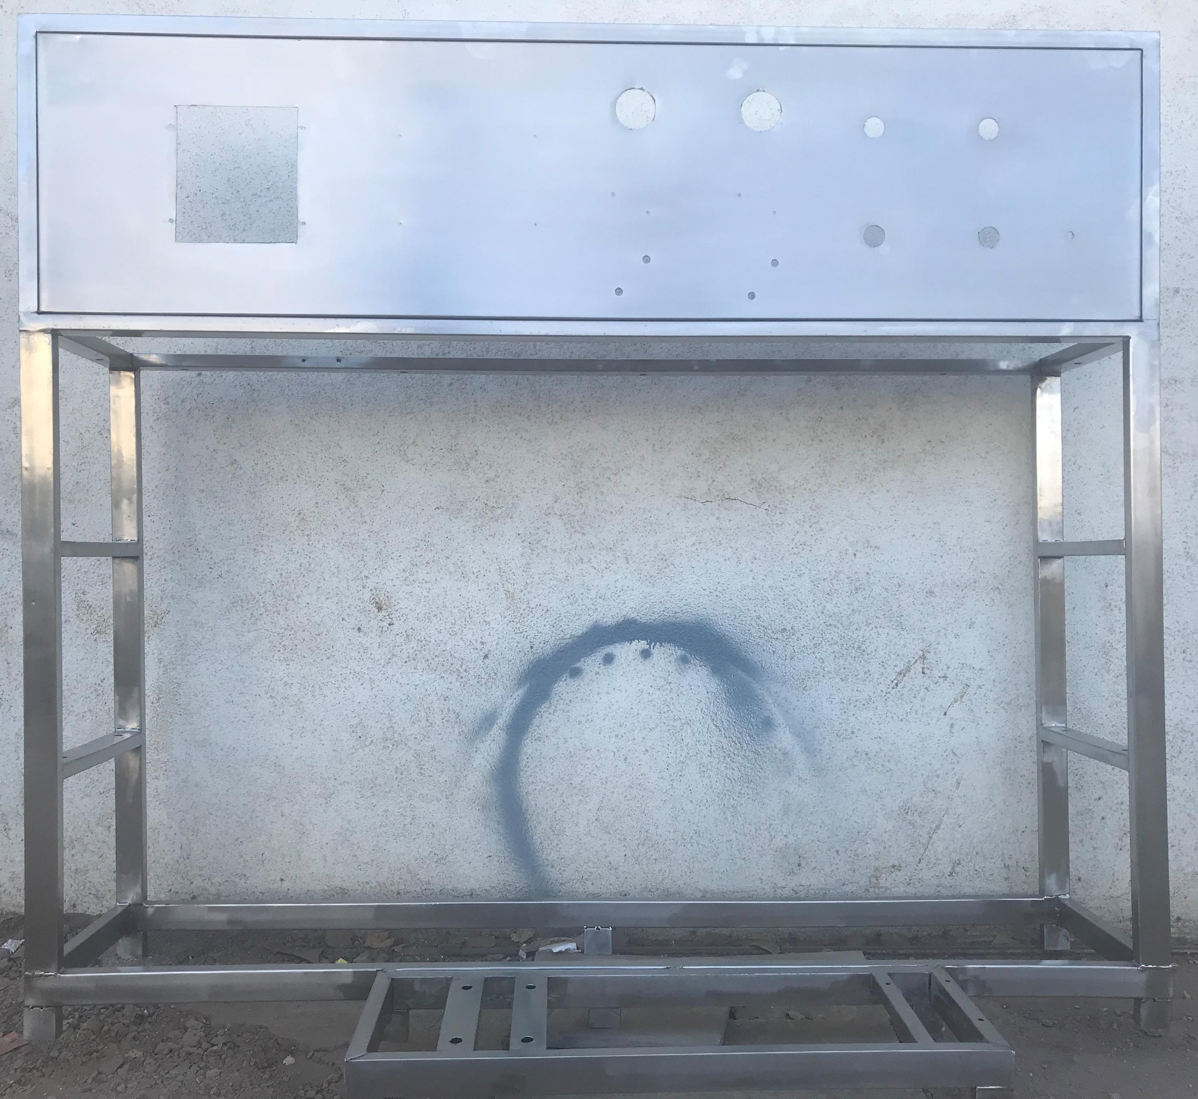

Stainless Steel : | S.S 304

Application :-

Complete stand for unit will be made of S.S.304
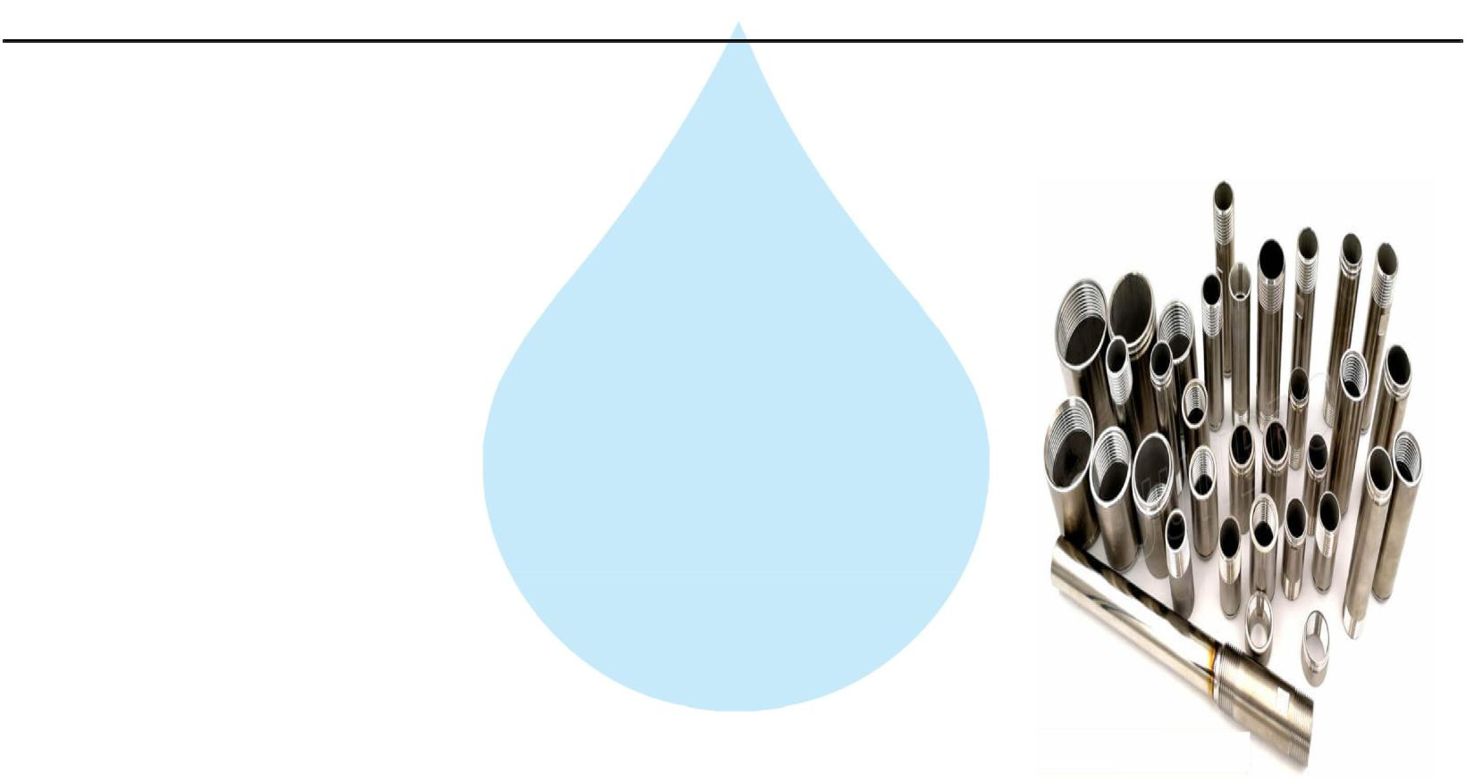

28. SS Interconnecting Pipe Lines

Stainless Steel : | S.S 316

Application :-

All interconnecting pipelines Raw water Pump to Ozone Circulating tank will be provided of S.S 304 by us

