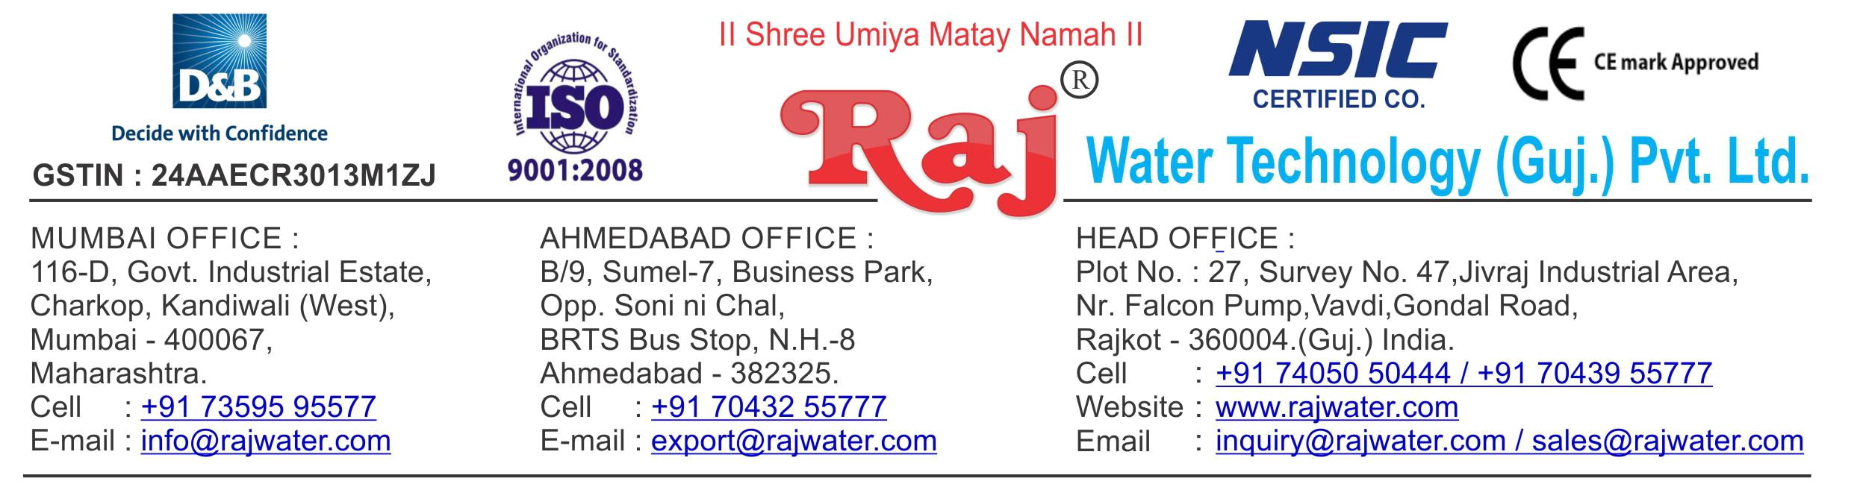

Date :- 11th February 2019

Monday

Quotation No | :- RW/2018-19/Q_9690/R_5
55Concern Person | :- | Mr. Pradip
Concern Number | :- | 9601558317
Email Id | :-
Company Name | :-
Address | :-


Quotation For Packaged Drinking Water Project

Dear Sir ,

We are pleased to enclose our detailed Techno-Commercial offer, based on your requirement.

Contents of the Quotation

Commercial Proposal
Terms & Condition
Technical Specification for each product

Machinery Offer

Packaged Drinking Water Project

We hope the same is in line with your requirement. We shall gladly assist you in case you need any further clarification or information.

With warm Regards,

For , Raj Water Technology (Guj.) Pvt. Ltd.

DESHANI KHUSHBU

Designation : Marketing Asst. Manager

Mobile : 7043755777
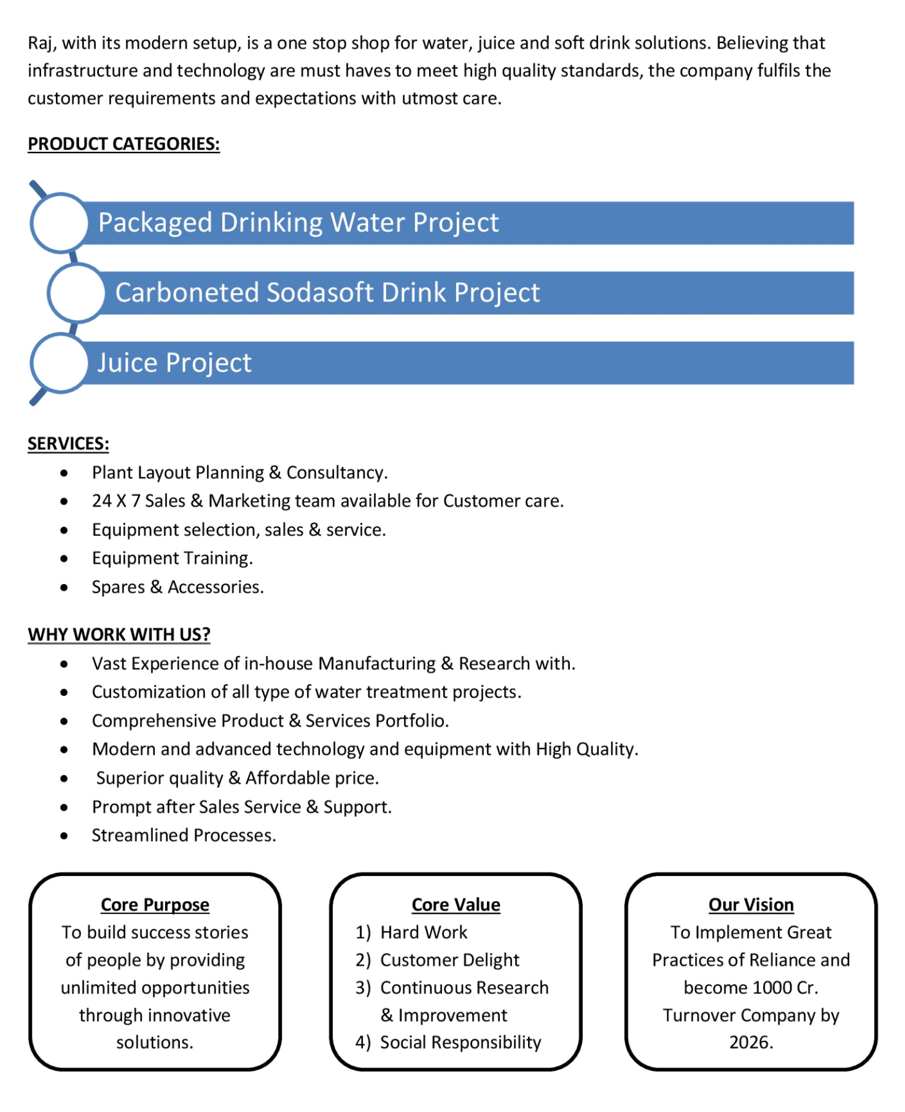
Commercial Proposal

Sr | Equipment Name | Qty | Basic Rate | Amount
No.
1 | 2000 Litre Per Hours (SS-304) RO Plant, With U.V | 1 | 550000.00 | 550000.00
 | System, SS Storage Tank 2000 Litre 2-Nos. Added
 | Mineral System
 | With Ozon Circulating system
2 | Oxygenation Circulation System | 1 | 45000.00 | 45000.00
3 | Complete Lab BIS Approve (14543-Standard) | 1 | 300000.00 | 300000.00
 | Testing Instrument, Glassware , Chemical As Per List
4 | Automatic Bottle Rinsing, Filling & Capping Machine 30- | 1 | 750000.00 | 750000.00
 | BPM
 | With Heat Shrink Tunnel For Label, Input-Output
 | Conveyor Belt
5 | Automatic Inkjet Batch Coding Machine | 1 | 200000.00 | 200000.00
6 | Semi-Automatic Shrink Wrapping Machine For Bulk | 1 | 326000.00 | 326000.00
 | Bottle Packing
 | - SS Piping Charges Extra 500 Rs Per SQFT

Total Amount in Words :- |  | Total Amount | 21,71,000.00
Twenty One Lakh Seventy One Thousand
Terms & Condition

- Price

The Quoted Prices Are Ex-factory. (For India)

The Quoted Prices Are FOB. (For Export)

- TAX

GST 18% Extra Applicable. (For India)

- Payment

50% Advance Along With The Purchase Order, 30% After Inspection, & 20% Before Material Dispatch.

In Case Of Cancellation Of Confirmed Order Due To Any Reason, As A Part Of Penalty 25% Amount Of The Order Value Shall Have To Pay By You To Raj Water.

- Packing, Freight & Transit Insurance, & Unloading

Packing Charge Will Be Extra (Depend On Packing Material)

Transportation Is Including In Quotation Amount

- Delivery

Schedule For Dispatch Will Be Notified.

Delivery Dates Are Approximate Only, And Assume Timely Receipt Of All Information, Test Materials & Payment.

- Warranty

We Shall Provide 1 Year Warranty For The Following:

Manufacturing Defects, Raw Water Pump, High Pressure Pump, Treated Water Transfer Pump.

Due To Fluctuation In Power Supply, Attempted Repaired By Person Other Than Our Technical Representative, Improper Handling Or Negligence By End Users, Poor Maintenance, Improper Use Of Equipment, That All Type Of Damage Not Covered In Warranty Create Area.

During The Warranty Period, We Shall Provide Supervisory Services Of Our Technical Representative As And When Required.

- Accommodation

Technician Charge Will Be Extra 1000/- Rs. Per Day.

Travelling, Lodging And Boarding, Local Conveyance And Any Other Miscellaneous Expense Of Our Technical Representative Will Have To Be Borne By Client.

- Validity

Our Offer Is Valid For Your Acceptance For A Period Of 6 Months From The Date; Thereafter It Will Be Subject To Confirmation By Us.

- Image

Images Are For Representation Purpose Only.

- Jurisdiction

All Terms Subject To Rajkot, Gujarat Jurisdiction.
Technical Specification

1. Raw Water Quality

R.O. plant is | 1500 TDS
designed based On :
Hardness : | 300

Application :-

2. Treated Water Quality

Suspended Solids :

Nill

Turbidity :

Nill

PH :

7.0 To 7.5

T D S :

Less than 40 ppm

Total Hardness :

30 ppm as CaCo3

Bacteria Coliform :

Nill

Application :-

The above water quality is approximate assumption, We can change property of minerals/ions in water by editing the raw water in R.O. treated water

3. Raw Water Feeding Pump
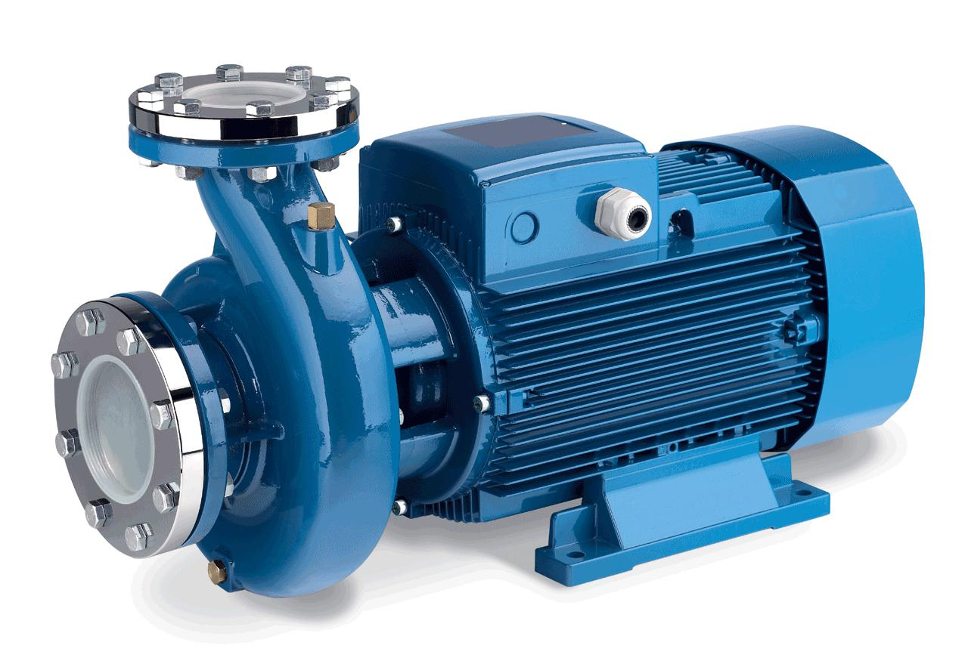

Type :

Centrifugal

Max. Flow :

5.50.00 m3/HR

Working Flow :

4.00 m3/HR

Working Pressure :

2 Kg. / Cm 2

M.O.C. :

C.I.

Power :

1 HP

Manufacturer :

Kirloskar / EQI

Nos. Offered :

1 Nos.

Application :-

To Pump Raw Water at Required Pressure so as to enable Transfer Through The RO Pre-Treatment Stage.
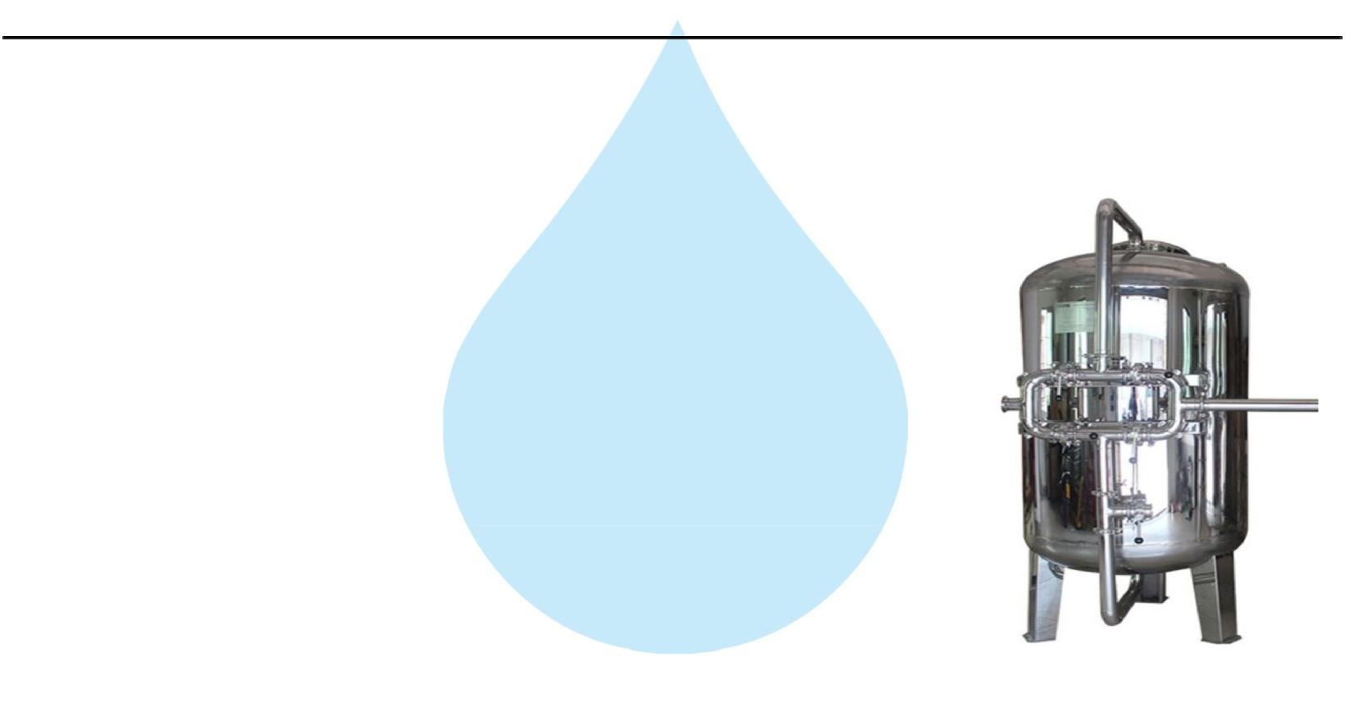

4. Pressure Sand Filter (SS)

Type :

Down Flow Graded Sand Type

Model :

1668/RW/MFG

M.O.C. :

SS 304

Size Dia X Height :

400 mm Dia X 1700 mm

Pipe Line Size :

25 mm.

Sand Qty. :

210 Kgs.

Valves :

SS Valve

Max. Flow :

5.50 m3/HR

Working Flow :

4.00 m3/HR

Application :-

By means of Multi size Graded sand filled in the Vessel of stainless steel material, which is natural process of filtration adopted by the nature Raw Water is first filtered by filtration unit in series prior feeding RO Plant. Pressure Sand Filter Unit is provided for removal of suspended matters & turbidity from raw water. PSF Unit is a SS vertical Pressure Vessel. Internally, it is fitted with bottom collecting system. Uniform grades silica quartz sand is charged on the supporting media of pebbles and gravels.

5. Activated Carbon Filter (SS)
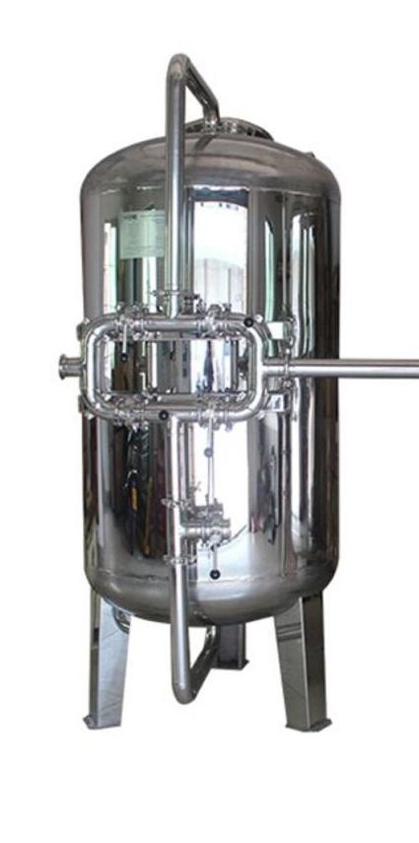

Type :

Down Flow Graded Sand Type

Model :

1668/RW/MFG

M.O.C. :

SS 304

Size Dia X Height :

400 mm X 1700 mm

Pipe Line Size :

25 mm

Carbon Qty. :

85Kgs.

Valves :

SS Valve

Max. Flow :

6.00 m3/HR

Working Flow :

4.00 m3/HR

Application :-

To Remove taste, odour, chlorine, colour and. It can absorb contaminated particles of Oil & Grease from the raw water. It will control the BOD & COD in the raw water. Activated Carbon can remove Chlorine, Odour, & Colour other organic material from feed water prior to reverse osmosis. This Carbon granules having larger surface area and specific property to absorb organics.
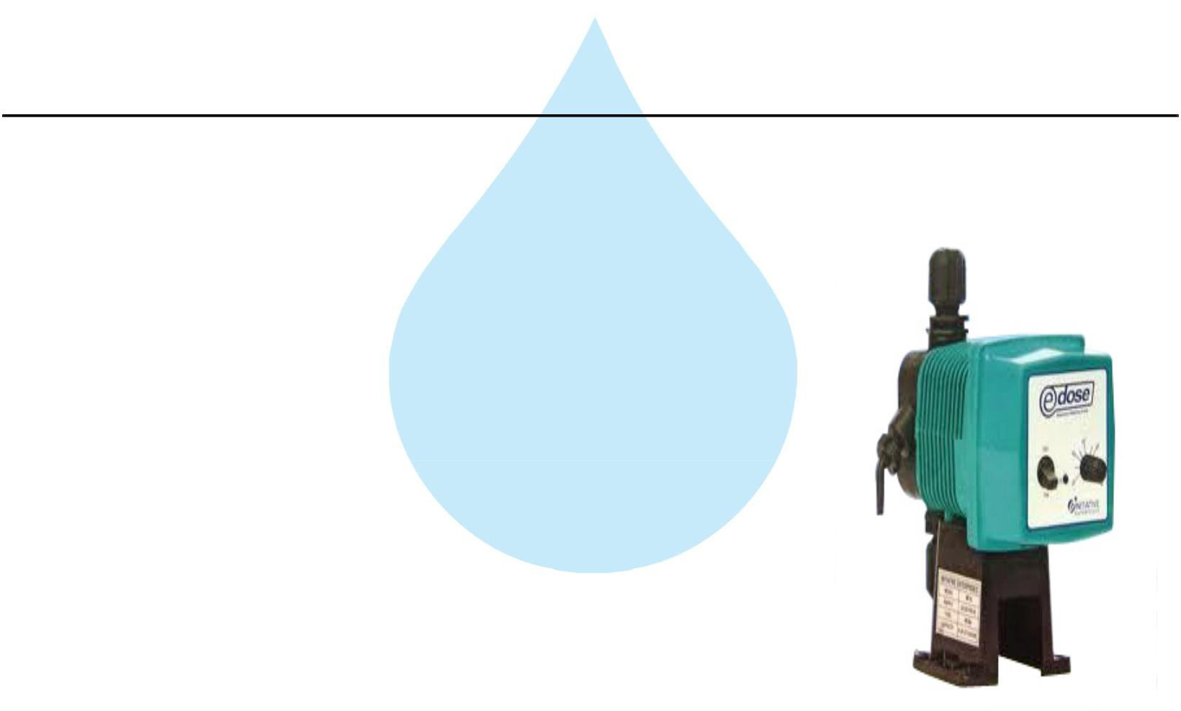

6. Antiscalant Dosing Pump

Type :

Ele. Diaphragm Type

Capacity :

0 to 6 LPH

M.O.C. :

PP

Dosing Chemical :

Antiscalent

Dosing Rate :

3 to 4 LPH

Make :

E Dose/ I Dose

Nos :

1 Nos

Application :-

The hardness salts of calcium & magnesium are likely to be precipitated if concentration exceeds its solubility limit

- it may faults the membranes resulting into scaling which ultimately leads to poor treated water quality from R.O.System.

7. Antiscaling Dosing Tank
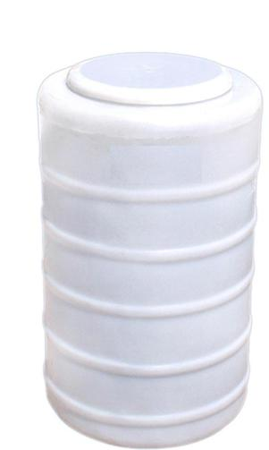

Type :

Conical Bottom

Capacity :

100 Ltr.

M.O.C. :

HDPE

Manufacturer :

Reputed

Nos :

1 Nos

8. Micron Cartridge Filter
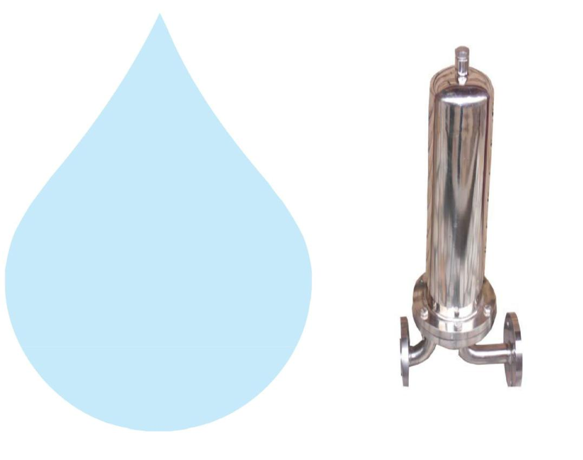

Model :

Size :

Micron Rating :

Type of Candle :

Material of Housing :

Nos. of Candles :

Max. Flow :

Working Flow :

MCF 20/RW/SS

20" Long

5 Micron

P. P. Spun / Wound

S.S 304

1 Nos. (Jumbo)

5.50m3/HR

4.00 m3/HR

Application :-

To protect the membrane and the high pressure pump from suspended particles by removing them up to 5 Micron.

9. High Pressure Pump
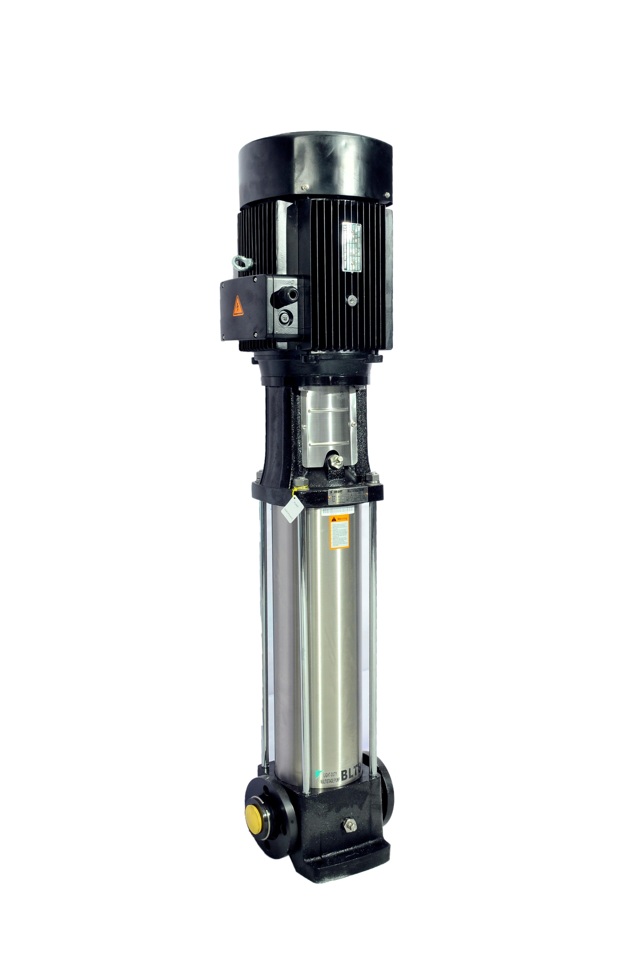

Type :

Vertical Centrifugal Pump

M.O.C. :

SS

Max. Pressure :

13 Kgs. / Cm 2.

Working Pressure :

10 Kgs. / Cm 2.

Max. Flow :

5.00 m3/HR

Working Flow :

4.00 m3/HR

Motor :

3 HP

Manufacturer :

2900 RPM

Nos. Offered :

3 Phase

Make of Pump :

PNC / EQI

Application :-

For Reverse Osmosis Process to take place feed pressure of water need to be raised. For this purpose a Vertical Multistage Centrifugal High Pressure Pump in S.S construction is provided R.O. System requires operating pressure of about 14-16 kg/cm^2 . High-pressure pump is fitted with S.S. discharge pipe work with necessary control valves. Necessary instruments like a High Pressure Switch, Pressure Gauge and recirculation valves are provided for safer operation of system
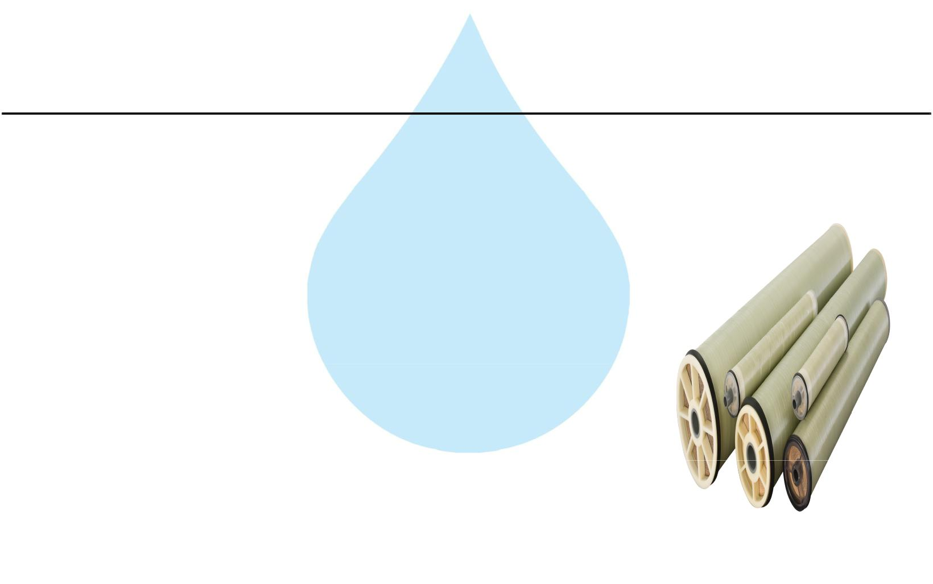

10. RO Membrane

Model :

8040 Element

Type :

TFC Spiral Wound

Material :

Polymide

Size :

8" Dia X 40" Long

Manufacturer :

Toray / Hydranautics / Dow / EQI

Nos. Offered :

2 Nos.

Application :-

To reduce Raw Water T.D.S. through the concept of Reverse Osmosis where R.O. Modules processes Raw Water and produces Purified Water having the Salt Rejection of Raw Water in the range of 90 – 95%. By using Semi permeable Membrane filter elements, where ion filtration process is carried out by applying pressure in the water. So finally we will get Low salt water with low total dissolve solids and High purity. Here will have to drain the water at one side to Wash the Membrane filter elements continuously because of filtration process there is nothing to be polluted in the system.
11. SS Pressure Vessels
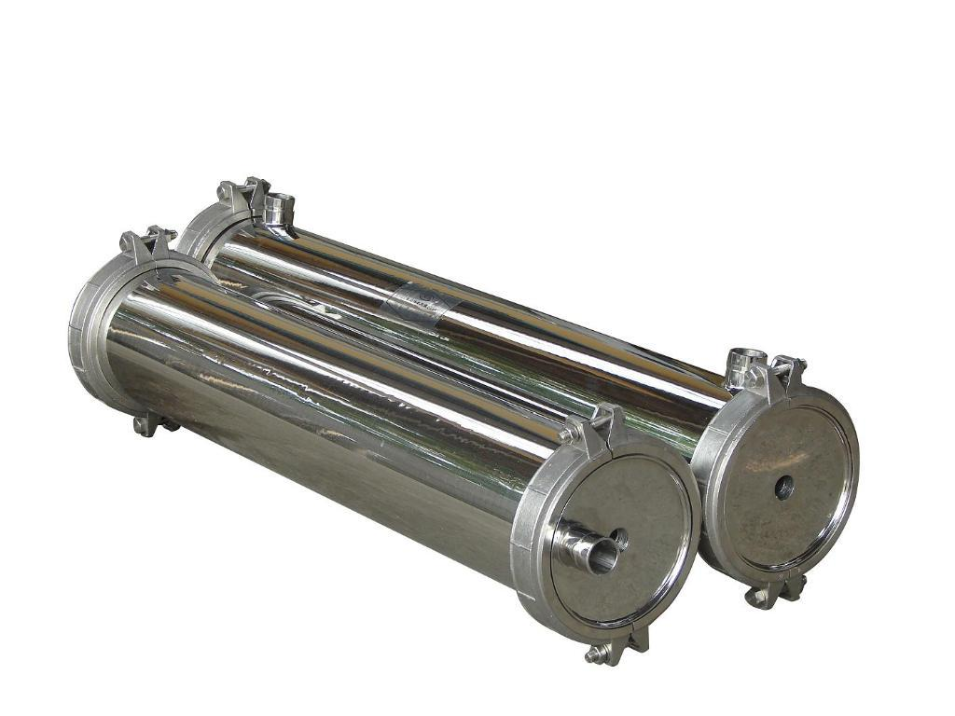

M.O.C. : | SS 304
Type : | Horizontal Tube Type
Size : | 8" X 80"
Max. Pressure : | 400 PSI
Working Pressure : | 150 PSI
Nos. Offered : | 1 Nos.

12. Mineral Dosing Pump
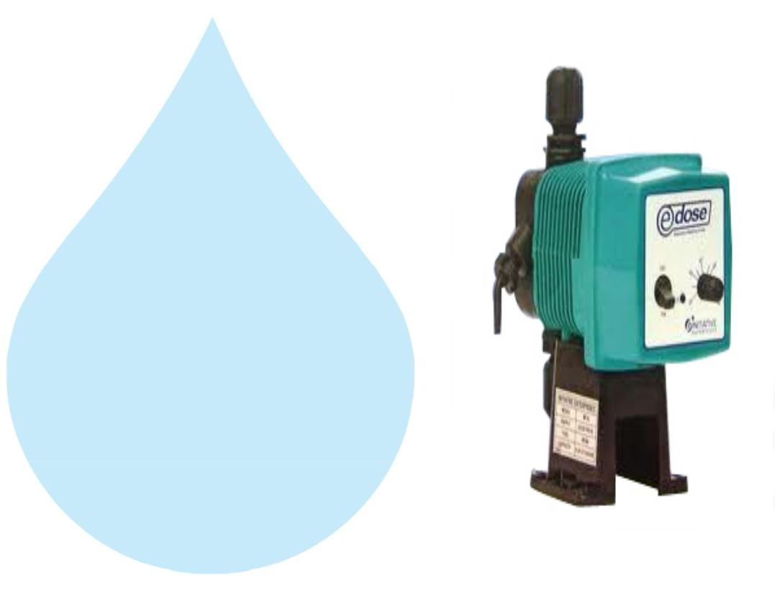

Type :

M.O.C. of Dosing

pump :

Electronic Diaphragm type

PP

Capacity : :

Make :

0 to 6 lph

E Dose / I Dose

13. Mineral Dosing Tank
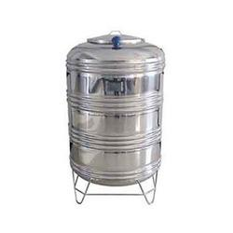

Type :

Capacity : :

M.O.C. :

Conical bottom

100 ltr

SS

14. Pressure Gauges
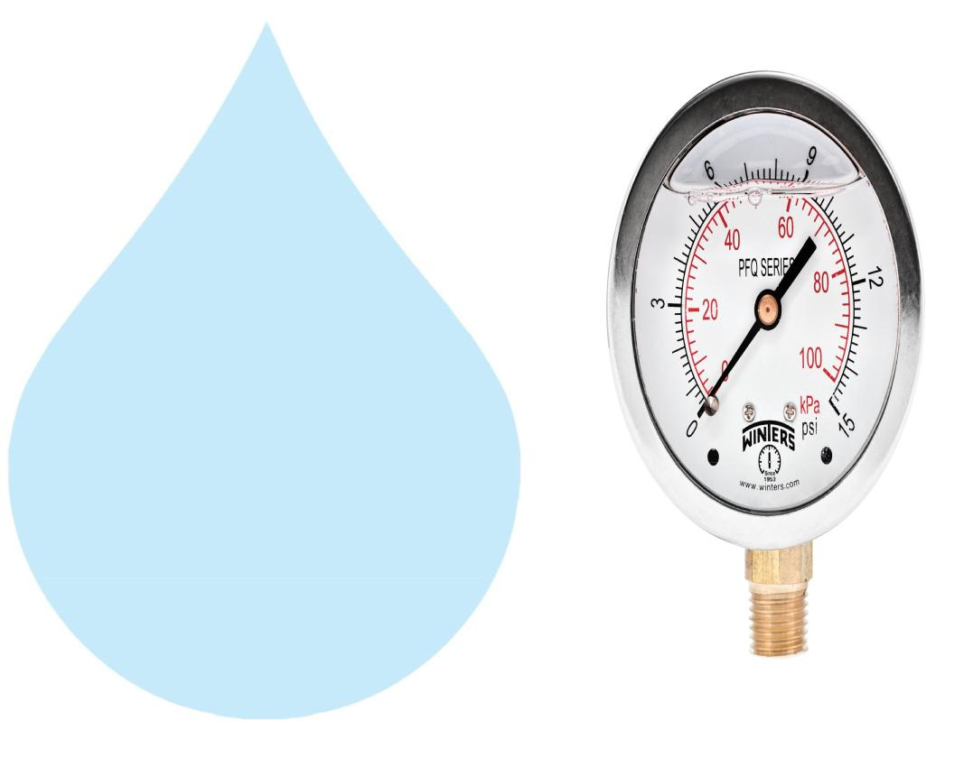

Pressure Gauges : | 7 | Nos.
Type : | Burdone Tube Type
Manufacturer : | Raj
Range : | 0 | - 28 , 0 - 7 Kg/cm2

15. Rota Meters
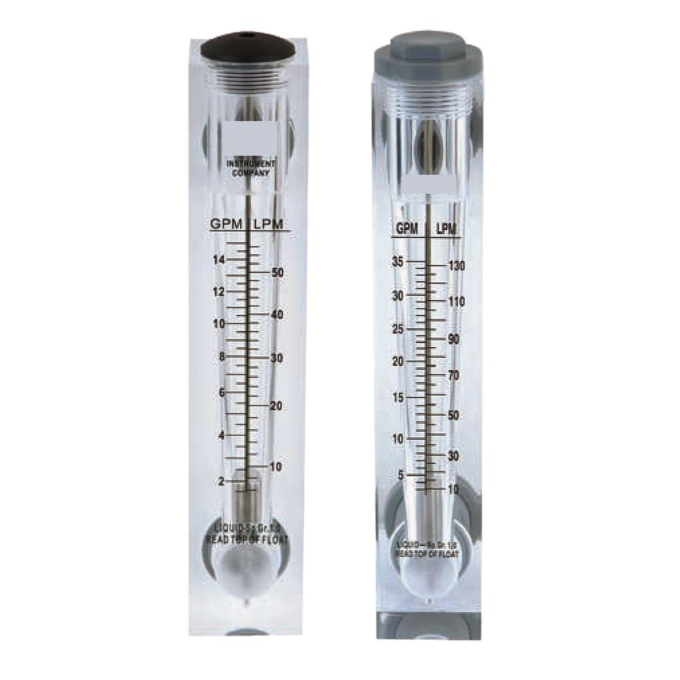

Rota Meters :

Type :

M.O.C. :

Reject Water Range :

Treated Water Range

:

2 Nos.

Float

Acrylic Body

SS Float (0 - 4000 Lph.)

SS Float (0 - 3000 Lph.)

16. Control Panel - PLC Base
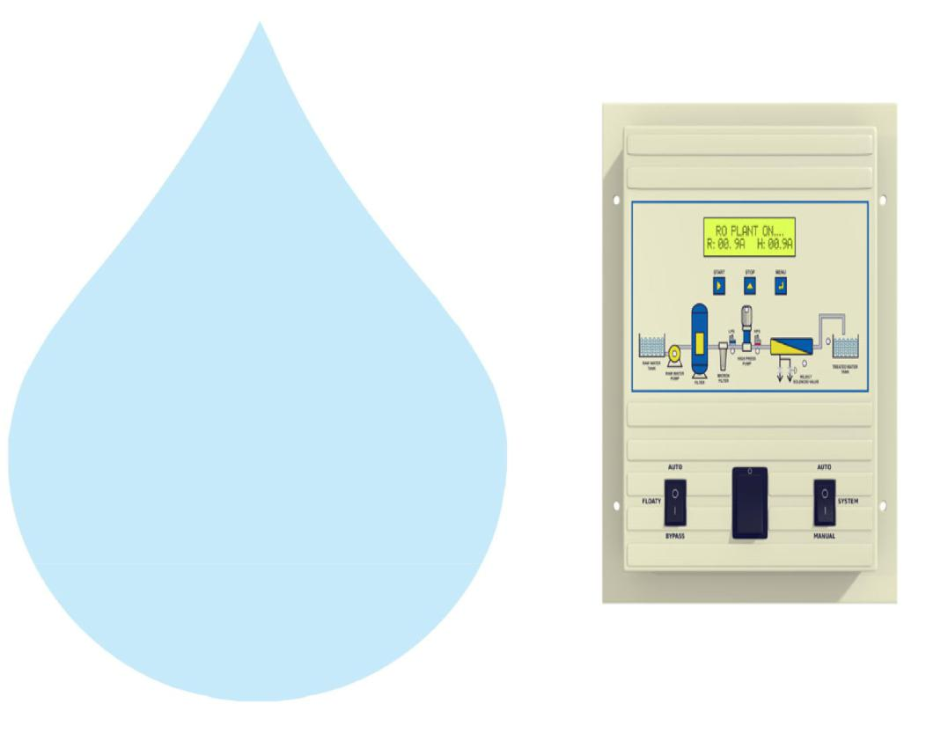

Manufacturer : Astral

17. Pressure Switch
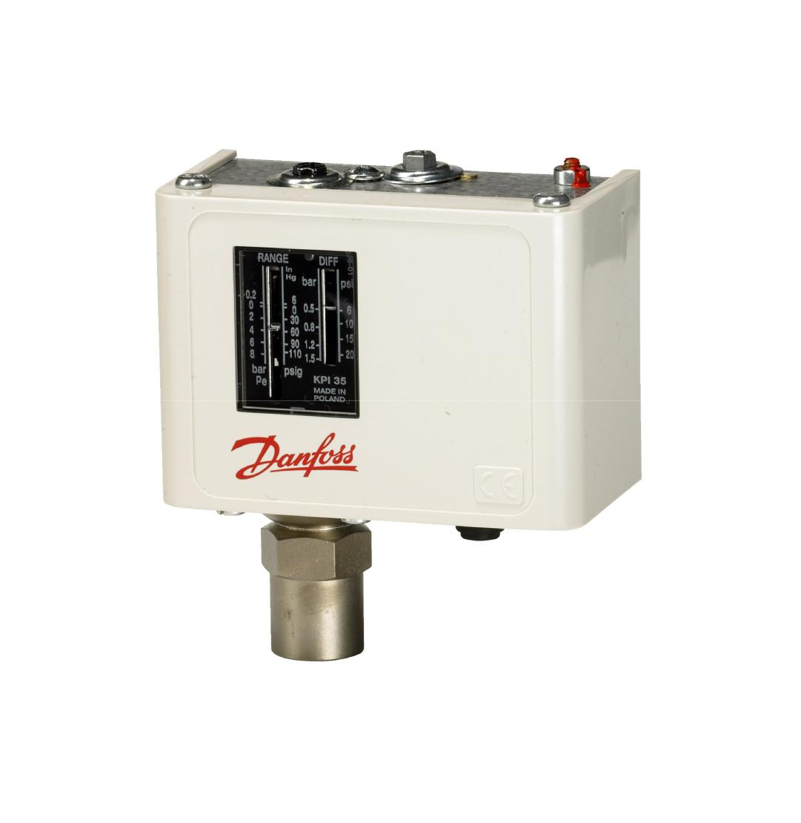

Pressure Switch :

2 Nos.

Type :

Low / High Pr.

Manufacturer :

Denfoss

Model :

IPS 70 / 400

18. Treated Water Storage Tank
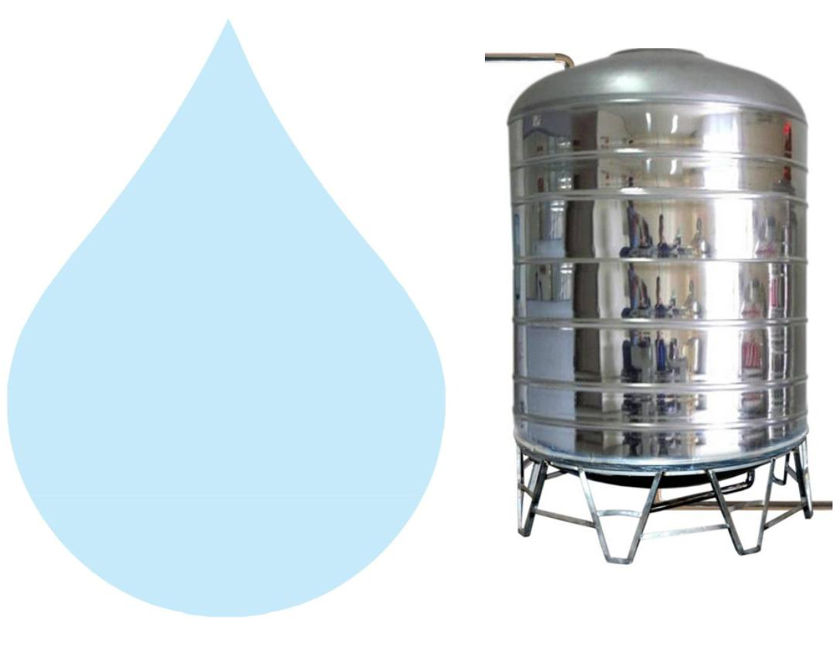

Nos. Offered :

1 Nos.

Type :

Vertical Cylindrical Type

M.O.C. :

SS 304

Capacity :

2000 Ltr.

Application :-

To store Reverse Osmosis permeate (product) water. It can remove back pressure in R.O. Membrane elements. It is only storage of the treated Water.

19. Treated Water Transfer Pump
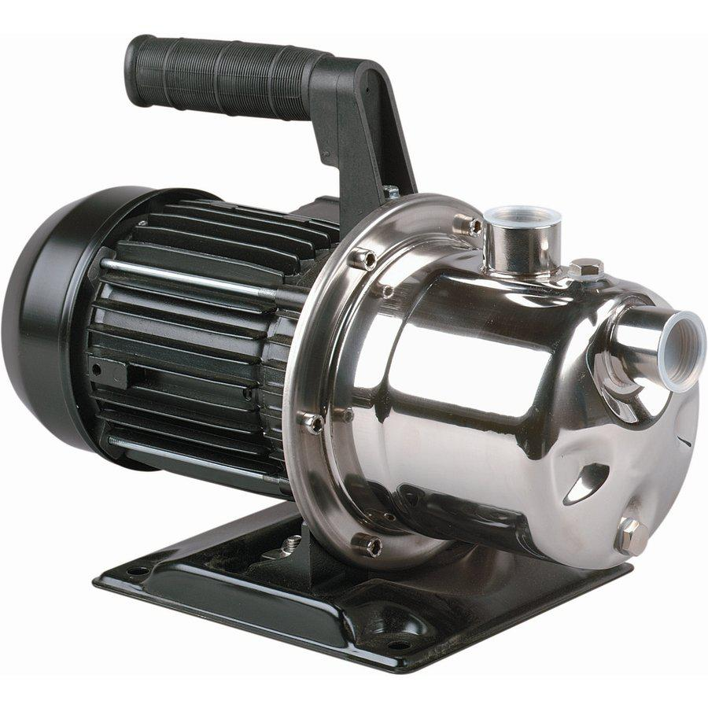

Type : Monoblock

Manufacturer : PNC

M.O.C. : SS

Capacity : | 0.5 HP

Application :-

To feed water to downstream to micron filters and UV system and filling line
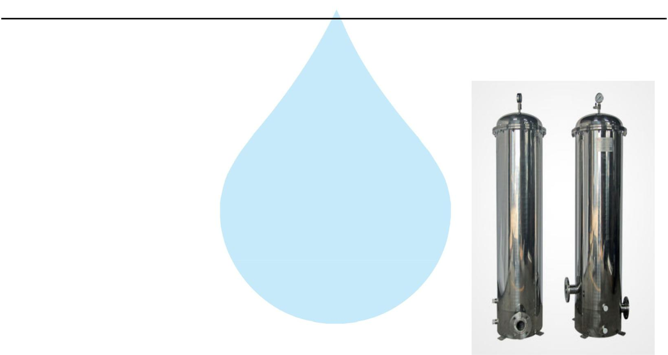

20. Post Micron Cartridge Filter-1

Model :

MCF 20/RW/SS

Size :

20" Long

Micron Rating :

2.0 Micron

Type of Candle :

P. P Spun

Material of Housing :

SS 304

Nos. of Candles :

1 Nos

Working Flow :

2.00 m3/HR

Application :-

During storage, atmospheric or any other contamination may take place in treated water. Hence, after passing water from R.O. System, water is once again passed through a micron cartridge filter. To remove micron particles up to 2.0 Micron sizes.

21. Post Micron Cartridge Filter-2
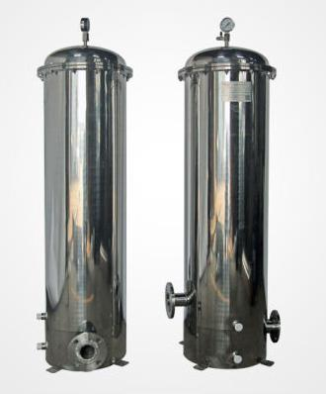

Model :

MCF 20/RW/SS

Size :

20" Long

Micron Rating :

1.0 Micron

Type of Candle :

P. P. Spun

Material of Housing :

SS 304

Nos. of Candles :

1 Nos

Working Flow :

2.00 m3/HR

Application :-

This Vessel fitted internally with P.P spun micron cartridge elements having absolute ratings of 1.0 micron & 0.2 microns which removes all bacterial impurities present in the water and make the water free of particulates.
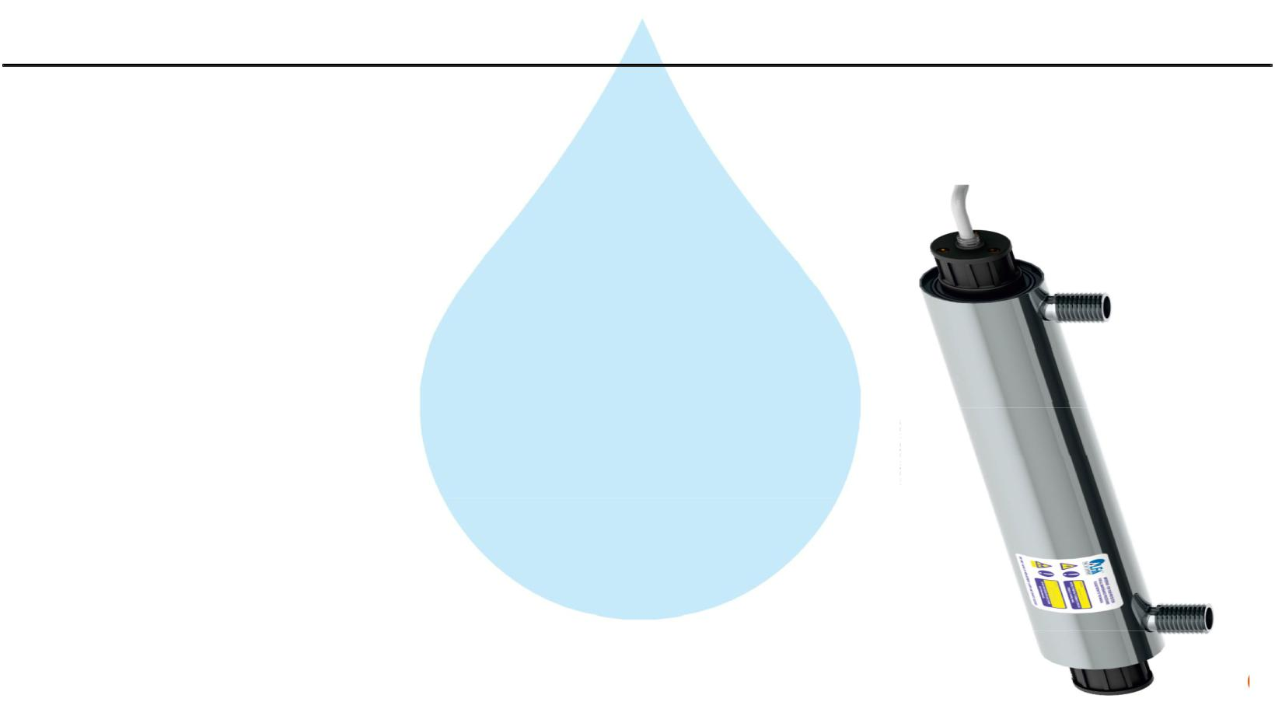

22. U. V. Disinfection System

Type :

Fluorescent Tube

Working Flow :

2000 Lph

Working Pressure :

1 Kg. / Cm 2

Material :

SS 304

Manufacturer :

Raj

Nos. Offered :

1 Nos.

Application :-

For removal of micro biological organisms up to 99.9%.

23. Ozone Generator
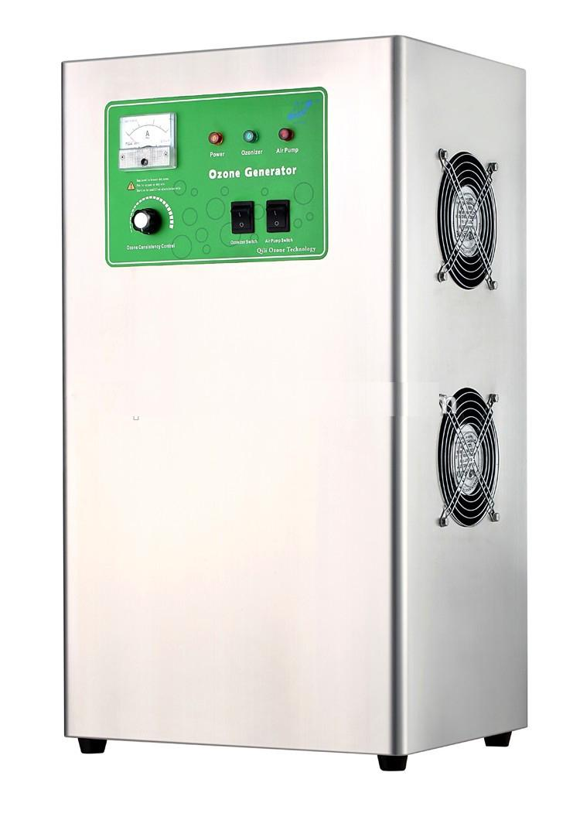

Nos. Offered :

1 Nos.

Type :

Natural Air Type

Flow Rate :

2000 Lph.

Ozone Dosing :

1 PPM

Casing :

SS

Manufacturer :

Aqua Zone or Equi

Application :-

Though R.O. System rejects all the micro – organisms like bacterial & virus and even after passing through U.V. System it may redevelop in packed bottles over a period of time. Hence, it is necessary to disinfect RO water prior to bottling filling. So that by using ozone gas generator we are producing ozone gas i.e. O3, & is passed through the water, as ozone is having capacity to kill the bacteria as well as to control the further growth In the stored & packed water. Also it is increasing the level of oxygen in the water, where water Becoming very healthy.
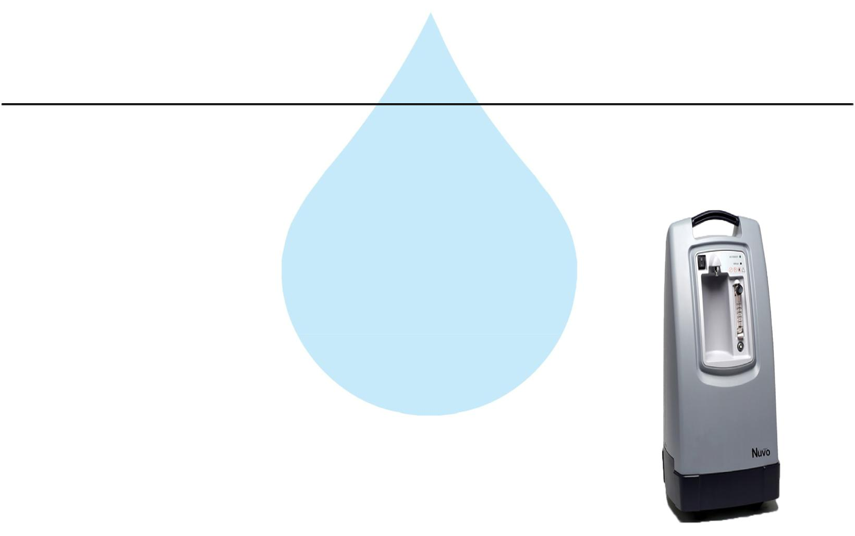

24. Oxygen Generator

Nos. Offered :

1 Nos.

Type :

Natural Air Type

Flow Rate :

2000 Lph

Make :

NUVO

Application :-

Though R.O. System rejects all the micro – organisms like bacterial & virus and even after passing through U.V. System it may redevelop in packed bottles over a period of time. Hence, it is necessary to disinfect RO water prior to bottling filling. So that by using ozone gas generator we are producing ozone gas i.e. O3, & is passed through the water, as ozone is having capacity to kill the bacteria as well as to control the further growth In the stored & packed water. Also it is increasing the level of oxygen in the water, where water Becoming very healthy.
25. Ozone Circulation Pump
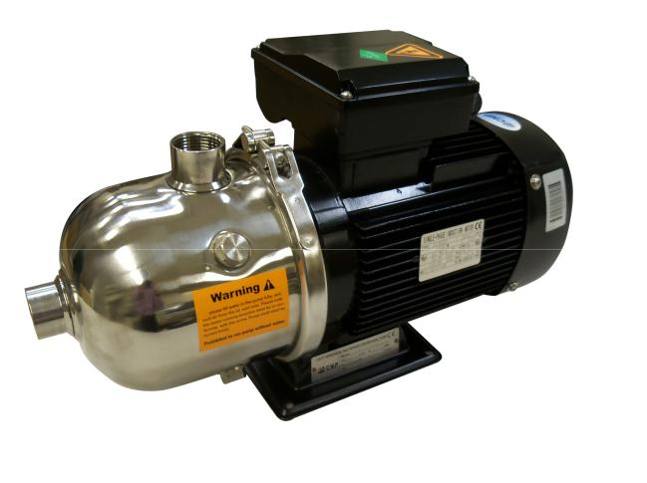

Type : Monoblock

Manufacturer : PNC

M.O.C. : SS

Capacity : | 0.5 HP

26. Ozone Circulation Tank

Nos. Offered :

1 Nos.

Type :

Vertical Cylindrical Type

M.O.C. :

SS 304

Capacity :

2000 Ltr.

Application :-

For required ppm Ozone gas mix up in finish product water. In ozone re-circulating tank water re-circulating by required flow rate pump . Ventury of ozone install out let of Pump it suction ozone and mix-up help with static mixer. This tank is provided with one no. of re-circulating pump and one no. of product water transfer pump to the filling section.

27. Stand For Unit
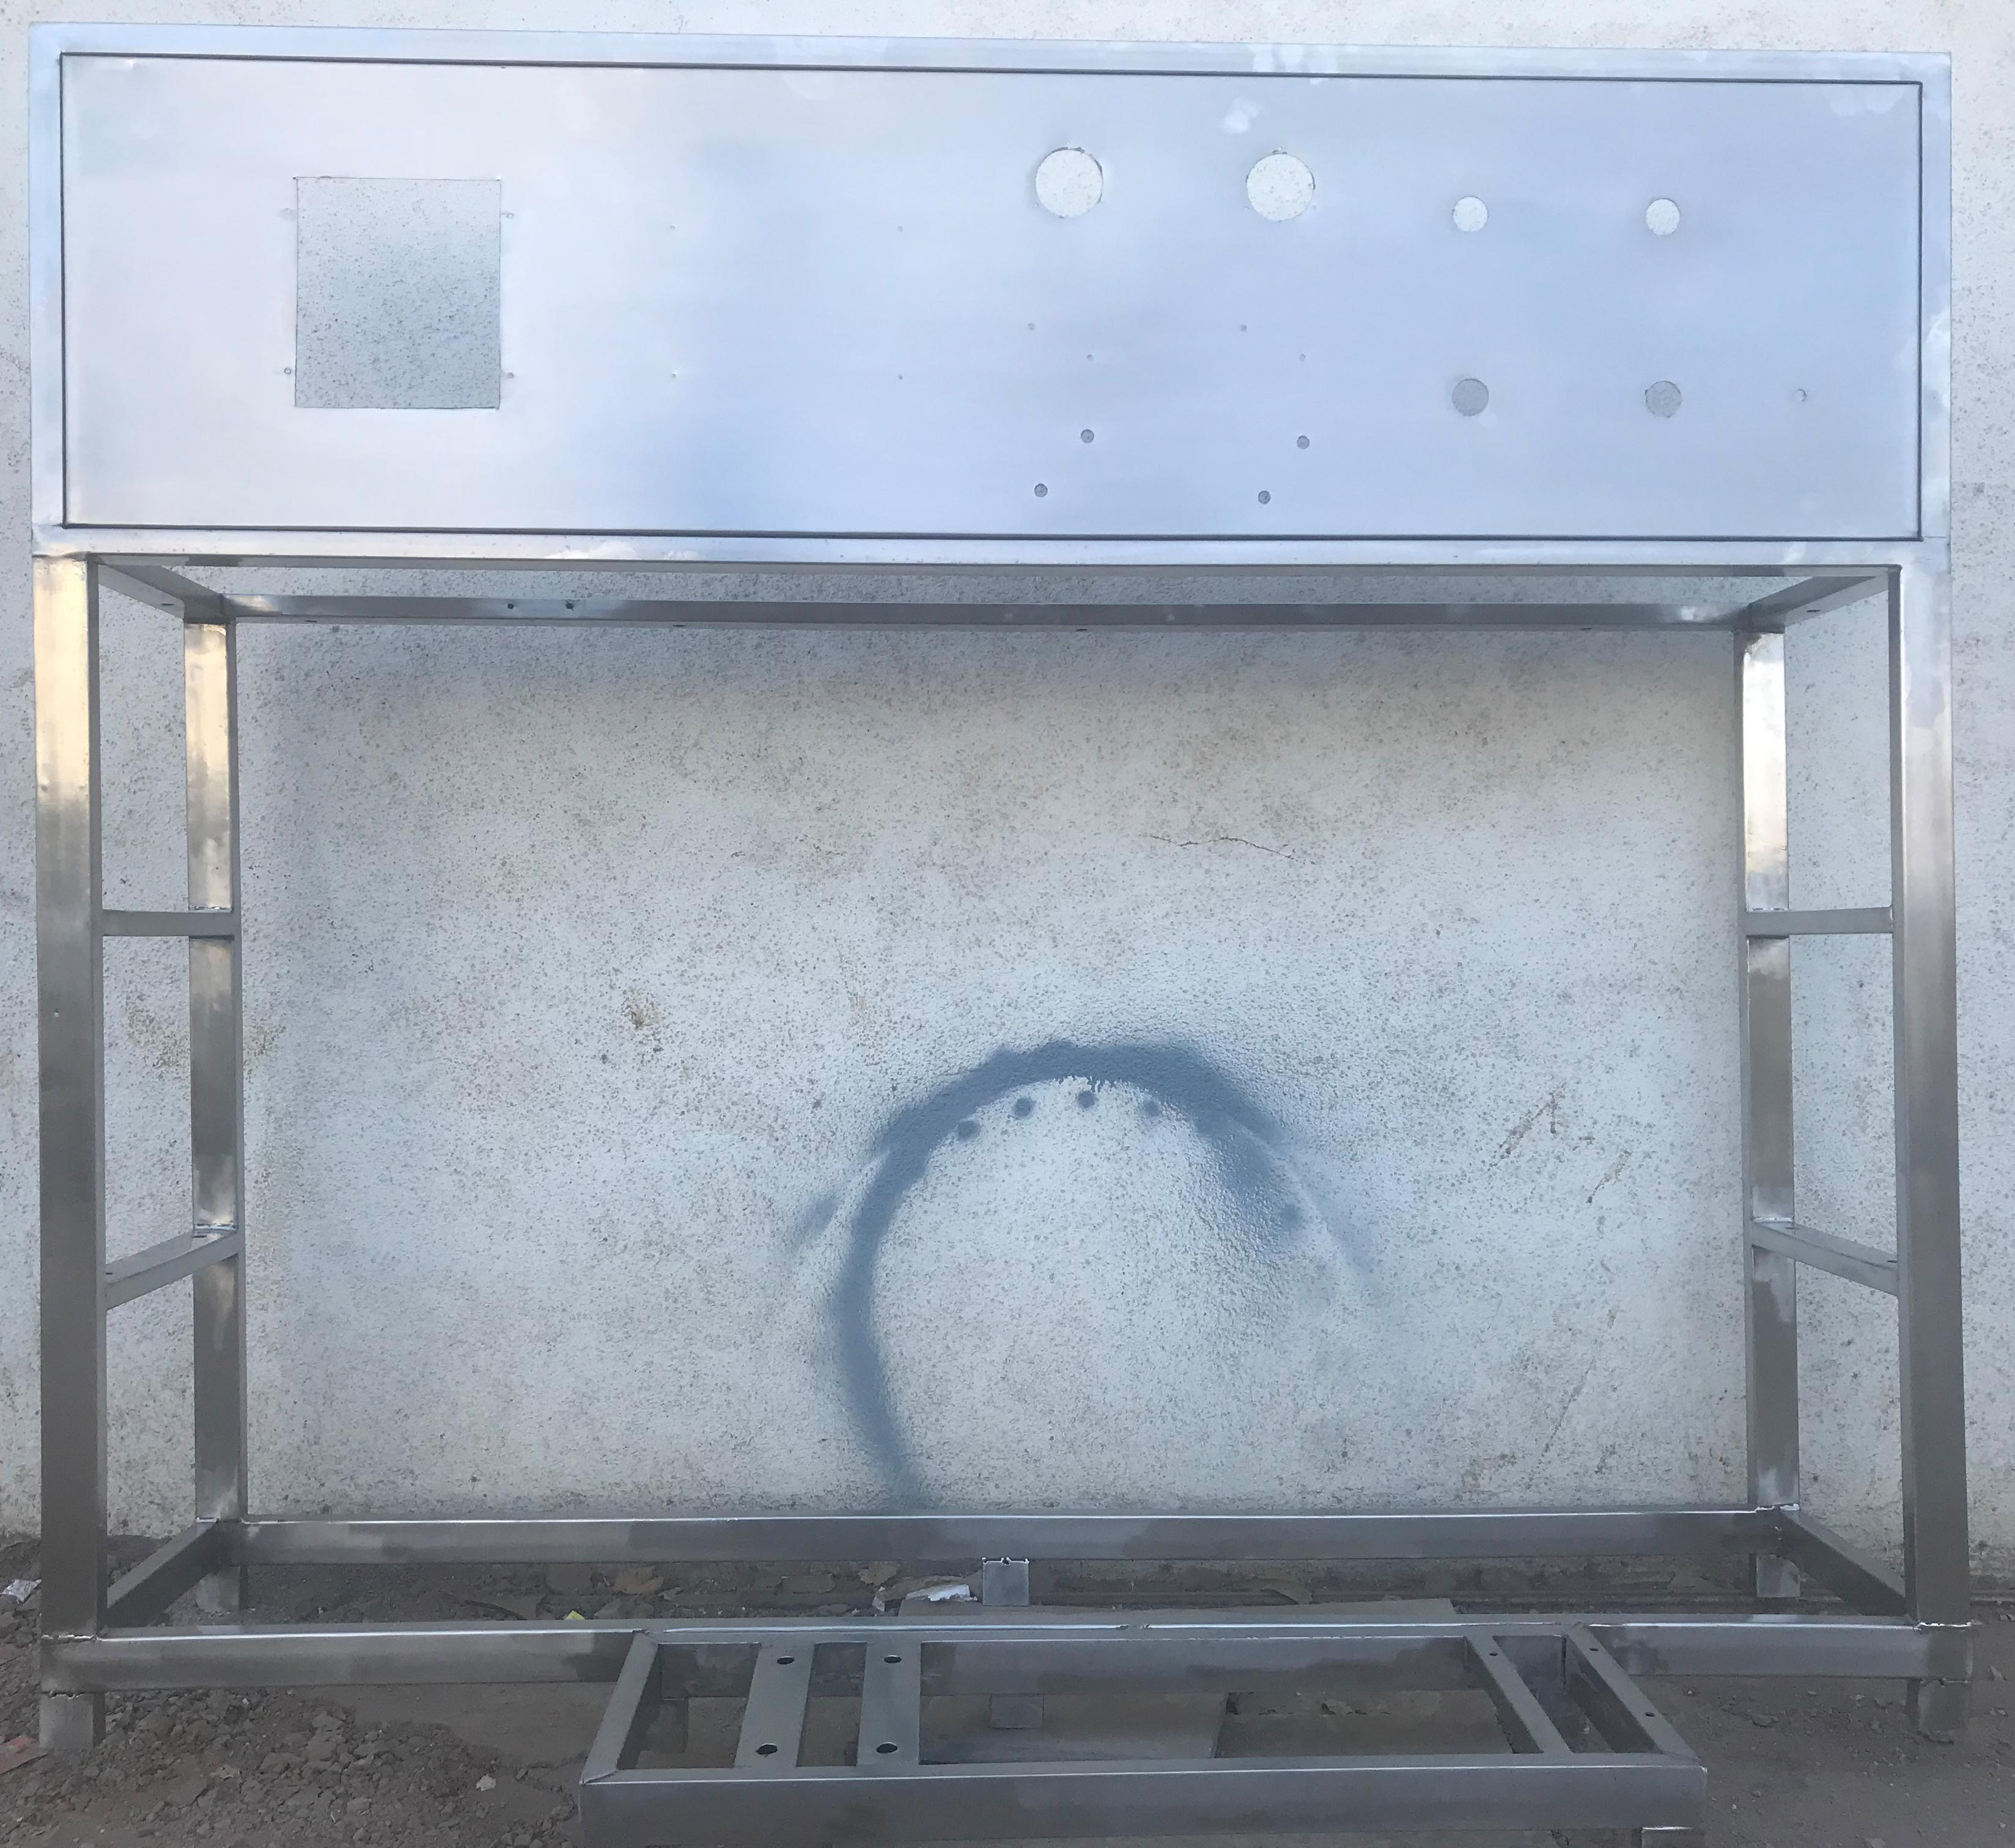

Stainless Steel : | S.S 304

Application :-

Complete stand for unit will be made of S.S.304
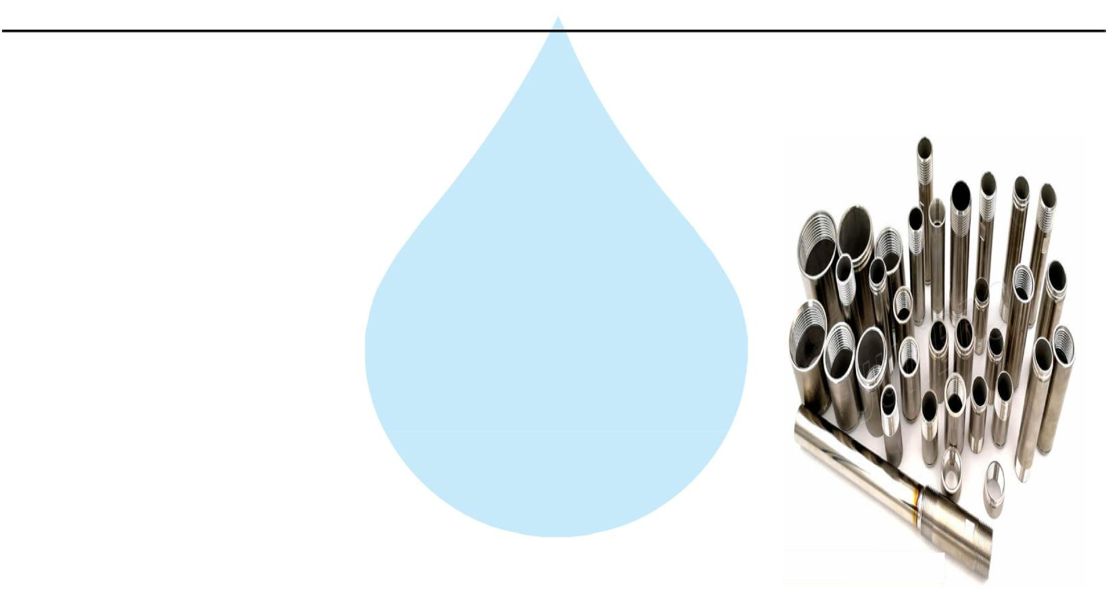

28. SS Interconnecting Pipe Lines

Stainless Steel : | S.S 304

Application :-

All interconnecting pipelines Raw water Pump to Ozone Circulating tank will be provided of S.S 304 by us

