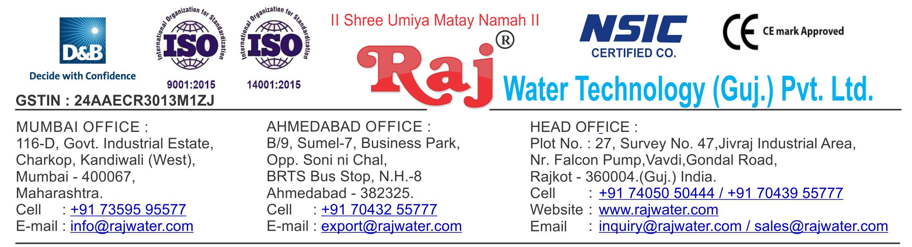

Date :- 1st April 2019

Monday

Quotation No | :- RW/2018-19/Q_9730/R_8
Concern Person | :- | Mr. Mahesh Laxman Teli
Concern Number | :- | 9922680365
Email Id | :- | ganeshteli30996@gmail.com
Company Name | :- M/s Smile Water Plant
Address | :-


Quotation For Carbonated Soda Soft Drink Project

Dear Sir ,

We are pleased to enclose our detailed Techno-Commercial offer, based on your requirement.

Contents of the Quotation

Commercial Proposal
Terms & Condition
Technical Specification for each product

Machinery Offer

Carbonated Soda Soft Drink Project

We hope the same is in line with your requirement. We shall gladly assist you in case you need any further clarification or information.

With warm Regards,

For , Raj Water Technology (Guj.) Pvt. Ltd.

Khushbu Deshani

Designation : Marketing Co-ordinator

Mobile : 7405050444

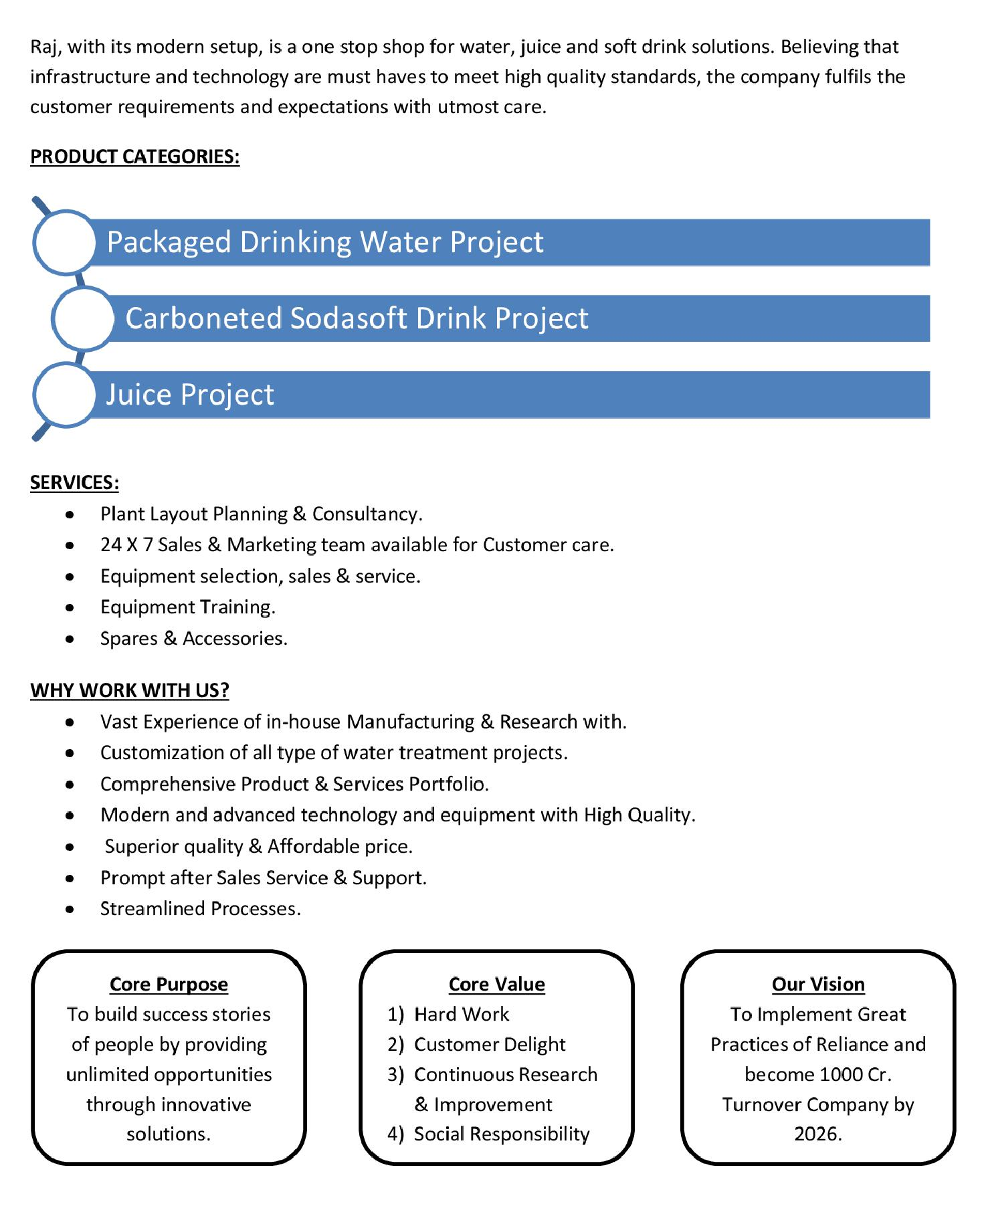

Commercial Proposal

Sr | Equipment Name |  | Qty | Basic Rate | Amount
No.
1 | Sugar Syrup Storage Triple Jacketed Tank 1000 Litre |  | 1 | 360000.00 | 360000.00
 | 1000 Lit. Ss 304 D.M. Water Storage Tank – Top &
 | Bottom Dish End ( 3 Mm) ,Shell 3mm + Half
 | Jacket(2.5mm Ss 304) + Acessories Like | Heater (16
 | Kw) + Spray Ball + Pg/Sv/Av For Shell | And Jkt +
 | Temp. Sensor+Llc Extra with control panel
 | Suger Filter Press 1000 LPH, With Pump & Hyflow |  | 1 | 350000.00 | 350000.00
2 | Coating, 100-Litre Tank Cooling PHE
3 | Sugar Loader With Control Panel |  | 1 | 250000.00 | 250000.00
4 | Flavored Mixing Tank 100 Litre, With Agitator & Pump |  | 1 | 85000.00 | 85000.00
5 | SS-304 1000 Litre Plain Tank For Sugar Syrup, With |  | 2 | 180000.00 | 360000.00
 | Agitator
6 | SS 304 Mixing Tank 2000 Litre, With Agitator |  | 2 | 300000.00 | 600000.00
 | Cooling Tower With Pump |  | 1 | 100000.00 | 100000.00
7
 | Water Chiller 25 Ton Capacity  Online Chiller Of 25 Tr Capacity, With Refrigerant And  Semi – Hermetic Scroll Compressor, Storage Tank With  Cooling Phe |  | 1 | 1125000.00 | 1125000.00
8
9 | Inter Connecting Piping For Sugar Syrup Room |  | 1 | 250000.00 | 250000.00
10 | Piping For Cooling Tower |  | 1 | 75000.00 | 75000.00
11 | Piping For Chiller Machine |  | 1 | 150000.00 | 150000.00

Sr | Equipment Name | Qty | Basic Rate | Amount
No.
 | Inter Connecting Piping Are Syrup Room To Filling | 1 | 150000.00 | 150000.00
12 | Machine Complete SS 304
 | Fully Automatic Rinser / C.P FILLER / Capper 12 X 12 | 1 | 3500000.00 | 3500000.00
 | X 4 Carbonated Soft Drink (CSD) PET
 | Rinser/Filler/Capper with Cap Elevator fitted with 600 ml
 | PET Bottle change parts, Rinser Water Circulation SS
13 | Tank with Pump, Pipe line and Electrical.
14 | Air Conveyor 7.5 Meters  7.5 Metres Stainless Steel Air Conveyors consisting of  straight section with 1 No Air Blower with Pre & Heppa  Filters for the above Line. | 1 | 300000.00 | 300000.00
15 | CHAIN CONVEYORS 10 Meters  Stainless Steel Section with MCC Holland plastic chain  conveyors with 1 No Inspection station and 1 Nos of  Drives for the above line. (As Per the Final Layout send  by you) | 1 | 350000.00 | 350000.00
 | Set Of Change Parts Suitable To Handle PET Bottles | 2 | 75000.00 | 150000.00
16 | For Rinser/Filler/Capper
18 | High Pressure Blower System  to remove the Water Droplets from the Bottle to be  installed on your single line conveyor after cooling  tunnel. | 1 | 150000.00 | 150000.00
19 | Carbonation Production Tank 2000 Litre Capacity | 1 | 1100000.00 | 1100000.00
20 | Co2 Manifold For 4 Cylinders | 1 | 85000.00 | 85000.00
21 | Mould For CSD 250 ML | 1 | 150000.00 | 150000.00
22 | Mould For CSD 500 ML | 1 | 175000.00 | 175000.00
23 | Mould For CSD 700 ML | 1 | 200000.00 | 200000.00
24 | Set Of Change Parts Suitable To Handle PET Bottles  For Labeller Make : | 3 | 150000.00 | 450000.00
 |  |  | Total Amount | 1,04,65,000.00

Terms & Condition

- Price

The Quoted Prices Are Ex-factory. (For India)

The Quoted Prices Are FOB. (For Export)

- TAX

GST 18% Extra Applicable. (For India)

- Payment

50% Advance Along With The Purchase Order, 30% After Inspection, & 20% Before Material Dispatch.

In Case Of Cancellation Of Confirmed Order Due To Any Reason, As A Part Of Penalty 25% Amount Of The Order Value Shall Have To Pay By You To Raj Water.

- Packing, Freight & Transit Insurance, & Unloading

Packing Charge Will Be Extra (Depend On Packing Material)

Transport To Be Arranged By The Customer OR If Arranged By Raj Water: Extra At Actual Plus GST.

Transportation Insurance In The Scope Of Buyer.

Unloading In The Scope Of Buyer. Buyer Has To Ready Forklift Or Crane And Unskilled Labor.

- Delivery

Schedule For Dispatch Will Be Notified.

Delivery Dates Are Approximate Only, And Assume Timely Receipt Of All Information, Test Materials & Payment.

- Warranty

We Shall Provide 1 Year Warranty For The Following:

Manufacturing Defects, Raw Water Pump, High Pressure Pump, Treated Water Transfer Pump.

Due To Fluctuation In Power Supply, Attempted Repaired By Person Other Than Our Technical Representative, Improper Handling Or Negligence By End Users, Poor Maintenance, Improper Use Of Equipment, That All Type Of Damage Not Covered In Warranty Create Area.

During The Warranty Period, We Shall Provide Supervisory Services Of Our Technical Representative As And When Required.

- Accommodation

Technician Charge Will Be Extra 1000/- Rs. Per Day.

Travelling, Lodging And Boarding, Local Conveyance And Any Other Miscellaneous Expense Of Our Technical Representative Will Have To Be Borne By Client.

- Validity

Our Offer Is Valid For Your Acceptance For A Period Of 6 Months From The Date; Thereafter It Will Be Subject To Confirmation By Us.

- Image

Images Are For Representation Purpose Only.

- Jurisdiction

All Terms Subject To Rajkot, Gujarat Jurisdiction.

