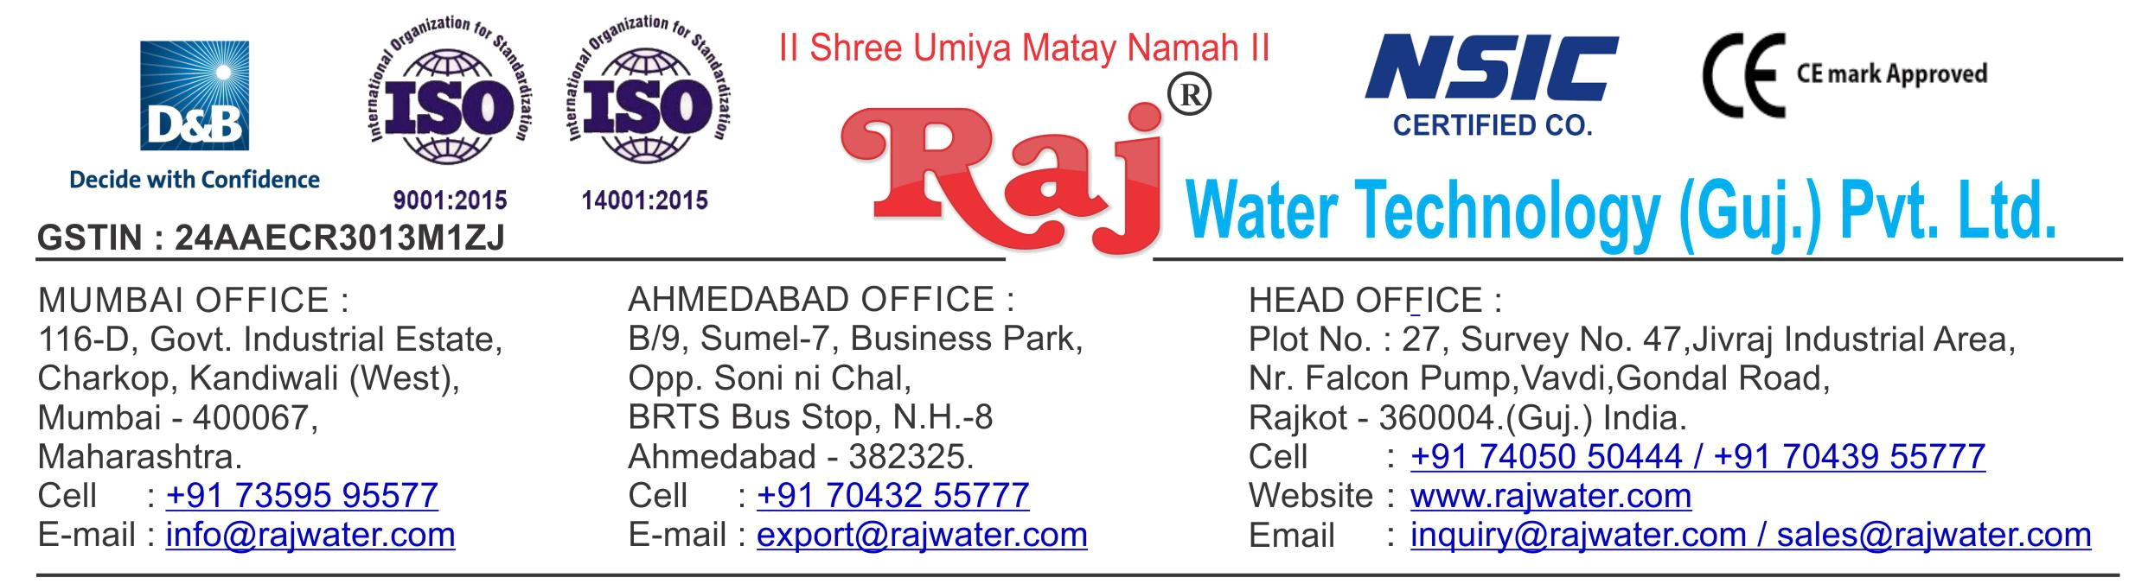

Date :- 1st April 2019

Monday

Quotation No | :- RW/2018-19/Q_9730/R_7
Concern Person | :- | Mr. Ganesh Teli
Concern Number | :- | 9922680365
Email Id | :- | ganeshteli30996@gmail.com
Company Name | :- M/s Smile Water Plant
Address | :-


Quotation For Packaged Drinking Water Project

Dear Sir ,

We are pleased to enclose our detailed Techno-Commercial offer, based on your requirement.

Contents of the Quotation

Commercial Proposal
Terms & Condition
Technical Specification for each product

Machinery Offer

Packaged Drinking Water Project

We hope the same is in line with your requirement. We shall gladly assist you in case you need any further clarification or information.

With warm Regards,

For , Raj Water Technology (Guj.) Pvt. Ltd.

KHUSHBU DESHANI

Designation : Marketing Asst. Manager

Mobile : 7405050444
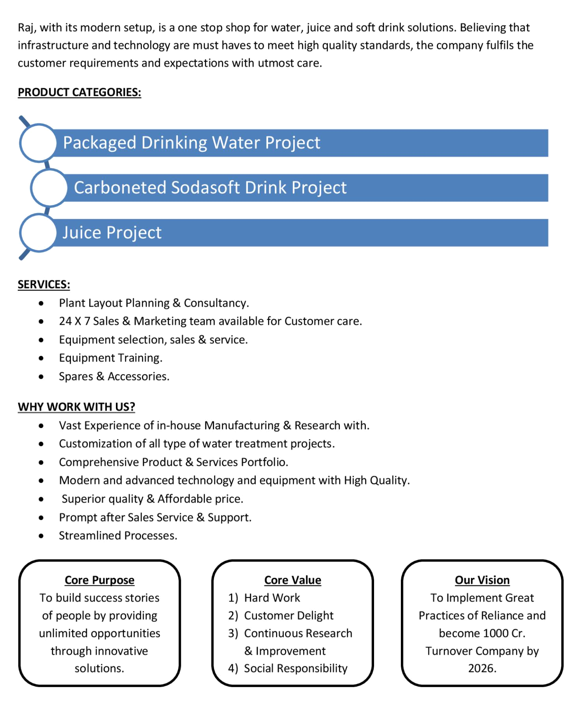
Commercial Proposal

Sr | Equipment Name | Qty | Basic Rate | Amount
No.
1 | 10000 Litre Per Hours SS-304 RO Plant With U.V | 1 | 2150000.00 | 2150000.00
 | System, SS Storage Tank 5000 Litre 2-Nos
 | With Ro Membrane Cleaning System, Mineral Dosing
 | System
 | Make : Raj
2 | Ozonation With Circulation System Make : Raj | 1 | 75000.00 | 75000.00
3 | Oxygenation Circulation System Make : Raj | 1 | 75000.00 | 75000.00
4 | WATER PET RINSER FILLER CAPPER : 16/16/6 ( 90 | 1 | 3500000.00 | 3500000.00
 | BPM)
 | Mineral Water PET Rinser/Filler/Capper with Cap
 | Elevator fitted with 200ml,500ml,1000 ml PET Bottle
 | change parts with Rinser Water Collection SS Tank
 | with Pump, Pipe line and Electrical.Note : All the
 | Product contact Parts like the Valves Filler Bowl/ Tank
Rinser Nozzles Pipes Fittings will be SS316L/316.
Make : Hilden
5 | Air CONVEYORS 10 METERS | 1 | 350000.00 | 350000.00
 | Stainless Steel Air Conveyors consisting of straight
 | section with 1 No Air Blower with Pre and Heppa filters
 | for the above line Make : Hilden
6 | CHAIN CONVEYORS 10 Meters | 1 | 350000.00 | 350000.00
 | Stainless Steel Section with MCC Holland plastic chain
 | conveyors with 1 No Inspection station and 1 Nos of
 | Drives for the above line. (As Per the Final Layout send
 | by you) Make : Hilden
7 | Fully Automatic BOPP Labeling Machine | 1 | 2450000.00 | 2450000.00
 | Fully Auto Labeling Machine.Roll feed labeling machine
 | with hot-melt glue Make : Hilden
8 | Set Of Change Parts Suitable To Handle PET Bottles | 3 | 150000 | 450000.00
 | For Labeller Make : Hilden
Sr | Equipment Name | Qty | Basic Rate | Amount
No.
9 | Automatic Pet Blowing Machine 5800 BPH, 4 KVT | 1 | 5500000.00 | 5500000.00
 | 1. Auto Preform loder and Hopper(SS)
 | 2. Auto Bottle Ejection and Transfer unit.
 | 3. Scrow Stretch Blow unit
 | 4. Air Recovery Unit
 | 5. Air Receiver/Tank made of MS. Theoretical
 | output 5800 Bottles/hr (200 ml - 2000 ml )
 | Make : Ishwari Pet
10 | High Pressure Air Compressor 75-HP (Oil Free) | 1 | 2150000.00 | 2150000.00
 | 200-CFM, 30 Kg / cm2 With Air Dryer Filter And Air
 | Receiver tank 500 Litre Make : Comp-Tech
11 | Low Pressure Air Compressor 40-HP Make : Comp-Tech | 1 | 400000.00 | 400000.00
12 | Low Pressure Air Dryer Make : Comp-Tech | 1 | 175000.00 | 175000.00
13 | Online Water Chiller 10-Ton With Storage Tank  Make : Bharat | 1 | 450000.00 | 450000.00
14 | Cooling Tower With Pump Make : Raj | 1 | 100000.00 | 100000.00
15 | 200 ML Mould 4-KVT Make : Raj | 1 | 350000.00 | 350000.00
16 | 500 ML Mould 4-KVT Make : Raj | 1 | 375000.00 | 375000.00
17 | 1 Litre Mould 4-KVT Make : Raj | 1 | 400000.00 | 400000.00
18 | 2 Litre Mould 4-KVT Make : Raj | 1 | 425000.00 | 425000.00
19 | Automatic Inkjet Batch Coding Machine Make : VideoJet | 1 | 200000.00 | 200000.00
20 | Automatic Shrink Wrapping With Auto Bottle Collating | 1 | 1350000.00 | 1350000.00
 | Feeding Unit, 90-BPM Make Saitech
21 | SS Piping RO Plant To Bottle Filling Machine Make : Raj | 1 | 100000.00 | 100000.00
Total Amount in Words :- |  |  | Total Amount | 2,13,75,000.00
Two Hundred thirteen Lakh Seventy Five Thousand
Terms & Condition

- Price

The Quoted Prices Are Ex-factory. (For India)

The Quoted Prices Are FOB. (For Export)

- TAX

GST 18% Extra Applicable. (For India)

- Payment

50% Advance Along With The Purchase Order, 30% After Inspection, & 20% Before Material Dispatch.

In Case Of Cancellation Of Confirmed Order Due To Any Reason, As A Part Of Penalty 25% Amount Of The Order Value Shall Have To Pay By You To Raj Water.

- Packing, Freight & Transit Insurance, & Unloading

Packing Charge Will Be Extra (Depend On Packing Material)

Transport To Be Arranged By The Customer OR If Arranged By Raj Water: Extra At Actual Plus GST.

Transportation Insurance In The Scope Of Buyer.

Unloading In The Scope Of Buyer. Buyer Has To Ready Forklift Or Crane And Unskilled Labor.

- Delivery

Schedule For Dispatch Will Be Notified.

Delivery Dates Are Approximate Only, And Assume Timely Receipt Of All Information, Test Materials & Payment.

- Warranty

We Shall Provide 1 Year Warranty For The Following:

Manufacturing Defects, Raw Water Pump, High Pressure Pump, Treated Water Transfer Pump.

Due To Fluctuation In Power Supply, Attempted Repaired By Person Other Than Our Technical Representative, Improper Handling Or Negligence By End Users, Poor Maintenance, Improper Use Of Equipment, That All Type Of Damage Not Covered In Warranty Create Area.

During The Warranty Period, We Shall Provide Supervisory Services Of Our Technical Representative As And When Required.

- Accommodation

Technician Charge Will Be Extra 1000/- Rs. Per Day.

Travelling, Lodging And Boarding, Local Conveyance And Any Other Miscellaneous Expense Of Our Technical Representative Will Have To Be Borne By Client.

- Validity

Our Offer Is Valid For Your Acceptance For A Period Of 6 Months From The Date; Thereafter It Will Be Subject To Confirmation By Us.

- Image

Images Are For Representation Purpose Only.

- Jurisdiction

All Terms Subject To Rajkot, Gujarat Jurisdiction.
Technical Specification

1. Chlorination Dosing Pump
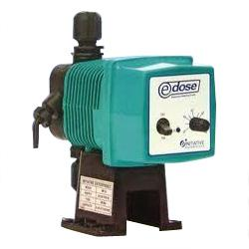

Type :

Dosing Type

Capacity : :

10 LPH

Make of pumps :

E-dose / I Dose

Power Requirement : Single phase 240 V

Nos : 1 Nos.

Application :-
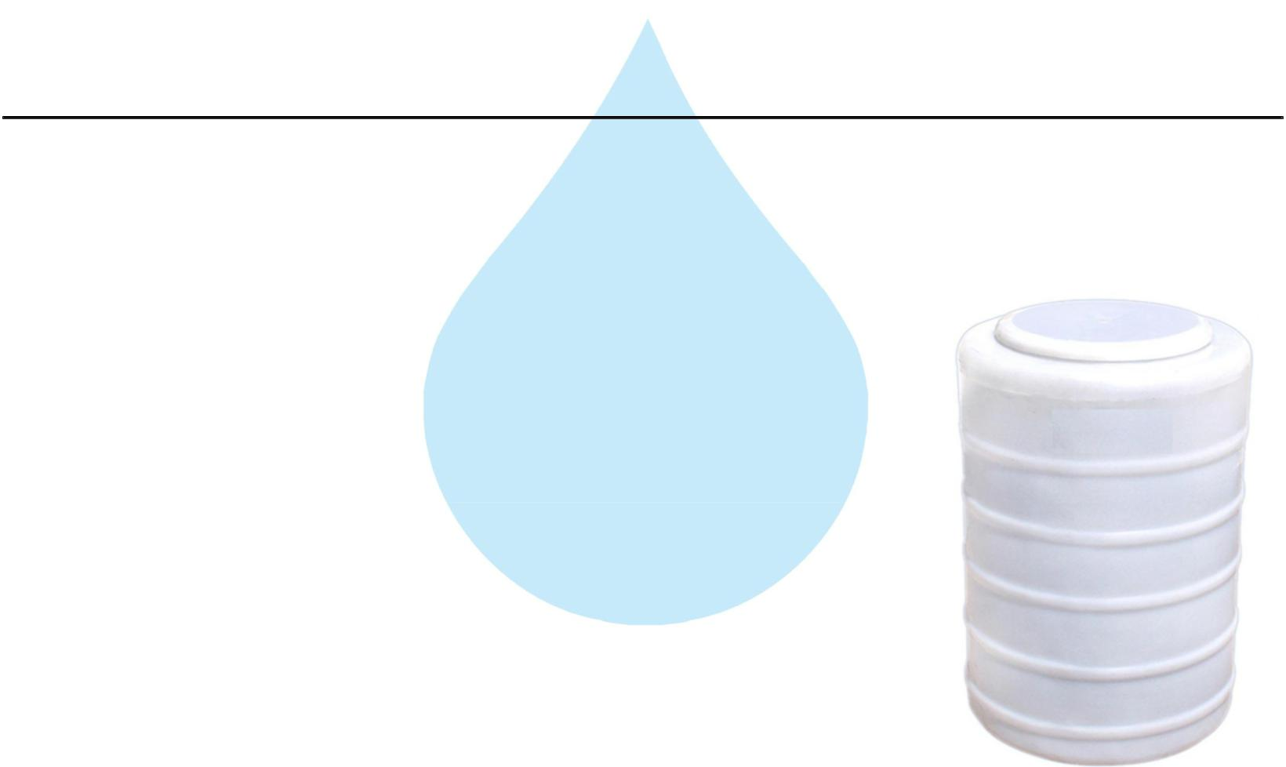

To Kill the harmful Bacteria in the raw water as well as To control the biological growth in the raw water, To prevent The organic fouling in the R.O. Membrane elements

2. Chlorination Dosing Tank

Type :

Conical Bottom

Capacity :

100 ltr

M.O.C. :

HDPE

3. Dechlorination Dosing Pump

Type :

Dosing type

Capacity :

10 LPH

Make of pumps :

Make of pumps

Power Requirement :

Single phase 240 V

Application :-

To Kill the harmful Bacteria in the raw water as well as, To control the biological growth in the raw water, To prevent,The organic fouling in the R.O. Membrane elements.
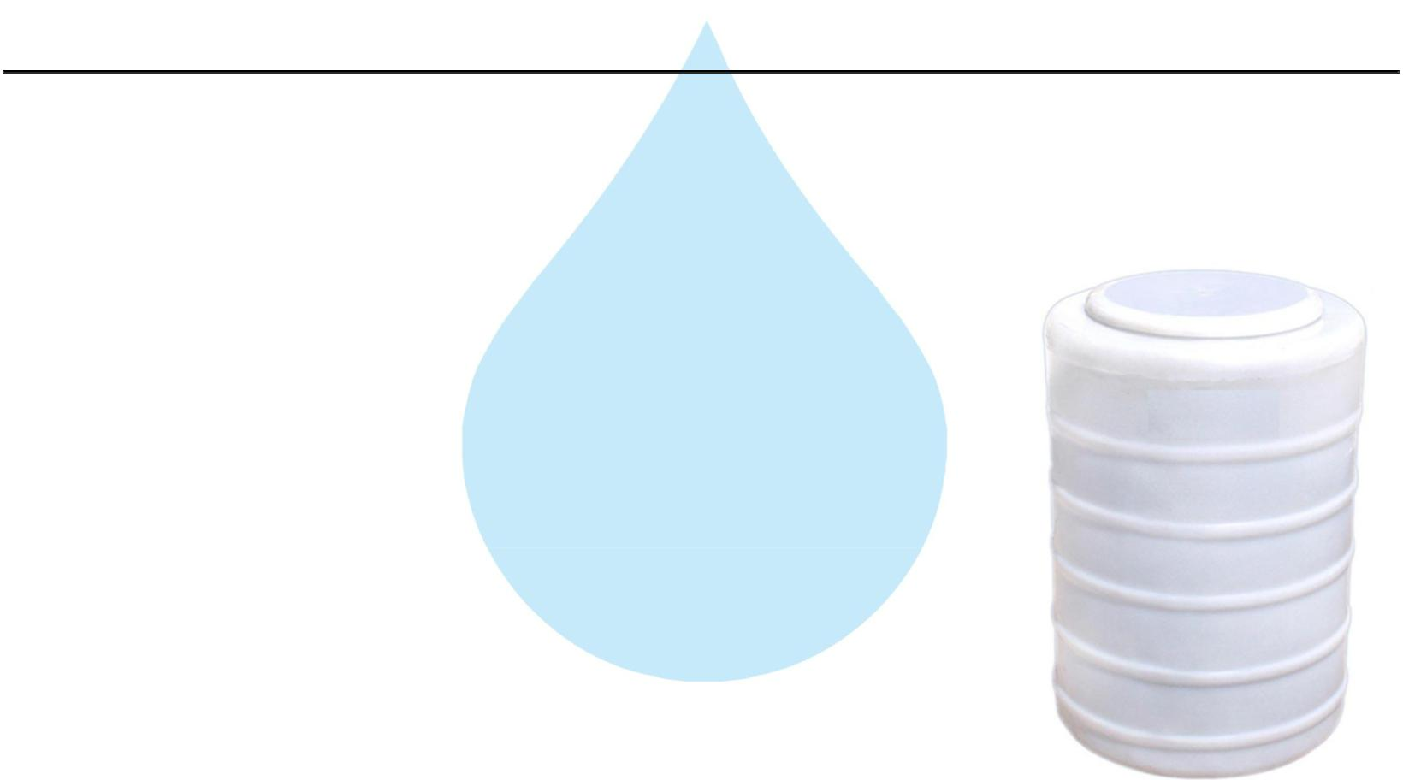

4. Dechlorination Dosing Tank

Type :

Conical Bottom

Capacity : :

100 Ltr

M.O.C :

HDPE

5. Raw Water Feeding Pump
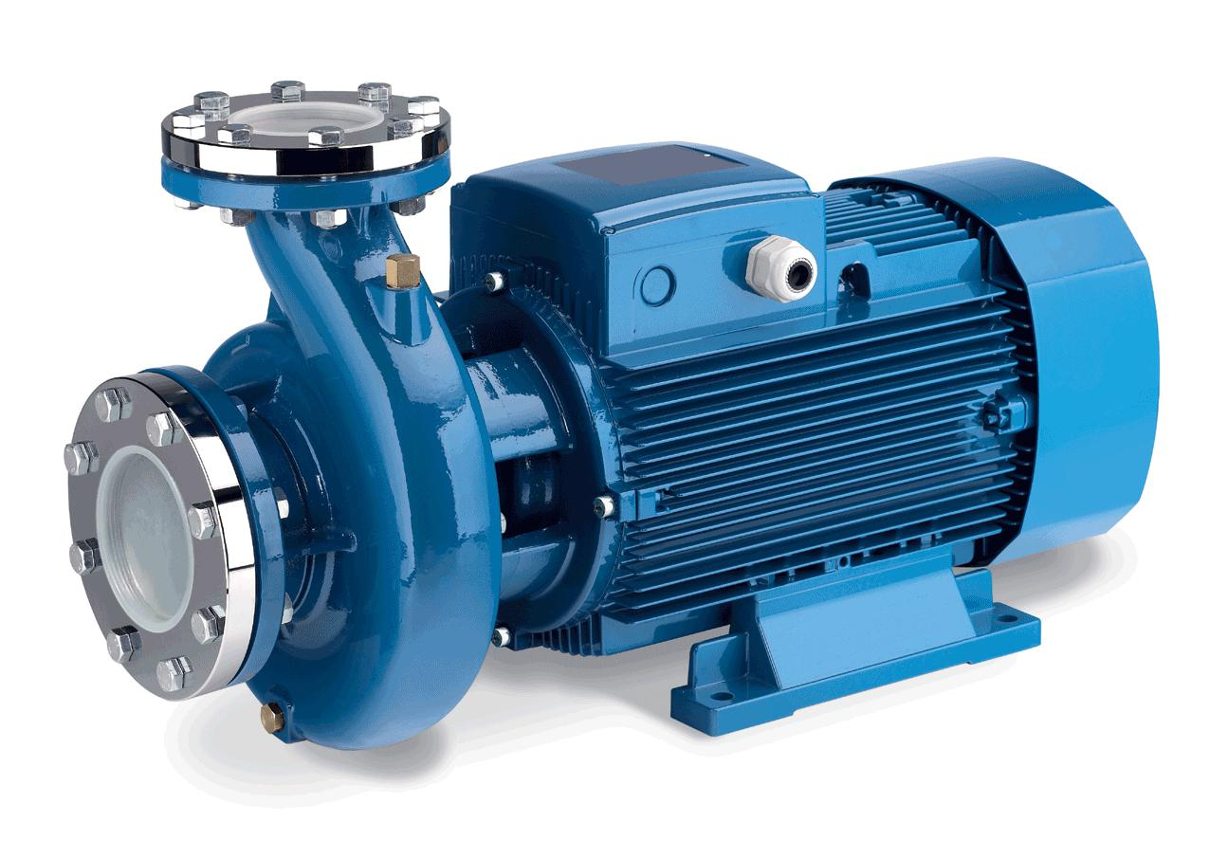

Type :

Centrifugal

Max. Flow :

22.00 m3/HR

Working Flow :

20.00 m3/HR

Working Pressure :

2 Kg. / Cm 2

M.O.C. :

C.I.

Power :

3.0 HP

Manufacturer :

Kirloskar / EQI

Nos. Offered :

1 Nos.

Application :-

To Pump Raw Water at Required Pressure so as to enable Transfer Through The RO Pre-Treatment Stage.
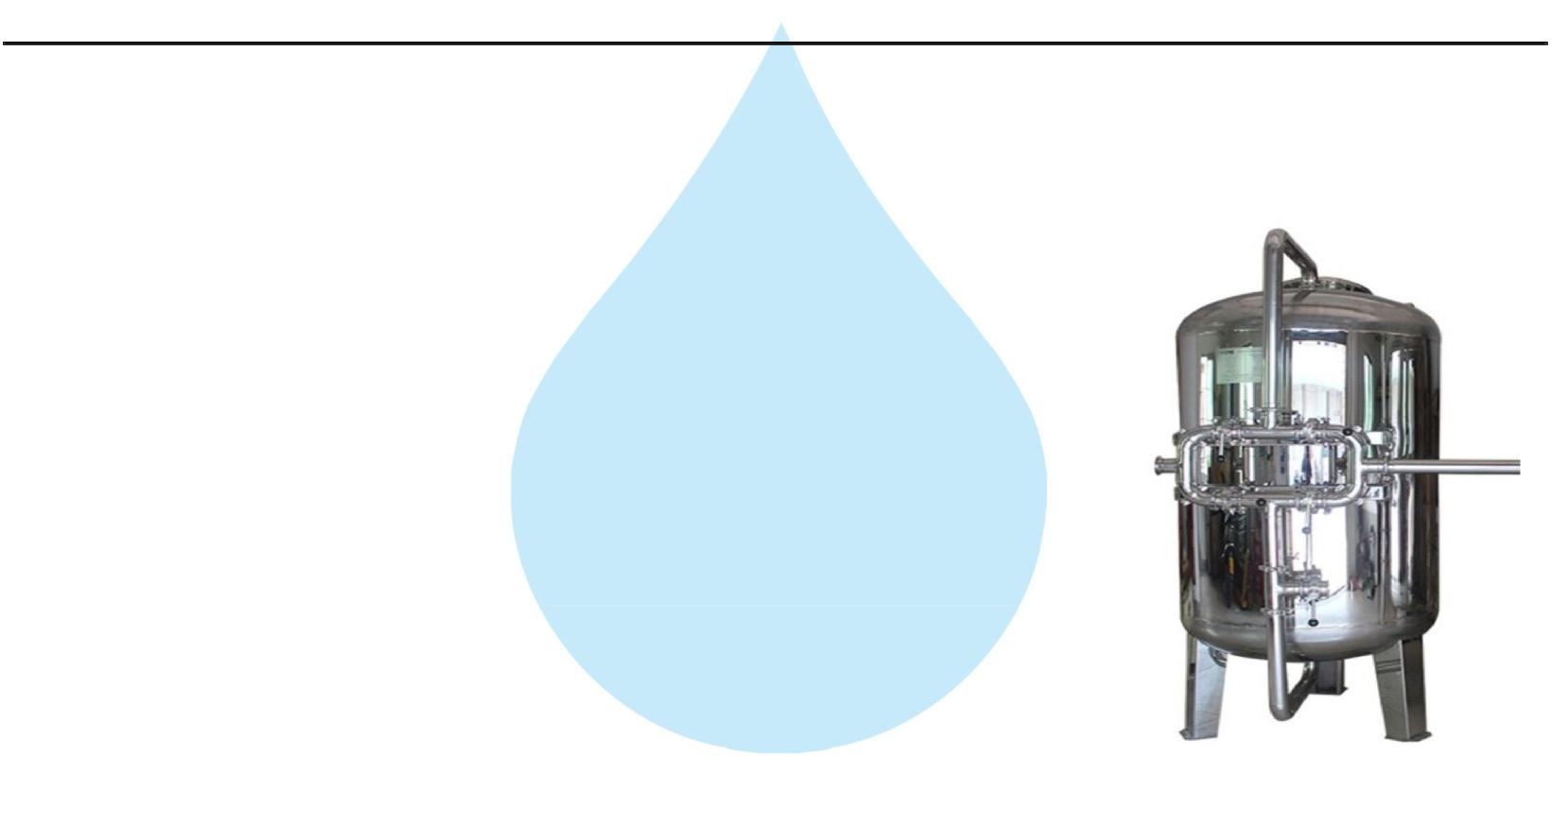

6. Pressure Sand Filter (SS)

Type :

Down Flow Graded Sand Type

Model :

4872/RW/MFG

M.O.C. :

SS 304

Size Dia X Height :

1200 mm Dia X 1800 mm

Pipe Line Size :

40 mm.

Sand Qty. :

1910 Kgs.

Valves :

SS Valve

Max. Flow :

22.00m3/HR

Working Flow :

20.00 m3/HR

Application :-

By means of Multi size Graded sand filled in the Vessel of stainless steel material, which is natural process of filtration adopted by the nature Raw Water is first filtered by filtration unit in series prior feeding RO Plant. Pressure Sand Filter Unit is provided for removal of suspended matters & turbidity from raw water. PSF Unit is a SS vertical Pressure Vessel. Internally, it is fitted with bottom collecting system. Uniform grades silica quartz sand is charged on the supporting media of pebbles and gravels.

7. Activated Carbon Filter (SS)
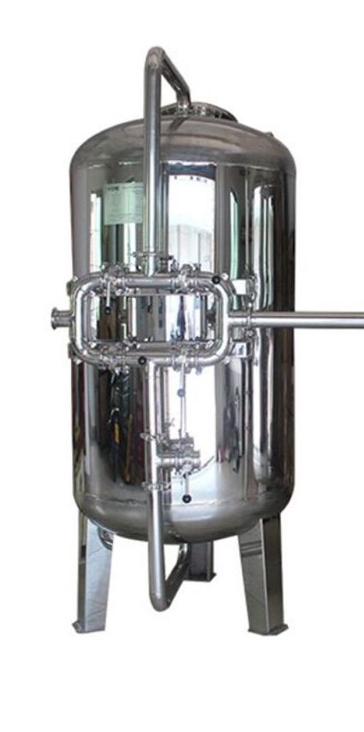

Type :

Down Flow Graded Sand Type

Model :

4872/RW/MFG

M.O.C. :

SS 304

Size Dia X Height :

1200 mm X 1800 mm

Pipe Line Size :

40 mm

Carbon Qty. :

765Kgs.

Valves :

SS Valve

Max. Flow :

22.00 m3/HR

Working Flow :

20.00 m3/HR

Application :-

To Remove taste, odour, chlorine, colour and. It can absorb contaminated particles of Oil & Grease from the raw water. It will control the BOD & COD in the raw water. Activated Carbon can remove Chlorine, Odour, & Colour other organic material from feed water prior to reverse osmosis. This Carbon granules having larger surface area and specific property to absorb organics.
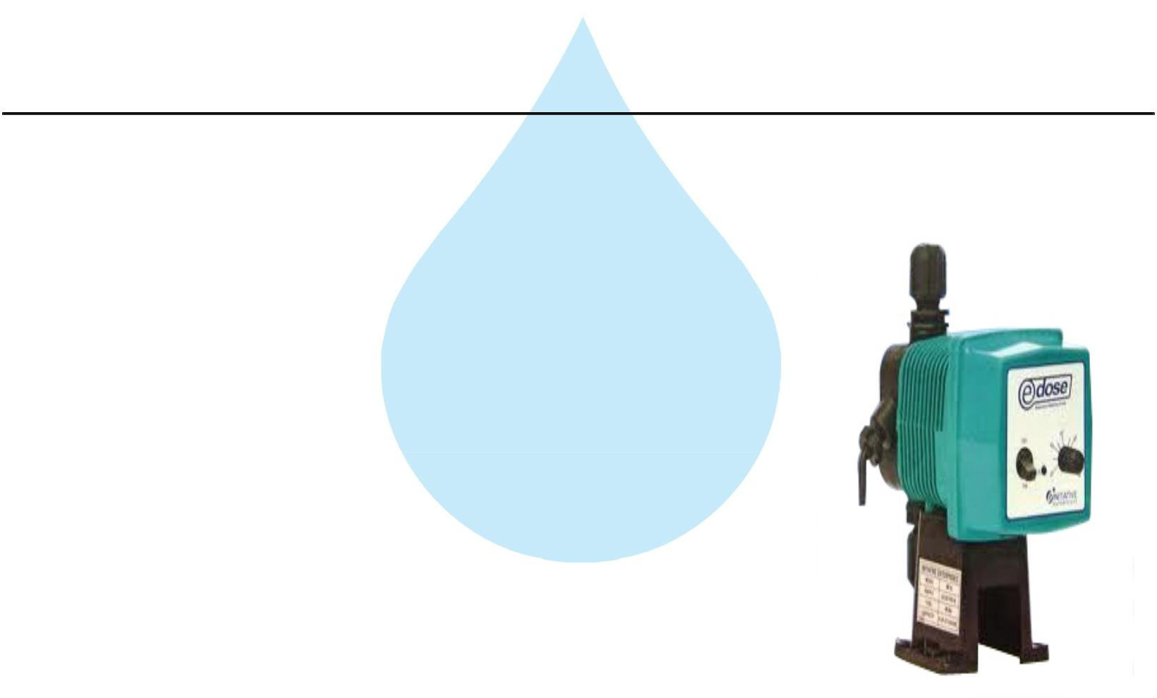

8. Antiscalant Dosing Pump

Type :

Ele. Diaphragm Type

Capacity :

0 to 6 LPH

M.O.C. :

PP

Dosing Chemical :

Antiscalent

Dosing Rate :

3 to 4 LPH

Make :

E Dose/ I Dose

Nos :

2 Nos

Application :-

The hardness salts of calcium & magnesium are likely to be precipitated if concentration exceeds its solubility limit

- it may faults the membranes resulting into scaling which ultimately leads to poor treated water quality from R.O.System.

9. Antiscaling Dosing Tank
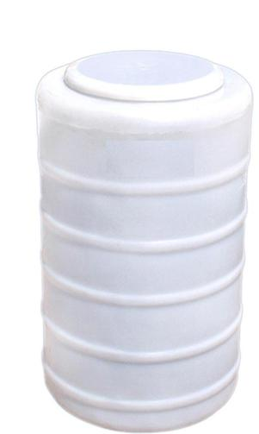

Type :

Conical Bottom

Capacity :

100 Ltr.

M.O.C. :

HDPE

Manufacturer :

Reputed

Nos :

2 Nos

10. Micron Cartridge Filter
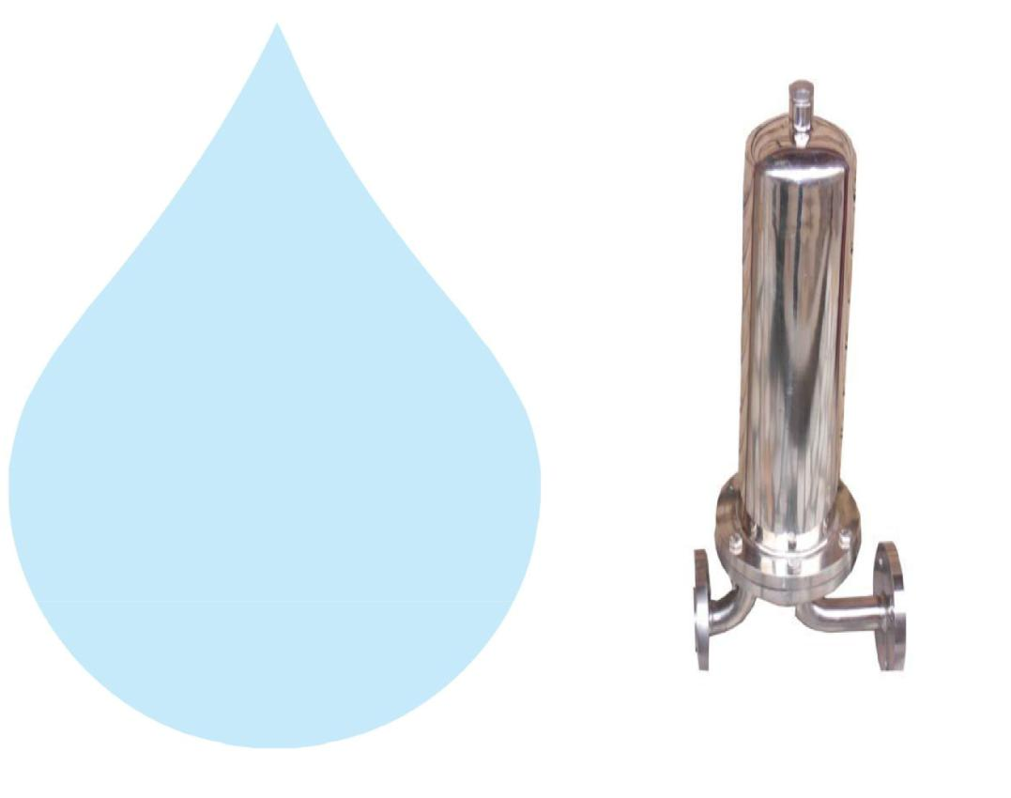

Model :

Size :

Micron Rating :

Type of Candle :

Material of Housing :

Nos. of Candles :

Max. Flow :

Working Flow :

MCF 30/RW/SS

30" Long

5 Micron

P. P. Spun / Wound

SS 304

6 Nos. (Jumbo)

22.00m3/HR

20.00 m3/HR

Application :-

To protect the membrane and the high pressure pump from suspended particles by removing them up to 5 Micron.

11. High Pressure Pump
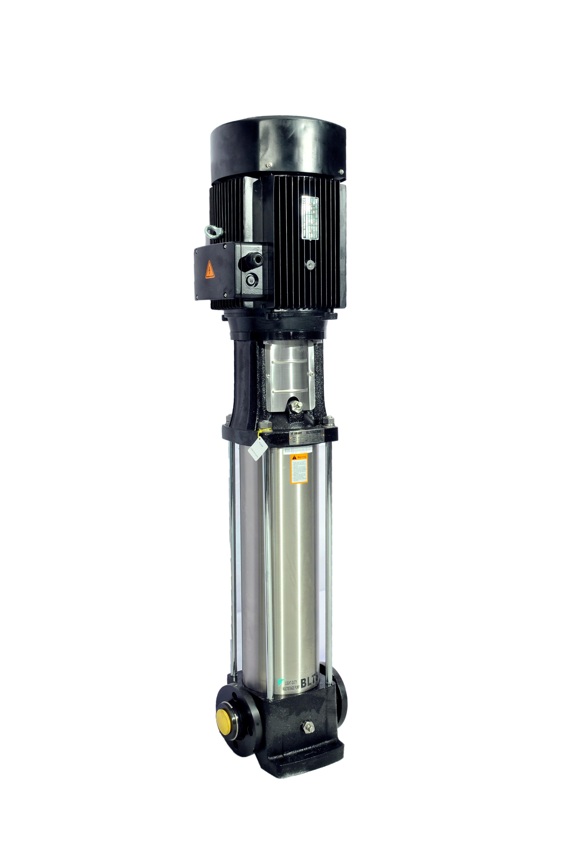

Type : | Vertical Centrifugal Pump
M.O.C. : | SS
Max. Pressure : | 13 | Kgs. / Cm 2.
Working Pressure : | 10 | Kgs. / Cm 2.
Max. Flow : | 22.00 m3/HR
Working Flow : | 20.00 m3/HR
Motor : | 15 | HP
Manufacturer : | 2900 RPM
Nos. Offered : | 3 Phase
Make of Pump : | PNC / EQI

Application :-

For Reverse Osmosis Process to take place feed pressure of water need to be raised. For this purpose a Vertical Multistage Centrifugal High Pressure Pump in S.S construction is provided R.O. System requires operating pressure of about 14-16 kg/cm^2 . High-pressure pump is fitted with S.S. discharge pipe work with necessary control valves. Necessary instruments like a High Pressure Switch, Pressure Gauge and recirculation valves are provided for safer operation of system
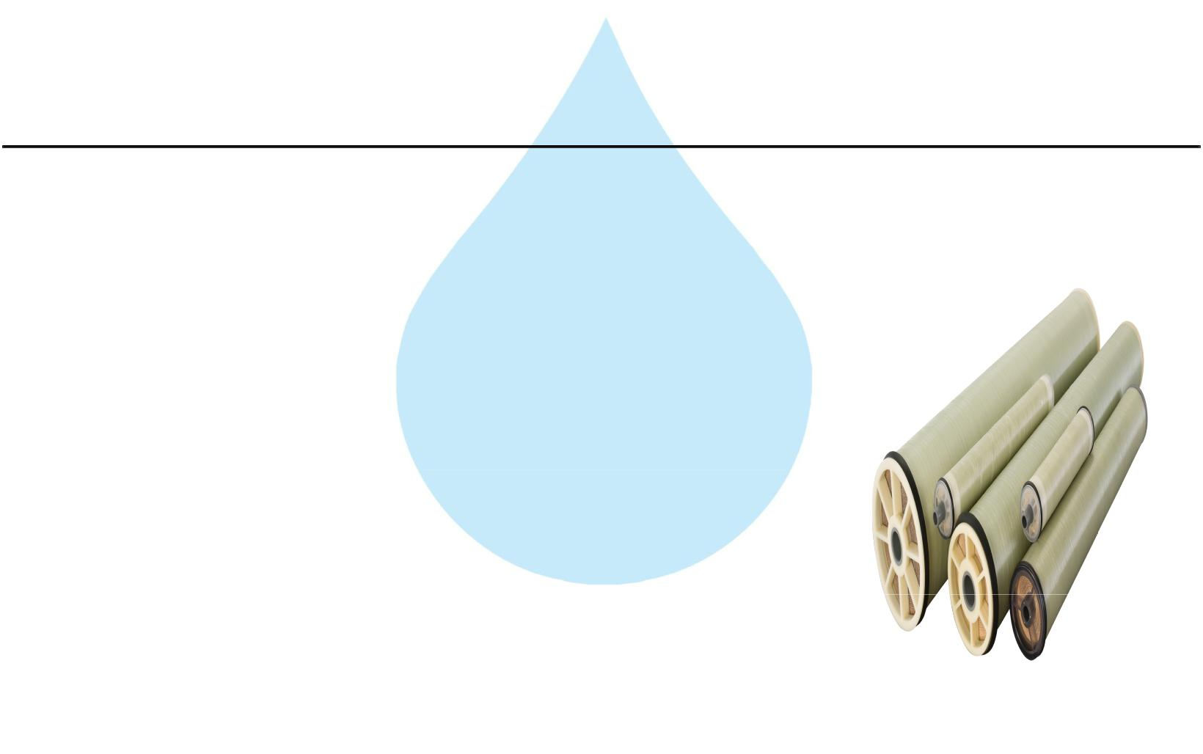

12. RO Membrane

Model :

8040 Element

Type :

TFC Spiral Wound

Material :

Polymide

Size :

8" Dia X 40" Long

Manufacturer :

Toray / Hydranautics / Dow / EQI

Nos. Offered :

10 Nos.

Application :-

To reduce Raw Water T.D.S. through the concept of Reverse Osmosis where R.O. Modules processes Raw Water and produces Purified Water having the Salt Rejection of Raw Water in the range of 90 – 95%. By using Semi permeable Membrane filter elements, where ion filtration process is carried out by applying pressure in the water. So finally we will get Low salt water with low total dissolve solids and High purity. Here will have to drain the water at one side to Wash the Membrane filter elements continuously because of filtration process there is nothing to be polluted in the system.
13. SS Pressure Vessels
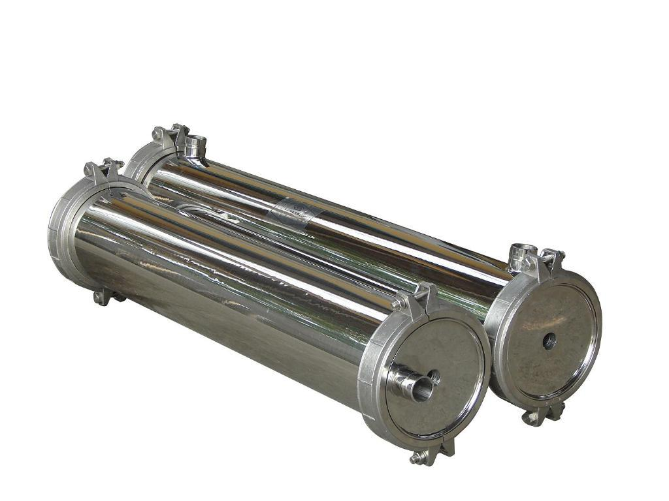

M.O.C. : | SS 304
Type : | Code/ SIDE/4
Size : | 8" X 200"
Max. Pressure : | 400 PSI
Working Pressure : | 150 PSI
Nos. Offered : | 2 Nos.

14. Mineral Dosing Pump
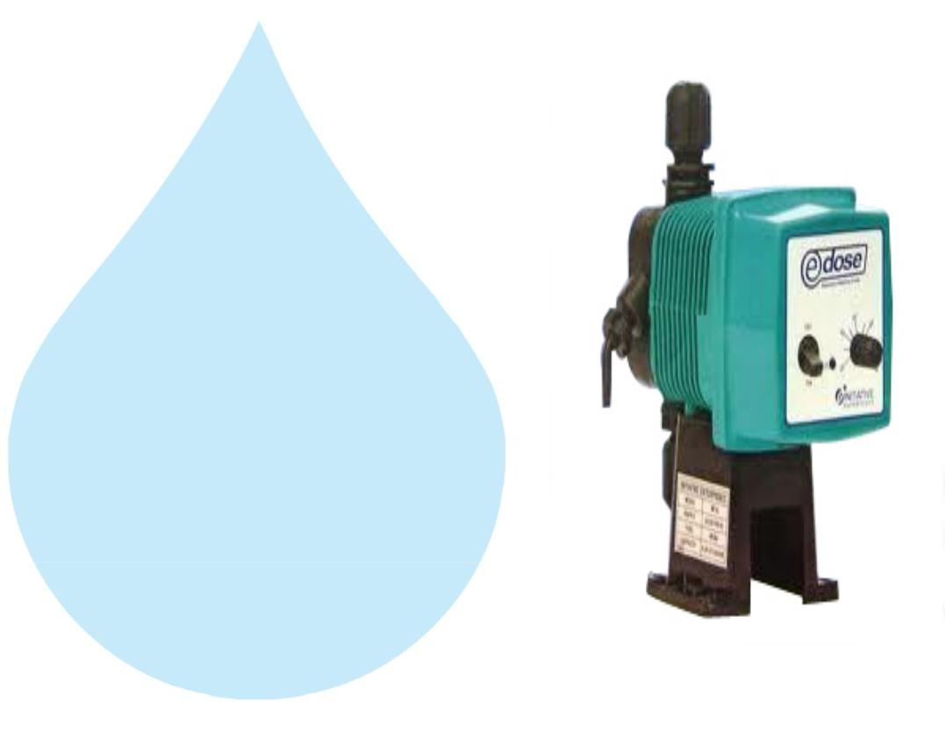

Type :

M.O.C. of Dosing

pump :

Electronic Diaphragm type

PP

Capacity : :

Make :

0 to 6 lph

E Dose / I Dose

15. Mineral Dosing Tank
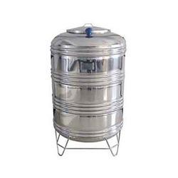

Type : | Conical bottom
Capacity : : | 100 ltr
M.O.C. : | SS 304

16. RO Membrane Cleaning Tank
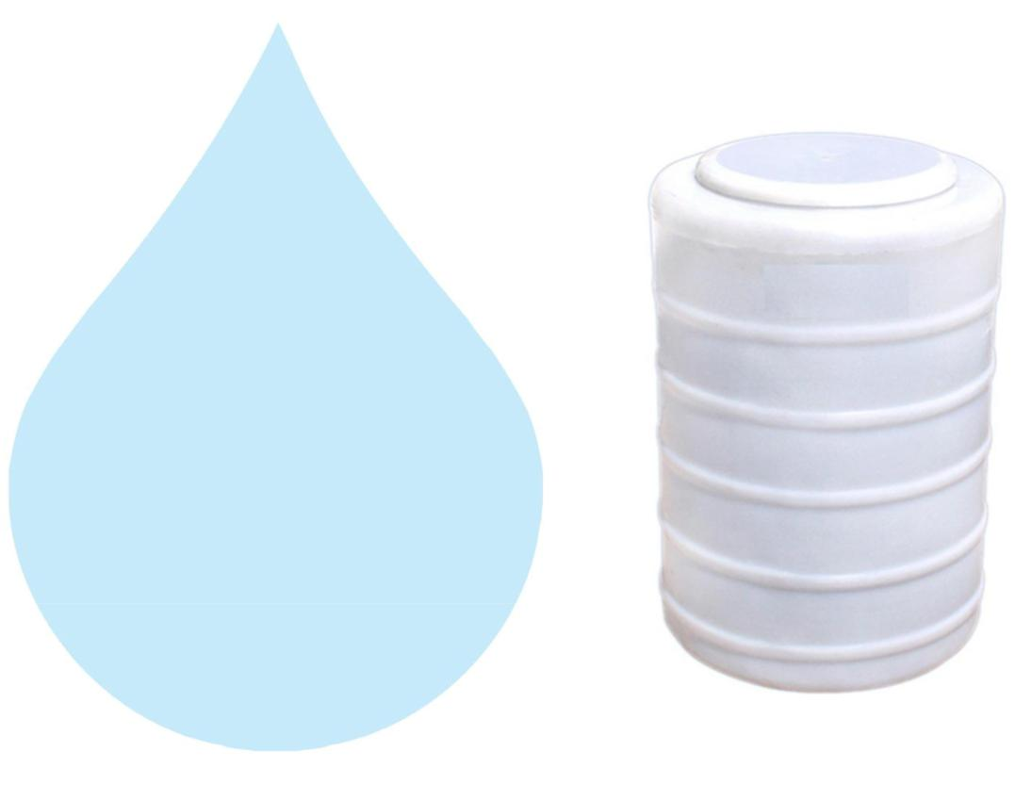

Working Flow :

Centrifugal

Working Flow :

1000 Ltr

M.O.C :

HDPE

17. RO Membrane Cleaning Pump

Model :

Centrifugal Multi Stage

Working flow :

8.00 m3/HR

Working pressure :

3.0 Kg/Cm2

Power :

1.H.P./2900 RPM

Make :

kirloskar

Nos :

1 Nos.

18. RO Membrane Cleaning Filter
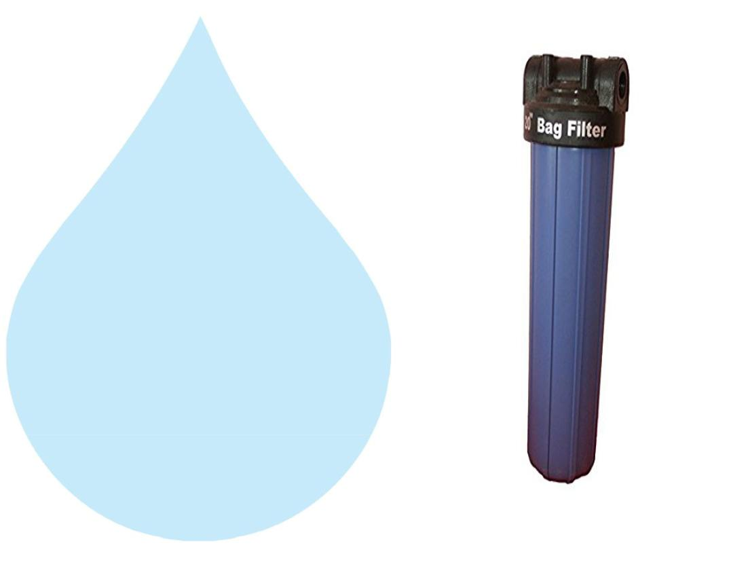

Model :

Size :

Micron Rating :

Type of Candle :

Material Of Housing :

Nos. of Candles :

Working Flow :

MCF 20/RW/PP

20” Long

5 Micron

P.P. Spun

PP

1 Nos.

8.00 m3/HR

19. Pressure Gauges
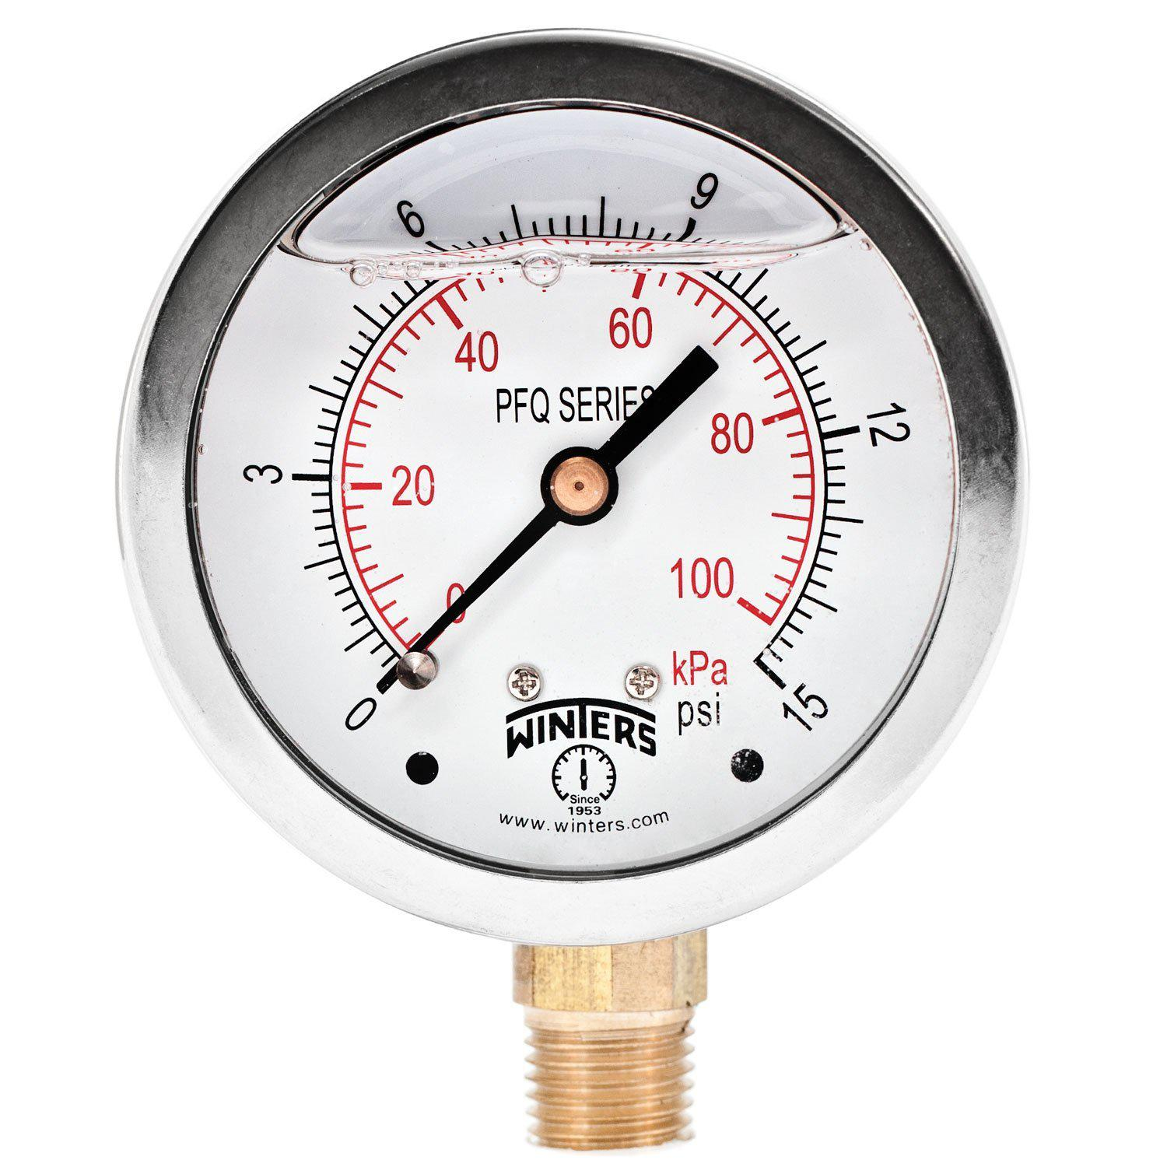

Pressure Gauges : | 7 | Nos.
Type : | Burdone Tube Type
Make : | Raj
Range : | 0 | - 28 , 0 - 7 Kg/cm2

20. Rota Meters
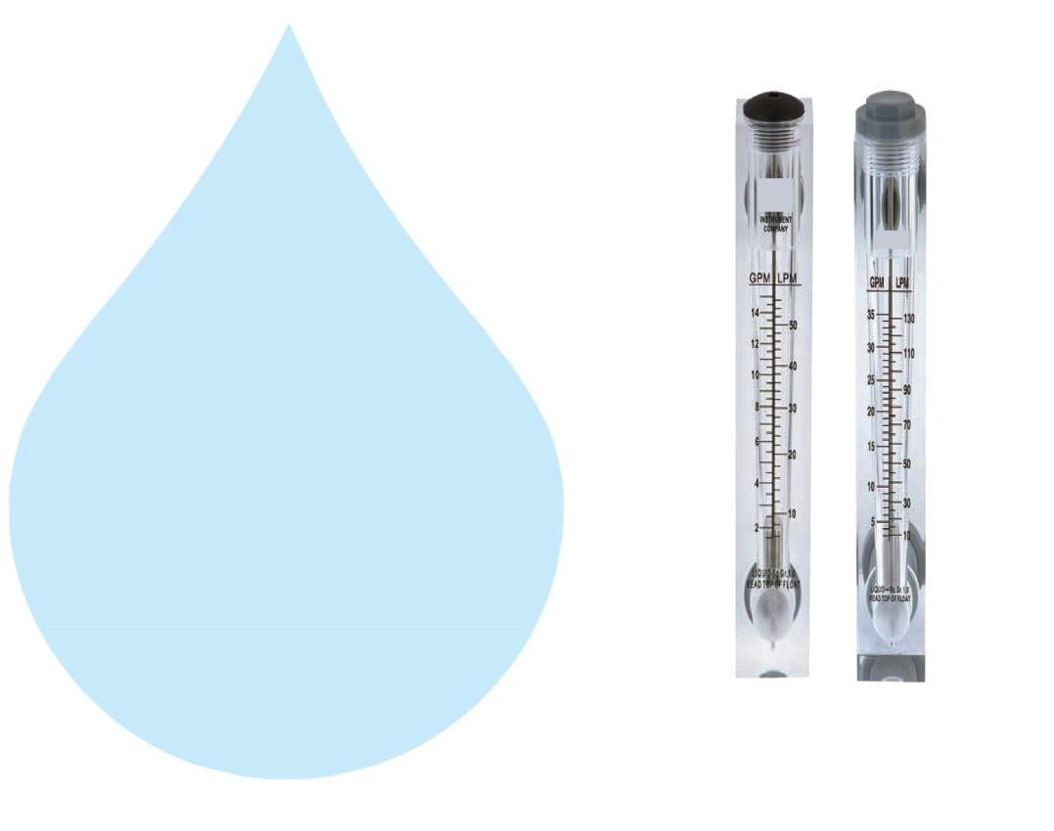

Rota Meters :

Type :

M.O.C. :

Reject Water Range :

Treated Water Range

:

2 Nos.

Float

Acrylic Body

SS Float (0 - 20000 Lph.)

SS Floar (0 - 12000 Lph.)

21. Control Panel - PLC Base
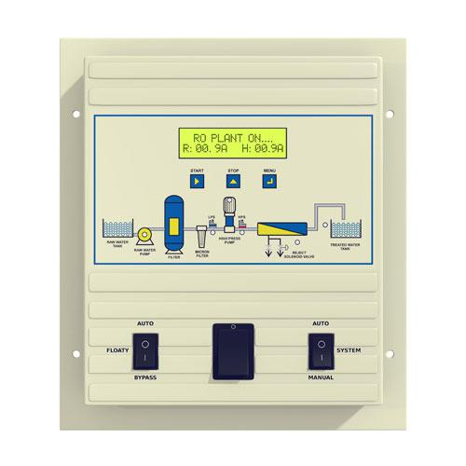

Make : Astral

22. Pressure Switch
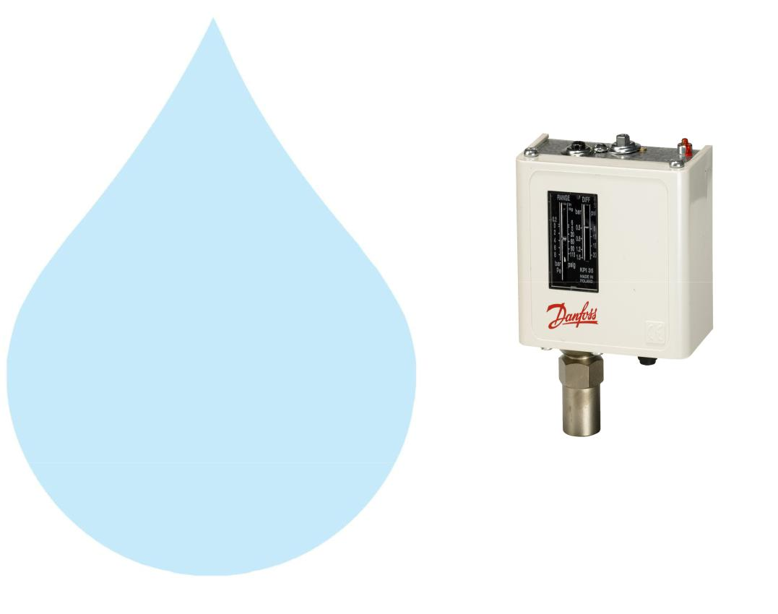

Pressure Switch :

Type :

Make :

Model :

2 Nos.

Low / High Pr.

Denfoss

IPS 70 / 400

23. Treated Water Storage Tank
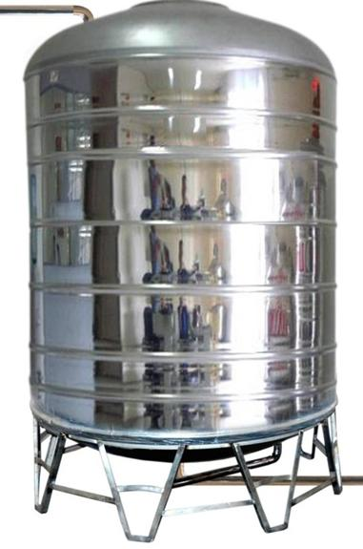

Nos. Offered :

1 Nos.

Type :

Vertical Cylindrical Type

M.O.C. :

SS 304

Capacity :

5000 Ltr.

Application :-

To store Reverse Osmosis permeate (product) water. It can remove back pressure in R.O. Membrane elements. It is only storage of the treated Water.
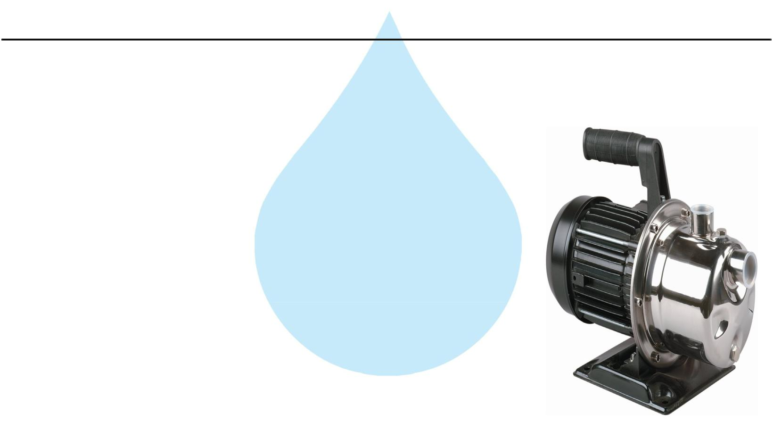

24. Treated Water Transfer Pump

Type :

Monoblock

Make :

PNC/Eqi

M.O.C. :

SS

Capacity :

2.0 HP

Working Flow :

10 M3/ HR

Application :-

To feed water to downstream to micron filters and UV system and filling line

25. Post Micron Cartridge Filter-1
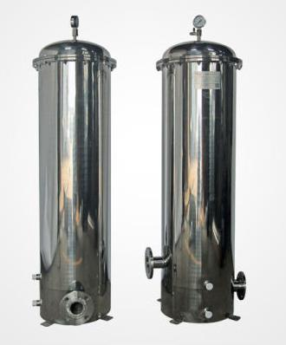

Model :

MCF 30/RW/SS

Size :

30" Long

Micron Rating :

2.0 Micron

Type of Candle :

P. P Spun

Material of Housing :

SS 304

Nos. of Candles :

1 Nos

Working Flow :

10.00 m3/HR

Application :-

During storage, atmospheric or any other contamination may take place in treated water. Hence, after passing water from R.O. System, water is once again passed through a micron cartridge filter. To remove micron particles up to 2.0 Micron sizes.
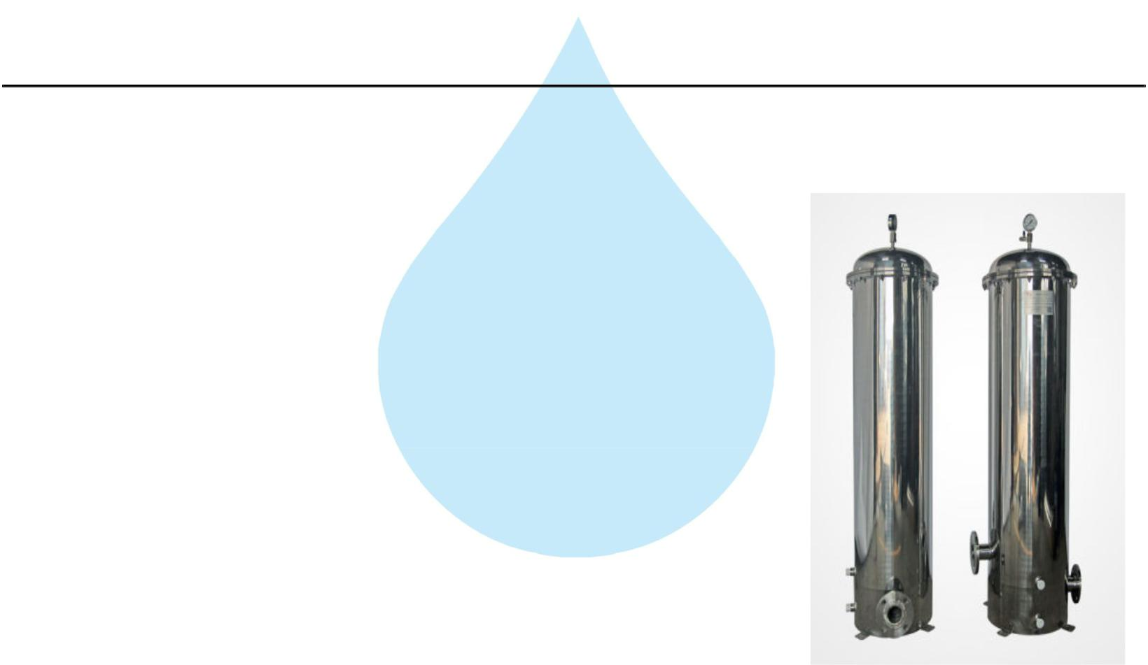

26. Post Micron Cartridge Filter-2

Model :

MCF 30/RW/SS

Size :

30" Long

Micron Rating :

1.0 Micron

Type of Candle :

P. P. Spun

Material of Housing :

SS 304

Nos. of Candles :

3 Nos

Working Flow :

10.00 m3/HR

Application :-

This Vessel fitted internally with P.P spun micron cartridge elements having absolute ratings of 1.0 micron & 0.2 microns which removes all bacterial impurities present in the water and make the water free of particulates.

27. Post Micron Cartridge Filter-3

Model :

MCF 30/RW/SS

Size :

30" Long

Micron Rating :

0.5 Micron

Type of Candle :

P. P Spun

Material of Housing :

SS 304

Nos. of Candles :

3 Nos

Working Flow :

10.00 m3/HR

Application :-

During storage, atmospheric or any other contamination may take place in treated water. Hence, after passing water from R.O. System, water is once again passed through a micron cartridge filter. To remove micron particles up to 2.0 Micron sizes.
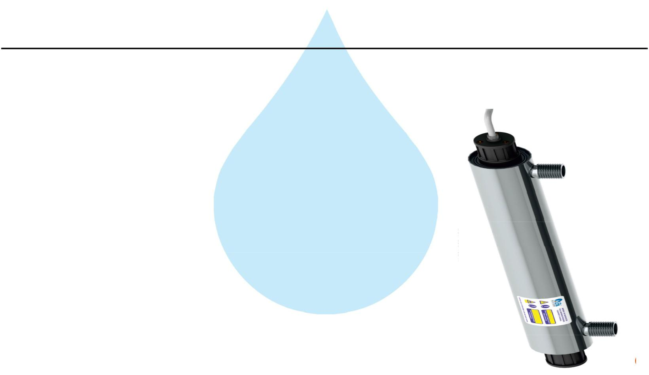

28. U. V. Disinfection System

Type :

Fluorescent Tube

Working Flow :

10000 Lph

Working Pressure :

1 Kg. / Cm 2

Material :

SS 304

Make :

Raj

Nos. Offered :

1 Nos.

Application :-

For removal of micro biological organisms up to 99.9%.

29. Ozone Generator
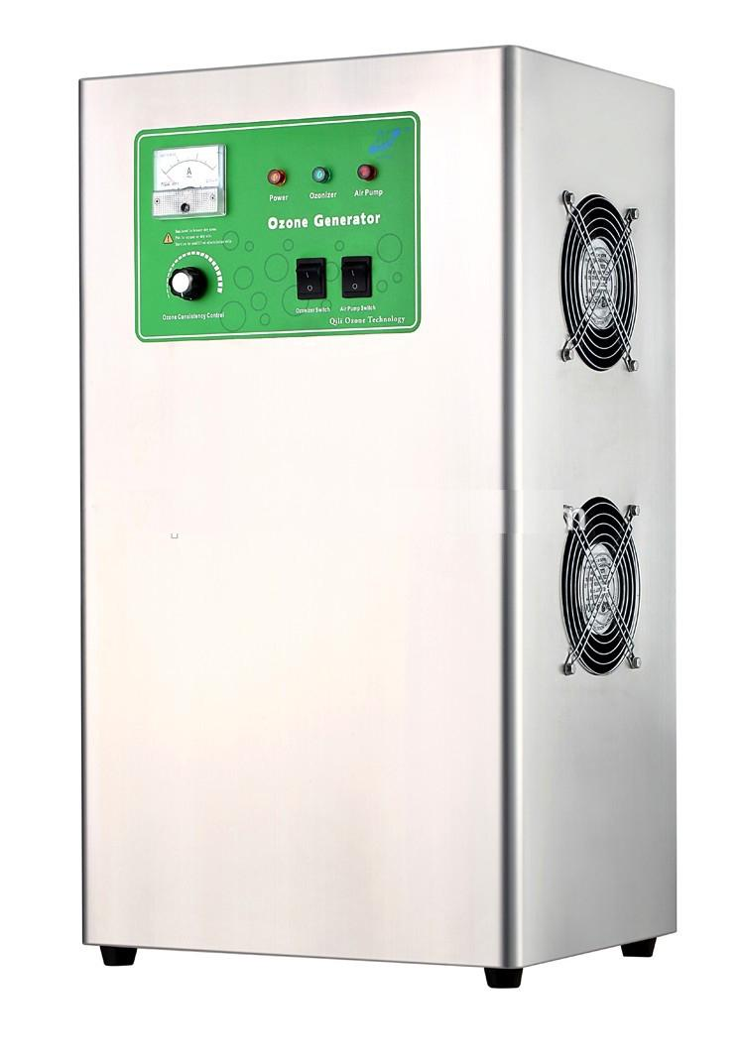

Nos. Offered :

1 Nos.

Type :

Natural Air Type

Flow Rate :

10000 Lph.

Ozone Dosing :

1 PPM

Casing :

SS

Make :

Aqua Zone or Equi

Application :-

Though R.O. System rejects all the micro – organisms like bacterial & virus and even after passing through U.V. System it may redevelop in packed bottles over a period of time. Hence, it is necessary to disinfect RO water prior to bottling filling. So that by using ozone gas generator we are producing ozone gas i.e. O3, & is passed through the water, as ozone is having capacity to kill the bacteria as well as to control the further growth In the stored & packed water. Also it is increasing the level of oxygen in the water, where water Becoming very healthy.
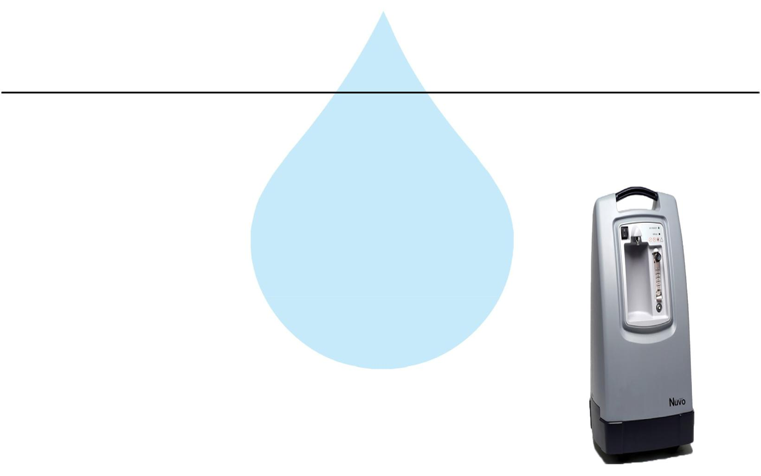

30. Oxygen Generator

Nos. Offered :

1 Nos.

Type :

Natural Air Type

Flow Rate :

10000 Lph

Make :

NUVO

Application :-

Though R.O. System rejects all the micro – organisms like bacterial & virus and even after passing through U.V. System it may redevelop in packed bottles over a period of time. Hence, it is necessary to disinfect RO water prior to bottling filling. So that by using ozone gas generator we are producing ozone gas i.e. O3, & is passed through the water, as ozone is having capacity to kill the bacteria as well as to control the further growth In the stored & packed water. Also it is increasing the level of oxygen in the water, where water Becoming very healthy.
31. Ozone Circulation Pump
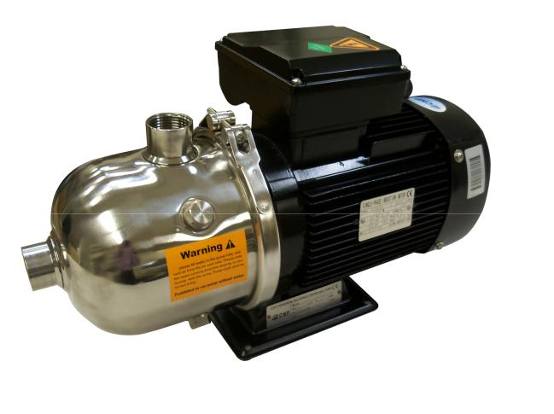

Type :

Monoblock

Make :

PNC/Eqi

M.O.C. :

SS

Capacity :

1.0 HP

Working Flow :

10.00 m3/HR

32. Ozone Circulation Tank
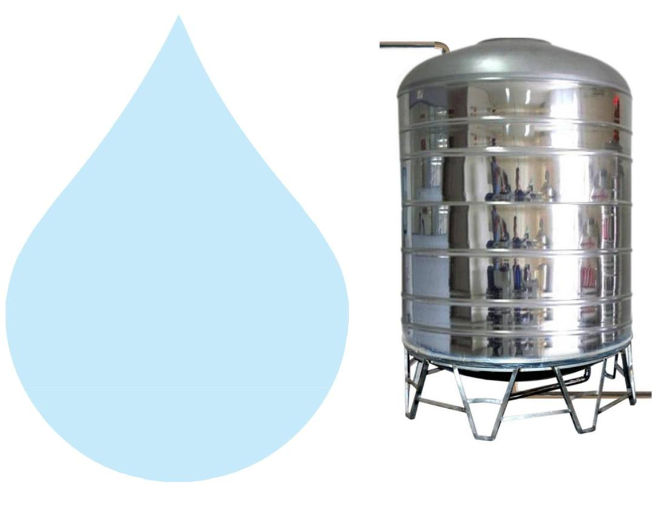

Nos. Offered :

1 Nos.

Type :

Vertical Cylindrical Type

M.O.C. :

SS 304

Capacity :

5000 Ltr.

Application :-

For required ppm Ozone gas mix up in finish product water. In ozone re-circulating tank water re-circulating by required flow rate pump . Ventury of ozone install out let of Pump it suction ozone and mix-up help with static mixer. This tank is provided with one no. of re-circulating pump and one no. of product water transfer pump to the filling section.

33. Final Water Transfer Pump
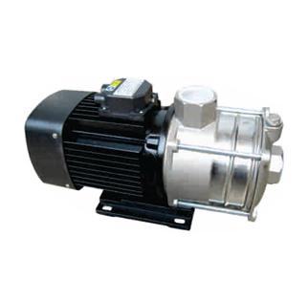

Type :

Make :

M.O.C. :

Capacity :

Working Flow :

Monoblock

PNC/Eqi

SS

2.0 HP

10M3/ HR

Application :-

To feed water to downstream to micron filters and UV system and filling line
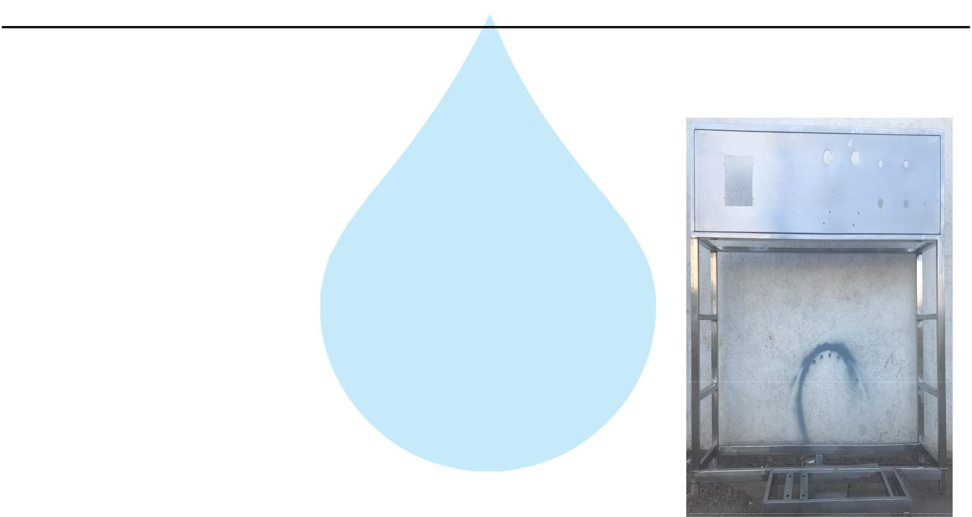

34. Stand For Unit

Stainless Steel : | S.S 304

Application :-

Complete stand for unit will be made of S.S.304

35. SS Interconnecting Pipe Lines
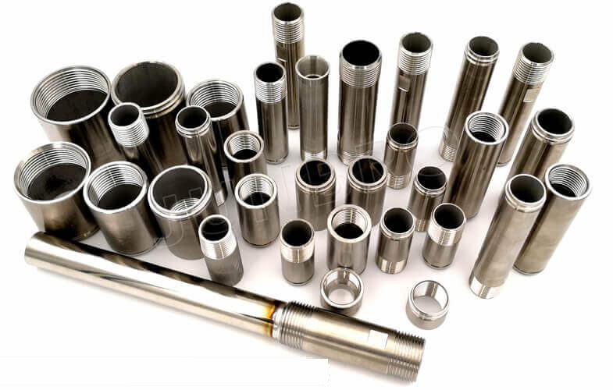

Stainless Steel : | S.S 304

Application :-

All interconnecting pipelines Raw water Pump to Ozone Circulating tank will be provided of S.S 304 by us
