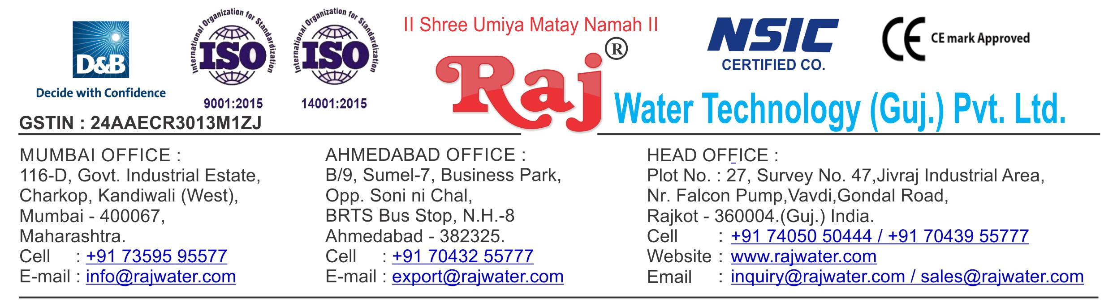

Date :- 26th April 2019

Friday

Quotation No | :- RW/2019-20/Q_250/R_3
Concern Person | :- | Mr. Naveen Shetty
Concern Number | :- | 7506643429
Email Id | :- | bbsmappl@gmail.com
Company Name | :- M/s BBS Milk & Agri Products Pvt Ltd
Address | :- N3/445, IRC Village, Nayapalli, Bhubaneswar - 751015, Odisha.


Quotation For Carbonated Soda Soft Drink Project

Dear Sir ,

We are pleased to enclose our detailed Techno-Commercial offer, based on your requirement.

Contents of the Quotation

Commercial Proposal
Terms & Condition
Technical Specification for each product

Machinery Offer

Carbonated Soda Soft Drink Project

We hope the same is in line with your requirement. We shall gladly assist you in case you need any further clarification or information.

With warm Regards,

For , Raj Water Technology (Guj.) Pvt. Ltd.

DESHANI KHUSHBU

Designation : Marketing Asst. Manager

Mobile : 7405050222
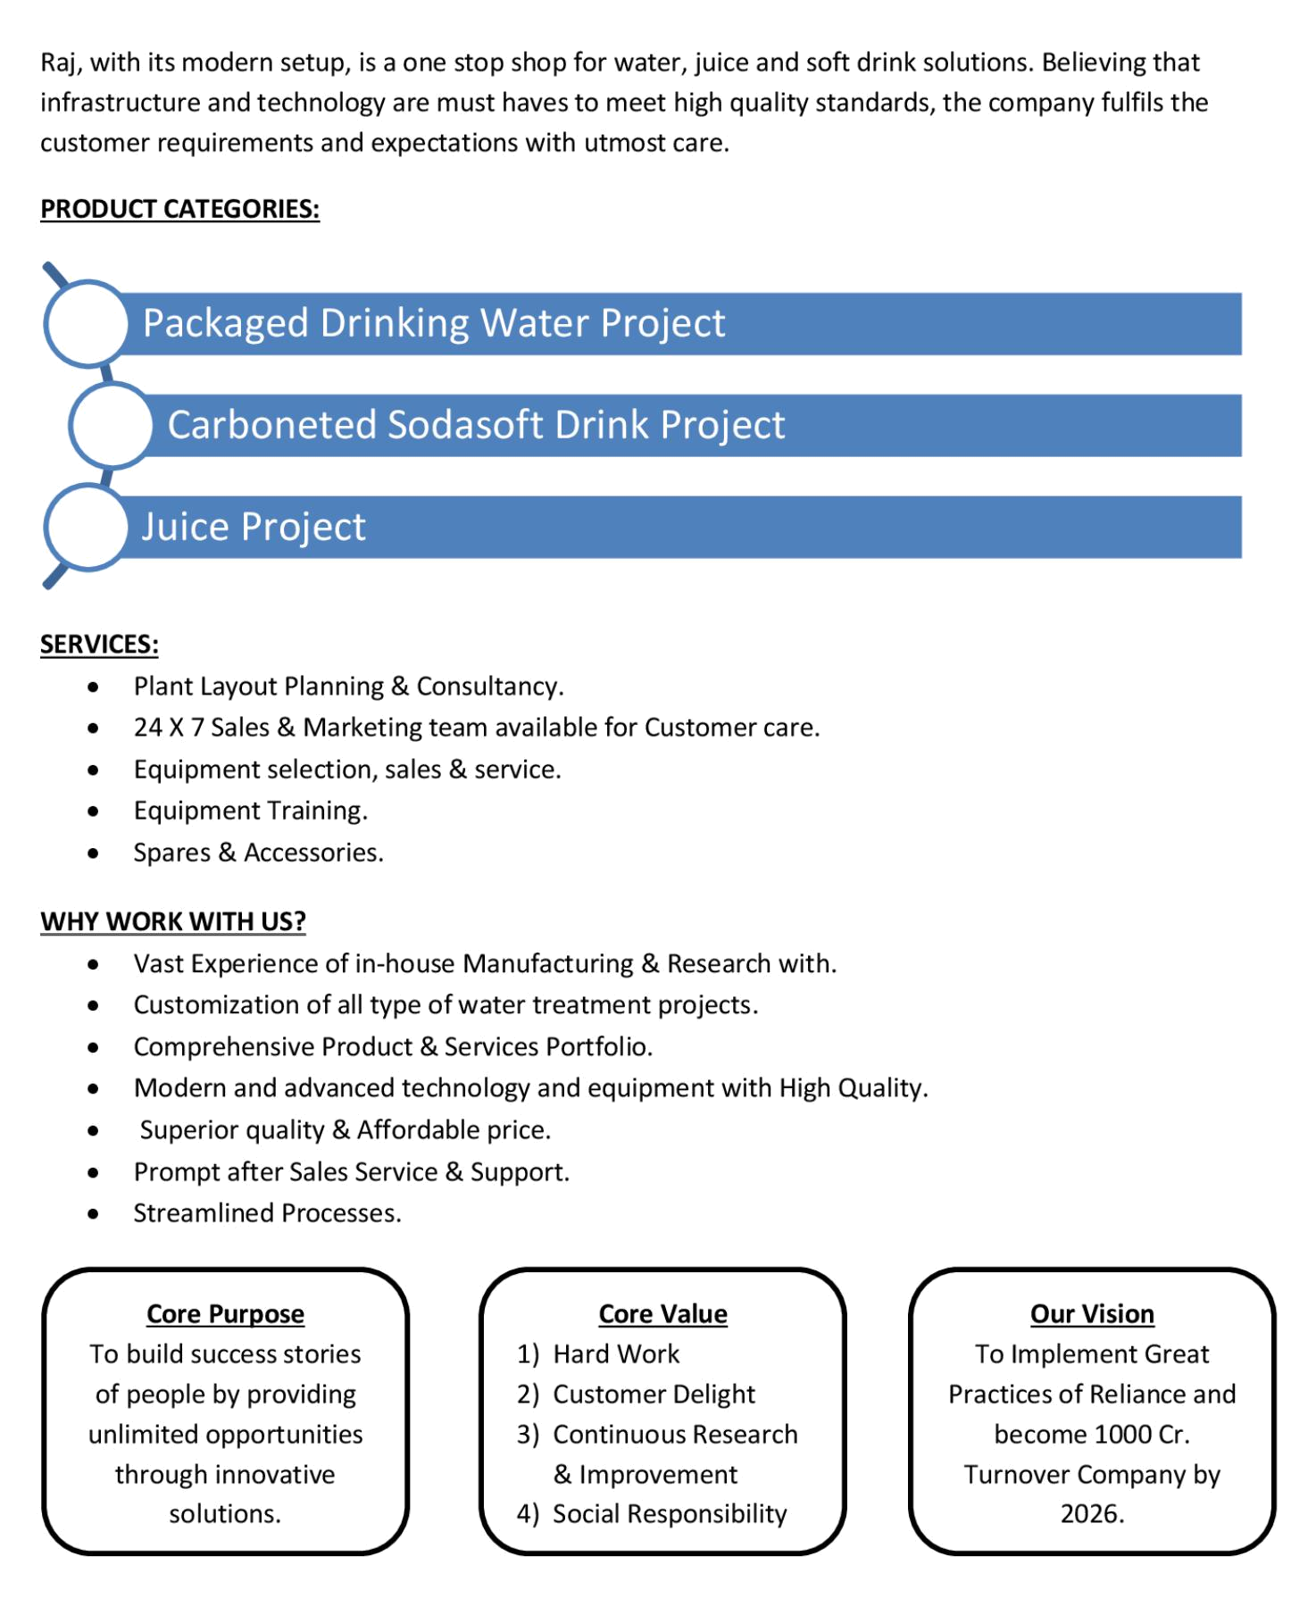
Commercial Proposal

Sr | Equipment Name |  | Qty | Basic Rate | Amount
No.
1 | Sugar Syrup Storage Triple Jacketed Tank 1000 Litre |  | 1 | 360000.00 | 360000.00
 | 500 Lit. Ss 304 D.M. Water Storage Tank – Top &
 | Bottom Dish End ( 3 Mm) ,Shell 3mm + Half
 | Jacket(2.5mm Ss 304) + Acessories Like | Heater (16
 | Kw) + Spray Ball + Pg/Sv/Av For Shell | And Jkt +
 | Temp. Sensor+Llc Extra
2 | Cooling PHE 1000 Litre For Sugar |  | 1 | 90000.00 | 90000.00
3 | Cooling Tower With Pump |  | 1 | 75000.00 | 75000.00
4 | Sugar Filter Press, With Pump ,With Hy – Flow Coating |  | 1 | 195000.00 | 195000.00
 | Tank
5 | S.S 304 Plain Sugar Syrup Storage Tank 1000 Litre, |  | 1 | 175000.00 | 175000.00
 | With Transfer Pump
6 | SS 304 Mixing Tank 2000 Liter With Agitator, Transfer |  | 2 | 400000.00 | 800000.00
 | Pump
7 | Online Water Chiller 25-Ton |  | 1 | 1125000.00 | 1125000.00
 | With R – 22 As Refrigerant And Semi – Hermetic Scroll
 | Compressor, Storage Tank
8 | Cooling PHE 1000lt For Glycol Chiller |  | 1 | 90000.00 | 90000.00
9 | Carbonation Production Tank With Buffer Tank |  | 1 | 850000.00 | 850000.00
10 | Fully Automatic Rinser/ Filler/Capper 12-12-4) With Cap |  | 1 | 2800000.00 | 2800000.00
 | Elevator For CSD Speed 60 BPM
 | Infeed Conveyor-2.5 mtr,Outfeed conveyor - 5 mtr
 | Air Blower 1hp,Shrink Tunnel,
 | Inspection,Collecting table
11 | Shrink Machine For Label |  | 1 | 65000.00 | 65000.00
12 | Automatic Ink Jet Batch Coding Machine |  | 1 | 200000.00 | 200000.00
13 | Semi -Automatic Shrink Wrapping Machine For Bulk Bottle Packing |  | 1 | 350000.00 | 350000.00
14 | Inter Connecting Piping |  | 1 | 150000.00 | 150000.00
 |  |  |  | Grand Total | 73,25,000.00

Terms & Condition

- Price

The Quoted Prices Are Ex-factory. (For India)

The Quoted Prices Are FOB. (For Export)

- TAX

GST 18% Extra Applicable. (For India)

- Payment

50% Advance Along With The Purchase Order, 30% After Inspection, & 20% Before Material Dispatch.

In Case Of Cancellation Of Confirmed Order Due To Any Reason, As A Part Of Penalty 25% Amount Of The Order Value Shall Have To Pay By You To Raj Water.

- Packing, Freight & Transit Insurance, & Unloading

Packing Charge Will Be Extra (Depend On Packing Material)

Transport To Be Arranged By The Customer OR If Arranged By Raj Water: Extra At Actual Plus GST.

Transportation Insurance In The Scope Of Buyer.

Unloading In The Scope Of Buyer. Buyer Has To Ready Forklift Or Crane And Unskilled Labor.

- Delivery

Schedule For Dispatch Will Be Notified.

Delivery Dates Are Approximate Only, And Assume Timely Receipt Of All Information, Test Materials & Payment.

- Warranty

We Shall Provide 1 Year Warranty For The Following:

Manufacturing Defects, Raw Water Pump, High Pressure Pump, Treated Water Transfer Pump.

Due To Fluctuation In Power Supply, Attempted Repaired By Person Other Than Our Technical Representative, Improper Handling Or Negligence By End Users, Poor Maintenance, Improper Use Of Equipment, That All Type Of Damage Not Covered In Warranty Create Area.

During The Warranty Period, We Shall Provide Supervisory Services Of Our Technical Representative As And When Required.

- Accommodation

Technician Charge Will Be Extra 1000/- Rs. Per Day.

Travelling, Lodging And Boarding, Local Conveyance And Any Other Miscellaneous Expense Of Our Technical Representative Will Have To Be Borne By Client.

- Validity

Our Offer Is Valid For Your Acceptance For A Period Of 6 Months From The Date; Thereafter It Will Be Subject To Confirmation By Us.

- Image

Images Are For Representation Purpose Only.

- Jurisdiction

All Terms Subject To Rajkot, Gujarat Jurisdiction.

