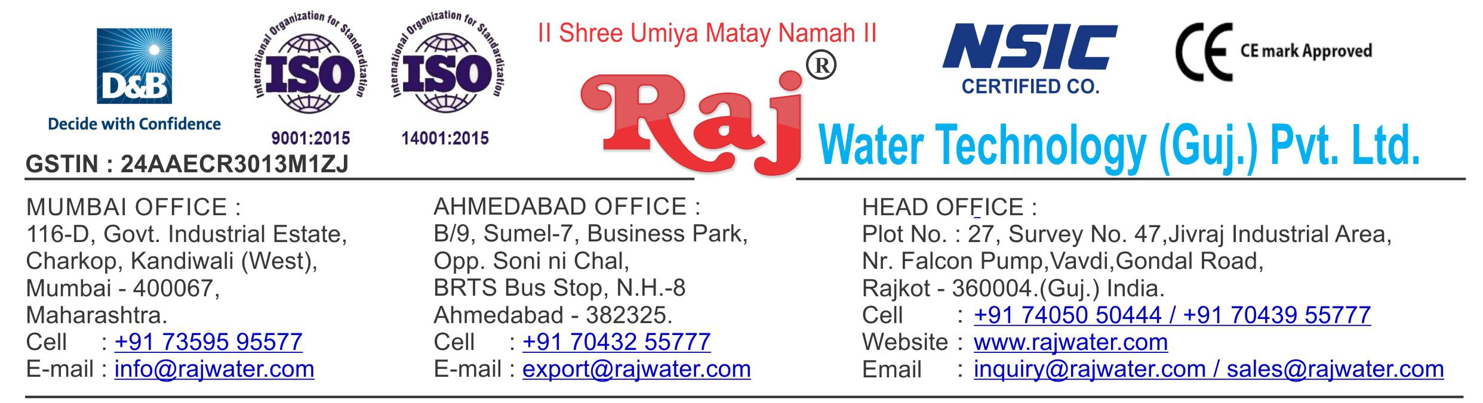

Date :- 1st may 2019

Quotation No | :- RW/2019-20/Q_1289
Concern Person | :- | Devendrabhai
Concern Number | :- | 9825689412 / 8347395731
Email Id | :-
Company Name | :-
Address | :-


Quotation For Carbonated Soda Soft Drink Project

Dear Sir ,

We are pleased to enclose our detailed Techno-Commercial offer, based on your requirement.

Contents of the Quotation

Commercial Proposal
Terms & Condition
Technical Specification for each product

Machinery Offer

Carbonated Soda Soft Drink Project

We hope the same is in line with your requirement. We shall gladly assist you in case you need any further clarification or information.

With warm Regards,

For , Raj Water Technology (Guj.) Pvt. Ltd.

Khushbu Deshani

Designation : Asst.Marketing Manager

Mobile : 7405050444
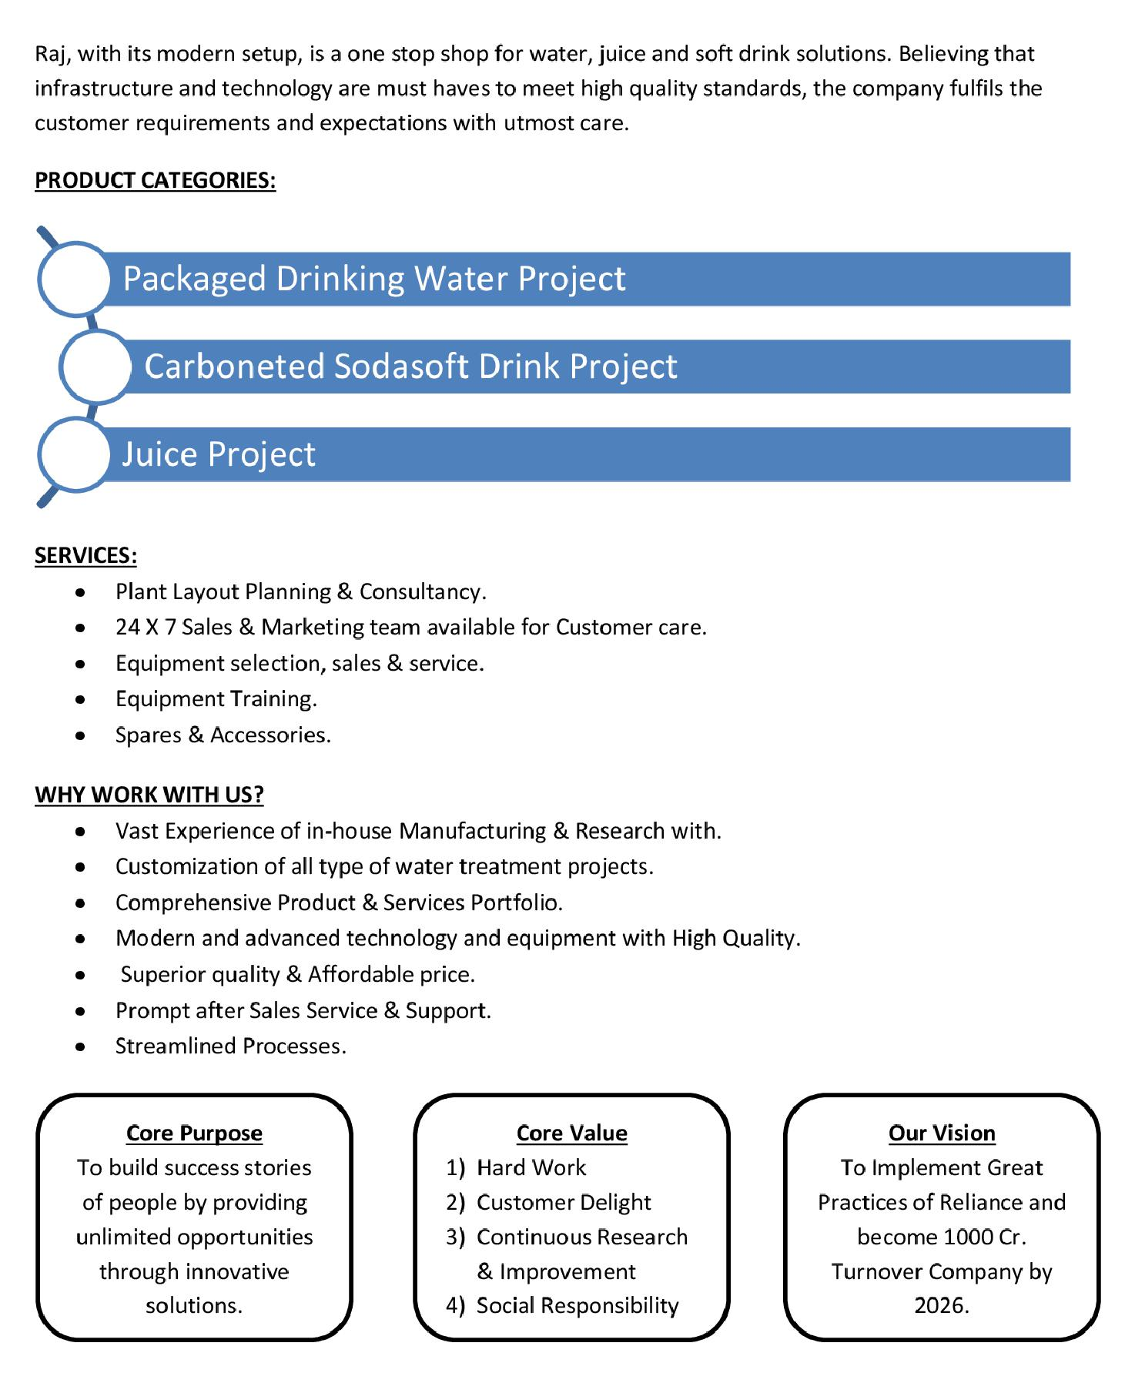

Commercial Proposal

Sr | Equipment Name |  | Qty | Basic Rate | Amount
No.
1 | 2000 Litre Per Hours (SS-304) RO Plant, With U.V |  | 1 | 550000.00 | 550000.00
 | System, SS Storage Tank 2000 Litre 1-Nos. |  |  | 550000.00 | 550000.00
2 | Sugar Syrup Storage Triple Steam Jacketed Tank 1000 Litre Steam Jacketed Kettle 1000 Litres Complete With Agitator Drain Valve Trap Pressure Gauge & Safety Valve |  | 1 | 360000.00 | 360000.00
3 | Suger Filter Press 1000 LPH, With Pump & Hyflow |  | 1 | 350000.00 | 350000.00
 | Coating, 100-Litre Tank Cooling PHE |  |  | 350000.00 | 350000.00
4 | Sugar Loader With Control Panel |  | 1 | 250000.00 | 250000.00
5 | Flavored Mixing Tank 100 Litre, With Agitator & Pump |  | 1 | 85000.00 | 85000.00
6 | SS-304 1000 Litre Plain Tank For Sugar Syrup, With |  | 1 | 180000.00 | 180000.00
 | Agitator |  |  | 180000.00 | 180000.00
7 | SS 304 Mixing Tank 2000 Litre, With Agitator |  | 2 | 300000.00 | 600000.00
8 | Two Tank Semi-Automatic CIP System |  | 1 | 850000.00 | 850000.00
9 | SS-304 1000 Litre Final Beverages Tank For Sugar  Syrup |  | 1 | 180000.00 | 180000.00
10 | Cooling Tower With Pump |  | 1 | 100000.00 | 100000.00
11 | Steam Boiler 500 Kg Per Hour Non I.B.R. Wood Fire |  | 1 | 450000.00 | 450000.00
12 | Chimney Design & Fabrication (Guy Roap Supported) |  | 1 | 85000.00 | 85000.00
13 | Water Chiller 35 Ton Capacity |  | 1 | 1550000.00 | 1550000.00
 | Online Chiller Of 35 Tr Capacity, With Refrigerant And |  |  | 1550000.00 | 1550000.00
 | Semi – Hermetic Scroll Compressor, Storage Tank With |  |  | 1550000.00 | 1550000.00
 | Cooling Phe |  |  | 1550000.00 | 1550000.00
14 | Inter Connecting Piping For Sugar Syrup Room |  | 1 | 250000.00 | 250000.00
15 | Piping For Cooling Tower |  | 1 | 75000.00 | 75000.00
16 | Piping For Boiler With Insulation |  | 1 | 150000.00 | 150000.00
17 | Piping For CIP |  | 1 | 225000.00 | 225000.00
18 | Piping For Chiller Machine |  | 1 | 150000.00 | 150000.00

Sr | Equipment Name | Qty | Basic Rate | Amount
No.
 | Inter Connecting Piping Are Syrup Room To Filling  Machine Complete SS 304 | 1 | 150000.00 | 150000.00
19 |  |  | 150000.00 | 150000.00
 | RINSER FILLER CAPPER 16/16/6 (90bpm)  Carbonated soft drink (CSD) PET Rinser/Filler/Capper  with Cap Elevator fitted with 250 ml PET Bottle change  parts, Rinser Water Circulation SS Tank with Pump,  Pipe line and Electrical. | 1 | 3900000.00 | 3900000.00
20 |  |  | 3900000.00 | 3900000.00
21 | AIR CONVEYORS 5 Metres Stainless Steel Air Conveyors consisting straight section with 1 No Air Blower with Pre and Heppa Filters for the above line | 1 | 350000.00 | 350000.00
22 | CHAIN CONVEYORS 7.5 Metres Stainless Steel Section with MCC Holland plastic chain conveyors consisting of Inspection Light, Collecting Table | 1 | 550000.00 | 550000.00
 | Set Of Change Parts Suitable To Handle PET Bottles  For Rinser/Filler/Capper | 2 | 75000.00 | 150000.00
23
 | High Pressure Blower System  to remove the Water Droplets from the Bottle to be  installed on your single line conveyor after cooling  tunnel. | 1 | 150000.00 | 150000.00
24
25 | Carbonation Production Tank 3000 Litre Capacity | 1 | 1350000.00 | 1350000.00
26 | Co2 Manifold For 4 Cylinders | 1 | 85000.00 | 85000.00
 | Fully Automatic BOPP Labeling Machine  Fully Auto Labeling Machine.Roll feed labeling machine  with hot-melt glue | 1 | 2000000.00 | 2000000.00
27 |  |  | 2000000.00 | 2000000.00
 | Set Of Change Parts Suitable To Handle PET Bottles  For Labeller | 2 | 150000.00 | 300000.00
28 |  |  | 150000.00 | 300000.00
29 | Automatic Inkjet Batch Coding Machine | 1 | 200000.00 | 200000.00
 | Automatic Shrink Wrapping Machine For Bulk  Bottle Packing – 90 BPM | 1 | 1350000.00 | 1350000.00
30 |  |  | 1350000.00 | 1350000.00
 |  |  | Total Amount | 1,69,75,000.00

Terms & Condition

- Price

The Quoted Prices Are Ex-factory. (For India)

The Quoted Prices Are FOB. (For Export)

- TAX

GST 18% Extra Applicable. (For India)

- Payment

50% Advance Along With The Purchase Order, 30% After Inspection, & 20% Before Material Dispatch.

In Case Of Cancellation Of Confirmed Order Due To Any Reason, As A Part Of Penalty 25% Amount Of The Order Value Shall Have To Pay By You To Raj Water.

- Packing, Freight & Transit Insurance, & Unloading

Packing Charge Will Be Extra (Depend On Packing Material)

Transport To Be Arranged By The Customer OR If Arranged By Raj Water: Extra At Actual Plus GST.

Transportation Insurance In The Scope Of Buyer.

Unloading In The Scope Of Buyer. Buyer Has To Ready Forklift Or Crane And Unskilled Labor.

- Delivery

Schedule For Dispatch Will Be Notified.

Delivery Dates Are Approximate Only, And Assume Timely Receipt Of All Information, Test Materials & Payment.

- Warranty

We Shall Provide 1 Year Warranty For The Following:

Manufacturing Defects, Raw Water Pump, High Pressure Pump, Treated Water Transfer Pump.

Due To Fluctuation In Power Supply, Attempted Repaired By Person Other Than Our Technical Representative, Improper Handling Or Negligence By End Users, Poor Maintenance, Improper Use Of Equipment, That All Type Of Damage Not Covered In Warranty Create Area.

During The Warranty Period, We Shall Provide Supervisory Services Of Our Technical Representative As And When Required.

- Accommodation

Technician Charge Will Be Extra 1000/- Rs. Per Day.

Travelling, Lodging And Boarding, Local Conveyance And Any Other Miscellaneous Expense Of Our Technical Representative Will Have To Be Borne By Client.

- Validity

Our Offer Is Valid For Your Acceptance For A Period Of 6 Months From The Date; Thereafter It Will Be Subject To Confirmation By Us.

- Image

Images Are For Representation Purpose Only.

- Jurisdiction

All Terms Subject To Rajkot, Gujarat Jurisdiction.

