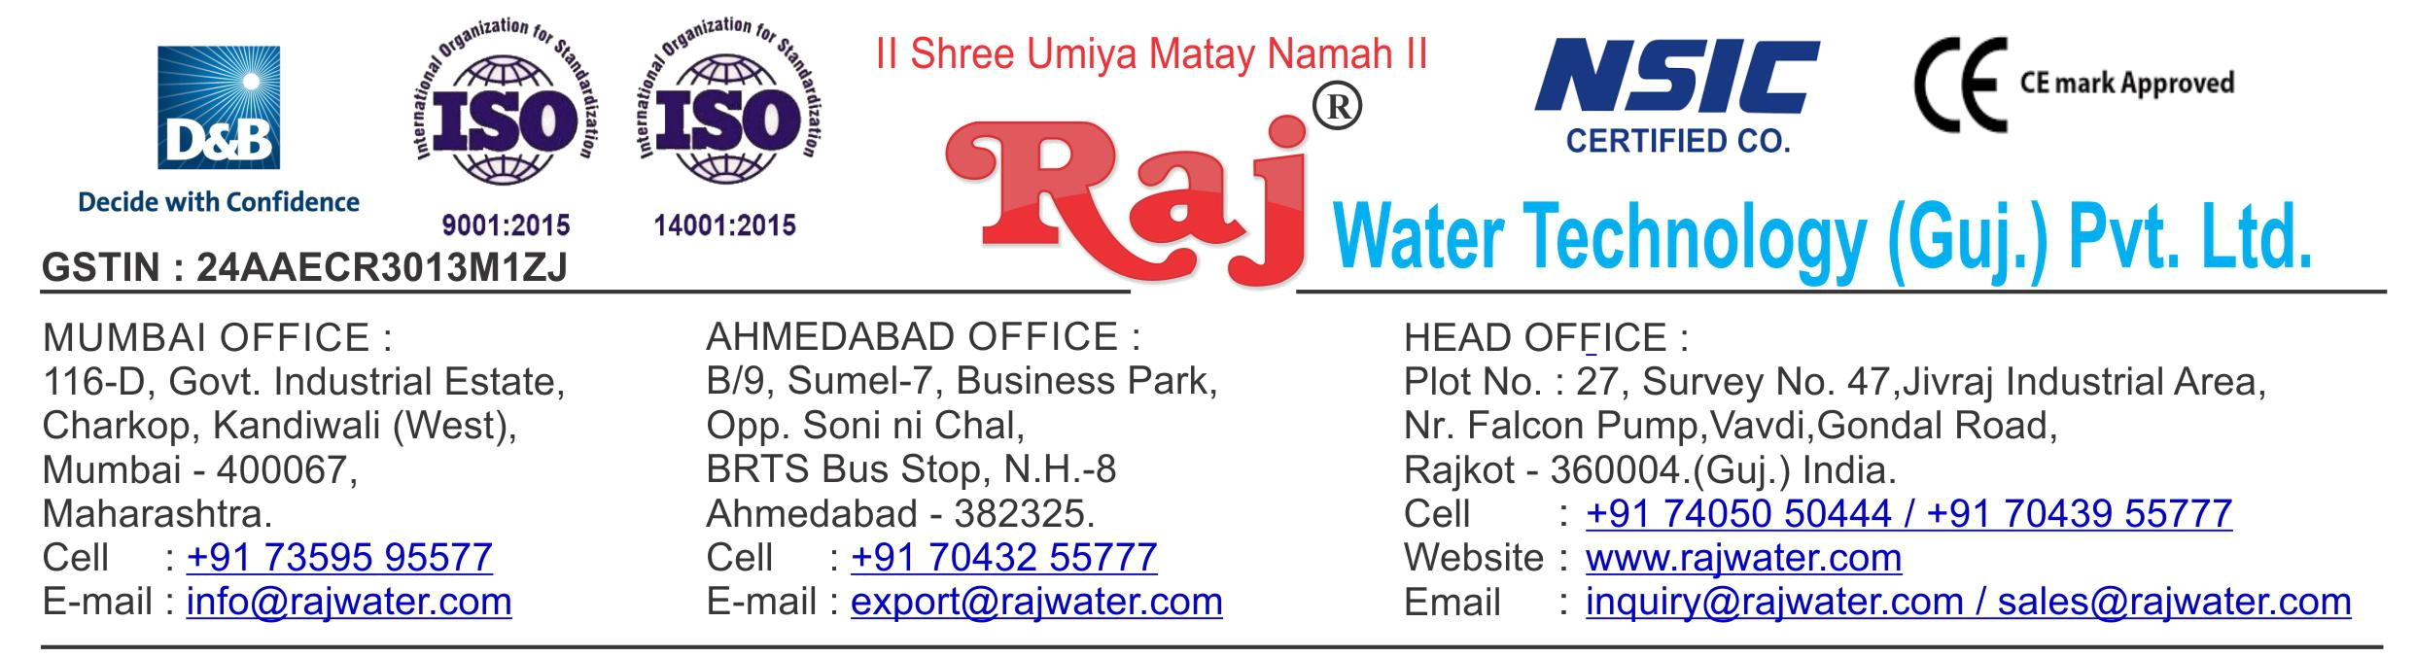

Date :- 7th June 2019

Friday

Quotation No | :- RW/2018-19/Q_13630/R_6
Concern Person | :- | Mr. ZAHIDUL ISLAM
Concern Number | :- | 9678221010
Email Id | :- | zislam523@gmail.com
Company Name | :- AZ Chinaki Food & Beverages
Address | :- | Bongaigaon ,Assam


Quotation For Juice Project

Dear Sir ,

We are pleased to enclose our detailed Techno-Commercial offer, based on your requirement.

Contents of the Quotation

Commercial Proposal
Terms & Condition
Technical Specification for each product

Machinery Offer Juice Project

We hope the same is in line with your requirement. We shall gladly assist you in case you need any further clarification or information.

With warm Regards,

For , Raj Water Technology (Guj.) Pvt. Ltd.

KHUSHBU DESHANI

Designation : Marketing Asst. Manager

Mobile : 7405050444
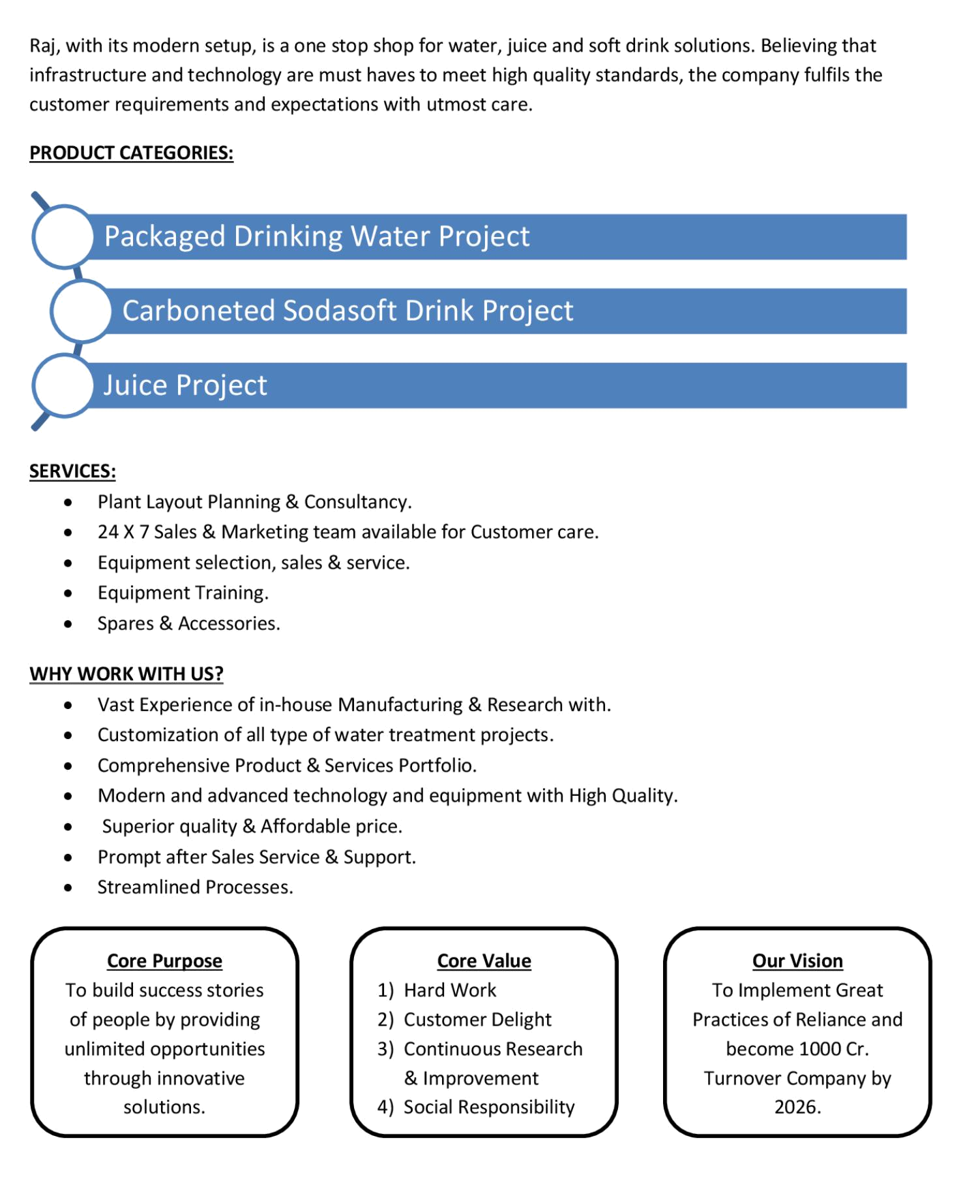
Commercial Proposal

Sr | Equipment Name | Qty | Basic Rate | Amount
No.
1 | 3000 Liter Per Hour SS-304 RO Plant , With U.V | 1 | 700000.00 | 700000.00
 | System, SS Storage Tank 3000 Liter 1 Nos
2 | Sugar Syrup Storage Triple Steam Jacketed Tank 1000 | 1 | 400000.00 | 400000.00
 | Litre
 | Steam Jacketted Kettle 1000 Litres Complete With
 | Agitator Drain Valve Trap Pressure Gauge & Safty Valve
3 | Sugar Loader With Control Panel | 1 | 250000.00 | 250000.00
4 | Sugar Filter Press, With Pump ,With Hy – Flow Coating | 1 | 195000.00 | 195000.00
 | Tank
5 | Cooling PHE 1000 Litre For Sugar | 1 | 90000.00 | 90000.00
6 | Pulp Dumping Tank | 1 | 75000.00 | 75000.00
7 | Flavored Mixing Tank 100 Litre, With Agitator & Pump | 1 | 85000.00 | 85000.00
8 | S.S 304 Plain Sugar Syrup Storage Tank 1000 Litre, | 1 | 175000.00 | 175000.00
 | With Transfer Pump
9 | SS 304 Mixing Tank 1000 Liter With Agitator,Transfer | 4 | 175000.00 | 700000.00
 | Pump
10 | Homogeniser Capacity 1000 Litre Per Hour | 1 | 1050000.00 | 1050000.00
 | With double stage including motor starter & all
 | necessary access orie
11 | SS-304 1000 Litre Ready Beverages Tank For Sugar | 1 | 175000.00 | 175000.00
 | Syrup, With Agitator,Transfer Pump
12 | Pasteurizer 1000 Litre Per Hours, With Phe Pid | 1 | 1350000.00 | 1350000.00
 | Controlled Valves
13 | Single Tank Semi-Automatic CIP System | 1 | 750000.00 | 750000.00
14 | Inter Connecting Piping For Sugar Syrup Room | 1 | 350000.00 | 350000.00
15 | Steam Boiler 500 Kg Per Hour Non I.B.R. Wood Fire | 1 | 550000.00 | 550000.00
16 | Chimney Design & Fabrication (Guy Roap Supported) | 1 | 85000.00 | 85000.00
17 | Online Water Chiller 15-Ton | 1 | 650000.00 | 650000.00
 | With R – 22 As Refrigerant And Semi – Hermetic Scroll
 | Compressor, Storage Tank
18 | Cooling PHE 1000lt For Glycol Chiller | 1 | 90000.00 | 90000.00
19 | Carbonation Production Tank With Buffer Tank | 1 | 750000.00 | 750000.00
Sr | Equipment Name | Qty | Basic Rate | Amount
No.
20 | Co2 Manifold For 4 Cylinders | 1 | 85000.00 | 85000.00
21 | Automatic Juice Filling & Capping Machine 30-BPM | 1 | 1950000.00 | 1950000.00
 | Hot Juice Bottle Sizes 200ml – 2 Litre Machine Is
 | Designed With Gravtitation Filling System . Machine Is
 | Complete With Its Return Line System Having
 | Automatic Controllers With The Tank Bowl Level And
 | Temperatures.
 | In Feed Air Conveyor 8 Feet ,Out Feed Chain Conveyor
 | 16 Feet
22 | High Pressure Blower | 1 | 150000.00 | 150000.00
 | to blow water droplet from bottle system to be installed
 | on Cooler discharge conveyor end
23 | Cooling Tunnel For Cool Down The Bottle Temperature | 1 | 1600000.00 | 1600000.00
 | 80 To 40 Degree
24 | Fully Automatic Rinser/ Filler/Capper With Cap Elevator | 1 | 1875000.00 | 1875000.00
 | For CSD Speed 30 BPM
 | Infeed Conveyor-2.5 mtr,Outfeed conveyor - 5 mtr ,Air
 | Blower 1hp,Shrink Tunnel, Inspection,Collecting table
25 | High Pressure Blower | 1 | 150000.00 | 150000.00
 | to blow water droplet from bottle system to be installed
 | on Cooler discharge conveyor end
26 | Shrink Machine For Label | 2 | 65000.00 | 130000.00
27 | Cooling Tower With Pump | 1 | 75000.00 | 75000.00
28 | Automatic Inkjet Batch Coding Machine | 2 | 200000.00 | 400000.00
29 | Semi-Automatic Shrink Wrapping Machine For Bulk | 2 | 350000.00 | 700000.00
 | Bottle Packing
30 | Piping For Boiler With Insulation | 1 | 150000.00 | 150000.00
31 | Piping For CIP | 1 | 250000.00 | 250000.00
32 | Piping For Cooling Tower | 1 | 75000.00 | 75000.00
33 | Piping For Chiller Machine | 1 | 200000.00 | 200000.00
34 | Inter Connecting Piping For Compressor | 1 | 125000.00 | 125000.00
35 | Inter Connecting Piping, From Syrup Room To Filling | 1 | 350000.00 | 350000.00
 | Machine (SS 304 For 40-BPM Juice Plant)
Sr | Equipment Name | Qty | Basic Rate | Amount
No.
36 | Semi-Automatic Pet Blow Moulding Machine 2-KVT | 2 | 400000.00 | 800000.00
 | 1-Blow + 1-Conveyor, With Linear Oven & Manual
 | Loading Device (Double Cavity Semi Automatic
 | Machine) Machine Suitable For Neck Size 46mm, Up to
 | 1 Litre, 1000 To 1200 BPH, Neck Dia 28mm Double
 | Cavity Auto Drop
37 | High Pressure Air Compressor 20-HP | 2 | 250000.00 | 500000.00
38 | Water Chiller 3- Ton With 200 Litre Storage Tank | 2 | 130000.00 | 260000.00
39 | Moisturizer Separator | 2 | 50000.00 | 100000.00
40 | Mould For CSD Bottle 200 ML,300 ML,600 ML,1250 ML | 4 | 45000.00 | 180000.00
41 | Mould For Juice 125 ML, 160 ML,600 ML,1250 ML | 4 | 45000.00 | 180000.00
42 | 2 Liter Mould For CSD | 1 | 90000.00 | 90000.00
43 | 2 Liter Mould For Juice | 1 | 90000.00 | 90000.00
Total Amount in Words :- |  |  | Total Amount | 1,89,35,000.00
One Hundred Eigthy Nine Lakh Thirty Five Thousand

