Quotation

Mr. Tushar deb |  | Quotation No:-RW/2018-19/Q_8071  Date:-20th June 2019
Sr no | Equipment Name | Qty | Basic Rate | Amount
1 | Arsenic & Iron Removal Filtration Plant.  - PPGI Cabin 10 Feet X 15 Feet  - 2 KW Solar System With Battery Back Up &  - Inventor  - 1000 LPH Iron & Arsenic Removal Plant  - 2000 Liter SS Product water Storage Tank & 3  Nos water ATM | 1 | 1500000 | 1500000
 |  |  | Grand Total | 1500000
Raj Water Technology (Guj)Pvt.Ltd

Technical Data Trunkey Project For Arsenic & Iron Removal Water Treatment Plant
Complete With Borwell , Solar System filtration Unit And Inter Connecting Piping

1.Submersible Water Pump.
Type : Centrifugal
Max. Flow : 3.0 m3/hr.
Working flow : 2.0 m3/hr.
Power : 2 HP.
Make : Bhumi
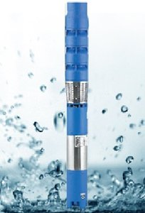
Nos. Offered : One No.

2.OZONE GENERATOR
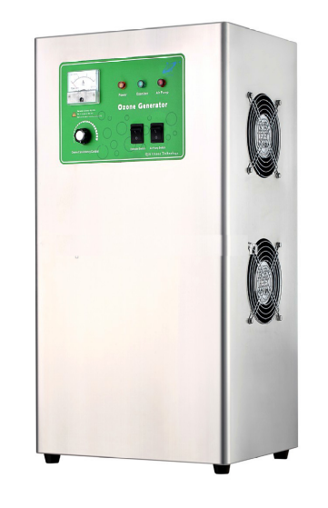
No. offered : One no.
Type : Ozone from Natural Air type.
Flow rate : 1000 Lph.
Ozone dosing : 1 PPM
Casing : S.S.
Make of ozone generator : Aqua zone or equi.

3. Automatic MNO2 And Greensand Filter.
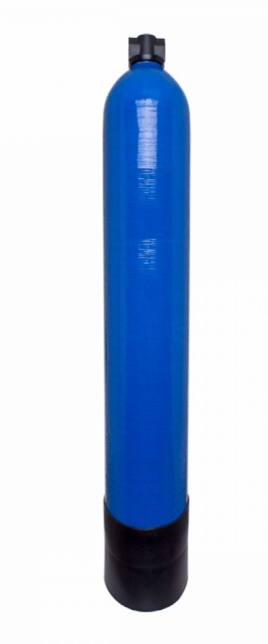
Type : Down Flow Graded Sand Type
Model : 1465/RW/MGF
M.O.C. : FRP
Size Dia X Height. : 350 mm Dia X 1625 mm
Pipe Line Size : 25 mm.
Sand Qty. : 175Kgs
Valves : Automatic valve.
Working Flow : 1.00 m3/hr.

4. Automatic Fine Sand Filter.
Type : Down Flow Graded Sand Type
Model : 1465/RW/MGF
M.O.C. : FRP
Size Dia X Height. : 350 mm Dia X 1625 mm
Pipe Line Size : 25 mm.
Sand Qty. : 175Kgs
Valves : Automatic valve.
Working Flow : 1.00 m3/hr.

5.Arsenic Removal Filter.
Type : Down Flow Graded Sand Type
Model : 1465/RW/MGF
M.O.C. : FRP
Size Dia X Height. : 350 mm Dia X 1625 mm
Pipe Line Size : 25 mm.
Resin Qty. : 100 Liter LAR 714
Valves : MPV valve.
Working Flow : 1.00 m3/hr.

6.Regeneration Tank. 2 Nos
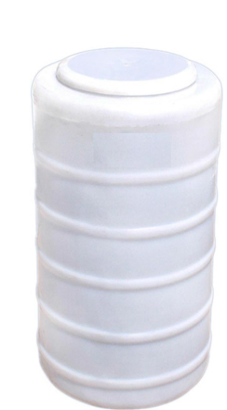
Type :Conical bottom.
Capacity. :100 liter.
M.O.C. :HDPE.
Make : reputed.

7.Autoamtic Activated Carbon Filter.
Type : Down Flow Graded Sand Type
Model : 1465/RW/MGF
M.O.C. : FRP
Size Dia X Height. : 350 mm Dia X 1625 mm
Pipe Line Size : 25 mm.
Carbon Qty. : 75 Kg
Valves : Automatic valve.
Working Flow : 1.00 m3/hr.

8.U. V. Disinfection System.
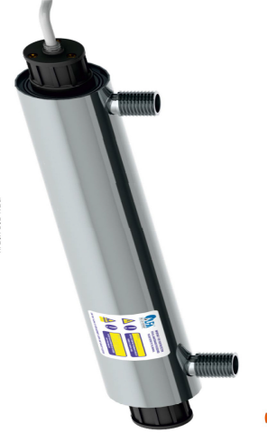
Type : Fluorescent Tube
Working Flow : 1000 Lph
Working Pressure : 1 Kg/cm2
Material : SS 304
Make of UV Tube : RAJ
No of UV system offered : 1 nos.

9.Treated Water Storage Tank
Nos. offered : one no.
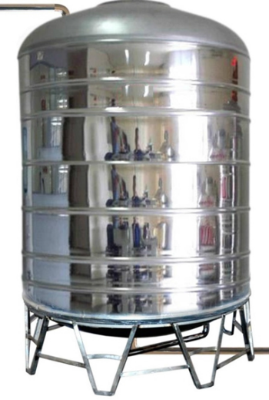
Type : Vertically Cylindrical type.
MOC : SS 304
Holding Capacity : 2000 Liters

10. Water ATM Machine 3 Nos
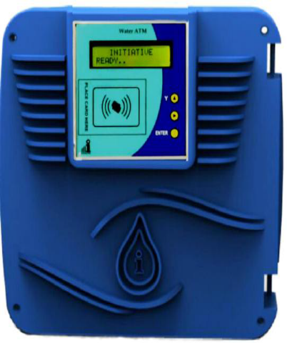

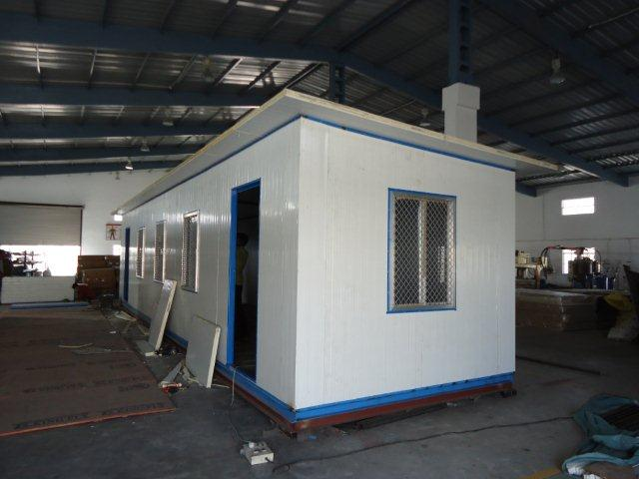

11. Inter Connecting Piping

All Inter Connecting Piping are Borwell To Complete Plant UPVC Provide By US

