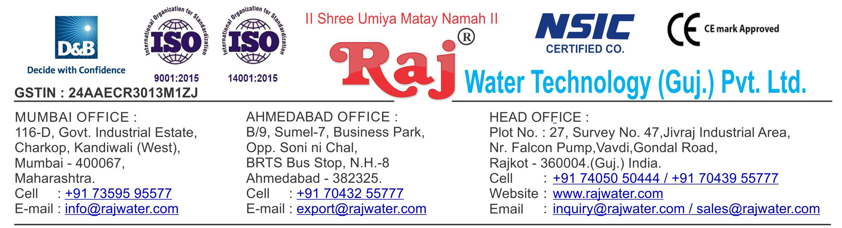

Date :- 18th May 2019

Saturday

Quotation No | :- RW/2018-19/Q_11281/R_4
Concern Person | :- | Mrs. Lataben Dhananjay Patil
Concern Number | :- | 9082192399 / 9823122281
Email Id | :-
Company Name | :- | DAIKO FOODS(OPC) PVT. LTD.
Address | :- | PLOT NO 10A/6+5B, SAHAKARI MANDLI VANZ,SACHIN, SURAT, GUJARAT 394230.


Quotation For Fruit Juice Processor,Homogenizer,AsepticPacking And Filling Unit

Dear Sir ,

We are pleased to enclose our detailed Techno-Commercial offer, based on your requirement.

Contents of the Quotation

Commercial Proposal
Terms & Condition
Technical Specification for each product

Machinery Offer Juice Project

We hope the same is in line with your requirement. We shall gladly assist you in case you need any further clarification or information.

With warm Regards,

For , Raj Water Technology (Guj.) Pvt. Ltd.

KHUSHBU DESHANI

Designation : Marketing Asst. Manager

Mobile : 7405050444

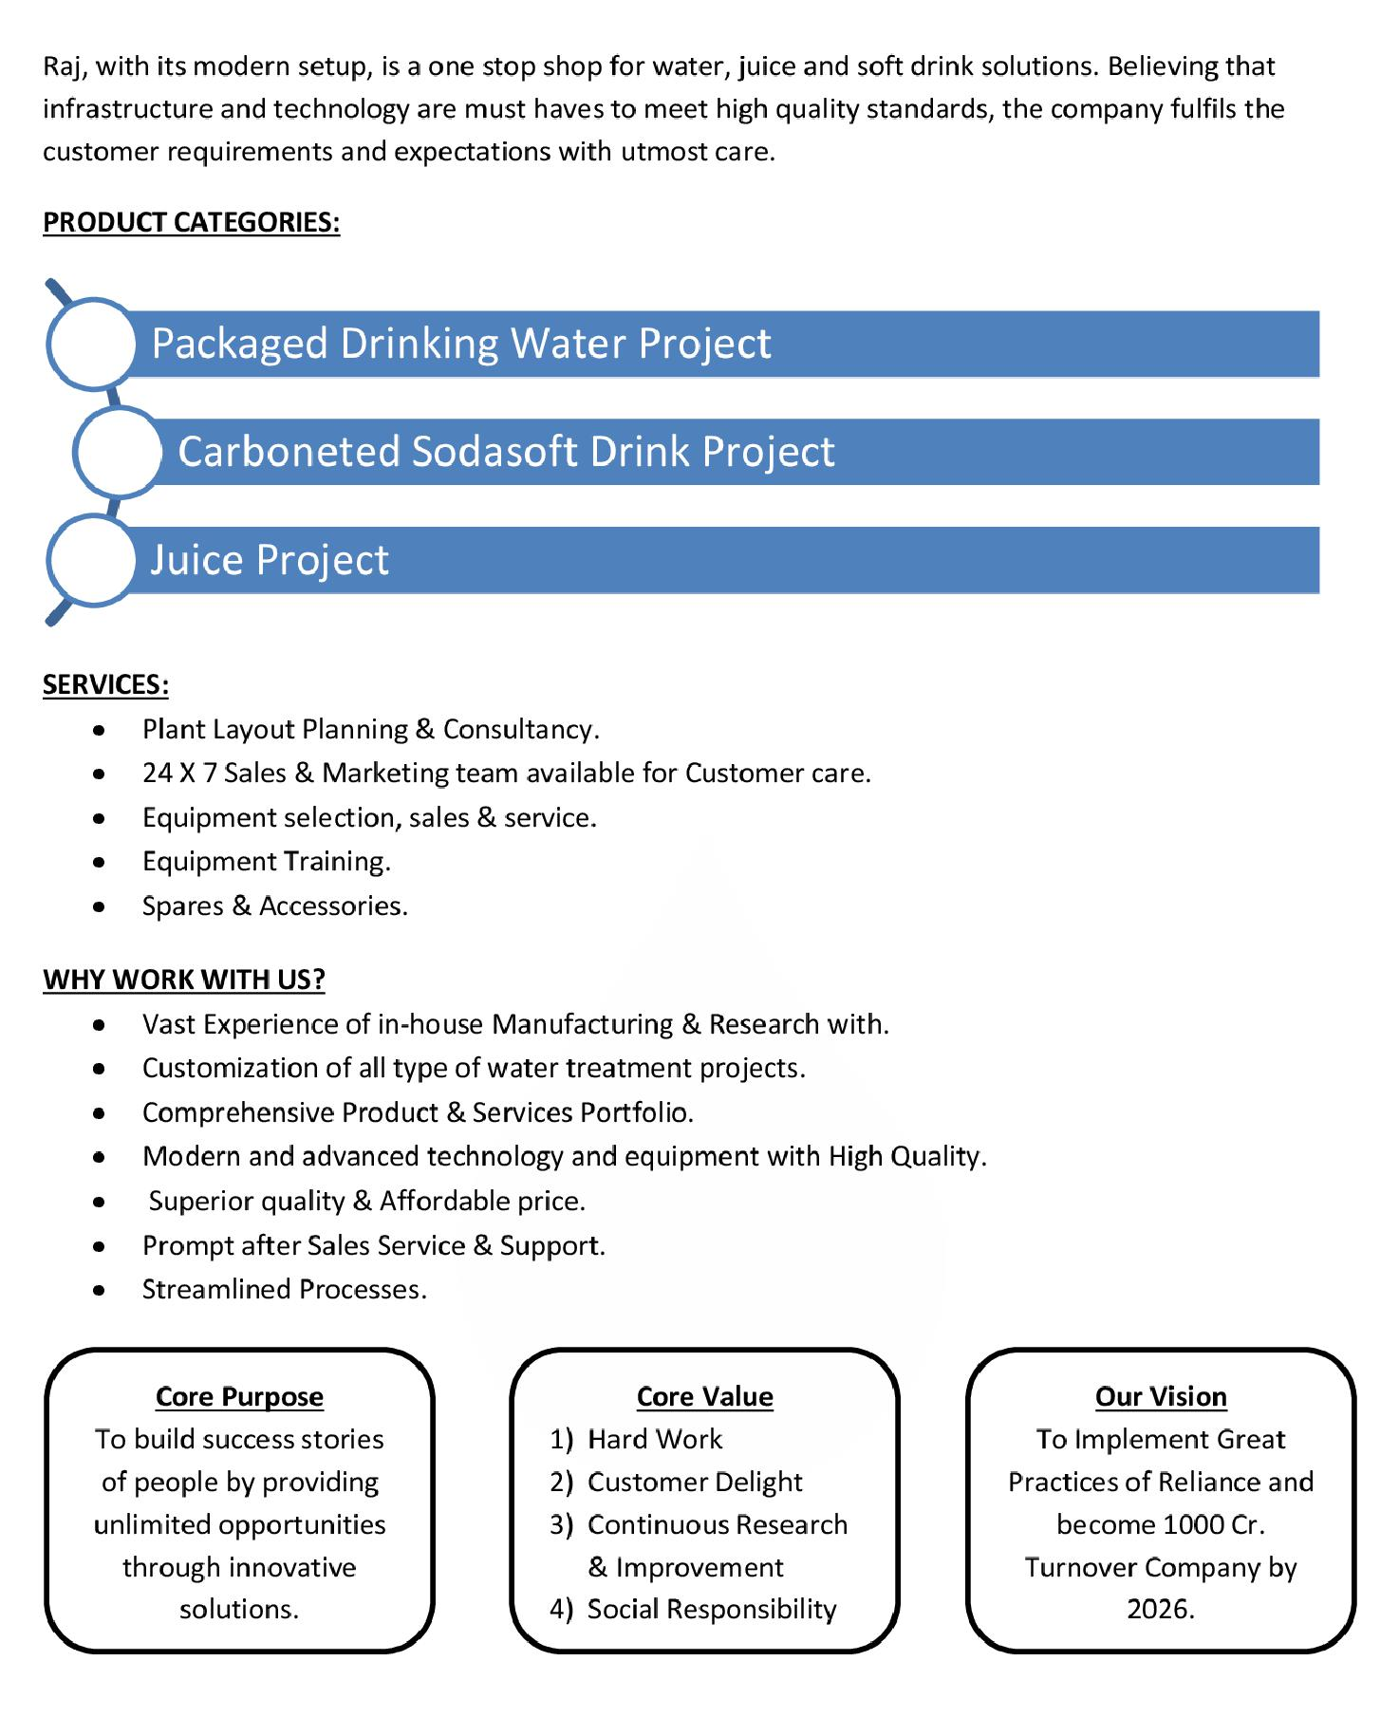

Commercial Proposal

Sr | Equipment Name | Qty | Basic Rate | Amount
No.
1 | RO Plant FRP 1000 Litre Per Hours With | 1 | 230000.00 | 230000.00
 | U.V System,Transfer Pump,Storage Tank SS 304 1000
 | Litre
2 | Sugar Syrup Storage Triple Steam Jacketed Tank 500 | 1 | 290000.00 | 290000.00
 | Litre
 | Steam Jacketted Kettle 500 Litres Complete With
 | Agitator Drain Valve Trap Pressure Gauge & Safty
 | Valve Extra
3 | Sugar Filter Press, With Pump ,With Hy – Flow Coating | 1 | 195000.00 | 195000.00
 | Tank
4 | Cooling PHE 1000 Litre For Sugar | 1 | 90000.00 | 90000.00
5 | Pulp Dumping Tank | 1 | 75000.00 | 75000.00
6 | S.S 304 Plain Sugar Syrup Storage Tank 500 Litre, | 1 | 100000.00 | 100000.00
 | With Transfer Pump
7 | SS 304 Mixing Tank 1000 Liter With Agitator,Transfer | 2 | 150000.00 | 300000.00
 | Pump
8 | Homogeniser Capacity 1000 Litre Per Hour | 1 | 850000.00 | 850000.00
 | With double stage including motor starter & all
 | necessary access orie
9 | SS-304 1000 Litre Ready Beverages Tank For Sugar | 1 | 150000.00 | 150000.00
 | Syrup, With Agitator,Transfer Pump
10 | Pasteurizer 1000 Litre Per Hours, With Phe Pid | 1 | 1100000.00 | 1100000.00
 | Controlled Valves
11 | Inter Connecting Piping For Sugar Syrup Room | 1 | 350000.00 | 350000.00
12 | Steam Boiler 500 Kg Per Hour Non I.B.R. Wood Fire | 1 | 550000 | 550000.00
13 | Chimney Design & Fabrication (Guy Roap Supported) | 1 | 85000.00 | 85000.00
14 | Automatic Juice Filling & Capping Machine 30-BPM | 1 | 1740000.00 | 1740000.00
 | Hot Juice Bottle Sizes 200ml – 2 Litre Machine Is
 | Designed With Gravtitation Filling System . Machine Is
 | Complete With Its Return Line System Having
 | Automatic Controllers With The Tank Bowl Level And
 | Temperatures.
 | In Feed Air Conveyor 8 Feet ,Out Feed Chain Conveyor
 | 16 Feet

Sr | Equipment Name | Qty | Basic Rate | Amount
No.
15 | Shrink Machine For Label | 1 | 165000.00 | 165000.00
16 | Cooling Tower With Pump | 1 | 175000.00 | 175000.00
17 | Automatic Inkjet Batch Coding Machine | 1 | 300000.00 | 300000.00
18 | Semi-Automatic Shrink Wrapping Machine For Bulk | 1 | 450000.00 | 450000.00
 | Bottle Packing
19 | Piping For Boiler With Insulation | 1 | 150000.00 | 150000.00
20 | Piping For CIP | 1 | 225000.00 | 225000.00
21 | Piping For Cooling Tower | 1 | 75000.00 | 75000.00
22 | Inter Connecting Piping, From Syrup Room To Filling | 1  1 | 350000.00  3455000.00 | 350000.00  3455000.00
 | Machine (SS 304 For 40-BPM Juice Plant) | 1  1 | 350000.00  3455000.00 | 350000.00  3455000.00
 | Juice Extractor &Homogenizer | 1  1 | 350000.00  3455000.00 | 350000.00  3455000.00
23

Total Amount in Words :- |  |  | Total Amount | 1,14,50,000.00

Terms & Condition

- Price

The Quoted Prices Are Ex-factory. (For India)

The Quoted Prices Are FOB. (For Export)

- TAX

GST 18% Extra Applicable. (For India)

- Payment

50% Advance Along With The Purchase Order, 30% After Inspection, & 20% Before Material Dispatch.

In Case Of Cancellation Of Confirmed Order Due To Any Reason, As A Part Of Penalty 25% Amount Of The Order Value Shall Have To Pay By You To Raj Water.

- Packing, Freight & Transit Insurance, & Unloading

Packing Charge Will Be Extra (Depend On Packing Material)

Transport To Be Arranged By The Customer OR If Arranged By Raj Water: Extra At Actual Plus GST.

Transportation Insurance In The Scope Of Buyer.

Unloading In The Scope Of Buyer. Buyer Has To Ready Forklift Or Crane And Unskilled Labor.

- Delivery

Schedule For Dispatch Will Be Notified.

Delivery Dates Are Approximate Only, And Assume Timely Receipt Of All Information, Test Materials & Payment.

- Warranty

We Shall Provide 1 Year Warranty For The Following:

Manufacturing Defects, Raw Water Pump, High Pressure Pump, Treated Water Transfer Pump.

Due To Fluctuation In Power Supply, Attempted Repaired By Person Other Than Our Technical Representative, Improper Handling Or Negligence By End Users, Poor Maintenance, Improper Use Of Equipment, That All Type Of Damage Not Covered In Warranty Create Area.

During The Warranty Period, We Shall Provide Supervisory Services Of Our Technical Representative As And When Required.

- Accommodation

Technician Charge Will Be Extra 1000/- Rs. Per Day.

Travelling, Lodging And Boarding, Local Conveyance And Any Other Miscellaneous Expense Of Our Technical Representative Will Have To Be Borne By Client.

- Validity

Our Offer Is Valid For Your Acceptance For A Period Of 6 Months From The Date; Thereafter It Will Be Subject To Confirmation By Us.

- Image

Images Are For Representation Purpose Only.

- Jurisdiction

All Terms Subject To Rajkot, Gujarat Jurisdiction.

