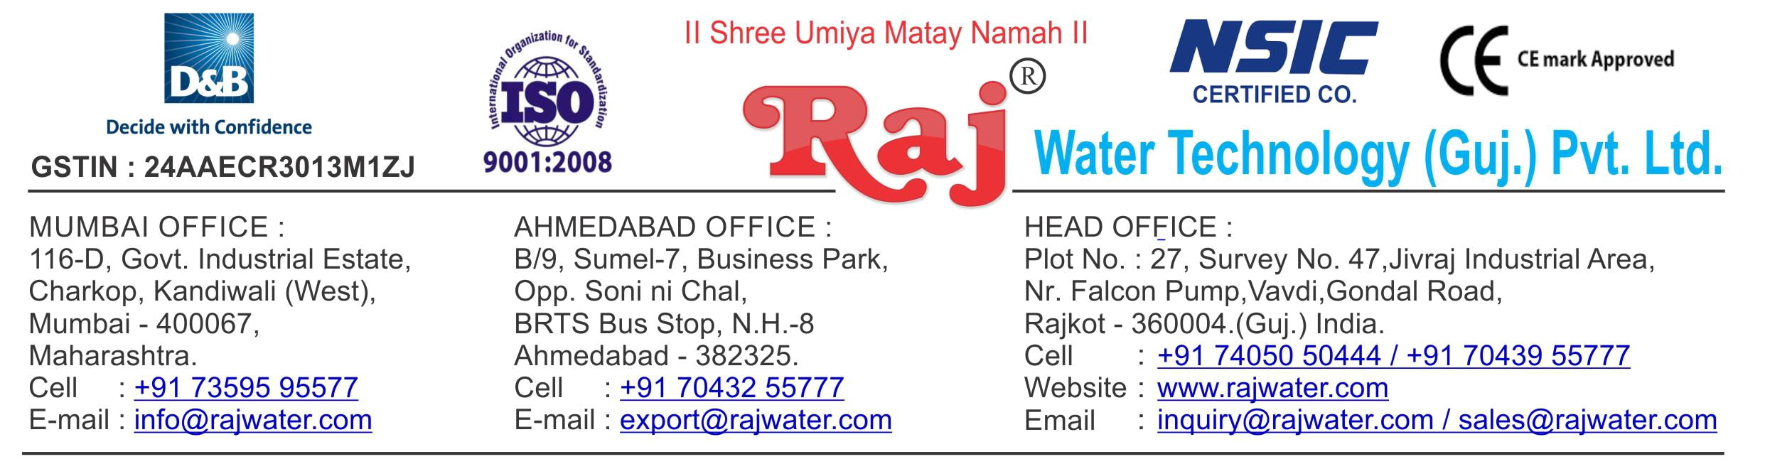

Technical Specification 6000LPH RO Plant

1. Raw Water Feeding Pump
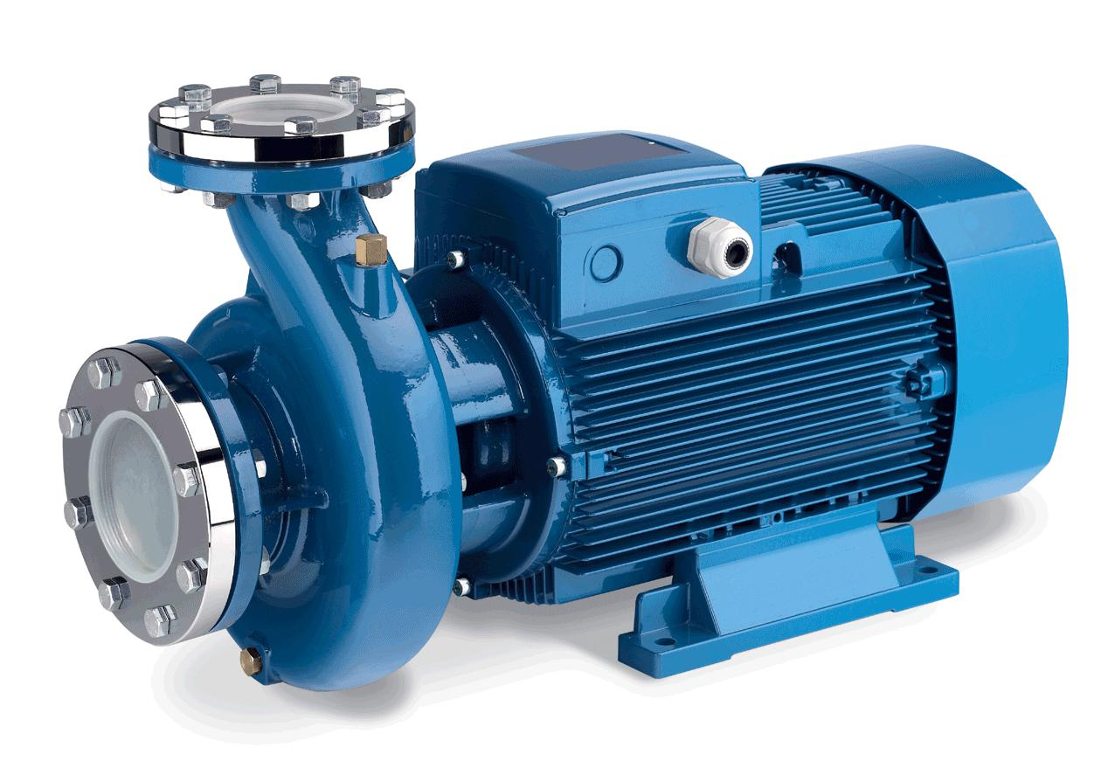

Type :

Centrifugal

Max. Flow :

25.00 m3/HR

Working Flow :

22.00 m3/HR

Working Pressure :

2 Kg. / Cm 2

M.O.C. :

C.I.

Power :

5.0 HP

Manufacturer :

Grundfoss

Nos. Offered :

1 Nos.

Application :-
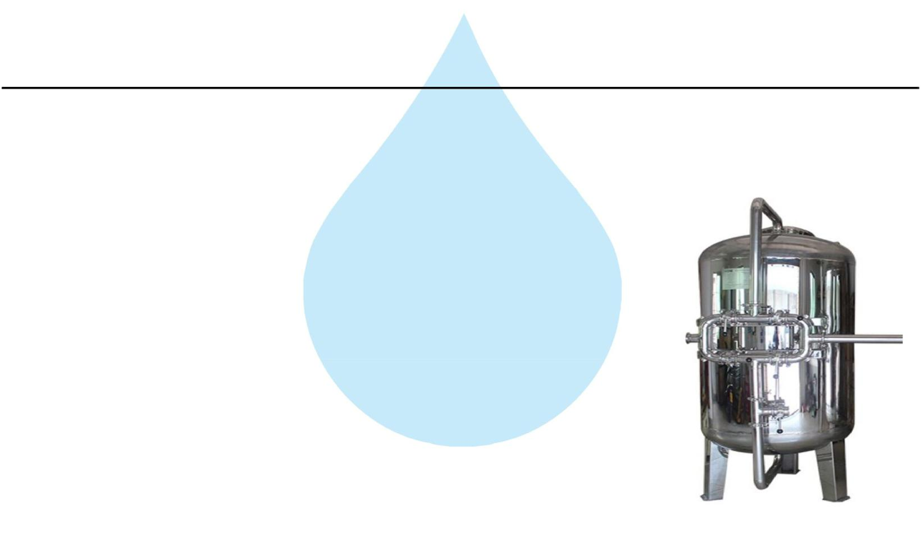
To Pump Raw Water at Required Pressure so as to enable Transfer Through The RO Pre-Treatment Stage.

2. Pressure Sand Filter (SS)

Type :

Down Flow Graded Sand Type

Model :

4872/RW/MFG

M.O.C. :

SS 304

Size Dia X Height :

1200 mm Dia X 1800 mm

Pipe Line Size :

Sand Qty :

40 mm

1900 KG

Valves :
Automatic Valve

Max. Flow :

25.00m3/HR

Working Flow :

22.00 m3/HR

Application :-

By means of Multi size Graded sand filled in the Vessel of stainless steel material, which is natural process of filtration adopted by the nature Raw Water is first filtered by filtration unit in series prior feeding RO Plant. Pressure Sand Filter Unit is provided for removal of suspended matters & turbidity from raw water. PSF Unit is a SS vertical Pressure Vessel. Internally, it is fitted with bottom collecting system. Uniform grades silica quartz sand is charged on the supporting media of pebbles and gravels.

3. Activated Carbon Filter (SS)
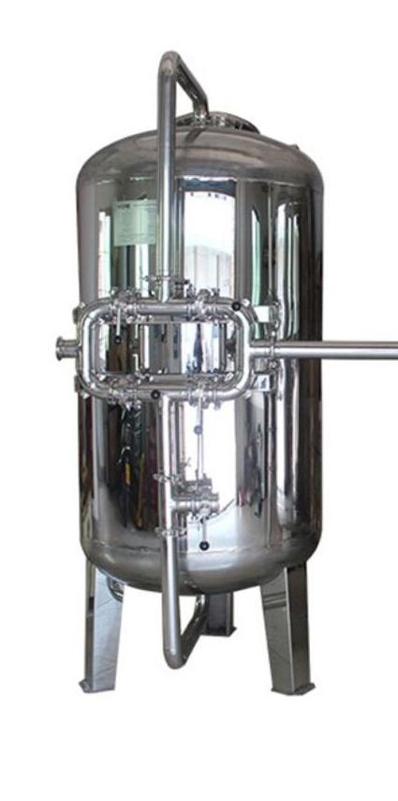

Type :

Down Flow Graded Sand Type

Model :

4872/RW/MFG

M.O.C. :

SS 304

Size Dia X Height :

1200 mm X 1800 mm

Pipe Line Size :

40 mm

Carbon Qty. :

750Kgs.

Valves :

Automatic Valve

Max. Flow :

25.00 m3/HR

Working Flow :

22.00 m3/HR

Application :-

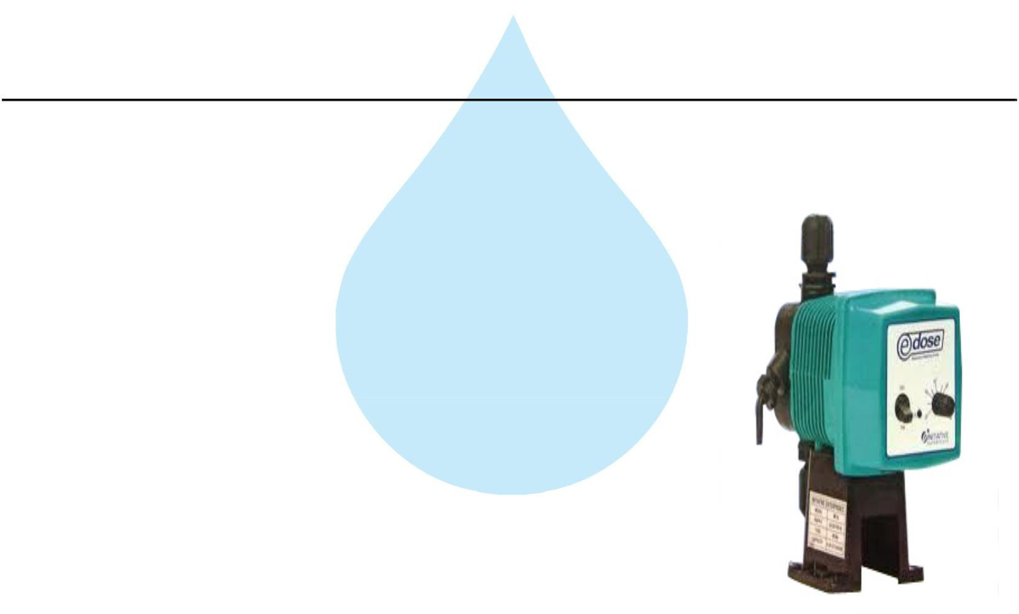
To Remove taste, odour, chlorine, colour and. It can absorb contaminated particles of Oil & Grease from the raw water. It will control the BOD & COD in the raw water. Activated Carbon can remove Chlorine, Odour, & Colour other organic material from feed water prior to reverse osmosis. This Carbon granules having larger surface area and specific property to absorb organics.

4.ORP Meter

5. Antiscalant Dosing Pump

Type :

Ele. Diaphragm Type

Capacity :

0 to 10 LPH

M.O.C. :

PP

Dosing Chemical :

Antiscalent

Dosing Rate :

3 to 4 LPH

Make :

E Dose

Nos :

2 Nos

Application :-

The hardness salts of calcium & magnesium are likely to be precipitated if concentration exceeds its solubility limit

- it may faults the membranes resulting into scaling which ultimately leads to poor treated water quality from R.O.System.

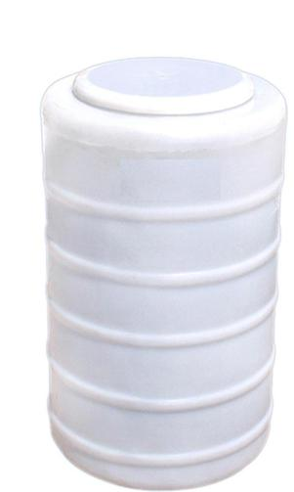
6. Antiscaling Dosing Tank

Type :

Conical Bottom

Capacity :

100 Ltr.

M.O.C. :

HDPE

Manufacturer :

Reputed

Nos :

2 Nos

7. Micron Cartridge Filter
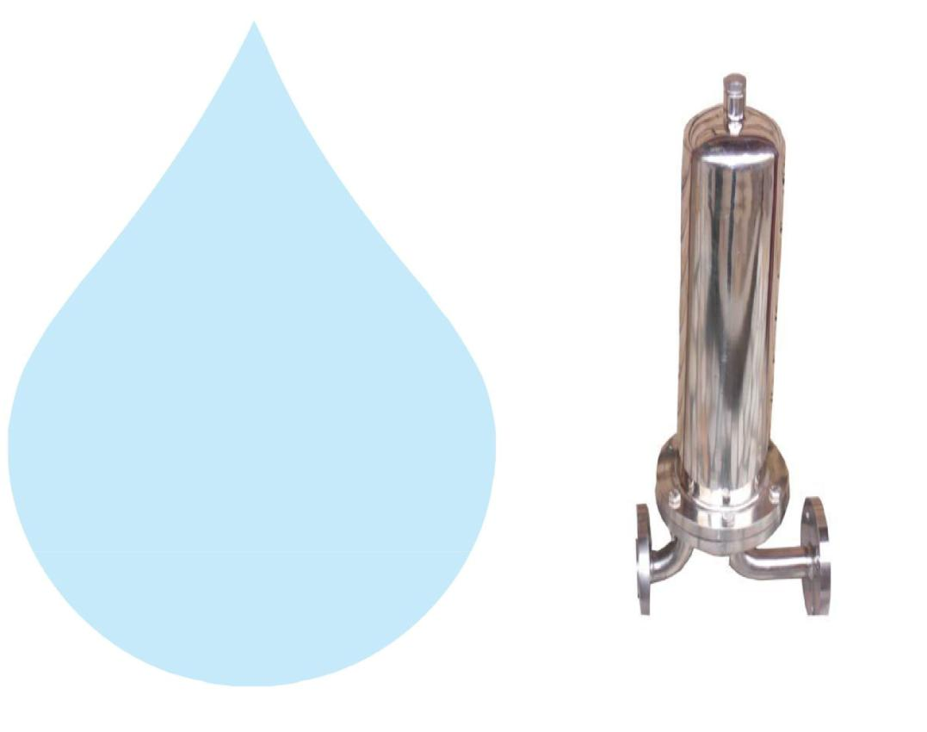

Model :

Size :

Micron Rating :

Type of Candle :

Material of Housing :

Nos. Of Filter

Nos. of Candles :

Max. Flow :

Working Flow :

MCF 30/RW/SS

30" Long

5 Micron

P. P. Spun / Wound

SS 304

2 nos

4 Nos. (Jumbo)

25.00m3/HR

22.00 m3/HR

Application :-

To protect the membrane and the high pressure pump from suspended particles by removing them up to 5 Micron.

8. High Pressure Pump
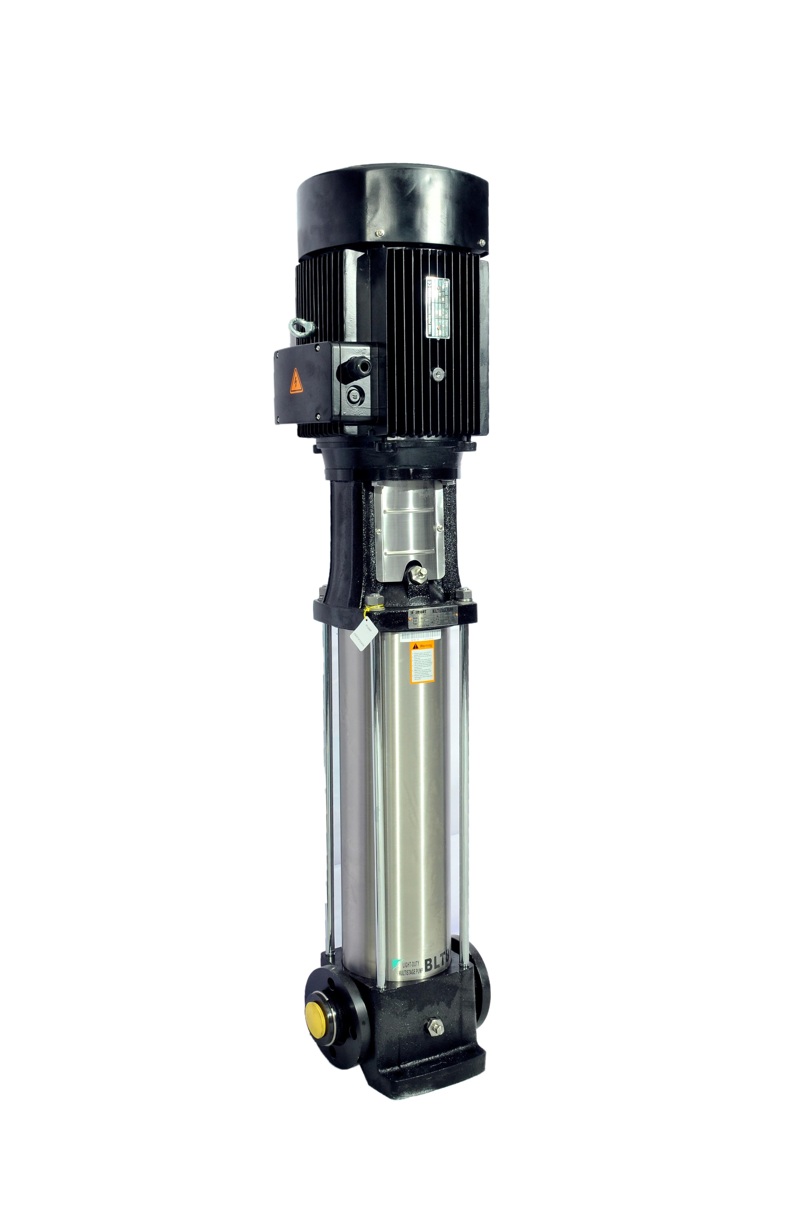

Type : | Vertical Centrifugal Pump
M.O.C. : | SS
Max. Pressure : | 13 | Kgs. / Cm 2.
Working Pressure : | 10 | Kgs. / Cm 2.
Max. Flow : | 25.00 m3/HR
Working Flow : | 22.00 m3/HR
Motor : | 25 | HP
Manufacturer : | 2900 RPM
Nos. Offered : | 3 Phase
Make of Pump : | Grundfos

Application :-

For Reverse Osmosis Process to take place feed pressure of water need to be raised. For this purpose a Vertical Multistage Centrifugal High Pressure Pump in S.S construction is provided R.O. System requires operating pressure of about 14-16 kg/cm^2 . High-pressure pump is fitted with S.S. discharge pipe work with necessary control valves. Necessary instruments like a High Pressure Switch, Pressure Gauge and recirculation valves are provided for safer operation of system

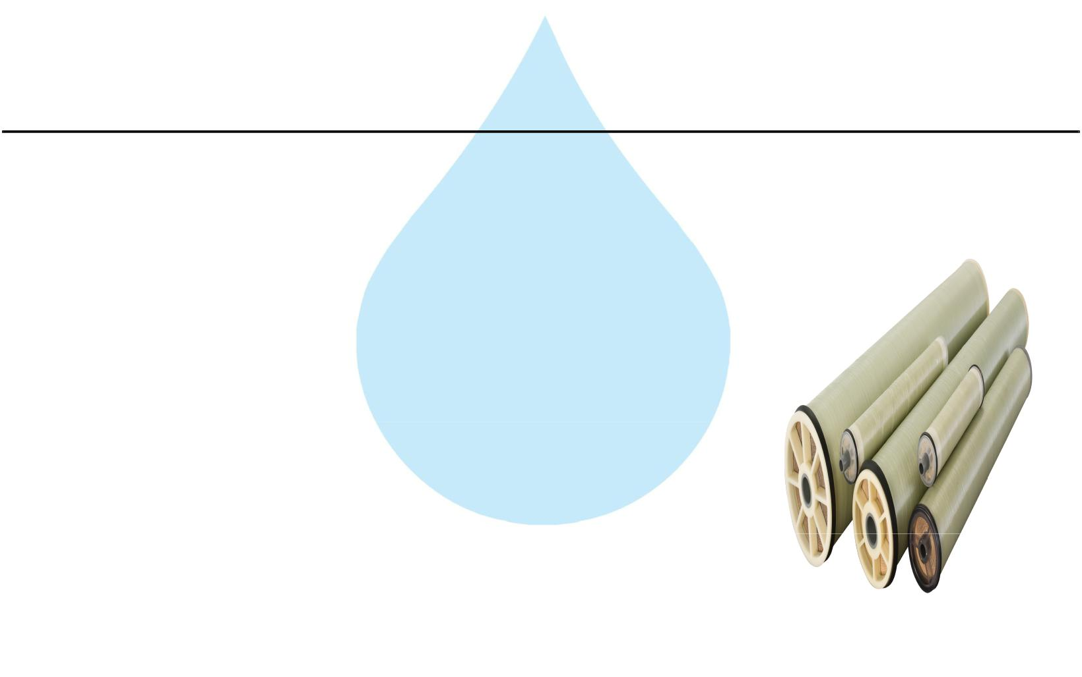
9. RO Membrane

Model :

8040 Element

Type :

TFC Spiral Wound

Material :

Polymide

Size :

8" Dia X 40" Long

Manufacturer :

Toray / Hydranautics / Dow / EQI

Nos. Offered :

Application :-

11 Nos.

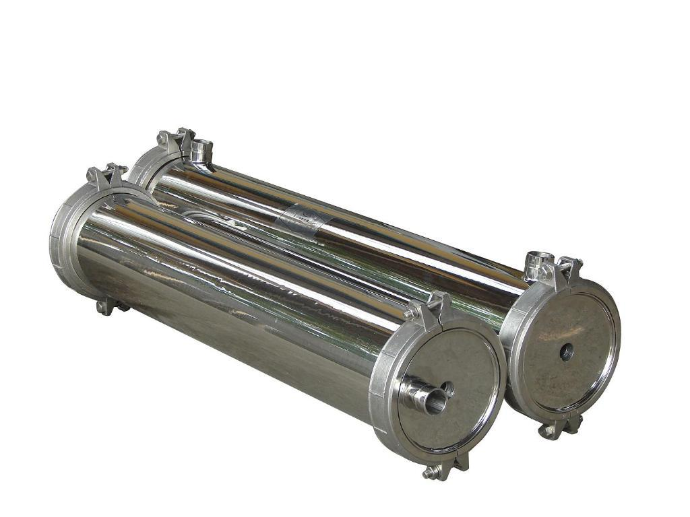
To reduce Raw Water T.D.S. through the concept of Reverse Osmosis where R.O. Modules processes Raw Water and produces Purified Water having the Salt Rejection of Raw Water in the range of 90 – 95%. By using Semi permeable Membrane filter elements, where ion filtration process is carried out by applying pressure in the water. So finally we will get Low salt water with low total dissolve solids and High purity. Here will have to drain the water at one side to Wash the Membrane filter elements continuously because of filtration process there is nothing to be polluted in the system.

10. SS Pressure Vessels

M.O.C. : | SS 304
Type : | Code/ SIDE/4
Size : | 8" X 160"
Max. Pressure : | 400 PSI
Working Pressure : | 150 PSI
Nos. Offered : | 3 Nos.

11.RO Membrane Cleaning Pump

Type :

Centrifugal

Working Flow :

25.00 m3/HR

Working Pressure :

2 Kg. / Cm 2

M.O.C. :

Power :

Manufacturer :

C.I.

3.0HP

Grundfos

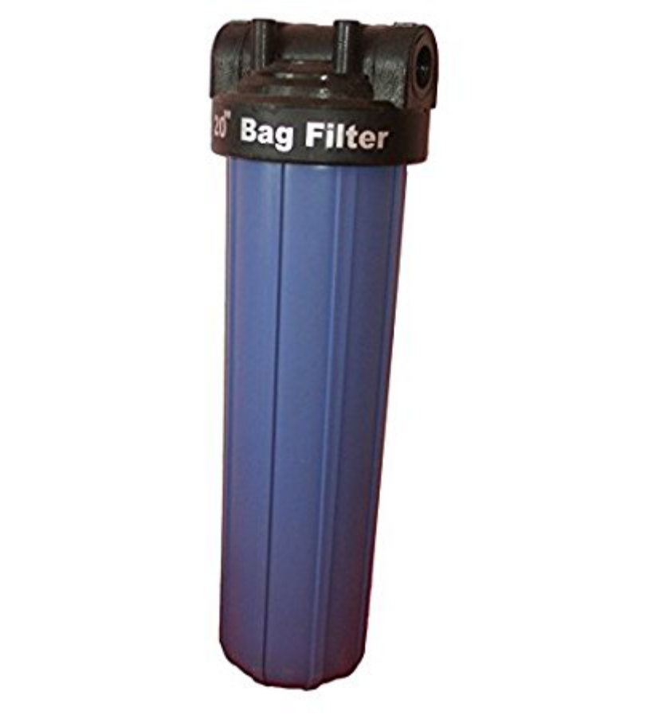
12.RO Membrane Cleaning Filter

Model :

MCF 20/RW/PP

Size :

20" Long

Micron Rating :

1.0 Micron

Type of Candle :

P. P. Spun / Wound

Material of Housing :

PP

Nos. of Candles :

Filter :

3 Nos

3Nos

13.RO Membrane Cleaning Tank

Type :

Conical Bottom

Capacity :

200 Ltr.

M.O.C. :

HDPE

Manufacturer :

Reputed

Nos :
1 No

14. PH Dosing Pump
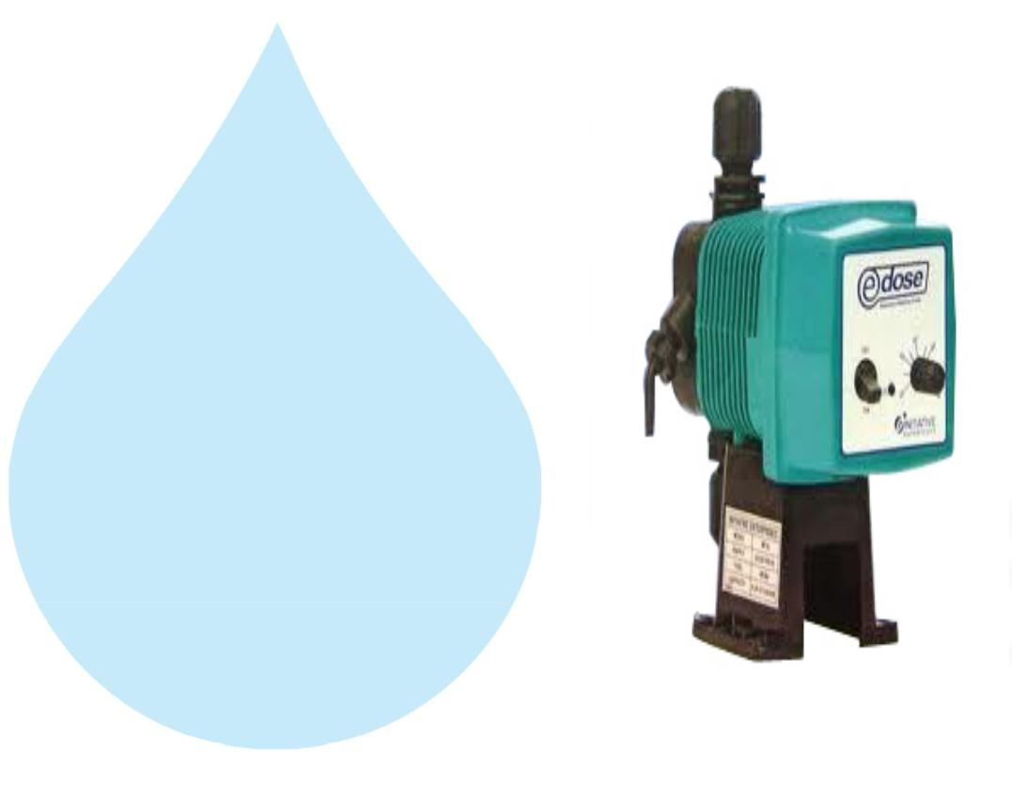

Type :

M.O.C. of Dosing

Electronic Diaphragm type

PP

Capacity : :

Make :
0 to 6 lph

E Dose

15. PH Dosing Tank

Type : | Conical bottom
Capacity : : | 100 ltr
M.O.C. : | HDPE

16. Pressure Gauges
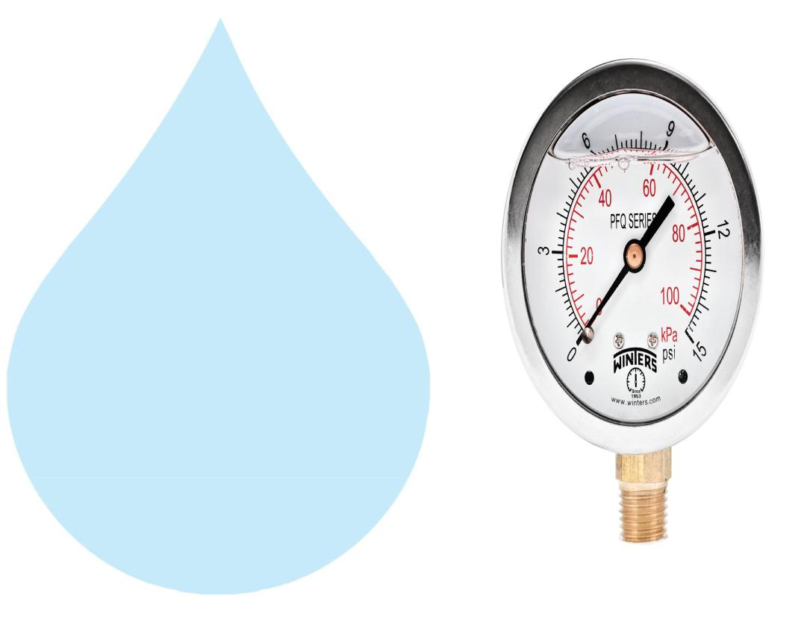

Pressure Gauges : | 6 | Nos.
Type : | Burdone Tube Type
Make : | Raj
Range : | 0 | - 28 , 0 - 7 Kg/cm2

17. Rota Meters
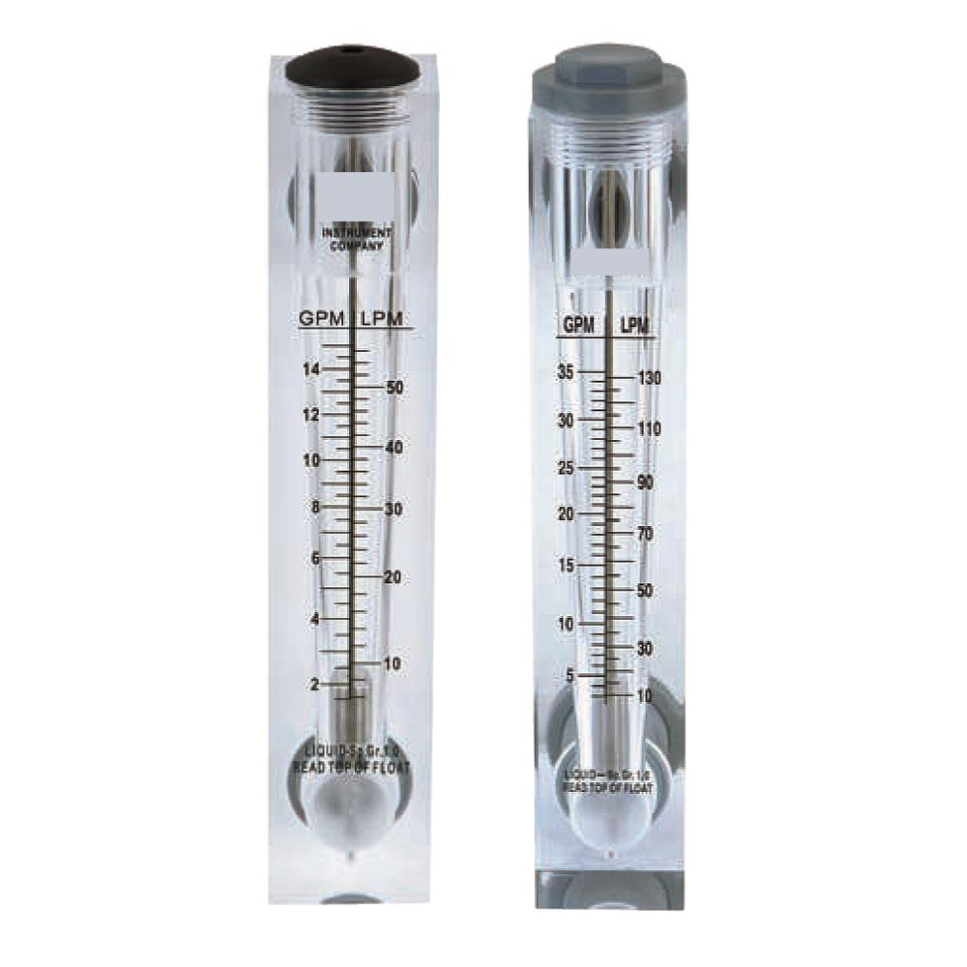

Rota Meters :

Type :

M.O.C. :

Reject Water Range :

Treated Water Range

:

2 Nos.

Float

Acrylic Body

SS Float (0 - 20000 Lph.)

SS Floar (0 - 15000 Lph.)

18. Control Panel - PLC Base
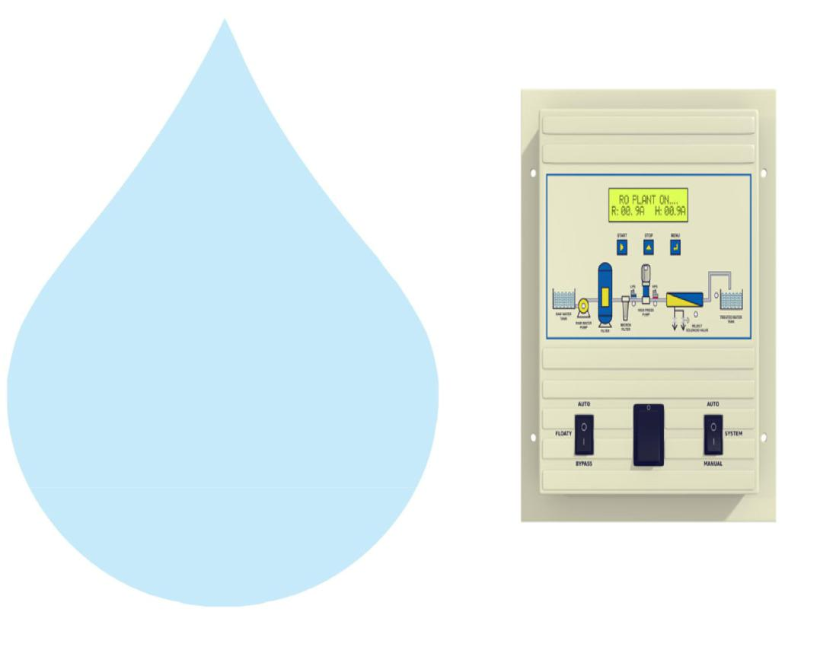

Make : Astral

19. Pressure Switch
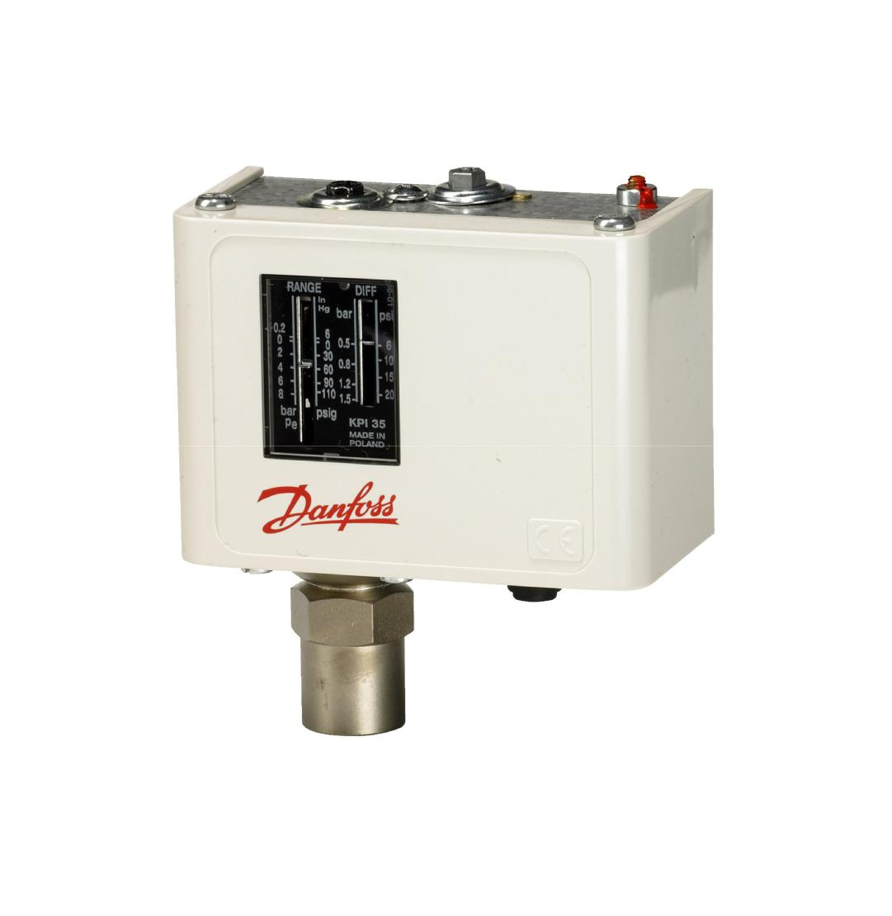

Pressure Switch :

2 Nos.

Type :

Low / High Pr.

Make :

Denfoss

Model :
IPS 70 / 400

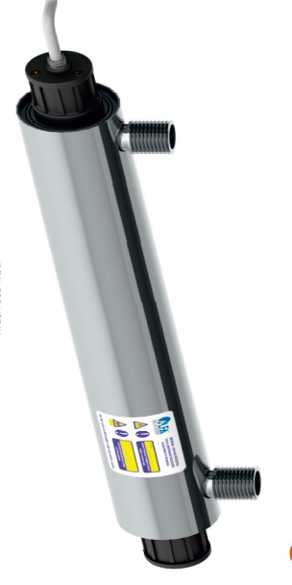
20.U. V. Disinfection System

Type : Fluorescent Tube

Working Flow : 11000 Lph

Working Pressure : 1 Kg. / Cm 2

Material : SS 304

Manufacturer : Raj

Nos. Offered : 1 Nos.

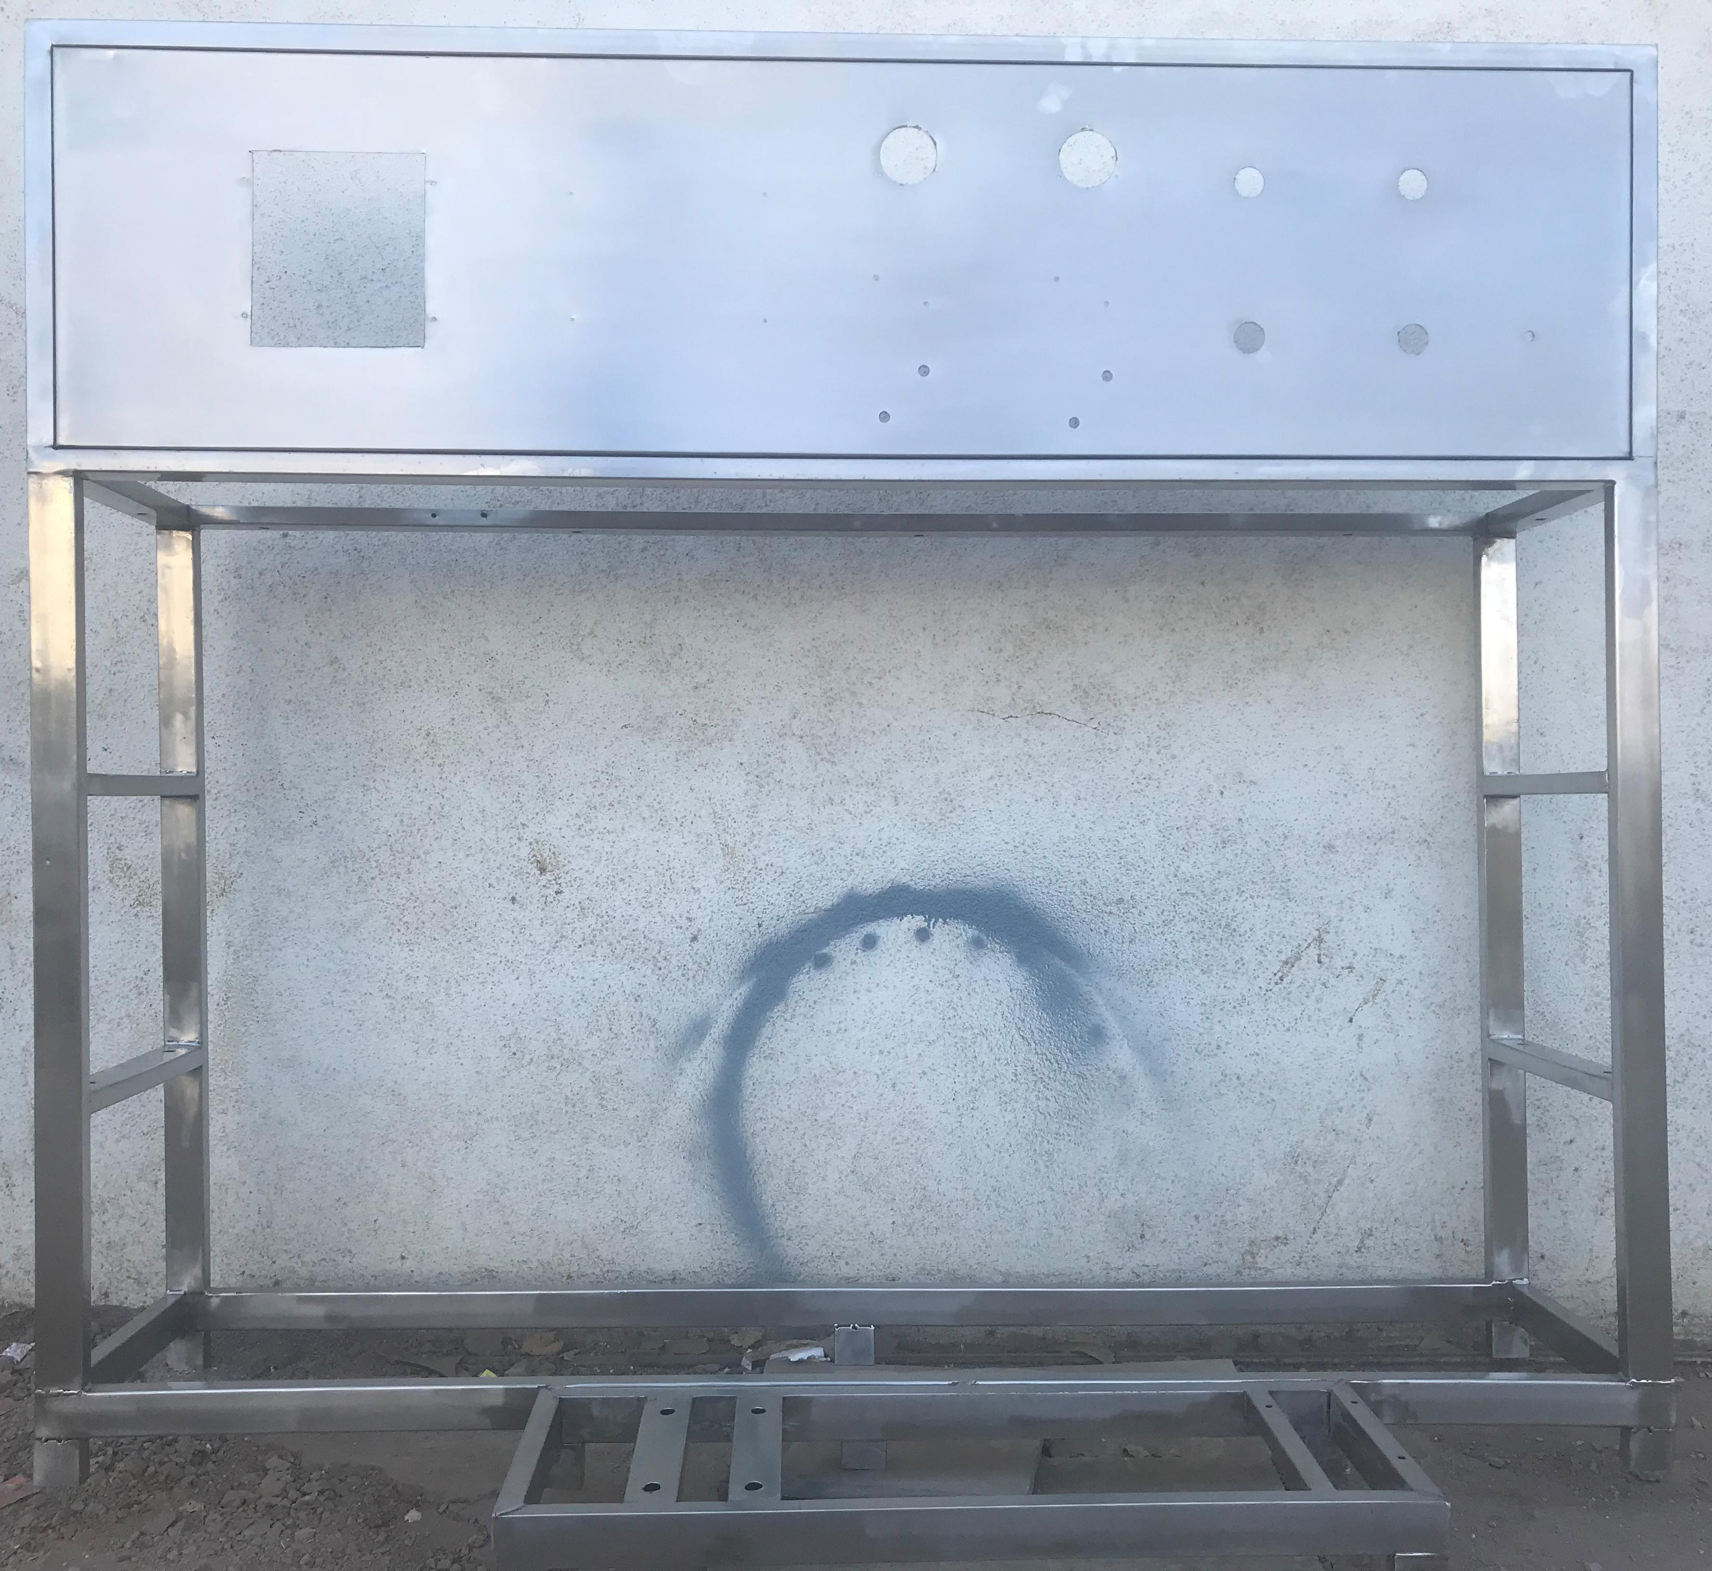
21.Stand For Unit

Stainless Steel : | S.S 304

Application :-

Complete stand for unit will be made of S.S.304
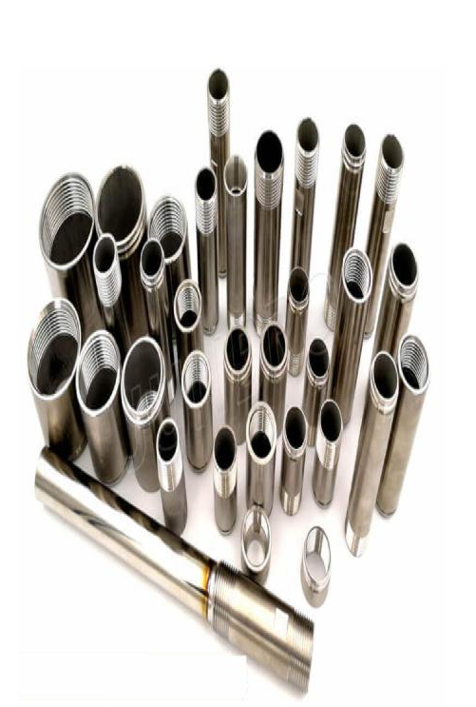
22. SS Interconnecting Pipe Lines

Stainless Steel : | S.S 304

Application :-
All interconnecting pipelines Raw water Pump to RO will be provided of S.S 304 by us

