Technical Specification

1. Raw Water Quality

R.O. plant is | 1500 TDS
designed based On :
Hardness : | 300

Application :-

2. Treated Water Quality

Suspended Solids :

Nill

Turbidity :

Nill

PH :

8.5 To 9

T D S :

100 ppm


Total Hardness :

-

Bacteria Coliform :

Nill

Application :-

The above water quality is approximate assumption, We can change property of minerals/ions in water by editing the raw water in R.O. treated water

3. Raw Water Feeding Pump
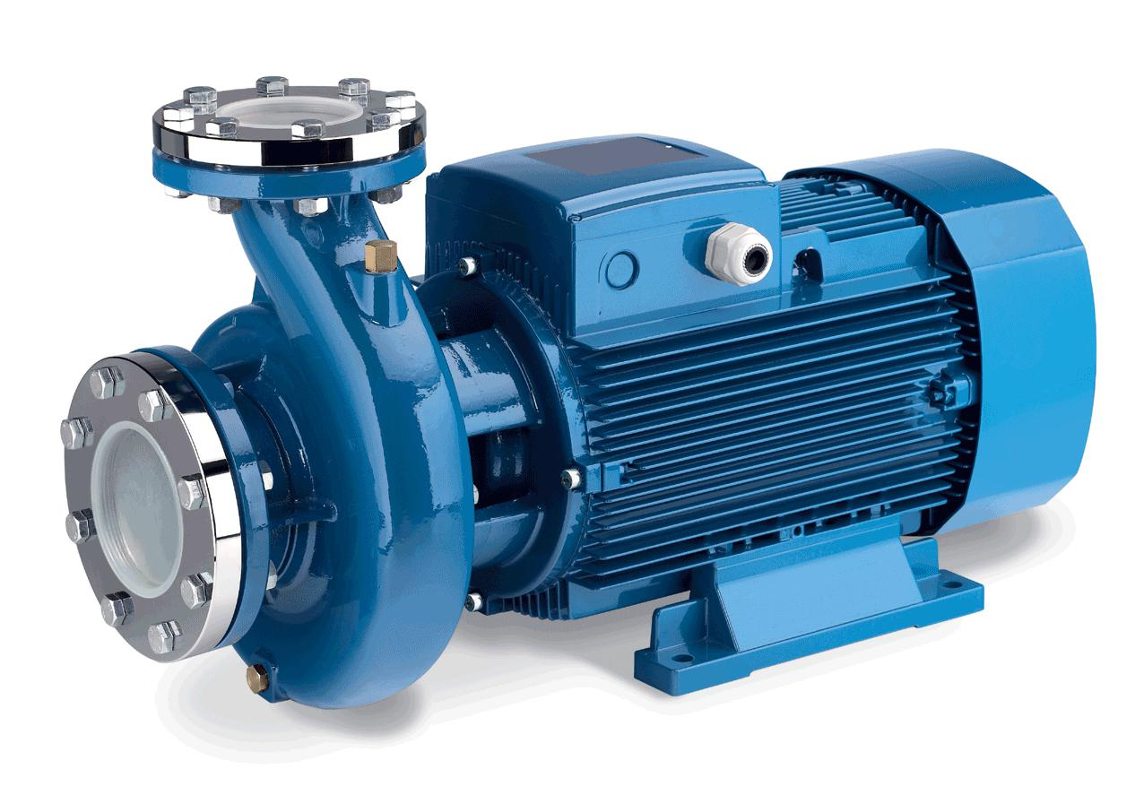

Type :

Centrifugal

Max. Flow :

10.00 m3/HR

Working Flow :

8.00 m3/HR

Working Pressure :

2 Kg. / Cm 2

M.O.C. :

C.I.

Power :

1.5 HP

Manufacturer :

Kirloskar / EQI

Nos. Offered :

1 Nos.

Application :-

To Pump Raw Water at Required Pressure so as to enable Transfer Through The RO Pre-Treatment Stage.

4. Pressure Sand Filter (SS)
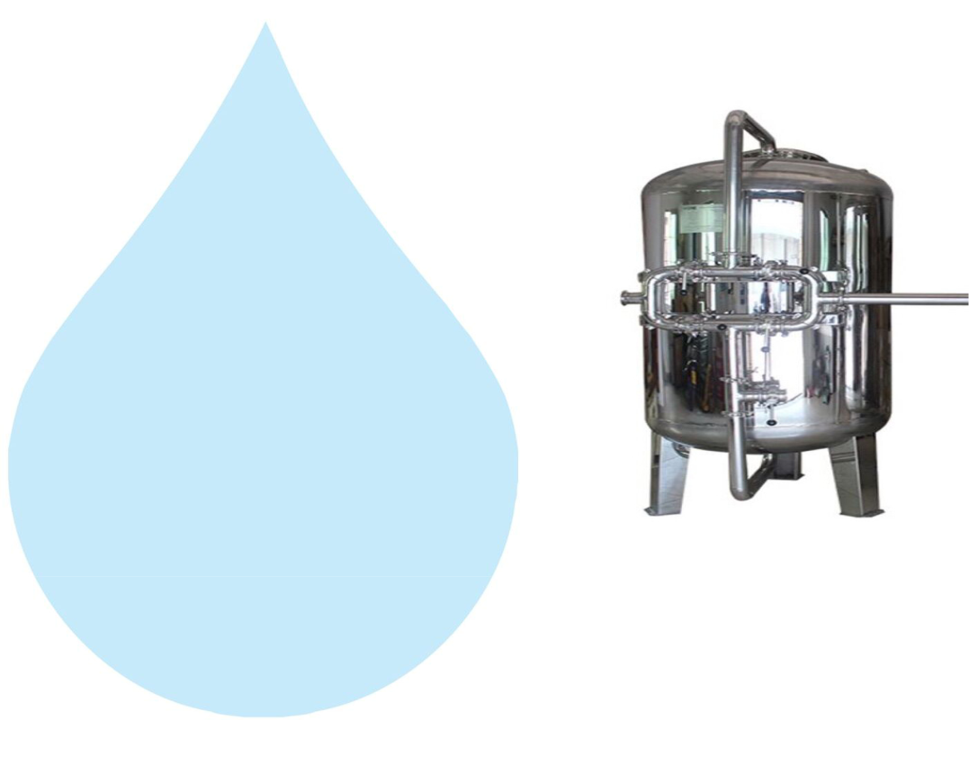

Type :

Down Flow Graded Sand Type

Model :

2068/RW/MFG

M.O.C. :

SS 304

Size Dia X Height :

500 mm Dia X 1700 mm

Pipe Line Size :

40 mm.

Sand Qty. :

330 Kgs.

Valves :

SS Valve

Max. Flow :

10.00m3/HR

Working Flow :

8.00 m3/HR

Application :-

By means of Multi size Graded sand filled in the Vessel of stainless steel material, which is natural process of filtration adopted by the nature Raw Water is first filtered by filtration unit in series prior feeding RO Plant. Pressure Sand Filter Unit is provided for removal of suspended matters & turbidity from raw water. PSF Unit is a SS vertical Pressure Vessel. Internally, it is fitted with bottom collecting system. Uniform grades silica quartz sand is charged on the supporting media of pebbles and gravels.

5. Activated Carbon Filter (SS)
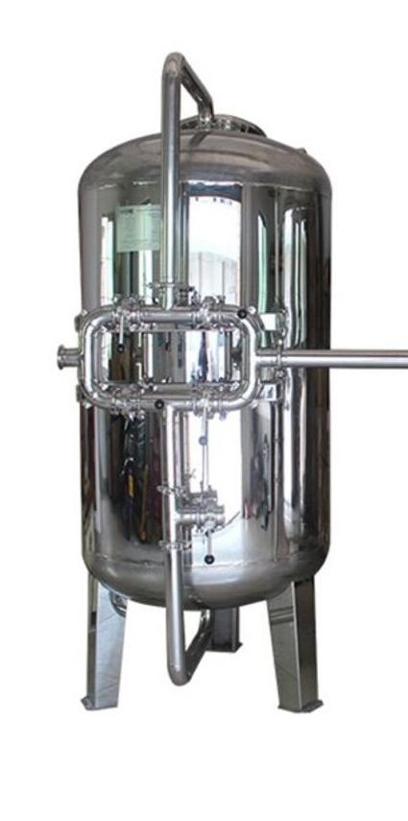

Type :

Down Flow Graded Sand Type

Model :

2068/RW/MFG

M.O.C. :

SS 304

Size Dia X Height :

500 mm X 1700 mm

Pipe Line Size :

40 mm

Carbon Qty. :

135Kgs.

Valves :

SS Valve

Max. Flow :

10.00 m3/HR

Working Flow :

8.00 m3/HR

Application :-

To Remove taste, odour, chlorine, colour and. It can absorb contaminated particles of Oil & Grease from the raw water. It will control the BOD & COD in the raw water. Activated Carbon can remove Chlorine, Odour, & Colour other organic material from feed water prior to reverse osmosis. This Carbon granules having larger surface area and specific property to absorb organics.
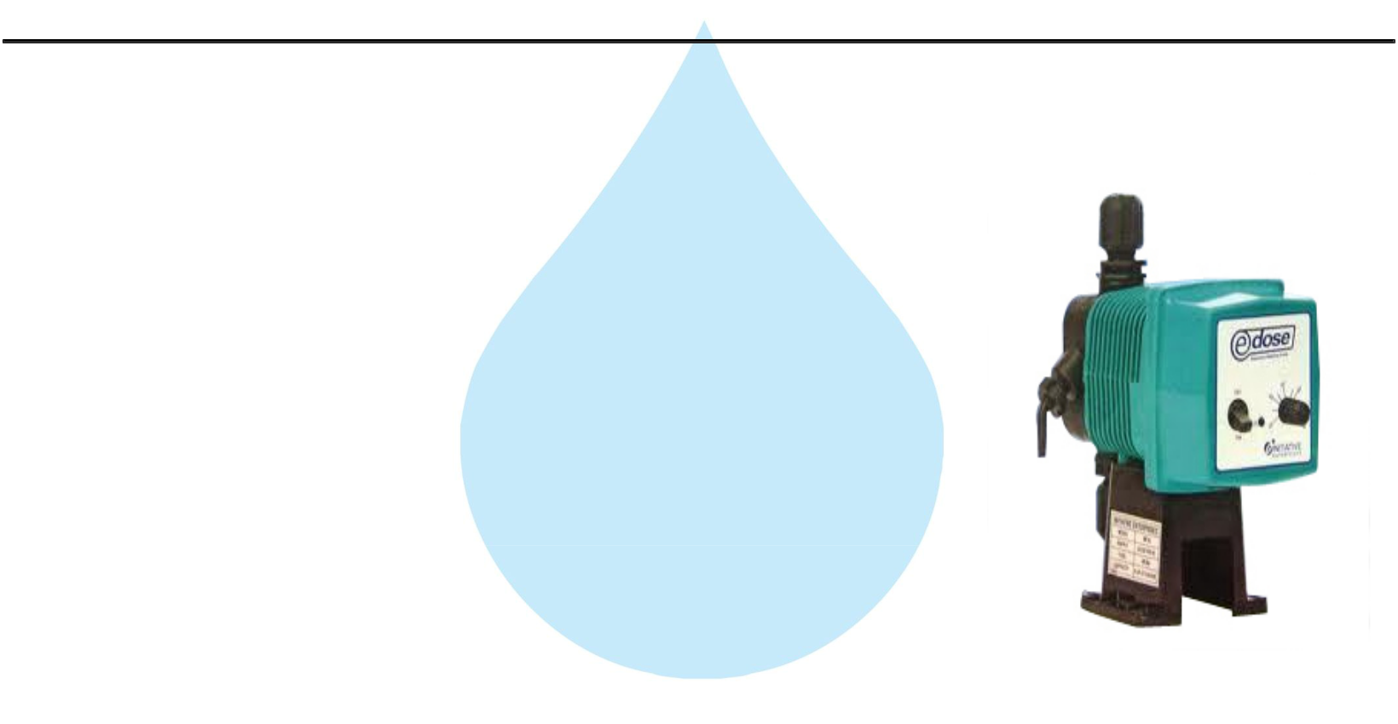

6. Antiscalant Dosing Pump

Type :

Ele. Diaphragm Type

Capacity :

0 to 6 LPH

M.O.C. :

PP

Dosing Chemical :

Antiscalent

Dosing Rate :

3 to 4 LPH

Make :

E Dose/ I Dose

Nos :

1 Nos

Application :-

The hardness salts of calcium & magnesium are likely to be precipitated if concentration exceeds its solubility limit

- it may faults the membranes resulting into scaling which ultimately leads to poor treated water quality from R.O.System.

7. Antiscaling Dosing Tank
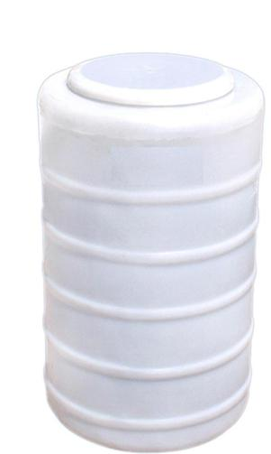

Type :

Conical Bottom

Capacity :

100 Ltr.

M.O.C. :

HDPE

Manufacturer :

Reputed

Nos :

1 Nos

8. Micron Cartridge Filter
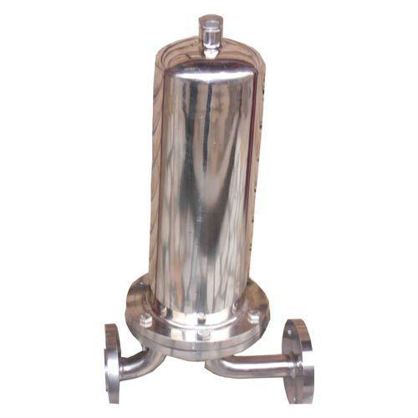

Model :

Size :

Micron Rating :

Type of Candle :

Material of Housing :

Nos. of Candles :

Max. Flow :

Working Flow :

MCF 20/RW/SS

20" Long

5 Micron

P. P. Spun / Wound

SS 304

1 Nos. (Jumbo)

10.00m3/HR

8.00 m3/HR

Application :-

To protect the membrane and the high pressure pump from suspended particles by removing them up to 5 Micron.

9. High Pressure Pump
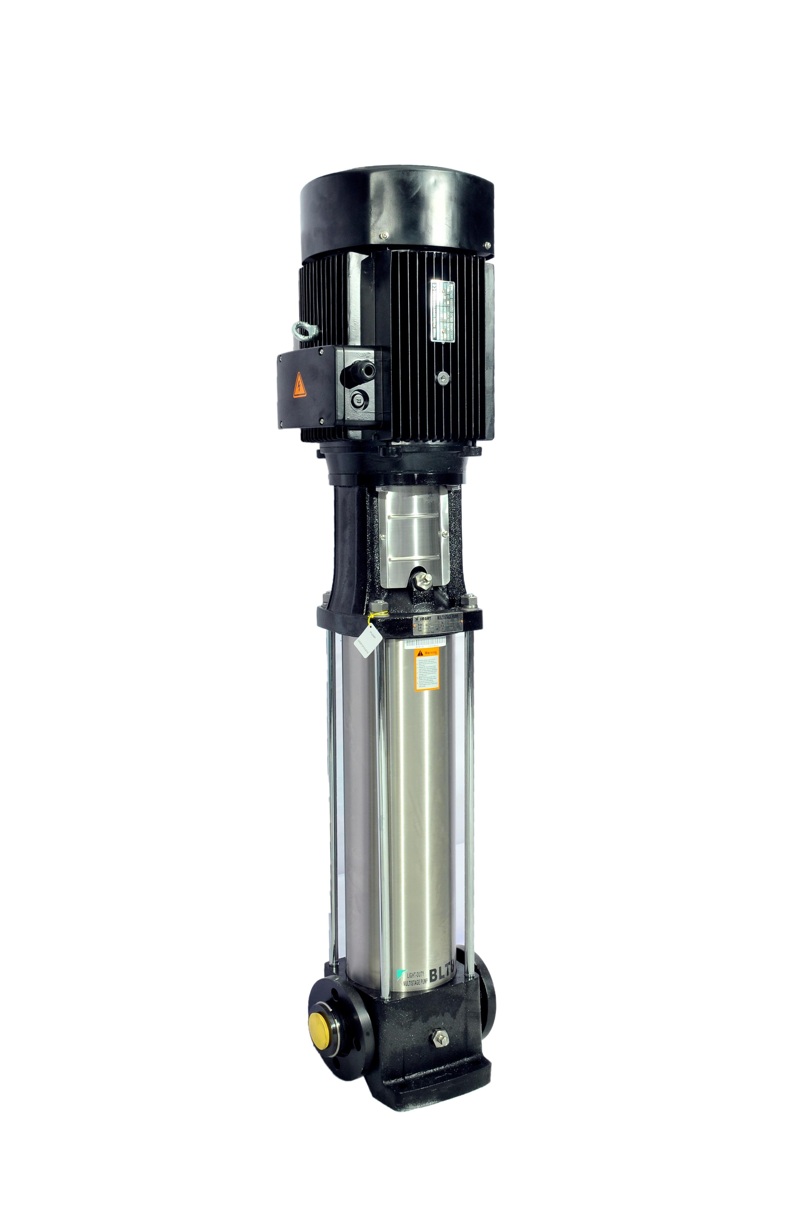

Type :

Vertical Centrifugal Pump

M.O.C. :

SS

Max. Pressure :

13 Kgs. / Cm 2.

Working Pressure :

10 Kgs. / Cm 2.

Max. Flow :

10.00 m3/HR

Working Flow :

8.00 m3/HR

Motor :

5.5 HP

Manufacturer :

2900 RPM

Nos. Offered :

3 Phase

Make of Pump :

PNC / EQI

Application :-

For Reverse Osmosis Process to take place feed pressure of water need to be raised. For this purpose a Vertical Multistage Centrifugal High Pressure Pump in S.S construction is provided R.O. System requires operating pressure of about 14-16 kg/cm^2 . High-pressure pump is fitted with S.S. discharge pipe work with necessary control valves. Necessary instruments like a High Pressure Switch, Pressure Gauge and recirculation valves are provided for safer operation of system
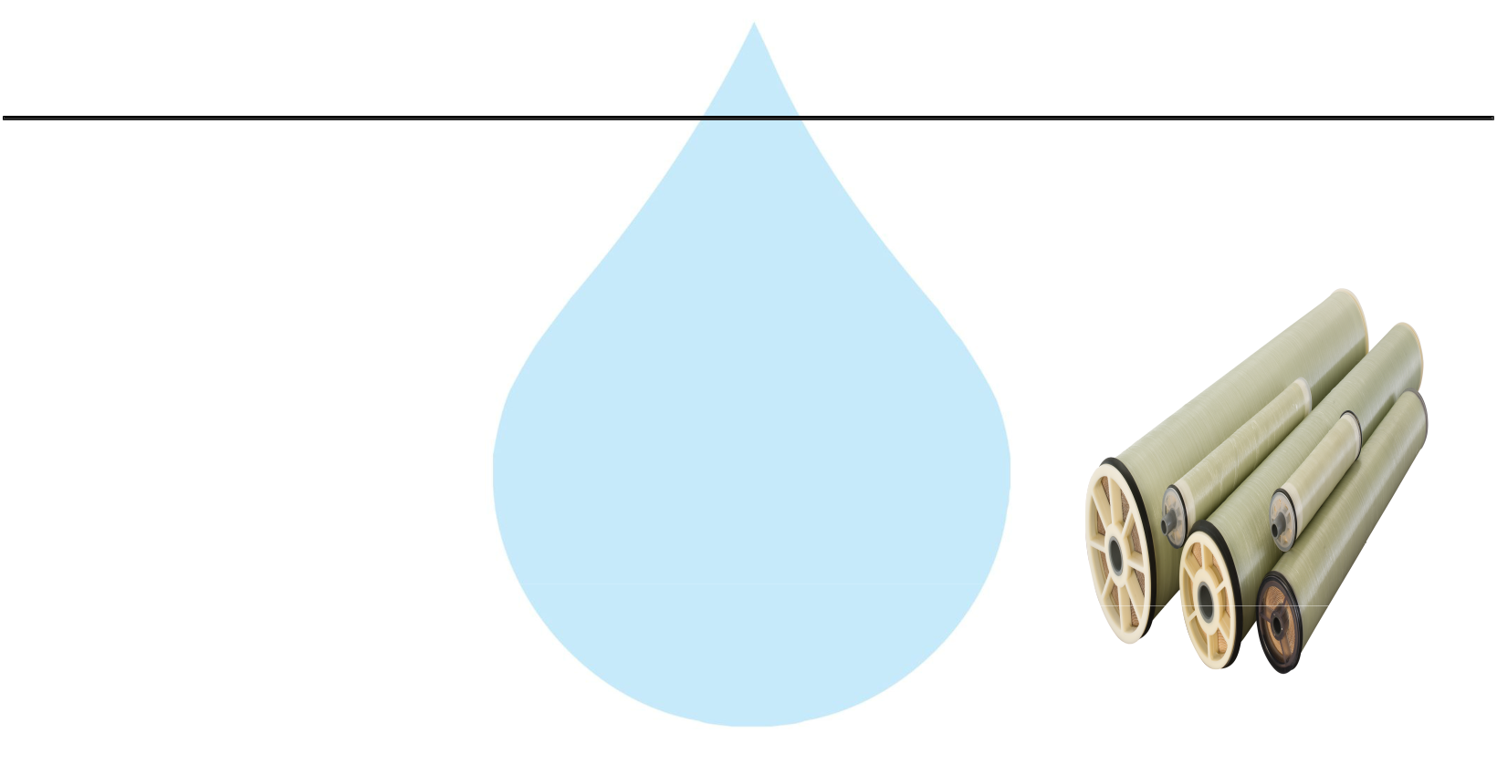

10. RO Membrane

Model :

8040 Element

Type :

TFC Spiral Wound

Material :

Polymide

Size :

8" Dia X 40" Long

Manufacturer :

Toray / Hydranautics / Dow / EQI

Nos. Offered :

4 Nos.

Application :-

To reduce Raw Water T.D.S. through the concept of Reverse Osmosis where R.O. Modules processes Raw Water and produces Purified Water having the Salt Rejection of Raw Water in the range of 90 – 95%. By using Semi permeable Membrane filter elements, where ion filtration process is carried out by applying pressure in the water. So finally we will get Low salt water with low total dissolve solids and High purity. Here will have to drain the water at one side to Wash the Membrane filter elements continuously because of filtration process there is nothing to be polluted in the system.

11. SS Pressure Vessels
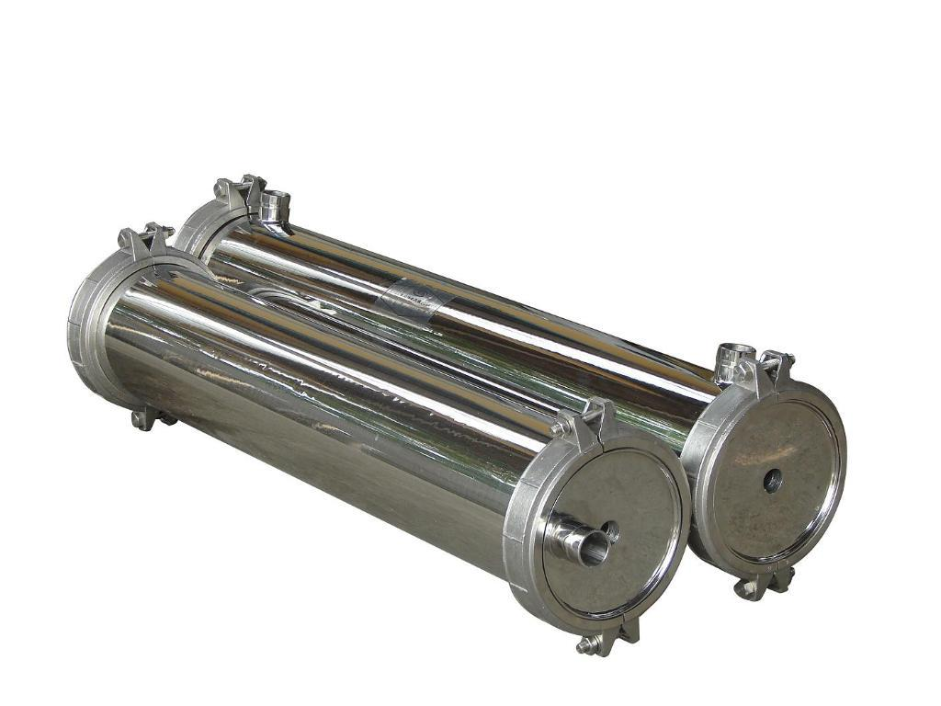

M.O.C. : | SS 304
Type : | Horizontal Tube Type
Size : | 8" X 80"
Max. Pressure : | 400 PSI
Working Pressure : | 150 PSI
Nos. Offered : | 2 Nos.

12. Pressure Gauges
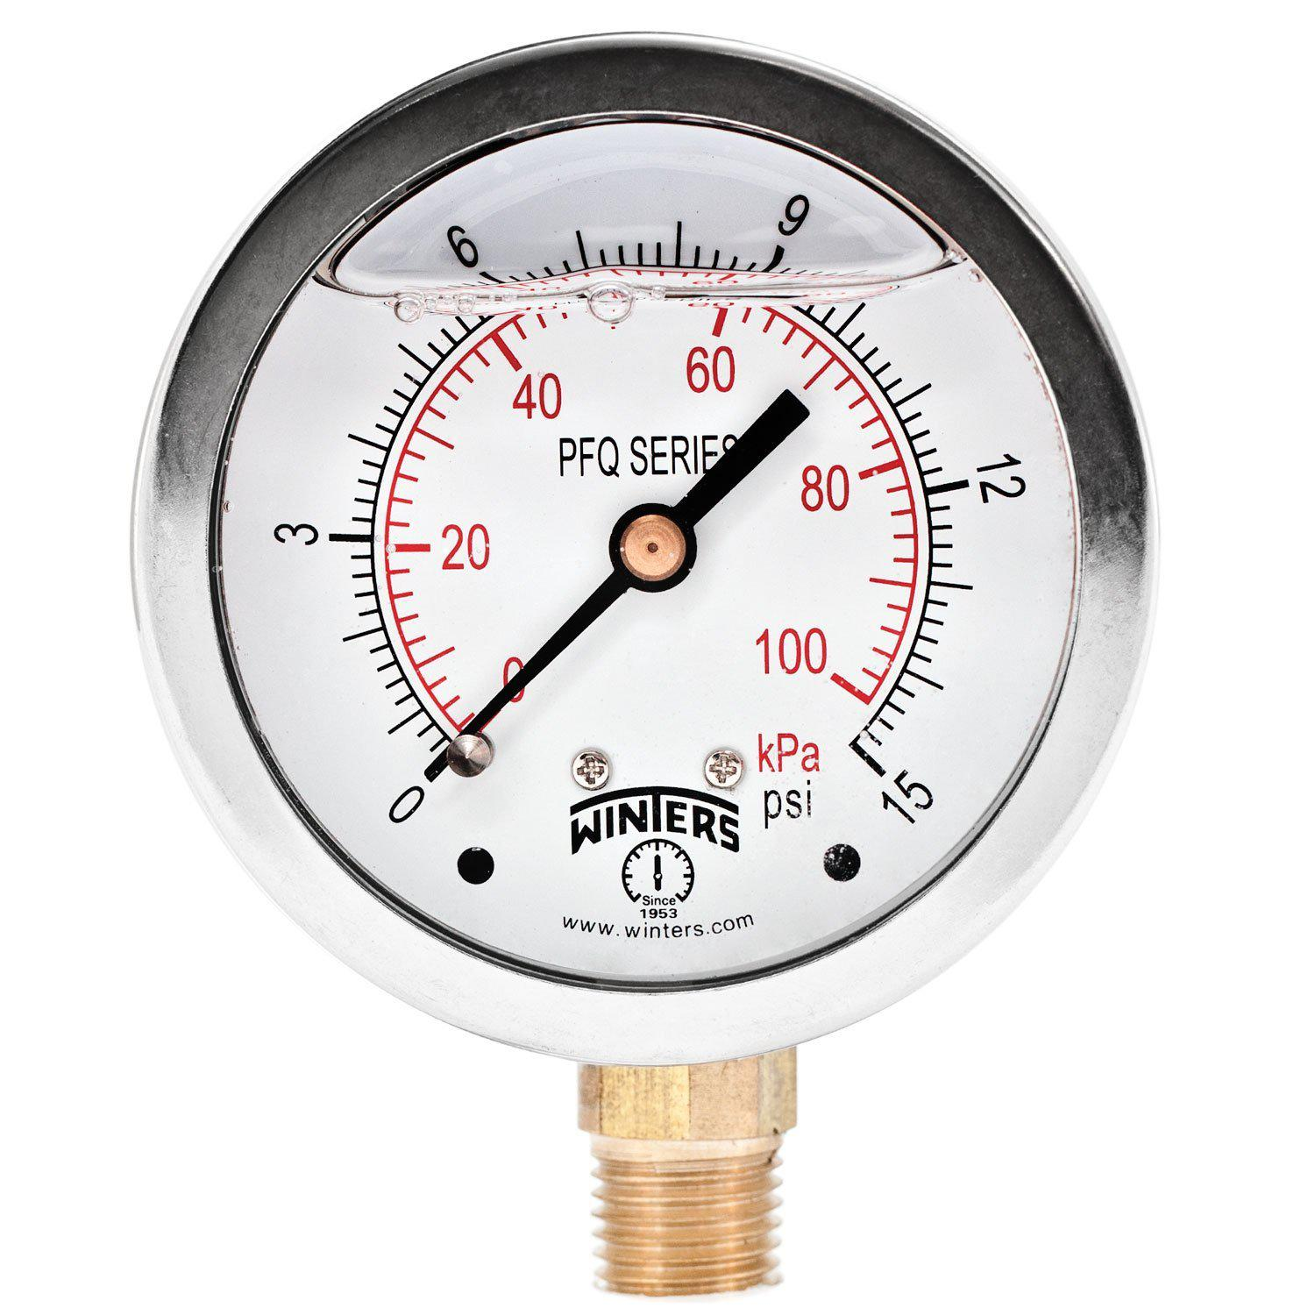

Pressure Gauges : | 7 | Nos.
Type : | Burdone Tube Type
Manufacturer : | Raj
Range : | 0 | - 28 , 0 - 7 Kg/cm2
13. Rota Meters
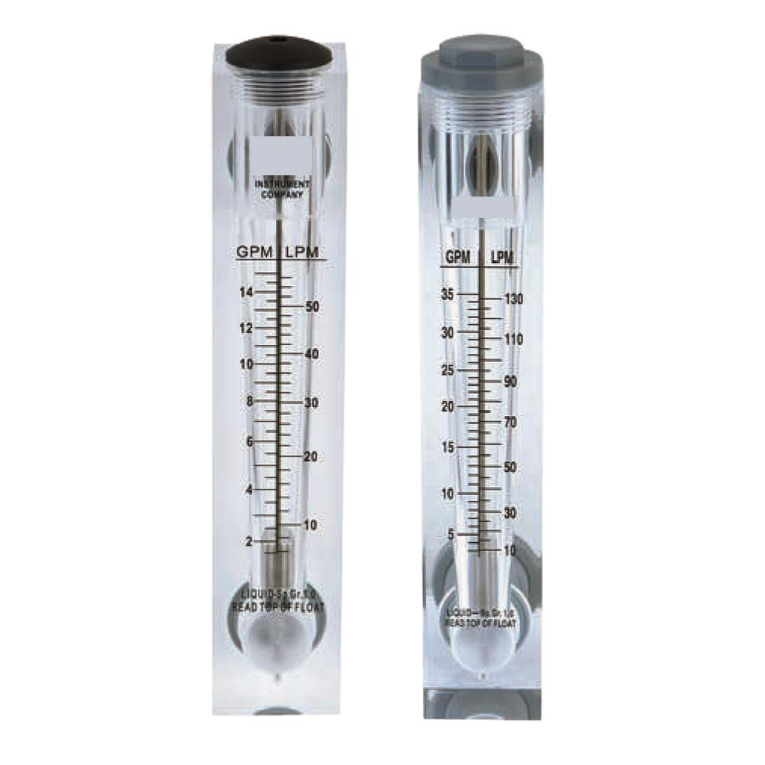

Rota Meters :

Type :

M.O.C. :

Reject Water Range :

Treated Water Range

:

2 Nos.

Float

Acrylic Body

SS Float (0 - 8000 Lph.)

SS Float (0 - 5000 Lph.)

14. Control Panel - PLC Base
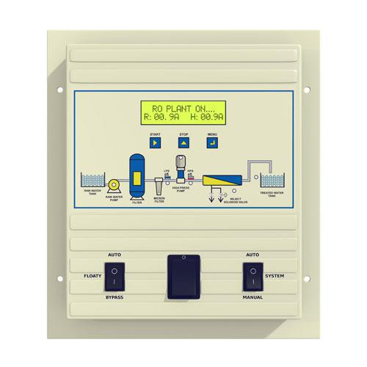

Manufacturer : Astral

15. Pressure Switch
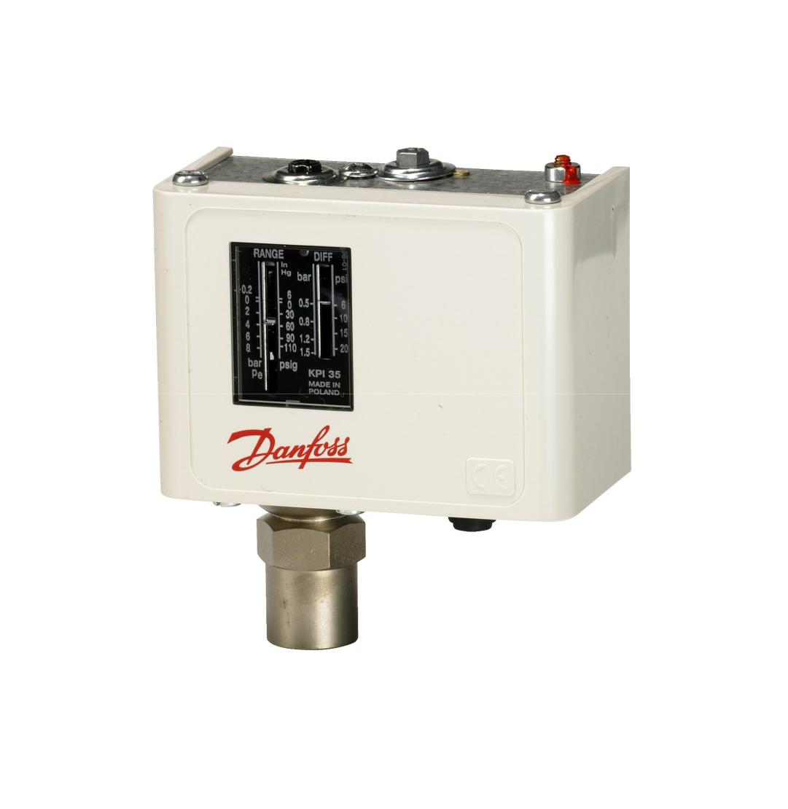

Pressure Switch :

2 Nos.

Type :

Low / High Pr.

Manufacturer :

Denfoss

Model :

IPS 70 / 400

16. Treated Water Storage Tank
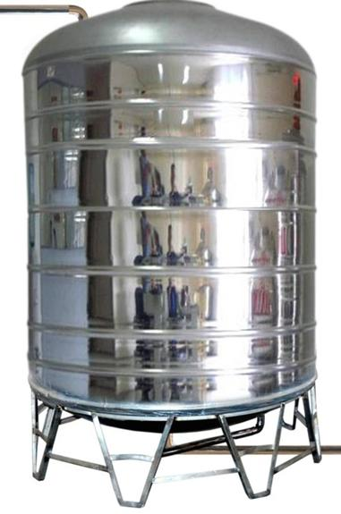

Nos. Offered :

1 Nos.

Type :

Vertical Cylindrical Type

M.O.C. :

SS 304

Capacity :

2000 Ltr.

Application :-

To store Reverse Osmosis permeate (product) water. It can remove back pressure in R.O. Membrane elements. It is only storage of the treated Water.

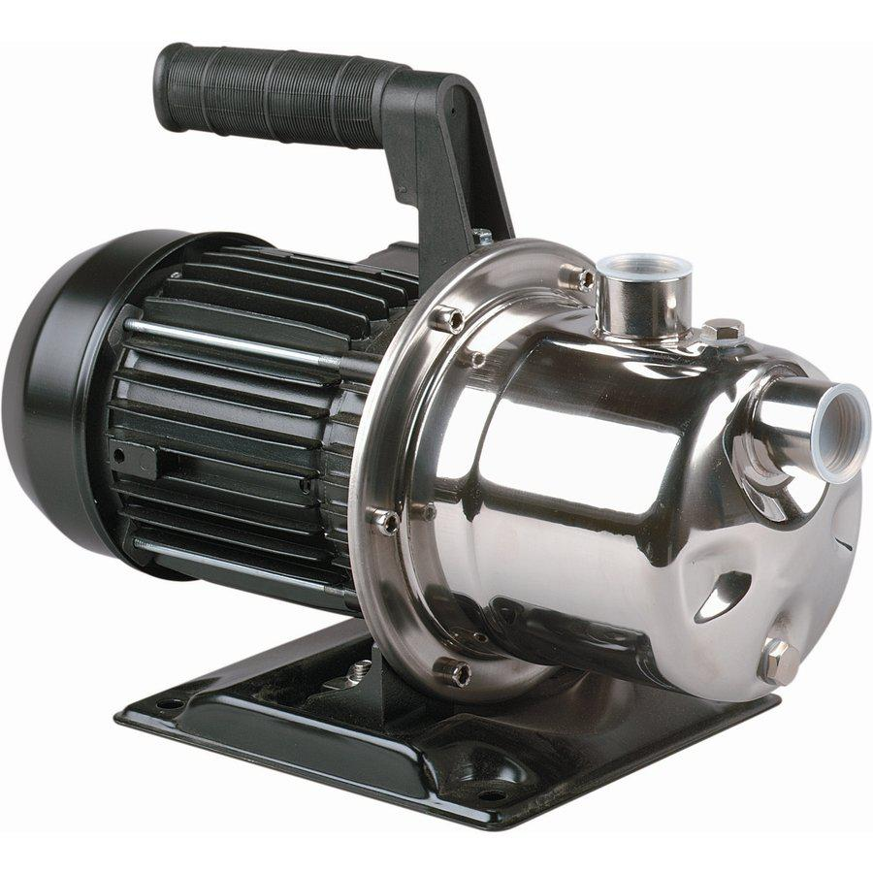
17. Treated Water Transfer Pump

Type : Monoblock

Manufacturer : PNC

M.O.C. : SS

Capacity : | 0.5 HP

Application :-

To feed water to downstream to micron filters and UV system and filling line

18.Alkaline Filter (SS)

Type :

Down Flow Graded Sand Type

Model :

2068/RW/MFG

M.O.C. :

SS 304

Size Dia X Height

500 mm X 1700 mm

Pipe Line Size

40 mm

Media Qty.

Working Flow

Valves

250Kgs.

4.00 m3/ Hr

SS Valve

19. Post Micron Cartridge Filter-1
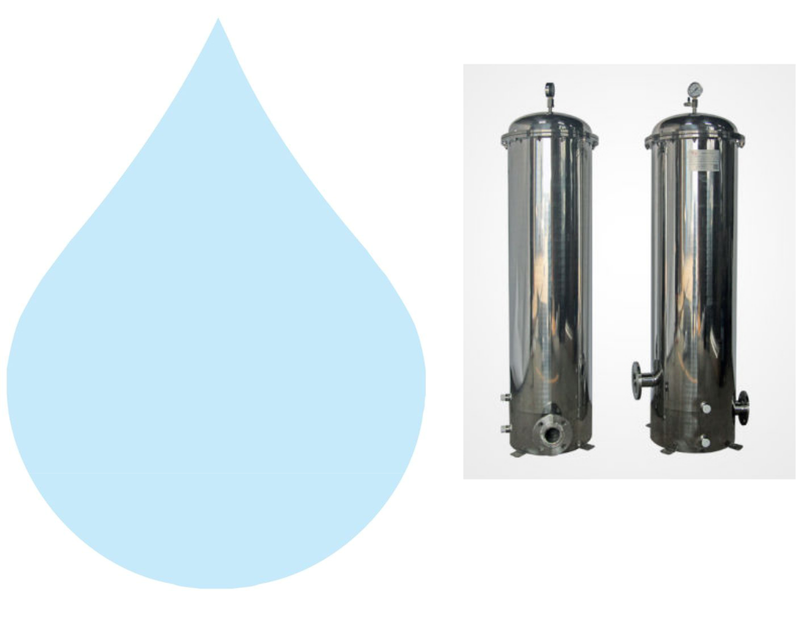

Model :

MCF 20/RW/SS

Size :

20" Long

Micron Rating :

2.0 Micron

Type of Candle :

P. P Spun

Material of Housing :

SS 304

Nos. of Candles :

1 Nos

Working Flow :

4.00 m3/HR

Application :-

During storage, atmospheric or any other contamination may take place in treated water. Hence, after passing water from R.O. System, water is once again passed through a micron cartridge filter. To remove micron particles up to 2.0 Micron sizes.

20. Post Micron Cartridge Filter-2
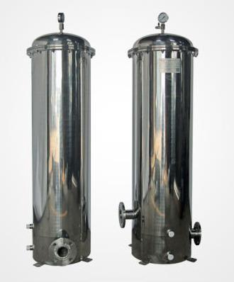

Model :

MCF 20/RW/SS

Size :

20" Long

Micron Rating :

1.0 Micron

Type of Candle :

P. P. Spun

Material of Housing :

SS 304

Nos. of Candles :

1 Nos

Working Flow :

4.00 m3/HR

Application :-

This Vessel fitted internally with P.P spun micron cartridge elements having absolute ratings of 1.0 micron & 0.2 microns which removes all bacterial impurities present in the water and make the water free of particulates.
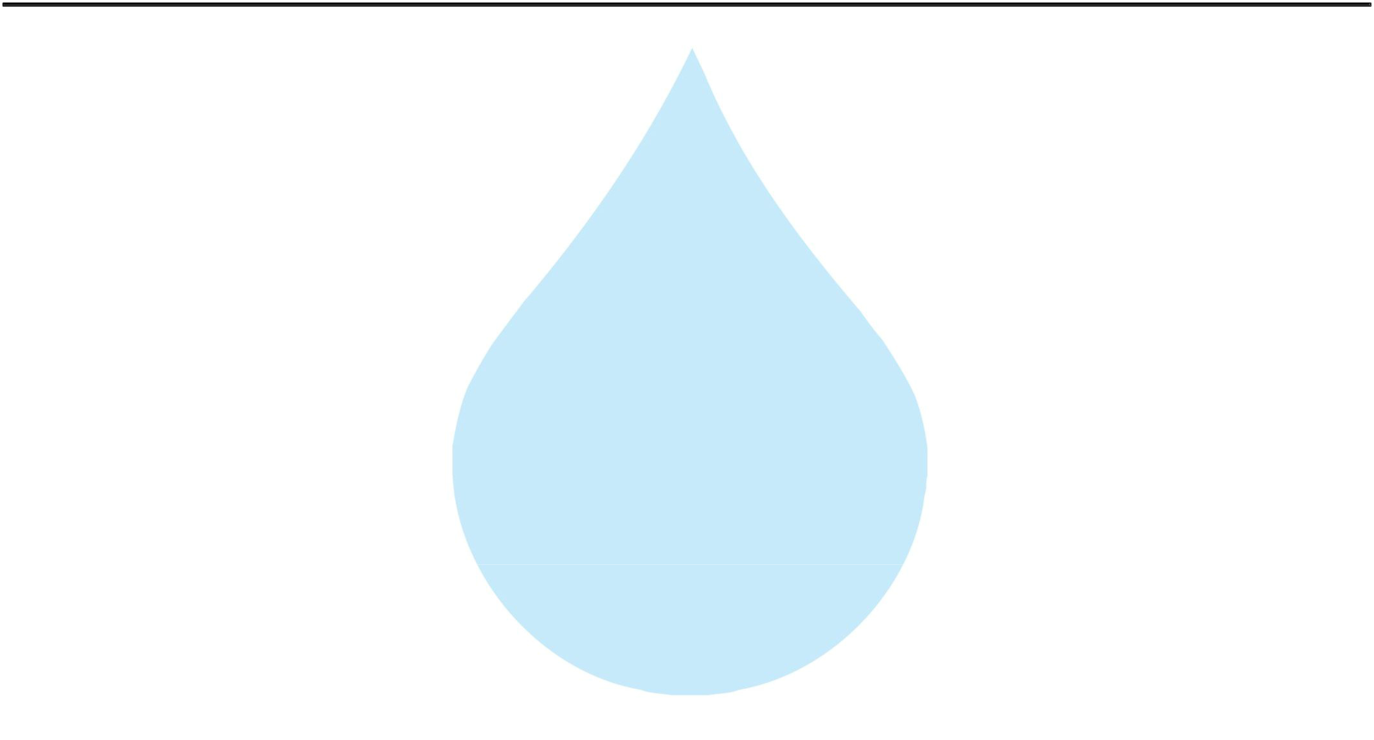

21. U. V. Disinfection System
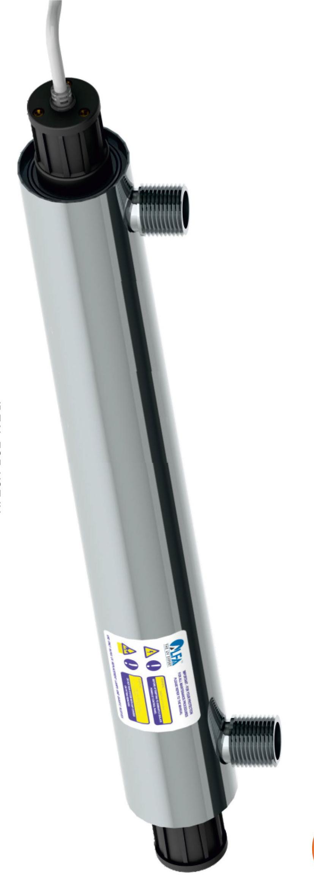

Type :

Fluorescent Tube

Working Flow :

4000 Lph

Working Pressure :

1 Kg. / Cm 2

Material :

SS 304

Manufacturer :

Raj

Nos. Offered :

1 Nos.

Application :-

For removal of micro biological organisms up to 99.9%.

22.Product Water Transfer Pump

Type : Monoblock

Manufacturer : PNC

M.O.C. : SS

Capacity : | 0.5 HP

23.Product Water Tank

Nos. Offered :

1 Nos.

Type :

Vertical Cylindrical Type

M.O.C. :

SS 304

Capacity :

2000 Ltr.

Application :-

For required ppm Ozone gas mix up in finish product water. In ozone re-circulating tank water re-circulating by required flow rate pump . Ventury of ozone install out let of Pump it suction ozone and mix-up help with static mixer. This tank is provided with one no. of re-circulating pump and one no. of product water transfer pump to the filling section.
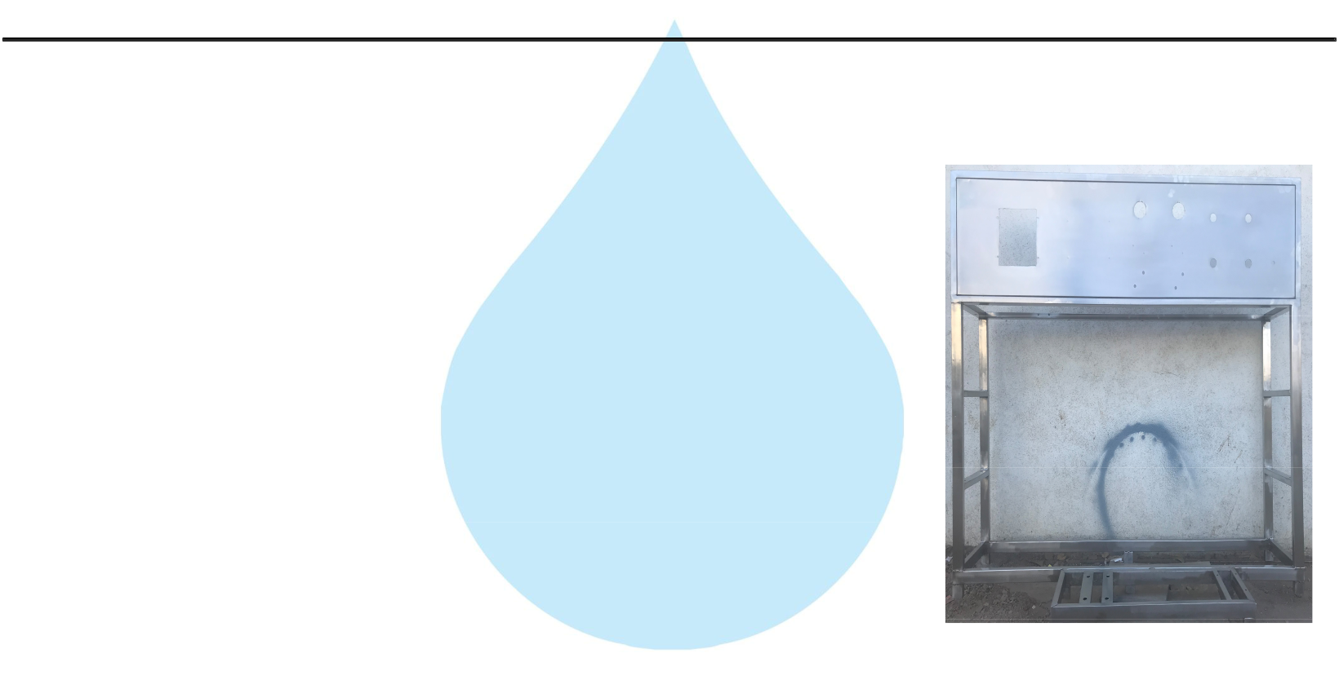

24. Stand For Unit

Stainless Steel : | S.S 304

Application :-

Complete stand for unit will be made of S.S.304
25. SS Interconnecting Pipe Lines
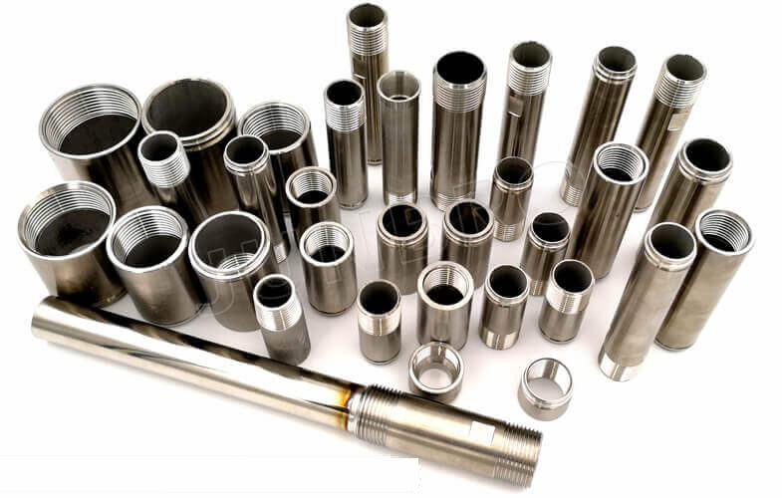

Stainless Steel : | S.S 304

Application :-

All interconnecting pipelines Raw water Pump to Product Water tank will be provided of S.S 304 by us
