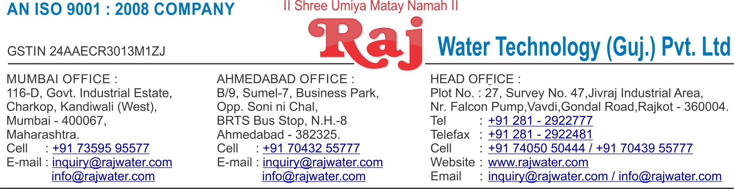

Quotation No :- RW/2018-19/Q_8730 Concern Person :- Mr. Alpesh

Concern Number :- 9979929599

Email Id :- [export@medipackprocesstechnologies.com](mailto:export@medipackprocesstechnologies.com) Company Name :- Medipack Process & Technologies

Address :-

Date :- 26th October 2018

Friday

**Quotation For Carbonated Soda Soft Drink Project**

**Dear Sir ,**

We are pleased to enclose our detailed Techno-Commercial offer, based on your requirement.

**Contents of the Quotation** Commercial Proposal Terms & Condition

Technical Specification for each product

**Machinery Offer**

Carbonated Soda Soft Drink Project

We hope the same is in line with your requirement. We shall gladly assist you in case you need any further clarification or information.

With warm Regards,

**For , Raj Water Technology (Guj.) Pvt. Ltd. CHIRAG PARMAR**

**Designation : Marketing Co-ordinator Mobile : 7043981222**

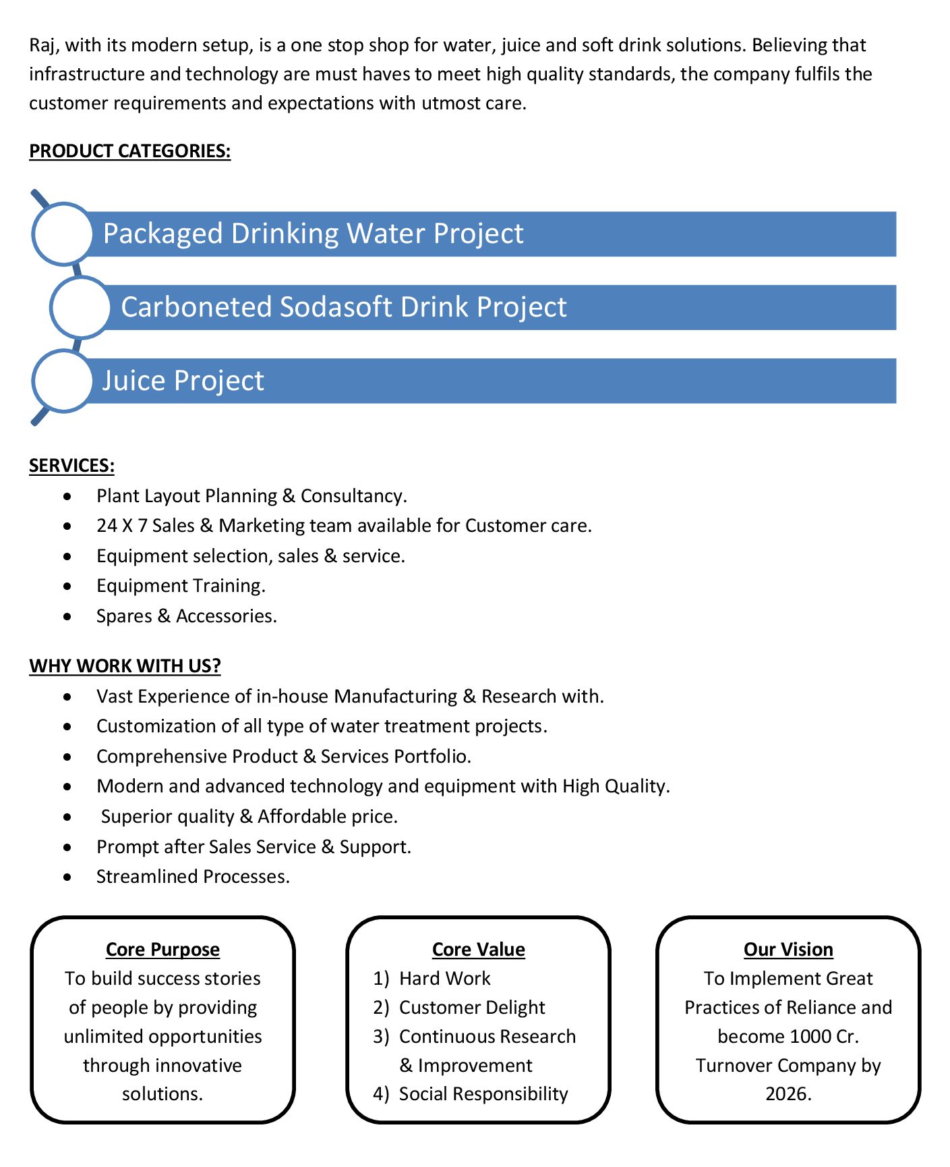



**Commercial Proposal**

|  |  |  |  |  |
| --- | --- | --- | --- | --- |
| **Sr No.** | **Equipment Name** | **Qty** | **Basic Rate** | **Amount** |
| 1 | RO Plant FRP 500LPH With S.S Stand | 1 | 135000.00 | 135000.00 |
| 2 | U.V System | 1 | 15000.00 | 15000.00 |
| 3 | Transfer Pump | 1 | 15000.00 | 15000.00 |
| 4 | SS Storage Tank 1000 Litre Capacity | 1 | 25000.00 | 25000.00 |
| 5 | Carbonation Production Tank 10" 6 Feet Height | 1 | 150000.00 | 150000.00 |
| 6 | Semi-Automatic 4-Head Counter Pressure Filling & Capping Machine  Production cpacity 500 BPH | 1 | 325000.00 | 325000.00 |
| 7 | Water Chiller 3-Ton, With Storage Tank For CSD Plant | 1 | 157000.00 | 157000.00 |
| 8 | SS 304 Mixing Tank 500 Litre, With Agitator | 1 | 100000.00 | 100000.00 |
| 9 | Sugar Syrup Storage Tank 200 Litre With Agitator | 1 | 65000.00 | 65000.00 |
| 10 | Sugar Syrup Transfer Pump | 2 | 15000.00 | 30000.00 |
| 11 | Sugar Syrup Filter 20" | 1 | 10000.00 | 10000.00 |
| 12 | Compressor 2-HP | 1 | 26000.00 | 26000.00 |
| 13 | Inter Connecting Piping | 1 | 55000.00 | 55000.00 |
| **Total Amount in Words :-**  Eleven Lakh Eight Thousand | | | **Total Amount** | **11,08,000.00** |

**Terms & Condition**

# Price

The Quoted Prices Are Ex-factory. (For India) The Quoted Prices Are FOB. (For Export)

# TAX

GST 18% Extra Applicable. (For India)

# Payment

50% Advance Along With The Purchase Order, 30% After Inspection, & 20% Before Material Dispatch.

In Case Of Cancellation Of Confirmed Order Due To Any Reason, As A Part Of Penalty 25% Amount Of The Order Value Shall Have To Pay By You To Raj Water.

# Packing, Freight & Transit Insurance, & Unloading

Packing Charge Will Be Extra (Depend On Packing Material)

Transport To Be Arranged By The Customer OR If Arranged By Raj Water: Extra At Actual Plus GST. Transportation Insurance In The Scope Of Buyer.

Unloading In The Scope Of Buyer. Buyer Has To Ready Forklift Or Crane And Unskilled Labor.

# Delivery

Schedule For Dispatch Will Be Notified.

Delivery Dates Are Approximate Only, And Assume Timely Receipt Of All Information, Test Materials & Payment.

# Warranty

We Shall Provide 1 Year Warranty For The Following:

Manufacturing Defects, Raw Water Pump, High Pressure Pump, Treated Water Transfer Pump.

Due To Fluctuation In Power Supply, Attempted Repaired By Person Other Than Our Technical Representative, Improper Handling Or Negligence By End Users, Poor Maintenance, Improper Use Of Equipment, That All Type Of Damage Not Covered In Warranty Create Area.

During The Warranty Period, We Shall Provide Supervisory Services Of Our Technical Representative As And When Required.

# Accommodation

Technician Charge Will Be Extra 1000/- Rs. Per Day.

Travelling, Lodging And Boarding, Local Conveyance And Any Other Miscellaneous Expense Of Our Technical Representative Will Have To Be Borne By Client.

# Validity

Our Offer Is Valid For Your Acceptance For A Period Of 6 Months From The Date; Thereafter It Will Be Subject To Confirmation By Us.

# Image

Images Are For Representation Purpose Only.

# Jurisdiction

All Terms Subject To Rajkot, Gujarat Jurisdiction.