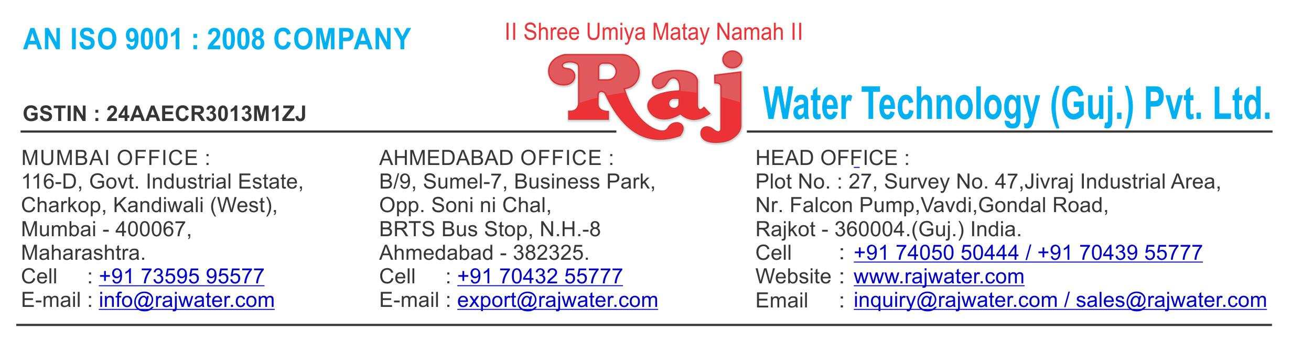

Date :- 6th December 2018

|  |  |  |
| --- | --- | --- |
| Quotation No | :- RW/2018-19/Q_10123/R_1 | |
| Concern Person | :- Mr. Jikarbhai Bijalbhai Wagh | |
| Concern Number | :- | 9825282681 |
| Email Id | :- | r.m.kshatriya@gmail.com |
| Company Name | :- |  |
| Address | :- |  |



**Quotation For Carbonated Soda Soft Drink Project**

**Dear Sir ,**

We are pleased to enclose our detailed Techno-Commercial offer, based on your requirement.



**Contents of the Quotation**

Commercial Proposal



Terms & Condition



Technical Specification for each product



**Machinery Offer**

Carbonated Soda Soft Drink Project



We hope the same is in line with your requirement. We shall gladly assist you in case you need any further clarification or information.

With warm Regards,

**For , Raj Water Technology (Guj.) Pvt. Ltd.**

**KHUSHBU DESHANI**

**Designation : Marketing Asst. Manager**

**Mobile : 7405050444**

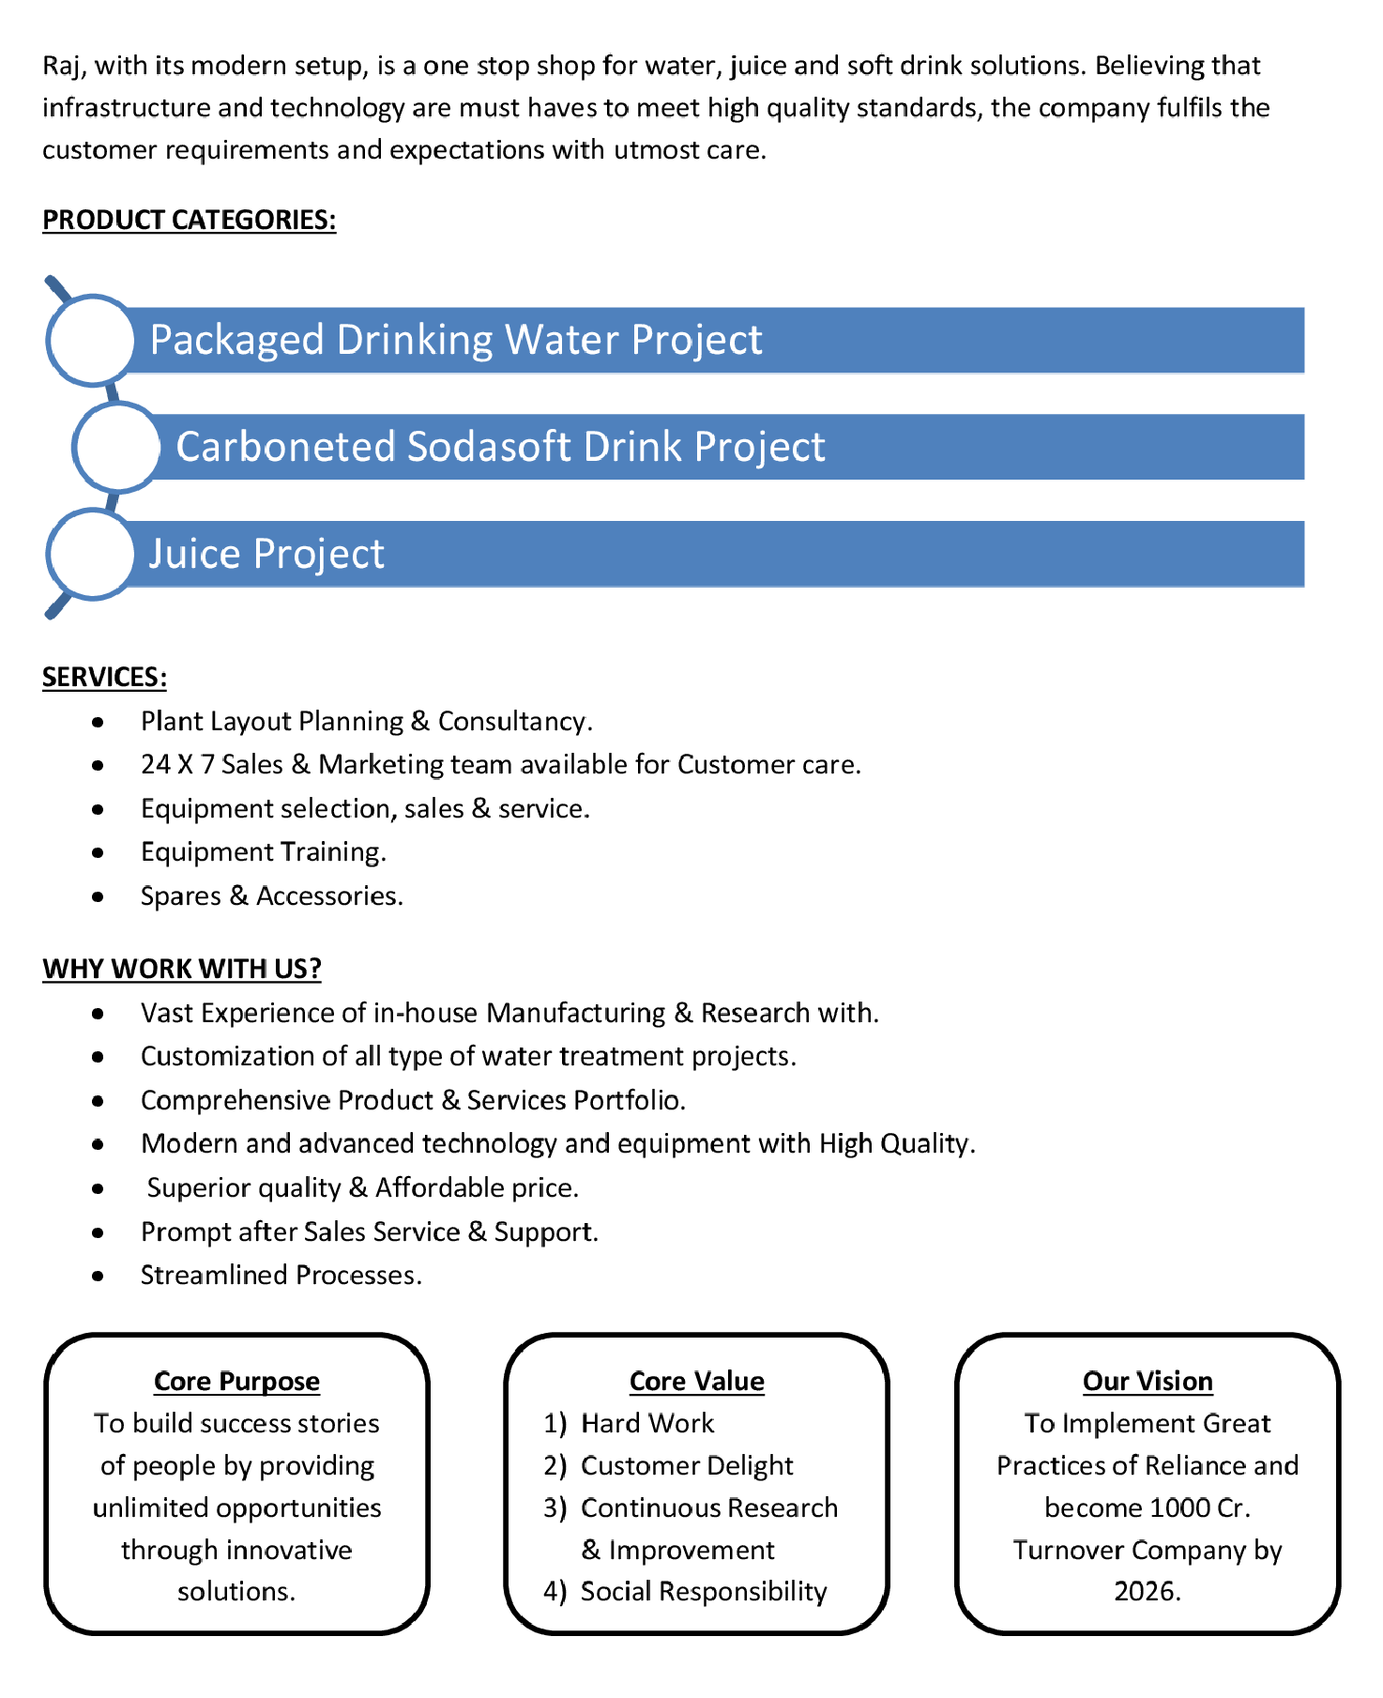

**Commercial Proposal**

|  |  |  |  |  |
| --- | --- | --- | --- | --- |
| **Sr** | **Equipment Name** | **Qty** | **Basic Rate** | **Amount** |
| **No.** |  |  |  |  |
|  |  |  |  |  |
| 1 | Rinser / Filler / Capper : 120-BPM (200-Ml To 2000-Ml ) | 1 | 4200000.00 | 4200000.00 |
|  | Model 20 X 20 X 6 |  |  |  |
|  | Carbonated Soft Drink (CSD) PET Rinser/Filler/Capper |  |  |  |
|  | With Cap Elevator fitted With SS Tank With Pump, |  |  |  |
|  | Pipe Line And Electrical500 Ml PET Bottle Change |  |  |  |
|  | Parts, Rinser Water Circulation |  |  |  |
|  | **Make : Hilden** |  |  |  |
|  |  |  |  |  |
| 2 | Set Of Change Parts Suitable To Handle PET Bottles | 2 | 75000.00 | 150000.00 |
|  | For Rinser/Filler/Capper |  |  |  |
|  |  |  |  |  |
| 3 | Hot Melt Labeller | 1 | 1500000.00 | 1500000.00 |
|  | Auto hotmelt labeller Fitted with PET Bottle change |  |  |  |
|  | parts. Glue Unit |  |  |  |
|  | In Feed And Out Feed Transfer Table With frequency |  |  |  |
|  | drive for Infeed conveyor & Controls |  |  |  |
|  | **Make : Auto Concept** |  |  |  |
|  |  |  |  |  |
| 4 | Set Of Change Parts Suitable To Handle PET Bottles | 2 | 100000.00 | 200000.00 |
|  | For Labeller |  |  |  |
|  |  |  |  |  |
| 5 | High Pressure Blower | 1 | 150000.00 | 150000.00 |
|  | to blow water droplet from bottle system to be installed |  |  |  |
|  | on Cooler discharge conveyor end |  |  |  |
|  |  |  |  |  |
| 6 | Air Conveyor 7.5 Meters | 1 | 375000.00 | 375000.00 |
|  | 7.5 Metres Stainless Steel Air Conveyors consisting of |  |  |  |
|  | straight section with 1 No Air Blower with Pre & Heppa |  |  |  |
|  | Filters for the above Line. |  |  |  |
|  | **Make : Hilden** |  |  |  |
|  |  |  |  |  |
| 7 | Chain Conveyor 7.5 Meters | 1 | 500000.00 | 500000.00 |
|  | 7.5 Metres Stainless Steel |  |  |  |
|  | **Make : hilden** |  |  |  |
|  |  |  |  |  |



|  |  |  |  |  |
| --- | --- | --- | --- | --- |
| **Sr** | **Equipment Name** | **Qty** | **Basic Rate** | **Amount** |
| **No.** |  |  |  |  |
|  |  |  |  |  |
| 8 | Carbonation 4 KL | 1 | 1800000.00 | 1800000.00 |
|  | Carbonation With HP Pump And PHE For Glycol With |  |  |  |
|  | PHE Tank 4000 Litre (4-KL) |  |  |  |
|  | **Make : Hilden** |  |  |  |
|  |  |  |  |  |
| 9 | Co2 Manifold For 4 Cylinders | 1 | 85000.00 | 85000.00 |
|  |  |  |  |  |
|  |  |  |  |  |
| 10 | Accessories | 1 | 165000.00 | 165000.00 |
|  | Stainless Steel cable trays, cables and Control panels |  |  |  |
|  | for the full Conveyor line |  |  |  |
|  | **Make : Hilden** |  |  |  |
|  |  |  |  |  |
| 11 | Automatic Laser Batch Coding Machine **Make : Videojet** | 1 | 1050000.00 | 1050000.00 |
|  |  |  |  |  |
| 12 | Fully Automatic Shrink Wrapping Machine 120BPM | 1 | 1500000.00 | 1500000.00 |
|  | Shrink Tunnel With Tray Packing |  |  |  |
|  | **Make:Magic** |  |  |  |
|  |  |  |  |  |
| 13 | Change Parts For Pet Bottle Consisting Of The Main | 2 | 100000.00 | 200000.00 |
|  | Central Mandrel |  |  |  |
|  | Infeed Feedscrew & Cutter assembly |  |  |  |
|  |  |  |  |  |
|  |  |  |  |  |
| **Total Amount in Words :-** | |  | **Total Amount** | **1,18,75,000.00** |
| One Hundred Eighteen Lakh Seventy Five Thousand | |  |  |  |
|  |  |  |  |  |



**Terms & Condition**

1. **Price**

 The Quoted Prices Are Ex-factory. (For India)

 The Quoted Prices Are FOB. (For Export)

1. **TAX**

 GST 18% Extra Applicable. (For India)

1. **Payment**

 50% Advance Along With The Purchase Order, 30% After Inspection, & 20% Before Material Dispatch.

 In Case Of Cancellation Of Confirmed Order Due To Any Reason, As A Part Of Penalty 25% Amount Of The Order Value Shall Have To Pay By You To Raj Water.

1. **Packing, Freight & Transit Insurance, & Unloading**

 Packing Charge Will Be Extra (Depend On Packing Material)

 Transport To Be Arranged By The Customer OR If Arranged By Raj Water: Extra At Actual Plus GST.

 Transportation Insurance In The Scope Of Buyer.

 Unloading In The Scope Of Buyer. Buyer Has To Ready Forklift Or Crane And Unskilled Labor.



1. **Delivery**

 Schedule For Dispatch Will Be Notified.

 Delivery Dates Are Approximate Only, And Assume Timely Receipt Of All Information, Test Materials & Payment.

1. **Warranty**

 We Shall Provide 1 Year Warranty For The Following:

 Manufacturing Defects, Raw Water Pump, High Pressure Pump, Treated Water Transfer Pump.

 Due To Fluctuation In Power Supply, Attempted Repaired By Person Other Than Our Technical Representative, Improper Handling Or Negligence By End Users, Poor Maintenance, Improper Use Of Equipment, That All Type Of Damage Not Covered In Warranty Create Area.

 During The Warranty Period, We Shall Provide Supervisory Services Of Our Technical Representative As And When Required.

1. **Accommodation**

 Technician Charge Will Be Extra 1000/- Rs. Per Day.

 Travelling, Lodging And Boarding, Local Conveyance And Any Other Miscellaneous Expense Of Our Technical Representative Will Have To Be Borne By Client.

1. **Validity**

 Our Offer Is Valid For Your Acceptance For A Period Of 6 Months From The Date; Thereafter It Will Be Subject To Confirmation By Us.

1. **Image**

 Images Are For Representation Purpose Only.

1. **Jurisdiction**

 All Terms Subject To Rajkot, Gujarat Jurisdiction.