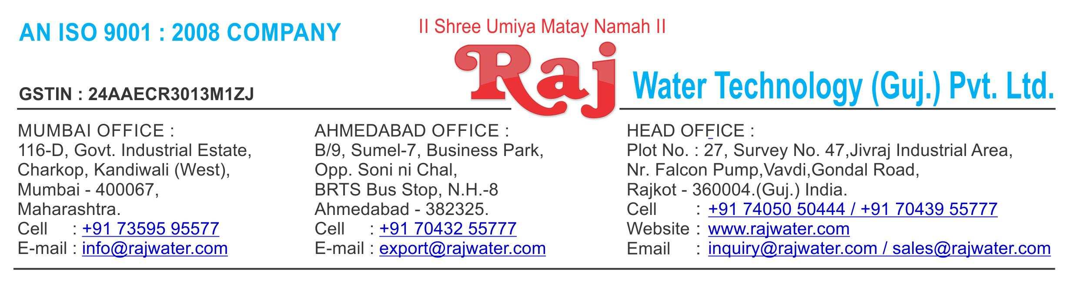

Date :- 6th December 2018

|  |  |  |
| --- | --- | --- |
| Quotation No | :- RW/2018-19/Q_10123/R_4 | |
| Concern Person | :- Mr. Jikarbhai Bijalbhai Wagh | |
| Concern Number | :- | 9825282681 |
| Email Id | :- | r.m.kshatriya@gmail.com |
| Company Name | :- |  |
| Address | :- |  |



**Quotation For Syrup Process Room**

**Dear Sir ,**

We are pleased to enclose our detailed Techno-Commercial offer, based on your requirement.



**Contents of the Quotation**

Commercial Proposal



Terms & Condition



Technical Specification for each product



**Machinery Offer**

Carbonated Soda Soft Drink Project



We hope the same is in line with your requirement. We shall gladly assist you in case you need any further clarification or information.

With warm Regards,

**For , Raj Water Technology (Guj.) Pvt. Ltd.**

**KHUSHBU DESHANI**

**Designation : Marketing Asst. Manager**

**Mobile : 7405050444**

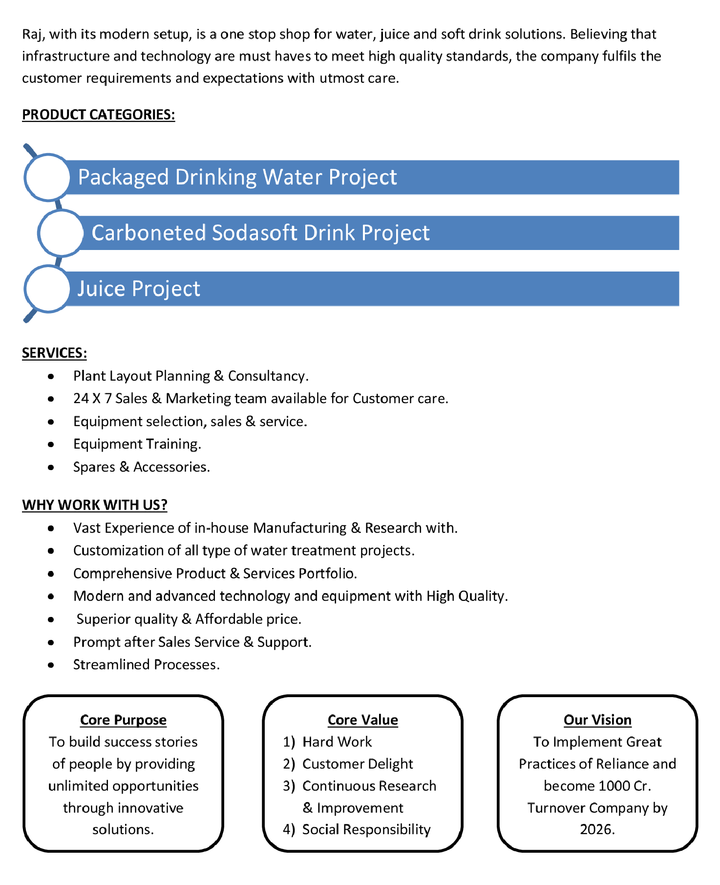

**Commercial Proposal**

|  |  |  |  |  |
| --- | --- | --- | --- | --- |
| **Sr** | **Equipment Name** | **Qty** | **Basic Rate** | **Amount** |
| **No.** |  |  |  |  |
|  |  |  |  |  |
| 1 | Sugar Syrup Preparation Section 1500 Liter +1500 Liter | 2 | 1100000.00 | 2200000.00 |
|  |  |  |  |  |
| 2 | Pulp/Concentrate Collection And Transfer Section | 1 | 175000.00 | 175000.00 |
|  |  |  |  |  |
| 3 | Homogenizer Capacity 2000 Litre Per Hour | 1 | 2050000.00 | 2050000.00 |
|  | With double stage including motor starter & all |  |  |  |
|  | necessary accessorie |  |  |  |
|  |  |  |  |  |
| 4 | Beverage Blending Storage Section For Juice 2000 | 1 | 1550000.00 | 1550000.00 |
|  | Litre Tank |  |  |  |
|  |  |  |  |  |
| 5 | Beverage Blending Storage Section For CSD 3000 Liter | 1 | 1300000.00 | 1300000.00 |
|  | Tank |  |  |  |
|  |  |  |  |  |
| 6 | Skid Mounted Pasteurization Section 2000 LPH For Hot | 1 | 2050000.00 | 2050000.00 |
|  | Fill Juice |  |  |  |
|  |  |  |  |  |
| 7 | Two Tank Automatic CIP Module | 2 | 1400000.00 | 2800000.00 |
|  |  |  |  |  |
| 8 | Inter Connecting Piping For Sugar Syrup Room | 1 | 500000.00 | 500000.00 |
|  |  |  |  |  |
| 9 | Beverages CSD Mixing Tank 3000 Liter | 1 | 400000.00 | 400000.00 |
|  |  |  |  |  |
| **Total Amount in Words :-** | |  | **Total Amount** | **1,30,25,000.00** |
| One Hundred thirty Lakh Twenty Five Thousand | |  |  |  |
|  |  |  |  |  |



**Terms & Condition**

1. **Price**

 The Quoted Prices Are Ex-factory. (For India)

 The Quoted Prices Are FOB. (For Export)

1. **TAX**

 GST 18% Extra Applicable. (For India)

1. **Payment**

 50% Advance Along With The Purchase Order, 30% After Inspection, & 20% Before Material Dispatch.

 In Case Of Cancellation Of Confirmed Order Due To Any Reason, As A Part Of Penalty 25% Amount Of The Order Value Shall Have To Pay By You To Raj Water.

1. **Packing, Freight & Transit Insurance, & Unloading**

 Packing Charge Will Be Extra (Depend On Packing Material)

 Transport To Be Arranged By The Customer OR If Arranged By Raj Water: Extra At Actual Plus GST.

 Transportation Insurance In The Scope Of Buyer.

 Unloading In The Scope Of Buyer. Buyer Has To Ready Forklift Or Crane And Unskilled Labor.



1. **Delivery**

 Schedule For Dispatch Will Be Notified.

 Delivery Dates Are Approximate Only, And Assume Timely Receipt Of All Information, Test Materials & Payment.

1. **Warranty**

 We Shall Provide 1 Year Warranty For The Following:

 Manufacturing Defects, Raw Water Pump, High Pressure Pump, Treated Water Transfer Pump.

 Due To Fluctuation In Power Supply, Attempted Repaired By Person Other Than Our Technical Representative, Improper Handling Or Negligence By End Users, Poor Maintenance, Improper Use Of Equipment, That All Type Of Damage Not Covered In Warranty Create Area.

 During The Warranty Period, We Shall Provide Supervisory Services Of Our Technical Representative As And When Required.

1. **Accommodation**

 Technician Charge Will Be Extra 1000/- Rs. Per Day.

 Travelling, Lodging And Boarding, Local Conveyance And Any Other Miscellaneous Expense Of Our Technical Representative Will Have To Be Borne By Client.

1. **Validity**

 Our Offer Is Valid For Your Acceptance For A Period Of 6 Months From The Date; Thereafter It Will Be Subject To Confirmation By Us.

1. **Image**

 Images Are For Representation Purpose Only.

1. **Jurisdiction**

 All Terms Subject To Rajkot, Gujarat Jurisdiction.