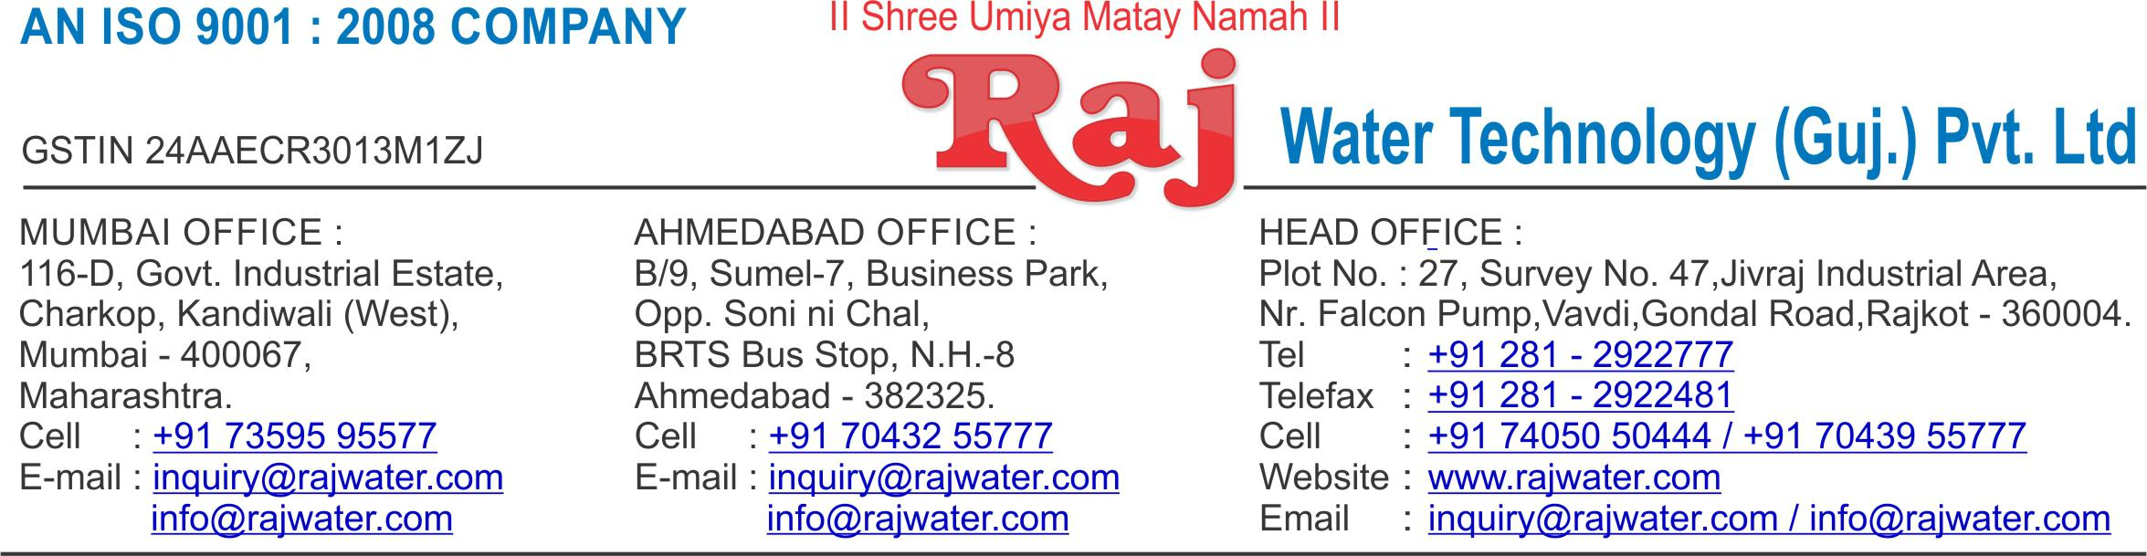

|  |  |  |
| --- | --- | --- |
|  |  | Date :- 6th December 2018 |
|  |  |  |
| Quotation No | :- RW/2018-19/Q_10123/R_5 | |
| Concern Person | :- | Mr. Jikarbhai Bijalbhai Wagh |
| Concern Number | :- | 9825282681 |
| Email Id | :- | r.m.kshatriya@gmail.com |
| Company Name | :- | Shreeji Karpa |
| Address | :- |  |



**Quotation For Pet Blow Moulding Machine**

**Dear Sir ,**

We are pleased to enclose our detailed Techno-Commercial offer, based on your requirement.



**Contents of the Quotation**

Commercial Proposal



Terms & Condition



Technical Specification for each product



**Machinery Offer**

Pet Blow Moulding Machine



We hope the same is in line with your requirement. We shall gladly assist you in case you need any further clarification or information.

With warm Regards,

**For , Raj Water Technology (Guj.) Pvt. Ltd.**

**DESHANI KHUSHBU**

**Designation : Marketing Asst. Manager**

**Mobile : 7405050444**

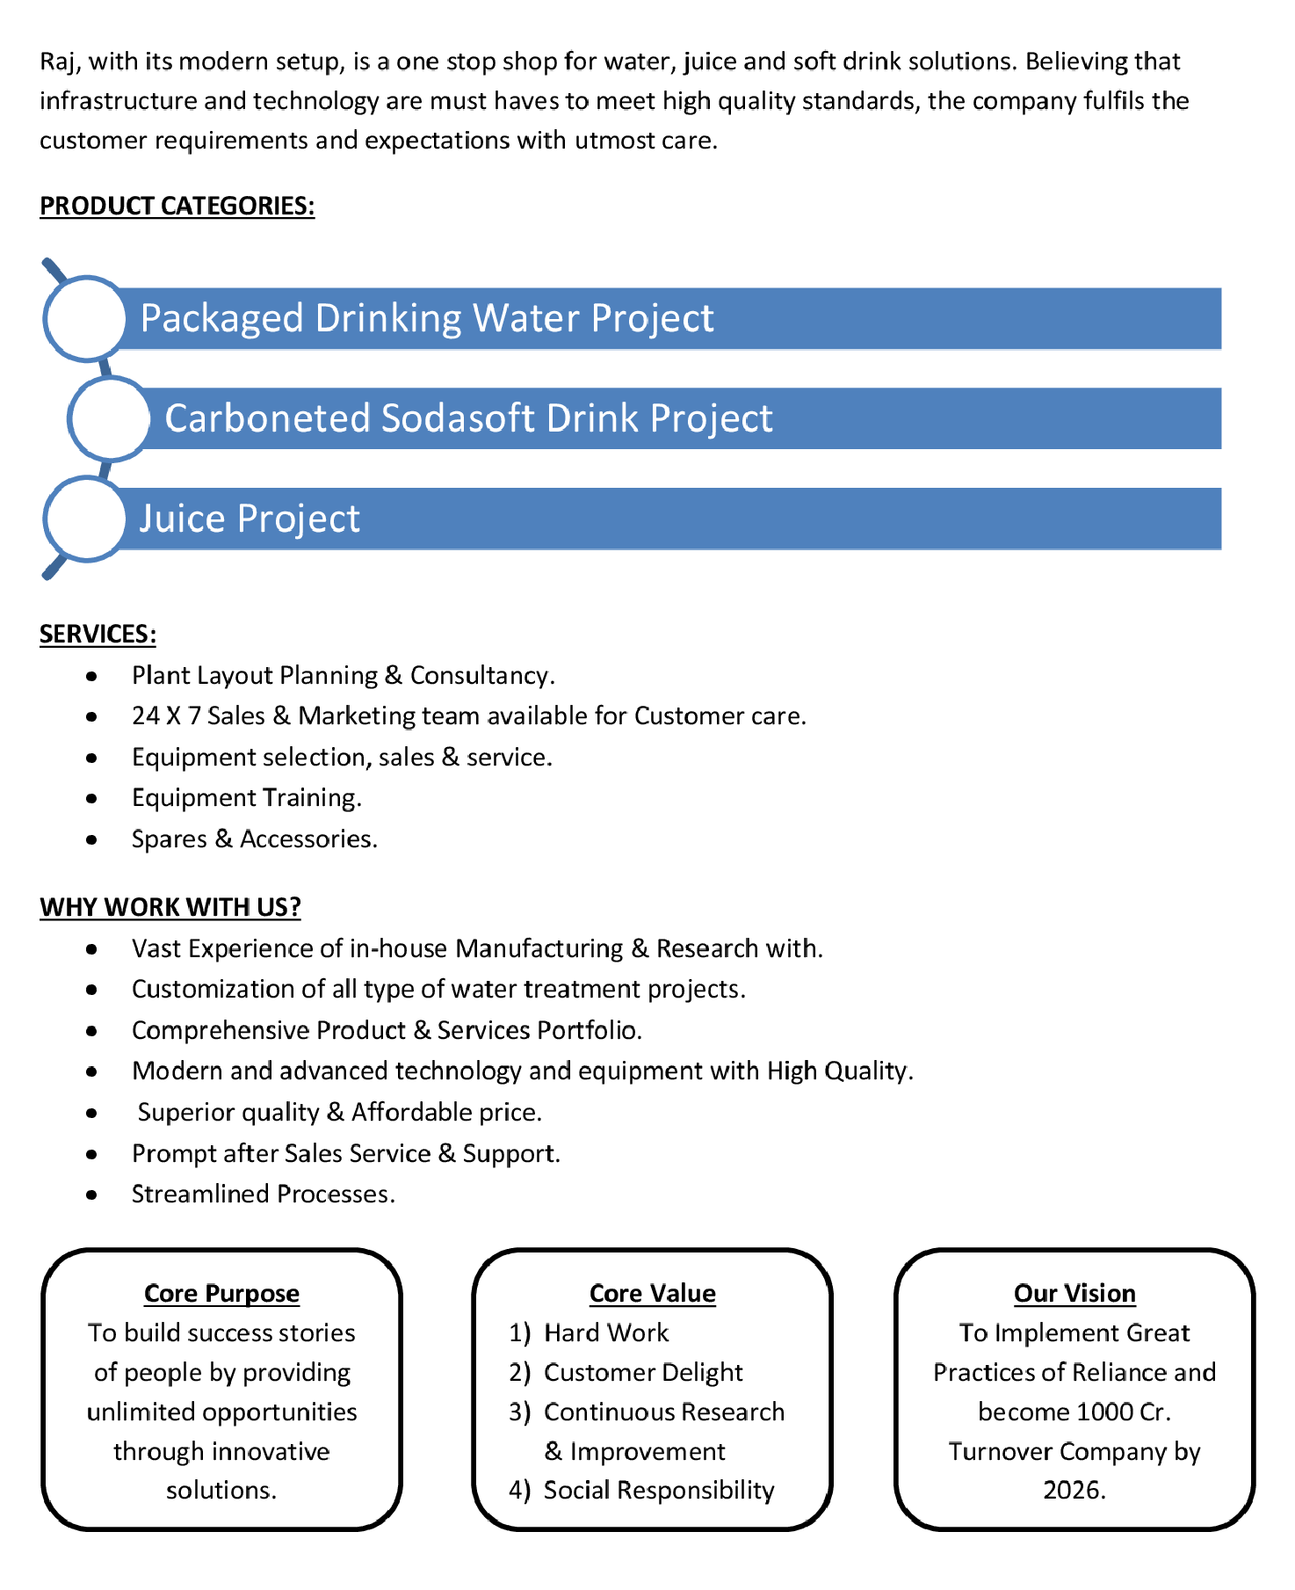

**Commercial Proposal**

|  |  |  |  |  |  |
| --- | --- | --- | --- | --- | --- |
| **Sr** |  | **Equipment Name** | **Qty** | **Basic Rate** | **Amount** |
| **No.** |  |  |  |  |  |
|  |  | |  |  |  |
| 1 | Automatic Pet Blowing Machine 5400 BPH, 4 KVT | | 2 | 5100000.00 | 10200000.00 |
|  | 1. | Auto Preform loder and Hopper(SS) |  |  |  |
|  | 2. | Auto Bottle Ejection and Transfer unit. |  |  |  |
|  | 3. | Scrow Stretch Blow unit |  |  |  |
|  | 4. | Air Recovery Unit |  |  |  |
|  | 5. | Air Receiver/Tank made of MS. Theoretical |  |  |  |
|  |  | output 5800 Bottles/hr (200 ml - 2000 ml ) |  |  |  |
|  |  | |  |  |  |
| 2 | High Pressure Air Compressor 75-HP (Oil Free) | | 2 | 2045000.00 | 4090000.00 |
|  | 200-CFM, 30 Kg / cm2 With Air Dryer Filter And Air | |  |  |  |
|  | Receiver tank 500 Litre  Make : Compack | |  |  |  |
|  |  | |  |  |  |
| 3 | Low Pressure Air Compressor 30-HP | | 2 | 400000.00 | 800000.00 |
|  | 160-CFM With Air Dryer | |  |  |  |
|  |  | |  |  |  |
| 4 | Online Water Chiller 10-Ton With Storage Tank | | 2 | 350000.00 | 700000.00 |
|  |  | |  |  |  |
| 5 | Cooling Tower With Pump | | 2 | 100000.00 | 200000.00 |
|  |  | |  |  |  |
| 6 | CSD Bottle Mould 200ML, 600ML, 1.25ML | | 6 | 335000.00 | 2010000.00 |
|  |  | |  |  |  |
|  |  | |  |  |  |
|  | **Total Amount in Words:-**  **One Hundred Eighteen Lakh** | |  | **Total Amount** | **1,80,00,000** |
|  |  | |  |  |  |





**Terms & Condition**

1. **Price**

 The Quoted Prices Are Ex-factory. (For India)

 The Quoted Prices Are FOB. (For Export)

1. **TAX**

 GST 18% Extra Applicable. (For India)

1. **Payment**

 50% Advance Along With The Purchase Order, 30% After Inspection, & 20% Before Material Dispatch.

 In Case Of Cancellation Of Confirmed Order Due To Any Reason, As A Part Of Penalty 25% Amount Of The Order Value Shall Have To Pay By You To Raj Water.

1. **Packing, Freight & Transit Insurance, & Unloading**

 Packing Charge Will Be Extra (Depend On Packing Material)

 Transport To Be Arranged By The Customer OR If Arranged By Raj Water: Extra At Actual Plus GST.

 Transportation Insurance In The Scope Of Buyer.

 Unloading In The Scope Of Buyer. Buyer Has To Ready Forklift Or Crane And Unskilled Labor.



1. **Delivery**

 Schedule For Dispatch Will Be Notified.

 Delivery Dates Are Approximate Only, And Assume Timely Receipt Of All Information, Test Materials & Payment.

1. **Warranty**

 We Shall Provide 1 Year Warranty For The Following:

 Manufacturing Defects, Raw Water Pump, High Pressure Pump, Treated Water Transfer Pump.

 Due To Fluctuation In Power Supply, Attempted Repaired By Person Other Than Our Technical Representative, Improper Handling Or Negligence By End Users, Poor Maintenance, Improper Use Of Equipment, That All Type Of Damage Not Covered In Warranty Create Area.

 During The Warranty Period, We Shall Provide Supervisory Services Of Our Technical Representative As And When Required.

1. **Accommodation**

 Technician Charge Will Be Extra 1000/- Rs. Per Day.

 Travelling, Lodging And Boarding, Local Conveyance And Any Other Miscellaneous Expense Of Our Technical Representative Will Have To Be Borne By Client.

1. **Validity**

 Our Offer Is Valid For Your Acceptance For A Period Of 6 Months From The Date; Thereafter It Will Be Subject To Confirmation By Us.

1. **Image**

 Images Are For Representation Purpose Only.

1. **Jurisdiction**

 All Terms Subject To Rajkot, Gujarat Jurisdiction.