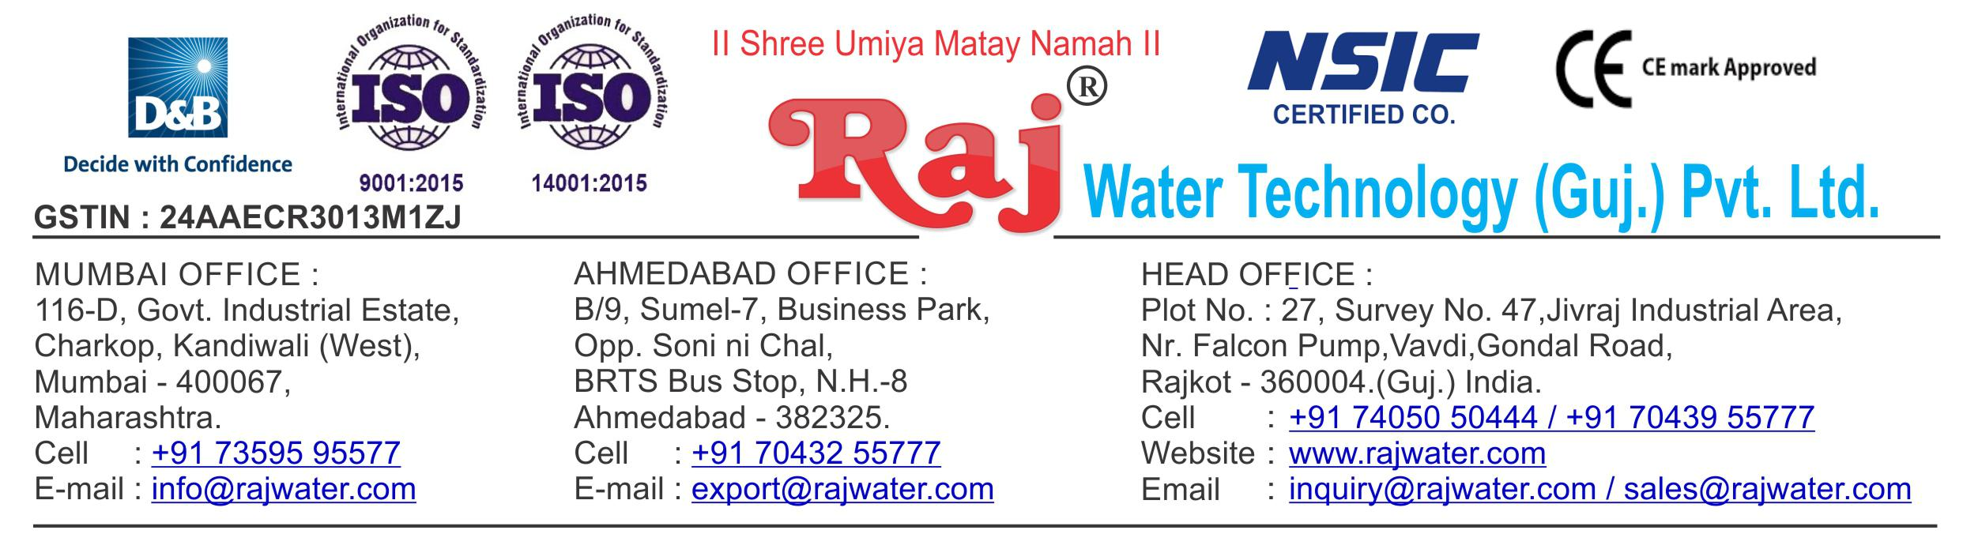

Date :- 13th February 2019

Wednesday

|  |  |  |
| --- | --- | --- |
| Quotation No | :- RW/2018-19/Q_6850/R_9 | |
| Concern Person | :- | Mr. Mustaq Jalal |
| Concern Number | :- | 9892361449 / 9765229222 |
| Email Id | :- | mushtaqjalal@yahoo.co.uk |
| Company Name | :- M/S Jalal Internation Pvt Ltd. | |
| Address | :- 146-Kempton Avenue, Benoni, South Africa. | |



**Quotation For Carbonated Soda Soft Drink Project**

**Dear Sir ,**

We are pleased to enclose our detailed Techno-Commercial offer, based on your requirement.



**Contents of the Quotation**

Commercial Proposal



Terms & Condition



Technical Specification for each product



**Machinery Offer**

Carbonated Soda Soft Drink Project



We hope the same is in line with your requirement. We shall gladly assist you in case you need any further clarification or information.

With warm Regards,

**For , Raj Water Technology (Guj.) Pvt. Ltd.**

**KHUSHBU DESHANI**

**Designation : Marketing Asst. Manager**

**Mobile : 7405050444**

Image not found or type unknown



**Commercial Proposal**

|  |  |  |  |  |
| --- | --- | --- | --- | --- |
| **Sr** | **Equipment Name** | **Qty** | **Basic Rate** | **Amount** |
| **No.** |  |  |  |  |
|  |  |  |  |  |
| 1 | RO Plant FRP 500LPH With S.S Stand | 1 | 142100.00 | 142100.00 |
|  |  |  |  |  |
| 2 | U.V System | 1 | 16100.00 | 16100.00 |
|  |  |  |  |  |
| 3 | Transfer Pump | 1 | 16100.00 | 16100.00 |
|  |  |  |  |  |
| 4 | SS Storage Tank 1000 Litre Capacity | 1 | 26600.00 | 26600.00 |
|  |  |  |  |  |
| 5 | Sugar Syrup Storage Tank 200 Litre With Agitator | 1 | 68600.00 | 68600.00 |
|  |  |  |  |  |
| 6 | Sugar Syrup Plain Tank 200 Litre | 1 | 68600.00 | 68600.00 |
|  |  |  |  |  |
| 7 | SS 304 Mixing Tank 1000 Liter With Agitator,Transfer | 1 | 157500.00 | 157500.00 |
|  | Pump |  |  |  |
|  |  |  |  |  |
| 8 | Sugar Syrup Filter 20" | 1 | 10500.00 | 10500.00 |
|  |  |  |  |  |
| 9 | Water Chiller 5-Ton With Storage Tank For CSD Plant | 1 | 289100.00 | 289100.00 |
|  |  |  |  |  |
| 10 | Cooling PHE 1000lt For Glycol Chiller | 1 | 94500.00 | 94500.00 |
|  |  |  |  |  |
| 11 | Carbonation Production Tank With Buffer Tank | 1 | 472500.00 | 472500.00 |
|  |  |  |  |  |
| 12 | Bottle Rinsing Unit 2-Head | 1 | 31500.00 | 31500.00 |
|  |  |  |  |  |
| 13 | Semi-Automatic 9-Head Counter Pressure Filling  Machine Production Capacity 1000-BPH / 300-ML | 1 | 520100.00 | 520100.00 |
|  |  |  |  |
|  |  |  |  |
|  |  |  |  |
| 14 | Semi-Automatic 1 Head Capping Machine | 1 | 58100.00 | 58100.00 |
|  | Production Capacity 1000-BPH / 300-ml |  |  |  |
|  |  |  |  |  |
| 15 | Shrink Machine For Label | 1 | 68600.00 | 68600.00 |
|  |  |  |  |  |
| 16 | Motorized Table Top Batch Coding Machine | 1 | 37100.00 | 37100.00 |
|  |  |  |  |  |
| 17 | Inter Connecting Piping (SS-304 For 9 Head CSD | 1 | 89600.00 | 89600.00 |
|  | Project) |  |  |  |
|  |  |  |  |  |
| 18 | 300 ML Mould 2-KVT | 1 | 47600.00 | 47600.00 |
|  |  |  |  |  |
| 19 | 500 ML , 1 Litre , 2 Litre Mould 2-KVT | 3 | 47600.00 | 142800.00 |
|  |  |  |  |  |
| 20 | 1.5 Litre Mould 2 KVT | 1 | 47600.00 | 47600.00 |
|  |  |  |  |  |
| 21 | Semi-Automatic Shrink Wrapping Machine For Bulk | 1 | 350000 | 350000.00 |
|  | Bottle Packing |  |  |  |
|  |  |  |  |  |
| 22 | CIF Charges 40’ Shipment To Durban | 1 | 175000.00 | 175000.00 |
|  |  |  |  |  |

|  |  |  |  |  |  |  |
| --- | --- | --- | --- | --- | --- | --- |
|  |  |  |  |  |  |  |
|  | |  | **Total Amount** | **29,30,200.00** |  |  |
|  |  |
|  |  |  |
|  |  |  |  |  |





**Terms & Condition**

1. **Price**

 The Quoted Prices Are Ex-factory. (For India)

 The Quoted Prices Are FOB. (For Export)

1. **TAX**

 GST 18% Extra Applicable. (For India)

1. **Payment**

 50% Advance Along With The Purchase Order, 30% After Inspection, & 20% Before Material Dispatch.

 In Case Of Cancellation Of Confirmed Order Due To Any Reason, As A Part Of Penalty 25% Amount Of The Order Value Shall Have To Pay By You To Raj Water.

1. **Packing, Freight & Transit Insurance, & Unloading**

 Packing Charge Will Be Extra (Depend On Packing Material)

 Transport To Be Arranged By The Customer OR If Arranged By Raj Water: Extra At Actual Plus GST.

 Transportation Insurance In The Scope Of Buyer.

 Unloading In The Scope Of Buyer. Buyer Has To Ready Forklift Or Crane And Unskilled Labor.



1. **Delivery**

 Schedule For Dispatch Will Be Notified.

 Delivery Dates Are Approximate Only, And Assume Timely Receipt Of All Information, Test Materials & Payment.

1. **Warranty**

 We Shall Provide 1 Year Warranty For The Following:

 Manufacturing Defects, Raw Water Pump, High Pressure Pump, Treated Water Transfer Pump.

 Due To Fluctuation In Power Supply, Attempted Repaired By Person Other Than Our Technical Representative, Improper Handling Or Negligence By End Users, Poor Maintenance, Improper Use Of Equipment, That All Type Of Damage Not Covered In Warranty Create Area.

 During The Warranty Period, We Shall Provide Supervisory Services Of Our Technical Representative As And When Required.

1. **Accommodation**

 Technician Charge Will Be Extra 1000/- Rs. Per Day.

 Travelling, Lodging And Boarding, Local Conveyance And Any Other Miscellaneous Expense Of Our Technical Representative Will Have To Be Borne By Client.

1. **Validity**

 Our Offer Is Valid For Your Acceptance For A Period Of 6 Months From The Date; Thereafter It Will Be Subject To Confirmation By Us.

1. **Image**

 Images Are For Representation Purpose Only.

1. **Jurisdiction**

 All Terms Subject To Rajkot, Gujarat Jurisdiction.