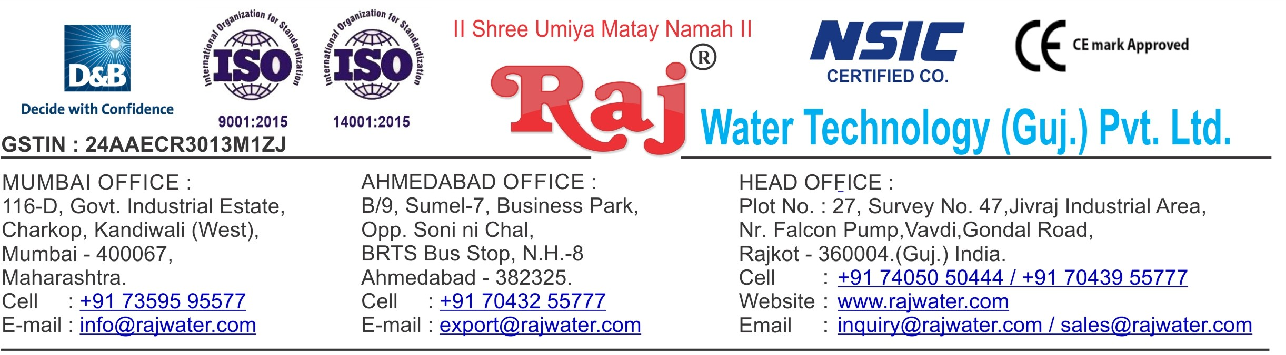

Quotation No :- RW/2018-19/Q_13111

Concern Person :- Mr. Shyam Kumar

Concern Number :- 9912002376 / 8555984789

Email Id :- [maramshyam672@gmail.com](mailto:maramshyam672@gmail.com)

Company Name :- SHIVA GANGA MINERAL WATER ENTERPRISES

Date :- 8th March 2019

Friday

# Quotation For Packaged Drinking Water Project& Juice Project

## Dear Sir ,

We are pleased to enclose our detailed Techno-Commercial offer, based on your requirement.

**Contents of the Quotation** Commercial Proposal Terms & Condition

Technical Specification for each product

## Machinery Offer

Packaged Drinking Water Project

We hope the same is in line with your requirement. We shall gladly assist you in case you need any further clarification or information.

With warm Regards,

## For , Raj Water Technology (Guj.) Pvt. Ltd.

**DESHANI KHUSHBU**

**Designation : Marketing Asst. Manager Mobile : 7405050444**

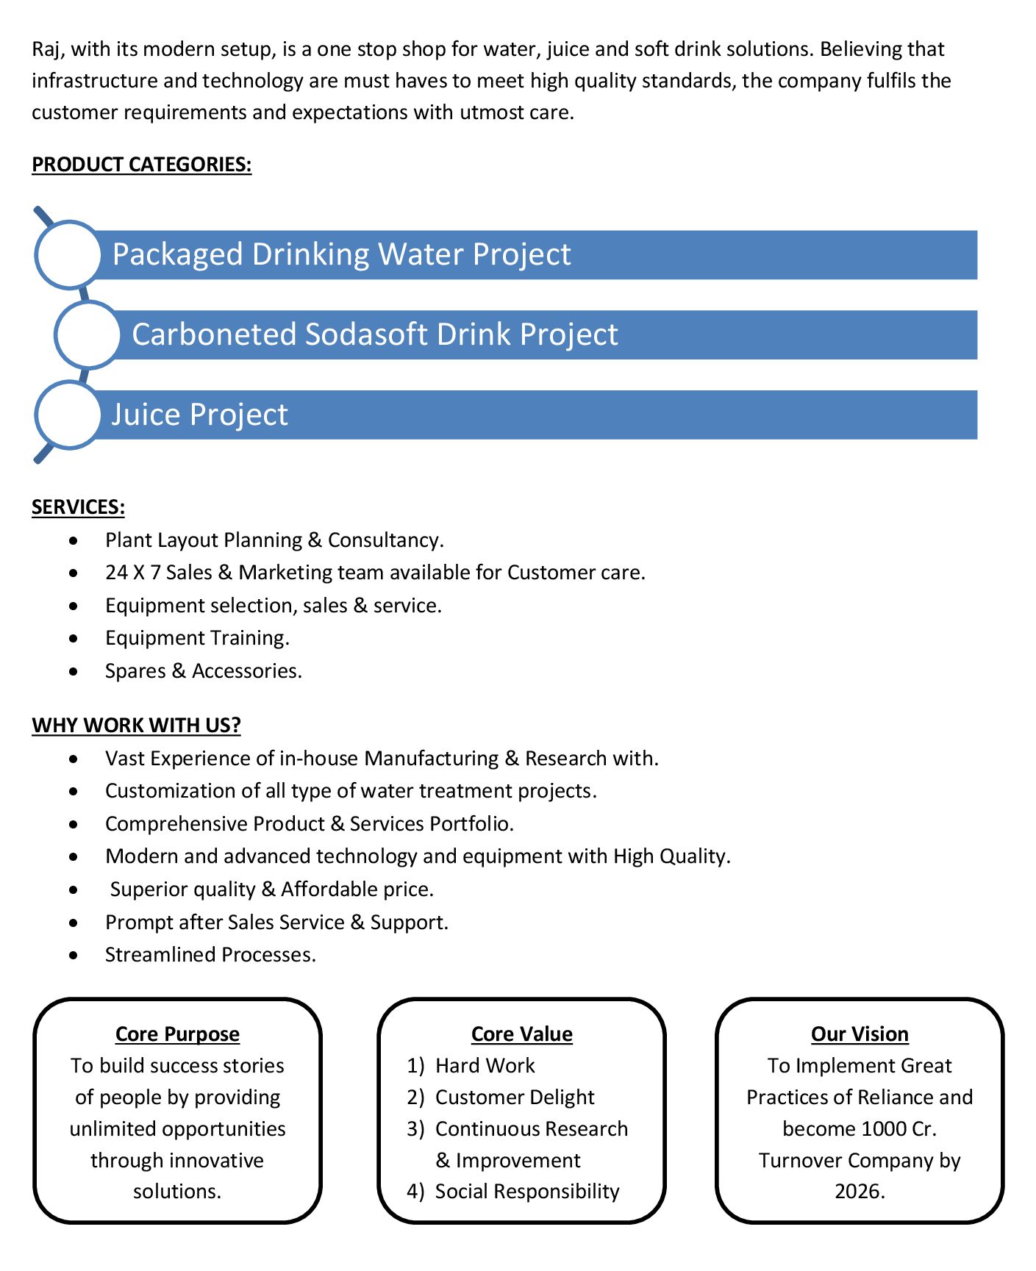

**Commercial Proposal** **Packaged Drinking Water(Part-1)**

|  |  |  |  |  |
| --- | --- | --- | --- | --- |
| **Sr No.** | **Equipment Name** | **Qty** | **Basic Rate** | **Amount** |
| 1 | Automatic Bottle Rinsing, Filling & Capping Machine 40- BPM With Automatic Cap Elevator | 1 | 1446375.00 | 1446375.00 |
| 2 | Fully Automatic BOPP Labeling Machine  Fully Auto Labeling Machine.Roll feed labeling machine with hot-melt glue | 1 | 2100687.00 | 2100687.00 |
| 3 | Set Of Change Parts Suitable To Handle PET Bottles For Labeller | 3 | 137750.00 | 413250.00 |
| 4 | 200 ML Mould 2 KVT | 1 | 103312.00 | 103312.00 |
| 5 | 500 ML Mould 2-KVT | 1 | 103312.00 | 103312.00 |
| 6 | 1 Litre Mould 2 KVT | 1 | 103312.00 | 103312.00 |
| 7 | 2 Litre Mould 2-KVT | 1 | 103312.00 | 103312.00 |
| 8 | Low Pressure Air Compressor 10-HP | 1 | 206625.00 | 206625.00 |
| 9 | Low Pressure Air Dryer | 1 | 137750.00 | 137750.00 |
| 10 | Automatic Inkjet Batch Coding Machine | 1 | 275500.00 | 275500.00 |
| 11 | Automatic Shrink Wrapping , Shrink Tunnel, With Tray Packing 60-BPM | 1 | 929812.00 | 929812.00 |
| 12 | Hot & Cold Jar Washing Machine  SS 304 Machine For 20 Litre Jar Rinser Machine Single Jet Nozzle-Tank Capacity 60 Ltr 2 Nos  Machine Diamension L800 X W 800 X H 800,For Internal Jar Rinsing Unit With 0.5 HP Motor PNC Make 2 Nos And 2 KW Heater ,Controll Panel ,timer base Working | 1 | 75762.00 | 75762.00 |
| 13 | SS Piping RO Plant To Bottle Filling Machine To Jar Filling | 1 | 137750.00 | 137750.00 |

|  |  |  |
| --- | --- | --- |
|  | **Sub Total Amount(Part-1)** | **61,36,759.00** |



**Commercial Proposal Juice Plant**

|  |  |  |  |  |
| --- | --- | --- | --- | --- |
| **Sr No.** | **Equipment Name** | **Qty** | **Basic Rate** | **Amount** |
| 1 | 6000 Litre Per Hours SS-304 RO Plant With U.V System, SS Storage Tank 3000 Litre 2-Nos | 1 | 1653000.00 | 1653000.00 |
| 2 | Ozonation With Circulation System | 1 | 103312.00 | 103312.00 |
| 3 | Oxygenation Circulation System | 1 | 103312.00 | 103312.00 |
| 4 | Complete Lab BIS Approve (14543-Standard) Testing Instrument, Glassware , Chemical As Per List | 1 | 413250.00 | 413250.00 |
| 5 | Sugar Syrup Storage Triple Steam Jacketed Tank 500 Litre  Steam Jacketted Kettle 500 Litres Complete With Agitator Drain Valve Trap Pressure Gauge & Safty Valve Extra | 1 | 399475.00 | 399475.00 |
| 6 | Sugar Filter Press, With Pump | 1 | 151525.00 | 151525.00 |
| 7 | Cooling PHE 1000 Litre For Sugar | 1 | 123975.00 | 123975.00 |
| 8 | Pulp Dumping Tank | 1 | 103312.00 | 103312.00 |
| 9 | S.S 304 Plain Sugar Syrup Storage Tank 500 Litre, With Transfer Pump | 1 | 137750.00 | 137750.00 |
| 10 | SS 304 Mixing Tank 1000 Liter With Agitator,Transfer Pump | 2 | 206625.00 | 413250.00 |
| 11 | Homogeniser Capacity 1000 Litre Per Hour  With double stage including motor starter & all necessary access orie | 1 | 1308625.00 | 1308625.00 |
| 12 | SS-304 1000 Litre Ready Beverages Tank For Sugar Syrup, With Agitator,Transfer Pump | 1 | 206625.00 | 206625.00 |
| 13 | Pasteurizer 1000 Litre Per Hours, With Phe Pid Controlled Valves | 1 | 1653000.00 | 1653000.00 |
| 14 | Single Tank Semi-Automatic CIP System | 1 | 895375.00 | 895375.00 |
| 15 | Steam Boiler 500 Kg Per Hour Non I.B.R. Diesel Chimney Design & Fabrication (Guy Roap Supported) | 1 | 757625.00 | 757625.00 |
| 16 | Chimney Design & Fabrication (Guy Roap Supported) | 1 | 117087.00 | 117087.00 |
| 17 | Automatic Juice Filling & Capping Machine 30-BPM  Hot Juice Bottle Sizes 200ml – 2 Litre Machine Is Designed With Gravtitation Filling System . Machine Is Complete With Its Return Line System Having Automatic Controllers With The Tank Bowl Level And Temperatures.  In Feed Air Conveyor 8 Feet ,Out Feed Chain Conveyor 16 Feet | 1 | 2534600.00 | 2534600.00 |
| 18 | Cooling Tunnel For Cool Down The Bottle Temperature 80 To 40 Degree | 1 | 1825187.00 | 1825187.00 |

|  |  |  |  |  |
| --- | --- | --- | --- | --- |
| 19 | Shrink Machine For Label | 1 | 89537.00 | 89537.00 |
| 20 | Cooling Tower With Pump | 1 | 103312.00 | 103312.00 |
| 21 | Automatic Inkjet Batch Coding Machine | 1 | 275500.00 | 275500.00 |
| 22 | Semi-Automatic Shrink Wrapping Machine For Bulk Bottle Packing | 1 | 482125.00 | 482125.00 |
| 23 | Piping For Boiler With Insulation | 1 | 137750.00 | 137750.00 |
| 24 | Piping For CIP | 1 | 206625.00 | 206625.00 |
| 25 | Piping For Cooling Tower | 1 | 68875.00 | 68875.00 |
| 26 | Inter Connecting Piping, From Syrup Room To Filling Machine (SS 304 For 40-BPM Juice Plant) | 1 | 344375.00 | 344375.00 |
| 27 | Fully Automatic Pet Blow Moulding Machine 2-KVT  Fully Automatic Reheat Stretch Forming Machine For 2- Cavity, 200ml / 1000ml Machine Center Distance 140mm, 2-cavity Double Slide Two Rows of Heating Element Along with Cooling Arrangement. Numeric Locking System Multipoint for High Speed Clamping for Faster Cycle Time. Online System Output Rate - 2200 - 2400 B/H | 1 | 2479500.00 | 2479500.00 |
| 28 | Auto Loader | 1 | 413250.00 | 413250.00 |
| 29 | Water Chiller 3- Ton With 200 Litre Storage Tank | 1 | 179075.00 | 179075.00 |
| 30 | High Pressure Air Compressor 30-HP 74 CFM 30 Kg/cm2 | 1 | 482125.00 | 482125.00 |
| 31 | Low Pressure Air Compressor 20-HP 60-CFM,12 Kg / cm2 | 1 | 275500.00 | 275500.00 |
| 32 | High Pressure Air Dryer | 1 | 172187.00 | 172187.00 |
| 33 | Low Pressure Air Dryer | 1 | 137750.00 | 137750.00 |
| 34 | Cooling Tower With Pump | 1 | 137750.00 | 137750.00 |
| 35 | Mould 200 Ml For Juice | 1 | 103312.00 | 103312.00 |
| 36 | Mould 500 Ml For Juice | 1 | 103312.00 | 103312.00 |
|  | | | **Sub Total Amount(Part-2)** | **1,90,92,145.00** |
| **Sub Total Amount(Part-1)**  **Sub Total Amount(Part-2)** | **61,36,759.00 1,90,92,145.00** |
| **Total**  **GST@18%** | **2,52,28,904.00**  **45,41,202.00** |
| **Grand Total** | **2,97,70,106.00** |

**Terms & Condition**

1. **Price**

The Quoted Prices Are Ex-factory. (For India) The Quoted Prices Are FOB. (For Export)

1. **TAX**

GST 18% Extra Applicable. (For India)

1. **Payment**

50% Advance Along With The Purchase Order, 30% After Inspection, & 20% Before Material Dispatch.

In Case Of Cancellation Of Confirmed Order Due To Any Reason, As A Part Of Penalty 25% Amount Of The Order Value Shall Have To Pay By You To Raj Water.

1. **Packing, Freight & Transit Insurance, & Unloading**

Packing Charge Will Be Extra (Depend On Packing Material)

Transport To Be Arranged By The Customer OR If Arranged By Raj Water: Extra At Actual Plus GST. Transportation Insurance In The Scope Of Buyer.

Unloading In The Scope Of Buyer. Buyer Has To Ready Forklift Or Crane And Unskilled Labor.

1. **Delivery**

Schedule For Dispatch Will Be Notified.

Delivery Dates Are Approximate Only, And Assume Timely Receipt Of All Information, Test Materials & Payment.

1. **Warranty**

We Shall Provide 1 Year Warranty For The Following:

Manufacturing Defects, Raw Water Pump, High Pressure Pump, Treated Water Transfer Pump.

Due To Fluctuation In Power Supply, Attempted Repaired By Person Other Than Our Technical Representative, Improper Handling Or Negligence By End Users, Poor Maintenance, Improper Use Of Equipment, That All Type Of Damage Not Covered In Warranty Create Area.

During The Warranty Period, We Shall Provide Supervisory Services Of Our Technical Representative As And When Required.

1. **Accommodation**

Technician Charge Will Be Extra 1000/- Rs. Per Day.

Travelling, Lodging And Boarding, Local Conveyance And Any Other Miscellaneous Expense Of Our Technical Representative Will Have To Be Borne By Client.

1. **Validity**

Our Offer Is Valid For Your Acceptance For A Period Of 6 Months From The Date; Thereafter It Will Be Subject To Confirmation By Us.

1. **Image**

Images Are For Representation Purpose Only.

1. **Jurisdiction**

All Terms Subject To Rajkot, Gujarat Jurisdiction.