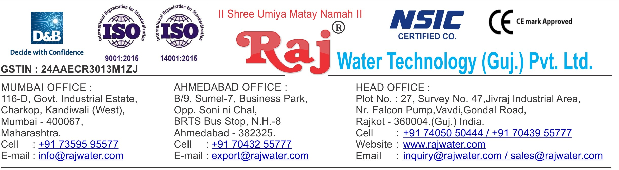

Quotation No :- RW/2018-19/Q_10779/R_7 Concern Person :- Mr. Dharmik Patel

Concern Number :- 6352879123

Email Id :- patelpet2018@yahoo.com Company Name :- M/s. Patel Pet

Date :- 15th March 2019

Friday

Address :- 319, 2nd Floor, Shubham Industrial Estate, Makna,Ta. Kamrej, Surat-394325. Gujarat, INDIA

**Quotation For Pet Blow Moulding Machine**

**Dear Sir ,**

We are pleased to enclose our detailed Techno-Commercial offer, based on your requirement.

**Contents of the Quotation** Commercial Proposal Terms & Condition

Technical Specification for each product

**Machinery Offer**

Pet Blow Moulding Machine

We hope the same is in line with your requirement. We shall gladly assist you in case you need any further clarification or information.

With warm Regards,

**For , Raj Water Technology (Guj.) Pvt. Ltd.**

**DESHANI KHUSHBU**

**Designation : Marketing Asst. Manager Mobile : 7043755777**

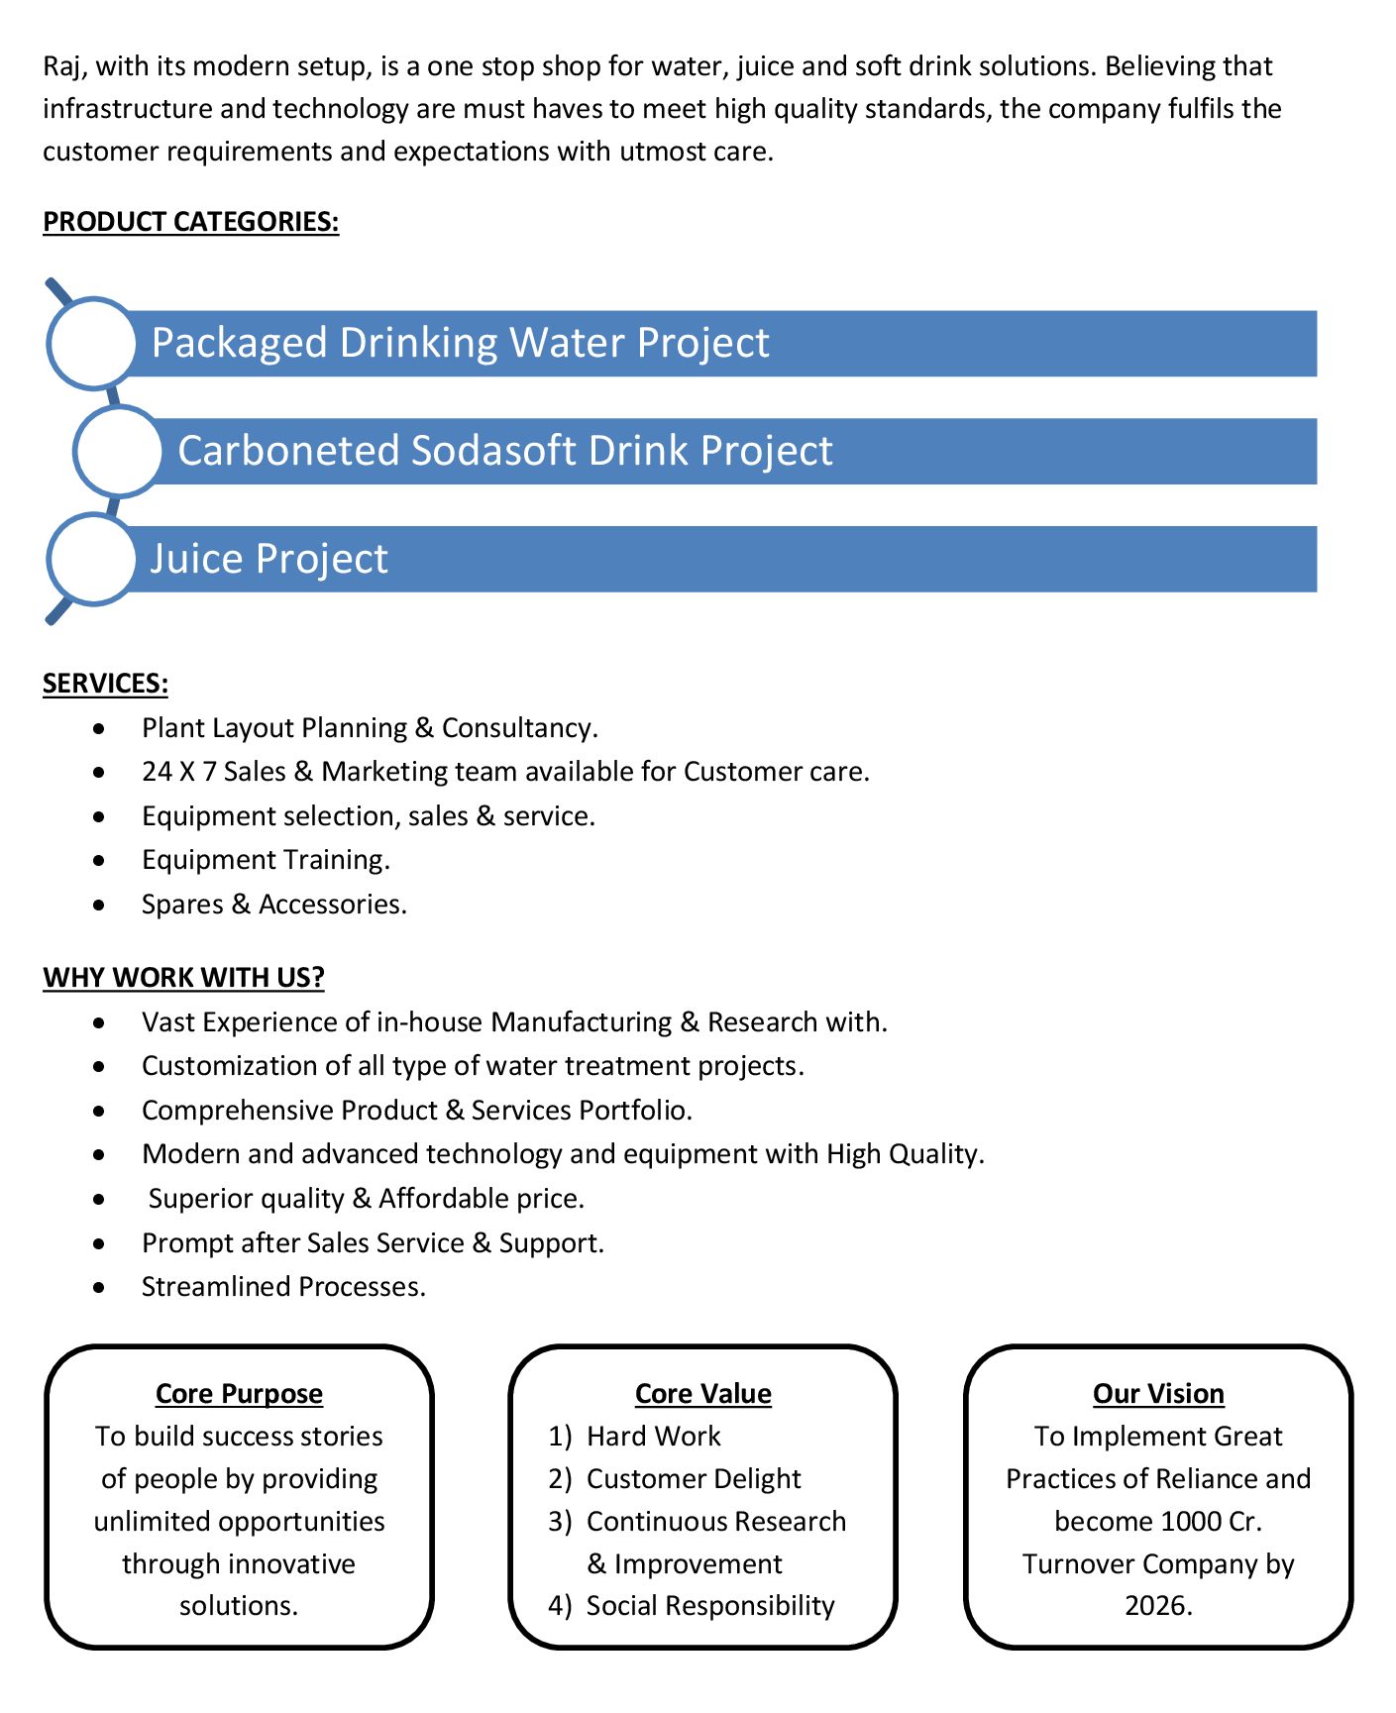

**Commercial Proposal**

|  |  |  |  |  |
| --- | --- | --- | --- | --- |
| **Sr No.** | **Equipment Name** | **Qty** | **Basic Rate** | **Amount** |
| 1 | FullyAutomatic Blow Moulding Machine 2 Cavity With  Suitable High Pressure & Low Pressure Compresser with Air Dryer & Chiller | 1 | 3290000.00 | 3290000.00 |
|  |  |  |  |  |
|  | | | **Sub Total** | **32,90,000.00** |
|  | | | **GST @ 18%** | **5,92,200.00** |
| **Total Amount in Words :-**  Thirty Eight Lakh Eigthy Two Thousand Two Hundred | | | **Total Amount** | **38,82,200.00** |

**Terms & Condition**

# Price

The Quoted Prices Are Ex-factory. (For India) The Quoted Prices Are FOB. (For Export)

# Payment

15% Advance Along With The Purchase Order, & 85% Before Material Dispatch.

In Case Of Cancellation Of Confirmed Order Due To Any Reason, As A Part Of Penalty 25% Amount Of The Order Value Shall Have To Pay By You To Raj Water.

# Packing, Freight & Transit Insurance, & Unloading

Packing Charge Will Be Extra (Depend On Packing Material)

Transport To Be Arranged By The Customer OR If Arranged By Raj Water: Extra At Actual Plus GST. Transportation Insurance In The Scope Of Buyer.

Unloading In The Scope Of Buyer. Buyer Has To Ready Forklift Or Crane And Unskilled Labor.

# Delivery

Schedule For Dispatch Will Be Notified.

Delivery Dates Are Approximate Only, And Assume Timely Receipt Of All Information, Test Materials & Payment.

# Warranty

We Shall Provide 1 Year Warranty For The Following:

Manufacturing Defects, Raw Water Pump, High Pressure Pump, Treated Water Transfer Pump.

Due To Fluctuation In Power Supply, Attempted Repaired By Person Other Than Our Technical Representative, Improper Handling Or Negligence By End Users, Poor Maintenance, Improper Use Of Equipment, That All Type Of Damage Not Covered In Warranty Create Area.

During The Warranty Period, We Shall Provide Supervisory Services Of Our Technical Representative As And When Required.

# Accommodation

Technician Charge Will Be Extra 1000/- Rs. Per Day.

Travelling, Lodging And Boarding, Local Conveyance And Any Other Miscellaneous Expense Of Our Technical Representative Will Have To Be Borne By Client.

# Validity

Our Offer Is Valid For Your Acceptance For A Period Of 6 Months From The Date; Thereafter It Will Be Subject To Confirmation By Us.

# Image

Images Are For Representation Purpose Only.

# Jurisdiction

All Terms Subject To Rajkot, Gujarat Jurisdiction.