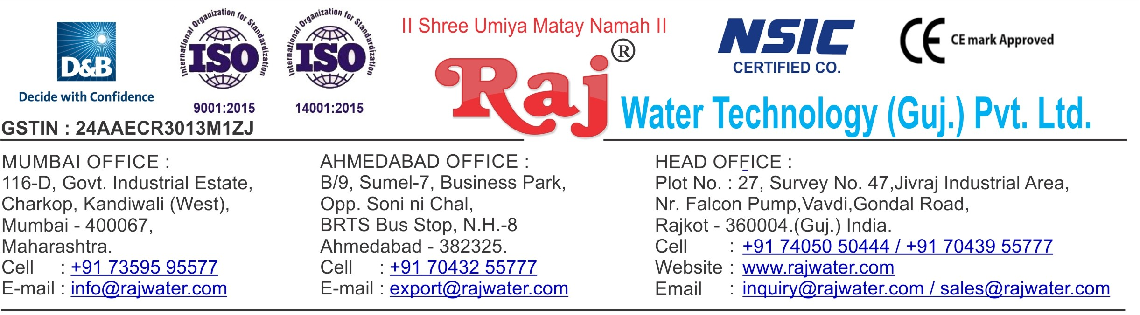

Quotation No :- RW/2019-20/Q_1289

Concern Person :- Devendrabhai

Concern Number :- 9825689412 / 8347395731

Email Id :-

Company Name :-

Address :- Ahmedabad

Date :- 1st May , 2019

Wednesday

**Quotation For Carbonated Soda Soft Drink Project**

**Dear Sir ,**

We are pleased to enclose our detailed Techno-Commercial offer, based on your requirement.

**Contents of the Quotation** Commercial Proposal Terms & Condition

Technical Specification for each product

**Machinery Offer**

Carbonated Soda Soft Drink Project

We hope the same is in line with your requirement. We shall gladly assist you in case you need any further clarification or information.

With warm Regards,

**For , Raj Water Technology (Guj.) Pvt. Ltd.**

**KHUSHBU DESHANI**

**Designation : Marketing Asst. Manager Mobile : 7405050444**

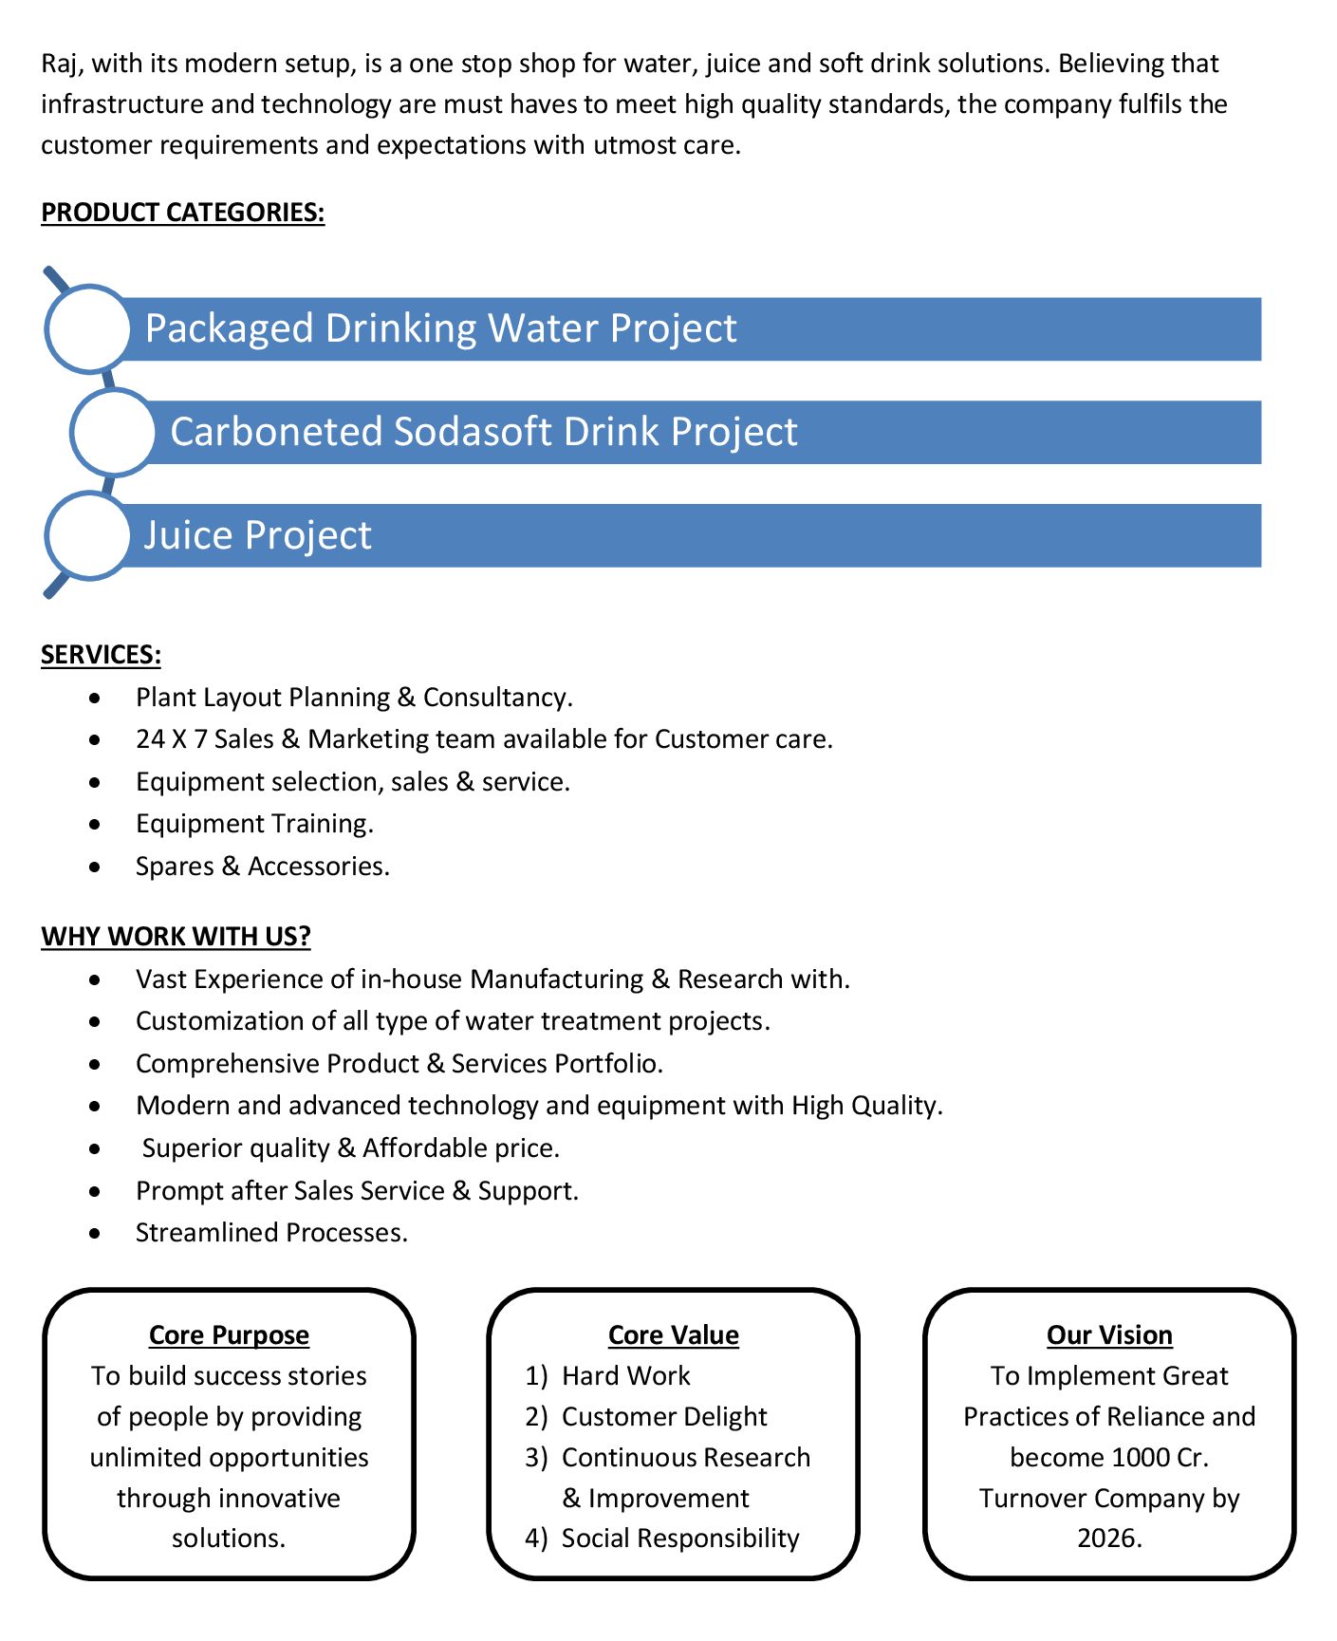

**Commercial Proposal**

|  |  |  |  |  |
| --- | --- | --- | --- | --- |
| **Sr No.** | **Equipment Name** | **Qty** | **Basic Rate** | **Amount** |
| 1 | 4000 Litre Per Hour SS-304 RO Plant With U.V System, SS Storage Tank 2000 Litre 2-Nos | 1 | 950000.00 | 950000.00 |
| 2 | Sugar Syrup Preparation Triple Jacketed Tank 1500 Litre | 1 | 450000.00 | 450000.00 |
| 3 | Suger Filter Press 1500 LPH, With Pump & Hyflow Coating 100-Litre Tank  Cooling PHE | 1 | 425000.00 | 425000.00 |
| 4 | Sugar Loader With Control Panel | 1 | 250000.00 | 250000.00 |
| 5 | Flavored Mixing Tank 100 Litre, With Agitator & Pump | 1 | 85000.00 | 85000.00 |
| 6 | S.S 304 Plain Sugar Syrup Storage Tank 1500 Litre, With Agitator Pump | 1 | 275000.00 | 275000.00 |
| 7 | SS 304 Mixing Tank 3000 Litre, With Agitator & Transfer Pump | 2 | 400000.00 | 800000.00 |
| 8 | Two Tank 1000 Litre Semi-Automatic CIP System | 1 | 850000.00 | 850000.00 |
| 9 | Skid Mounted Pasteurization Section 2000 LPH For Carbonated Soft Drink | 1 | 1850000.00 | 1850000.00 |
| 10 | SS-304 1000 Litre Final Beverages Tank For Sugar Syrup | 1 | 180000.00 | 180000.00 |
| 11 | Cooling Tower With Pump | 1 | 100000.00 | 100000.00 |
| 12 | Steam Boiler 500 Kg Per Hour Non I.B.R. Wood Fire | 1 | 450000.00 | 450000.00 |
| 13 | Chimney Design & Fabrication (Guy Roap Supported) | 1 | 85000.00 | 85000.00 |
| 14 | Online Water Cooled Chilling Plant Glycol Base Of  40.00 TR Capacity  R – 22 As Refrigerant And SCREW Compressor From BITZER / FRASCOLD With Cooling Tower &PHE And 1000 ltr Tank | 1 | 1850000.00 | 1850000.00 |
| 15 | Inter Connecting Piping For Sugar Syrup Room | 1 | 250000.00 | 250000.00 |
| 16 | Piping For Cooling Tower | 1 | 75000.00 | 75000.00 |
| 17 | Piping For Boiler With Insulation | 1 | 150000.00 | 150000.00 |
| 18 | SS 304 Piping For CIP | 1 | 225000.00 | 225000.00 |
| 19 | Piping For Chiller Machine | 1 | 150000.00 | 150000.00 |

|  |  |  |  |  |
| --- | --- | --- | --- | --- |
| **Sr No.** | **Equipment Name** | **Qty** | **Basic Rate** | **Amount** |
| 20 | Inter Connecting Piping Are Syrup Room To Filling Machine Complete SS 304 | 1 | 150000.00 | 150000.00 |
| 21 | Rinser / Filler / Capper : 120-BPM (200-Ml To 2000-Ml ) Model 20 X 20 X 6  Carbonated Soft Drink (CSD) PET Rinser/Filler/Capper With Cap Elevator fitted With SS Tank With Pump, Pipe Line And Electrical500 Ml PET Bottle Change Parts, Rinser Water Circulation | 1 | 4600000.00 | 4600000.00 |
| 22 | Set Of Change Parts Suitable To Handle PET Bottles For Rinser/Filler/Capper | 2 | 75000.00 | 150000.00 |
| 23 | Air Conveyor 7.5 Meters  7.5 Metres Stainless Steel Air Conveyors consisting of straight section with 1 No Air Blower with Pre & Heppa Filters for the above Line. | 1 | 500000.00 | 500000.00 |
| 24 | Chain Conveyor 7.5 Meters  7.5 Metres Stainless Steel | 1 | 725000.00 | 725000.00 |
| 25 | High Pressure Blower System  to remove the Water Droplets from the Bottle to be installed on your single line conveyor after cooling tunnel. | 1 | 150000.00 | 150000.00 |
| 26 | Hot Melt Labeller :  Auto hotmelt labeller fitted with 1000 ML PET Bottle change parts. For Wrap around labelling.Infeed outfeed transfer table with drive for the  Hotmelt labeller. | 1 | 3150000.00 | 3150000.00 |
| 27 | Set Of Change Parts Suitable To Handle PET Bottles For Labeller | 2 | 100000.00 | 200000.00 |
| 28 | Carbonation 4 KL  Carbonation With HP Pump And PHE For Glycol With PHE Tank 4000 Litre (4-KL) | 1 | 2050000.00 | 2050000.00 |



|  |  |  |  |  |
| --- | --- | --- | --- | --- |
| **Sr No.** | **Equipment Name** | **Qty** | **Basic Rate** | **Amount** |
| 29 | Co2 Manifold For 4 Cylinders | 1 | 85000.00 | 85000.00 |
| 30 | Automatic Inkjet Batch Coding Machine | 1 | 200000.00 | 200000.00 |
| 31 | Automatic Shrink Wrapping Machine For Bulk Bottle Packing-120 BPM | 1 | 1550000.00 | 1550000.00 |
|  | | | **Total Amount** | **2,29,60,000.00** |



**Terms & Condition**

# Price

The Quoted Prices Are Ex-factory. (For India) The Quoted Prices Are FOB. (For Export)

# TAX

GST 18% Extra Applicable. (For India)

# Payment

50% Advance Along With The Purchase Order, 30% After Inspection, & 20% Before Material Dispatch.

In Case Of Cancellation Of Confirmed Order Due To Any Reason, As A Part Of Penalty 25% Amount Of The Order Value Shall Have To Pay By You To Raj Water.

# Packing, Freight & Transit Insurance, & Unloading

Packing Charge Will Be Extra (Depend On Packing Material)

Transport To Be Arranged By The Customer OR If Arranged By Raj Water: Extra At Actual Plus GST. Transportation Insurance In The Scope Of Buyer.

Unloading In The Scope Of Buyer. Buyer Has To Ready Forklift Or Crane And Unskilled Labor.

# Delivery

Schedule For Dispatch Will Be Notified.

Delivery Dates Are Approximate Only, And Assume Timely Receipt Of All Information, Test Materials & Payment.

# Warranty

We Shall Provide 1 Year Warranty For The Following:

Manufacturing Defects, Raw Water Pump, High Pressure Pump, Treated Water Transfer Pump.

Due To Fluctuation In Power Supply, Attempted Repaired By Person Other Than Our Technical Representative, Improper Handling Or Negligence By End Users, Poor Maintenance, Improper Use Of Equipment, That All Type Of Damage Not Covered In Warranty Create Area.

During The Warranty Period, We Shall Provide Supervisory Services Of Our Technical Representative As And When Required.

# Accommodation

Technician Charge Will Be Extra 1000/- Rs. Per Day.

Travelling, Lodging And Boarding, Local Conveyance And Any Other Miscellaneous Expense Of Our Technical Representative Will Have To Be Borne By Client.

# Validity

Our Offer Is Valid For Your Acceptance For A Period Of 6 Months From The Date; Thereafter It Will Be Subject To Confirmation By Us.

# Image

Images Are For Representation Purpose Only.

# Jurisdiction

All Terms Subject To Rajkot, Gujarat Jurisdiction.