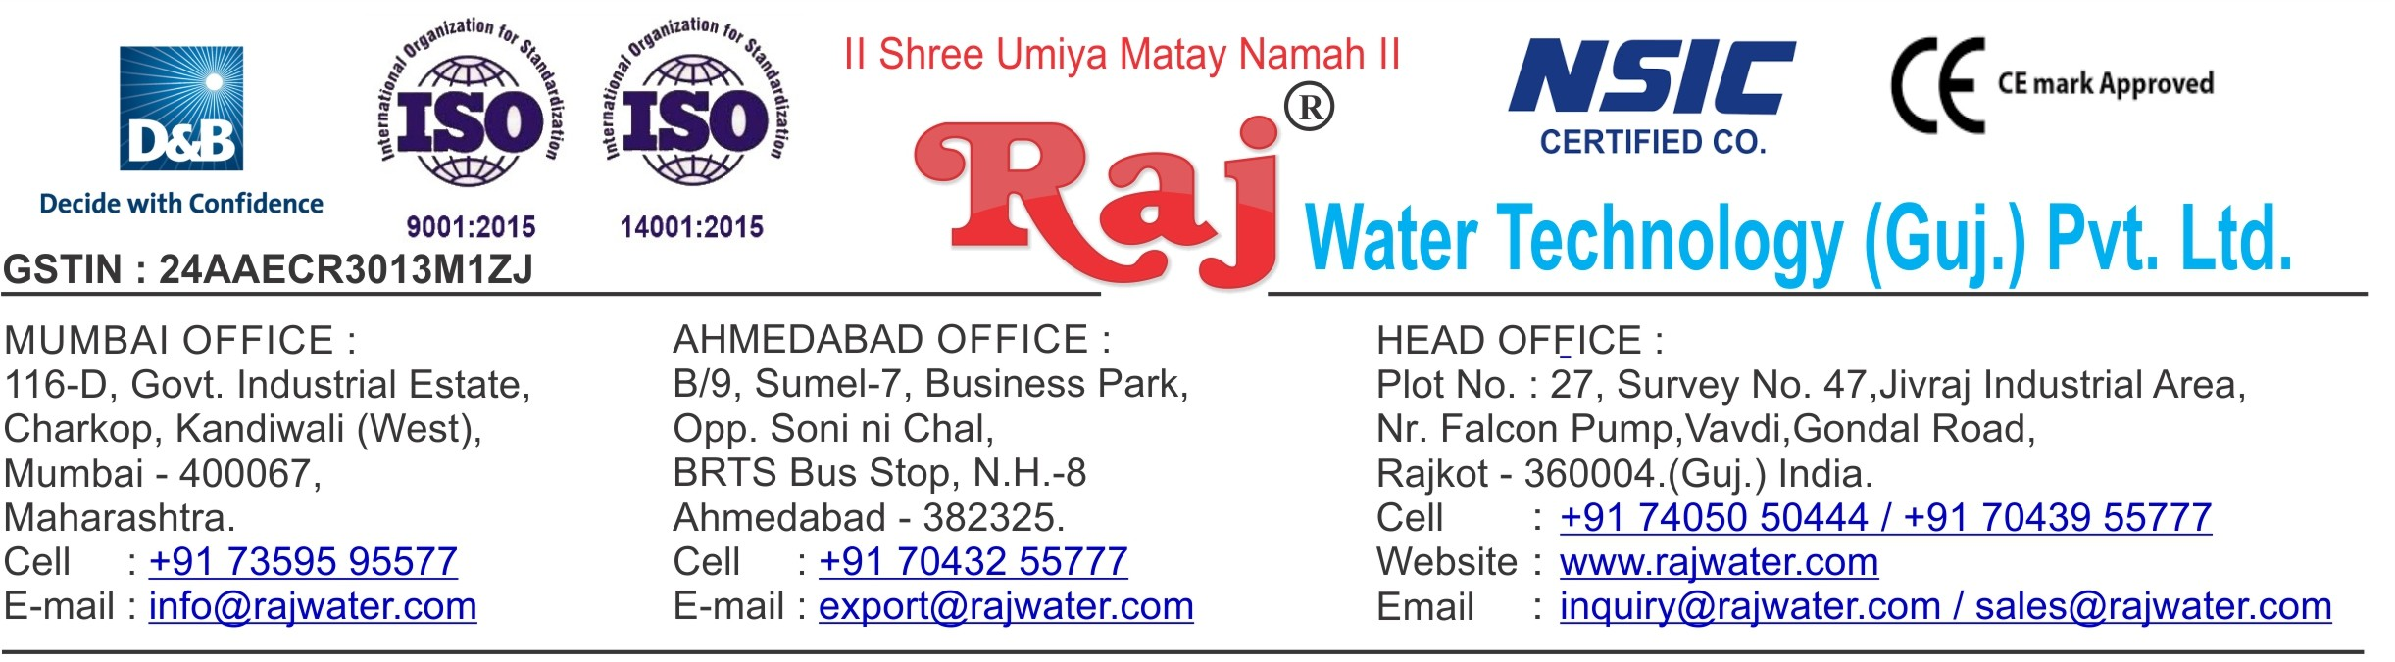

**Proforma Invoice**

|  |  |
| --- | --- |
| **To,**  Mr. Issack  SKYLINK OIL LIMITED  [skylinkoillimited@gmail.com](mailto:skylinkoillimited@gmail.com)  254-4726421562 / 254726421562  P.O BOX 87986-80100 MOMBASA-KENYA | **Performa Invoice No.:RW-019_027**  **Performa Invoice Date: 22/05/2019** |
|  | **Quotation No.-**  RW/2018-19/Q_12298/R_1 |

|  |  |  |  |  |
| --- | --- | --- | --- | --- |
| Sr.No. | Description | Qty | Rate/pc **US$** | Amount **US$** |
| 1 | Automatic Bottle Rinsing, Filling & Capping Machine 60-  BPM (12X12X6)With Infeed And Out Feed Conveyor Belt,Automatic  cap elevator | 1 | 20000.00 | 20000.00 |
| 2 | FOB & Packing Charges | 1 | 500.00 | 500.00 |
|  |  |  |  |  |
| **Grand Total** | **20500$** |
|  | PAY TO : J P MORGAN CHASE, NY // SWIFT: CHASUS33XXX |  | | |
| FOR CREDIT TO : A/C NO. 0011407376 // AXIS BANK LTD, MUMBAI |
| A/C NO. : 917030066188944 |
| ULTIMATE BENEFICIARYNAME: RAJ WATER TECHNOLOGY (GUJ) PVT LTD |
| FOR FURTHER CREDIT TO: AXIS BANK LTD, RAJKOT //SWIFT: AXISINB087 |
| **Raj Water Technology (Guj.) Pvt. Ltd.** | | | | |



**Terms & Condition**

**1) Price**

* **The Quoted Prices Are Ex-Factory**

**2)   TAX**

* **GST 18% Applicable.**

**3)   Payment**

* **30 % advance along with the purchase order, 40 % after inspection, & 30 % before material dispatch.**
* **In Case Of Cancellation Of Confirmed Order Due To Any Reason, As A Part Of Penalty 25% Amount Of The Order Value Shall Have To Pay By You To Raj Water.**

**4)   Packing, Freight & Transit Insurance, & Unloading**

* **Packing Charge Will Be Extra (Depend On Packing Material)**
* **Transport To Be Arranged By The Customer OR If Arranged By Raj Water: Extra At Actual Plus GST.**
* **Transportation Insurance In The Scope Of Buyer.**
* **Unloading In The Scope Of Buyer. Buyer Has To Ready Forklift Or Crane And Unskilled Labor.**

**5)  Delivery**

* **Schedule For Dispatch Will Be Notified.**
  + **Delivery Dates Are Approximate Only, And Assume Timely Receipt Of All Information, Test Materials & Payment.**

**6)   Warranty**

* **We Shall Provide 1 Year Warranty For The Following:**
* **Manufacturing Defects, Raw Water Pump, High Pressure Pump, Treated Water Transfer Pump.**
* **Due To Fluctuation In Power Supply, Attempted Repaired By Person Other Than Our Technical Representative, Improper Handling Or Negligence By End Users, Poor Maintenance, Improper Use Of Equipment, That All Type Of Damage Not Covered In Warranty Create Area.**
* **During The Warranty Period, We Shall Provide Supervisory Services Of Our Technical Representative As And When Required.**

**7)    Accommodation**

* **Technician Charge Will Be Extra 1000/- Rs. Per Day.**
* **Travelling, Lodging And Boarding, Local Conveyance And Any Other Miscellaneous Expense Of Our Technical Representative Will Have To Be Borne By Client.**

**8)   Validity**

* **Our Offer Is Valid For Your Acceptance For A Period Of 6 Months From The Date; Thereafter It Will Be Subject To Confirmation By Us.**

**9)    Image**

* **Images Are For Representation Purpose Only.**

**10)  Jurisdiction**

* **All Terms Subject To Rajkot ,Gujarat Jurisdiction**