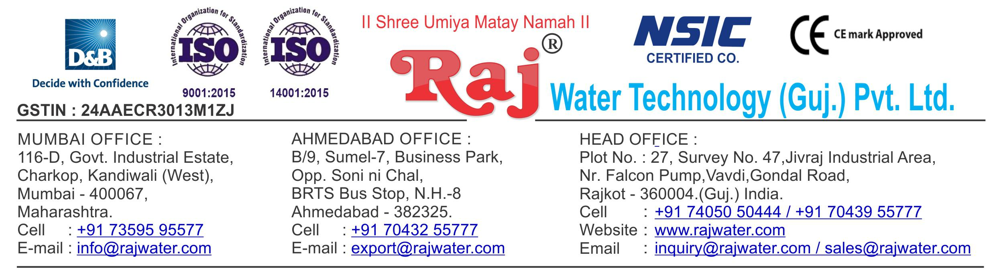

**Quotation For Water Treatment Project**

**Technical Specification**

**1. Raw Water Quality**

|  |  |
| --- | --- |
| R.O. plant is | 270 TDS |
| designed based On : |  |
| Hardness : |  |

**Application :-**



**2. Treated Water Quality**

Suspended Solids :

Nill

Turbidity :

Nill

PH :

7.0 To 7.5

T D S :

5 ppm



Total Hardness :

30 ppm as CaCo3

Bacteria Coliform :

Nill

**Application :-**

The above water quality is approximate assumption, We can change property of minerals/ions in water by editing the raw water in R.O. treated water

**3. Raw Water Feeding Pump**

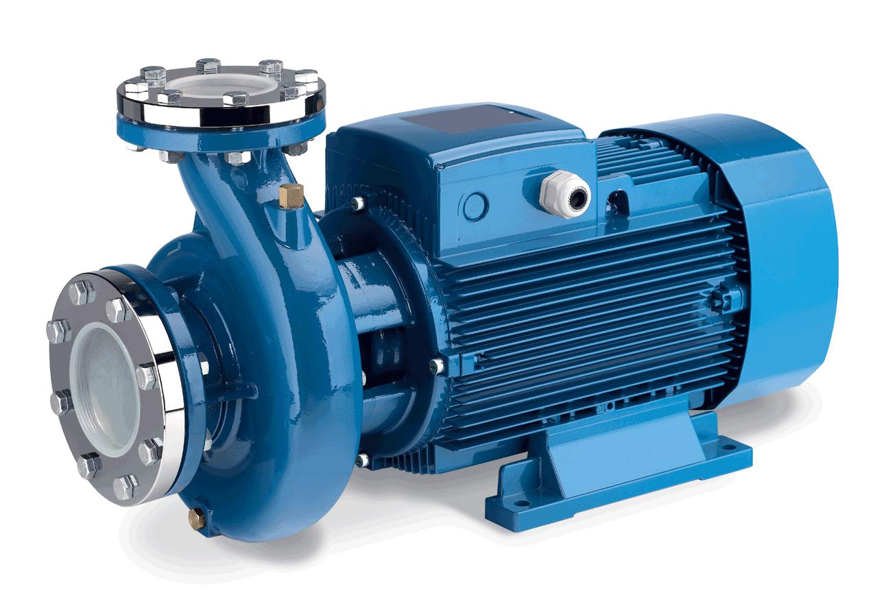

Type :

Centrifugal

Max. Flow :

22.0 m3/HR

Working Flow :

20.0 m3/HR

Working Pressure :

2 Kg. / Cm 2

M.O.C. :

C.I.

Power :

3 HP

Manufacturer :

Kirloskar / EQI

Nos. Offered :

1 Nos.

**Application :-**

To Pump Raw Water at Required Pressure so as to enable Transfer Through The RO Pre-Treatment Stage.



**4. Pressure Sand Filter (FRP)**

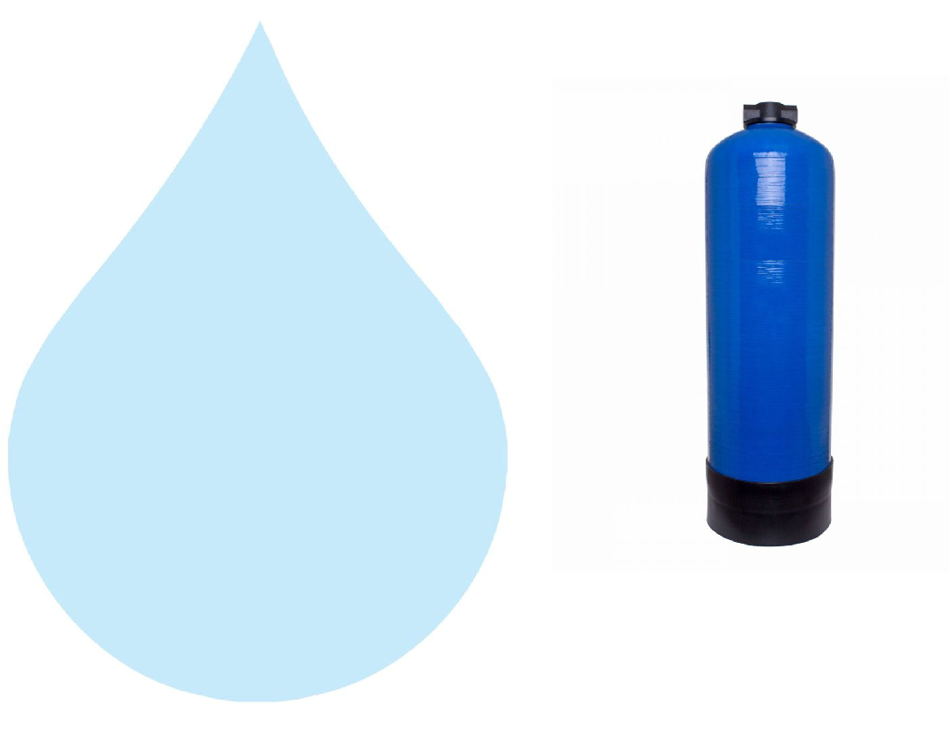

Type :

Down Flow Graded Sand Type

Model :

3672/RW/MGF

M.O.C. :

FRP

Size Dia X Height :

900 mmX 1800 mm

Pipe Line Size :

50 mm

Sand Qty. :

850 kgs

Valves :

PP multiport valve

Max. Flow :

22.00 m3/hr.

Working Flow :

20.00 m3 /hr.

**Application :-**

By means of Multi size Graded sand filled in the Vessel of stainless steel material, which is natural process of filtration adopted by the nature Raw Water is first filtered by filtration unit in series prior feeding RO Plant. Pressure Sand Filter Unit is provided for removal of suspended matters & turbidity from raw water. PSF Unit is a SS vertical Pressure Vessel. Internally, it is fitted with bottom collecting system. Uniform grades silica quartz sand is charged on the supporting media of pebbles and gravels.

**5. Activated Carbon Filter (FRP)**

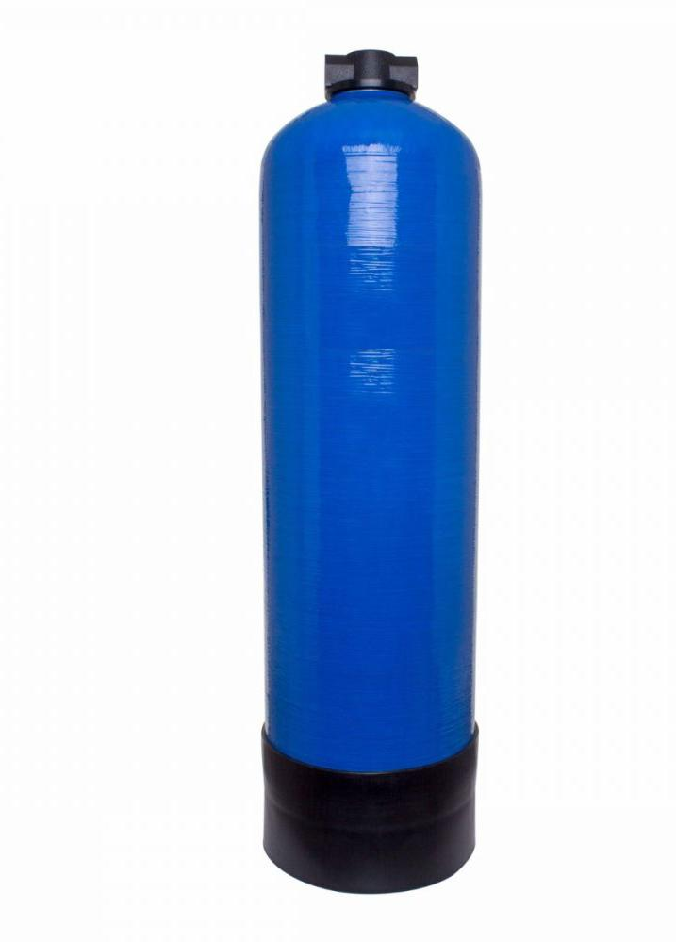

Type :

Down Flow Graded Sand Type

Model :

3672/RW/MGF

M.O.C. :

FRP

Size Dia X Height :

900 mmX 1800 mm

Pipe Line Size :

50 mm.

Carbon Qty. :

330 Kgs.

Valves :

PP multiport valve

Max. Flow :

22.00 m3/hr

Working Flow :

20.00 m3/hr.

**Application :-**

To Remove taste, odour, chlorine, colour and. It can absorb contaminated particles of Oil & Grease from the raw water. It will control the BOD & COD in the raw water. Activated Carbon can remove Chlorine, Odour, & Colour other organic material from feed water prior to reverse osmosis. This Carbon granules having larger surface area and specific property to absorb organics.

**6.Softener Filter (FRP)**



Type :

Down Flow Graded Sand Type

Model :

3672/RW/MGF

M.O.C. :

FRP

Size Dia X Height :

900 mmX 1800 mm

Pipe Line Size :

50 mm.

Resin Qty. :

770 Kgs.

Valves :

PP multiport valve

Max. Flow :

22.00 m3/hr

Working Flow :

20.00 m3/hr.

**Application :-**

To Remove taste, odour, chlorine, colour and. It can absorb contaminated particles of Oil & Grease from the raw water. It will control the BOD & COD in the raw water. Activated Carbon can remove Chlorine, Odour, & Colour other organic material from feed water prior to reverse osmosis. This Carbon granules having larger surface area and specific property to absorb organics.

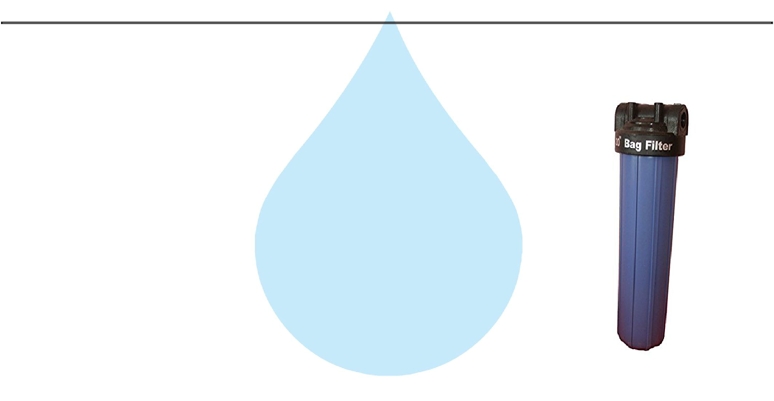**7. Micron Cartridge Filter Housing**

Model :

MCF 20/RW/PP

Size :

20" Long

Micron Rating :

5 Micron

Type of Candle :

P. P. Spun / Wound

Material of Housing :

PP

Nos. of Candles :

4 nos

Max. Flow :

22.00m3/HR

Working Flow :

20.00 m3/HR

**Application :-**

To protect the membrane and the high pressure pump from suspended particles by removing them up to 5 Micron.

**8.Lime Dosing Pump**

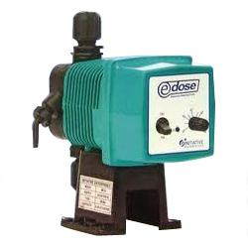

Type :

Ele. Diaphragm Type

Capacity :

0 to 6 LPH

M.O.C. :

PP

Dosing Chemical :

Lime

Dosing Rate :

3 to 4 LPH

Make :

E Dose/ I Dose

Nos :

1 Nos

**Application :-**

The hardness salts of calcium & magnesium are likely to be precipitated if concentration exceeds its solubility limit

* + it may faults the membranes resulting into scaling which ultimately leads to poor treated water quality from R.O.System.

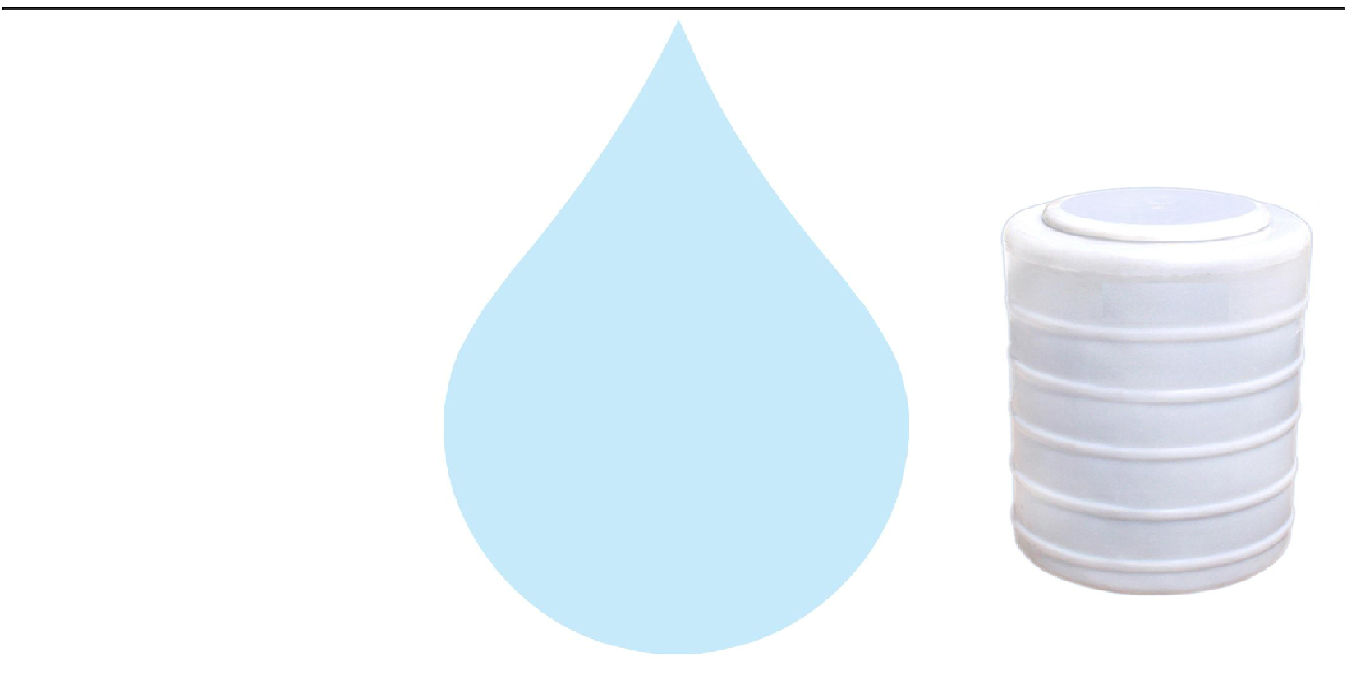

**9.Lime Dosing Tank**

Type :

Conical Bottom

Capacity :

100 Ltr.

M.O.C. :

HDPE

Manufacturer :

Reputed

Nos : 1 Nos

**10. Antiscalant Dosing Pump**



Type :

Ele. Diaphragm Type

Capacity :

0 to 6 LPH

M.O.C. :

PP

Dosing Chemical :

Antiscalent

Dosing Rate :

3 to 4 LPH

Make :

E Dose/ I Dose

Nos :

1 Nos

**Application :-**

The hardness salts of calcium & magnesium are likely to be precipitated if concentration exceeds its solubility limit

* + it may faults the membranes resulting into scaling which ultimately leads to poor treated water quality from R.O.System.

**11.Antiscaling Dosing Tank**



Type :

Conical Bottom

Capacity :

100 Ltr.

M.O.C. :

HDPE

Manufacturer :

Reputed

Nos :

1 Nos

**12. High Pressure Pump**

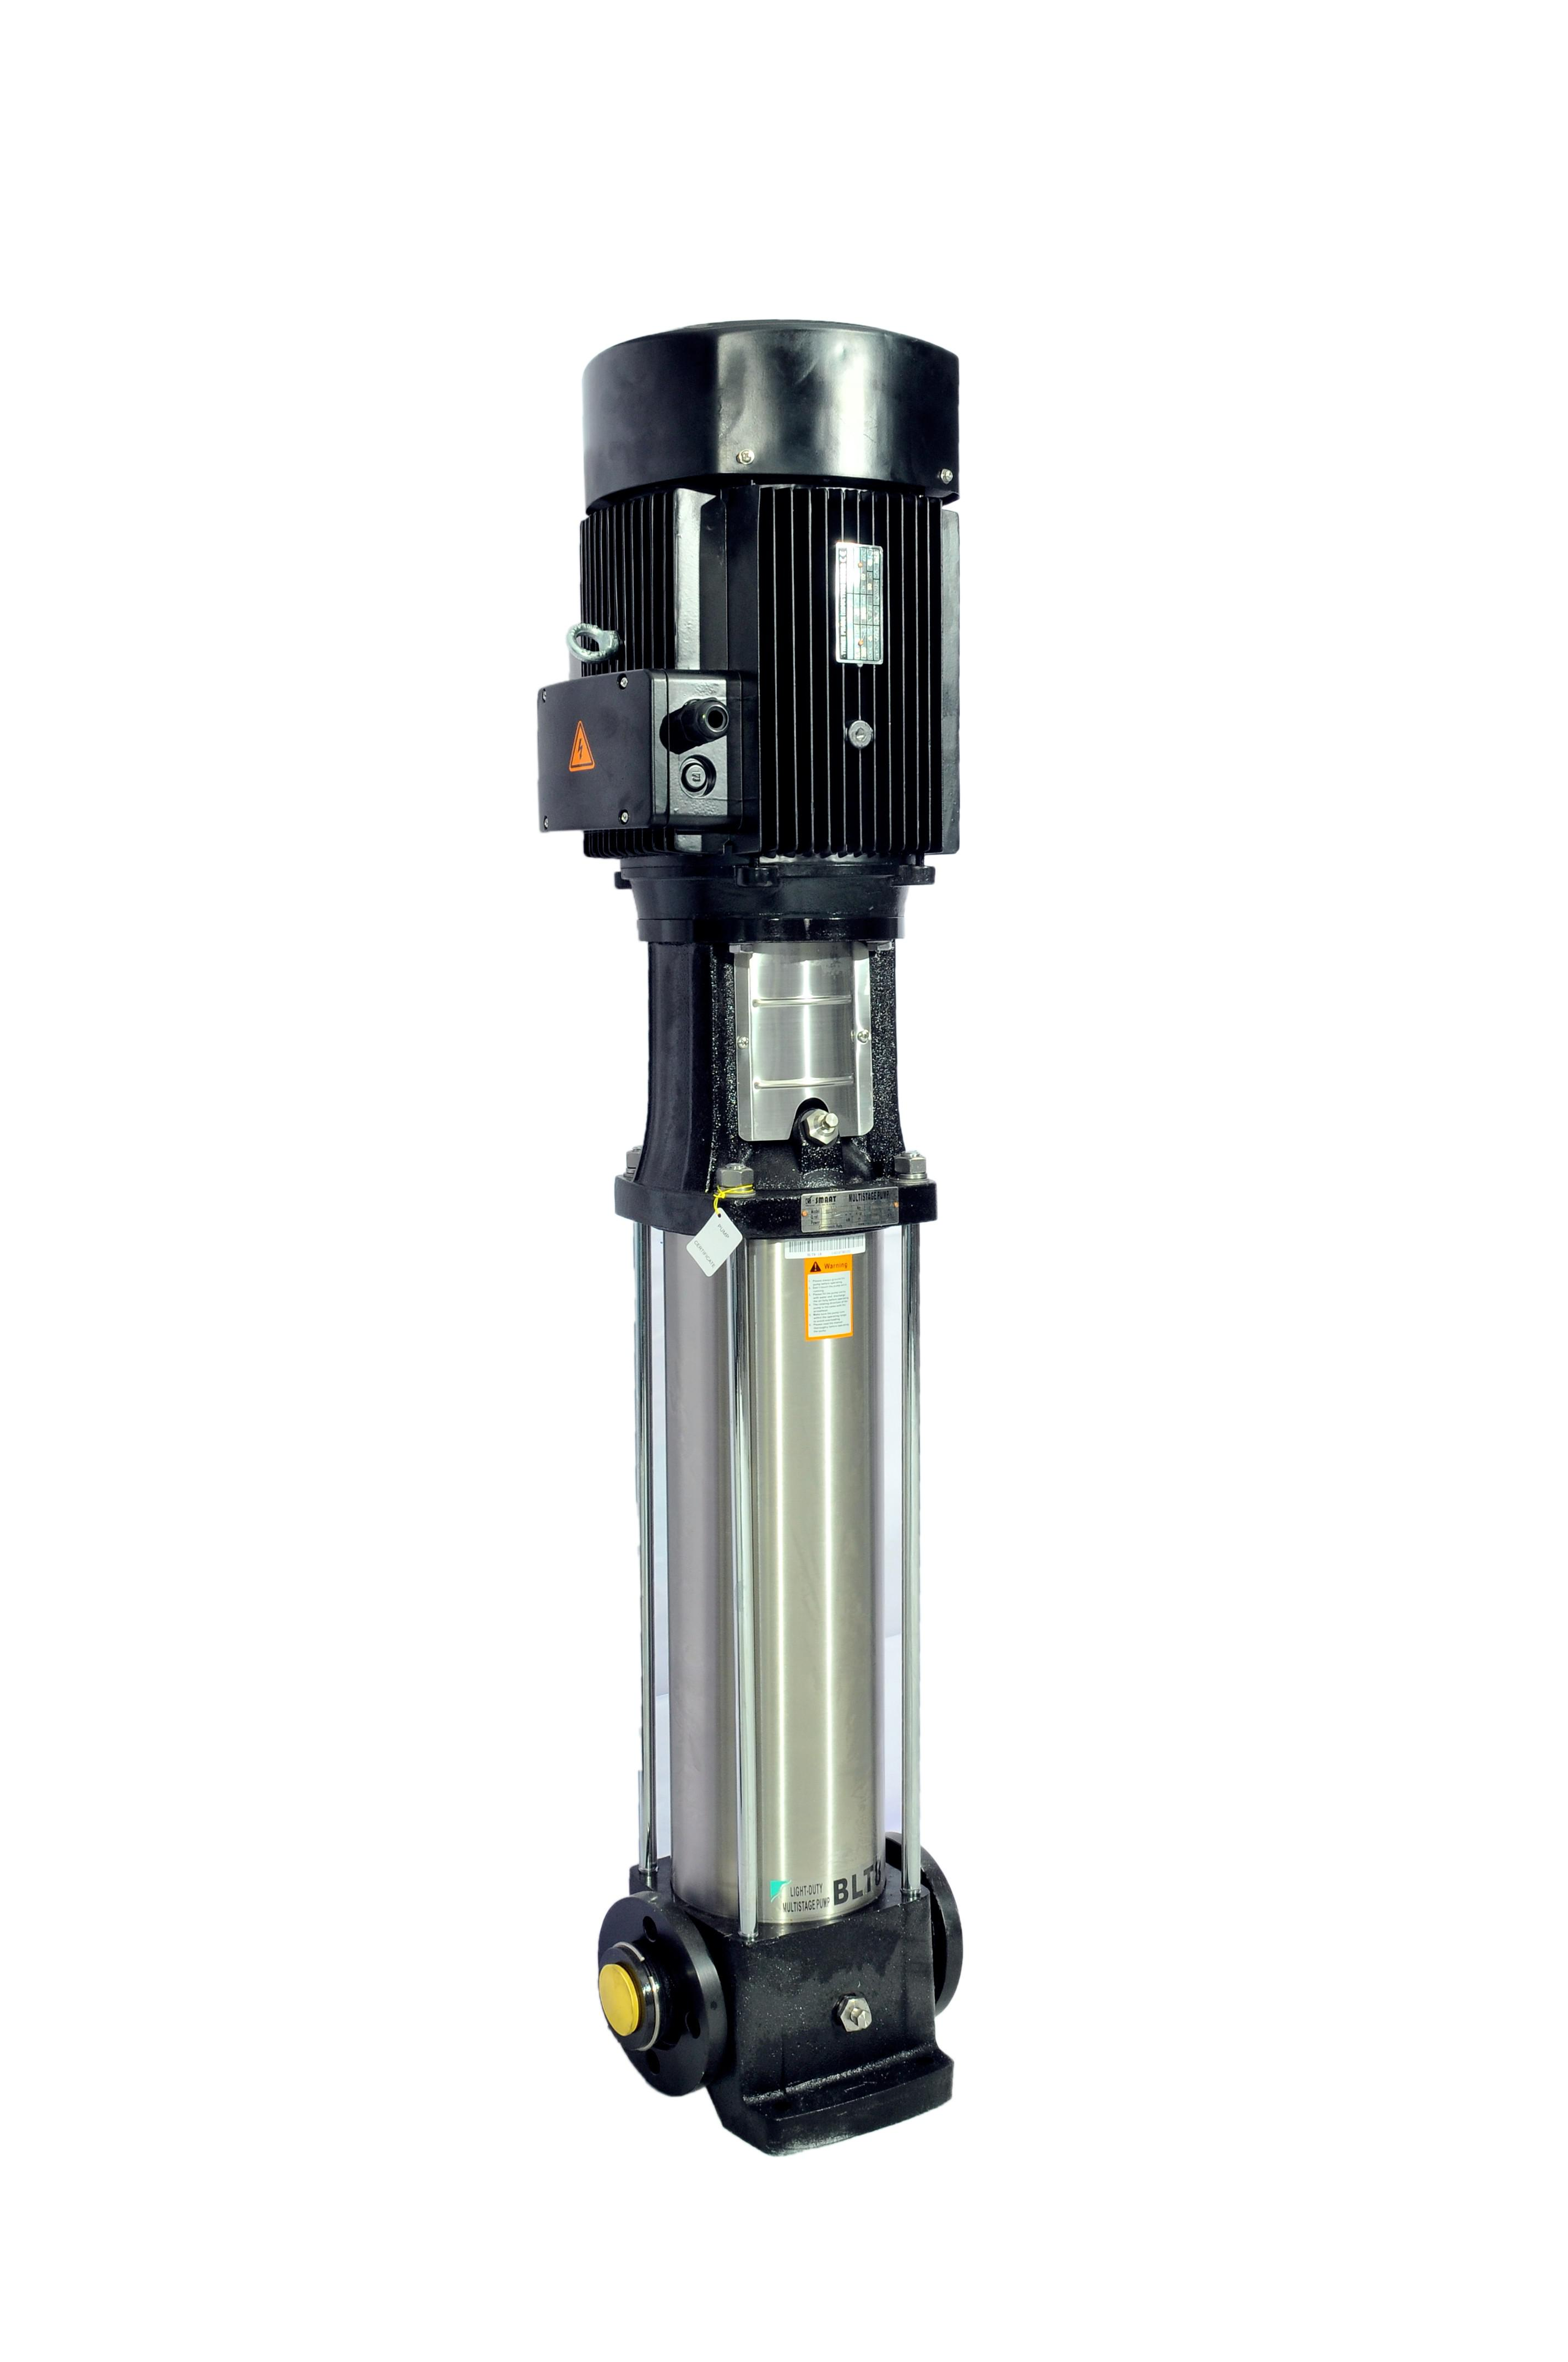

Type :

Vertical Centrifugal Pump

M.O.C. :

SS

Max. Pressure :

13 Kgs. / Cm 2.

Working Pressure :

10 Kgs. / Cm 2.

Max. Flow :

22.0 m3/HR

Working Flow :

20.0 m3/HR

Motor :

11KW

Manufacturer :

2900 RPM

Nos. Offered :

3 Phase

Make of Pump :

PNC

**Application :-**

For Reverse Osmosis Process to take place feed pressure of water need to be raised. For this purpose a Vertical Multistage Centrifugal High Pressure Pump in S.S construction is provided R.O. System requires operating pressure of about 14-16 kg/cm^2 . High-pressure pump is fitted with S.S. discharge pipe work with necessary control valves. Necessary instruments like a High Pressure Switch, Pressure Gauge and recirculation valves are provided for safer operation of system

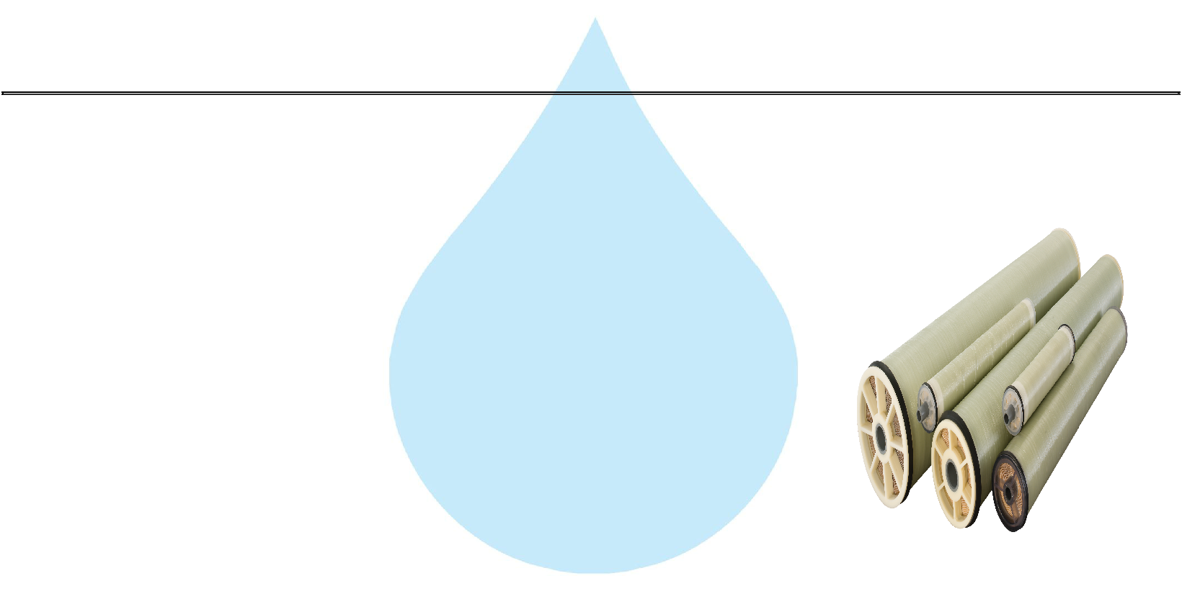

**13. RO Membrane**

Model :

8040 Element

Type :

TFC Spiral Wound

Material :

Polymide

Size :

8" Dia X 40" Long

Manufacturer :

Toray / Hydranautics / Dow / EQI

Nos. Offered :

10 Nos.

**Application :-**

To reduce Raw Water T.D.S. through the concept of Reverse Osmosis where R.O. Modules processes Raw Water and produces Purified Water having the Salt Rejection of Raw Water in the range of 90 – 95%. By using Semi permeable Membrane filter elements, where ion filtration process is carried out by applying pressure in the water. So finally we will get Low salt water with low total dissolve solids and High purity. Here will have to drain the water at one side to Wash the Membrane filter elements continuously because of filtration process there is nothing to be polluted in the system.

**14. Fiber - Reinforced Plastic Pressure Vessels**

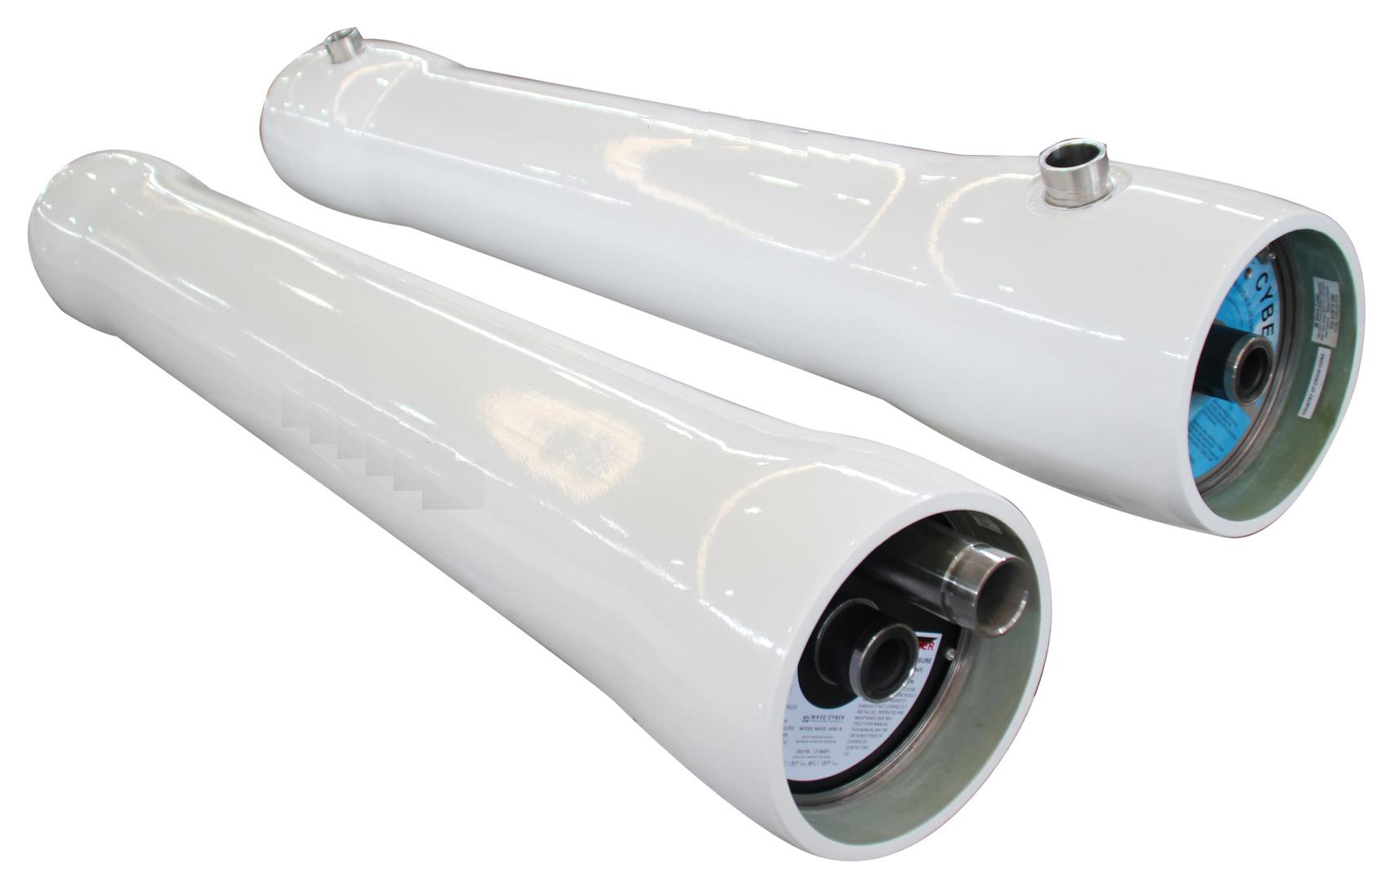

M.O.C. :

Type :

Size :

Max. Pressure :

Working Pressure :

Nos. Offered :

Code Line/FRP

Horizontal Tube Type

8"X200"

250 PSI

150 PSI

2 Nos.



**15.P.H Dosing Pump**



Type :

Ele. Diaphragm Type

Capacity :

0 to 6 LPH

M.O.C. :

PP

Dosing Chemical :

PH

Dosing Rate :

3 to 4 LPH

Make :

E Dose/ I Dose

Nos :

1 Nos

**Application :-**

The hardness salts of calcium & magnesium are likely to be precipitated if concentration exceeds its solubility limit

* + it may faults the membranes resulting into scaling which ultimately leads to poor treated water quality from R.O.System.



**16.PH Dosing Tank**

Type :

Conical Bottom

Capacity :

100 Ltr.

M.O.C. :

HDPE

Manufacturer :

Reputed

Nos : 1 Nos

**17. Pressure Gauges**

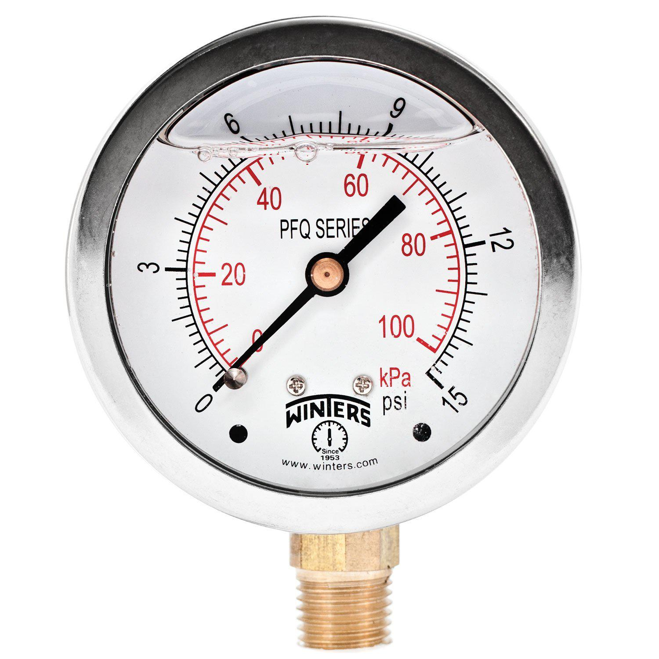

|  |  |  |
| --- | --- | --- |
| Pressure Gauges : | 7 | Nos. |
| Type : | Burdone Tube Type | |
| Manufacturer : | Raj | |
| Range : | 0 | - 28 |



**18. Rota Meters**

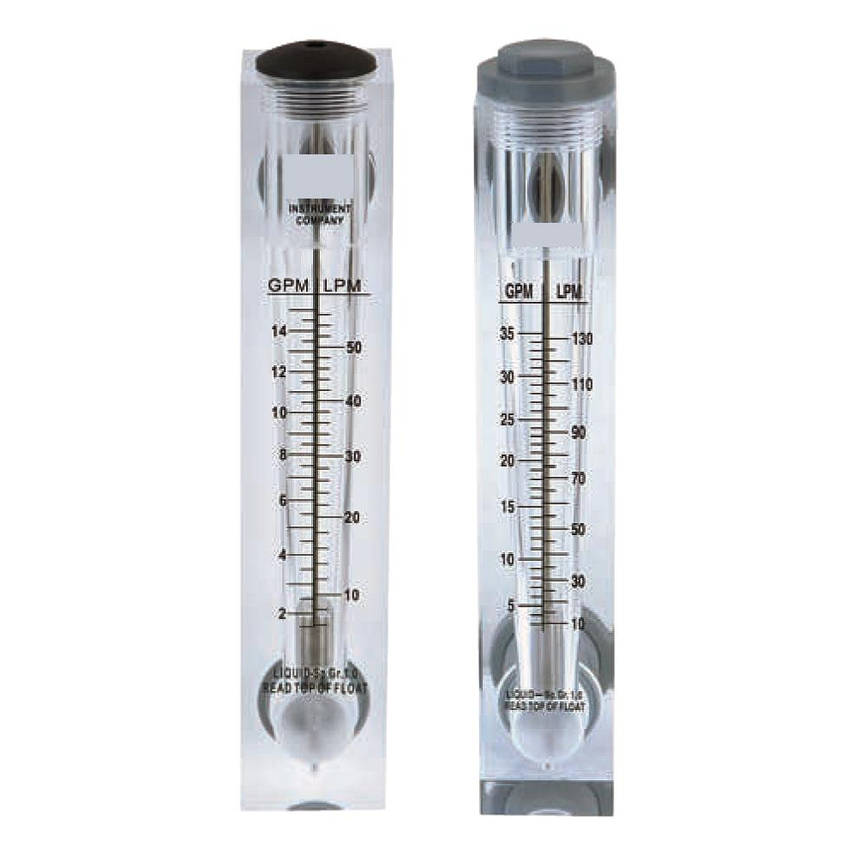

Rota Meters :

Type :

M.O.C. :

Reject Water Range :

Treated Water Range

:

2 Nos.

Float

Acrylic Body

SS Float (0 - 20000 Lph.)

SS Float (0 - 12000 Lph.)



**19. Control Panel - PLC Base**

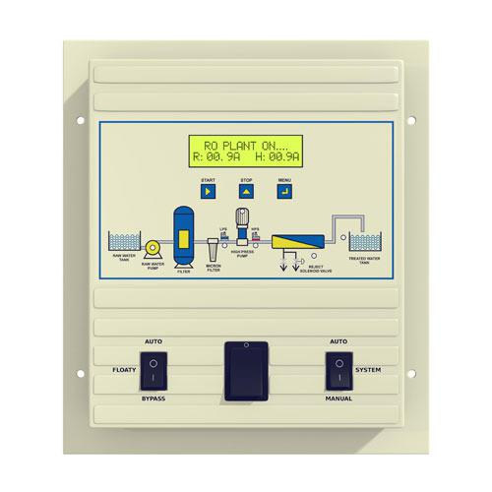

Manufacturer : Astral



**20. Pressure Switch**

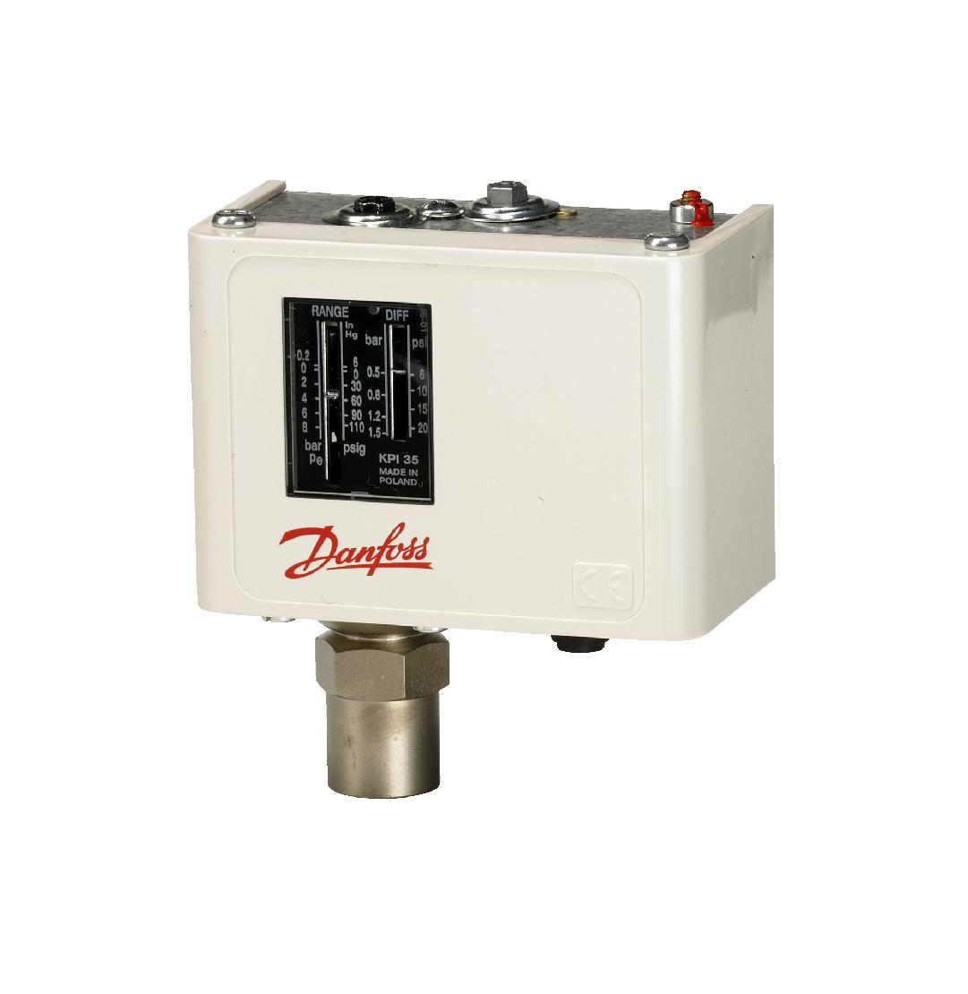

Pressure Switch :

Type :

Manufacturer :

Model :

2 Nos.

Low / High Pr.

Denfoss

IPS 70 / 400



**21. Stand For Unit**

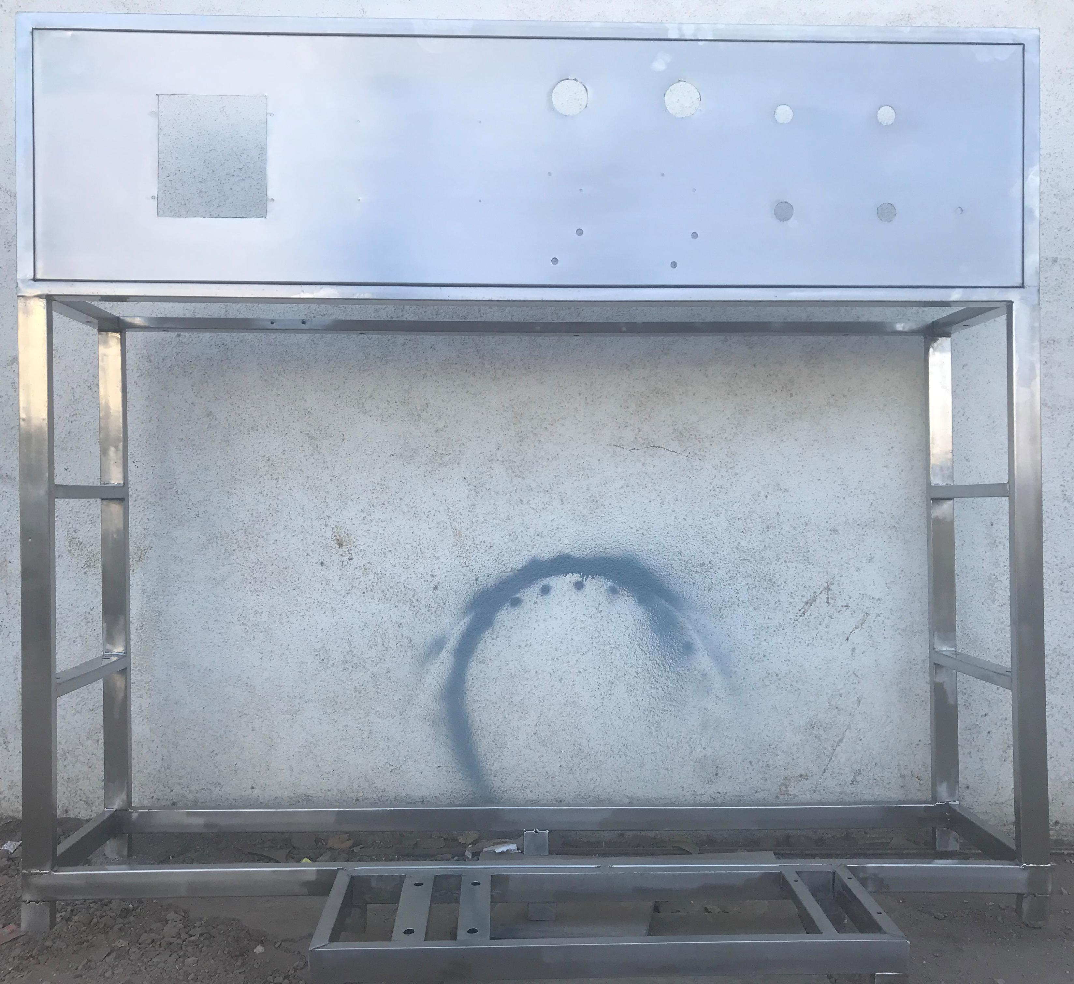

Stainless Steel : Complete stand for unit will be made of S.S.



**Application :-**

Complete stand for unit will be made of S.S.304

**22. UPVC Interconnecting Pipe Lines**

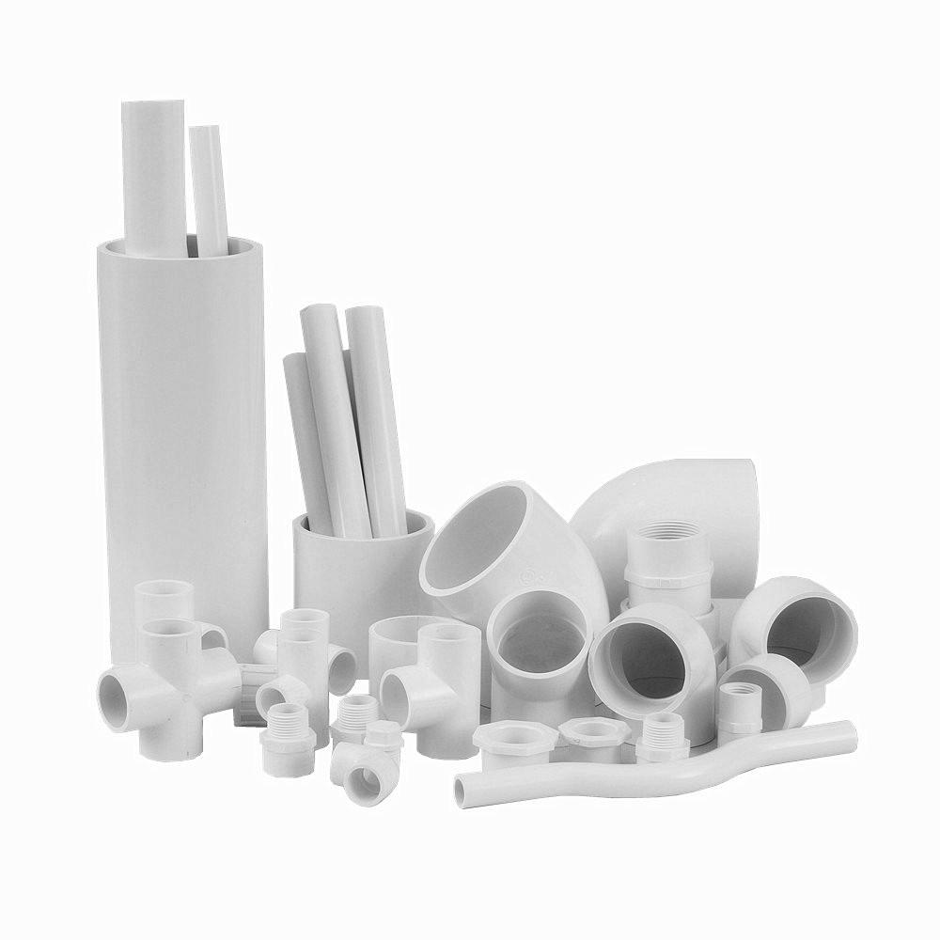

Interconnecting Pipe Lines :

All interconnecting pipelines Are raw water pump to HP Pump UPVC And HP Pump To Ro Plant SS will be provided by us.

**Application :-**

All interconnecting Piping Raw Water Pump To RO will be provided of UPVC by us.

