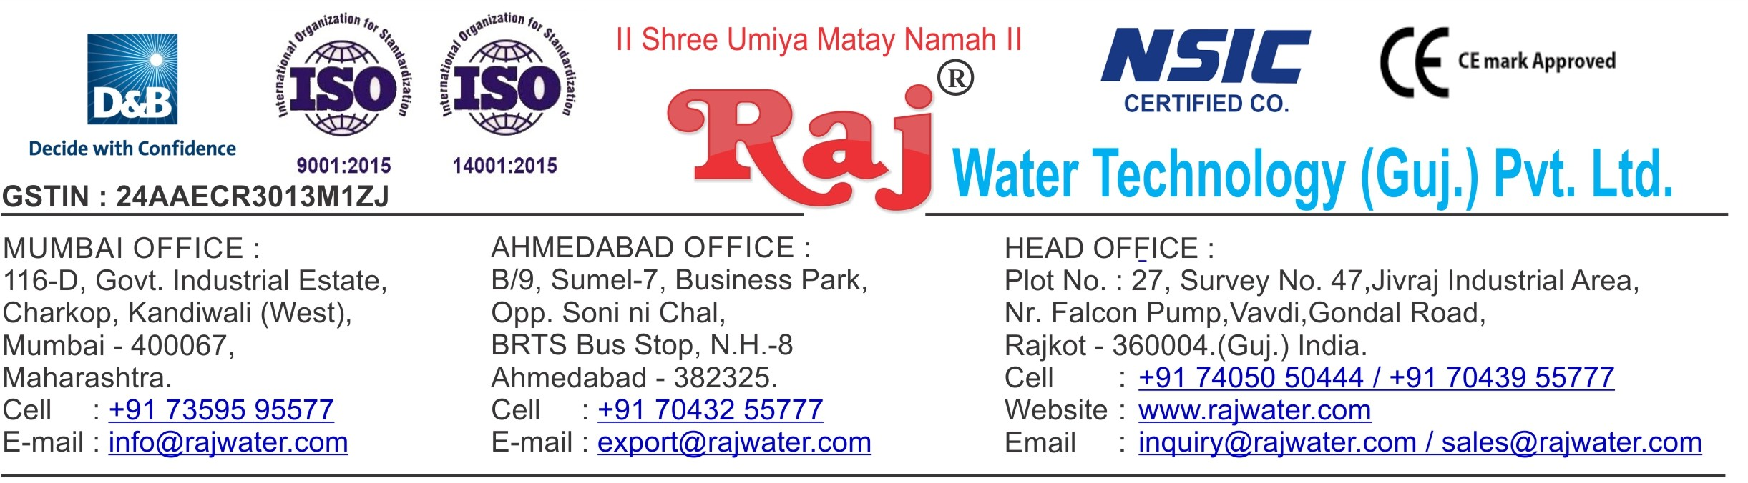

Power Calculation

|  |  |  |  |  |  |
| --- | --- | --- | --- | --- | --- |
| **To,**  Mr. Anil Ghosh 7002776613/8876131713 | | **P.C. No. :-**RW/2019-20/PC-1 **P.C. Date :-**30-05-2019 | | | |
| **Quotation No. :-**RW/2018-19/Q_12300/R_9 **Quotation Date :-**30-05-2019 | | | |
| **Sr.**  **No.** | **Product Name** | | **Qty** | **Power In HP** | **Power in KW** |
| 1 | 4000 Litre Per Hour SS-304 RO Plant With U.V System, SS Storage Tank 2000 Litre 2-Nos With Added Mineral Sysem | | 1 | 7 | 5.2199 |
| 2 | Ozonation With Circulation System | | 1 | 0 | 0 |
| 3 | Complete Lab BIS Approve (14543-Standard) Testing Instrument, Glassware , Chemical As Per List | | 1 | 0 | 0 |
| 4 | Automatic Bottle Rinsing, Filling & Capping Machine 40-BPM With Automatic Cap Elevator | | 1 | 12 | 8.9484 |
| 5 | Single Cavity Automatic PET Stretch Blowing Machine - Manual Preform Loading  Production Capacity - 25 mm To 28 mm neck size bottles ,200ml to 1000ml. PET bottles 1000ml Bottle (28mm / 19gm Alaska)-1500 BPH,Standard Accessories with machine Holder set of 28mm neck size.No. Of Cavities-1 | | 1 | 15 | 11.1855 |
| 6 | High Pressure Air Compressor 20-HP | | 1 | 25 | 18.6425 |
| 7 | Water Chiller 3- Ton With 200 Litre Storage Tank | | 1 | 5 | 3.7285 |

|  |  |  |  |  |
| --- | --- | --- | --- | --- |
| **Sr.**  **No.** | **Product Name** | **Qty** | **Power In HP** | **Power in KW** |
| 8 | Air Dryer | 1 | 0 | 0 |
| 9 | 200 ML, 500Ml, 1Litre Mould 2KVT | 3 | 0 | 0 |
| 10 | Hot & Cold Jar Washing Machine  SS 304 Machine For 20 Litre Jar Rinser Machine Single Jet Nozzle-Tank Capacity 60 Ltr 2 Nos  Machine Diamension L800 X W 800 X H 800,For Internal Jar Rinsing Unit With 0.5 HP Motor PNC Make 2 Nos And 2 KW Heater ,Controll Panel ,timer base Working | 1 | 1 | 0.7457 |
| 11 | Automatic Inkjet Batch Coding Machine | 1 | 0 | 0 |
| 12 | SS Piping RO Plant To Bottle Filling Machine | 1 | 0 | 0 |
| 13 | Semi-Automatic Shrink Wrapping Machine | 1 | 16 | 11.9312 |
| **Total Power Consumption** | | | **81HP** | **60.4017KW** |

