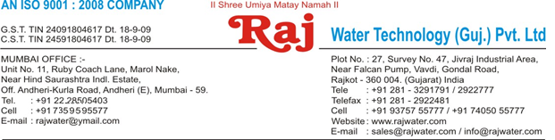

**Technical Specification**

**1. Raw Water Quality**

|  |  |
| --- | --- |
| R.O. plant is | 1500 TDS |
| designed based On : |  |
| Hardness : | 300 |

**Application :-**



**2. Treated Water Quality**

Suspended Solids :

Nill

Turbidity :

Nill

PH :

7.0 To 7.5

T D S :

Less than 40 ppm

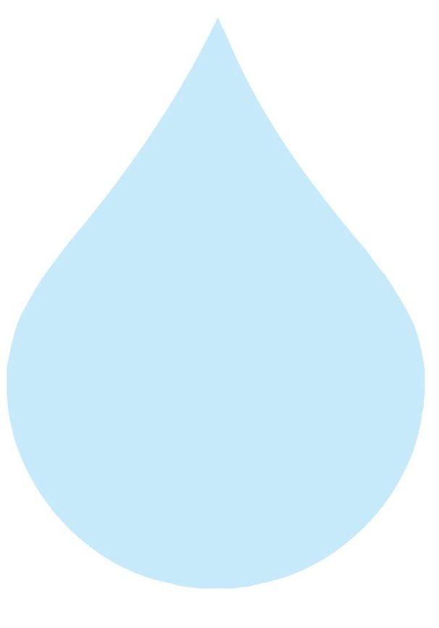

Total Hardness :

30 ppm as CaCo3

Bacteria Coliform :

Nill

**Application :-**

The above water quality is approximate assumption, We can change property of minerals/ions in water by editing the raw water in R.O. treated water

**3. Raw Water Feeding Pump**

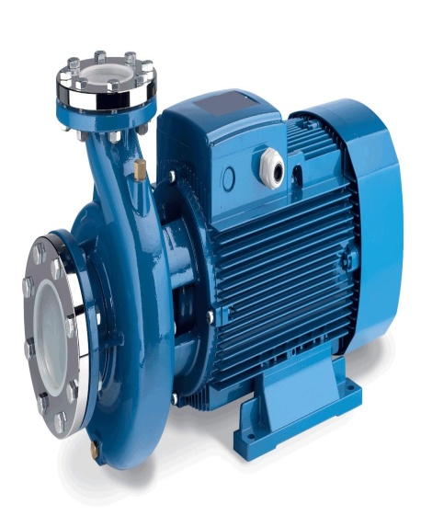

Type :

Centrifugal

Max. Flow :

3.5 m3/HR

Working Flow :

2.0 m3/HR

Working Pressure :

2 Kg. / Cm 2

M.O.C. :

C.I.

Power :

1 HP

Manufacturer :

Kirloskar / EQI

Nos. Offered :

1 Nos.

**Application :-**

To Pump Raw Water at Required Pressure so as to enable Transfer Through The RO Pre-Treatment Stage.



**4. Pressure Sand Filter (SS)**

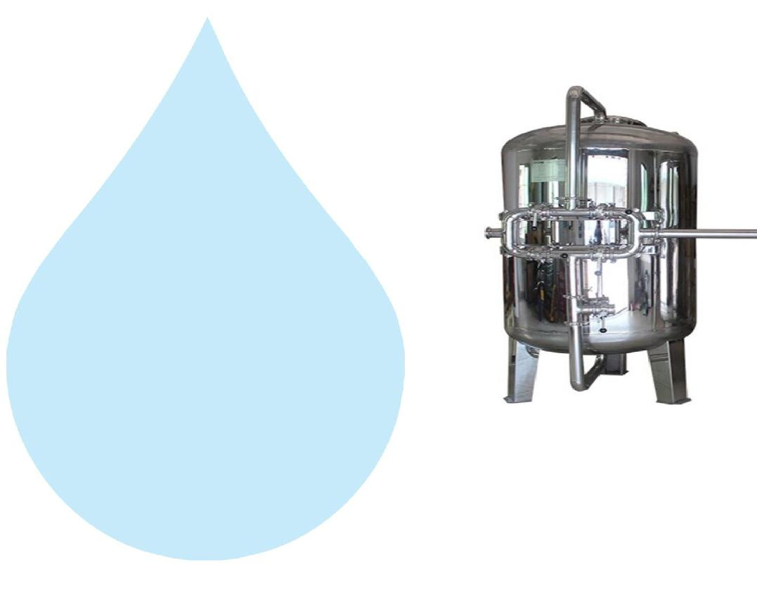

Type :

Down Flow Graded Sand Type

Model :

1268/RW/MFG

M.O.C. :

SS 304

Size Dia X Height :

300 mm Dia X 1700 mm

Pipe Line Size :

25 mm.

Sand Qty. :

120 Kgs.

Valves :

SS Valve

Max. Flow :

3.5 m3/HR

Working Flow :

2.0 m3/HR

**Application :-**

By means of Multi size Graded sand filled in the Vessel of stainless steel material, which is natural process of filtration adopted by the nature Raw Water is first filtered by filtration unit in series prior feeding RO Plant. Pressure Sand Filter Unit is provided for removal of suspended matters & turbidity from raw water. PSF Unit is a SS vertical Pressure Vessel. Internally, it is fitted with bottom collecting system. Uniform grades silica quartz sand is charged on the supporting media of pebbles and gravels.

**5. Activated Carbon Filter (SS)**

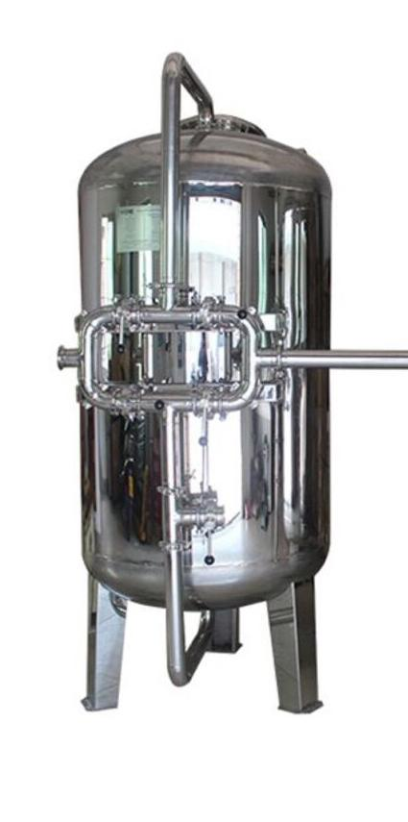

Type :

Down Flow Graded Sand Type

Model :

1268/RW/MFG

M.O.C. :

SS 304

Size Dia X Height :

300 mm X 1700 mm

Pipe Line Size :

25 mm

Carbon Qty. :

50Kgs.

Valves :

SS Valve

Max. Flow :

3.5 m3/HR

Working Flow :

2.00 m3/HR

**Application :-**

To Remove taste, odour, chlorine, colour and. It can absorb contaminated particles of Oil & Grease from the raw water. It will control the BOD & COD in the raw water. Activated Carbon can remove Chlorine, Odour, & Colour other organic material from feed water prior to reverse osmosis. This Carbon granules having larger surface area and specific property to absorb organics.

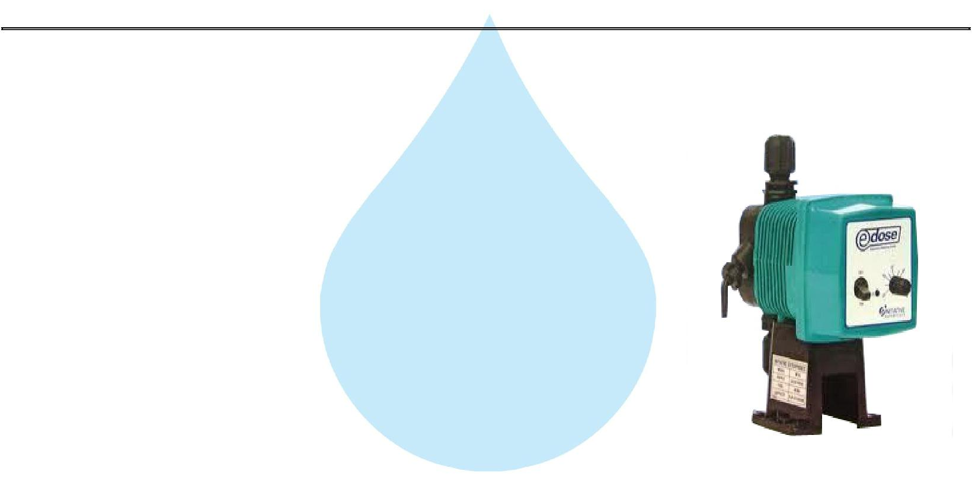

**6. Antiscalant Dosing Pump**

Type :

Ele. Diaphragm Type

Capacity :

0 to 6 LPH

M.O.C. :

PP

Dosing Chemical :

Antiscalent

Dosing Rate :

3 to 4 LPH

Manufacturer :

E Dose / I dose

**Application :-**

The hardness salts of calcium & magnesium are likely to be precipitated if concentration exceeds its solubility limit

* it may faults the membranes resulting into scaling which ultimately leads to poor treated water quality from R.O.System.

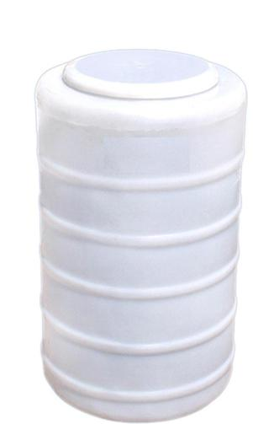

**7. Antiscaling Dosing Tank**

Type : Conical Bottom

Capacity : 100 Ltr.

M.O.C. : HDPE

Manufacturer : Reputed



**8. Mineral Dosing Pump**

Type : Electronic Diaphragm type

Capacity : 0 to 6 LPH

M.O.C. PP

Dosing Chemical : Mineral Dosing

Manufacturer : E Dose / I dose

**Application :-**

The hardness salts of calcium & magnesium are likely to be precipitated if concentration exceeds its solubility limit

& it may faults the membranes resulting into scaling which ultimately leads to poor treated water quality from R.O.System.

**9. Mineral Dosing Tank**

Type :

Conical Bottom

Capacity :

100 Ltr.

M.O.C. :

HDPE

Manufacturer :

Reputed



**10. Micron Cartridge Filter**

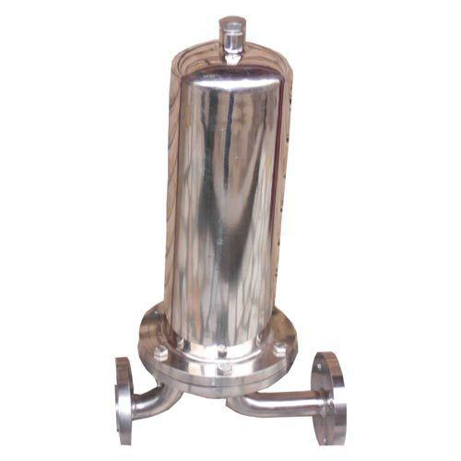

Model :

Size :

Micron Rating :

Type of Candle :

Material of Housing :

Nos. of Candles :

Max. Flow :

Working Flow :

MCF 20/RW/SS



20" Long

5 Micron

P.P Spun/Wound

SS 304

1 Nos. (Jumbo)

3.5 m3/HR

1.0 m3/HR

**Application :-**

To protect the membrane and the high pressure pump from suspended particles by removing them up to 5 Micron.

**11. High Pressure Pump**

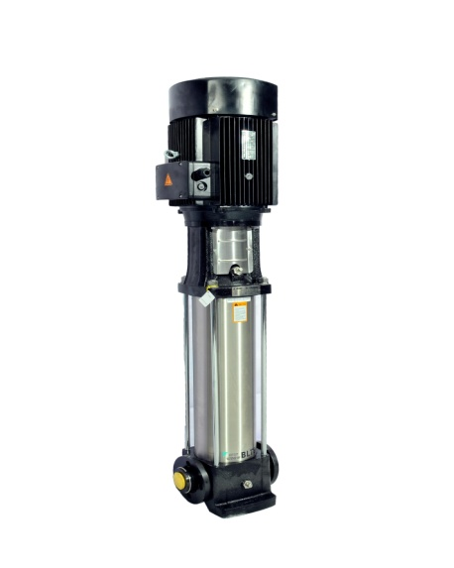

Type :

Vertical Centrifugal Pump

M.O.C. :

SS

Max. Pressure :

13 Kgs. / Cm 2.

Working Pressure :

10 Kgs. / Cm 2.

Max. Flow :

3.5 m3/HR

Working Flow :

2.0 m3/HR

Motor :

3HP

Manufacturer :

2900 RPM

Nos. Offered :

3 Phase

Make of Pump :

PNC/EQI

**Application :-**

For Reverse Osmosis Process to take place feed pressure of water need to be raised. For this purpose a Vertical Multistage Centrifugal High Pressure Pump in S.S construction is provided R.O. System requires operating pressure of about 14-16 kg/cm^2 . High-pressure pump is fitted with S.S. discharge pipe work with necessary control valves. Necessary instruments like a High Pressure Switch, Pressure Gauge and recirculation valves are provided for safer operation of system

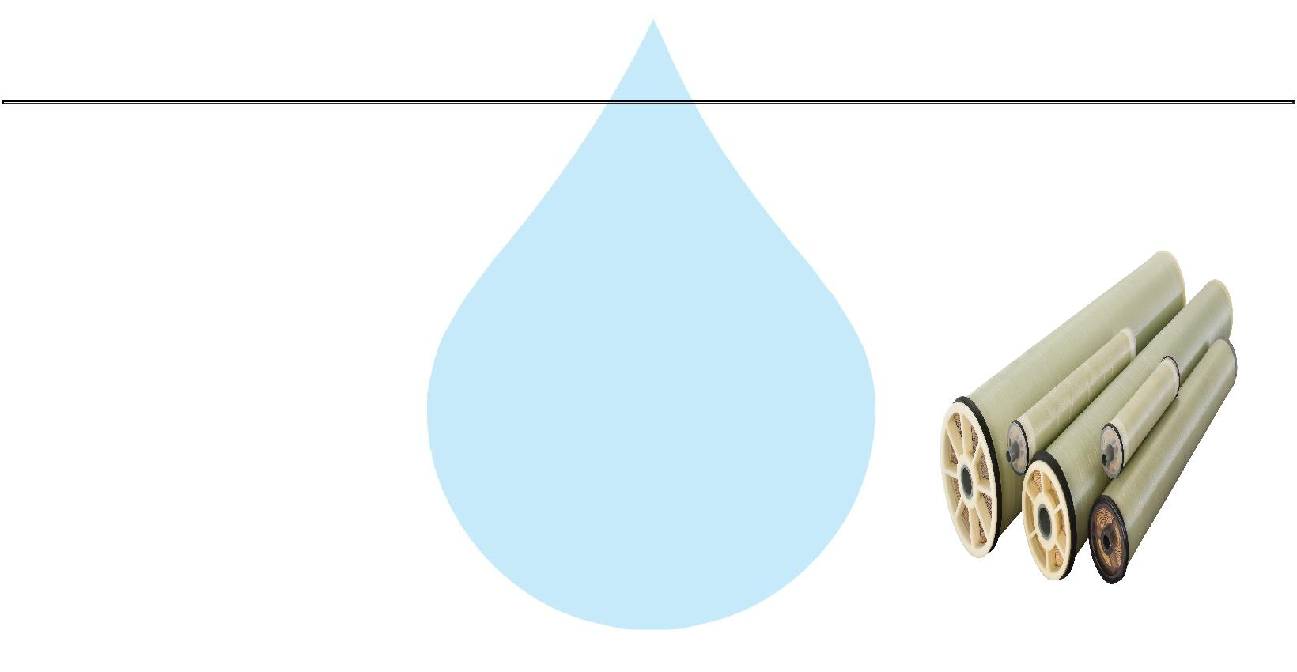

**12. RO Membrane**

Model :

4040 Element

Type :

TFC Spiral Wound

Material :

Polymide

Size :

4" Dia X 40" Long

Manufacturer :

Toray / Hydranautics / Dow / EQI

Nos. Offered :

4 Nos.

**Application :-**

To reduce Raw Water T.D.S. through the concept of Reverse Osmosis where R.O. Modules processes Raw Water and produces Purified Water having the Salt Rejection of Raw Water in the range of 90 – 95%. By using Semi permeable Membrane filter elements, where ion filtration process is carried out by applying pressure in the water. So finally we will get Low salt water with low total dissolve solids and High purity. Here will have to drain the water at one side to Wash the Membrane filter elements continuously because of filtration process there is nothing to be polluted in the system.

**13. SS Pressure Vessels**

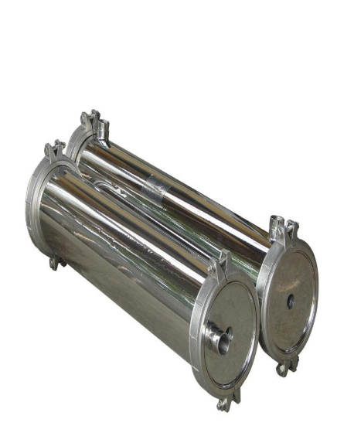

|  |  |
| --- | --- |
| M.O.C. : | SS 304 |
| Type : | Horizontal Tube Type |
| Size : | 4" X 80" |
| Max. Pressure : | 400 PSI |
| Working Pressure : | 150 PSI |
| Nos. Offered : | 2 Nos. |



**14. Pressure Gauges**

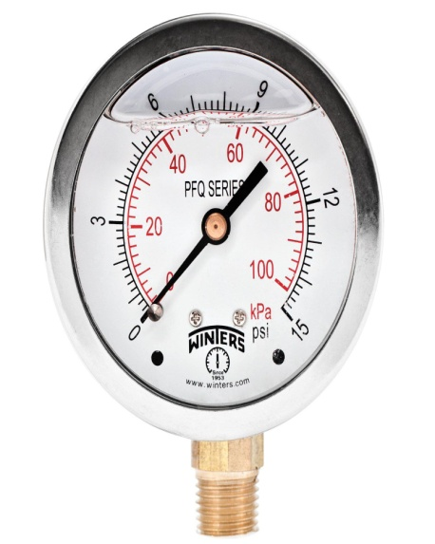

|  |  |  |
| --- | --- | --- |
| Pressure Gauges : | 7 | Nos. |
| Type : | Burdone Tube Type | |
| Manufacturer : | Raj | |
| Range : | 0 | - 28 |



**15. Rota Meters**

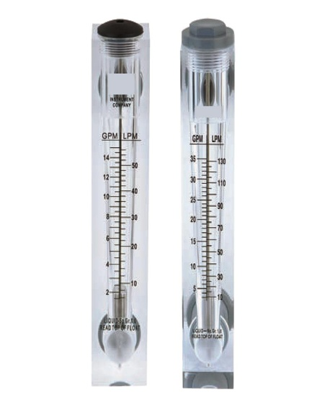

Rota Meters :

Type :

M.O.C. :

Reject Water Range :

Treated Water Range

:

2 Nos.

Float

Acrylic Body

SS Float (0 - 2000 Lph.)

SS Float (0 - 1500 Lph.)



**16. Control Panel - PLC Base**

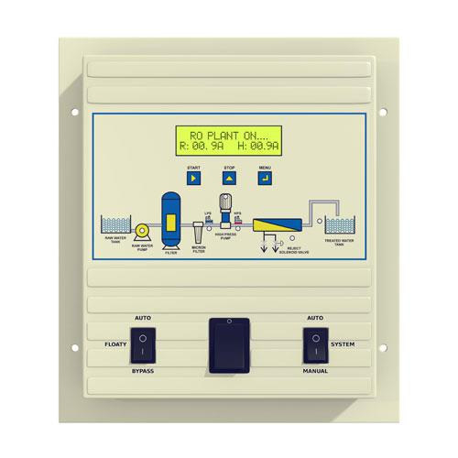

Manufacturer : Astral



**17. Pressure Switch**

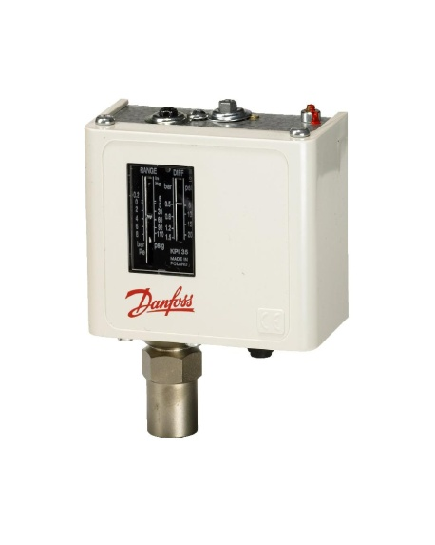

Pressure Switch :

2 Nos.

Type :

Low / High Pr.

Manufacturer :

Denfoss

Model :

IPS 70 / 400



**18. Treated Water Storage Tank**

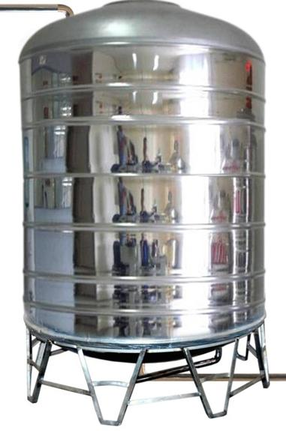

Nos. Offered :

1 Nos.



Type :

Vertical Cylindrical Type

M.O.C. :

SS 304

Capacity :

1000 Ltr.

**Application :-**

To store Reverse Osmosis permeate (product) water. It can remove back pressure in R.O. Membrane elements. It is only storage of the treated Water.

**19. Treated Water Transfer Pump**

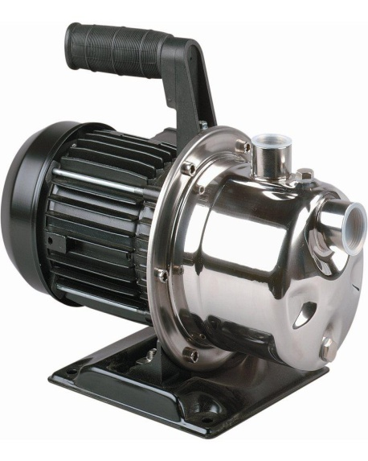

Type :

Manufacturer :

M.O.C. :

Capacity :

Monoblock

PNC

SS

0.5 HP

**Application :-**

To feed water to downstream to micron filters and UV system and filling line



**20. Alkaline Filter (SS)**



Type : Down Flow Graded Sand Type

Model : 1268/RW/MFG

M.O.C. : SS 304

Size Dia X Height : 300 mm Dia X 1700 mm

Pipe Line Size : 25 mm.

Media Qty. : 75 Kgs.

Valves : SS Valve

Working Flow : 1.0 m3/HR

**21. Post Micron Cartridge Filter-2**

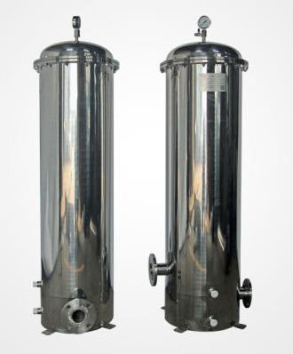

Model :

MCF 20/RW/SS

Size :

20" Long

Micron Rating :

1.0 Micron

Type of Candle :

P. P. Spun

Material of Housing :

SS 304

Nos. of Candles :

1 Nos

Working Flow :

1.00 m3/HR

**Application :-**

This Vessel fitted internally with P.P spun micron cartridge elements having absolute ratings of 1.0 micron & 0.2 microns which removes all bacterial impurities present in the water and make the water free of particulates.



**22. U. V. Disinfection System**

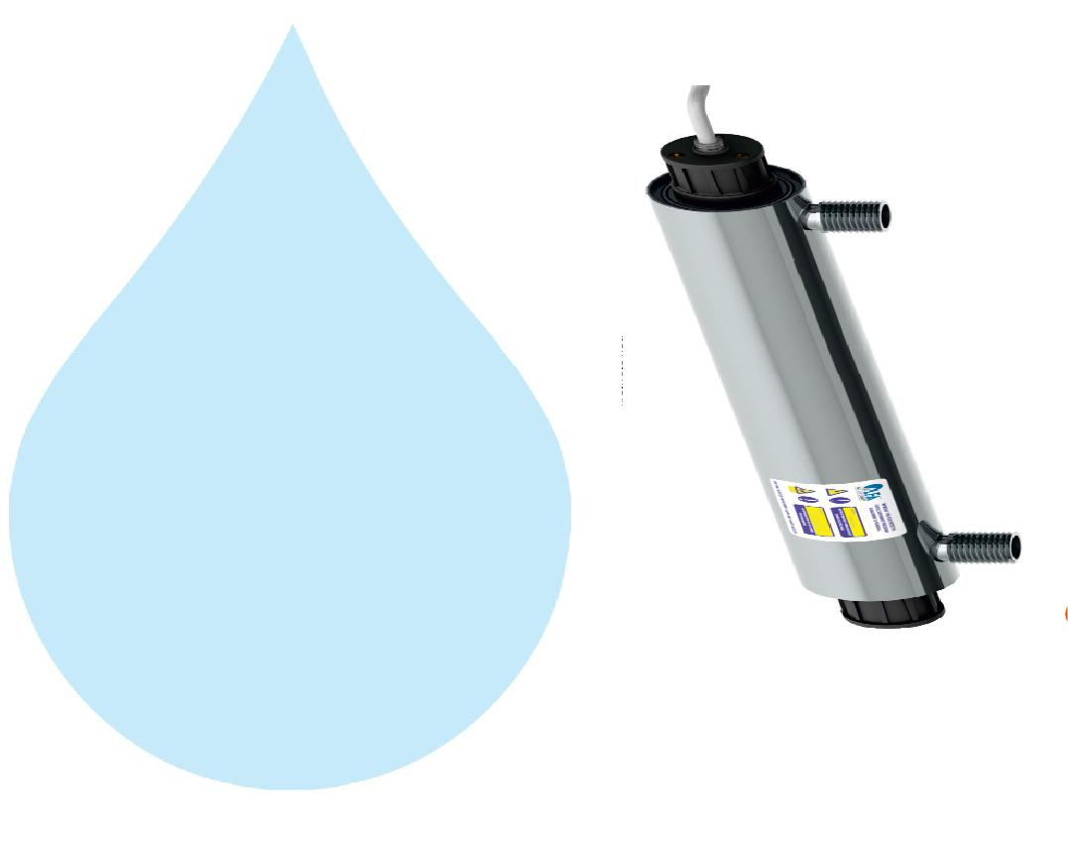

Type :

Working Flow :

Working Pressure :

Material :

Manufacturer :

Nos. Offered :

Fluorescent Tube

1000 Lph

1 Kg. / Cm 2

SS 304

Raj

1 Nos.

**Application :-**

For removal of micro biological organisms up to 99.9%.

**23. Stand For Unit**

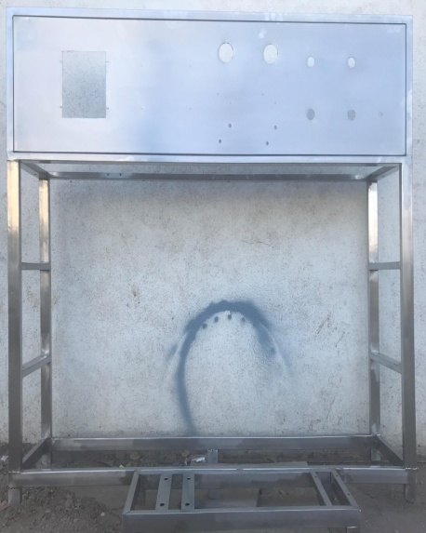

|  |  |
| --- | --- |
| Stainless Steel : | SS 304 |

**Application :-**

Complete stand for unit will be made of S.S.304



**24. SS Interconnecting Pipe Lines**

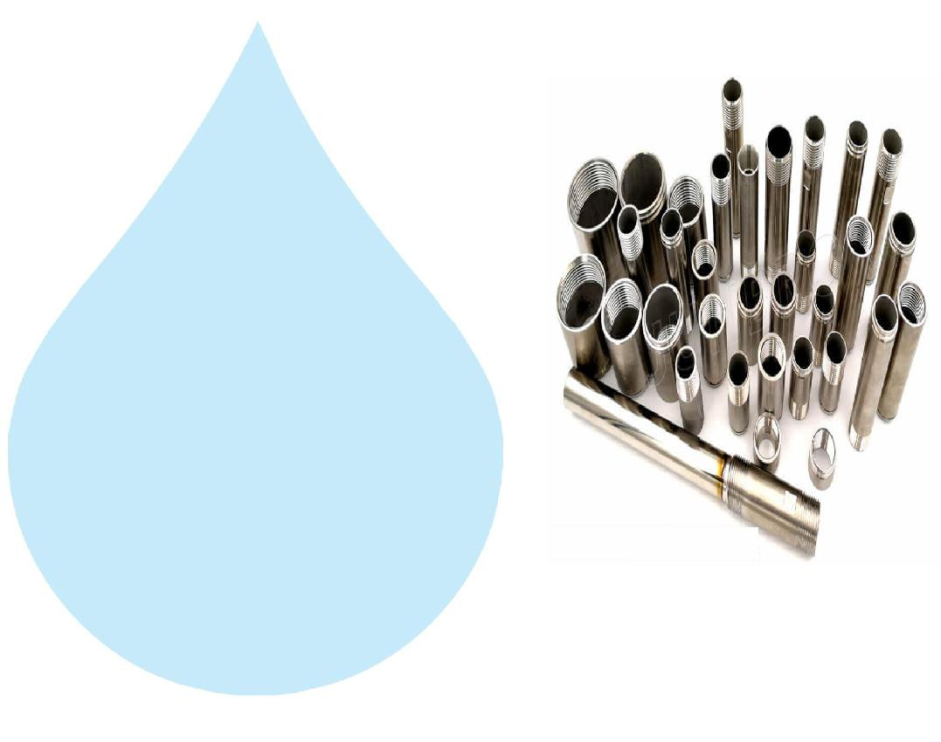

|  |  |
| --- | --- |
| Stainless Steel : | S.S 304 |

**Application :-**

All interconnecting pipelines Raw water Pump toTreated water storage tank will be provided of S.S 304 by us