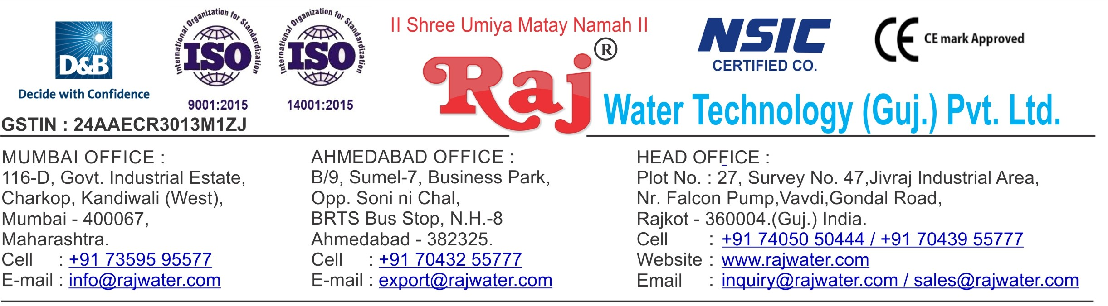

Quotation No :- RW/2019-20/Q_3664 Concern Person :- Mr. JAY KOOBER Concern Number :- 8000730771

Email Id :- [info@jaykoober.com](mailto:info@jaykoober.com)

Date :- 15th July 2019

Monday

Company Name :- JAY KOOBER FLOUR AND FOOD PRODUCTS PRIVATE LIMITED

Address :- Survey No. 256/4, Village- Baska, Taluka- Halol, District- Panchmahal, PIN Code - 389350, Gujarat, India

**Quotation For Carbonated Soda Soft Drink Project**

**Dear Sir ,**

We are pleased to enclose our detailed Techno-Commercial offer, based on your requirement.

**Contents of the Quotation** Commercial Proposal Terms & Condition

Technical Specification for each product

**Machinery Offer**

Carbonated Soda Soft Drink Project

We hope the same is in line with your requirement. We shall gladly assist you in case you need any further clarification or information.

With warm Regards,

**For , Raj Water Technology (Guj.) Pvt. Ltd.**

**DESHANI KHUSHBU**

**Designation : Marketing Asst. Manager Mobile : 7405050222**

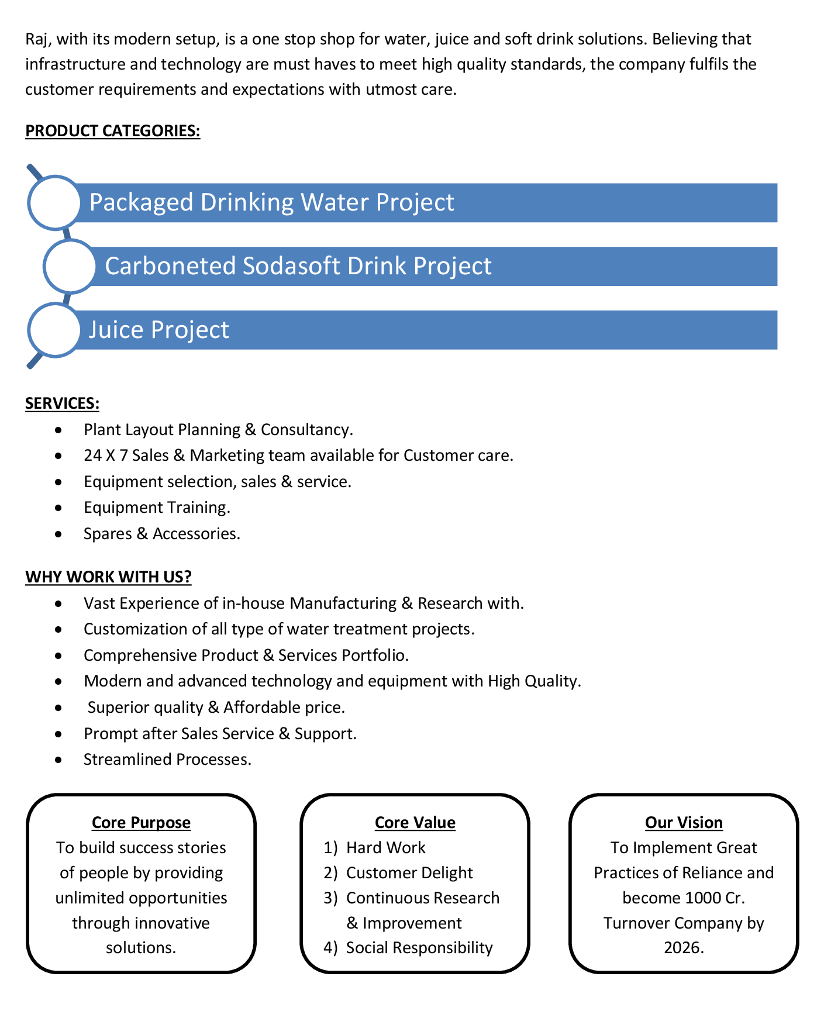

**Commercial Proposal**

|  |  |  |  |  |
| --- | --- | --- | --- | --- |
| **Sr No.** | **Equipment Name** | **Qty** | **Basic Rate** | **Amount** |
| 1 | Sugar Syrup Storage Triple Jacketed Tank 500 Litre  500 Lit. Ss 304 D.M. Water Storage Tank – Top & Bottom Dish End ( 3 Mm) ,Shell 3mm + Half Jacket(2.5mm Ss 304) + Acessories Like Heater (16 Kw) + Spray Ball + Pg/Sv/Av For Shell And Jkt + Temp. Sensor+Llc Extra  Thickness :- 2MM To 2.5 MM | 1 | 290000.00 | 290000.00 |
| 2 | Cooling PHE 1000 Litre For Sugar | 1 | 90000.00 | 90000.00 |
| 3 | Cooling Tower With Pump-20TR | 1 | 75000.00 | 75000.00 |
| 4 | |  |  | | --- | --- | |  | Sugar Loader With Control Panel | | 1 | 275000.00 | 275000.00 |
| 4 | Sugar Filter Press, With Pump ,With Hy – Flow Coating Tank 100 liter | 1 | 195000.00 | 195000.00 |
| 5 | S.S 304 Plain Sugar Syrup Storage Tank 500 Litre, With Transfer Pump Thickness :- 2MM To 2.5 MM | 1 | 100000.00 | 100000.00 |
| 6 | SS 304 Mixing Tank 1000 Liter With Agitator,Transfer Pump Thickness :- 2MM To 2.5 MM | 2 | 150000.00 | 300000.00 |
| 7 | Online Water Chiller 15-Ton  With R – 22 As Refrigerant And Semi – Hermetic Scroll Compressor, Storage Tank With Glycol | 1 | 575000.00 | 575000.00 |
| 8 | Cooling PHE 1000lt For Glycol Chiller | 1 | 90000.00 | 90000.00 |
| 9 | Carbonation Production Tank With Buffer Tank-2000 liter | 1 | 600000.00 | 600000.00 |
| 10 | Co2 Manifold For 4 Cylinders | 1 | 85000.00 | 85000.00 |
| 11 | Fully Automatic Rinser/ Filler/Capper With Cap Elevator For CSD Speed 30 BPM  Infeed Conveyor-2.5 mtr,Outfeed conveyor - 5 mtr ,Air Blower 1hp,Shrink Tunnel, Inspection,Collecting table | 1 | 1765000.00 | 1765000.00 |
| 12 | Shrink Machine For Label | 1 | 65000.00 | 65000.00 |
| 13 | Automatic Inkjet Batch Coding Machine | 1 | 200000.00 | 200000.00 |
| 14 | Semi-Automatic Shrink Wrapping Machine For Bulk Bottle Packing | 1 | 300000.00 | 300000.00 |
| 15 | Piping For CIP | 1 | 100000.00 | 100000.00 |
| 16 | Inter Connecting Piping | 1 | 150000.00 | 150000.00 |
| 17 | 2 Head Juice Filling And Capping Machine | 1 | 100000.00 | 100000.00 |
| 18 | Compressor 2-HP | 1 | 30000.00 | 30000.00 |

|  |  |  |  |  |
| --- | --- | --- | --- | --- |
| **Sr No.** | **Equipment Name** | **Qty** | **Basic Rate** | **Amount** |
|  |  |  |  |  |
|  | | | **Total** | **53,85,000.00** |
|  | | | **Discount** | **1,75,000.00** |
|  | | | **Total Amount** | **52,10,000.00** |



**Terms & Condition**

# Price

The Quoted Prices Are Ex-factory. (For India) The Quoted Prices Are FOB. (For Export)

# TAX

GST 18% Extra Applicable. (For India)

# Payment

50% Advance Along With The Purchase Order, 30% After Inspection, & 20% Before Material Dispatch.

In Case Of Cancellation Of Confirmed Order Due To Any Reason, As A Part Of Penalty 25% Amount Of The Order Value Shall Have To Pay By You To Raj Water.

# Packing, Freight & Transit Insurance, & Unloading

Packing Charge Will Be Extra (Depend On Packing Material)

Transport To Be Arranged By The Customer OR If Arranged By Raj Water: Extra At Actual Plus GST. Transportation Insurance In The Scope Of Buyer.

Unloading In The Scope Of Buyer. Buyer Has To Ready Forklift Or Crane And Unskilled Labor.

# Delivery

Schedule For Dispatch Will Be Notified.

Delivery Dates Are Approximate Only, And Assume Timely Receipt Of All Information, Test Materials & Payment.

# Warranty

We Shall Provide 1 Year Warranty For The Following:

Manufacturing Defects, Raw Water Pump, High Pressure Pump, Treated Water Transfer Pump.

Due To Fluctuation In Power Supply, Attempted Repaired By Person Other Than Our Technical Representative, Improper Handling Or Negligence By End Users, Poor Maintenance, Improper Use Of Equipment, That All Type Of Damage Not Covered In Warranty Create Area.

During The Warranty Period, We Shall Provide Supervisory Services Of Our Technical Representative As And When Required.

# Accommodation

Technician Charge Will Be Extra 1000/- Rs. Per Day.

Travelling, Lodging And Boarding, Local Conveyance And Any Other Miscellaneous Expense Of Our Technical Representative Will Have To Be Borne By Client.

# Validity

Our Offer Is Valid For Your Acceptance For A Period Of 6 Months From The Date; Thereafter It Will Be Subject To Confirmation By Us.

# Image

Images Are For Representation Purpose Only.

# Jurisdiction

All Terms Subject To Rajkot, Gujarat Jurisdiction.