8000730771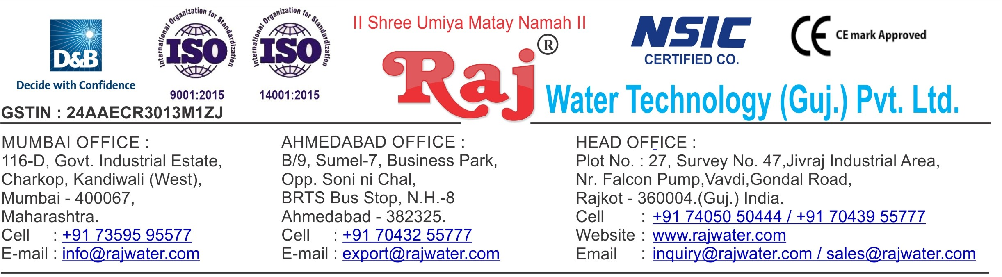

Quotation No :- RW/2019-20/Q_3664 Concern Person :- Mr. Sumit Khandelwal

Concern Number :- 8000730771

Email Id :- [info@jaykoober.com](mailto:info@jaykoober.com)

Date :- 22th July 2019

Monday

Company Name :- Aahana International Beverages

Address :- Opp. Sarvottam Hotel, Halol-Vadodara Highway, Village – Baska, Taluka – Halol, District – Panchmahal, Gujarat, GST No: 24AWOPK3308D1ZT

**Quotation For Pet Blow Molding Machine**

**Dear Sir ,**

We are pleased to enclose our detailed Techno-Commercial offer, based on your requirement.

**Contents of the Quotation** Commercial Proposal Terms & Condition

Technical Specification for each product

**Machinery Offer**

Carbonated Soda Soft Drink Project

We hope the same is in line with your requirement. We shall gladly assist you in case you need any further clarification or information.

With warm Regards,

**For , Raj Water Technology (Guj.) Pvt. Ltd.**

**DESHANI KHUSHBU**

**Designation : Marketing Asst. Manager Mobile : 7405050222**

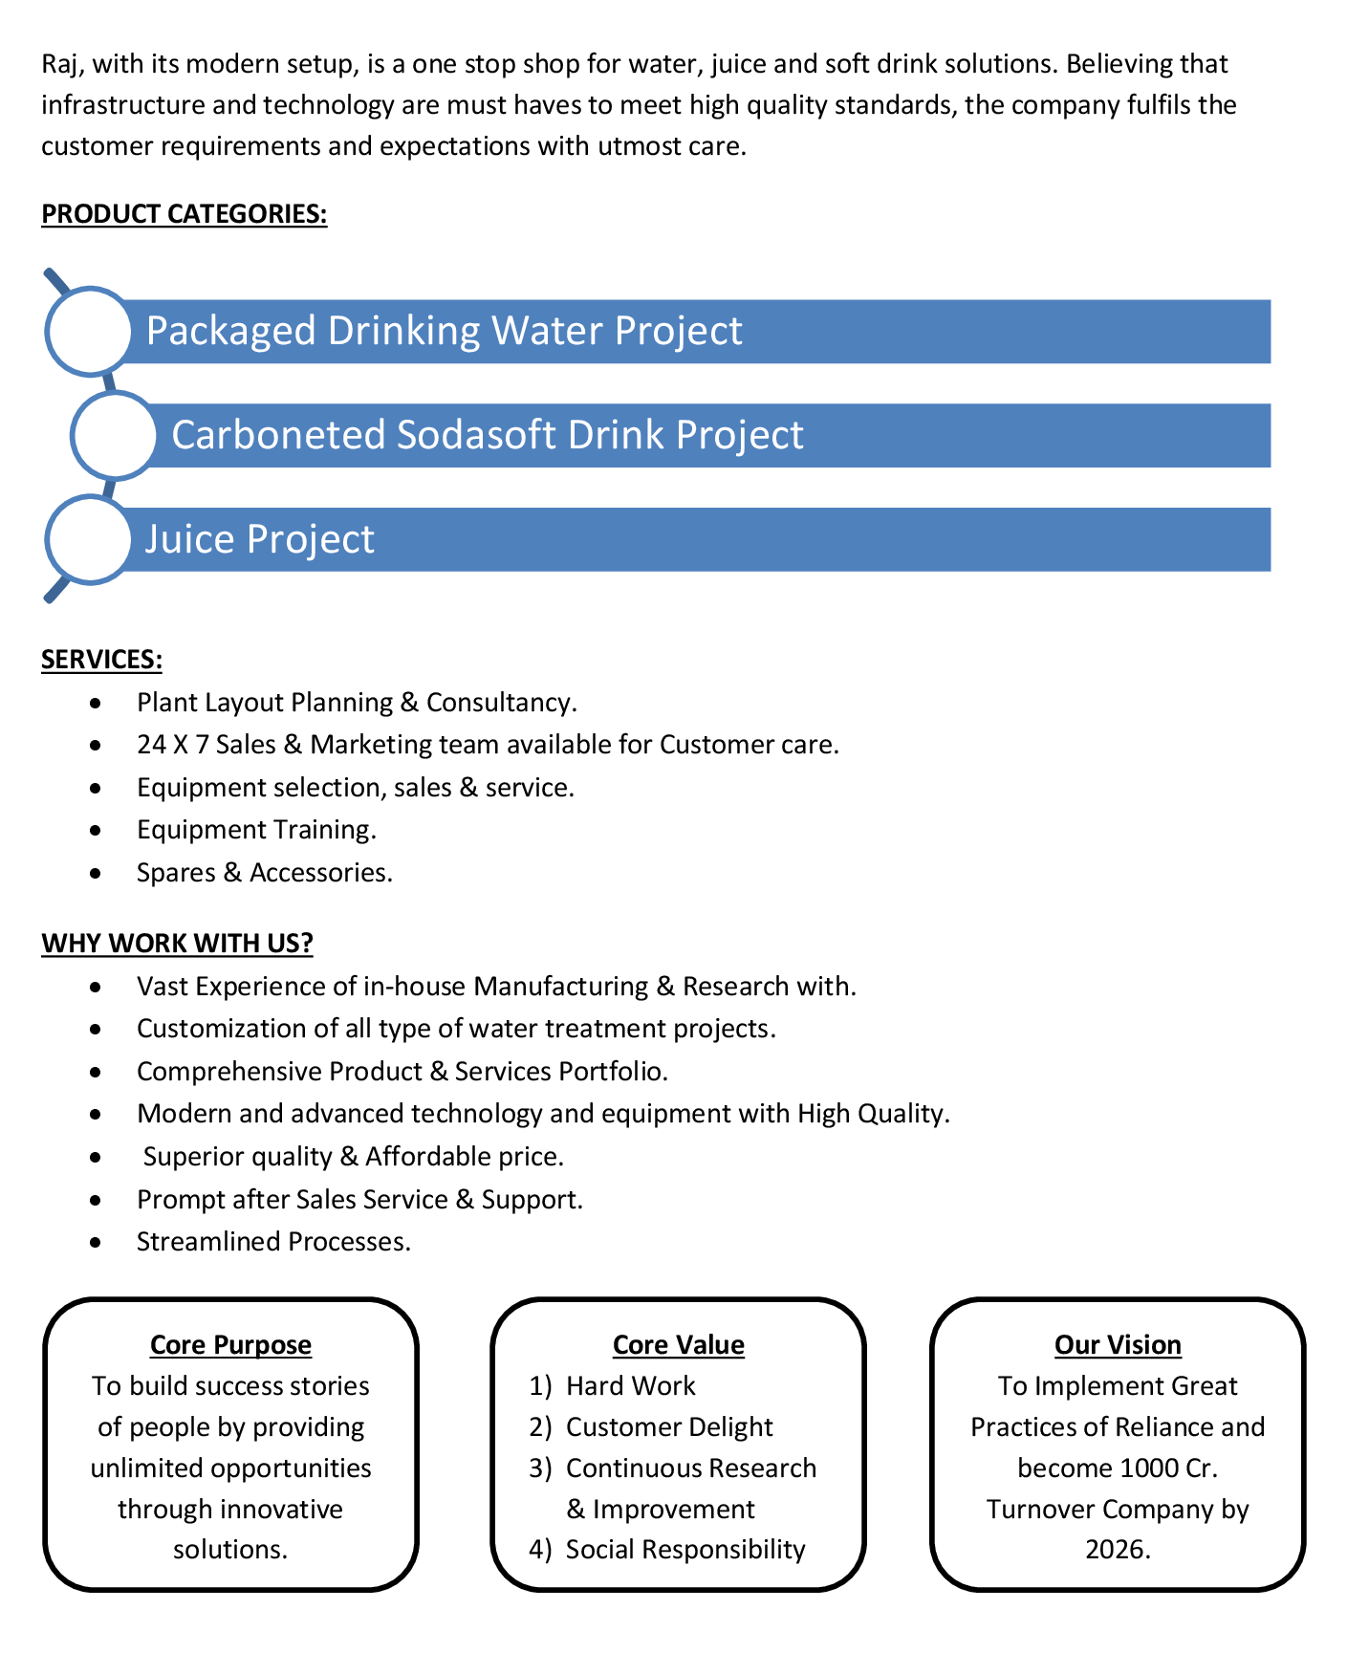

**Commercial Proposal**

|  |  |  |  |  |
| --- | --- | --- | --- | --- |
| **Sr No.** | **Equipment Name** | **Qty** | **Basic Rate** | **Amount** |
| 1 | Semi-Automatic Pet Blow Moulding Machine 2-KVT  1-Blow + 1-Conveyor, With Linear Oven & Manual Loading Device (Double Cavity Semi- Automatic Machine) Machine Suitable For Neck Size 46mm, Up to 1 Litre, 1000 To 1200 BPH, Neck Dia 28mm Double Cavity Auto Drop | 1 | 400000.00 | 400000.00 |
| 2 | High Pressure Air Compressor 20-HP | 1 | 250000.00 | 250000.00 |
| 3 | Water Chiller 3- Ton With 200 Litre Storage Tank | 1 | 130000.00 | 130000.00 |
| 4 | Moisturizer Separator | 1 | 50000.00 | 50000.00 |
| 5 | Mould 200 ML For 2KVT | 1 | 45000.00 | 45000.00 |
|  |  |  |  |  |
|  | | | **Amount**  **Discount** | * **875000.00** * **75000.00** |
|  | | | **Total Amount** | * **800000.00** |

**Terms & Condition**

# Price

The Quoted Prices Are Ex-factory. (For India) The Quoted Prices Are FOB. (For Export)

# TAX

GST 18% Extra Applicable. (For India)

# Payment

35% Advance Along With The Purchase Order, 10% PDC Cheque Before Dispatch Against Performa Invoice, & 55% Before Delivery Time .

In Case Of Cancellation Of Confirmed Order Due To Any Reason, As A Part Of Penalty 25% Amount Of The Order Value Shall Have To Pay By You To Raj Water.

# Packing, Freight & Transit Insurance, & Unloading

Packing Charge Will Be Extra (Depend On Packing Material)

Transport To Be Arranged By The Customer OR If Arranged By Raj Water: Extra At Actual Plus GST. Transportation Insurance In The Scope Of Buyer.

Unloading In The Scope Of Buyer. Buyer Has To Ready Forklift Or Crane And Unskilled Labor.

# Delivery

Schedule For Dispatch Will Be Notified.

Delivery Dates Are Approximate Only, And Assume Timely Receipt Of All Information, Test Materials & Payment.

# Warranty

We Shall Provide 1 Year Warranty For The Following:

Manufacturing Defects, Raw Water Pump, High Pressure Pump, Treated Water Transfer Pump.

Due To Fluctuation In Power Supply, Attempted Repaired By Person Other Than Our Technical Representative, Improper Handling Or Negligence By End Users, Poor Maintenance, Improper Use Of Equipment, That All Type Of Damage Not Covered In Warranty Create Area.

During The Warranty Period, We Shall Provide Supervisory Services Of Our Technical Representative As And When Required.

# Accommodation

Travelling, Lodging And Boarding, Local Conveyance And Any Other Miscellaneous Expense Of Our Technical Representative Will Have To Be Borne By Client.

# Validity

Our Offer Is Valid For Your Acceptance For A Period Of 6 Months From The Date; Thereafter It Will Be Subject To Confirmation By Us.

# Image

Images Are For Representation Purpose Only.

# Jurisdiction

All Terms Subject To Rajkot, Gujarat Jurisdiction.