8000730771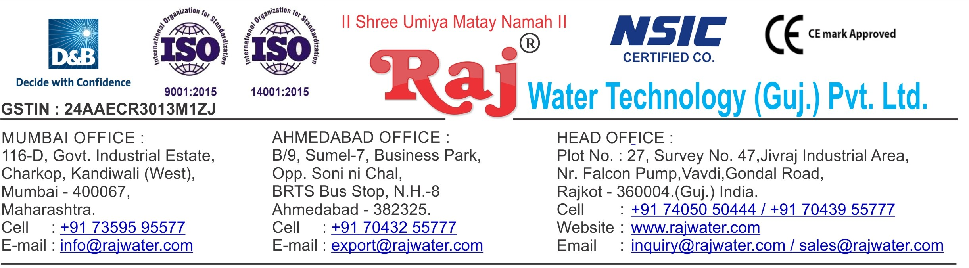

**Performa Invoice**

|  |  |  |  |  |
| --- | --- | --- | --- | --- |
| To,  Aahana International Beverages  Mr. Sumit Khandelwal  8000730771/[info@jaykoober.com](mailto:info@jaykoober.com)  Opp. Sarvottam Hotel, Halol-Vadodara Highway, Village – Baska, Taluka – Halol, District – Panchmahal, Gujarat, GST No: 24AWOPK3308D1ZT | | **Performa Invoice No.: RW-019_028**  **Performa Invoice Date:22/07/2019** | | |
|  | | **Quotation No:** **RW/2019-20/Q_3664** | | |
| **Sr No.** | **Equipment Name** | **Qty** | **Basic Rate** | **Amount** |
| 1 | Fully Automatic Rinser/ Filler/Capper With Cap Elevator For CSD Speed 40 BPM  Infeed Conveyor-2.5 mtr,Outfeed conveyor - 5 mtr ,Air Blower 1hp,Shrink Tunnel, Inspection, Collecting table | 1 | 1589625.00 | 1589625.00 |
|  | | | **Total Amount** | **1589625.00** |
| **Axis Bank Ltd., Mavdi, Rajkot, Gujarat**  **A/c. No. –** 917030066188944  **IFCI Code -** UTIB0002860 | | |  | |
| **Raj Water Technology (Guj)Pvt. Ltd** | | | | |

**Terms & Condition**

# Price

The Quoted Prices Are Ex-factory. (For India) The Quoted Prices Are FOB. (For Export)

# TAX

GST 18% Extra Applicable. (For India)

# Payment

35% Advance Along With The Purchase Order, 10% PDC Cheque Before Dispatch Against Performa Invoice, & 55% Before Delivery Time .

In Case Of Cancellation Of Confirmed Order Due To Any Reason, As A Part Of Penalty 25% Amount Of The Order Value Shall Have To Pay By You To Raj Water.

# Packing, Freight & Transit Insurance, & Unloading

Transport To Be Arranged By The Customer OR If Arranged By Raj Water: Extra At Actual Plus GST. Transportation Insurance In The Scope Of Buyer.

Unloading In The Scope Of Buyer. Buyer Has To Ready Forklift Or Crane And Unskilled Labor.



# Delivery

Schedule For Dispatch Will Be Notified.

Delivery Dates Are Approximate Only, And Assume Timely Receipt Of All Information, Test Materials & Payment.

# Warranty

We Shall Provide 1 Year Warranty For The Following:

Manufacturing Defects, Raw Water Pump, High Pressure Pump, Treated Water Transfer Pump.

Due To Fluctuation In Power Supply, Attempted Repaired By Person Other Than Our Technical Representative, Improper Handling Or Negligence By End Users, Poor Maintenance, Improper Use Of Equipment, That All Type Of Damage Not Covered In Warranty Create Area.

During The Warranty Period, We Shall Provide Supervisory Services Of Our Technical Representative As And When Required.

# Accommodation

Travelling, Lodging And Boarding, Local Conveyance And Any Other Miscellaneous Expense Of Our Technical Representative Will Have To Be Borne By Client

* Labour assistance for plant will be given by Raj water
* Fully training to operate and run the entire machinery will be given by Raj water to client
* At initially, quality of each flavor will be set by Raj water.

# Validity

Our Offer Is Valid For Your Acceptance For A Period Of 6 Months From The Date; Thereafter It Will Be Subject To Confirmation By Us.

# Image

Images Are For Representation Purpose Only.

# Jurisdiction

All Terms Subject To Rajkot, Gujarat Jurisdiction.