8000730771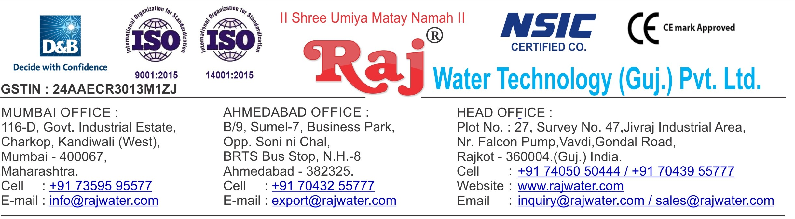



**Performa Invoice**

|  |  |  |  |  |
| --- | --- | --- | --- | --- |
| To,  Aahana International Beverages  Mr. Sumit Khandelwal  8000730771/[info@jaykoober.com](mailto:info@jaykoober.com)  Opp. Sarvottam Hotel, Halol-Vadodara Highway, Village – Baska, Taluka – Halol, District – Panchmahal, Gujarat, GST No: 24AWOPK3308D1ZT | | **Performa Invoice No.: RW-019_029**  **Performa Invoice Date:22/07/2019** | | |
|  |  | **Quotation No:** **RW/2019-20/Q_3664** | | |
| **Sr No.** | **Equipment Name** | **Qty** | **Basic Rate** | **Amount** |
| 1 | Sugar Syrup Storage Triple Jacketed Tank 500 Litre  500 Lit. Ss 304 D.M. Water Storage Tank – Top & Bottom Dish End ( 3 Mm) ,Shell 3mm + Half Jacket(2.5mm Ss 304) + Acessories Like Heater (16 Kw) + Spray Ball + Pg/Sv/Av For Shell And Jkt + Temp. Sensor +Llc Extra Thickness :- 2MM To 2.5 MM | 1 | 275500.00 | 275500.00 |
| 2 | Cooling PHE 1000 Liter For Sugar | 1 | 85500.00 | 85500.00 |
| 3 | Cooling Tower With Pump-20TR | 1 | 71250.00 | 71250.00 |
| 4 | Sugar Loader With Control Panel | 1 | 261250.00 | 261250.00 |
| 5 | Sugar Filter Press, With Pump ,With Hy – Flow Coating Tank 100 liter | 1 | 185250.00 | 185250.00 |
| 6 | S.S 304 Plain Sugar Syrup Storage Tank 500 Litre, With Transfer Pump Thickness :- 2MM To 2.5 MM | 2 | 95000.00 | 190000.00 |
| 7 | SS 304 Mixing Tank 1000 Liter With Agitator,Transfer Pump Thickness :- 2MM To 2.5 MM | 2 | 142500.00 | 285000.00 |
| 8 | Online Water Chiller 15-Ton  With R – 22 As Refrigerant And Semi – Hermetic Scroll Compressor, Storage Tank With Glycol | 1 | 488625.00 | 488625.00 |
| 9 | Cooling PHE 1000lt For Glycol Chiller | 1 | 85500.00 | 85500.00 |
| 10 | Carbonation Production Tank With Buffer Tank-2000 liter | 1 | 540000.00 | 540000.00 |
| 11 | Co2 Manifold For 4 Cylinders | 1 | 80750.00 | 80750.00 |
| 12 | Carbon Filter | 1 | 50000.00 | 50000.00 |
| 13 | Shrink Machine For Label | 1 | 61750.00 | 61750.00 |
| 14 | Automatic Inkjet Batch Coding Machine | 1 | 180000.00 | 180000.00 |
| 15 | Semi-Automatic Shrink Wrapping Machine For Bulk Bottle Packing | 1 | 270000.00 | 270000.00 |
| 16 | Piping For CIP | 1 | 90000.00 | 90000.00 |
| 17 | Inter Connecting Piping | 1 | 142500.00 | 142500.00 |
| 18 | 2 Head Juice Filling And Capping Machine | 1 | 90000.00 | 90000.00 |
| 19 | Compressor 2-HP | 1 | 28500.00 | 28500.00 |
|  | | | **Total Amount** | **3461375.00** |
| Axis Bank Ltd., Mavdi, Rajkot, Gujarat  A/c. No. – 917030066188944  IFCI Code - UTIB0002860 | | |  | |
| **Raj Water Technology (Guj)Pvt. Ltd** | | | | |

**Terms & Condition**

# Price

The Quoted Prices Are Ex-factory. (For India) The Quoted Prices Are FOB. (For Export)

# TAX

GST 18% Extra Applicable. (For India)

# Payment

35% Advance Along With The Purchase Order, 10% PDC Cheque Before Dispatch Against Performa Invoice, & 55% Before Delivery Time .

In Case Of Cancellation Of Confirmed Order Due To Any Reason, As A Part Of Penalty 25% Amount Of The Order Value Shall Have To Pay By You To Raj Water.

# Packing, Freight & Transit Insurance, & Unloading

Transport To Be Arranged By The Customer OR If Arranged By Raj Water: Extra At Actual Plus GST. Transportation Insurance In The Scope Of Buyer.

Unloading In The Scope Of Buyer. Buyer Has To Ready Forklift Or Crane And Unskilled Labor.

# Delivery

Schedule For Dispatch Will Be Notified.

Delivery Dates Are Approximate Only, And Assume Timely Receipt Of All Information, Test Materials & Payment.

# Warranty

We Shall Provide 1 Year Warranty For The Following:

Manufacturing Defects, Raw Water Pump, High Pressure Pump, Treated Water Transfer Pump.

Due To Fluctuation In Power Supply, Attempted Repaired By Person Other Than Our Technical Representative, Improper Handling Or Negligence By End Users, Poor Maintenance, Improper Use Of Equipment, That All Type Of Damage Not Covered In Warranty Create Area.

During The Warranty Period, We Shall Provide Supervisory Services Of Our Technical Representative As And When Required.

# Accommodation

Travelling, Lodging And Boarding, Local Conveyance And Any Other Miscellaneous Expense Of Our Technical Representative Will Have To Be Borne By Client

* Labour assistance for plant will be given by Raj water
* Fully training to operate and run the entire machinery will be given by Raj water to client
* At initially, quality of each flavor will be set by Raj water

.

# Validity

Our Offer Is Valid For Your Acceptance For A Period Of 6 Months From The Date; Thereafter It Will Be Subject To Confirmation By Us.

# Image

Images Are For Representation Purpose Only.

# Jurisdiction

All Terms Subject To Rajkot, Gujarat Jurisdiction.