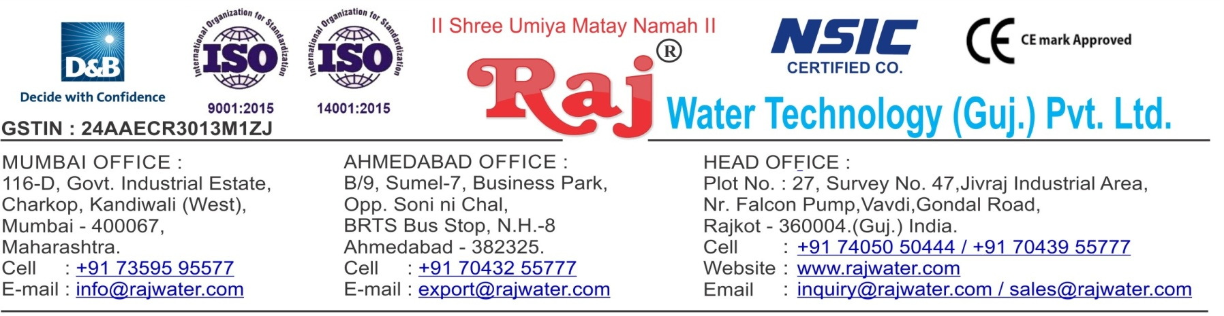

|  |  |  |  |
| --- | --- | --- | --- |
|  | | | Date :- 29th July 2019  Monday |
| Quotation No | :- | RW/2019-20/Q_2522/R_7 |  |
| Concern Person | :- | Mr. Apurva |  |
| Concern Number | :- | 9820001716 |  |
| Email Id | :- | [apurva@essenrfid.com](mailto:apurva@essenrfid.com) |  |
| Company Name | :- |  |  |
| Address | :- |  |  |

# Quotation For Water Treatment Project

## Dear Sir ,

We are pleased to enclose our detailed Techno-Commercial offer, based on your requirement.

**Contents of the Quotation** Commercial Proposal Terms & Condition

Technical Specification for each product

## Machinery Offer

Water Treatment Project

We hope the same is in line with your requirement. We shall gladly assist you in case you need any further clarification or information.

With warm Regards,

## For , Raj Water Technology (Guj.) Pvt. Ltd.

**PARMAR CHIRAG**

**Designation : Marketing Asst. Manager Mobile : 7043511222**

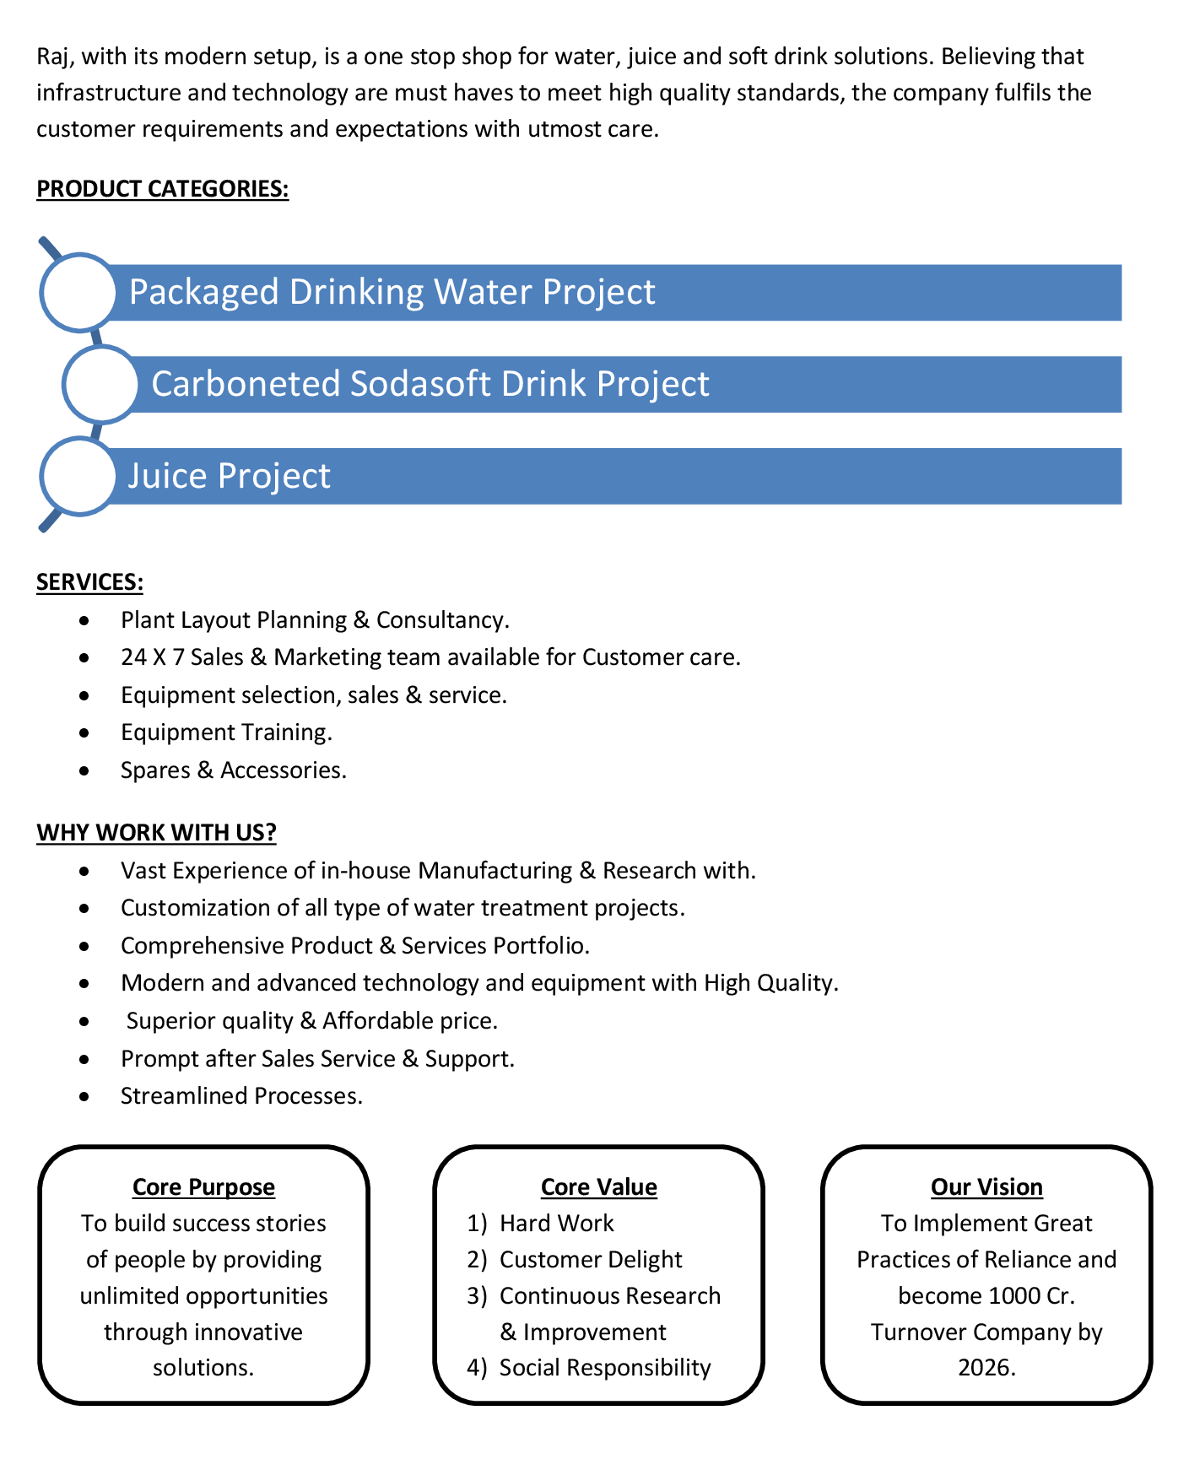



|  |  |  |  |  |
| --- | --- | --- | --- | --- |
| **Sr No.** | **Equipment Name** | **Qty** | **Basic Rate** | **Amount** |
| 1 | Automatic RO Plant FRP 3000 Litre Per Hours | 1 | 400250.00 | 400250.00 |
|  |  |  |  |  |
|  |  |  | **Total** | **4,00,250.00** |
|  |  |  | **18% GST** | **72,045.00** |
| **Total Amount in Words :-**  Four Lakh Seventy Two Thousand Two Hundred Ninety Five | | | **Total Amount** | **4,72,295.00** |

1. **Payment**

50% Advance Along With The Purchase Order, 30% Before Material Dispatch & 20% After Installation,

In Case Of Cancellation Of Confirmed Order Due To Any Reason, As A Part Of Penalty 25% Amount Of The Order Value Shall Have To Pay By You To Raj Water.

1. **Delivery**

Schedule For Dispatch Will Be Notified.

Delivery Dates Are Approximate Only, And Assume Timely Receipt Of All Information, Test Materials & Payment.

* Delivery will be at your site.

1. **Warranty**

We Shall Provide 1 Year Warranty For The Following:

Manufacturing Defects, Raw Water Pump, High Pressure Pump, Treated Water Transfer Pump.

Due To Fluctuation In Power Supply, Attempted Repaired By Person Other Than Our Technical Representative, Improper Handling Or Negligence By End Users, Poor Maintenance, Improper Use Of Equipment, That All Type Of Damage Not Covered In Warranty Create Area.

During The Warranty Period, We Shall Provide Supervisory Services Of Our Technical Representative As And When Required.

1. **Accommodation**

Technician Charge Will Be Extra 1000/- Rs. Per Day.

Travelling, Lodging And Boarding, Local Conveyance And Any Other Miscellaneous Expense Of Our Technical Representative Will Have To Be Borne By Client.

1. **Validity**

Our Offer Is Valid For Your Acceptance For A Period Of 6 Months From The Date; Thereafter It Will Be Subject To Confirmation By Us.

1. **Image**

Images Are For Representation Purpose Only.

1. **Jurisdiction**

All Terms Subject To Rajkot, Gujarat Jurisdiction.

# Technical Specification

## Raw Water Quality

R.O. plant is designed based On :

1500 TDS

Hardness : 300

### Application :-

1. **Treated Water Quality**

Suspended Solids : Nill Turbidity : Nill

PH : 7.0 To 7.5

T D S : Less than 40 ppm Total Hardness : 30 ppm as CaCo3 Bacteria Coliform : Nill

### Application :-

The above water quality is approximate assumption, We can change property of minerals/ions in water by editing the raw water in R.O. treated water

## Raw Water Feeding Pump

Type : Centrifugal

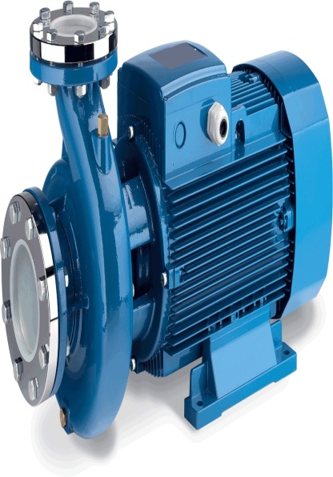Max. Flow : 6.0 m3/HR

Working Flow : 5.50 m3/HR Working Pressure : 2 Kg. / Cm 2

M.O.C. : C.I.

Power : 1.5 HP

Manufacturer : Kirloskar / EQI

Nos. Offered : 1 Nos.

### Application :-

To Pump Raw Water at Required Pressure so as to enable Transfer Through The RO Pre-Treatment Stage.

## 4. Automatic Multi Media Filter (FRP)

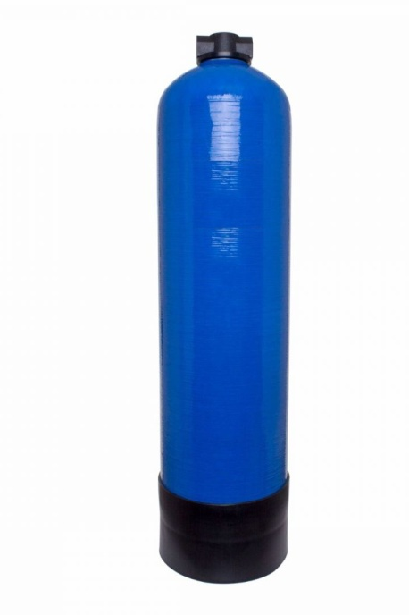Type : Down Flow Graded Multi Media Type

Model : 2162/RW/MGF

M.O.C. : FRP

Size Dia X Height : 525 mmX 1550 mm Pipe Line Size : 25 mm

Sand Qty. : 200 kgs

Carbon Qty. : 75 kgs

Valves : Automatic valve

Max. Flow : 8.00m3/hr.

Working Flow : 6.00 m3 /hr.

### Application :-

By means of Multi size Graded sand and carbon filled in the Vessel of stainless steel material, which is natural process of filtration adopted by the nature Raw Water is first filtered by filtration unit in series prior feeding RO Plant. Multi Media Filter Unit is provided for removal of suspended matters & turbidity from raw water. PSF Unit is a SS vertical Pressure Vessel. Internally, it is fitted with bottom collecting system. Uniform grades silica quartz sand is charged on the supporting media of pebbles and gravels. To Remove taste, odor, chlorine, color and. It can absorb contaminated particles of Oil & Grease from the raw water. It will control the BOD & COD in the raw water. Carbon can remove Chlorine, Odor, & Color other organic material from feed water prior to reverse osmosis. This Carbon granules having larger surface area and specific property to absorb organics.

## 5. Micron Cartridge Filter Housing

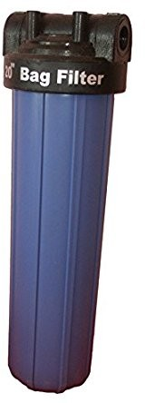Model : MCF 20/RW/PP

Size : 20" Long

Micron Rating : 5 Micron

Type of Candle : P. P. Spun / Wound Material of Housing : PP

Nos. of Candles : 2 nos

Max. Flow : 8.00m3/HR

Working Flow : 6.00 m3/HR

### Application :-

To protect the membrane and the high pressure pump from suspended particles by removing them up to 5 Micron.

## 6. Antiscaling Dosing Pump

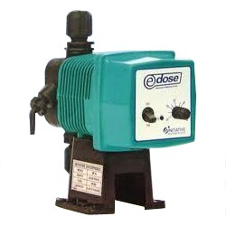Type : Ele. Diaphragm Type

Capacity : 0 to 6 LPH

M.O.C. : PP

Dosing Chemical : Antiscalent Dosing Rate : 3 to 4 LPH

Manufacturer : E Dose / I dose

### Application :-

The hardness salts of calcium & magnesium are likely to be precipitated if concentration exceeds its solubility limit & it may faults the membranes resulting into scaling which ultimately leads to poor treated water quality from R.O.System.

## 7. Antiscaling Dosing Tank

Type : Conical Bottom

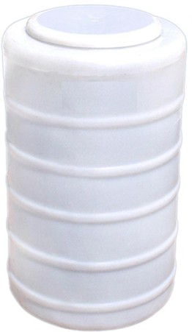Capacity : 100 Ltr.

M.O.C. : HDPE

Manufacturer : Reputed

## 8. High Pressure Pump

Type : Vertical Centrifugal Pump

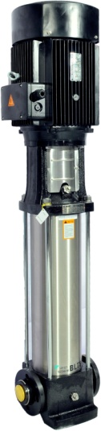M.O.C. : SS

Max. Pressure : 13 Kgs. / Cm 2. Working Pressure : 10 Kgs. / Cm 2. Max. Flow : 8.00 m3/HR

Working Flow : 6.00 m3/HR

Motor : 3HP

Manufacturer : 2900 RPM

Nos. Offered : 3 Phase

Make of Pump : PNC

### Application :-

For Reverse Osmosis Process to take place feed pressure of water need to be raised. For this purpose a Vertical Multistage Centrifugal High Pressure Pump in S.S construction is provided R.O. System requires operating pressure of about 14-16 kg/cm^2 . High-pressure pump is fitted with S.S. discharge pipe work with necessary control valves. Necessary instruments like a High Pressure Switch, Pressure Gauge and recirculation valves are provided for safer operation of system

## 9. RO Membrane

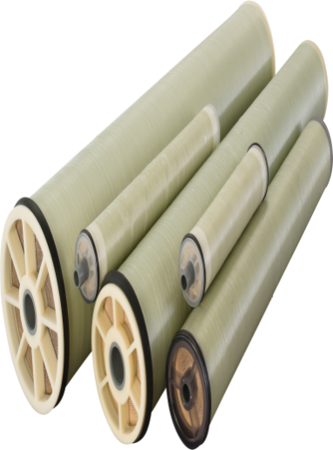

Model : 4040 Element

Type : TFC Spiral Wound

Material : Polymide

Size : 8" Dia X 40" Long

Manufacturer : Toray / Hydranautics / Dow / EQI Nos. Offered : 3 Nos.

### Application :-

To reduce Raw Water T.D.S. through the concept of Reverse Osmosis where R.O. Modules processes Raw Water and produces Purified Water having the Salt Rejection of Raw Water in the range of 90 – 95%. By using Semi permeable Membrane filter elements, where ion filtration process is carried out by applying pressure in the water. So finally we will get Low salt water with low total dissolve solids and High purity. Here will have to drain the water at one side to Wash the Membrane filter elements continuously because of filtration process there is nothing to be polluted in the system.



**10. Fiber - Reinforced Plastic Pressure Vessels**

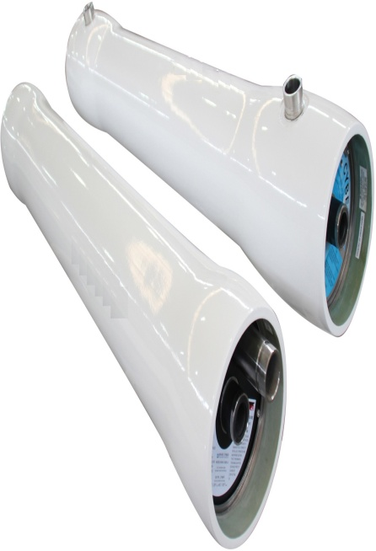M.O.C. : FRP

Type : Horizontal Tube Type

Size : 8" X 40"

Max. Pressure : 400 PSI Working Pressure : 150 PSI Nos. Offered : 3 Nos.

## 11. Pressure Gauges

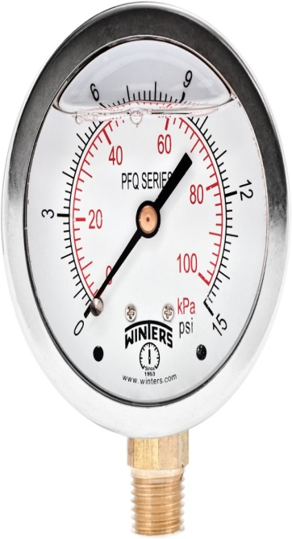Pressure Gauges : 4 Nos.

Type : Burdone Tube Type

Manufacturer : Raj

Range : 0 - 28,-7 Kg/cm2

## 12. Rota Meters

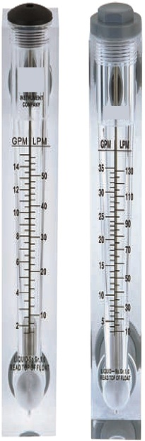Rota Meters : 2 Nos.

Type : Float

M.O.C. : Acrylic Body

Reject Water Range : SS Float (0 - 6000 Lph.)

Treated Water Range

:

SS Float (0 - 4000 Lph.)

## 13. Control Panel - PLC Base

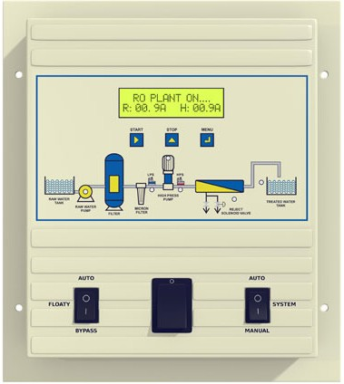Manufacturer : Astral

**14. Pressure Switch**

Pressure Switch : 2 Nos.

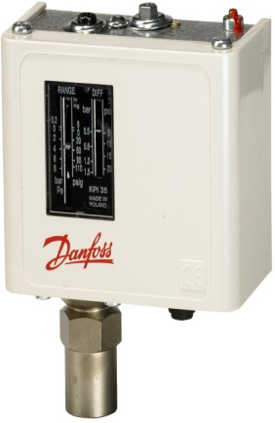Type : Low / High Pr.

Manufacturer : Denfoss

Model : IPS 70 / 400

## 15. Stand For Unit

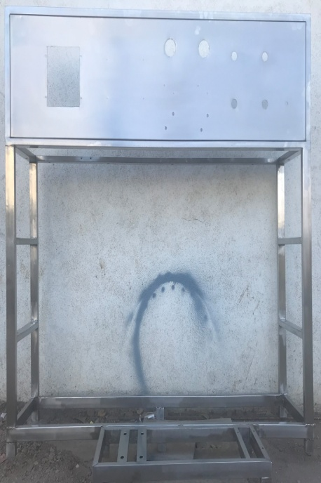Stainless Steel : Complete stand for unit will be made of S.S.304

### Application :-

Complete stand for unit will be made of S.S.304

## 16. UPVC Interconnecting Pipe Lines

Interconnecting Pipe Lines :

### Application :-

All interconnecting Piping Raw Water Pump to RO will be provided of Upvc by us.

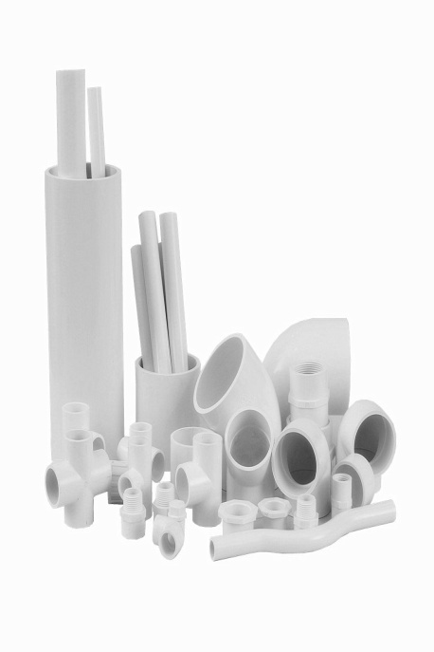All interconnecting Piping Raw Water Pump To RO will be provided of UPVC by us.