Machine Learning — Exercise 0
Dataset Description | Group: [GROUP NUMBER] | Members: [NAME 1], [NAME 2], [NAME 3]

1. Dataset selection and overview
We selected two classification datasets that differ in sample size, attribute types, missingness, and target distribution. Credit Card Fraud Classification is useful for studying a large dataset with a rare positive class; Adult ASD Screening is smaller and combines binary questionnaire responses with demographic categories. The contrast lets us describe how data representation and data quality influence the preparation and evaluation of classification data. Replace this rationale with the group's own final reasoning if your selection process differed.
Characteristic | Credit Card Fraud Classification | Adult ASD Screening
Original size | 28,480 samples; 31 attributes | 704 samples; 21 attributes
Inputs and target | 30 input features; target: class | 20 input features; target: Class/ASD
Attribute types | Numerical features; categorical target | Binary scores, numerical fields, categorical fields
Target distribution | otherwise: 28,431 (99.83%); fraud: 49 (0.17%) | NO: 515 (73.15%); YES: 189 (26.85%)
Missing values | None detected | 192 cells in age, ethnicity, relation

2. Attribute types, measurement scales, and ranges
In the fraud dataset, time, amount, and v1–v28 are stored numerically. The semantic interpretation of v1–v28 is not established by the inspected file alone. Amount is a ratio-scale quantity (zero represents no transaction amount and ratios are meaningful); time is a numeric elapsed-time field whose interpretation should follow the dataset documentation. The v1–v28 transformed features should be treated as numeric model inputs, but their original measurement scales cannot be confidently assigned from column names alone. The target class is nominal.
In the ASD dataset, A1_Score–A10_Score are binary indicators (0/1); gender, ethnicity, jundice, austim, contry_of_res, used_app_before, age_desc, relation, and Class/ASD are categorical, mostly nominal. Age is ratio scale in principle (years from a meaningful zero), although the observed value 383 is flagged as implausible. The result field ranges from 0 to 10 and appears to equal the sum of the ten binary questionnaire scores in the observed data; this should be confirmed with a reproducible check. A score is a count, so differences are meaningful. No original attribute is confidently identified as ordinal from the available columns.
Measurement-scale distinctions matter because nominal categories require categorical encoding rather than numeric distance calculations; ordinal values, when genuinely ordered, may preserve order; interval variables support meaningful differences but not meaningful ratios; and ratio variables have a meaningful zero and meaningful ratios. Preprocessing should reflect the variable's meaning, not only its Python dtype.

3. Distributions and target imbalance
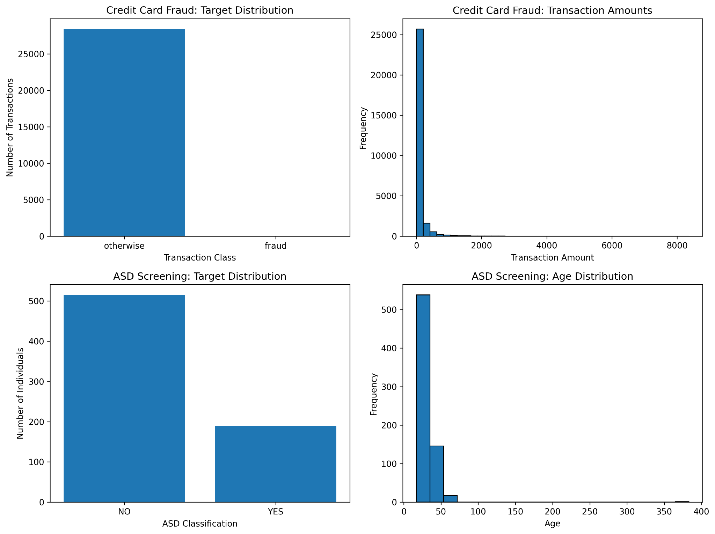
Figure 1. Target distributions and selected numerical distributions. The transaction-amount histogram uses a logarithmic frequency axis.
The fraud target is severely imbalanced: fraud represents 0.17% of the observations. A model predicting only the majority class could achieve high accuracy without detecting fraud, so accuracy alone would be misleading. The ASD target is also imbalanced, with 26.85% YES observations, but the imbalance is less extreme.
Figure 2. Selected categorical distributions in the ASD dataset; missing ethnicity values are shown explicitly.

4. Data quality and preprocessing considerations
No missing values were detected in the original fraud attributes. In the ASD dataset, age has 2 missing values, ethnicity has 95, and relation has 95, totaling 192 missing cells across the original attributes. One age entry (record index 52) is 383, an implausible value for a human age; it is flagged rather than silently changed. The age_desc field has only one observed category, so it may provide no useful variation. Some category strings appear to contain quote characters; these should be checked against the ARFF parsing and source data before any normalization. The result field appears to be the sum of A1_Score–A10_Score, but that relationship should be verified programmatically. Potential later steps include documented missing-value handling, categorical encoding, and algorithm-appropriate scaling, with transformations fitted on training data only.

5. Group contributions
[NAME 1]: [DESCRIBE CONTRIBUTION]
[NAME 2]: [DESCRIBE CONTRIBUTION]
[NAME 3]: [DESCRIBE CONTRIBUTION]

Reproducibility
The ZIP includes the original ARFF datasets, editable report source, Python scripts, requirements.txt, and generated figures. Run `python scripts/plot_distributions.py` and `python scripts/feature_analysis.py` from the project root after installing the dependencies in requirements.txt. The original datasets are not modified by these scripts.

