All code, plots reside here:
https://github.com/karunmj/usu-coursework/tree/master/cs5660datasc/hw/hw2

Data collection involved using request and beautiful soup libraries to get UFO data for circles, triangles and fireball shape sightings in the form of a Pandas data frame object in Python. The column labels include date of sighting, time of sighting, city, state, shape, duration, summary and posted date.

Data preprocessing involved including sighting between 1/1/2005 and 9/22/2016, representing duration of sighting in seconds and sightings in either of the 50 (+1 by including DC) states of US.

- Box plot of duration of UFO sightings of each shape
(not done)

- Time series figure with the number of sightings per year (one line per shape)
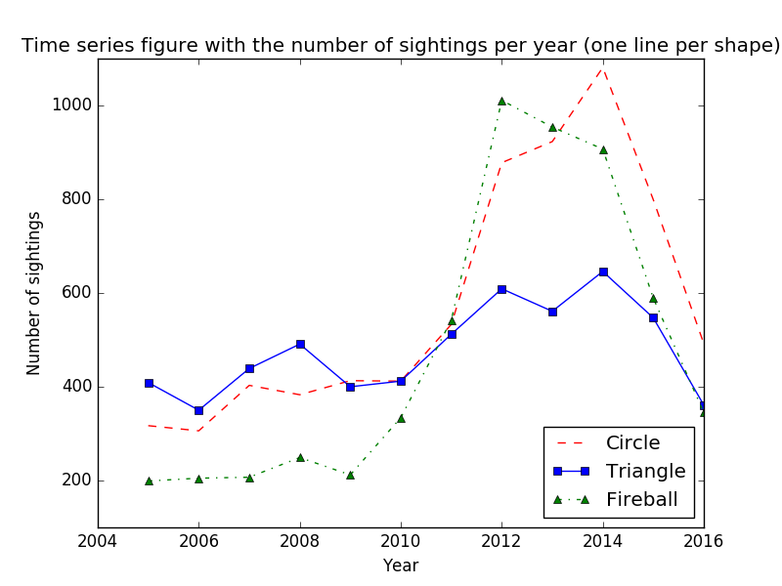

There seems to be higher number of sightings during 2012 to 2014 than the rest of years.

- Bar chart for sightings of:
  - Absolute numbers by state
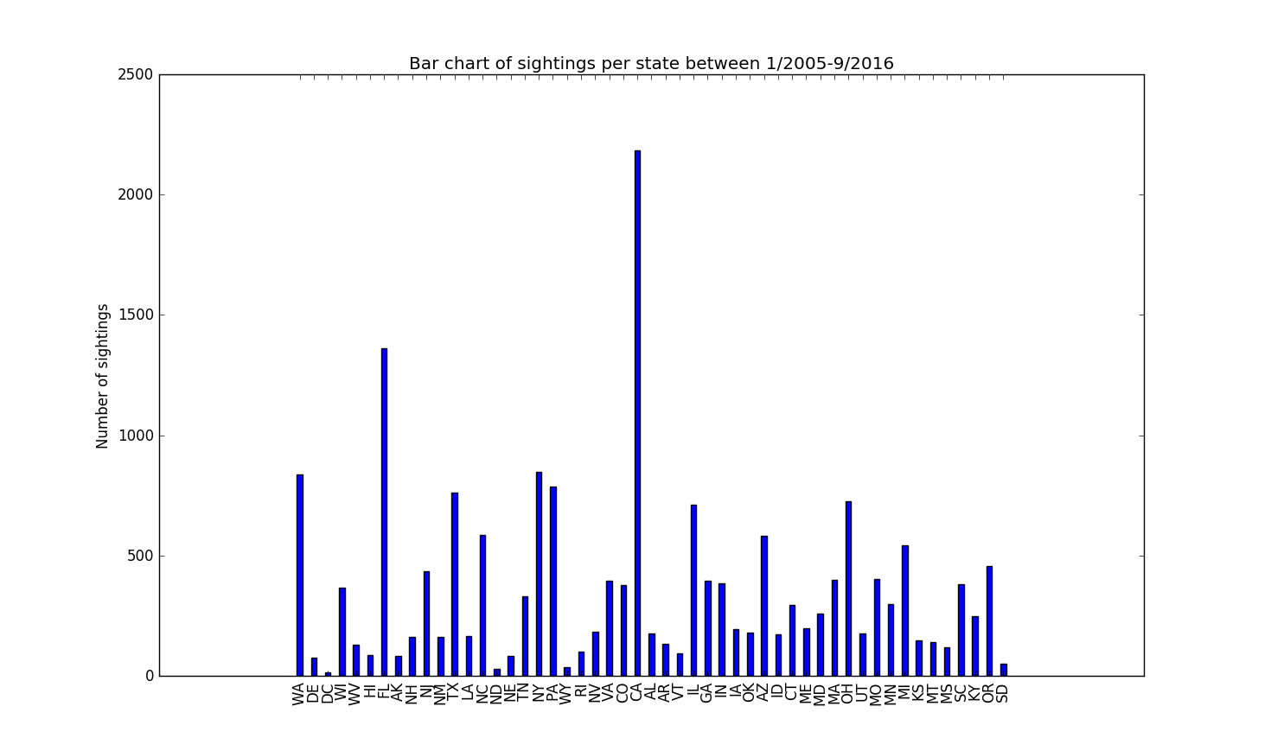
  - Normalized numbers, based on state population, by state
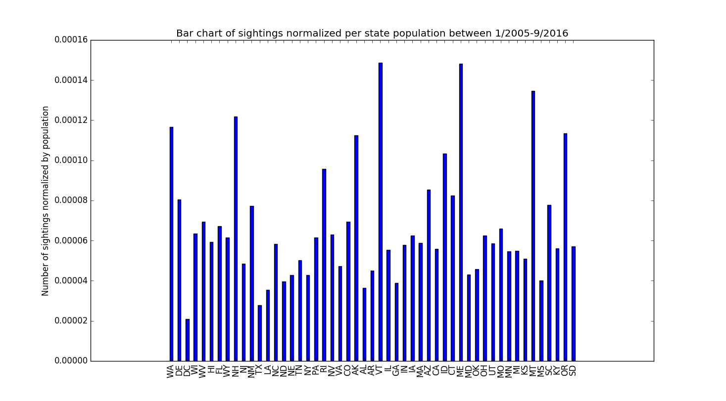

State population numbers were obtained from US Census API service for
- Normalized sightings by state population visualized on a map
Mapbox Studio had been used to generate a static HTML page with the normalized sightings.

It looks like states like Montana, Vermont and Maine had the highest number of sightings. These states also have very low population, hence higher sightings per person. Also, these states have fewer cities that result in lower light pollution levels. Residents are more likely to see moving planetary objects like comets. meteors which could be mistaken for UFOs.

For classification, Python’s sklearn tree package had been used to build the decision tree classifier. Since this package doesn’t deal with categorical type of attribute directly [which is in our case], they had to be vectorized. For example, given an observation’s attributes in training data set

time_of_day | region
night | s

it is converted to:

region=mw | region=ne | region=s | region=w | time_of_day=afternoon | time_of_day=evening | time_of_day=morning | time_of_day=night
0 | 0 | 1 | 0 | 0 | 0 | 0 | 1

Similarly, the class labels ‘Circle’, Fireball’ and ‘Triangle’ were mapped to 0, 1 and 2 respectively. Gini criterion had been used to build the classifier.

- Classification accuracy of decision tree using test set data
Python’s sklearn metrics’ precision score had been used to calculate the ratio
$\frac{t_{p}}{t_{p}+ f_{p}}$, where t_{p} is the number of true positives and f_{p} the number of false positives, for each class

Circle | Fireball | Triangle
0.43863816 | 0.35789094 | 0.33474576

The confusion matrix of predicted vs true class labels of test set data were as follows
True label | Circle | 1108 | 1067 | 197
True label | Fireball | 733 | 991 | 117
True label | Triangle | 685 | 711 | 158
True label |  | Circle | Fireball | Triangle
True label |  | Predicted label

Overall, the decision tree classifier had done a poor job.

- Illustration of built decision tree
