**Suitability of use of iUTAH GAMUT data for water quality modeling of Logan river, Cache Valley, Utah**

Water quality modeling is important for numerous purposes such as understanding the effects of population growth, land use change and climate scenarios, and running model simulations under various conditions. Such a model would require real world data, especially location specific which in our case is the Logan river in Cache valley, Utah. The Innovative Urban Transitions and Aridregion Hydro-sustainability (“iUTAH - Innovative Urban Transitions and Aridregion Hydro-Sustainability” 2016) cyberinfrastructure team provides raw and provisional data, that is readily available through their website (“iUTAH GAMUT Network Raw Data at Logan River near the Water Lab Advanced Aquatic Site (LR_WaterLab_AA) - iUTAH” 2016) for their aquatic Gradients Along Mountain To Urban Transitions (GAMUT) sites located at six different locations across the Logan river. Parameters being measured include temperature, specific conductance, pH, dissolved oxygen, turbidity, blue-green algae, chlorophyll fluorescence, colored dissolved organic matter, nitrogen and dissolved nitrate levels, every 15 minutes since 2013. Example plots of pH and dissolved oxygen levels of a GAMUT site near Utah Water Research Laboratory (UWRL) on the Logan river are included in the appendix for reference. From these figures, it is understood that significant amounts of data cleaning and processing is necessary before any modeling can be done. These measurements are made by industry-grade sensors, manufactured by Campbell Scientific dataloggers, and their methods of computing various metrics are reasonably accurate, mentioned in the metadata. Standard procedures are adopted by the iUTAH team to ensure no errors are present and data are of acceptable quality. For any model we develop, we will be able to use iUTAH’s data in the form of comma separated values that can be easily imported to the modeling software used such as R or Python, however it would have been even easier had the data been accessible though web based Application Programming Interphases (APIs). Also, not every six GAMUT sites have three years of historical data (some just two) and not every parameter mentioned above are being measured. Overall, I would recommend using iUTAH GAMUT data for any water quality models we develop.

Appendix:

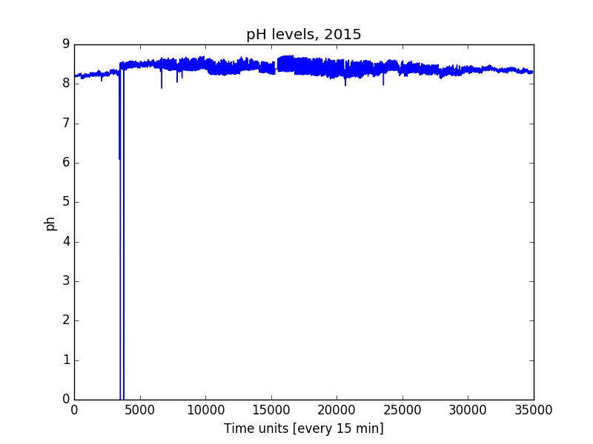

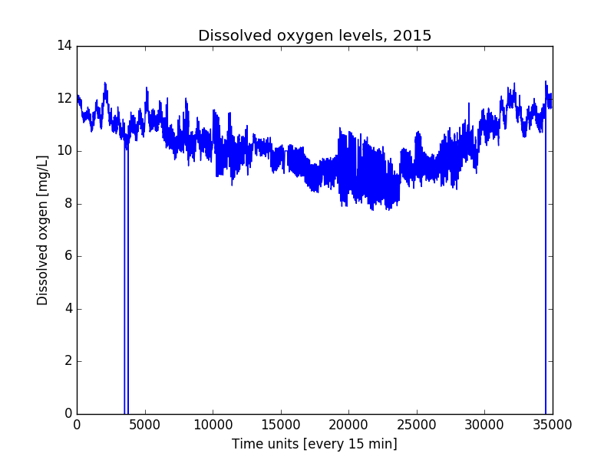

Python plotting code:

##Plotting pH and dissolved oxygen levels

import pandas as pd

import matplotlib.pyplot as plt

import numpy as np

#csv file contains logan river data for 2015 from water lab site

loganriverdata = pd.read_csv('iUTAH_GAMUT_LR_WaterLab_AA_RawData_2015.csv', skiprows=68)

#plotting ph

plt.plot(loganriverdata['pH'])

plt.ylabel('ph')

plt.xlabel('Time units [every 15 min]')

plt.title('pH levels, 2015')

plt.show()

#plotting dissolved oxygen

plt.plot(loganriverdata['ODO'])

plt.ylabel('Dissolved oxgen [mg/L]')

plt.xlabel('Time units [every 15 min]')

plt.title('Dissolved oxygen levels, 2015')

plt.show()

Bibliography:

“iUTAH - Innovative Urban Transitions and Aridregion Hydro-Sustainability.” 2016. Accessed September 15. http://iutahepscor.org/.

“iUTAH GAMUT Network Raw Data at Logan River near the Water Lab Advanced Aquatic Site (LR_WaterLab_AA) - iUTAH.” 2016. Accessed September 15. http://repository.iutahepscor.org/dataset/iutah-gamut-network-raw-data-at-logan-river-near-the-water-lab-advanced-aquatic-site-lr-waterlab-aa.