*Karun Joseph*

*A02240287*

*CEE 6110 Assignment #2 Datalogger programming and Data collection*

**Understanding relationship between thermostat set point and room temperature for a traditional residential building**

**Introduction**

Traditional household thermostats, that are usually installed in the living room, has a single embedded temperature sensor which drives the overall heating and cooling state. This may lead to uncomfortable temperatures in other part of the residential building such as an upstairs bedroom or bathroom due to lack of temperature feedback to the thermostat controller. This project aims to understand the relationship between the thermostat set point and an interior room’s temperature by deploying a data logger with temperature sensor over a 24-hour period.

**Methods**

A residential building in Logan, UT with a traditional thermostat set up in its living room (fig. 1), was chosen as the test bed. The thermostat was set to a constant set point of 24.4°C in a heat only mode which would switch on heat if the temperature went below the set point. The data collection period was 24 hours for the day 9/29/2016 from 12am to 12pm. A microcontroller board based on the ATmega328P (Arduino UNO) performed the data collection of an upstairs room’s temperature. Temperature data were recorded using a digital temperature and humidity sensor (AM2302) with a scan interval of 5s and recording interval of 10s. Figure 2 shows the instrumentation setup. The measured temperature’s time extent period, spacing and support were 24 hours, 10s and 5s respectively. These sampling decisions were made based on the smallest time period possible between observations for the AM2302 sensor which is 2s, and the variability in the measured parameter which doesn’t significantly change during 10s. The microcontroller and sensor were powered by an AC power supply. Temperature and humidity data were logged and saved to an SD card by the microcontroller in a comma delimited text file. The generated text file was loaded into Python software as a data frame object for analysis (Appendix C). First, a time series plot of room temperature over the 24-hr period is plotted with thermostat set point in fig. 3. Next, a box plot of room temperature is generated shown in fig. 4 along with its central tendency measures in table 1.

**Results**

During the initial data collection period (fig. 1) of around 12 hours, the room temperature dropped below the set point and the heat wasn’t switched on. Soon afterwards the sensor detected a spike which may indicate the heat switching on. The room temperature remained above the set point afterwards. However, it should be noted that the temperature for the later 12-hour period was recorded during daytime when the external weather conditions were relatively warmer. Fig. 4 and table 1 shows room the temperature to have an interquartile range between 22.7°C and 24.9°C.

**Conclusions**

The data collected show divergence of room temperature from thermostat set point for long periods of time. It may be concluded that the thermostat could have acted intelligently and maintained a steady temperature had it been informed of the room’s real time temperature. This study recommends installing a temperature sensor in every significant room of a building that could inform the thermostat to set custom heating and cooling for a residential building.

**References**

“AM2302 (Wired DHT22) Temperature-Humidity Sensor ID: 393 - $15.00 : Adafruit Industries, Unique & Fun DIY Electronics and Kits.” 2016. Accessed September 29. https://www.adafruit.com/product/393.

“Arduino - Introduction.” 2016. Accessed September 29. https://www.arduino.cc/en/Guide/Introduction.

**Appendix A: Figures**

Fig 1: Thermostat image

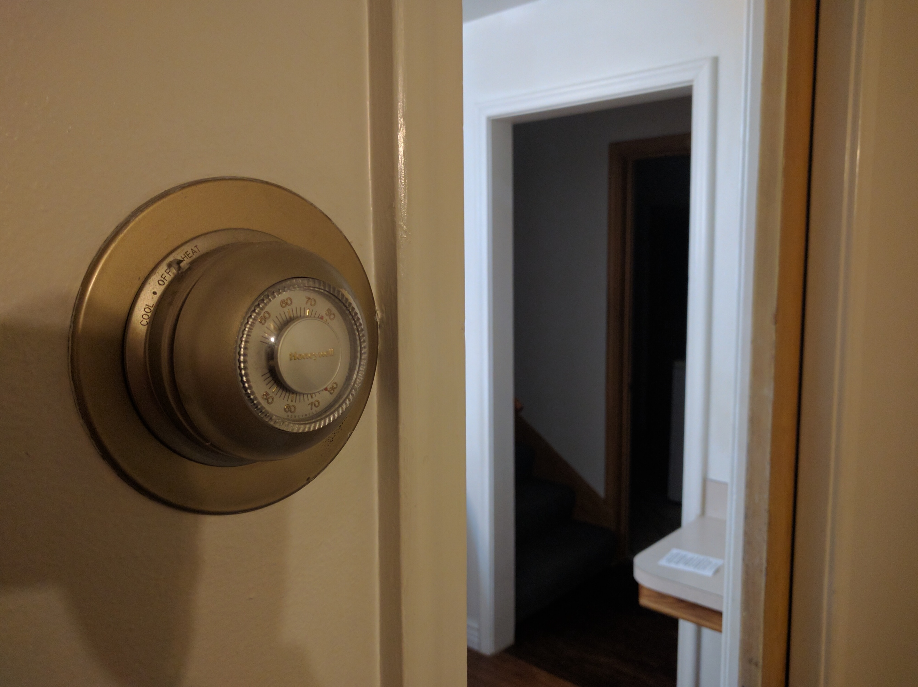

Fig 2: Picture of Arduino setup

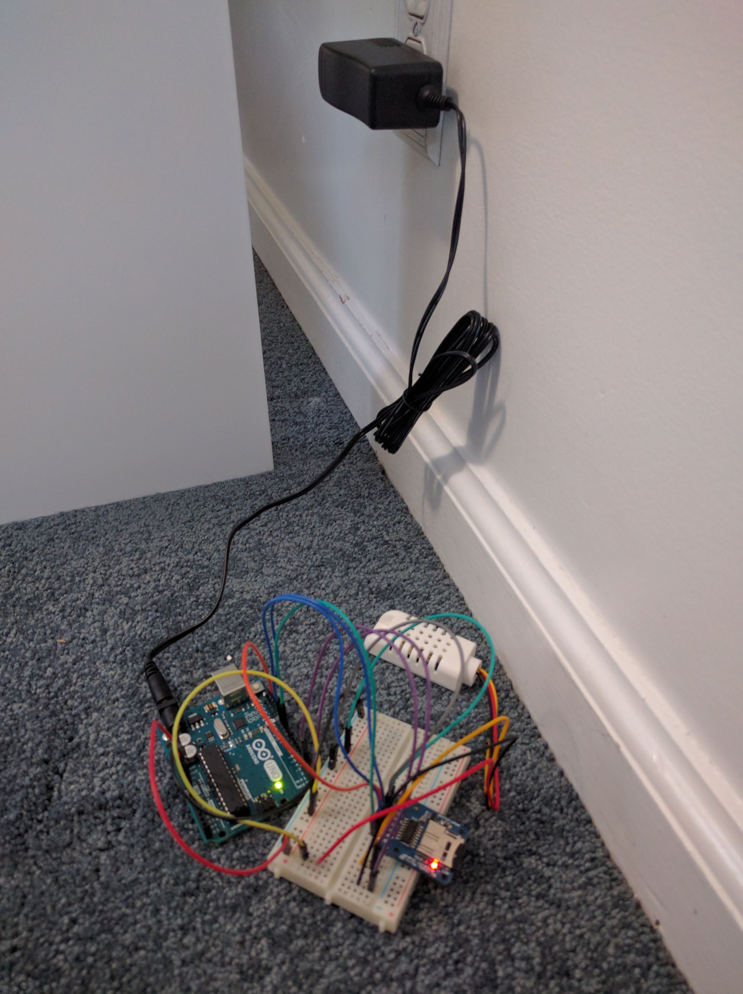

Fig 3: Time series data between room and thermostat set point

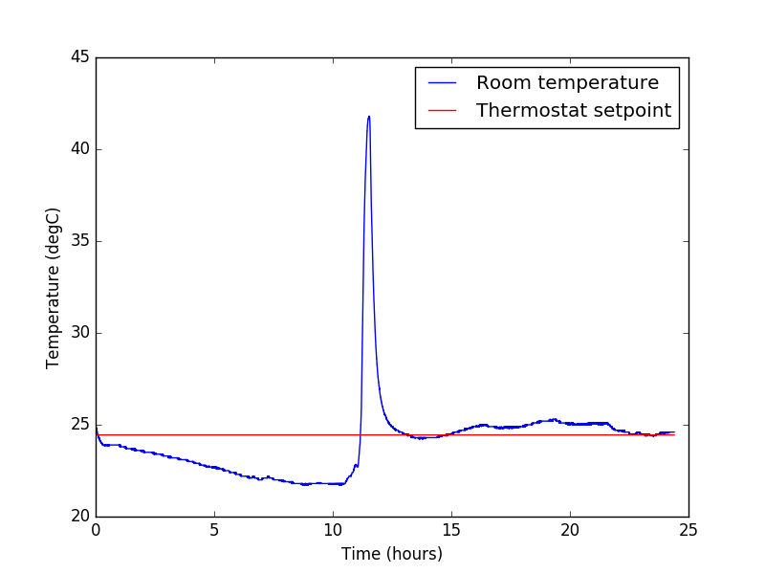

Fig 4: Box plot for room temperature

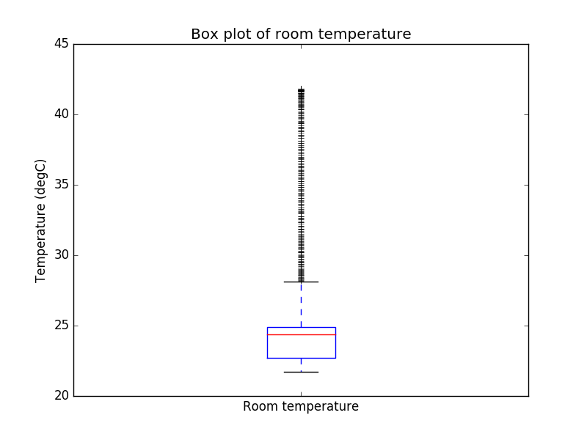

**Appendix B: Tables**

Table 1: Measures of central tendency for room temperature

|  |  |  |  |  |
| --- | --- | --- | --- | --- |
| Mean | Median | Mode | Q1 | Q3 |
| 24.13 C | 24.35 C | 21.8 C | 22.7C | 24.9C |

**Appendix C: Python code**

Link:

<https://github.com/karunmj/usu-coursework/blob/master/cee6110hydroinfo/hw/hw2/hw2.py>