*CEE 6110 Assignment #4 database implementation and loading data - resubmission*

*Karun Joseph*

*A02240287*

Database implementation and loading data - resubmission

Appendix: A Figures

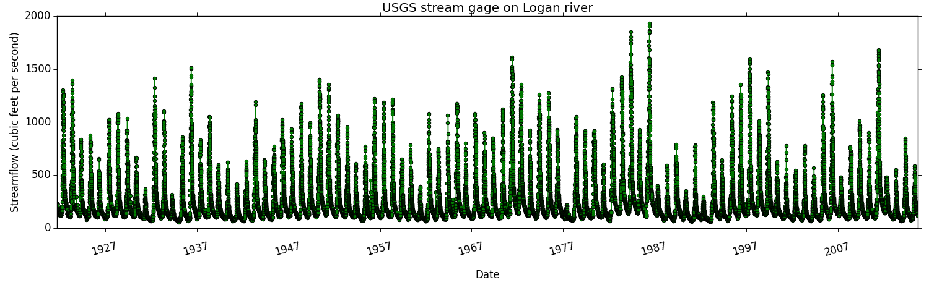

Fig 1: Stream flow measured at Logan river site ‘10109001’by USGS

Appendix: B Code, SQL queries

B1: Python code to format USGS stream flow values

*import pandas as pd*

*##usgs gauge data*

*logandaily = pd.read_csv('LoganDailyflow.csv')*

*logandailyflow = logandaily[['agency_id', 'site_no', 'Date', 'X_00060_00003']]*

*logandailyflow['SiteID'] = [14] * len(logandailyflow.index) #new site id*

*logandailyflow['VariableID'] = [17] * len(logandailyflow.index) #insert variable id for usgs flow*

*logandailyflow['MethodID'] = [26] * len(logandailyflow.index)*

*logandailyflow['SourceID'] = [2] * len(logandailyflow.index)*

*logandailyflow['QualityControlLevelID'] = [0] * len(logandailyflow.index)*

*logandailyflow['UTCOffset'] = [-7.0] * len(logandailyflow.index)*

*logandailyflow.rename(columns={'X_00060_00003': 'DataValue', 'Date': 'LocalDateTime'}, inplace=True)*

*#logandailyflow['DateTimeUTC']*

*logandailyflow = logandailyflow[['DataValue', 'LocalDateTime' ,'UTCOffset', 'SiteID', 'VariableID' ,'MethodID', 'SourceID', 'QualityControlLevelID']]*

*logandailyflow.to_csv('dailyflow.csv', index=False)*

B2: SQL queries to load USGS values

*-- load usgs flow data file*

*LOAD DATA LOCAL INFILE '/Users/karunjoseph/usu/usu-coursework/cee6110hydroinfo/hw/hw4/Hydroinformatics_Assignment-4_Data/dailyflow.csv'*

*INTO TABLE datavalues*

*FIELDS TERMINATED BY ','*

*ENCLOSED BY '"'*

*LINES TERMINATED BY '\n'*

*IGNORE 1 LINES*

*(DataValue,LocalDateTime,UTCOffset,SiteID,VariableID,MethodID,SourceID,QualityControlLevelID);*