*CEE 6110 Assignment #5 USING STRUCTURED QUERY LANGUAGE*

*Karun Joseph*

*A02240287*

Exploratory data analysis of Logan River using water temperature datasets

Introduction

Water temperature of a river is an important water quality indicator. It is necessary to understand their impact on cold water aquatic life, especially during the warmer months. This report performs an exploratory data analysis of Utah’s Logan River water temperature to assess their temporal and spatial variability.

Methods

Water quality standards for the State of Utah list the Logan River as Class 3A which is protected for cold water species of game fish and other cold water aquatic life, and require water temperature in the river not to exceed 20 °C (“UT Admin Code R317-2. Standards of Quality for Waters of the State. October 1, 2016” 2016). Water temperature data were obtained from iUTAH’s GAMUT aquatic monitoring sites across five locations on the Logan River in Utah for the year of 2014. The data were loaded into a local relational SQL based database with Observations Data Model (ODM) (Horsburgh et al. 2008) as the logical data model design. SQL queries (Appendix C) were used to assess water temperature for potential impacts on cold-water fish species. Tables 1, 2, 3 and 4 list period of record (begin and end date), total number of observations, central tendency measures, number of observations greater than 20 °C, their percent exceedance, location and month of year respectively. ODM Tools Python software was used to generate time series and exceedance frequency plots (Fig.1 and Fig.2) of water temperature.

Results

Fig 1 shows water temperature was higher during the months of July and August compared to rest of the months in 2014 for all sites. The Logan River aquatic site at Mendon Road (Site ID = 2) reported the highest percent exceedance from Fig. 2. The Mendon Road site was the only site to report temperature greater than 20 °C during the months of July and August, with percent exceedances of 14.3 and 13.71 respectively.

Conclusions

The Mendon Road site on Logan River has reported water temperature above the water quality criterion of 20 °C. There is more likely temperature related effects on fish population at this site. Higher water temperature at Mendon Road site may be due to its proximity to residential and commercial buildings, and agricultural fields unlike other monitoring sites.

References

Horsburgh, Jeffery S., David G. Tarboton, David R. Maidment, and Ilya Zaslavsky. 2008. “A Relational Model for Environmental and Water Resources Data.” *Water Resources Research* 44 (5): W05406. doi:10.1029/2007WR006392.

“UT Admin Code R317-2. Standards of Quality for Waters of the State. October 1, 2016.” 2016. Accessed October 26. http://www.rules.utah.gov/publicat/code/r317/r317-002.htm.

Appendix A: Figures

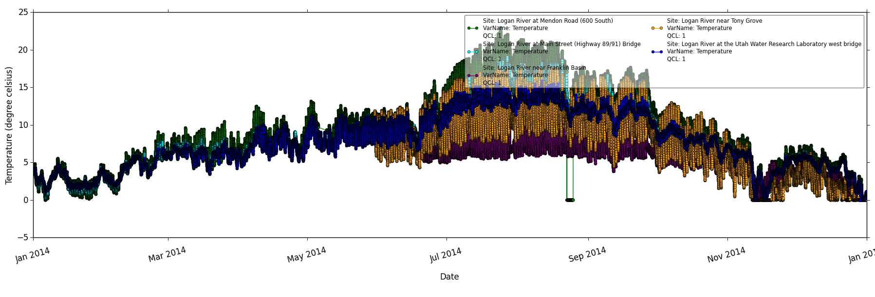

Fig 1: Time series of water temperature by site ID

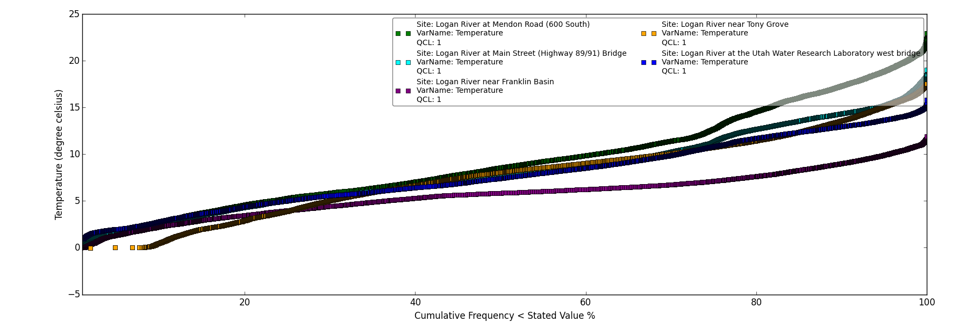

Fig 2: Exceedance frequency of water temperature by site ID

Appendix B: Tables

|  |  |  |  |  |  |  |
| --- | --- | --- | --- | --- | --- | --- |
| Site ID | Period of record | | Number of valid observations | Minimum (°C) | Maximum (°C) | Average (°C) |
| Begin date | End date |
| 1 | 2014-01-01 | 2015-01-01 | 34876 | -0.06 | 15.84 | 7.74 |
| 2 | 2014-01-01 | 2015-01-01 | 34554 | -0.04 | 22.94 | 9.23 |
| 3 | 2014-01-01 | 2015-01-01 | 35040 | -0.05 | 19 | 8.13 |
| 9 | 2014-05-30 | 2015-01-01 | 20676 | -0.04 | 17.55 | 7.56 |
| 10 | 2014-06-20 | 205-01-01 | 18668 | -0.04 | 11.89 | 5.65 |

Table 1: Period of record, total number, minimum, maximum and average values of water temperature measurements by site

|  |  |  |  |
| --- | --- | --- | --- |
| Site ID | Total number of observations | Number of observations greater than 20 °C | Percent exceedance |
|
| 1 | 34876 | 0 | 0 |
| 2 | 34554 | 818 | 2.37 |
| 3 | 35040 | 0 | 0 |
| 9 | 20676 | 0 | 0 |
| 10 | 18668 | 0 | 0 |

Table 2: Total number, number of observations greater than 20 °C and overall percent exceedance of water quality standard (above 20 °C) by site

|  |  |
| --- | --- |
| Month of year | Percent exceedance |
|
| January | 0 |
| February | 0 |
| March | 0 |
| April | 0 |
| May | 0 |
| June | 0 |
| July | 14.3 |
| August | 13.71 |
| September | 0 |
| October | 0 |
| November | 0 |
| December | 0 |

Table 3: Percent exceedance of water quality standard (above 20 °C) for Logan River at Mendon Road (Site ID = 2) by month of the year.

|  |  |
| --- | --- |
| Site ID | Percent exceedance |
|
| 1 | 0 |
| 2 | 14.3 |
| 3 | 0 |
| 9 | 0 |
| 10 | 0 |

Table 4: Percent exceedance of the water quality standard for the month of July by site

Appendix C: SQL queries

*/\**

*Q1. A table listing the period of record for water temperature measurements (e.g., begin*

*and end date), the number of observations, and the overall minimum, maximum,*

*and average values for each site at which quality controlled (QualityControlLevelID*

*= 1) water temperature (VariableID = 57) data have been collected.*

*\*/*

*SELECT SiteID, BeginDateTime, EndDateTime FROM SeriesCatalog WHERE VariableID = 57 AND QualityControlLevelID = 1;*

*SELECT SiteID, COUNT(DataValue), MAX(DataValue), MIN(DataValue), AVG(DataValue) FROM DataValues WHERE VariableID = 57 AND QualityControlLevelID = 1 AND DataValue <> -9999 GROUP BY SiteID;*

SQL query 1: Query for Table 1

*/\**

*Q2. A table listing the total number of temperature observations, the number of*

*observations greater than the water quality criterion value (i.e., 20 degrees C), and*

*the overall percent exceedance of the water quality criterion value for each site at*

*which quality controlled water temperature data have been collected*

*\*/*

*SELECT SiteID, COUNT(DataValue) FROM DataValues WHERE VariableID = 57 AND QualityControlLevelID = 1 AND DataValue <> -9999 GROUP BY SiteID;*

*SELECT SiteID, COUNT(DataValue) FROM DataValues WHERE VariableID = 57 AND QualityControlLevelID = 1 AND DataValue <> -9999 AND DataValue > 20 GROUP BY SiteID;*

*-- Only SiteID = 2 has above 20 deg c temps*

*SELECT SiteID, COUNT(DataValue)/(SELECT COUNT(DataValue) FROM DataValues WHERE VariableID = 57 AND QualityControlLevelID = 1 AND DataValue <> -9999 AND SiteID = 2) FROM datavalues WHERE VariableID = 57 AND QualityControlLevelID = 1 AND DataValue <> -9999 AND DataValue > 20 GROUP BY SiteID;*

SQL query 2: Query for Table 2

*/\**

*Q3 A table for the Logan River at Mendon Road (SiteID = 2) listing the percent*

*exceedance of the water quality standard for each month of the year.*

*\*/*

*SELECT SiteID, COUNT(DataValue), MONTH(LocalDateTime) FROM DataValues WHERE VariableID = 57 AND QualityControlLevelID = 1 AND DataValue <> -9999 AND DataValue > 20 AND SiteID = 2 GROUP BY MONTH(LocalDateTime);*

*-- Months where temp increases are July (7), August (8)*

*SELECT COUNT(DataValue)/(SELECT COUNT(DataValue) FROM DataValues WHERE VariableID = 57 AND QualityControlLevelID = 1 AND DataValue <> -9999 AND SiteID = 2 AND MONTH(LocalDateTime) = 7) FROM DataValues WHERE VariableID = 57 AND QualityControlLevelID = 1 AND DataValue <> -9999 AND DataValue > 20 AND SiteID = 2 AND MONTH(LocalDateTime) = 7;*

*SELECT COUNT(DataValue)/(SELECT COUNT(DataValue) FROM DataValues WHERE VariableID = 57 AND QualityControlLevelID = 1 AND DataValue <> -9999 AND SiteID = 2 AND MONTH(LocalDateTime) = 8) FROM DataValues WHERE VariableID = 57 AND QualityControlLevelID = 1 AND DataValue <> -9999 AND DataValue > 20 AND SiteID = 2 AND MONTH(LocalDateTime) = 8;*

SQL query 3: Query for Table 3

*/\**

*Q4, A table listing the percent exceedance of the water quality standard for each site at*

*which quality controlled data are available during the month of July, which is*

*generally a critical period with low flows and elevated temperatures.*

*\*/*

*SELECT COUNT(DataValue)/(SELECT COUNT(DataValue) FROM DataValues WHERE VariableID = 57 AND QualityControlLevelID = 1 AND DataValue <> -9999 AND SiteID = 2 AND MONTH(LocalDateTime) = 7) FROM DataValues WHERE VariableID = 57 AND QualityControlLevelID = 1 AND DataValue <> -9999 AND DataValue > 20 AND SiteID = 2 AND MONTH(LocalDateTime) = 7;*

SQL query 4: Query for Table 4