*Rezaul Haider, Karun Joseph*

*CEE6110: Final project problem statement*

**Back-end cyberinfrastructure for continuous real-time residential water use monitoring**

Rezaul Haider**,** Karun Joseph

Introduction

Significant reduction in household water consumption could be achieved by understanding its use patterns and frequencies. Monitoring water use would enable behavioral and technological interventions such as end-user nudges and water efficient device retrofits, and help understand household drivers for water consumption. Traditional water monitoring methods involve manual inspection of water meters which result in a single measurement per month. Such measurements lack granular temporal resolution and would not be possible to perform advanced analysis such as disaggregation, classification and fault detection. Recent advancements in sensing technologies and inexpensive web services make it possible for continuous real-time monitoring. This project aims to build a back-end web based cyberinfrastructure for continuous real time water use data collection, storage and analysis.

Methods

This project would depend on a parallel effort on water use data collection from Utah State University’s Living Learning Community (LLC) housing buildings using embedded microcontrollers that continuously transmit real-time data through the web. The focus would be on building a standalone back-end with minimum dependencies that makes it easy to swap and replace components. Fig. 1 shows a high level system architecture diagram of the proposed back-end. The back-end would be hosted using cloud computing from Amazon Web Services (AWS) due to its ease and low cost. A python based micro-web framework would implement RESTful API services that receives water use data and exposes this data to the outside world. A relational database management system such as MySQL would perform data storage and retrieval. Collected water use and analysis results would also be displayed externally through a web dashboard.

Appendix A: Figures

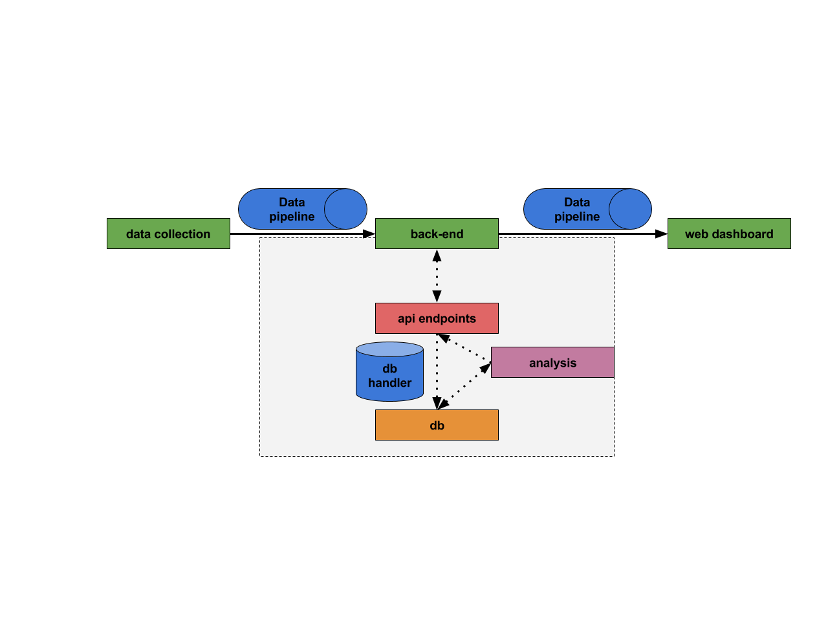

Fig. 1 Back-end system architecture